**Lecture 2 (Networking concepts)**

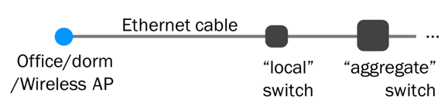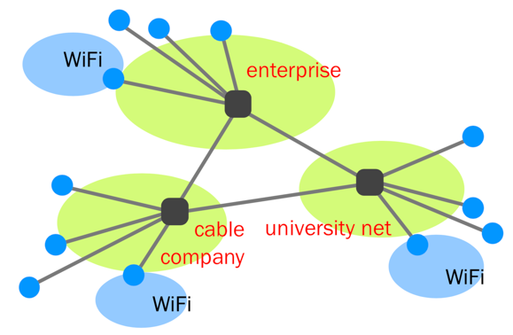

Switched networks enable efficient scaling

Sharing:

**Reservations -> circuit switch**

src sends reservations request to dst

Switches establish circuit

src starts sending data

src sends teardown message

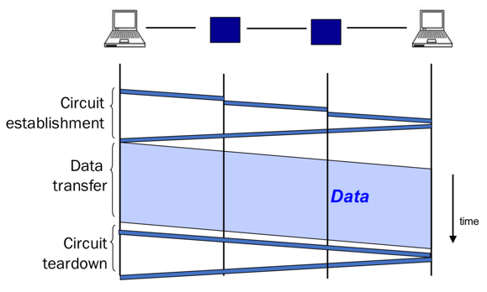

Pros: predictable performance, fast switching

Cons: circuit setup/teardown, bad with bursty traffic, if switch fails circuit will fail

**On demand -> packet switch**

Each packet has dst and treated independently, buffers absorb transient overload

Pros: efficient use of network resources, simple to implement, robust against switch fails

Cons: unpredictable performance, buffer management, congestion control

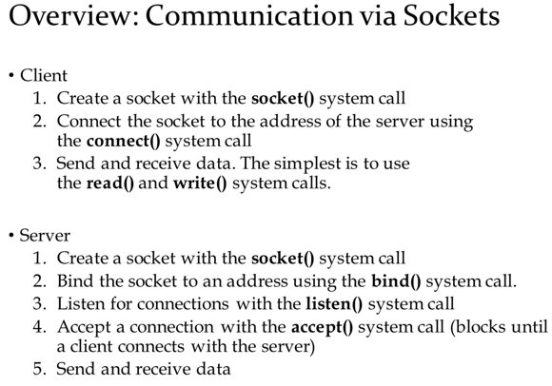

UDP does not need listen, accept, connect

**Lecture 3 (Performance metrics)**

Delay: How long does it take to send a packet from dst to src?

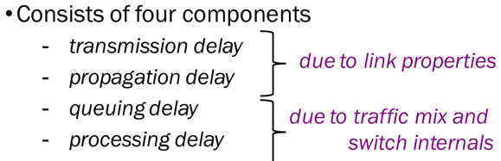

Link bandwidth: bits/sec

Propagation delay: secs for 1 bit to move through link

BDP=bandwidth x propagation delay

1mb = 1,000,000; 1ms = 1/10^3 s

Transmission delay: how long it takes to push all the bits of a packet into a link, packet size/link bandwidth

Queueing delay: how long a packet has to sit in buffer before being processed.

If arrival rate > departure rate, QD=inf.

A = average arrival rate

W = average packet wait time

L = average length of queue

L = A x W(hard to compute)

Processing delay: how long the switch takes to process a packet, negligible

Loss: fraction of packets dropped

Throughput: rate at which dst receiving packets, data size/transfer time

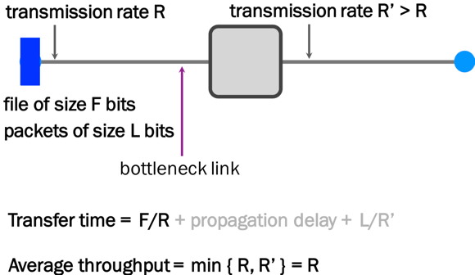

**Lecture 4 (IP routing algorithms)**

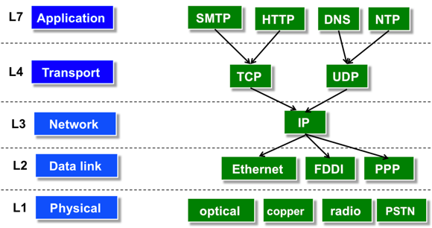

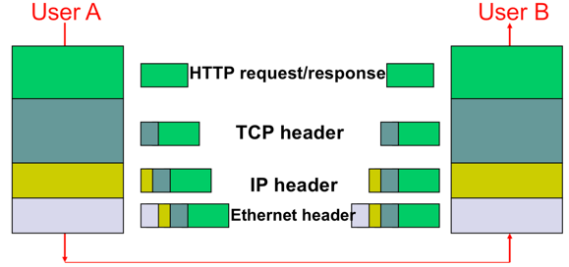

Host – implement all 5 layers

Switches – L1 and L2

Routers – L1, L2, L3

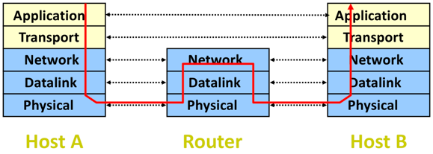

Forwarding: Local router determines output link, read address from packet’s network layer header, search forwarding table

Routing: Network wide process to determine content of forwarding tables (end to end path for each destinations)

Local routing is the forwarding table in a single router, global state refers to collection of forwarding tables in each of the routers

Routing state is valid if and only if there are no dead ends and there are no loops

**Distance vector:** only know neighbors, when routing table changes, send to neighbors

Distance vector algorithm, broadcast and receive neighboring forwarding tables, can calculate next hop for a destination and total cost to get to that destination. Good news travels fast and bad news travels slowly.

Poisoned reverse: distance is inf. If routes through itself

**Link state:** node floods local information to every other node in the network. Dijkstra to compute shortest path to every other node

**Lecture 5 (Addressing)**

Distance vector (RIP, IGRP) vs link state (OSPF) is a local routing problem

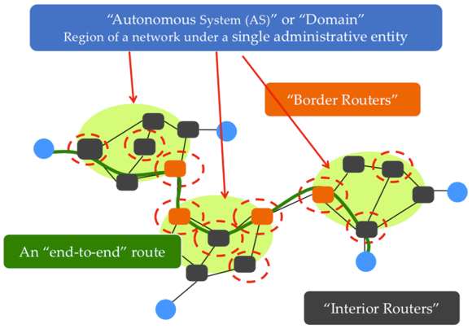

Forwarding table should have an entry for a range of addresses. Hose addressing is key

AS wants policy, autonomy, privacy

BGP (Border Gateway Protocol) extends distance vector to accommodate policy

IPv4 is 32 bit number split into prefix (network) and suffix (host)

Classful addressing only has 3 sizes, 1 byte, 2 byte, 3 byte network prefixes

**CIDR** (classless Interdomain routing) – flexible division between network and host addresses. 128.23.9/26 means 26 bits as network prefix. 26 represented by 32 bit mask

ICANN -> ARIN -> ISP -> individuals

**Lecture 6 (BGP)**

AS can be customer, provider, peer

Peers have similar traffic and route through each other to save money

BGP selects best route based on policy rather than shortest distance; sends entire path for each destination (rather than just distance metric, avoid loops); selective route advertisement; aggregate routes for different prefixes

eBGP – BGP between border routers

iBGP – between routers within same AS

IGP – intradomain routing protocol

**Security:** AS can claim to serve a prefix they do not have access to, AS can forward along a route different than advertised

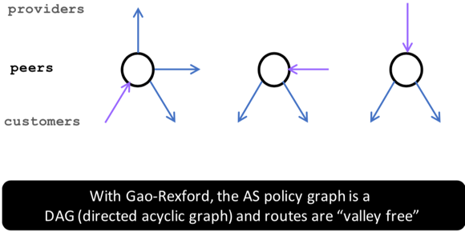

Gao-Rexford guaranteed to converge

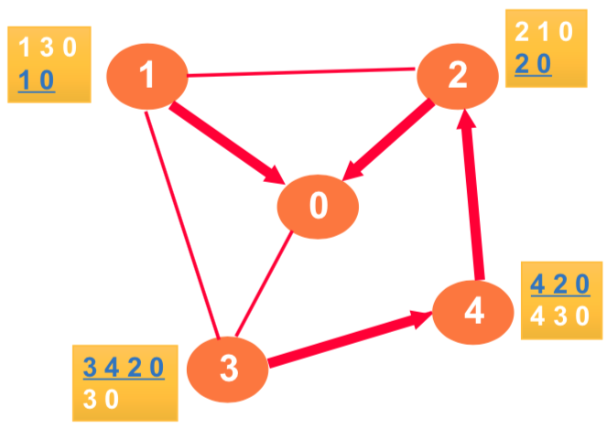

Persistent oscillation, AS path length mislead

**Lecture 7, 8(IP, TCP)**

IP Datagram – 20 bytes; Address resolution protocol ARP maps IP address to link level address to be used in direct delivery

Internet control message protocol (ICMP) – exchange control/error messages about delivery of IP datagrams: address mask, timestamp, source quench (traffic overload), parameter problem (errors in IP datagram field), echo, time exceeded (report expired datagrams), redirect, destination unreachable, traceroute (send datagrams each with increasing TTL)

**TCP:** sequence # specifies position of the segment data, ack # specifies position of next byte expected from communication partner. TCP flow control window: make sure receiving end can handle data (no regard for network). Accept iff ack # < syn # < ack # + window

SYN/FIN – establishing/terminating connect

ACK – when ACK is valid; URG – urgent pointer says where non urgent starts; PUSH; ABORT – abort connection.

NACK – packet did not arrive; cum. ACK – ACKS for all k < n; SACK – selective ACK

Key func: flow control, data transfer, congestion control, connection setup

Throughout=window/RTT

Know packet dropped when time out, receive duplicate ACKs

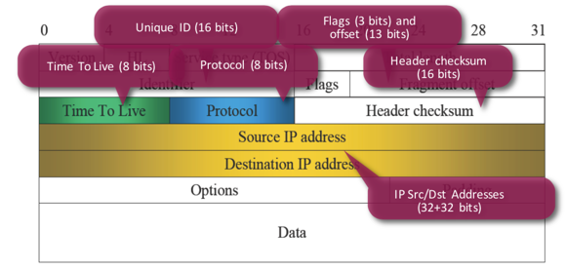

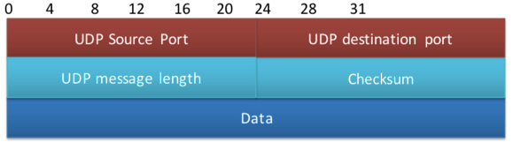

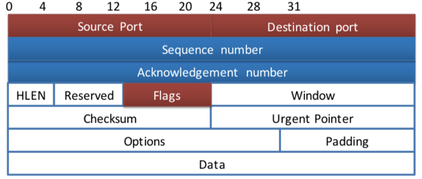

**TCP Congestion Control:** guessing about state of network, additive increase multiplicative decrease, KNEE – point at which throughput increases slow and delay increases fast, CLIFF – point after which throughput decreases to zero fast. Congestion control stay left of cliff, congestion avoidance stay left of knee.

**AIMD** – converges to efficiency and fairness

Maintain cwnd, flow_win, Ssthresh (update cwnd), for sending use min(cwnd, flow_win)

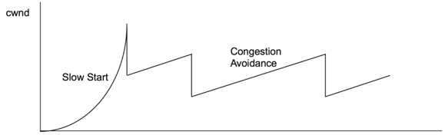

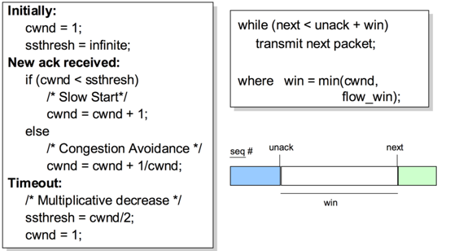

MIAD – not stable not fair; AIAD – stable not fair; MIMD – stable not fair; AIMD – stable fair

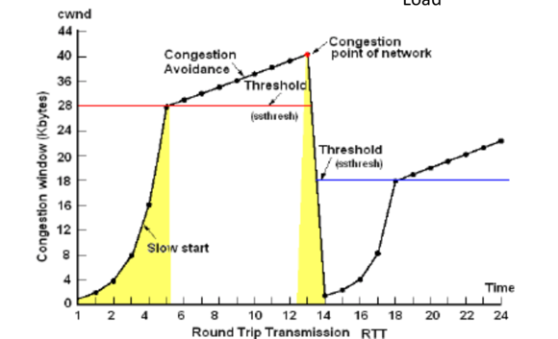

**Lecture 9 (FTP, DNS)**

FTP: transfer files between 2 computers; need to resolve OS, character, naming, directory

2 connections: Control (persistent connection, 21), Data (ephemeral connection, 20)

In active FTP the client tells the server which port the server should connect to (server initiates connection). Client firewall would usually block this so we use passive FTP

**DNS – local servers and resolver software**

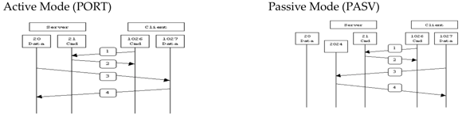

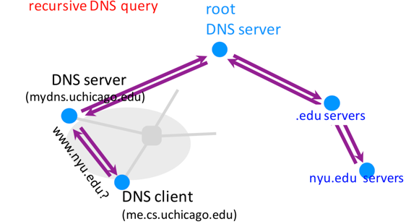

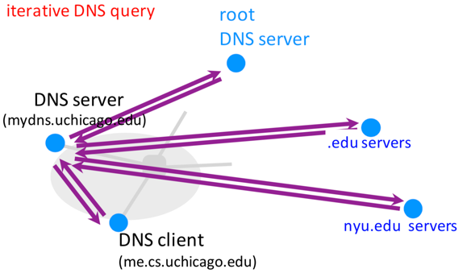

**Lecture 10 (DNS, RPC)**

DNS caching: DNS servers cache responses to queries, delete cached entry after TTL expires, top level servers rarely change

Attacking DNS: impersonate local DNS server and give wrong IP address to client; denial of service the root to make them unavailable

DNS properties: easy unique naming, fate sharing for network failures, reasonable trust model, caching lends scalability, performance

Server designs: iterative vs concurrent; connections vs connectionless; stateful vs stateless

Remote procedure call: called procedure not in same address space, transport independence, hides network from programmer, BLOCKS, there is more delay, cannot pass pointers, idempotent can be repeated safely non idempotent cannot

RPC calls can be lost/duplicated, at least once/zero or more (reply/no reply)

Request – transaction id, procedure id, credentials, verifier, params(XDR); REPLY – trans id, status, verifier, status, resultsXDR

XDR – specify how data object encoded, client server need to agree on format

