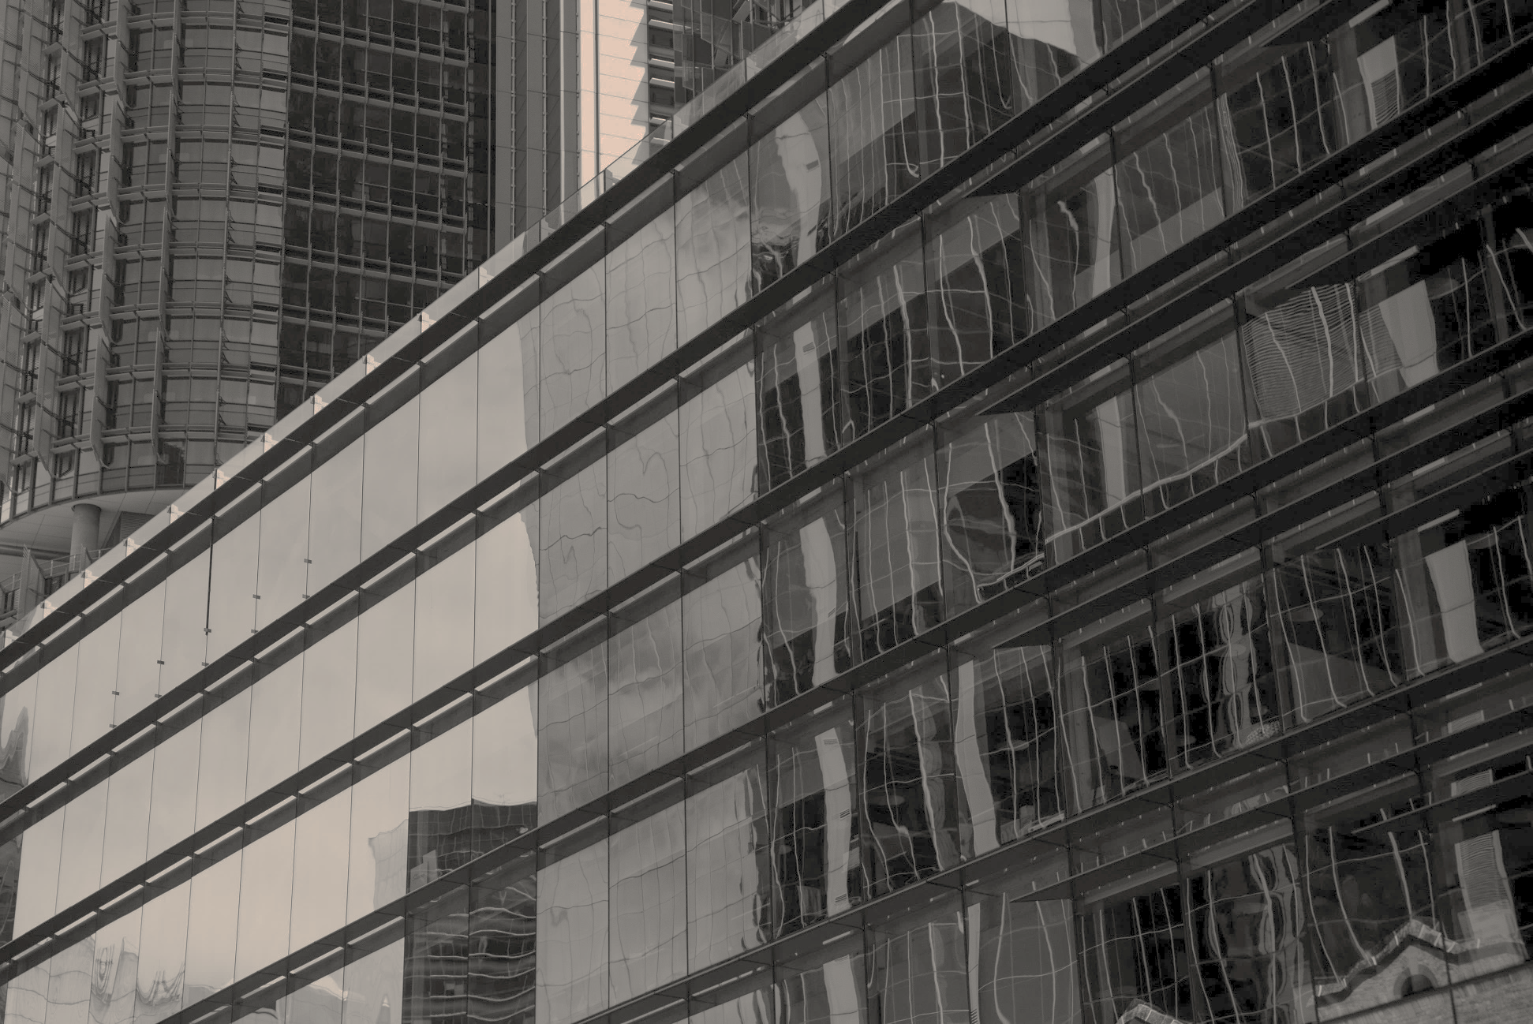

Risk Surveys | Replacement Costs | Thermal Scans

quotes@assetinspect.com.au

(02) 9555 6949

assetinspect.com.au

Asset Inspect Pty Ltd

559-563 Darling St

Rozelle NSW 2039

**%CLIENT%**

**Prepared for:**

**Name: %NAME%**

**Company: %COMPANY%**

**Issued On: %DATE%**

**Valid To: %VALID%**

**Instructions To:** quotes@assetinspect.com.au

**%TYPE%**

**%TITLE%**

**%TYPE%**

|  |  |
| --- | --- |
| **%TITLE% – %CLIENT%** | |
| %START% |  |
|  |  |
| **%LOCATION1%:** |  |
| %LOC1% |  |
| Insurance Risk Survey | **$%INSP1%** |
| Building Replacement Cost Report  **Replacement cost includes free desktop updates for 2026 and 2027 upon request** | **$%REPL1%** |
| Thermal Scan %NPAN1%  **Introductory Price** | **$%THER1%** |
| Discount – Combined Service | **-$%LDSC1%** |
| %END% |  |
|  |  |
|  |  |
| **%TRAV1%** | **$%TRAVCOST1%** |
| **Shared Travel (-50%)** | **-$%TDSC1%** |
|  |  |
| Discount %DISCREASON% | **-$%DISC%** |
|  |  |
| SUB TOTAL (exc. GST) | $%SUBT% |
| GST | $%GST% |
| **TOTAL (inc. GST)** | **$%TOT%** |
|  |  |

[[START:THERMAL_DISCLAIMER]]

Any additional switchboard panels identified on site beyond those outlined in this estimate will incur a charge of $50 per panel. No additional charges will be applied without prior communication and your agreement.

[[END:THERMAL_DISCLAIMER]]

To proceed, please provide instructions to quotes@assetinspect.com.au with billing and site contact details. Please note: if billed to the Insured, full payment must be received before our reports are released. A black and white logo

Any Risk Anywhere. In-House Consultants