**ASSESSMENT-01**

**Project Setup: Initialize a new Flutter project in your development environment for the below requirements.**

**Analysis of Design:** Study screenshots to grasp layout, components, and navigation. Identify reusable widgets like list tiles, buttons, and the profile area.

**Setting Up:** Install Flutter. Create a new project.

**Structuring the Project:** Organize into folders like pages, widgets, models, services.

**Design System:** Define a theme with matching colors, fonts, and sizes. Set constants for styling.

**Building the UI:**

**AppBar:** Custom top page bar.

**Profile Area:** Widget with image, name, phone number.

**List Tiles**: Use ListView.builder or Column for custom options list.

**Country Selection**: Use a dialog or screen.

**Bottom Navigation**: Custom navigation widget.

**Styling**: Apply dark theme using ThemeData. Create custom widgets for consistency.

**Navigation and Flow:** Use routing for screen/dialog navigation.

**Interactivity:** Add buttons and callbacks for user actions.

**Responsive Design:** Use MediaQuery for UI adaptability. Test on various screens.

**Implementing Logic:** Handle interactions like country change or logout.

**Testing:** Conduct UI tests to verify widget functionality.

**Optimization:** Profile for performance. Optimize images and animations.

**Note: UI Should be similar to the below images**

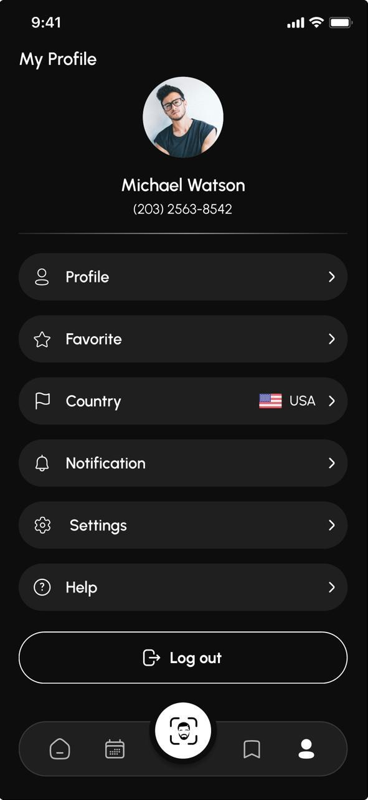

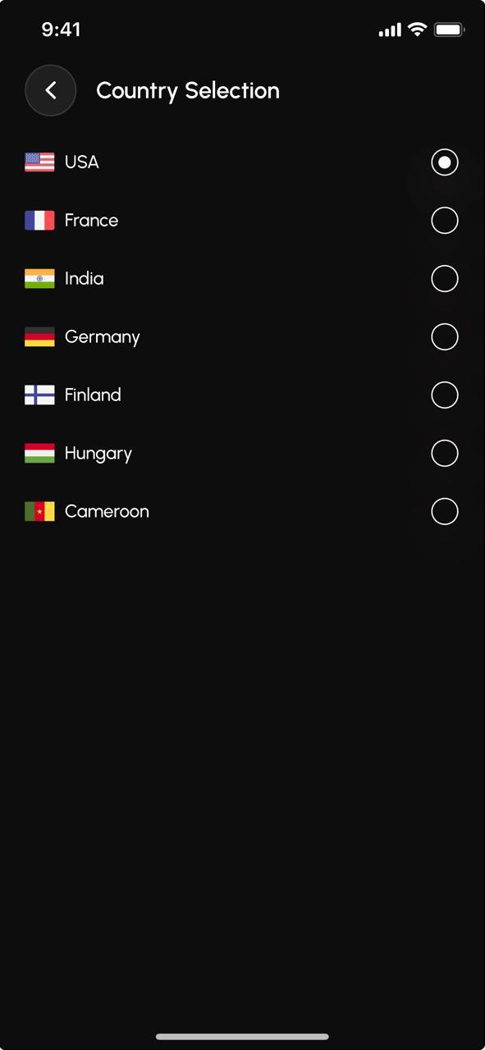

**Note :** Please submit your assessment to [sunil@hashteksolutions.com](mailto:sunil@hashteksolutions.com) & [vijaykumarb@hashteksolutions.com](mailto:vijaykumarb@hashteksolutions.com) by 14 th March,2024, 6 PM IST.

Add proper Readme steps on how to execute!