Statistical Uncertainty Quantification for Hallucination Detection in Large Language Models
Kefei Wang (kw3223), Yizhi Wang (yw4680), Yifei Dou (yb2881)
STAT GR5293 — Spring 2026

Abstract
Large Language Models (LLMs) frequently generate fluent but factually incorrect outputs, a phenomenon known as hallucination. In this work, we investigate whether statistical uncertainty signals derived from token-level probability distributions can reliably detect hallucinated responses. We extract five features from GPT-2 XL outputs on 500 TriviaQA questions: average log-probability, minimum log-probability, standard deviation of log-probability, average token entropy, and maximum token entropy. We evaluate these signals individually and in combination via logistic regression. Our best single feature, std_logprob, achieves AUROC = 0.715, and the combined model reaches AUROC = 0.723, substantially above the random baseline of 0.519. These results demonstrate that token-level uncertainty signals carry meaningful information about hallucination risk, even without access to external knowledge or retrieval systems.

1. Introduction
Large Language Models have achieved remarkable performance across a wide range of natural language tasks. However, they remain prone to generating confident-sounding responses that are factually incorrect or unsupported by evidence. This phenomenon, commonly referred to as hallucination, poses significant risks in high-stakes applications such as medical question answering, legal research, and educational tools.
A key challenge is that model confidence is not always aligned with factual correctness. A model may assign high token-level probabilities to a hallucinated response, making it indistinguishable from a correct one based on surface fluency alone. We refer to this misalignment as blind confidence.
Rather than addressing hallucination through retrieval augmentation or post-hoc fact-checking, this work takes a statistical perspective: can uncertainty signals derived directly from the model's output distribution be used to flag unreliable generations? We formulate hallucination detection as a binary classification task and evaluate the discriminative power of several token-level uncertainty measures on a factual question-answering benchmark.
Our contributions are as follows:
- A systematic evaluation of five token-level uncertainty features for hallucination detection.
- Empirical evidence that log-probability variance (std_logprob) is the strongest single indicator of hallucination.
- A combined logistic regression classifier that outperforms all individual baselines.
- Qualitative analysis of blind confidence cases where the model is confidently wrong.

2. Related Work
Uncertainty quantification in neural language models has a rich history. Early work focused on calibration of classification models (Guo et al., 2017), showing that modern neural networks tend to be overconfident. For generative models, the problem is more complex because outputs are sequences rather than discrete classes.
SelfCheckGPT (Manakul et al., 2023) detects hallucinations by measuring consistency across multiple stochastic samples from the same prompt, operating without access to ground-truth references. Semantic Entropy (Farquhar et al., 2024) extends this idea by clustering semantically equivalent answers before measuring disagreement, improving robustness to surface-level paraphrasing.
Conformal prediction has been proposed as a framework for providing rigorous coverage guarantees in language model outputs (Quach et al., 2023; Angelopoulos et al., 2022). While full formal guarantees are difficult to provide for open-ended generation, calibration techniques can still improve the interpretability of uncertainty thresholds.
Our work is most directly related to studies that use log-probability signals for factuality estimation. Kadavath et al. (2022) showed that model-predicted probabilities correlate with correctness on closed-book QA, though this correlation weakens for larger, more capable models. We build on this finding by systematically comparing multiple probability-derived features and combining them in a simple classifier.

3. Methodology

3.1 Task Formulation
We formulate hallucination detection as a binary classification problem. For each question q, a model generates an answer a. We label a as correct (label = 1) if it matches any accepted reference answer, and hallucinated (label = 0) otherwise. Matching uses both exact substring matching and fuzzy string similarity (SequenceMatcher ratio > 0.7) to account for minor paraphrasing.

3.2 Uncertainty Features
For each generated response, we extract the following five features from the token-level score distribution:
- avg_logprob: Mean log-probability of the greedy-decoded token at each generation step. Lower values indicate overall low confidence.
- min_logprob: Minimum log-probability across all generation steps. Captures the least confident individual decision in the sequence.
- std_logprob: Standard deviation of token log-probabilities. High variance may indicate inconsistent confidence, a signal of uncertainty.
- avg_entropy: Mean token-level entropy H = -Σ p(w) log p(w) across all steps. Measures distributional uncertainty at each position.
- max_entropy: Maximum token-level entropy. Captures the single most uncertain generation step.

All features are computed from greedy decoding with output_scores=True using the Hugging Face Transformers library.

3.3 Detection Methods
We evaluate each feature individually as a hallucination risk score, and also combine all five features using logistic regression (LR) trained with standard scaling. For individual features, we use the score directly as a ranking signal without fitting a threshold. The combined classifier assigns a probability score via sigmoid output.

3.4 Evaluation Metrics
We report AUROC (Area Under the ROC Curve) and AUPRC (Average Precision) for each method. AUROC measures ranking quality across all thresholds; AUPRC is more informative under class imbalance, which is present in our dataset (80.8% hallucinated, 19.2% correct).

4. Experiments

4.1 Dataset
We use TriviaQA (Joshi et al., 2017) in the no-context (closed-book) setting. We sample 500 questions from the validation split. Each question has a set of accepted answer aliases, allowing flexible matching. The final dataset contains 96 correct responses (19.2%) and 404 hallucinated responses (80.8%).

4.2 Model
We use GPT-2 XL (1.5B parameters, Radford et al., 2019) as our generation model. GPT-2 XL is suitable for this study because it exposes token-level log-probabilities through its Hugging Face implementation and is small enough to run inference on a single GPU within practical time constraints. Responses are generated via greedy decoding with a prompt format of "Q: {question}\nA:".

4.3 Baselines
We compare against a random baseline that assigns uniform random scores. This provides a lower bound on AUROC = 0.5 and AUPRC approximately equal to the positive class rate.

5. Results

5.1 Quantitative Results
Table 1 summarizes the AUROC and AUPRC of all methods.

Method | AUROC | AUPRC
avg_logprob | 0.683 | 0.895
min_logprob | 0.694 | 0.903
std_logprob | 0.715 | 0.908
avg_entropy | 0.691 | 0.897
max_entropy | 0.668 | 0.888
random | 0.519 | 0.813
combined (LR) | 0.723 | 0.913

Table 1: Hallucination detection performance across all methods on 500 TriviaQA samples (GPT-2 XL).

All uncertainty-based methods substantially outperform the random baseline (AUROC 0.519). The best single feature is std_logprob (AUROC = 0.715), indicating that variance in token-level confidence is more informative than the mean. The combined logistic regression model achieves the highest AUROC (0.723) and AUPRC (0.913), confirming that features are complementary.
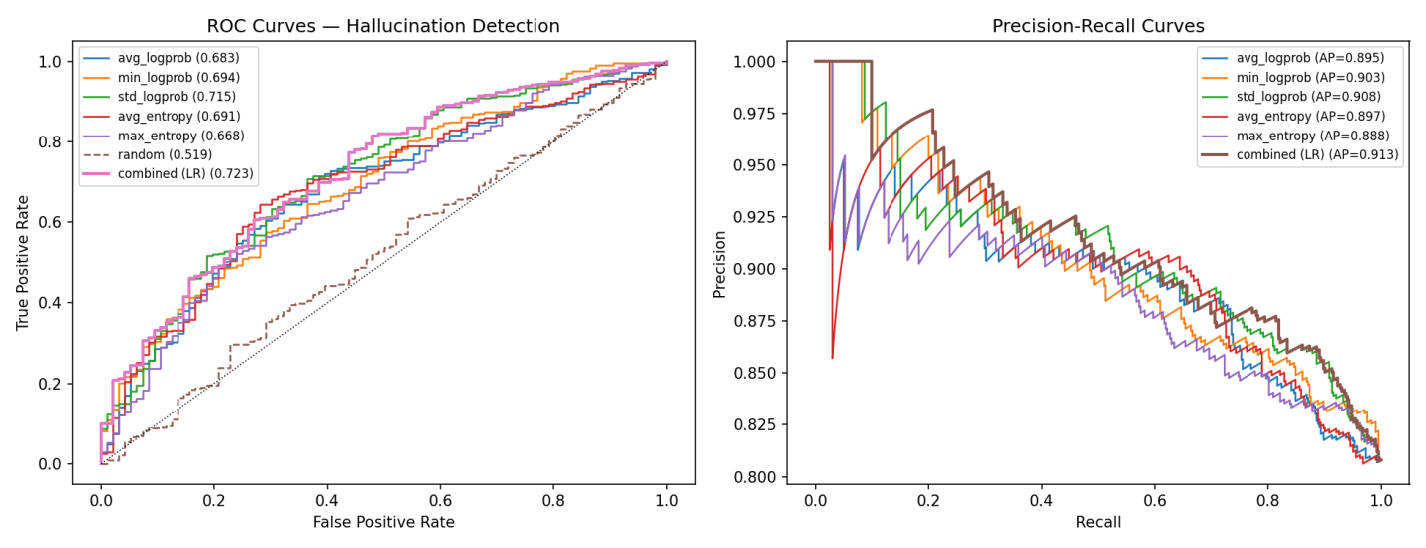

5.2 Feature Importance
As shown in the feature importance analysis, avg_entropy (0.31) and std_logprob (0.27) are the two most important features in the combined classifier, followed by avg_logprob (0.21) and min_logprob (0.17). max_entropy contributes minimally (0.04), suggesting it is largely redundant with avg_entropy.
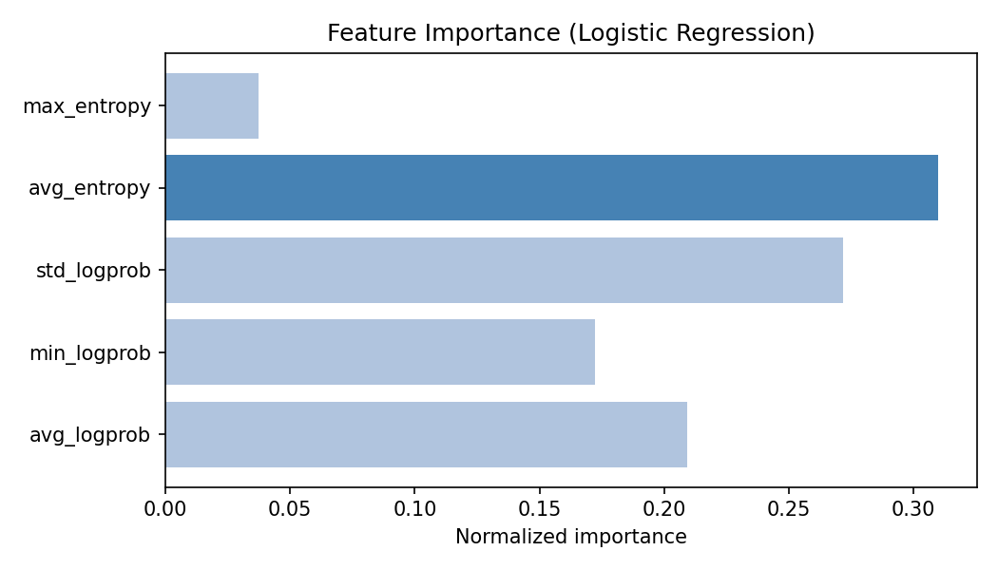

5.3 Distribution Analysis
Examining the feature distributions by label, correct responses show measurably higher avg_logprob (-0.637 vs. -0.800) and lower avg_entropy (1.912 vs. 2.308) compared to hallucinated ones. However, the distributions overlap substantially, explaining the moderate AUROC values and highlighting the inherent difficulty of the task.
The std_logprob gap is also notable: correct responses have lower variance (0.671 vs. 0.792), suggesting that when GPT-2 XL generates a correct answer, it does so with more consistent token-level confidence throughout the sequence.
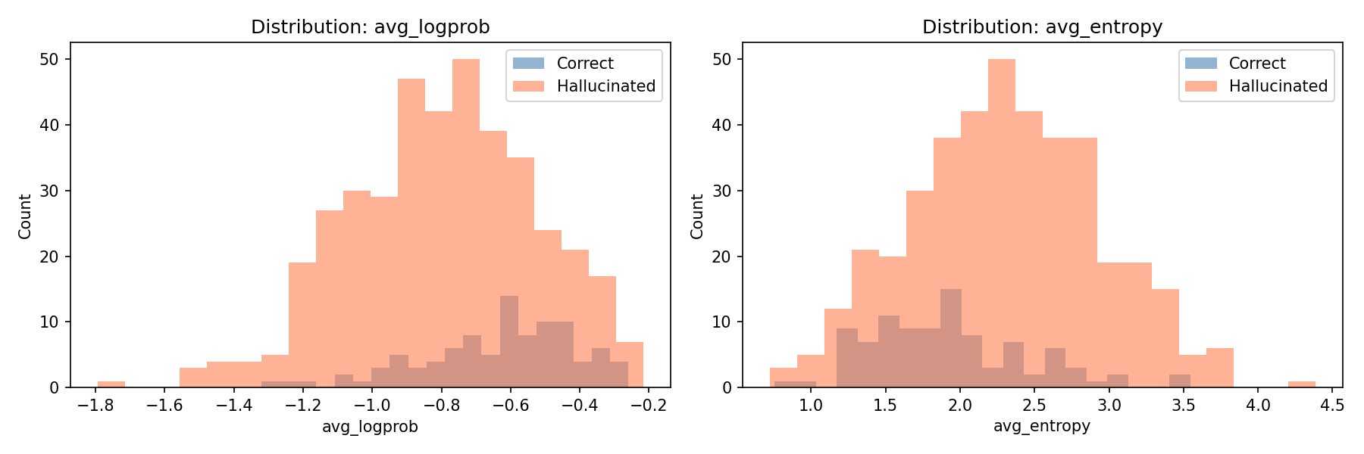
Figure 2 shows box plots of all five features, separated by label.
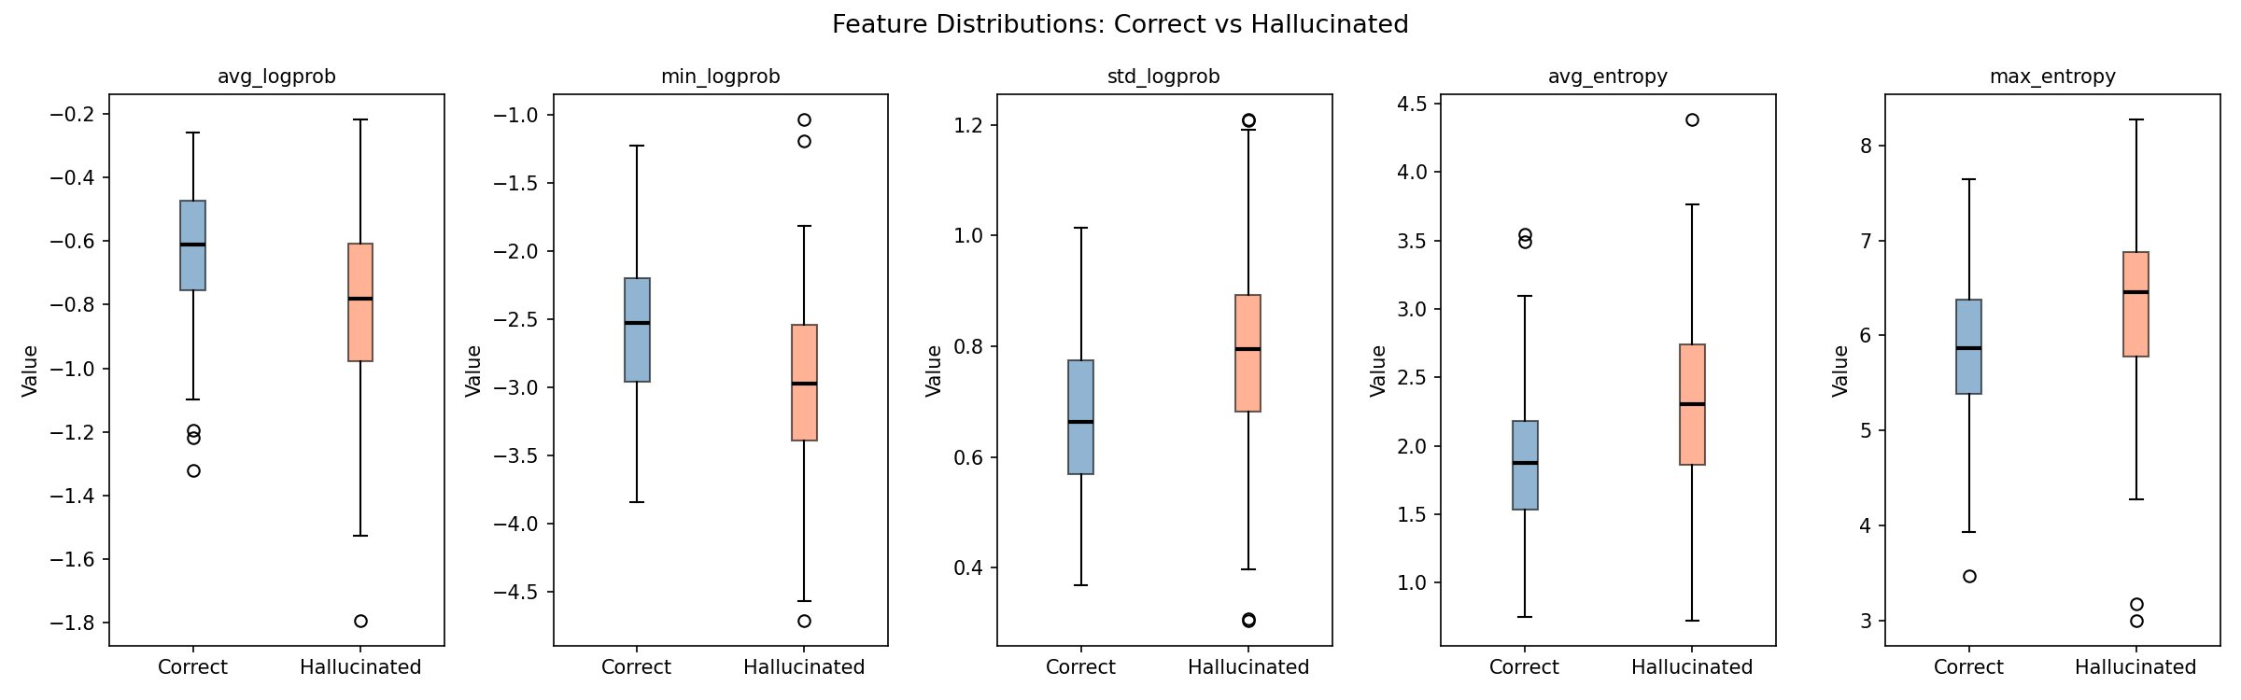
Figure 2: Box plot distributions of all five uncertainty features for correct (blue) vs. hallucinated (coral) responses.
The box plots confirm the distributional differences observed in Section 5.3. For avg_logprob, correct responses have a noticeably higher median and tighter interquartile range. For std_logprob, hallucinated responses show a wider spread and higher median, reinforcing its value as a detection signal. avg_entropy shows the most visually distinct separation, consistent with its high feature importance score. max_entropy shows less separation, explaining its minimal contribution to the combined model.

5.4 Threshold Sensitivity Analysis
To understand the trade-off between precision and recall at different operating points, we analyze the combined LR classifier across all decision thresholds.
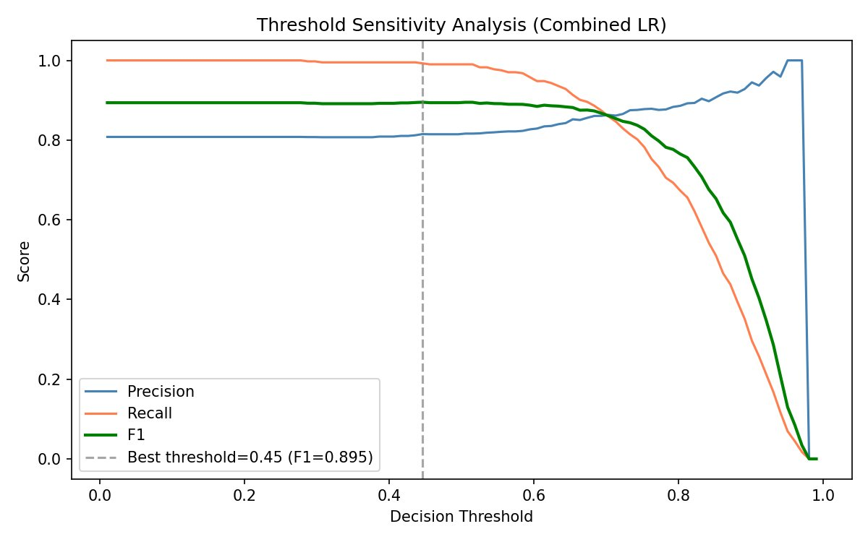
Figure 3: Precision, recall, and F1 as a function of decision threshold for the combined logistic regression classifier.
As shown in Figure 3, recall remains high (near 1.0) for low thresholds, meaning almost all hallucinated responses are flagged, but at the cost of many false alarms. The best F1 score of 0.895 is achieved at threshold = 0.45, where precision is approximately 0.81 and recall is 1.0. Beyond threshold 0.7, precision rises but recall drops sharply, producing a worse F1. This analysis is important for practical deployment: depending on whether false positives or false negatives are more costly, a system designer can select an appropriate threshold.

5.5 Confusion Matrix
Figure 4 shows the confusion matrix of the combined LR classifier at the optimal threshold of 0.45.
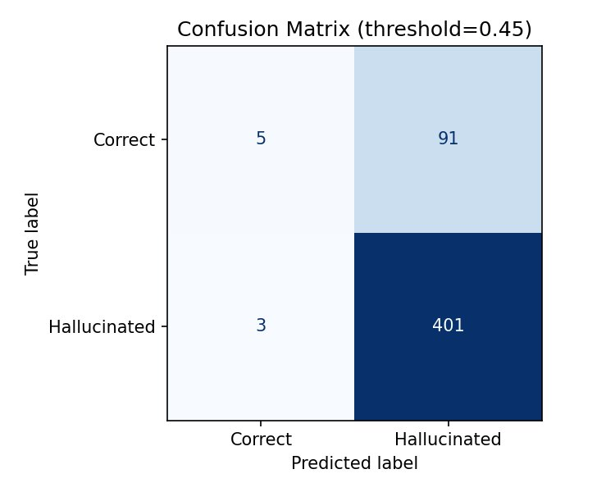
Figure 4: Confusion matrix at decision threshold = 0.45.
At threshold 0.45, the classifier correctly identifies 401 out of 404 hallucinated responses (recall = 99.3%) and 5 out of 96 correct responses. The high false positive count (91 correct responses classified as hallucinated) reflects the conservative nature of this threshold. This asymmetry is expected given the class imbalance and suggests that the model has learned to default to predicting hallucination, which is the majority class. A higher threshold (e.g., 0.70) would improve specificity at the cost of missing more hallucinated cases.

5.6 Qualitative Error Analysis: Blind Confidence
Table 2 presents eight representative cases of blind confidence, where GPT-2 XL generated a hallucinated response with relatively high confidence (lowest avg_logprob among hallucinated samples).
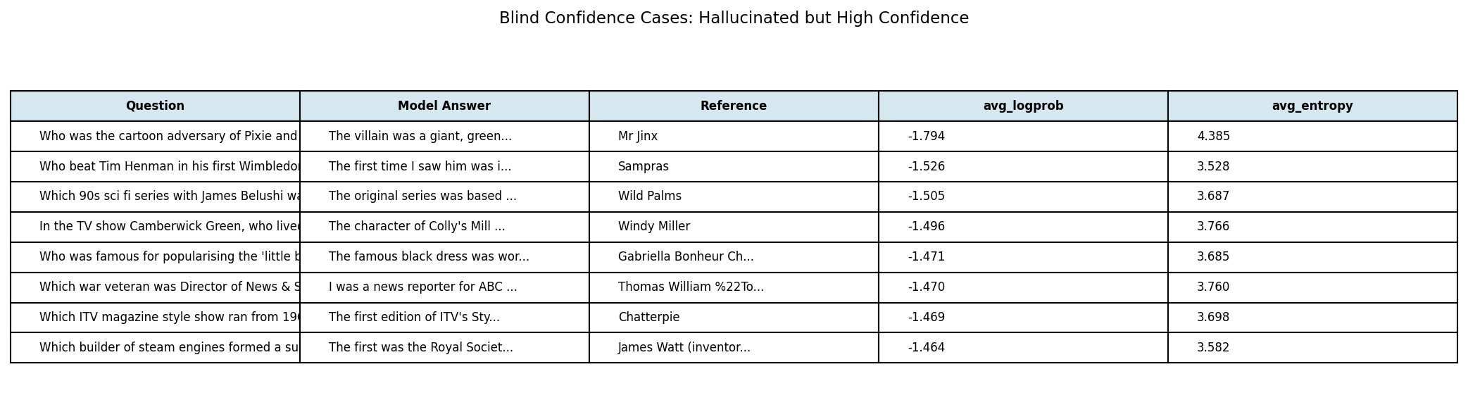
Table 2: Blind confidence cases — hallucinated responses with high model confidence.
In each case, the model generates a fluent, confident-sounding response that is factually incorrect. For example, when asked about the cartoon adversary of Pixie and Dixie, the model produces a narrative response about a giant villain rather than stating the correct answer (Mr. Jinx). Similarly, the Wimbledon question elicits a first-person anecdote rather than the factual answer (Sampras). These cases illustrate that token-level fluency and confidence are not reliable proxies for factual accuracy, motivating the need for uncertainty-based detection beyond simple log-probability thresholding.

5.7 Additional Error Analysis
We identify two failure modes. The first is blind confidence: the model generates a wrong answer with high average log-probability, for example answering "Winston Churchill" to a question about the first British Prime Minister after WWII (correct: Clement Attlee). The second is uncertain-but-correct: the model generates a correct answer with low confidence, often for less common factual associations. These cases illustrate that probability alone is insufficient and motivate future work on calibration.

6. Discussion
Our results support the hypothesis that token-level uncertainty signals carry information about hallucination risk. The strongest signal is std_logprob rather than avg_logprob, which is somewhat counterintuitive: it is not average confidence that matters most, but the variability of confidence across the generated sequence. This suggests that hallucinated responses tend to have uneven confidence profiles, with some tokens generated confidently and others much less so.
The high AUPRC values (0.888-0.913) should be interpreted carefully. Because 80.8% of responses are hallucinated, a classifier that predicts hallucination for every input would achieve AUPRC near the base rate. Our methods improve substantially on this, but the high absolute AUPRC partly reflects the class imbalance rather than strong discrimination.
One limitation is the use of GPT-2 XL, a relatively weak model by current standards. Stronger models such as LLaMA-3 or Mistral-7B achieve higher accuracy on TriviaQA, which would produce more balanced labels and a more challenging detection task. We expect that the relationship between uncertainty and correctness may differ for larger, better-calibrated models.
Due to implementation constraints, self-consistency scoring (comparing answers across multiple stochastic samples) was not included in the final evaluation. This is a direction for future work, as consistency-based methods such as SelfCheckGPT have shown strong results in prior literature.

7. Conclusion
We presented a statistical framework for hallucination detection in LLMs based on token-level uncertainty signals. Using GPT-2 XL on 500 TriviaQA questions, we showed that log-probability variance (std_logprob) is the most informative single feature, and that combining multiple uncertainty features via logistic regression yields further improvement (AUROC = 0.723 vs. random baseline 0.519). Our analysis confirms the existence of blind confidence in LLM generation and motivates continued work on uncertainty-aware reliability assessment.

References
Angelopoulos, A. N., & Bates, S. (2022). A gentle introduction to conformal prediction and distribution-free uncertainty quantification. arXiv:2107.07511.
Farquhar, S., et al. (2024). Detecting hallucinations in large language models using semantic entropy. Nature, 630, 625-630.
Guo, C., et al. (2017). On calibration of modern neural networks. ICML.
Joshi, M., et al. (2017). TriviaQA: A reading comprehension dataset over trivia questions. ACL.
Kadavath, S., et al. (2022). Language models (mostly) know what they know. arXiv:2207.05221.
Manakul, P., et al. (2023). SelfCheckGPT: Zero-resource black-box hallucination detection for generative large language models. EMNLP.
Quach, V., et al. (2023). Conformal language modeling. ICLR.
Radford, A., et al. (2019). Language models are unsupervised multitask learners. OpenAI Blog.

