Armor
Personal Armour
Front amor: 50  Left amor: 40  Right amor: 40  Rear amor: 30  Under amor: 30  Price: 22000 | 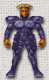

Power Suit
Front amor: 100  Left amor: 80  Right amor: 80  Rear amor: 70  Under amor: 60  Price: 42000 | 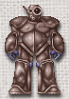

Flying Suit
Front amor: 110  Left amor: 90  Right amor: 90  Rear amor: 80  Under amor: 70  Price: 58000 | 