Petcube case. Asymmetric competition

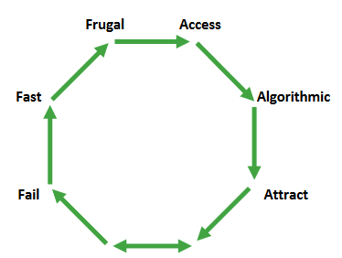

## Big

68% of households in US own a pet today. In the US market size amounted to 55 billion dollars in 2013. The global market is open as well. Most importantly, there is demand for their product. According to Yaroslav: “From very beginning we wanted to build a global business.” So big aspect of asymmetric competition is definitely a strong side of Petcube.

## Fail

Guys had a lot of trouble and failures on their way. First of all, the arrest of the director of the factory. Afterwards, they have received a rejection from Y Combinator three times in a row!!! Only the fourth one was successful. They were on the edge of fail, when Petcube owners and workets “were faced with the choice - either to fire half of the company, or cut salary in twice.” Luckily they have survived that moment.

## Fast

Beginning of 2012 3 men started to do something. It took them 14 months to develop a prototype with an opt from China. They got to Kickstarter very fast. Then almost immediately after they had a couple of huge investments from China accelerator, and angel investor. They grow fast, while maintaining frugality!

## Frugal

“We withdrew the last money we had from an ATM and gave them to each other as a salary, so that we had what to eat.” This means that they didn’t spend a lot of money from the very beginning. Moreover, they spent a lot of their personal money on the project. “We were faced with the choice - either to fire half of the company, then there were 15 of us.” They had as few people as possible for such a big start-up. After 3 years of company existence they had 30 employees on board.

## Access

It’s all about partners, and access to them. Access not only saves you capital. It helps you move more quickly. However, there were some problems with a supplier in China, which is resolved later on after some deeper connections with china. They also decided to proceeed in Silicon Valley as “there are many contacts with other entrepreneurs, there are advisers in various fields, people to meet, and exchange our experience.” However, I think they still don’t have enough access and connections.

## Algorithms

They gather a lot of data, but no real gain from it. There is nothing said about what is the plan for the next years. So this is one of the aspects to look after in the future.

## Magnetic (Attract)

Below is the graph of value produced by percentile of the greatest people.

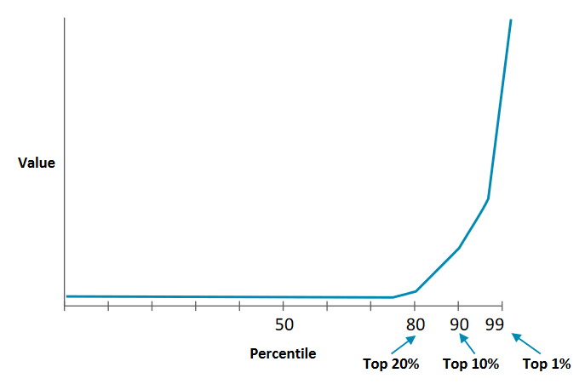

Everybody just wants the best people. Natalia Mantle was one of the top 1%. She said: “one of your best decisions was to hire me.” She hired one of the key members of the team, Christopher Madeiras. However, Petcube being a small startup still struggles with hiring the best people, and that’s one of the downsides of the company.

## Story

The market is dying for a good story. A great story. And you know what? Petcube has it. In the 2012, when the startup community only began to develop in Ukraine, three guys decided to target huge US market. After comes an inspiring story of 3 simple men from Ukraine managed to get a huge system work flawlessly after long and hard-working hours. That’s exactly kind of story that is needed by a lot of new companies. Moreover, good story saves a lot in advertising. So “journalists wanted to have an interesting story, and the guys were ready to tell about their invention and came out very well-prepared. In total, releases