The Finance Woman
Instagram Posts for Approval

10 posts · 42 slides

Post 1 of 10 Carousel · 3 slides
Bold Statement — Burgundy
Pin-worthy · Evergreen content

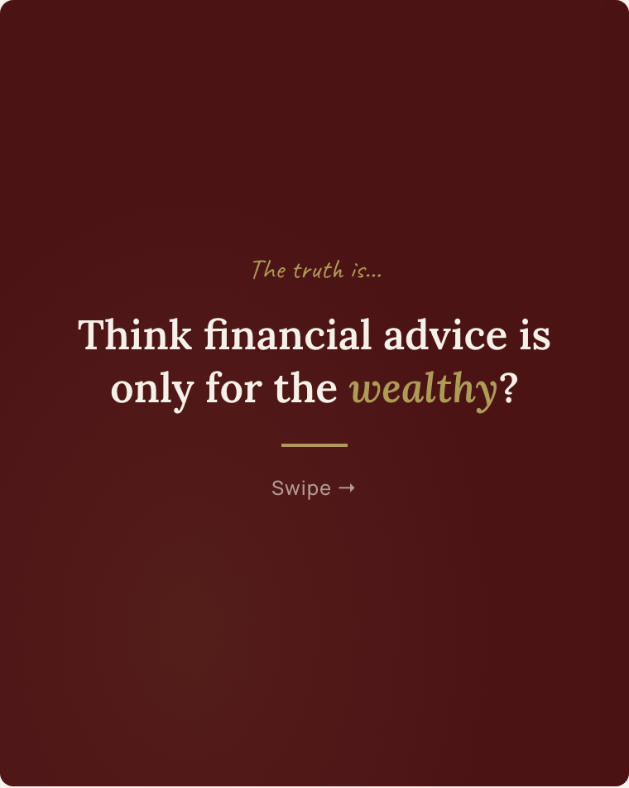 |  | 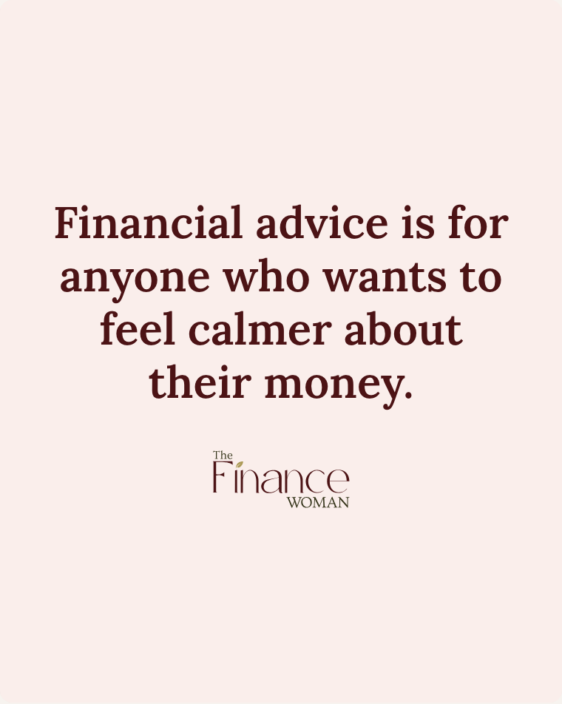

Caption
The truth is...
You don't need to have it all figured out. You don't need a massive salary or a spreadsheet full of savings.
You just need to be ready to start.
Financial advice isn't reserved for the wealthy. It's for anyone who wants to feel calmer and more in control of their money.
That's exactly what we do at The Finance Woman — clear, jargon-free advice for self-employed people who are ready to take the next step.
Free call — link in bio.
#financialadvice #selfemployed #pensions #financialplanning #selfemployeduk #thefinancewoman

Top performer. You loved this design — great for colour variations too.

Post 2 of 10 Carousel · 3 slides
Bold Statement — Blush
Mid-week · Save-worthy

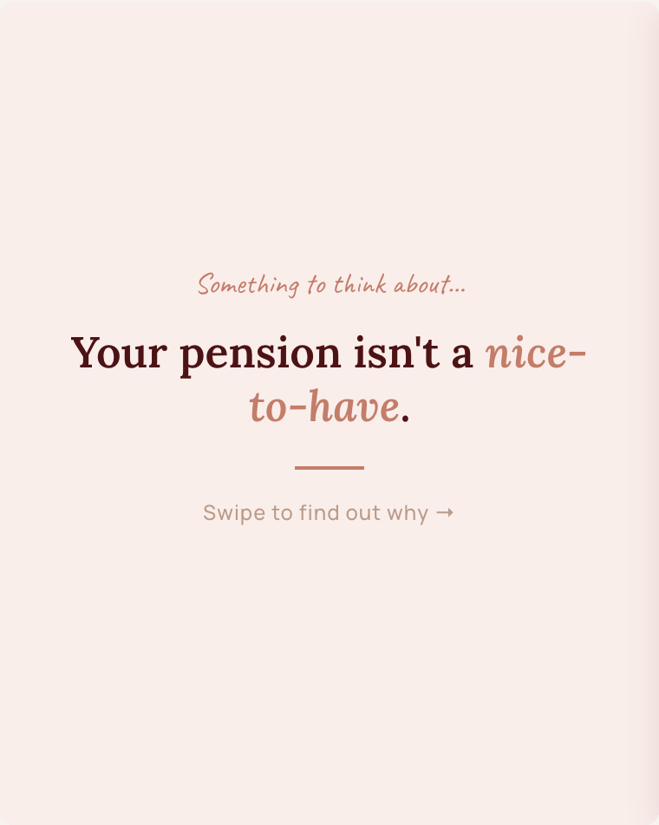 | 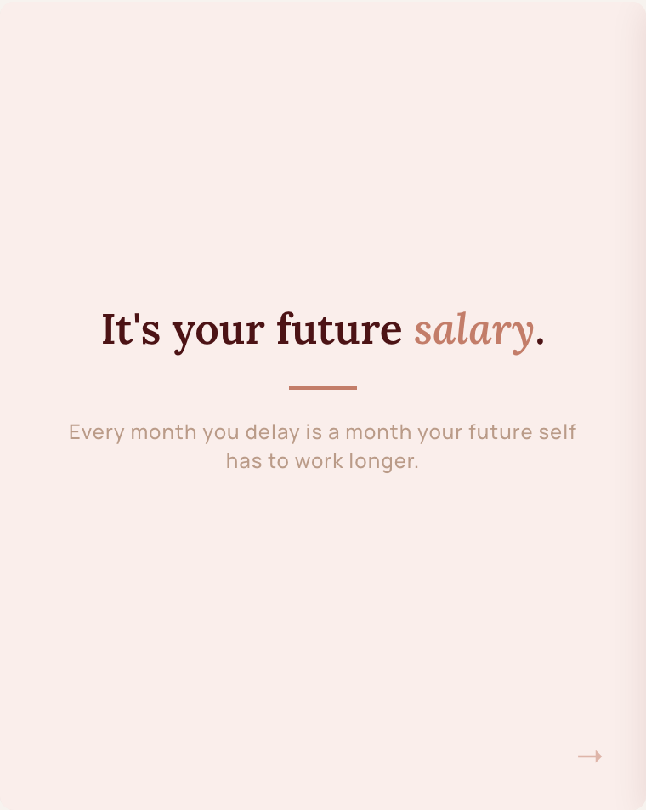 | 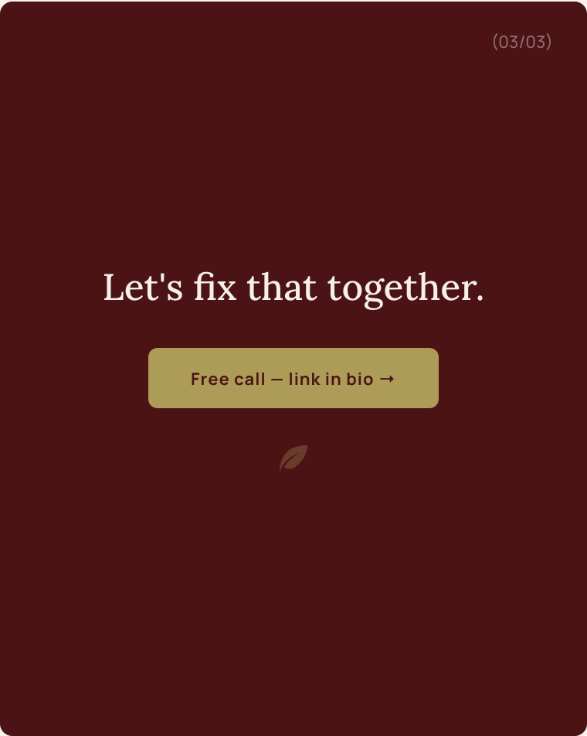

Caption
Your pension isn't a nice-to-have. It's your future salary.
I know it doesn't feel urgent when you're busy running a business. But every month you delay is a month your future self has to work longer.
The good news? Starting doesn't have to be complicated.
Even small, consistent contributions now can make a huge difference later. And if you're self-employed, there are some seriously tax-efficient ways to do it.
Let's have a chat about where you are and what makes sense for you.
Free call — link in bio.
#pension #selfemployedpension #financialplanning #futureself #selfemployeduk #thefinancewoman

Post 3 of 10 Carousel · 3 slides
The 72% Stat
Share-worthy · Eye-catching

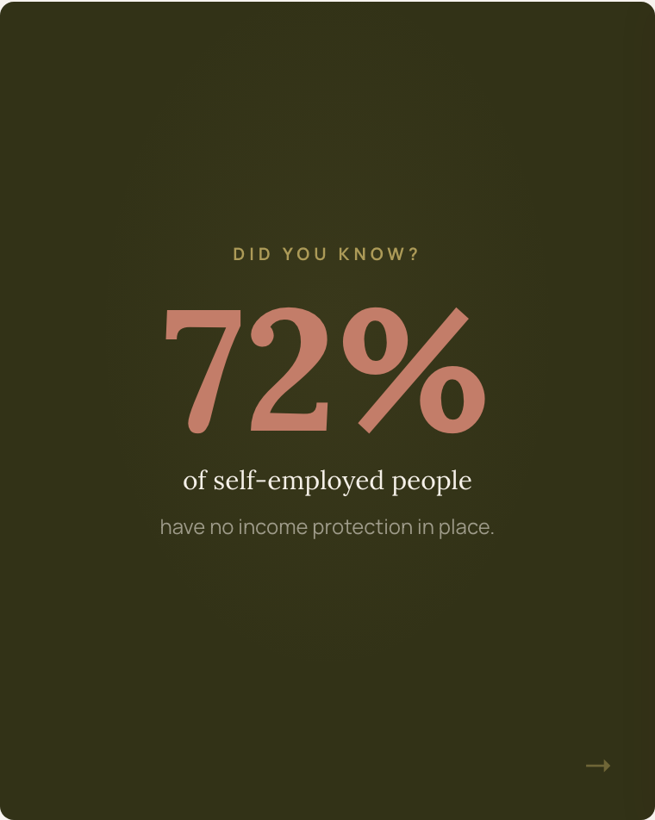 | 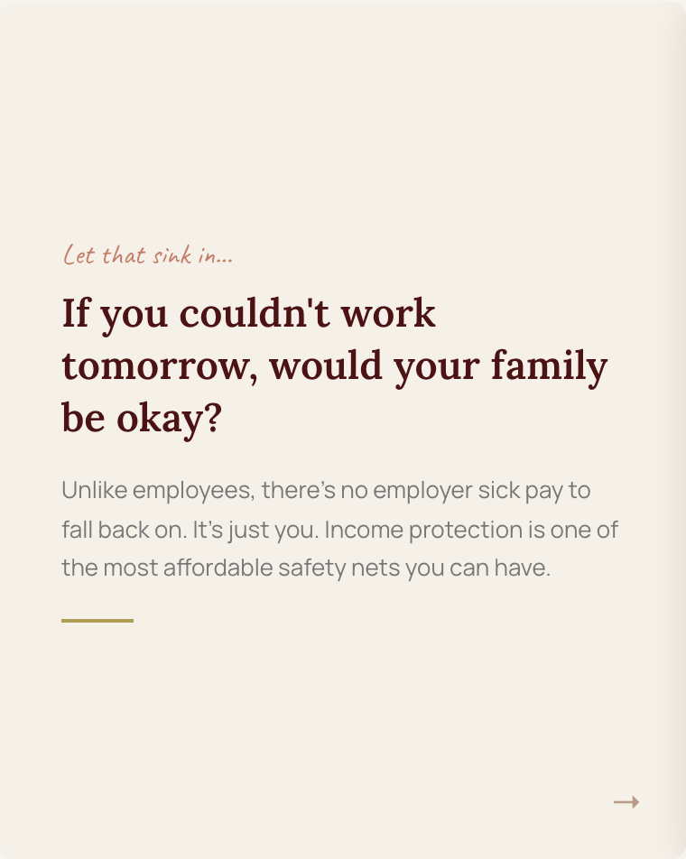 | 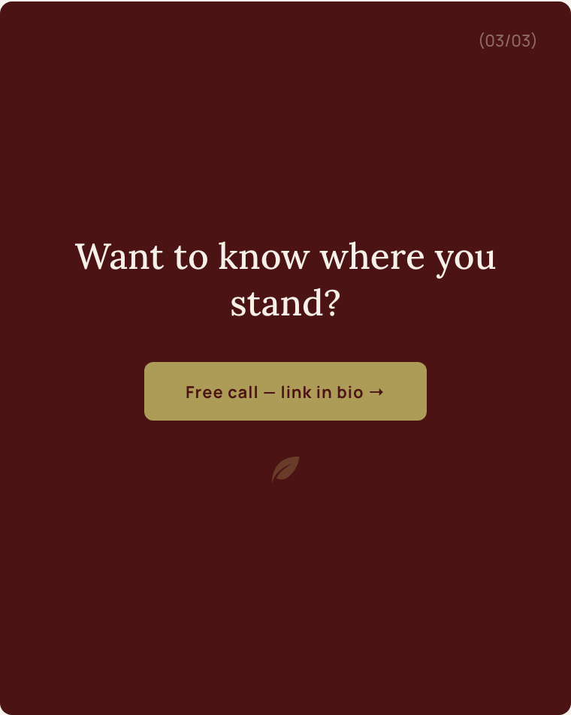

Caption
72% of self-employed people have no income protection in place.
Let that sink in.
If you got ill or injured tomorrow and couldn't work for 6 months — what happens to your mortgage? Your bills? Your family?
Unlike employees, there's no employer sick pay to fall back on. It's just you.
Income protection is one of the most affordable and most overlooked safety nets for the self-employed. And it can be set up in a single conversation.
Want to know where you stand? Free call — link in bio.
#incomeprotection #selfemployed #freelancer #financialplanning #selfemployeduk #thefinancewoman

Post 4 of 10 Carousel · 3 slides
Which Are You? — A/B Poll
Engagement driver · Comment bait

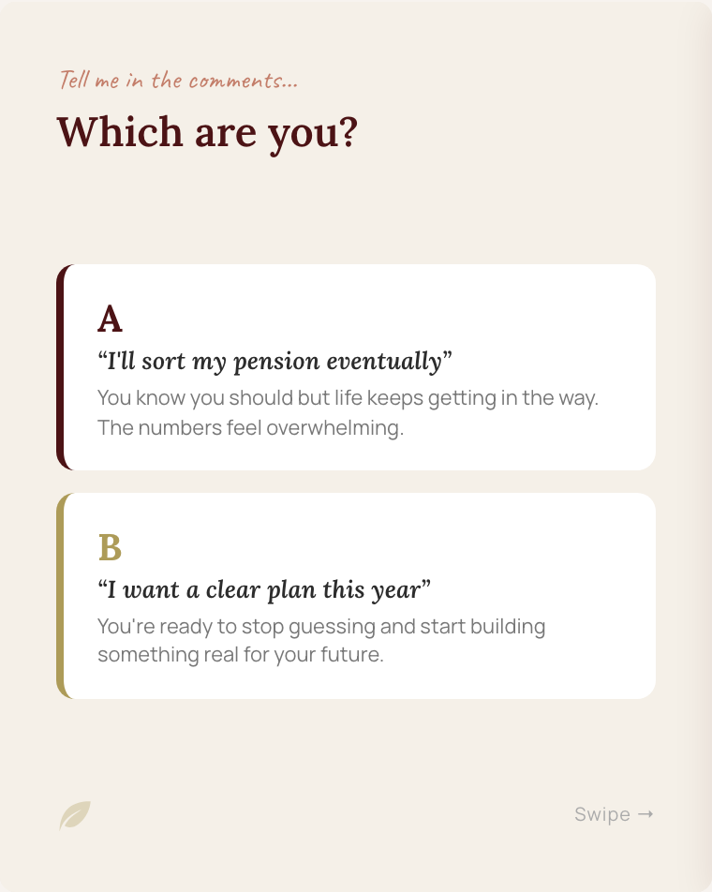 | 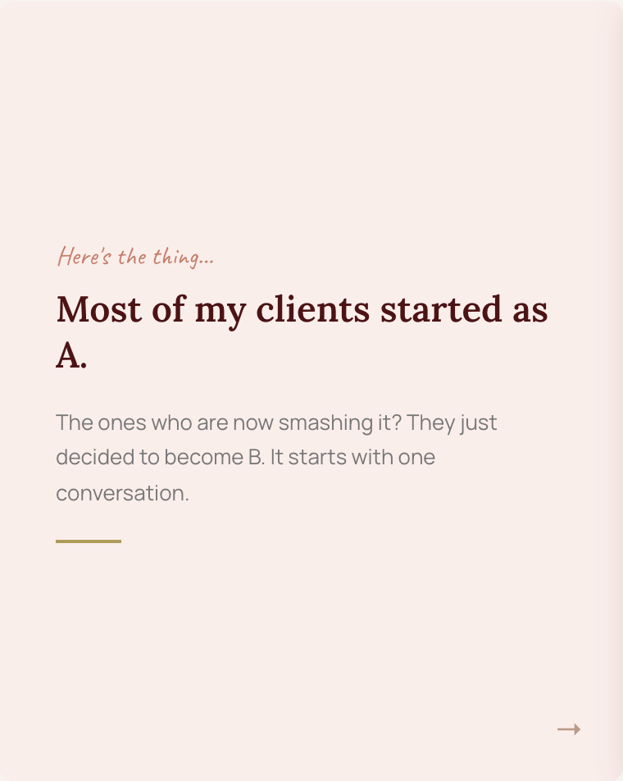 | 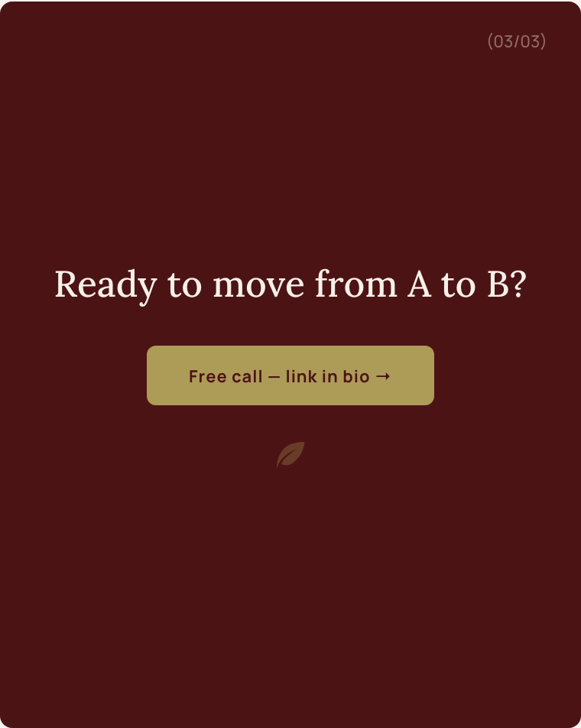

Caption
Be honest... which one are you?
A or B? Drop it in the comments.
No judgement either way. Most of my clients started as A. The ones who are now smashing it? They just decided to become B.
If you're ready to move from A to B, I'd love to help. It starts with one conversation.
Free call — link in bio.
#financialplanning #pension #selfemployed #selfemployedlife #moneygoals #thefinancewoman

Engagement post. The A/B format drives comments. Reply to every comment to boost reach.

Post 5 of 10 Carousel · 3 slides
Real Talk — Photo Overlay
Personal brand builder

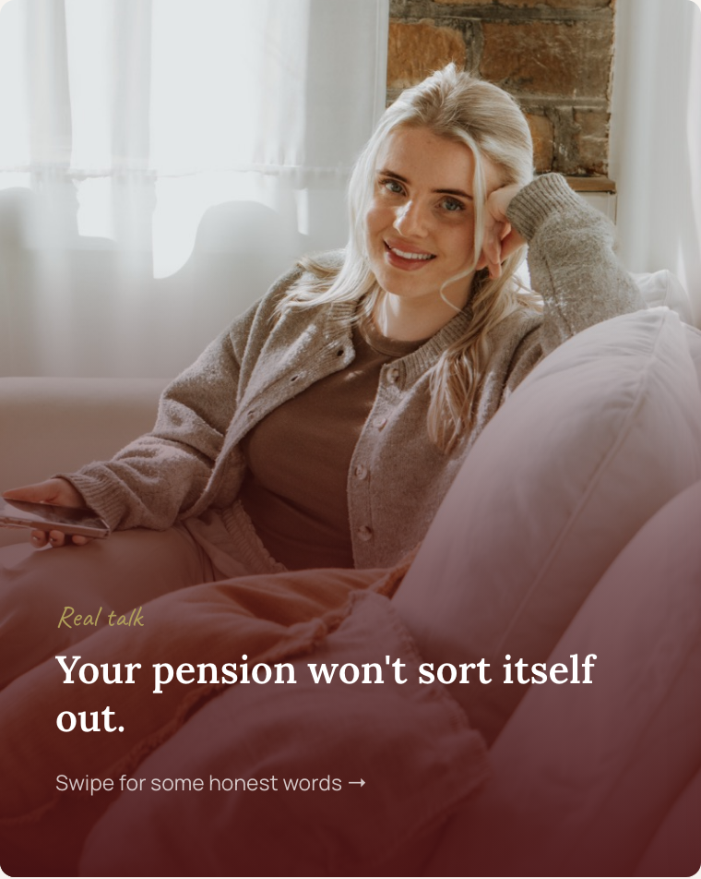 | 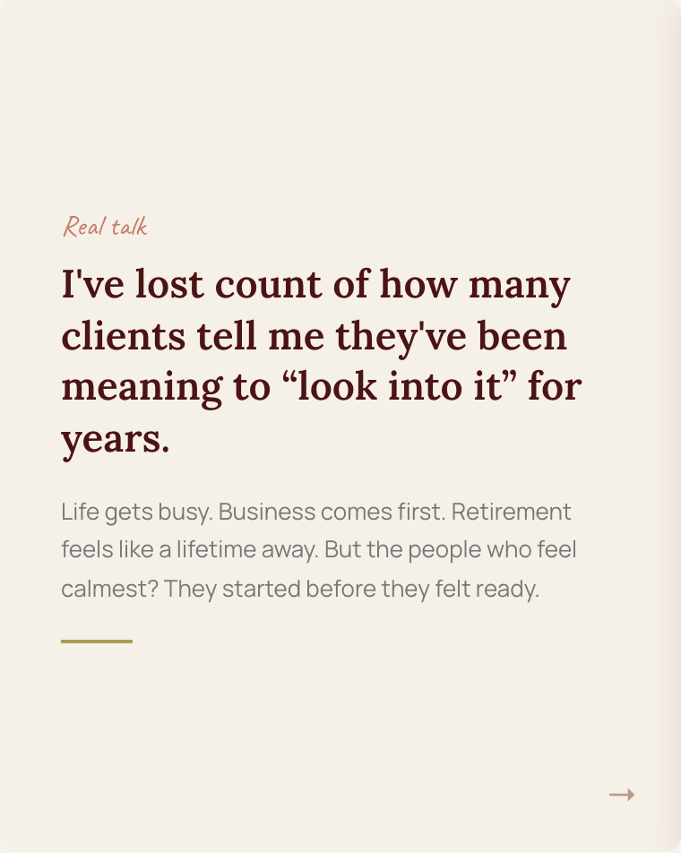 | 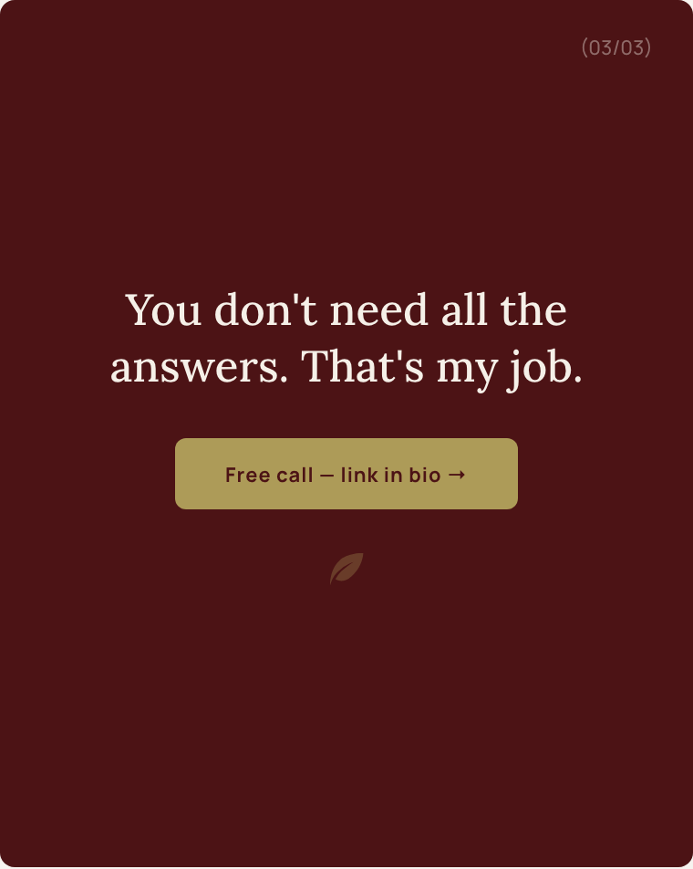

Caption
Real talk: your pension won't sort itself out.
I've lost count of how many clients tell me they've been meaning to "look into it" for years. Life gets busy. Business comes first. Retirement feels like a lifetime away.
But here's what I've learned — the people who feel calmest about their future are the ones who started before they felt ready.
You don't need to have all the answers. That's my job.
Let's have a conversation about where you are and where you want to be.
Free call — link in bio.
#pension #selfemployed #financialadviser #financialplanning #selfemployeduk #thefinancewoman

Post 6 of 10 Carousel · 7 slides
Myths About Investing
Save-worthy · High share potential

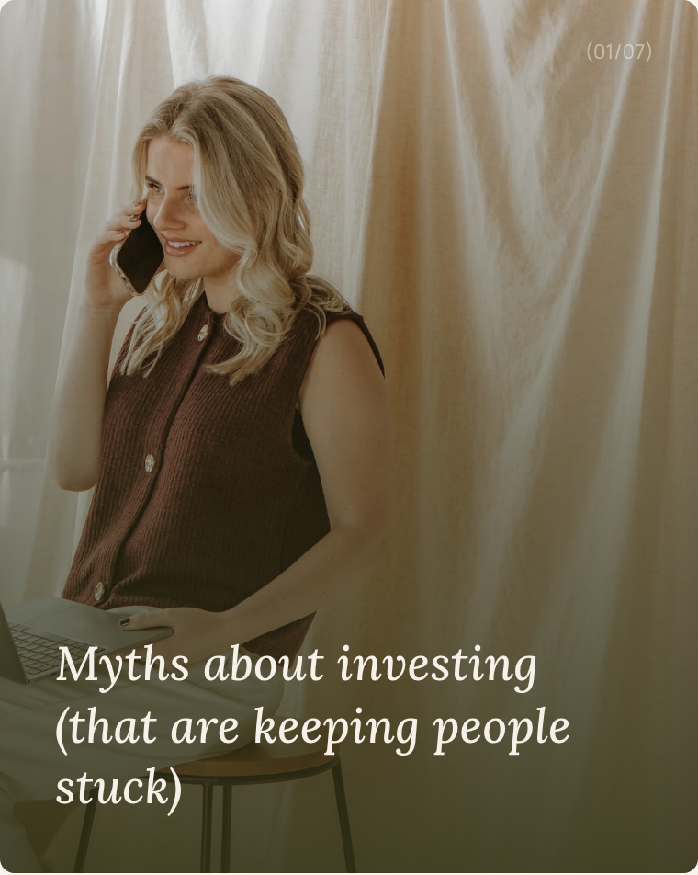 | 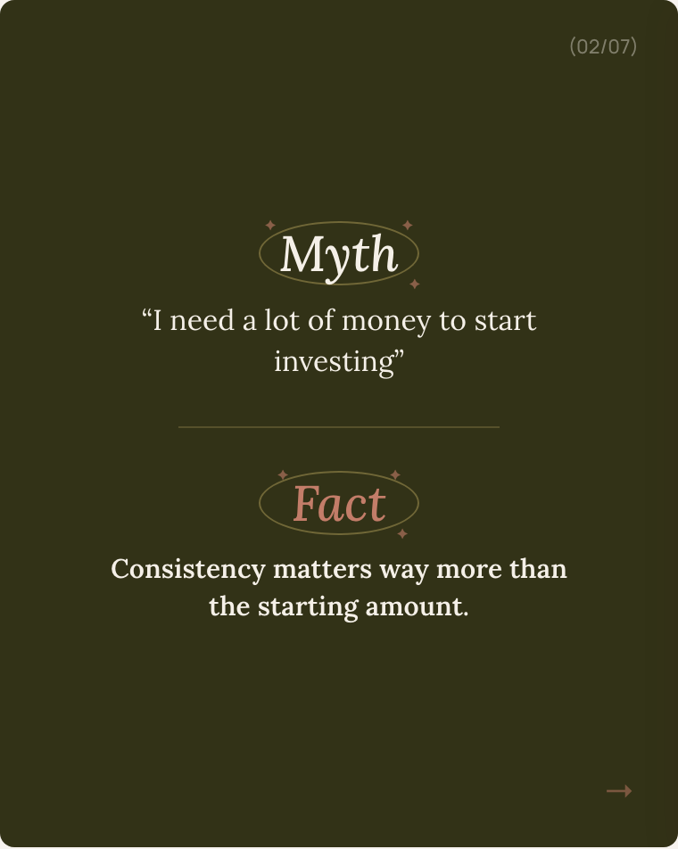 | 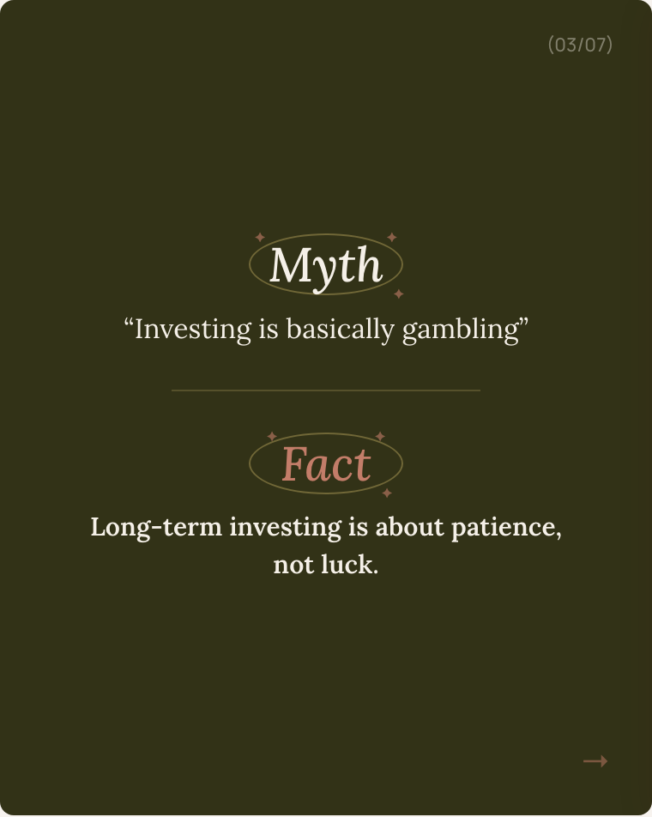
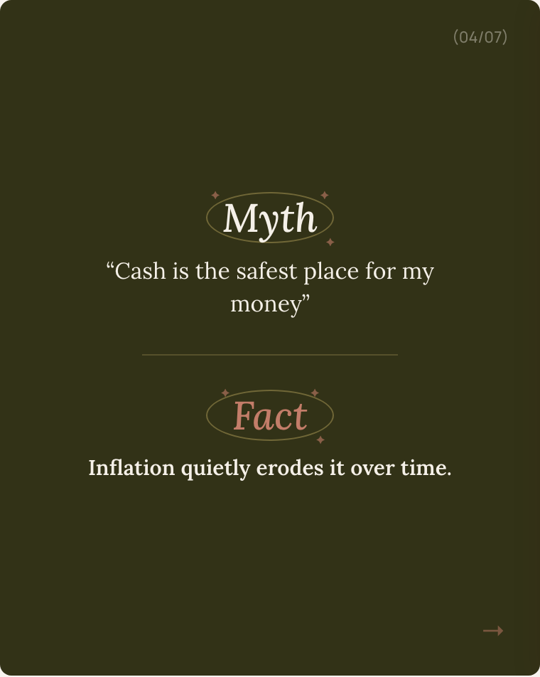 | 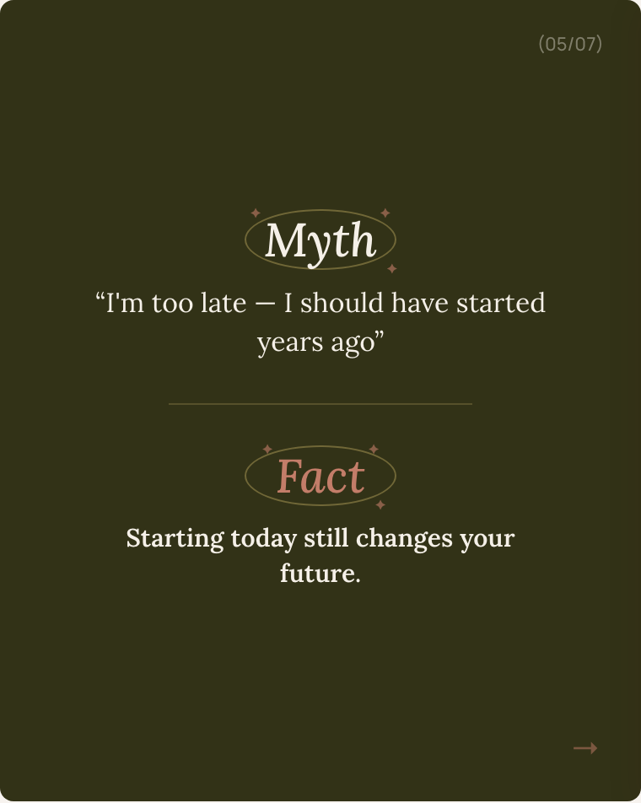 | 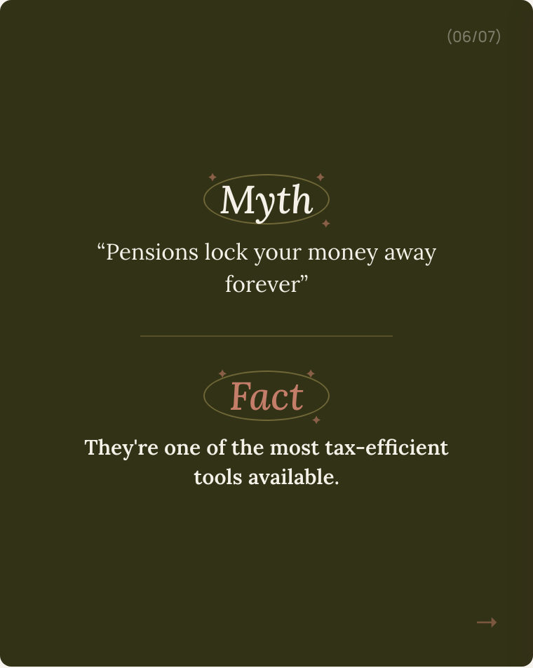
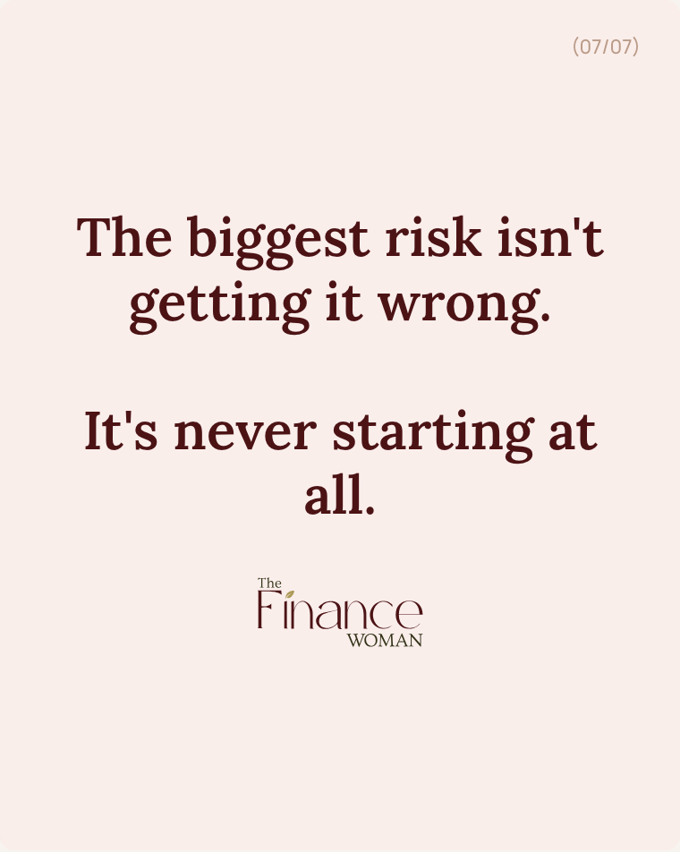

Caption
Myths about investing that are keeping people stuck.
Which one have you believed? (Be honest)
"I need loads of money to start" — Nope. Consistency beats size.
"It's basically gambling" — Not even close. Patience, not luck.
"Cash is safest" — Inflation says otherwise.
"I'm too late" — Starting today still changes everything.
"Pensions lock your money away" — They're actually one of the best tax tools going.
The biggest risk isn't getting it wrong. It's never starting at all.
If any of these myths have been holding you back — let's talk.
Free call — link in bio.
#investing #pensions #myths #selfemployed #financialplanning #thefinancewoman

Your content from Canva. I've recreated the exact Myth/Fact format with your brand styling. This is a strong save-and-share carousel.

Post 7 of 10 Carousel · 5 slides
3 Things Before April
Timely · Post before 5th April

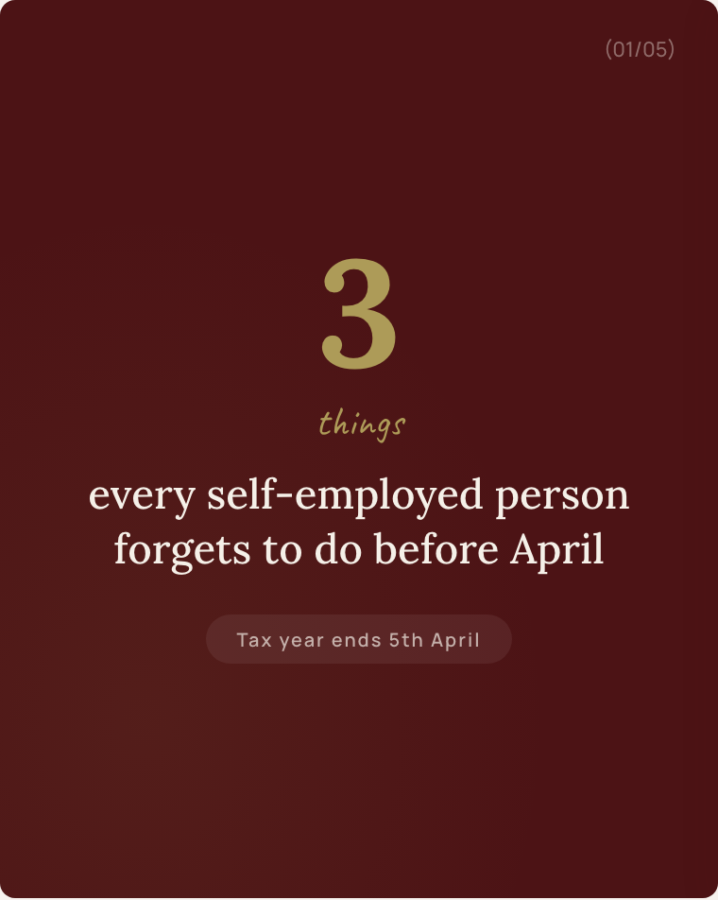 | 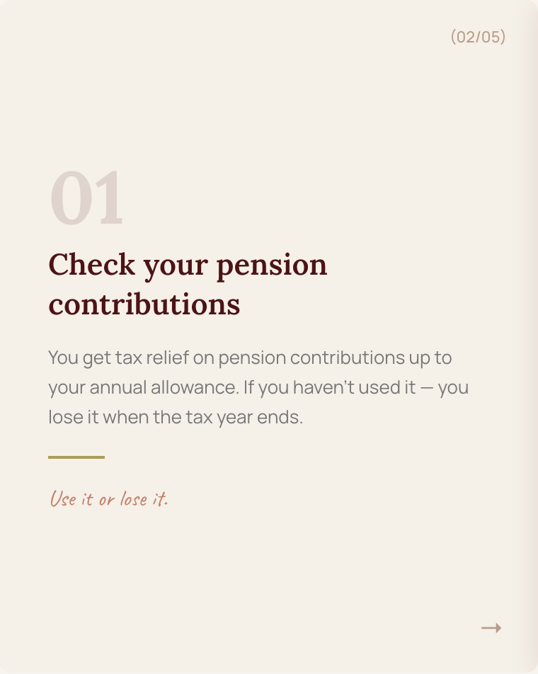 | 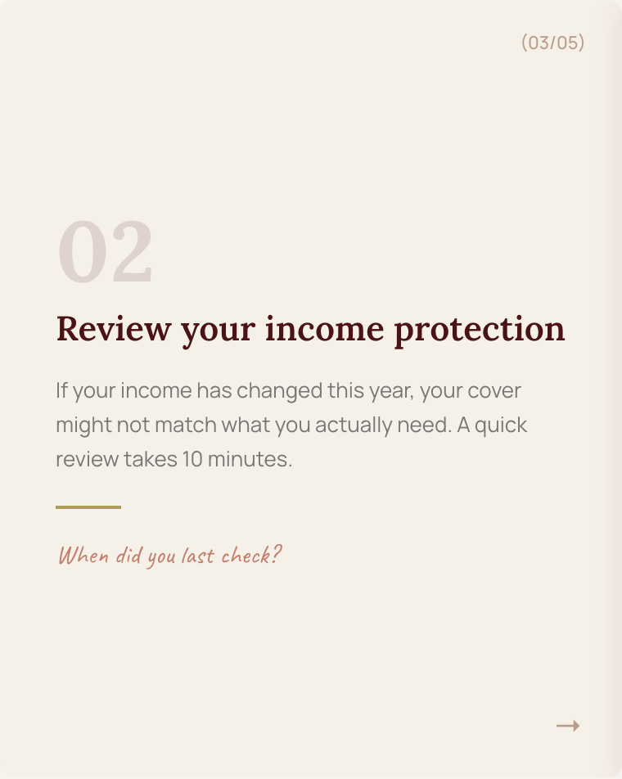
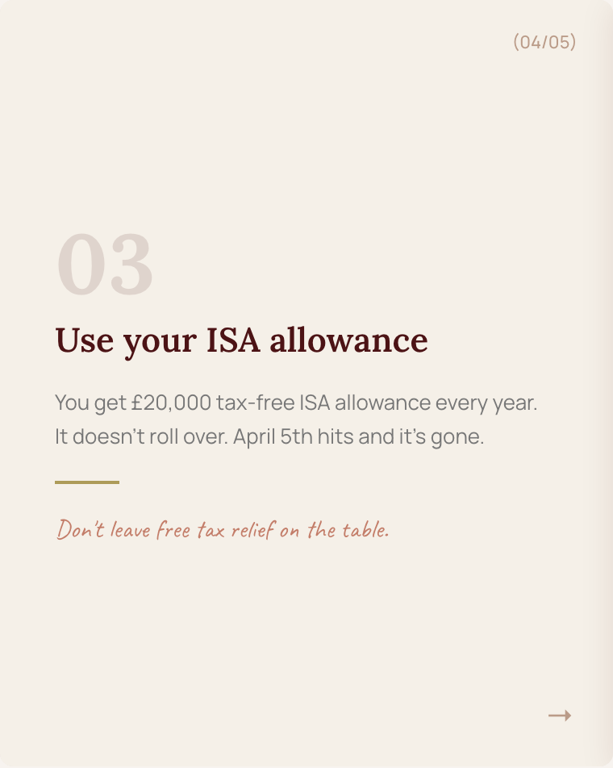 | 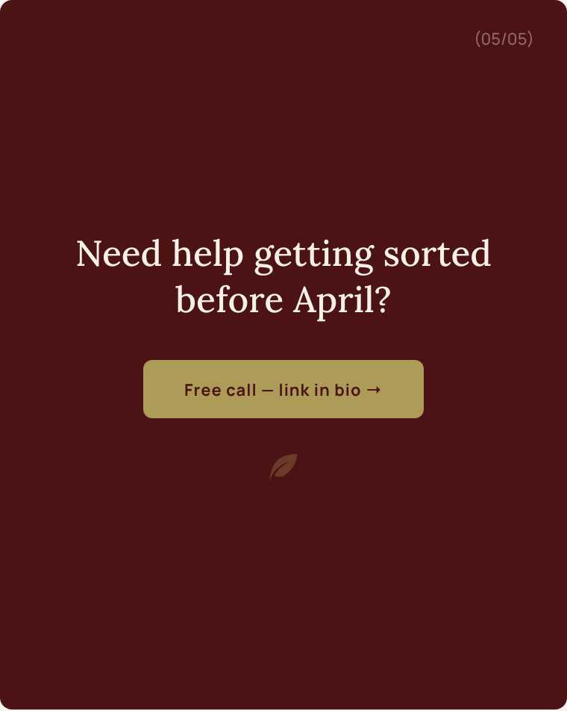

Caption
Tax year ends 5th April. Here are 3 things most self-employed people forget to do before then:
1. Check your pension contributions — you get tax relief, but you lose it if you don't use it before April.
2. Review your income protection — if your income has changed, your cover might not match anymore. Takes 10 minutes to check.
3. Use your ISA allowance — £20,000 tax-free. It doesn't roll over. Gone on 6th April.
Save this post and come back to it before the deadline.
Need help getting any of these sorted? Free call — link in bio.
#taxseason #selfemployed #pension #ISA #financialplanning #taxplanning #thefinancewoman

Time-sensitive. Post this in March for maximum relevance. The list format drives saves — people bookmark these.

Post 8 of 10 Carousel · 5 slides
What Happens in Our Call
Trust-builder · Overcomes objections

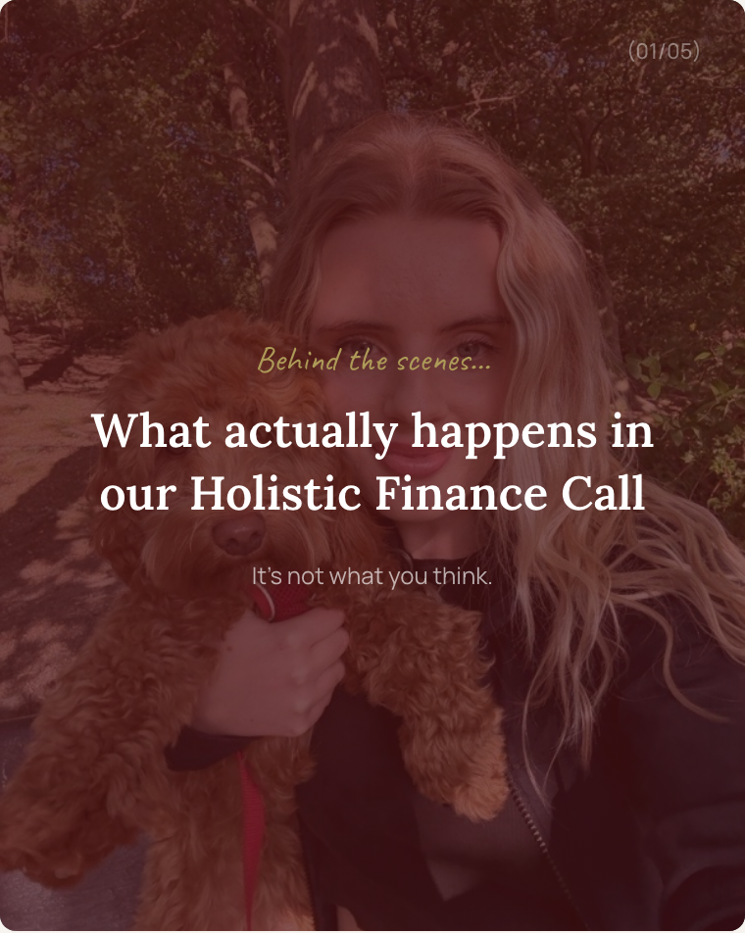 | 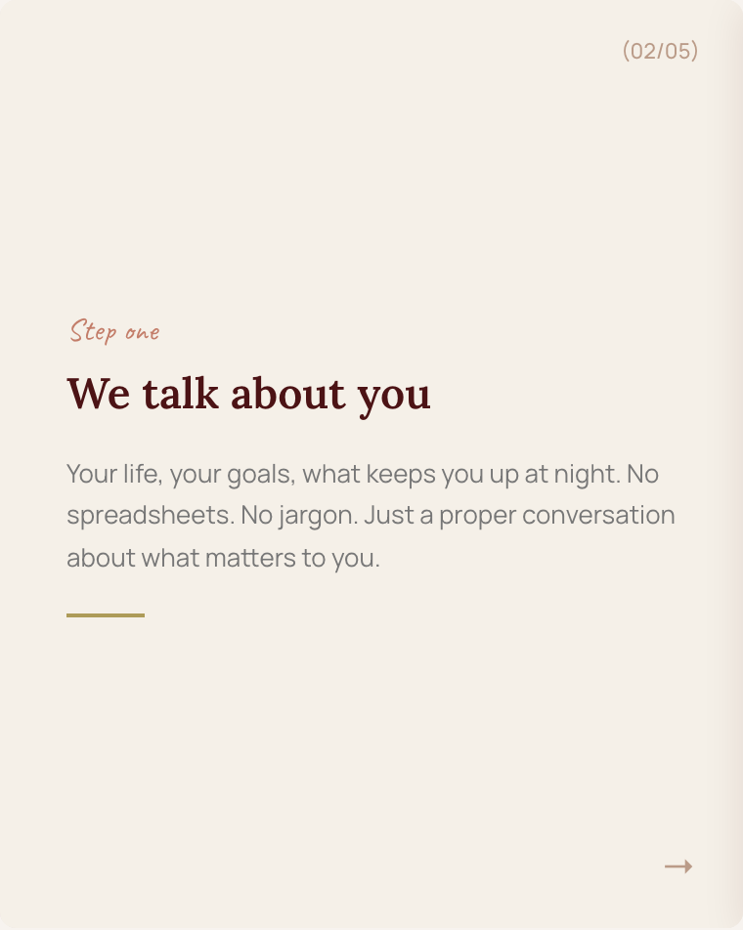 | 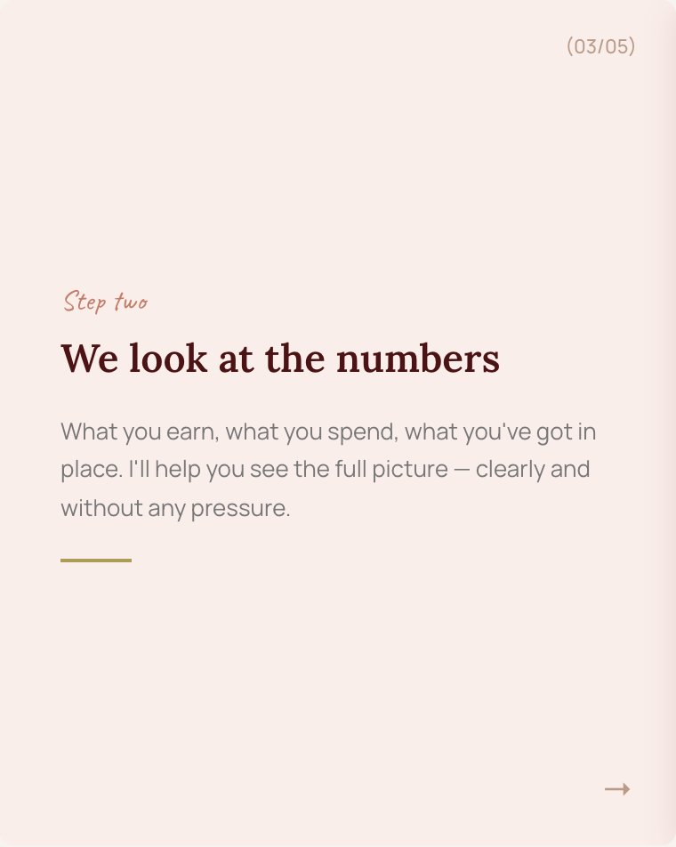
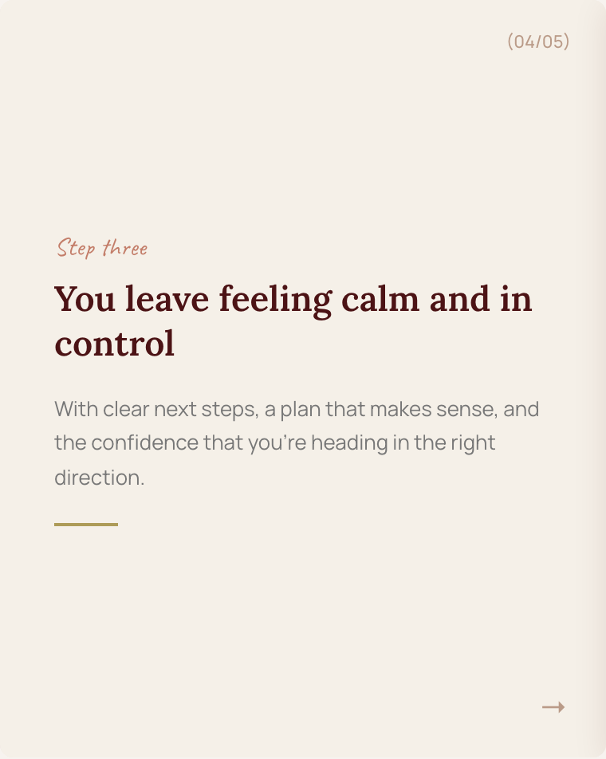 | 

Caption
What actually happens in our Holistic Finance Call? (It's not what you think.)
Step 1: We talk about you.
Not numbers. You. Your life, your goals, what keeps you up at night.
Step 2: We look at the full picture.
Income, outgoings, what's in place, what's missing. Clearly and without pressure.
Step 3: You leave feeling calm and in control.
With clear next steps and a plan that actually makes sense for your life.
No hard sell. No jargon. Just a proper conversation.
Book your free call — link in bio.
#financialplanning #holisticfinance #selfemployed #financialadviser #thefinancewoman

Objection buster. Most people are nervous about their first call. This carousel demystifies the process and builds trust.

Post 9 of 10 Carousel · 5 slides
This or That — Financial Edition
Engagement driver · Interactive

 | 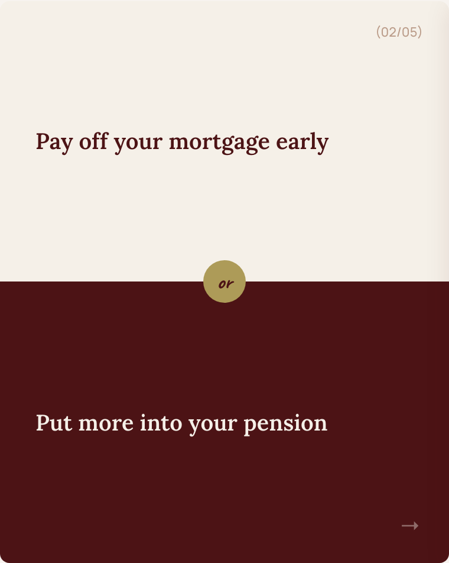 | 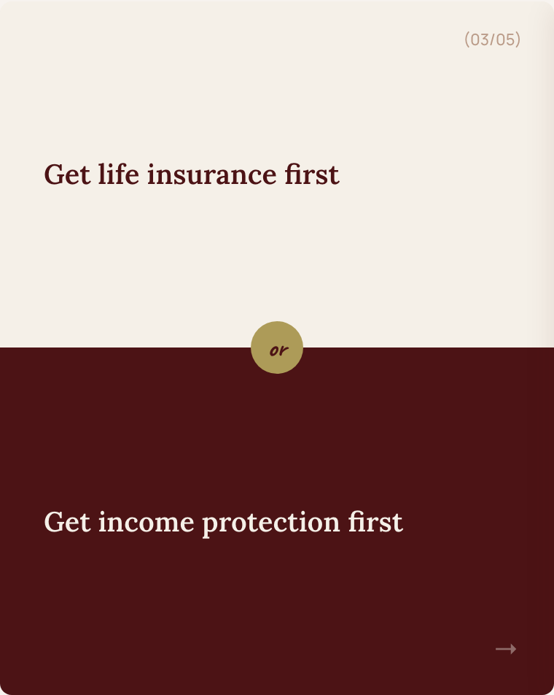
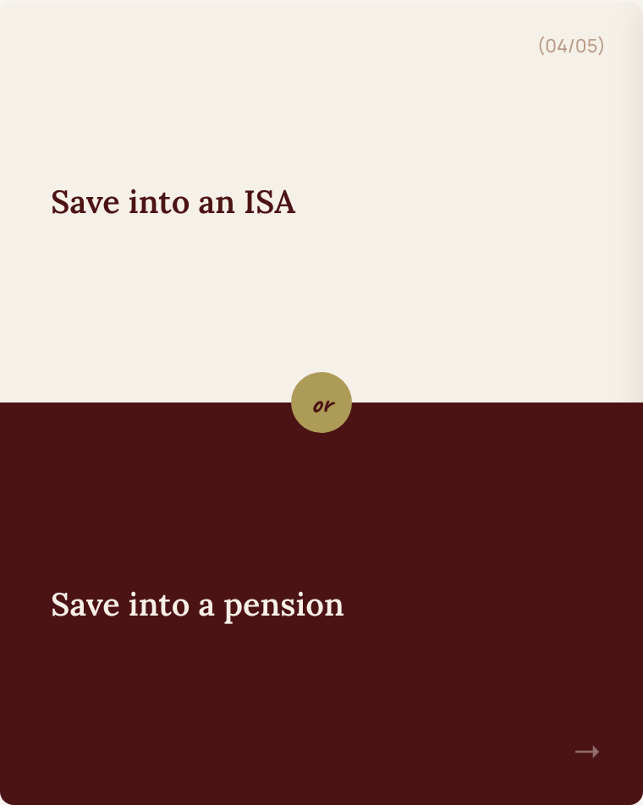 | 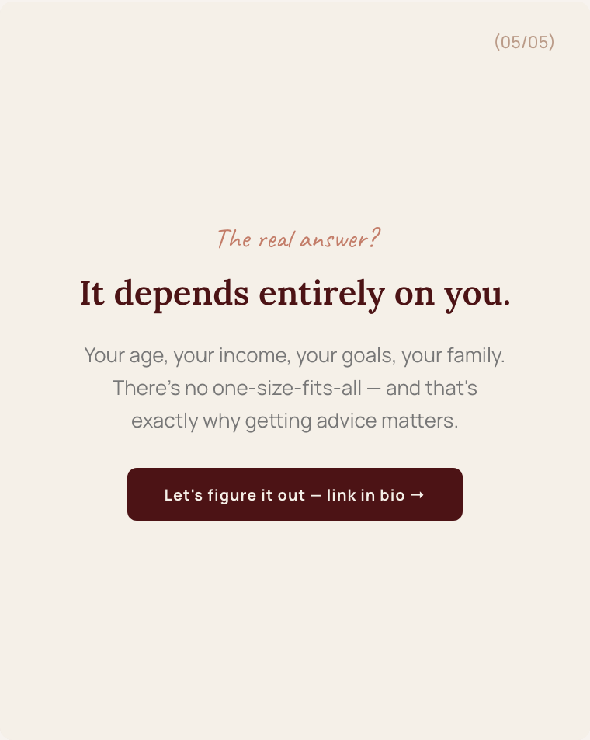

Caption
This or That — financial edition.
Mortgage vs pension?
Life insurance vs income protection?
ISA vs pension?
Before you answer — swipe through.
The truth is, there's no one-size-fits-all answer. It depends on your age, your income, your family, and your goals.
That's exactly why getting proper advice matters. Because what's right for your mate might not be right for you.
Want to figure out what's right for you? Free call — link in bio.
#financialplanning #thisorthat #pension #mortgage #selfemployed #thefinancewoman

Interactive format. Drives comments and saves. People love debating these — engage with every comment to boost reach.

Post 10 of 10 Carousel · 5 slides
Your Questions, Answered
Authority builder · FAQ format

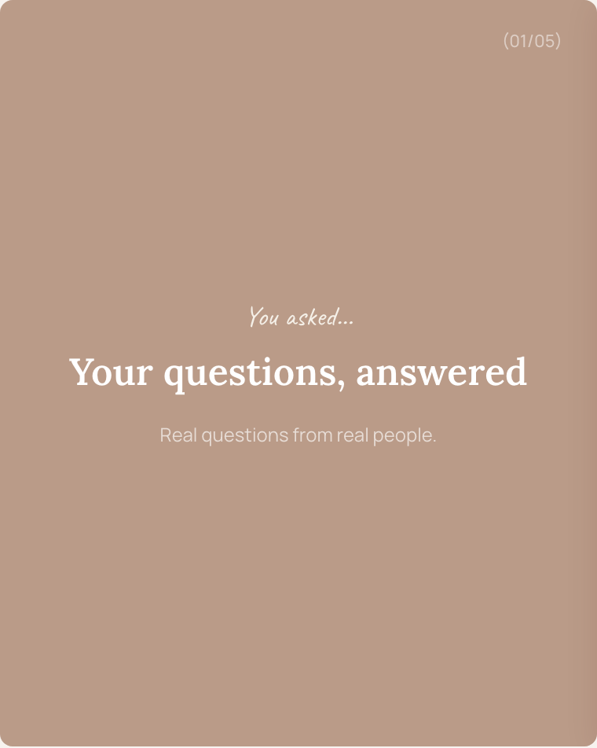 | 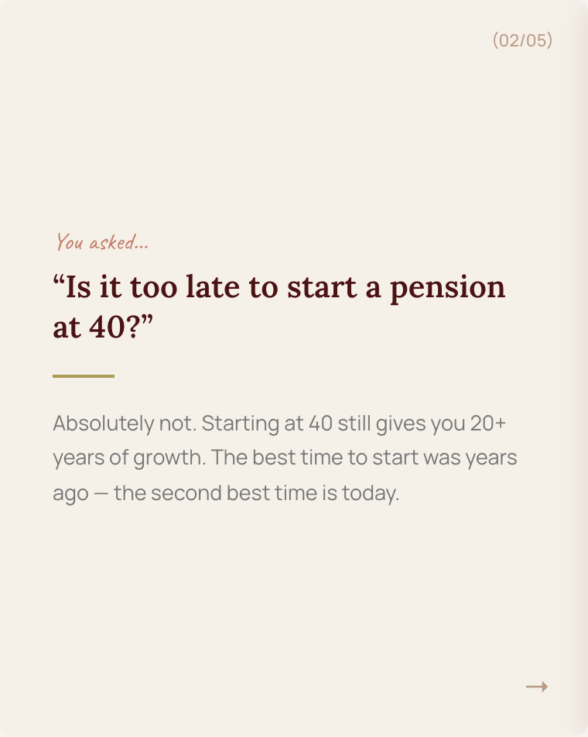 | 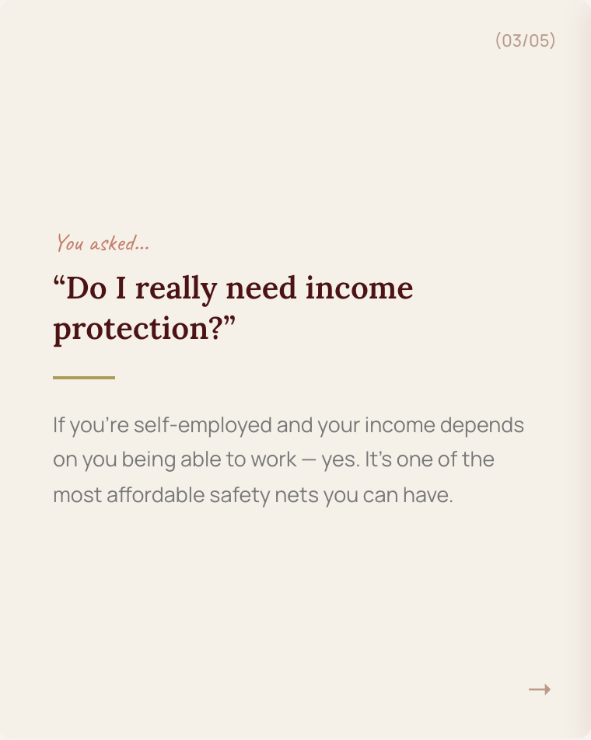
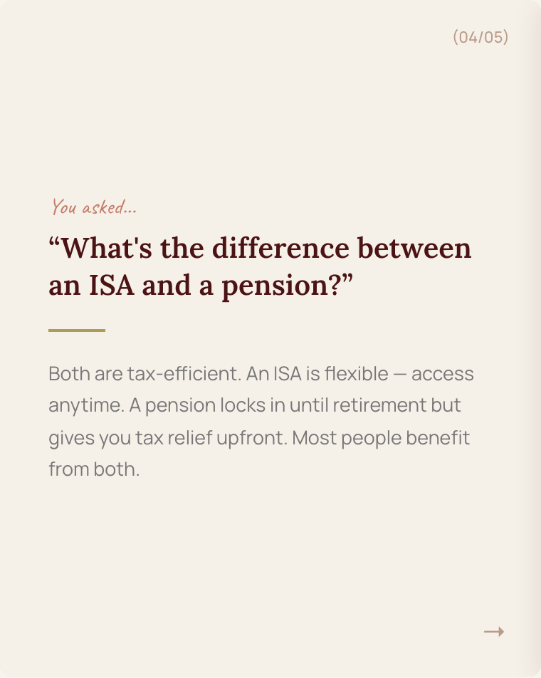 | 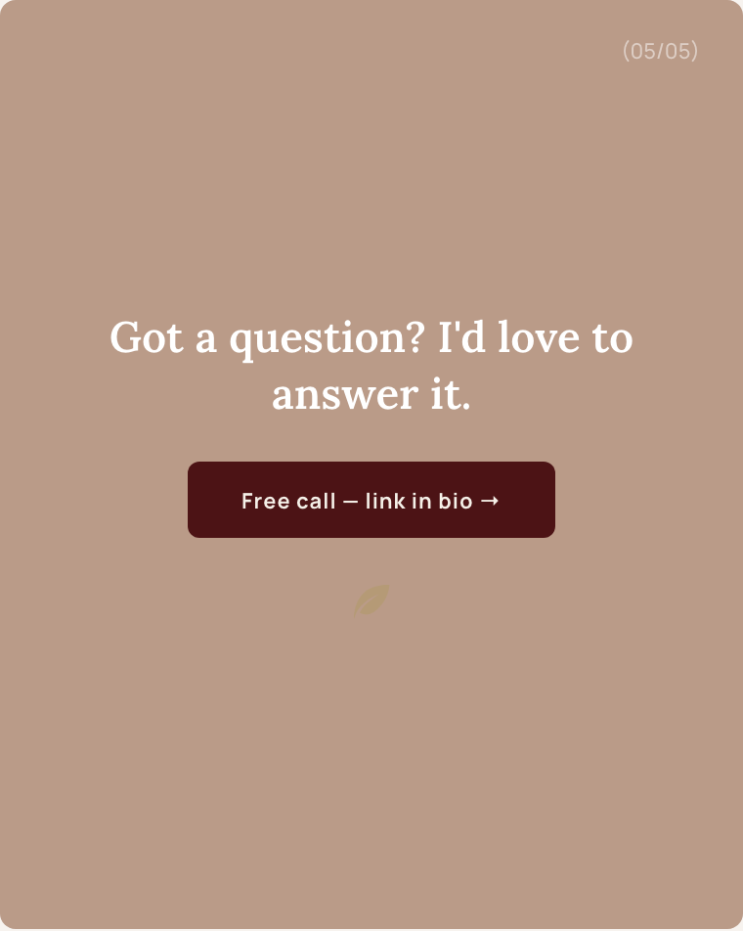

Caption
Your questions, answered.
These are real questions I get asked all the time:
"Is it too late to start a pension at 40?" — Absolutely not. You've still got 20+ years of growth ahead.
"Do I really need income protection?" — If your income depends on you working, yes. It's one of the most affordable safety nets going.
"What's the difference between an ISA and a pension?" — Both are tax-efficient, but they work differently. Most people benefit from both.
Got a question you want me to answer? Drop it in the comments or send me a DM — I might feature it next time.
Free call — link in bio.
#financialadvice #FAQ #pension #ISA #incomeprotection #selfemployed #thefinancewoman

Engagement + authority. Use the question sticker in Stories to collect real questions from followers, then turn those into future carousel slides.

