**Lun.ua**

* **Apartments for sale @**
* **Apartments for rent @**
* **Houses for sale @**
* **Daily rent @**
* **Account @**
* **Advertisement @**

**Backlog for “apartments for sale”:**

As a site visitor, I want to select :

* location of apartment:
* select region from list
* select apartment near the subway
* select street
* select particular house
* quantity of rooms from list
* area of apartment
* select apartment price range

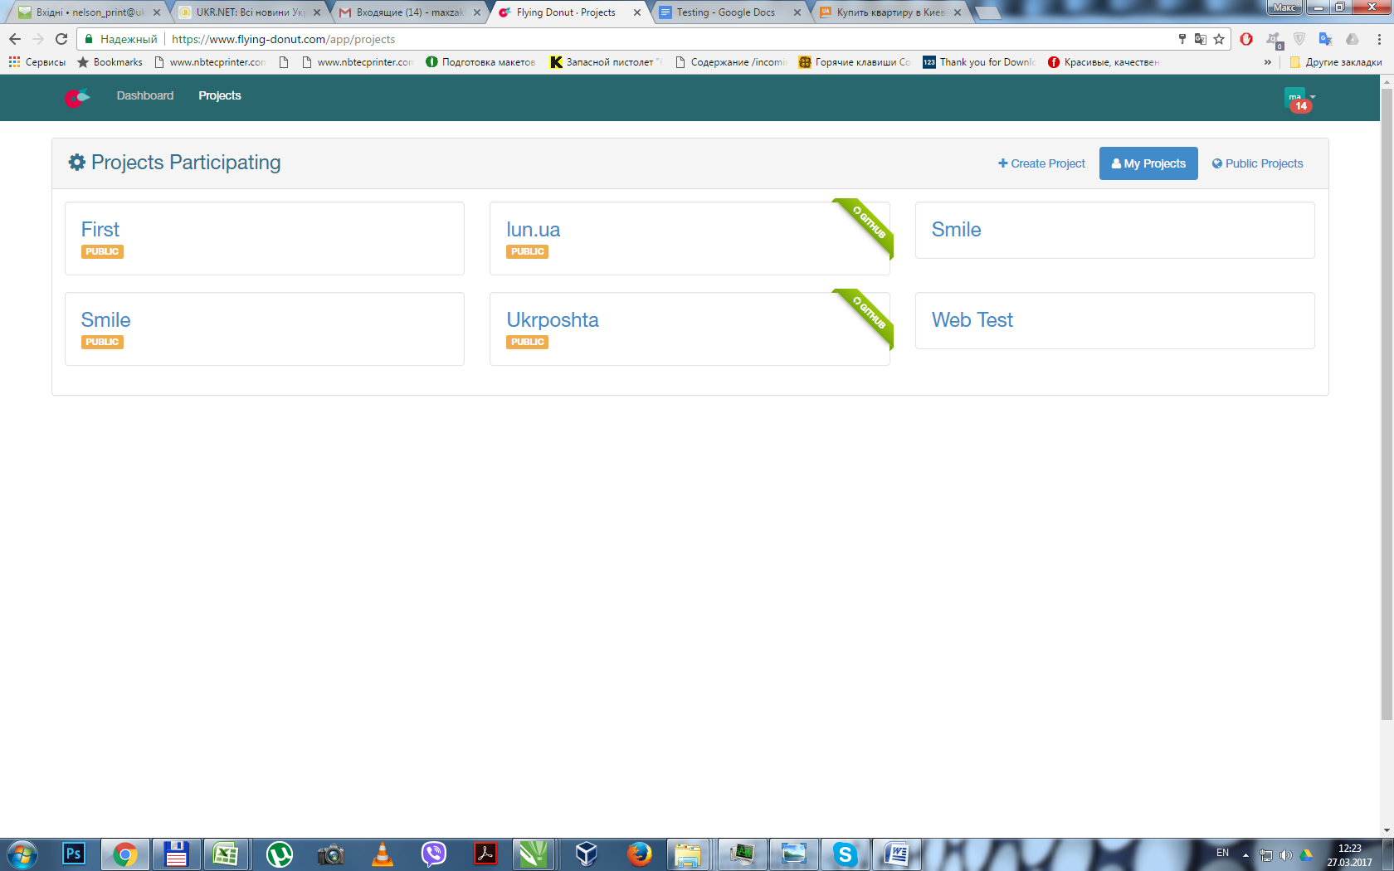

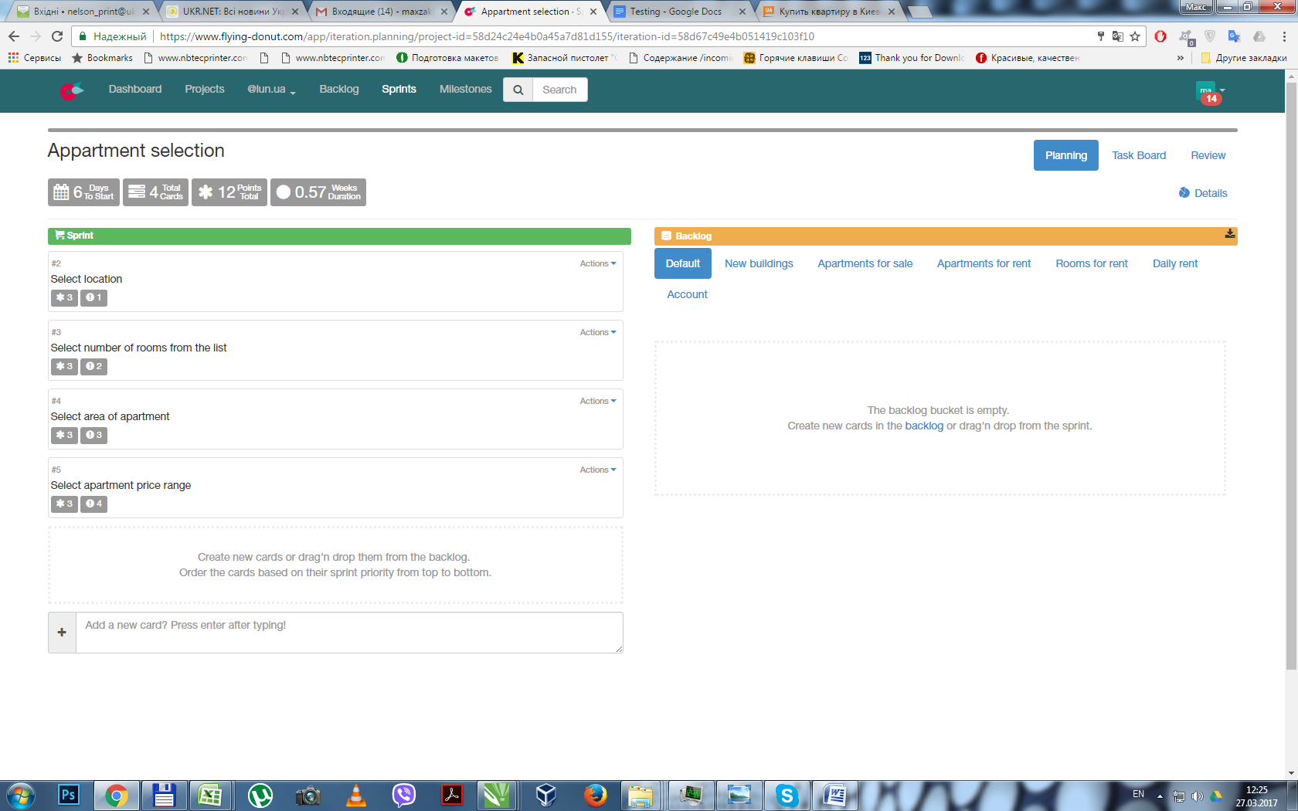

|  |  |  |
| --- | --- | --- |
| 1. Select location | Click on field «Район», scroll down to «Русановка» and click on check-box in front of «Русановка» | In the field should be selected district «Русановка». |
| 2 . Select number of rooms from list | Click on field «комнат», and in the expanded list click on check-box in front of «2» . | In the field should be selected rooms «2». |
| 1. Select apartment area | Click on field «площадь», and in the expanded list click on field «от» and write in «45». Then click on field «до» and write in «70». | In the field should be selected area «от 45 до 70м2». |
| 1. Select price of apartment | Click on field «Цена», and in the expanded list click on field «от» and write in «45000». Then click on field «до» and write in «50000». | In the field should be selected price «от 45000 до 50000». |
|  |  |  |
|  |  |  |
|  |  |  |
|  |  |  |

|  |  |  |  |
| --- | --- | --- | --- |
| **DEFECT REPORT** | | **Defect # 1.0.1** | |
| **Summary** | | | |
| When searching for an apartment in the field before you are allowed to enter a value less than in the field from. In this case, the search will not find anything and visitors of site will waste time. | | | |
| **Product:** | | **Version:** | **Build:** |
| Product Name “Lun.ua” | | - | - |
| **Reporter** | | Maxim Zakharov | |
| **Operation system** | | Windows 7 | |
| **Severity**  **(Critical, Major, Minor)** | | Major | |
| **Priority**  **(1 – most important, 2, 3)** | | 1 | |
| **Component** | | Searching for apartment by area and price | |
| **Test case** | | bug_in _search_by_area.html | |
| **Attachments** | | | |
|  | | | |
| **Scenario/Description** | | | |
| 1.open lun.ua  2. click on “select” to find apartments in Kyiv.  3. Click on field «area», and in the expanded list click on field «from» and write in «55». Then click on field «till» and write in «45».  4. Click on search and search will find nothing.  **Actual Result**: The field «till» is allowed to enter a value less than in the field «from».  **Expected Result**: The field «till» is not allowed to enter a value less than in the field «from». | | | |
| **Comments** | | | |
| **Author** | **Comment** | | |
| Date reported: 02/03/2017 | | | |