<$Scr_Ps::0>Overview
<$Scr_H::1><!$Scr_Ps::0><$Scr_Ps::1>System goal
<!$Scr_H::1><!$Scr_Ps::1>
Goal of the system is to collect temperature measurements from available temperature sensors, which are placed in different rooms in the house. In case, when one of the sensors sends measurement, which inside of backend service will be detected as HIGH or LOW - alarm on monitoring device is rised, if alarms of such sensors are enabled.
Additionally it should store incoming temperature measurements for future analysis, for example to check how temperature was changing during the night, or for example how big were differences in January / June / December.

<$Scr_H::1><$Scr_Ps::1>100 feet view
<!$Scr_H::1><!$Scr_Ps::1>
System is pretty straightforward when you look at it from the birds view. It is build out of following parts:
- spring boot app (backend service)
- react native client (monitoring/alarming component)
- temperature sensors
- administration client (via thymleaf templates)

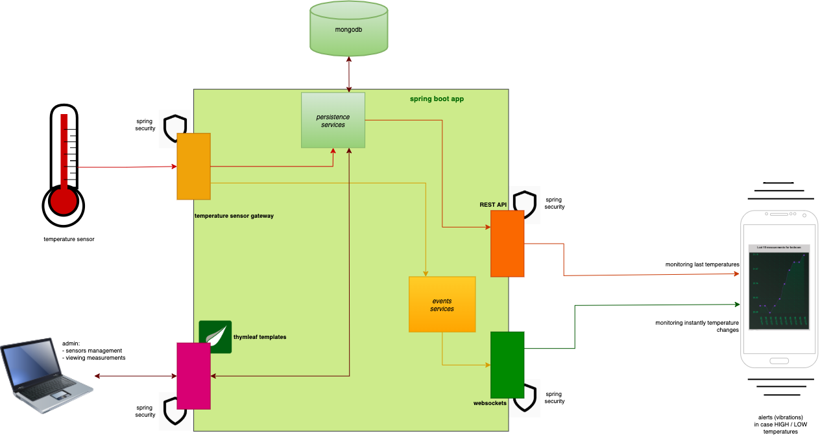

<$Scr_H::1><$Scr_Ps::1>Spring boot app / server
<!$Scr_H::1><!$Scr_Ps::1>
Is the heart of gathering, processing and providing information for peripherals. Main responsibilities:
- gathering sensors measurements
- providing administration panel (via thymleaf templates)
- exposing REST api for simple clients
- exposing STOMP over web socket channels for subscriptions for clients, which want to update measurement information instantly
- communicating with mongodb
- security of all exposed parts (only authenticated and authorized parties are allowed to perform specific actions)

<$Scr_H::1><$Scr_Ps::1>React native client
<!$Scr_H::1><!$Scr_Ps::1>
It’s a simple peripheral application, which only reads data from backend and eventually alarms HIGH/LOW temperatures in form of vibrations. Main responsibilities:
- presenting data to user in human readable way
- reacting on alerts (HIGH or LOW level measurements) i.e. rising alarms, when needed

<$Scr_H::1><$Scr_Ps::1>Temperature sensors
<!$Scr_H::1><!$Scr_Ps::1>
Simple electronic components combined into one unit, which sends measured temperature to defined REST endpoint (implemented in spring boot app). Main responsibilities:
- stay alive
- measure temperature
- sends measured temperature to specified REST endpoint in spring boot app

<$Scr_H::1><$Scr_Ps::1>Admin component
<!$Scr_H::1><!$Scr_Ps::1>
Small graphical management tool, integrated into backend, based on tymleaf templates. Main responsibilities:
- maintenance of sensors and their measurements
- viewing collected data in human readable way

