May Elmady
Student ID: 664430675
BDA400 – Data Science Tools and Techniques
CDI College – Data Analytics With Capstone
Assignment 2: Technical Analysis Using R, Preliminary Stage
October 2026

GitHub Repository: https://github.com/may0elmady-ship-it/TechnicalAnalysis

Introduction
This report documents the preliminary stage of a three-part technical analysis project in R. I set up a GitHub repository, installed R and RStudio, installed the technical analysis packages, created a portfolio file, and wrote functions to import stock data, compute statistics and display the results.
To make the project personal, I built my portfolio around my own business, Toronto Cakes, a custom cake business that takes orders through Instagram. Every stock in my portfolio is a company my business depends on in some way: the platform where my customers find me, the stores where I buy supplies, and the brands whose chocolate, cookies and flour go into my cakes. I called it "The Toronto Cakes Portfolio".

1. Setting up the GitHub Account and Repository
I already had a GitHub account from Assignment 1 (username: may0elmady-ship-it), so I signed in and created a new public repository named TechnicalAnalysis. I added a README file during creation so the repository would be initialized. Inside the repository I created a subfolder called Assignment2, which will hold all the files for this stage. Assignments 3 and 4 of this project will get their own folders (Assignment3, Assignment4) in the same repository, as required.
Steps followed: signed in to github.com, clicked New repository, entered the name TechnicalAnalysis, chose Public, ticked Add a README file, and clicked Create repository. Then I used Add file > Create new file and typed Assignment2/README.md to create the folder.
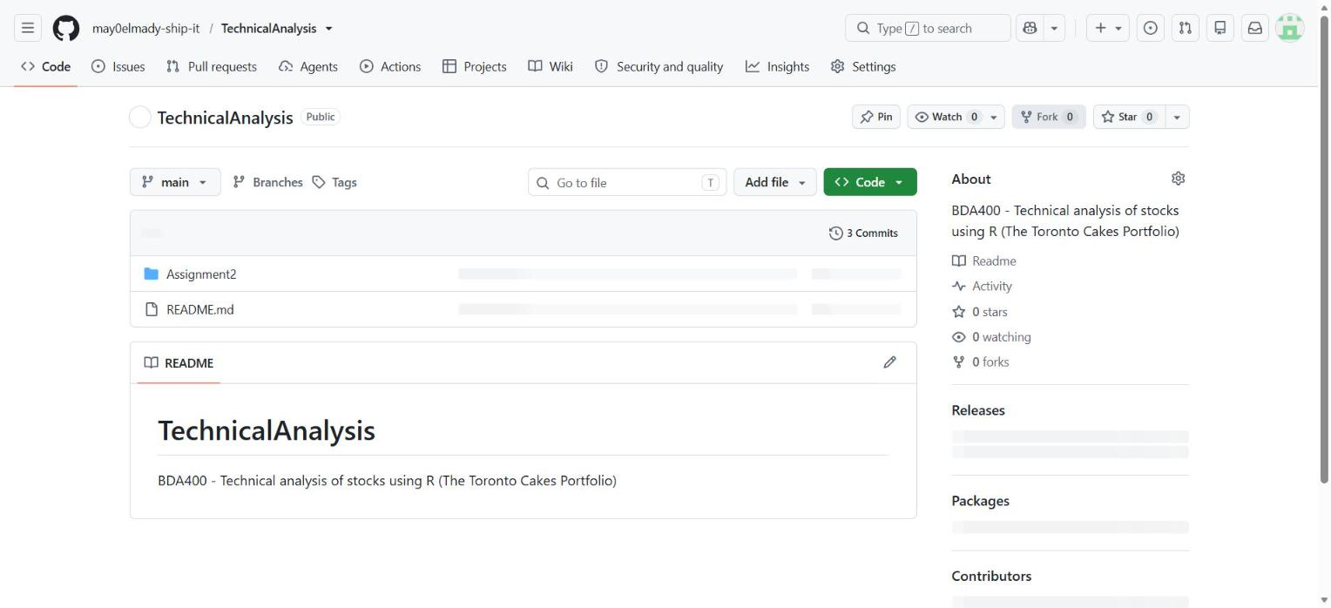
Figure 1 – The TechnicalAnalysis repository on GitHub (account may0elmady-ship-it)
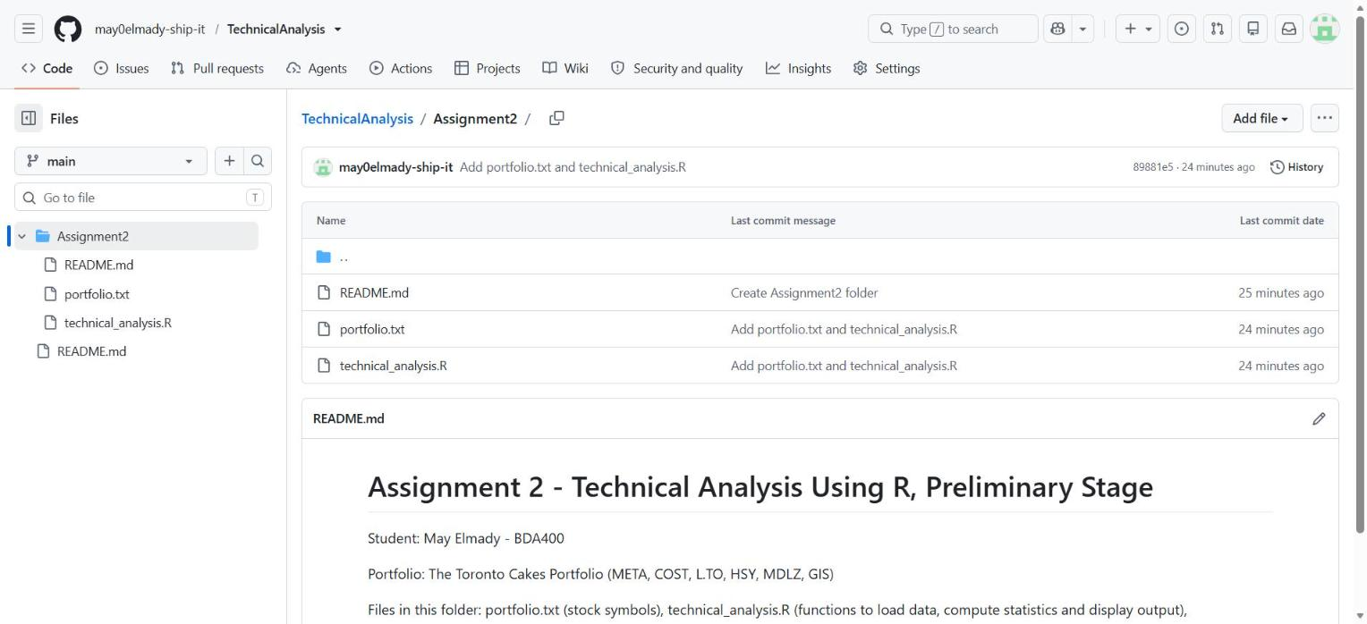
Figure 2 – The Assignment2 folder inside the repository

2. Installing and Configuring R and RStudio
I downloaded R from the CRAN website (cran.rstudio.com), choosing the version for my operating system, and ran the installer with the default options. After R was installed, I downloaded RStudio Desktop from the Posit website and installed it with the default settings. RStudio needs R to be installed first, which is why R was installed before RStudio.
To confirm everything worked, I opened RStudio and ran R.version.string in the Console, which printed the installed R version.
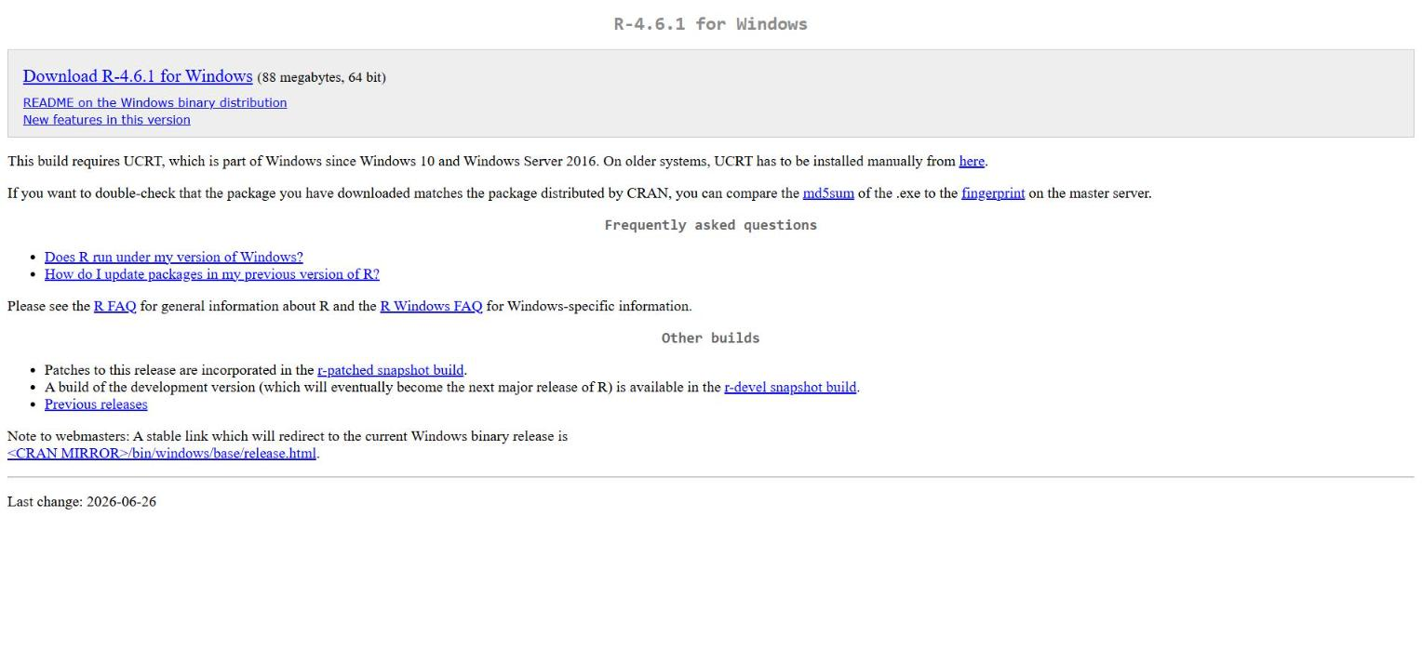
Figure 3 – Downloading R 4.6.1 for Windows from CRAN
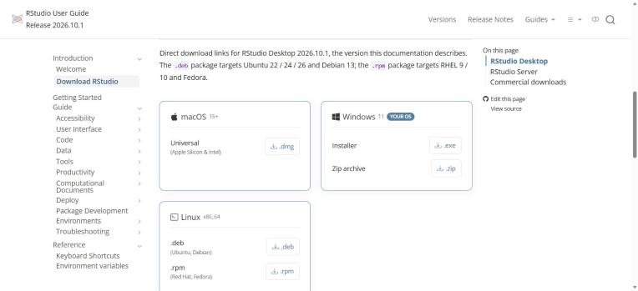
Figure 4 – Downloading the RStudio Desktop installer for Windows from Posit
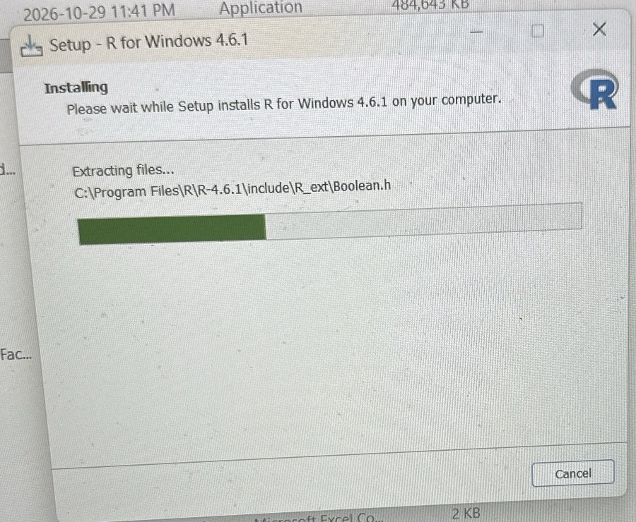
Figure 4a – R 4.6.1 setup wizard installing R into C:\Program Files\R\R-4.6.1
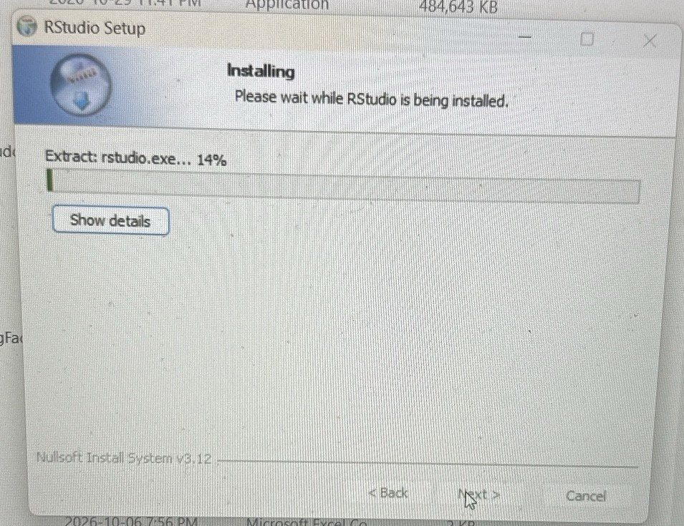
Figure 4b – RStudio setup wizard installing RStudio Desktop
For both installers I accepted the default options, clicked Yes on the Windows permission prompt, then Next until the install finished, and Finish.
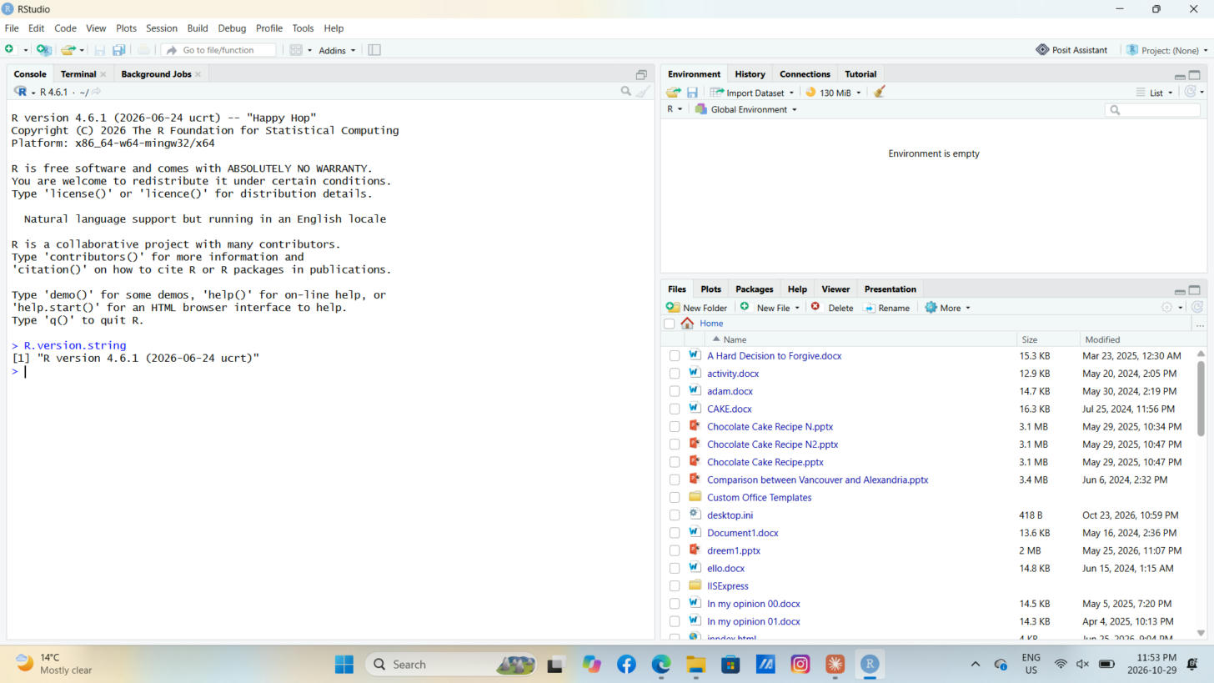
Figure 5 – RStudio running with R version 4.6.1 confirmed by R.version.string

3. Downloading and Installing R Packages for Technical Analysis
I installed the packages needed for technical analysis using install.packages(). The main packages are quantmod (downloads stock prices from Yahoo Finance and draws financial charts) and TTR, Technical Trading Rules (calculates indicators such as moving averages). I also installed xts and zoo, which quantmod uses to store time-series data.
install.packages(c("quantmod", "TTR", "xts", "zoo"))
In my R script I also wrote a small helper function, install_if_missing(), that checks each package and only installs it if it is not already on the computer. This makes the script safe to run again without reinstalling everything. After installing, I loaded the packages with library() and confirmed there were no errors.
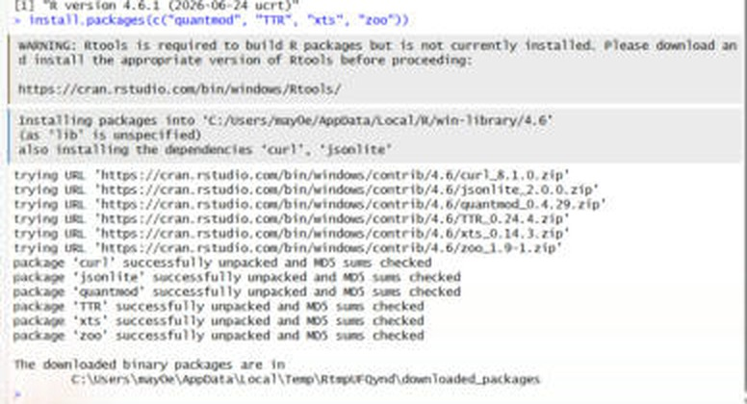
Figure 6 – install.packages() downloading quantmod, TTR, xts and zoo (plus dependencies curl and jsonlite)
The Rtools warning in the console only matters when building packages from source code. Here R installed ready-made Windows binaries, so all packages unpacked successfully.
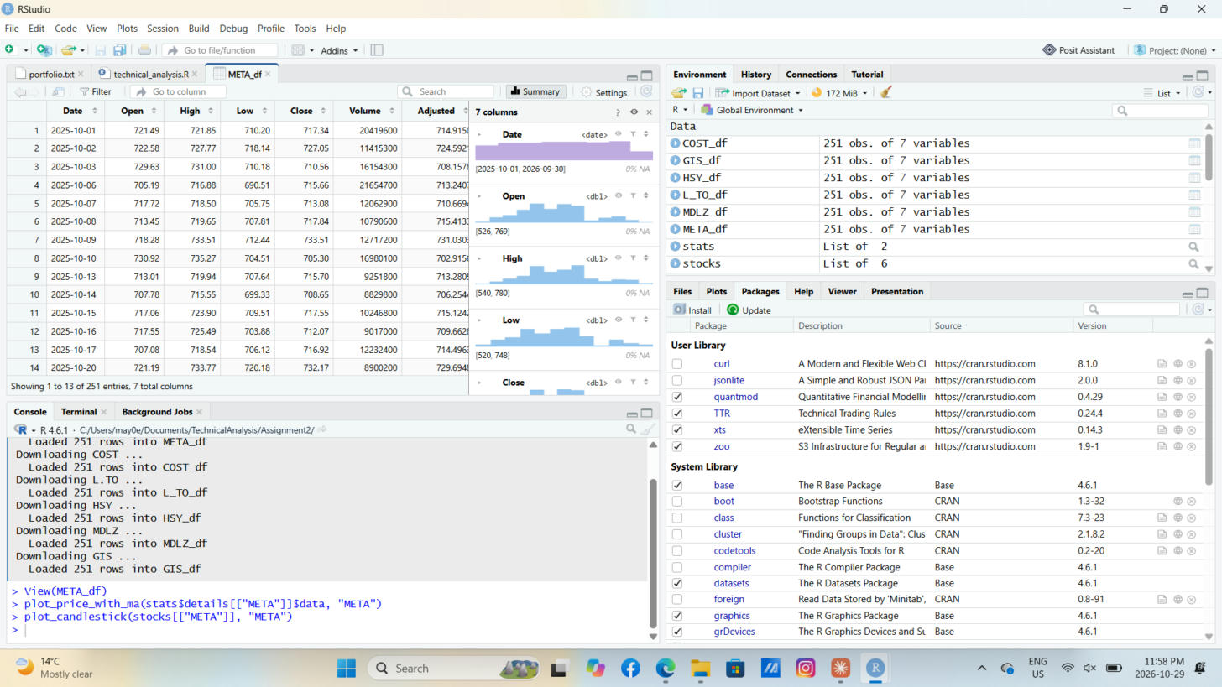
Figure 7 – Packages tab showing quantmod, TTR, xts and zoo installed and loaded

4. Project Configuration and Initialization (portfolio.txt)
I created a plain text file named portfolio.txt inside the Assignment2 folder and listed one stock symbol per line, with no extra spaces or blank lines. The symbols are exactly as they appear on Yahoo Finance:
- META – Meta Platforms: Instagram is where all Toronto Cakes orders and customer messages come in.
- COST – Costco: where I buy butter, eggs, flour and sugar in bulk for large wedding orders.
- L.TO – Loblaw Companies (Toronto Stock Exchange): my everyday grocery and baking supply store. The .TO suffix tells Yahoo Finance it is a TSX stock, so its prices are in Canadian dollars.
- HSY – The Hershey Company: chocolate for ganache and chocolate fudge cakes.
- MDLZ – Mondelez International: Oreo and Cadbury products I use for toppings and fillings.
- GIS – General Mills: flour and baking products.
In the R script, the function read_portfolio() reads this file, trims spaces, removes blank lines and duplicates, and returns the list of symbols. This means I can change my portfolio later just by editing the text file, without touching the code.
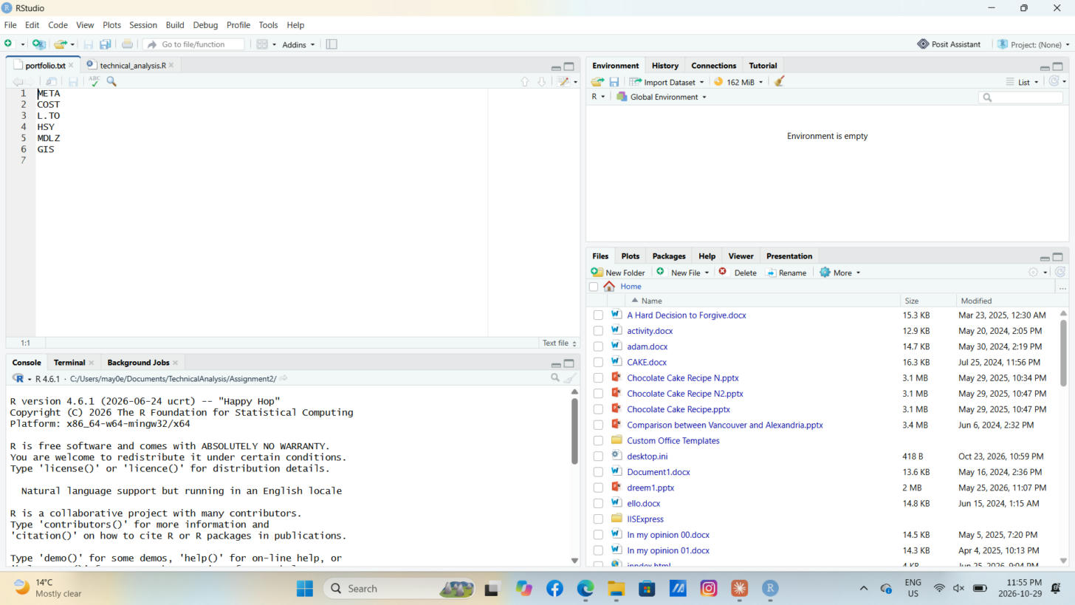
Figure 8 – portfolio.txt open in RStudio with the six stock symbols

5. Writing a Function to Import and Load Stocks Data
I wrote the function load_stock_data(), which reads portfolio.txt and downloads the daily stock data for each symbol using getSymbols() from quantmod, with Yahoo Finance as the source. I used one year of data, from 2025-10-01 to 2026-10-01.
stocks <- load_stock_data("portfolio.txt",
from = "2025-10-01", to = "2026-10-01")
For each symbol the function converts the downloaded data into a data frame with clear column names: Date, Open, High, Low, Close, Volume and Adjusted. Each stock is stored as its own separate data frame (for example META_df, COST_df and L_TO_df, since R names cannot contain a dot) and also inside a named list called stocks, so the later functions can loop through all of them. I used tryCatch() so that if one symbol fails to download, the function shows a warning and continues with the rest instead of stopping.
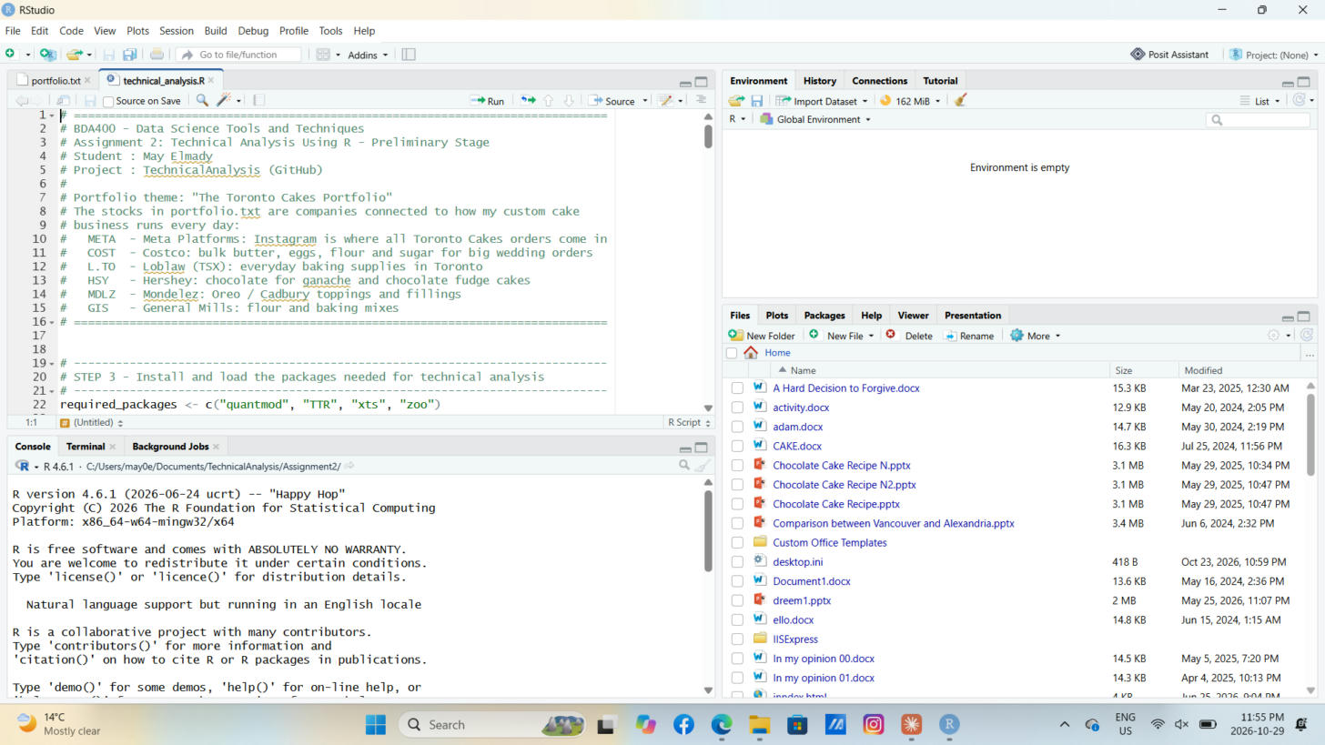
Figure 9 – technical_analysis.R open in the RStudio editor
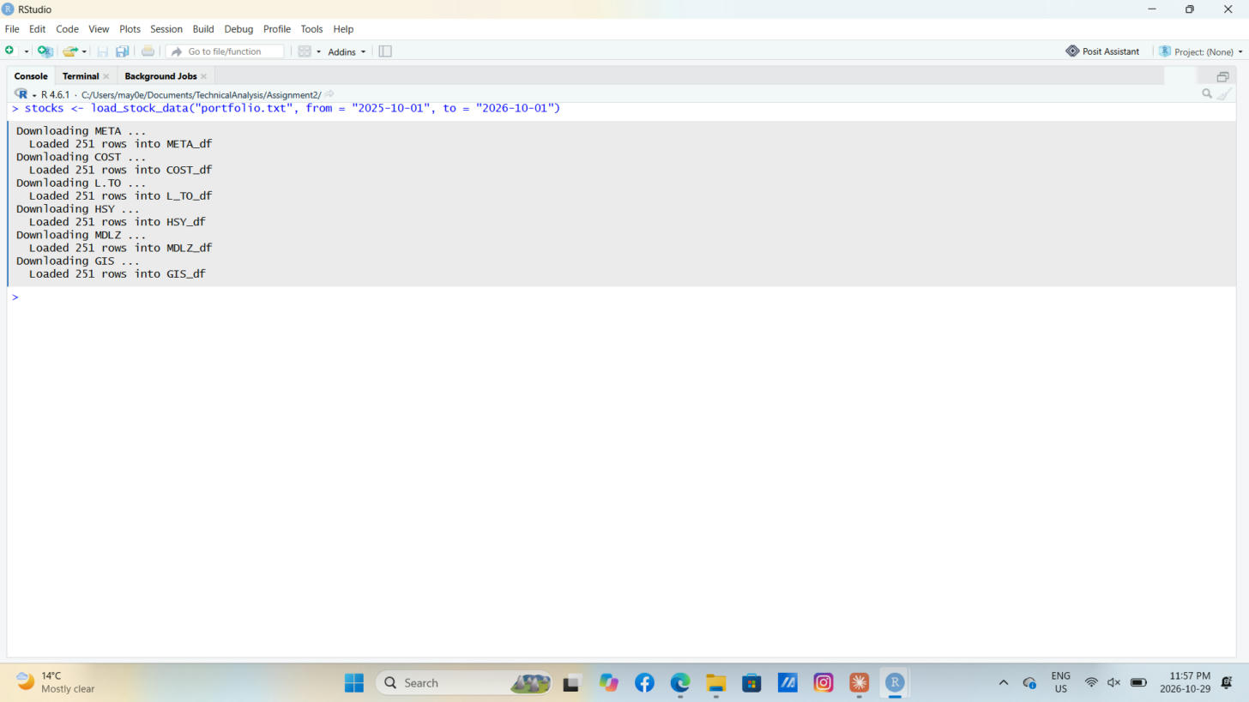
Figure 10 – load_stock_data() downloading each symbol: 251 trading days loaded for every stock
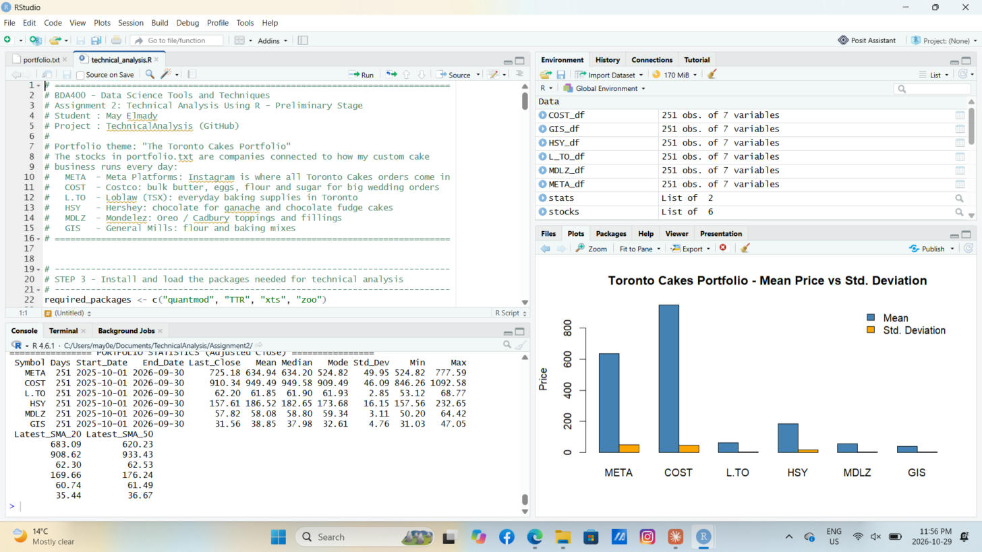
Figure 11 – Environment pane with a separate data frame for each stock (META_df, COST_df, L_TO_df, HSY_df, MDLZ_df, GIS_df)
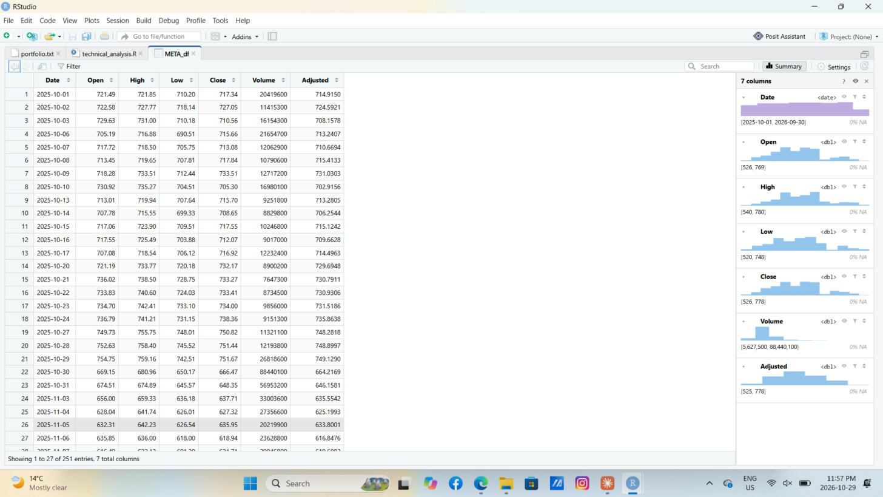
Figure 12 – META_df opened with View(), showing the Date, Open, High, Low, Close, Volume and Adjusted columns

6. Writing Functions to Compute Basic Statistics
I wrote the function calculate_statistics(), which takes one stock's data frame and calculates the required statistics on the Adjusted closing price (the closing price adjusted for dividends and splits, which gives a fairer picture over time):
- Moving averages: a 20-day and a 50-day Simple Moving Average using SMA() from the TTR package. These are added to the data frame as the columns SMA_20 and SMA_50.
- Mean, median and standard deviation using the base R functions mean(), median() and sd().
- Mode: R has no built-in mode function for numbers, so I wrote get_mode(). Because stock prices rarely repeat exactly, the function rounds prices to the cent and returns the most frequent value.
- Extra context: number of trading days, start and end dates, last close, minimum and maximum.
The function returns a list with a one-row summary data frame and the stock's data with the moving averages added. A second function, calculate_all_statistics(), runs this for every stock and combines all summaries into one structured data frame, so the whole portfolio can be compared in a single table.
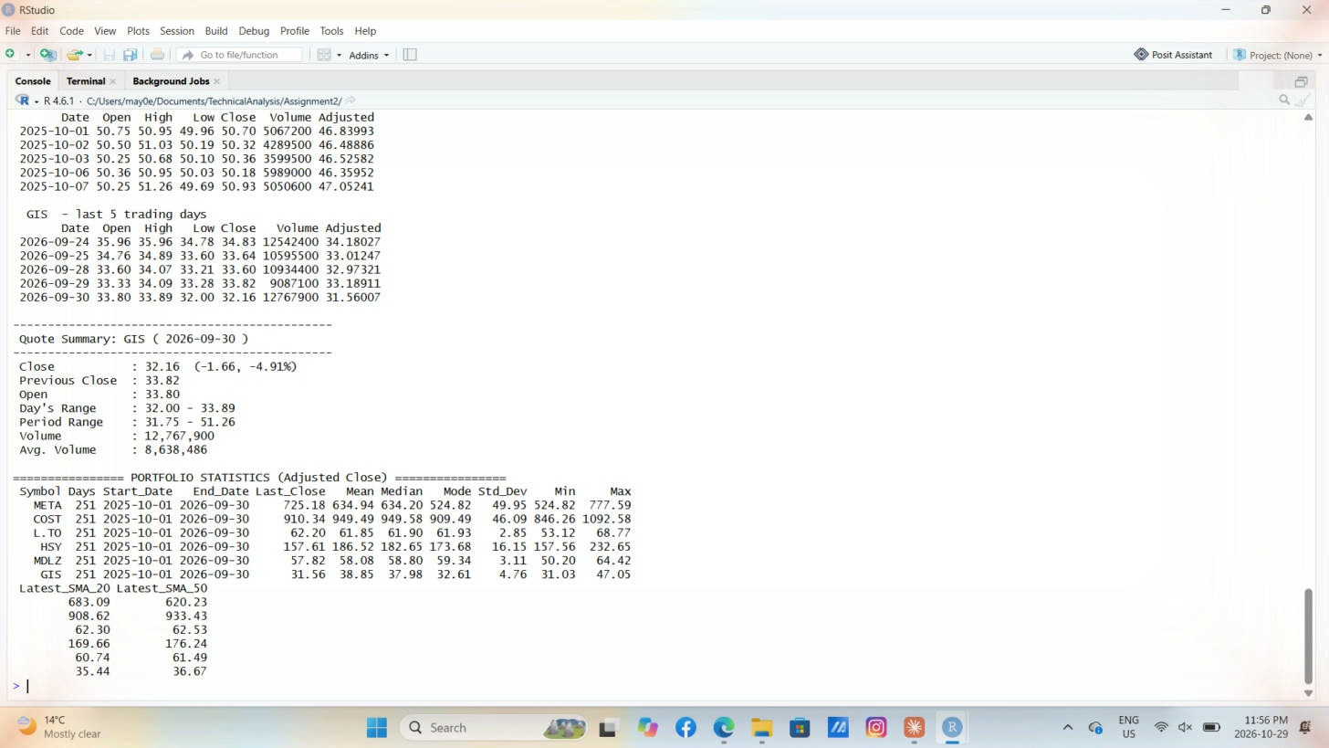
Figure 13 – Portfolio statistics table for all six stocks

7. Writing Utilities to Display Output
Before writing the display functions, I looked at how Yahoo Finance presents stock data. A quote page shows the price and daily change at the top, then a summary with previous close, open, day's range, 52-week range, volume and average volume, plus a price chart. I built my display functions to follow the same ideas:
- display_stock_data() prints the first and last five trading days of each data frame.
- display_quote_summary() prints a Yahoo Finance style summary for the last trading day: close with change and percent change, previous close, open, day's range, period range, volume and average volume.
- display_statistics_table() prints the full statistics table for the portfolio.
- plot_price_with_ma() draws a line chart of the adjusted close with the 20-day and 50-day moving averages.
- plot_candlestick() draws a candlestick chart with volume and a 20-day SMA using chartSeries() from quantmod.
- plot_portfolio_comparison() draws a bar chart comparing the mean price and standard deviation of all six stocks.
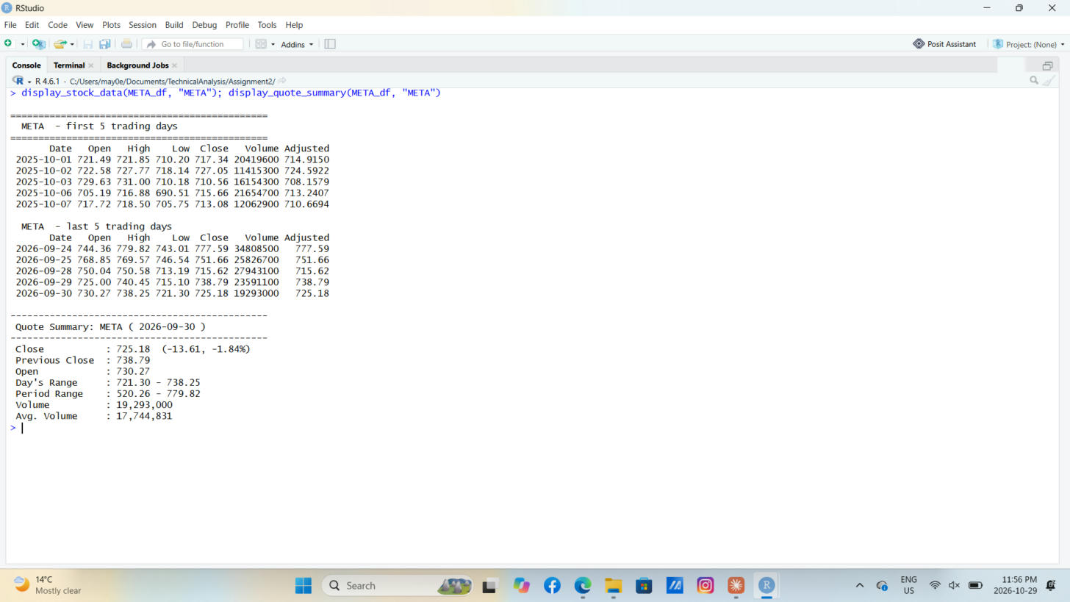
Figure 14 – display_stock_data() and the Yahoo Finance style display_quote_summary() for META
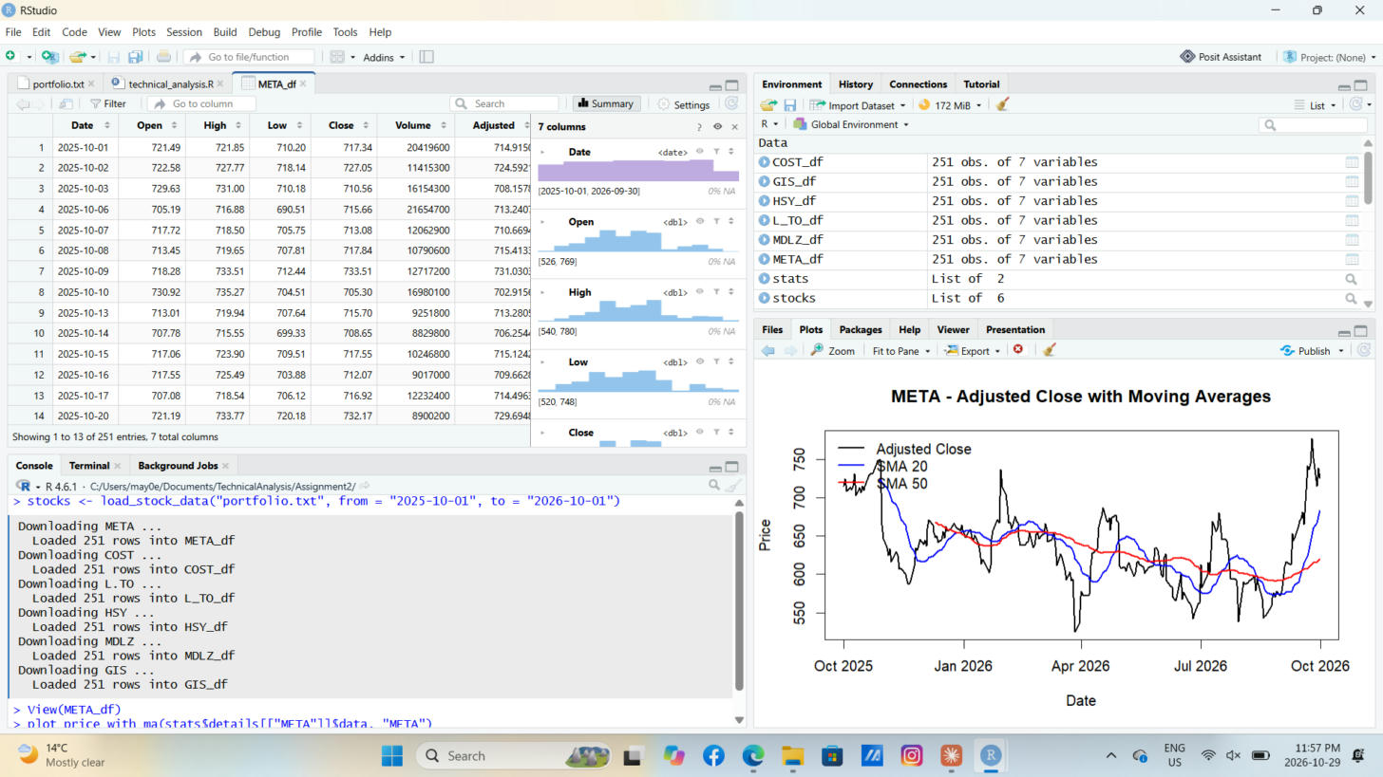
Figure 15 – META adjusted close with 20-day and 50-day moving averages
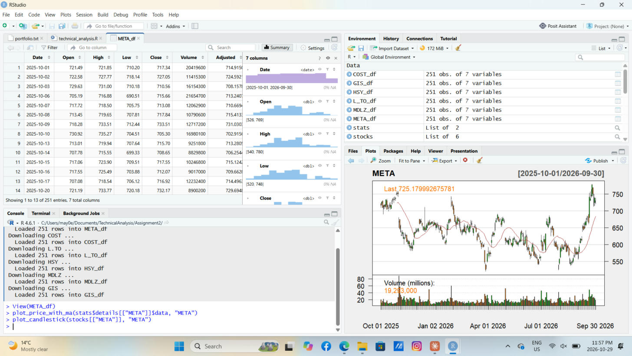
Figure 16 – META candlestick chart with volume and 20-day SMA
The portfolio comparison bar chart (Mean Price vs Std. Deviation) is shown in the Plots pane in Figure 11.

8. Results and Observations
I ran the script on one year of daily data (October 1, 2025 to September 30, 2026, 251 trading days per stock). Here is what the output shows:
- Volatility: META (49.95) and COST (46.09) have the largest standard deviations in dollars, but they are also the highest-priced stocks. Relative to its average price, GIS was the most volatile (about 12% of its mean), while Loblaw (L.TO) was the most stable (about 5%), which makes sense for a grocery chain people shop at every week.
- Trend: META is the only stock whose latest price (725.18) is above both its 20-day (683.09) and 50-day (620.23) moving averages, a sign of a recent upward trend. HSY, GIS, MDLZ and COST closed below their 50-day averages, showing short-term weakness. GIS closed at 31.56, very close to its one-year low of 31.03.
- Mean vs median: for every stock the mean and median are close (for example COST 949.49 vs 949.58), so the prices were not heavily skewed by a few extreme days.
- Mode: because stock prices rarely repeat exactly, the mode is the weakest measure here. For META it equals the minimum price (524.82), so the mean and median describe a typical price much better.
Note: L.TO is priced in Canadian dollars, while the other five stocks are priced in US dollars.

9. Uploading the Files to the GitHub Repository
I uploaded all the files for this stage into the Assignment2 folder of the TechnicalAnalysis repository using Add file > Upload files, then clicked Commit changes. The folder contains:
- portfolio.txt – the list of stock symbols
- technical_analysis.R – the R script with the functions for loading data, computing statistics and displaying the output
- Elmady_May_CA_BDA400_A02.docx – this report
Figure 2 shows the Assignment2 folder with the README, portfolio.txt and technical_analysis.R. This report was uploaded to the same folder as the final step.

10. Conclusion
This preliminary stage set up the full environment for the technical analysis project: a GitHub repository with one folder per assignment, a working R and RStudio installation, the quantmod and TTR packages, and a reusable set of functions that read any portfolio file, import the data, calculate statistics and display the results. Building the portfolio around Toronto Cakes made the analysis meaningful to me, because these are the companies my business relies on every week. In the next stages I will build on these functions to add more technical indicators and analysis.

GitHub Repository: https://github.com/may0elmady-ship-it/TechnicalAnalysis

