Senior Design

# Web Platform for Java Specifications

## Group May1620

Alex Dana, Deeksha Juneja, Cody Hanika

Advisor: Professor Rajan

# Table of Contents

1: Background Pg. 3

2: Project Statement Pg. 3

3: Requirements Pg. 3

4: Proposed Initial Solution Pg. 4

5: Assessment of the Initial Solution Pg. 5

6: System Description Pg. 5

7: Work Breakdown Pg. 6

# Figures:

Page 4: Figure 1 - This photo shows the basic high level design of our application and it’s cycle.

# 

# Background

Formal, behavioral software specifications allow a programmer to specify the behavior of a piece of code to aid in verifying the correctness of said code. These specifications are not required by the Java programming language, and are currently used by very few programmers when writing code. A large factor in the small adoption of formal specifications when writing Java code is the lack of easily available formal specifications for major public libraries. This project aims to solve this problem. Prior work in one this problem has taken a purely technical approach, which has failed to be accurate at creating specifications for widely used code. Having learned from this, our team will be taking a socio-technical approach that leverages the success of community-run websites, such as Stack Overflow, to solve this problem.

Project Statement

To make formal specifications widely available for Java programmers, a community driven web platform will developed that will allow developers to collaborate to create formal specifications for widely used Java libraries. This project will leverage Stack Overflow, at least initially, as the collaboration platform for creating these specifications. The questions will be created with approximations for code specifications and answers will be created by the community to verify or fix these specifications.

A program must be created to parse, finalize, and persist these specifications created by community answers on Stack Overflow. These specifications will then be made available to the community via a public REST API.

# Requirements

* A program that utilizes existing community Q & A platform to automatically post questions about formal specifications for widely used code for the programming community to answer.
* A program to monitor answers from the Q & A platform that will make decisions on what is most likely to be the correct answer. This program must also be able to persist these specifications.
* A public API to query the specifications that have been gathered from the web platform.

Proposed Initial Solution

Our project must be able to generate specifications and then submit these specifications to the Stack Overflow site in the form of a question. The answers to this question will then be analyzed to refine our initial “guess” at the specification. We will then store this new specification in a database to be used and possible refined later. The process will follow the figure below:

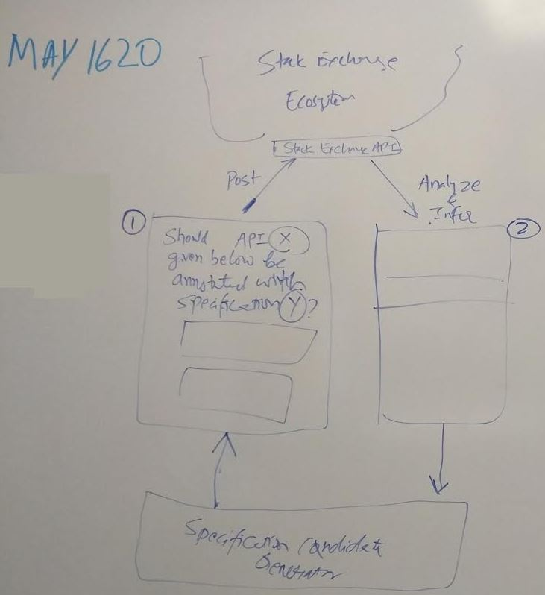

Figure 1: Diagram of our proposed project structure

To test this we will check to see if we can have questions automatically generated and posted to the Stack Overflow site using the Stack Exchange API. If this succeeds we will check to see if our newly refined specification, acquired from the analysis of comments and answers, is correct. Finally we will make sure that this new specification does indeed persist to the database.

Professor Rajan had a fairly clear vision of where he wanted to take this project but there were still alternative solutions proposed. The main alternative was to use a different site than Stack Overflow for the questioning process. However this did not make sense for us since the Stack Overflow site was setup so well for what we wanted. The main weakness to the site is the limit on API requests (capped at 10,000 which should not be a problem in the end) and the aversion of auto generated questions - meaning that we will need to have our program “pretend” to be a person posting the questions. Overall though the benefits of the Stack Overflow site outweigh the negatives so we decided to take this approach.

# Assessment of the Initial Solution

The proposed solution leaves 3 major challenges to be faced. The first is community participation. The proposed solution relies on the fact that the community will participate in answering specification questions posted to Stack Overflow. To spark interest, we may need a way to promote the positives of formal specifications in our questions posted to Stack Overflow. Once people find value in specifications, there is a positive outlook on people answering questions on them, as Stack Overflow has been so successful in drawing the community in to answer questions.

The second challenge is getting the correct specifications for a piece of code. As specifications are not widely used, there are not many experts in formal specifications. This would make getting initial, correct specifications difficult to obtain. However, Stack Overflow does have many users and the discussion format of the website would allow people to work together and review others’ work.

The final challenge is inferring the specifications from community answers. Discussion on the specifications needs to be allowed and not restricted, but the actual answer specification needs to be able to be inferred from the discussion. Since Stack Overflow does not currently have a built in mechanism for this, a grammar for answering questions on specifications may be necessary so a computer can parse the answers provided by the community.

A major strength of the proposed solution is utilizing the existing infrastructure that Stack Overflow provides. This will allow our team to not have to deal with creating a platform for collaboration on these specifications. This gives us much more time to focus on the other challenges that we will face, as listed above.

# System Description

The system will be built on a webapp (subject to change) that will utilyze a RESTful web service in order to send commands (post questions and retrieve answers) to/from the Stack Overflow site as well as have the specifications generated by these posts stored and retrieved in a database. Therefore we will use Java coupled with Maven to create a web application that uses Jersey REST. We will be using a MySQL server for our database. Later on we will be combining our application with May1639 in order to give them access to our specifications for their own use. Initial testing of our application can be done with simple posting and retrieving of questions as well as storing of these questions via a RESTful application.

# 

# Work Breakdown

Project Schedule:

|  |  |  |  |
| --- | --- | --- | --- |
| September | October | November | December |
| Initial meetings and project planning.  Come up with an initial system design.  Brainstorm solutions and possible issues. | Begin learning the technologies needed to complete the project.  Begin research on feasibility of solutions.  Create initial project plan. | Begin initial creation of specification generation and question posting.  Refine question wording to get best response from subjects. | Begin initial attempts of analysis on responses.  Refine specification generation and wording. |