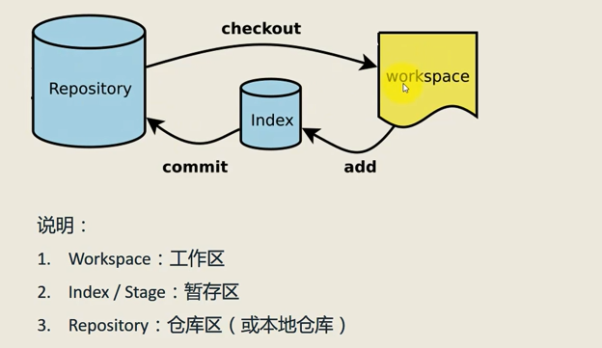

新建代码仓库

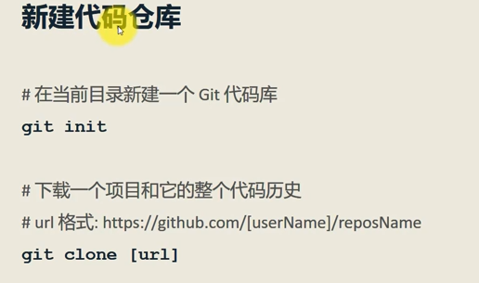

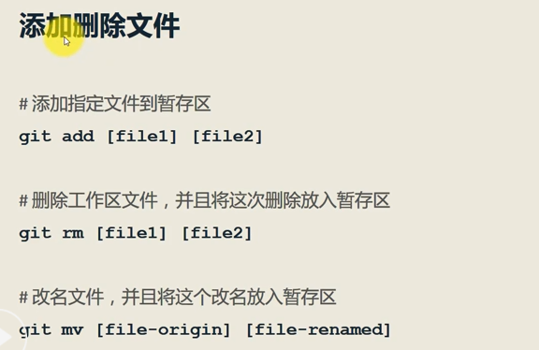

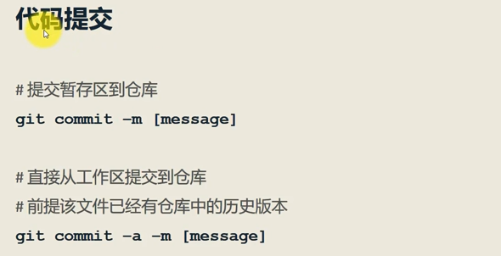

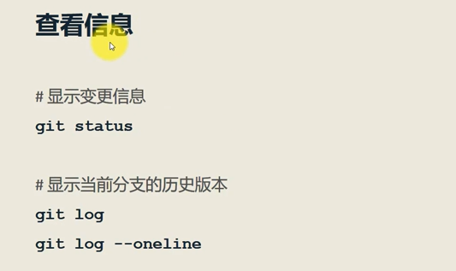

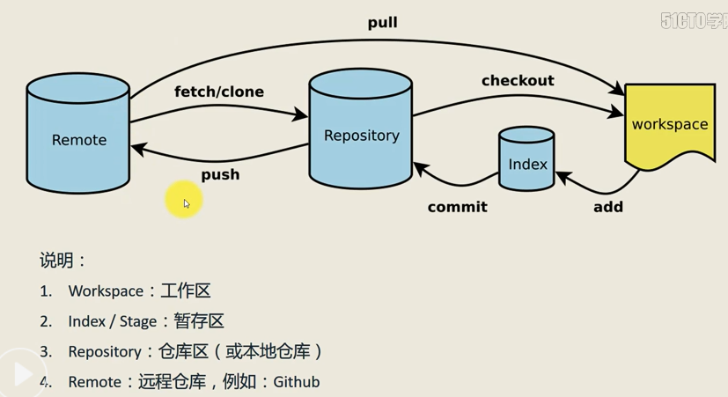

Git show +hash值 ---显示修改的信息

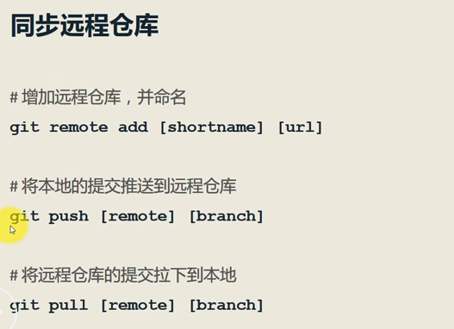

git remote add origin <https://github.com/mayHYT/My-study-note.git>

git remote -v --查看和几个远程仓库建立连接

git add . ---提交所有新添加的东西

git push origin master

git pull origin master

git clone <https://github.com/MayHYT/My-study-note>

git 设置url

仓库->Setting->GitHub Pages ->master branch ->save

删除仓库

仓库->Setting->Danger Zone->Delete this repository