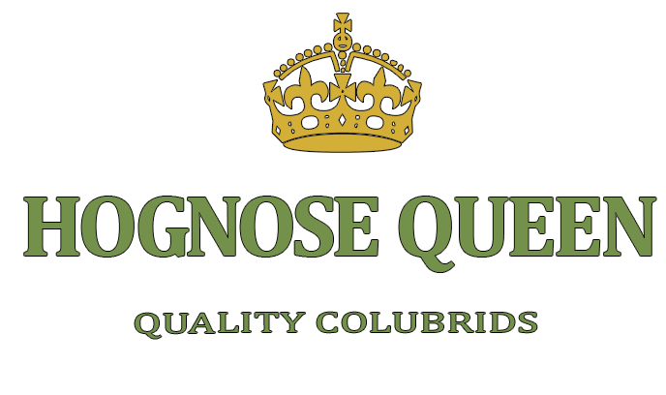
Care Sheet

Table of Contents

Section 1: Housing
Section 2: Husbandry
Section 3: Handling
Section 4: Feeding
Section 5: My Promise

Section 1: Housing

Disclaimer: There is a huge controversy regarding keeping Western Hognoses in tubs vs. tanks, but I am going to explain how to set up both.
But why?
Because they BOTH work and are convenient for different reasons, so it is up to you to decide what works best for you.
It is mainly preference, but if you read this and are still unsure about what kind of enclosure to use for your hognose, please feel free to contact me. Another (more advanced) option is creating a bioactive vivarium which includes live plants and bugs, and other components that are used to make the preferred ecosystem for your pet. This option absolutely requires research, so if you would like to go that route please seek more information online (Bioactive and Reptile-Related Facebook groups are EXTREMELY helpful) before attempting to do so.

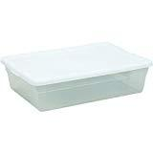VS. 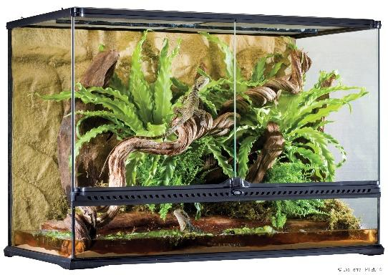

Hatchlings/Juveniles: Either a 5- or 10-gallon tank or a 6-quart tub will work fine for juvenile hognoses. They generally just need a water bowl (don’t use anything with a lid as they could drown in it), a small hide, and substrate. Humid hides are not generally necessary unless you live in a cold climate. If you’d like, you can clutter up their enclosures with things like paper towel tubes, hides and shrubs. They are very curious creatures and love to explore! Don’t spend too much money on their enclosure at this age though, as they may outgrow it (especially female hogs). The most commonly used substrate is aspen. I recommend it because it isn’t dusty, doesn’t make a mess, and hogs love to make tunnels in it. All hogs love to dig and burrow so give them at least 3” of substrate to play in. The more the better! Don’t forget to make ventilation holes for every tub you use. Snakes need oxygen too.

Adult Males and Females: Before I get started with this, YES – there is a huge size difference between male and female hognoses and it’s perfectly normal. It is also very adorable to witness when they are side-by-side. Adult male hognoses need at least a 20-gallon tank or 13-quart tub and females will need at least a 20-gallon long tank or a 28- to 32-quart tub. Adults just need a water bowl, hide, and substrate. As with juveniles, you can (and should) clutter their cage with décor, more hides and/or shrubs. Get creative, but make sure not to use anything that could harm your snake (i.e. sharp edges, small edible pieces and/or toxic paints).

Section 2: Husbandry

Temperatures: Hognoses need both a hot side and a cool side in order to digest properly. The hot side should be anywhere from 85-90 degrees Fahrenheit and the cool side should be somewhere around 75 degrees Fahrenheit. Always use a thermostat with any and all heat sources used to regulate the temperature. If you do not use a thermostat then your snake could get burned, become dehydrated, or even die. As an added safety measure, you can also purchase a heat gun on eBay for $10 that will give you an accurate temperature reading anywhere in your hoggie’s cage. Both breeders and keepers love these for peace of mind and I love mine too!

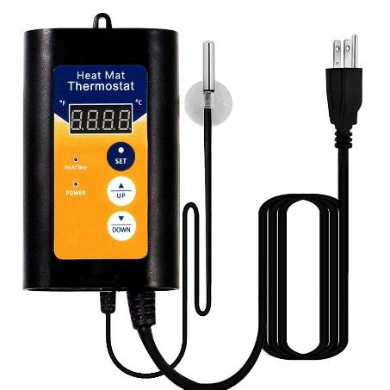

Temperature Gun Thermostat

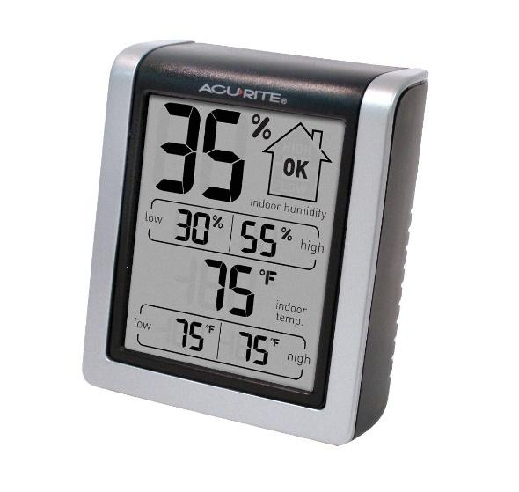
Humidity: Hognoses do not like too much humidity, but a little bit of humidity is just fine. They will not get a respiratory infection if the humidity is kept between 30% to 40% consistently. No need to spray or mist as they are an arid species. You can keep the humidity down in plastic enclosures by keeping water bowls away from/off the heat source and by making a lot of small ventilation holes around the walls of their tub. You will not get a lot of humidity in tanks if they have a mesh lid so no need to worry about that. For measuring humidity, you can (optionally) use a hygrometer, which can be placed on the inside of the tub or tank. Hygrometers are also quite cheap, but I personally do not worry about humidity enough to use a hygrometer since aspen is dry and my tubs are well ventilated. If you use a different substrate like soil or coco coir then you might need a hygrometer. That being said, there shouldn’t be a lot of condensation in your hoggie’s enclosure. If you see droplets, increase ventilation until they are gone.
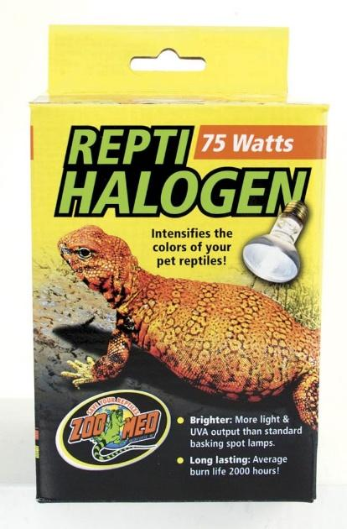
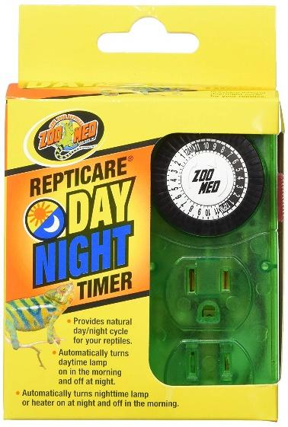
Lighting: Since hognoses do not technically need UVB or UVA, you can absolutely skip UVB/UVA lighting if you would like. Daylight is more than enough for them. However, they can absorb vitamin D3 from a UVB or UVA halogen lamp and will benefit from it, but it is up to you to decide the quality of life of your snakes. Whatever route you choose, aim to provide at least 10-13 hours of lighting per day. You can get a timer for your lighting in case you are not home to turn them off in time and/or like to travel often. It is best to use a timer with a dimmer. Do not use a pulse thermostat with halogen lamps because pulse thermostats will reduce your bulb’s lifespan and fluctuate your temperatures. As long as your hot side and cool side temperatures are correct, you are good to go.
Heating: In order to get your enclosure to the right temperatures, you will need a heating element, maybe two if you live in a cold climate. As I previously mentioned, if you decide to go with a halogen (UVA/UVB) bulb, they will sometimes provide heat in addition to light. Remember: Always use a thermostat to regulate your heat sources to avoid fires and burns. As an alternative to using a UVA/UVB bulb for heat, you can also buy a UTH (under-tank heater). There are also other options such as a heating mat, heat cable, heat tape, or a CHE (ceramic heat emitter, which does not provide light. If you choose to use natural sunlight as your light source, then all you will need is heat! Please note: Using a UTH alone will NOT get your enclosure to the right ambient temperatures, depending on the type of climate you live in. Here in Florida, either heat-emitting lamps or belly heat will work fine all by themselves, but those who live in colder climates might need to use a combination of heating elements to achieve ideal temperatures. Your best bet is to buy a heat gun and use it to get temps in every spot of your snake’s cage. To find the correct wattage measurement for heat bulbs, it usually goes by the size of the tank or tub you are using, so just read the back of the box to determine how many watts you should be using according to the size of your pet’s enclosure. Always keep your heat sources away from your pet, and lamps should be kept at least 12” away from the top of your enclosure in order to avoid any accidents.

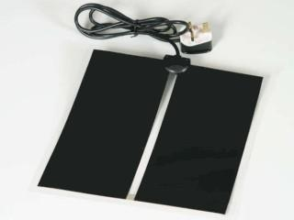
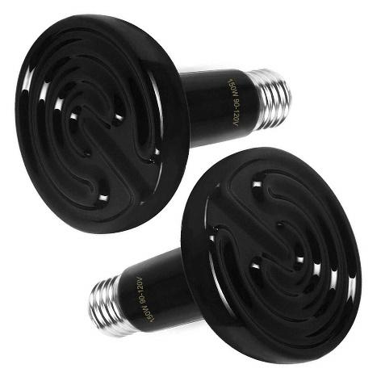
UTH CHE

Section 3: Handling

If this is your first Western Hognose snake ever, Congratulations!
You have just purchased a fun, feisty, mini cobra (that occasionally flings poop at you)

For the first 1-2 weeks of having your new hoggie, try not to bother them while they adjust to the environment. It is important to give them space in the beginning, so that they aren’t scared of you and will gladly take their first meal. Hognoses like to put up a huge bluff, but don’t worry, they rarely ever bite. Put your hand underneath them with confidence every time, even if they try to intimidate you. Think rationally and do not let them win.
Trust me, hognoses are just drama queens who do not like to be bothered at first, but they will get over it as soon as you pick them up. I recommend playing with your hognoses at least 15 minutes a day as a bonding exercise. Doing so will make them trust you (more like tolerate you) over time. If your hognose starts getting upset once you’ve picked them up, don’t give up! Just put them back and try again tomorrow. Always remember, if you can avoid it, try not to put extra stress on your snake. They will overcome their fear of you eventually.

Section 4: Feeding

I will keep this short and sweet. A lot of people will say hogs are known for being picky eaters. Mine are trash cans. It really all depends on the attitude of your snake, the husbandry you provide, and the feeding schedule you choose to adhere to. Also, their health/lineage is super important. Do NOT buy ANY snake that is less than a month old or not eating. Breeders that sell hatchlings less than a month old or noticeably underweight snakes should be avoided at all costs.

There will be times throughout the year that your snake might regularly refuse food – and it’s okay, I promise. They can go several months (sometimes years) without food but eventually, they will come around. Hognoses may refuse food around the spring due to breeding season and in the winter months due to brumation (which is basically snake hibernation season). They can also refuse food if they are in shed. Hognoses typically shed a few times a month but if they don’t, do not panic. I once had a snake not shed for over a year. If your snake goes off feed, do not panic. Keep an eye on your snake’s overall health and weight. Without adding any additional stress to your hog, keep offering food regularly but please see a vet if they become disoriented or lethargic, if they lose half of their body weight, or if you have any other concerns. If you need any tips on getting your snake to eat, please feel free to contact me as well. I have lots of tricks for picky eaters!

Here is a simple breakdown of my current feeding schedule:
Hatchlings: Offer food every 3-4 days
Juveniles: Offer food every 4-5 days
Adults: Offer food every 5-7 days

Remember: NEVER leave food in your snake’s enclosure for more than 24 hours and NEVER thaw your mice in the microwave (yes, people do this).
Also, do NOT thaw mice at room temperature as you are risking bacteria build-up, just like human food after being in the temperature danger zone. Trust me on that one. The most sanitary way to defrost prey is to put it inside of a Ziploc bag. Leave the bag in your fridge overnight and take it out for a few hours before feeding so it gets to room temperature. When you are getting ready to feed, simply run the bag under some hot water (if desired) and you are good to go. There is no need to move your snake outside of its enclosure to feed it – this will only cause them stress. If they eat a few pieces of substrate they will be fine. It’s not going to kill them. Don’t worry about it unless they ingest a large amount and/or your snake becomes ill, as they could have an impaction. Lastly, always use tongs to feed your snake and do not handle the snake for at least 1-2 days after feeding to risk the chance of regurgitation. You can either let them eat off the tongs or leave the mouse in their enclosure. Be sure to remove any uneaten prey after 24 hours.
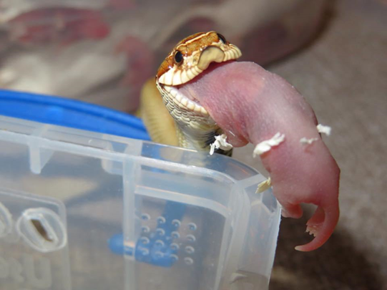

Section 5: My Promise

As the “Queen of Hogs”, top-quality hognoses and customer care are my specialty. With that being said, I also personally guarantee you my service for a lifetime.
All of my breeder snakes are selected from the finest of lineages, and every snake in my collection has been cared for deeply and to the highest standards possible.
I am always here to answer any questions you may have, so please feel free to reach out to me whenever you would like to!
Don't forget to follow us on Instagram and Facebook! ❤ (see links below)

Facebook: https://www.facebook.com/HognoseQueen/
Instagram: https://www.instagram.com/HognoseQueen/
Email: hognosequeen@gmail.com

