Title: Power Grasp Detection on 3D Objects via Multi-Height Mesh Analysis
Affiliated University: McMaster University
Type: Mentored Project
Name: Maya LeBlanc, Engineering Student at McMaster University
Professor: Dr. Gary M. Bone, PhD, PEng, Department of Mechanical Engineering, RMAL Head, McMaster University
Timeline: August 2025 – March 2026

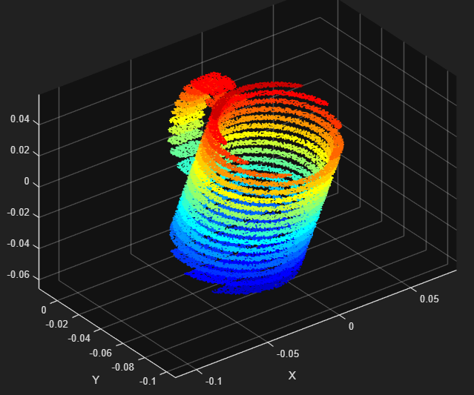

Table of Contents
Project Background 2
Challenge 3
Purpose 4
Definitions 4
Code Procedural Analysis 4
Section 1: Creating a Mesh 4
Section 2: Z-Plane Intersects Mug and Slices for Cross-Sectional Analysis 6
Section 3: Assemble and Visualize the Slice Contour 6
Section 4: Automating Slicing Across Multiple Heights. 7
Section 5: Analyse Slice Geometry for Grasping 8
Section 6: Multi-Height Slicing Automation 8
Section 7: Turning the Raw Slices into Something Meaningful 8
Section 8: Power-grasping region detection 8
Section 9: Power -grasp region detection 8
Conclusion or Reflection 8
References 8

Project Background
“The field of robotics is concerned with the generation of motions which will cause objects in the world to move in some desired way [1].” Among the well-recognized sub-areas there are: 1) the study of kinematic chains; 2) the description of compliance; 3) The problem of grasping; and 4) motion planning and obstacle avoidance. This project will focus on the problem of grasping.
Grasp planning is the process of determining the best way for a robot’s gripper to approach, contact, and securely hold an object to perform a task. This includes involvement of finding optimal contact points, gripper pose (position/orientation), and finger configurations that ensure stability, avoid collisions, and enable subsequent actions like lifting or moving. The input for such a process includes 3D object models (STL file, mesh polygon, etc.), sensor data (depth images, point clouds, etc.) or human demonstrations. Then an algorithm would define the interaction (contact points, normals, friction, gripper pose), identify potential contact regions, and evaluate certain types of grasps based on metrics for stability (force closure, resistance to disturbances), collision-free paths, able to be reached, and suitability for the task (lifting, insertion, etc.). The output, dependent on the purpose of the mission or project, would usually be a specific executable plan: the gripper’s final pose, finger positions, and the arm’s path to reach it. Note that it would be easier to determine a certain type of grasping position for the mission of just grasping a model than for the mission of grasping and moving a model. The previous must come before the latter.
There are multiple key considerations when it comes to grasp planning: object geometry (shape, size, texture), gripper type (parallel jaw, multi-fingered hands, suction cups, power/enveloping), task context, and uncertainty. Techniques to approach this include geometric methods (analyse object shape to find stable contact points), learning-based methods (using deep learning like CNNs or Learning from Demonstration, LfD, to predict grasps from visual input or human examples), and/or optimization (iteratively refine grasp parameters like contact points or approach direction to improve stability or reduce errors).
This project covers an algorithm able to take in an input of an STL file (3D object model) converted into a mesh polygon model and determine if capable of the power/enveloping grasp (type) without any type of movement.

Challenge
“The attachment is an STL file containing a model of mug. An STL file contains a triangular mesh. It’s easier to work with meshes than point clouds (and point clouds can be converted into meshes) so I thought this is a good place to start.
The first stage of the grasping planning problem is to find the regions of the object that can be power grasped by the fingers of a robotic hand. Specifically, a robotic that’s a simplified version of a human hand with only 3 fingers and 2 or 3 joints per finger. You may assume that the dimensions of its fingers and palm are known. A “power grasp” or “enveloping grasp” means that the fingers wrap around the object such that their inner surfaces contact it at multiple points. Common examples are holding a can of pop, or the handle of a milk jug or the handle of a mug. The challenge is finding those regions on the mesh of the mug. Here’s an idea to try:
Slicing the mesh and analyzing the shapes of the resulting polygon or polygons. If there is only one polygon, then its approximate radius could be determined from its area and perimeter and that approx. radius could be used to check if the fingers could wrap around it. If there are two polygons the smallest gap between them could be found and checked to see it is large enough for a 2D version of a finger to pass through. If it is large enough then the wrapping finger check could be done again. If all checks pass then the slicing plane can be translated and the process repeated
Let’s can the translation distance “delta”. If “n” translated planes allow the 2D finger to wrap around the polygon and n*delta>finger width then there is room for one 3D finger. This process could continue until the region wear multiple fingers can form a power grasp can be found.”
~ Dr. Gary M. Bone

Purpose
Programming challenge about grasp planning in robotics. Developed a complete MATLAB workflow to import, reorient, and analyze a 3D mug model by applying geometric transformations and generating cross-sectional data for engineering analysis.

Definitions
…:…
end = to terminate a block of code
(need to finish on my end)
idx = row number (index) (naming convention)
v1_idx = “the index of [vertex = col] 1” is which row number (naming convention)
(idx, :) = access entire row at index idx, all cols
v1_idx, v2_idx = variable names holding different values

Code Procedural Analysis

Section 1: Creating a Mesh
Before introducing any means of manipulation, scientific thought, or analysis, one must have access somehow to the STL file through MATLAB. One way to do this is to create a PDE model and load geometry.
A PDE model is a structured representation of a partial differential equation problem, managed by the PDE toolbox, that defines the equation type, geometry (2D/3D), mesh, material properties, and boundary conditions. It allows users to simulate complex physical phenomena like heat flow, structural stress, or electromagnetics using Finite Element Analysis (FEA). It bundles all simulation aspects into a PDE Model object. A good analogy is this: Imagine an open box (PDE Model) and you place (load geometry) an object (STL file) within the open box and close it and createpde. It cooks inside like a microwave and when its done cooking, the product can generate an edible product (further analysis like generateMesh).
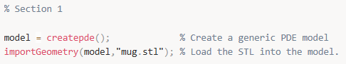
Note that the STL file must be in the same folder on the computer where the MATLAB script is saved, so MATLAB is able to find it. In addition, we will commit to utilizing PDE model to produce a triangular mesh polygon, as it is easier to manipulate on MATLAB for functionality and efficiency in the project.
Now to generate a mesh for this geometry, we write:
While creating a new variable that serves as the new variable holder of the mesh polygon from model that has the stored imported geometry of the STL file in the PDE model, we generate a mesh from model. The code above generates a triangular or tetrahedral mesh (depending on whether your model is 2D or 3D) with elements that don't exceed size 2 (in the units of our geometry). Smaller Hmax values create finer, more detailed meshes with more elements, while larger values create coarser meshes with fewer elements.
As per Step 3 in Section 1, extracting vertices and faces transforms the abstract mesh into explicit geometric data used to query, visualize, and use to apply precise constraints based on spatial location and connectivity.
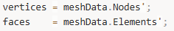
When you extract mesh data from MATLAB PDE model, you are converting the computational mesh into raw geometric data that can be used for visualization, analysis, or applying constraints. .Nodes contains the spatial coordinates of all vertices (nodes) in the mesh. Each column represents one vertex/node, and each row represents a spatial dimension (x, y, z coordinates). For a 3D mesh, typically would be a 3xn matrix where n = number of vertices. For a 2D mesh, typically would be a 2xn matrix.
Example structure:
.Elements contains the connectivity information defining which vertices form each face/element. Each column represents one triangular face (2D) or tetrahedral element (3D) and each row contains indices pointing to vertices in the .Nodes array. For triangular meshes, typically would be 3xm matrix where there are 3 vertices per triangle. For tetrahedral meshes, typically would be 4xm matrix where there are 4 vertices per tetrahedron.
Example Structure:
However, we have transposed .Nodes and .Elements into .Nodes’ and .Elements’. The transpose operation converts the matrices into a more conventional format because .Nodes’(nx3) and .Elements’(mx3) format is the standard convention used by visualization functions (trisurf(), patch(), trimesh()), constraint algorithms that iterate over vertices or faces, and most graphics and computational geometry libraries.
Example Usage:
It makes working with rows more intuitive to loop through, as each row would represent a complete geometric entity, rather than having to work with column vectors, easier.
Note that Dr. Gary M. Bone has mentioned that all this work of slicing can be easily done through MeshLab software and PDE is unnecessary as we will not be using partial differential equations in any manner (and I do not know of them either lol). However, learning the long way as an exemplar is better for the long run, personally.
There is a Section 1.5 which regards the necessary unit conversion to meters. Fprintf(‘’); prints onto the command window in MATLAB. Below is the code.
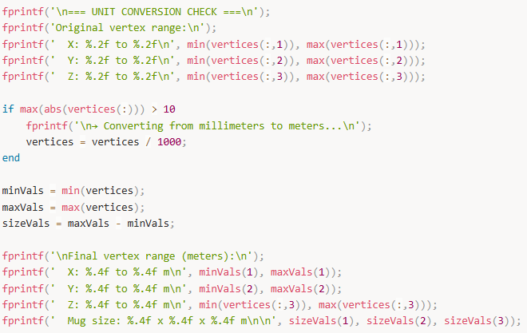

Section 2: Z-Plane Intersects Mug and Slices for Cross-Sectional Analysis
Now that we have our model converted to right units and scaled correctly, we can start developing a method to “slice” through the mug to create a cross-sectional view of the mug necessary for analysis for our challenge. To do this, we can initiate a plane to “slice” an object and can repeat this process multiple times later in another section, as we must start with one slice to get it going.
We need to pick a slicing direction using a plane from the xyz plane. We usually slice horizontally along the z plane (like cutting a cake layer by layer horizontally). To do this we save two variables z_min and z_max as containers for the values that are your slicing range. These values are directly the maximum and minimum height coordinates of the mesh polygon model. This will aid at which height your slicing plane should be located with prepared constraints.
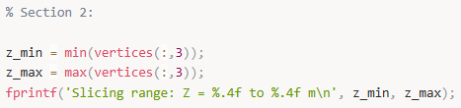
Above finds the vertical range (perpendicular to the slicing z-plane utilizing) of the 3D mesh and displays it. Z_min contains the lowest point of the mesh in the vertical (z) direction. Verticies(:,3) selects all rows (:) from col 3 (the z-coordinates) and through min(…) finds the smallest value among all z-coordinates. This is then stores the minimum z-coordinate in z_min.
Z_max contains the highest point of the mesh in the vertical (z) direction with the same code under the same col 3 for z-coordinates but finds the maximum among all z-coordinates.
Output results can display: “Slicing range: Z = 0.0000 to 15.2500 m”
This is essential information before proceeding with analysis, slicing or applying boundary conditions, as you are understanding your model’s vertical extent.
Here z0 represents the slicing mug’s height at which the plane is located on the z-axis. Note that the plane is offset from the z_min plane (openly optional to choose z_max but better to start at the base going up) which contains the coordinates through a matrix by adding 0.02 m or 2 cm above the base. This will automatically adjust to your mesh polygon model.
Now that we have a defined slice within the constraints of the mesh polygon model, we shall implement a single slice. The thought process is this: we want to “slice” a 3D shape (made of triangles) with a flat plane (say, z=z0). That slide is not a solid – it is a curve (a loop of line segments) that shows where the plane cuts through the shape. So to get that slice, we need to 1) Look at every triangle in the mesh; 2) Ask: does this triangle get cut by the plane?; 3) If Yes: find the exact 2D line segment where the plane intersects that triangle; 4) Collect all those little line segments and together they form the outline of the mug at that height.
This code below slices a 3D mesh with a horizontal plane to extract the 2D cross-section at a specific height.
Our setup includes the height of the slicing place (z0) and an empty array that will store all the line segments that form the cross-section (segments).
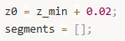
Then there is a main loop where it processes each triangle.
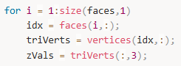
It loops through every triangle in the mesh (for i in …). It gets the 3 vertex indices for triangle I (). It looks up the actual coordinates of those 3 vertices (). It extracts just the z-coordinates (heights) of the 3 vertices().
Example:
The code then questions and responds accordingly to does this triangle intersect the plane. There are three conditions it needs to meet if the triangle chosen intersects the plane.
- At least one vertex is at or above the plane
- At least one vertex is at or below the plane
- Not all vertices are exactly on the plane (avoids degenerate cases)
If these conditions are met, then we find the intersection points with edges. (Pts stores points where edges cross the plane.)
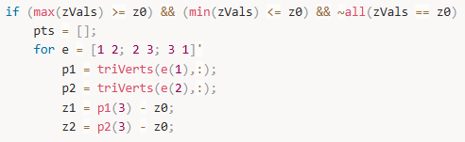

Section 3: Assemble and Visualize the Slice Contour
Currently, the segments array is a pile of disconnected line segments. In order to connect them and make it an actual slice that works, we need to 1) Organize and connect slice into a continuous loop; 2) Visualize; 3) Interpret.
- Organize and connect the slice into a continuous loop
We need to connect intersection points so that they form a closed contour representing the cross-section outline of the mug at height z0. We currently have segments, which is a list of small line segments, each represented by two 3D points where a triangle intersects the slicing plane. Right now, these are disconnected pieces – like having puzzle pieces scattered on a table. We want to assemble them into a continuous loop (or multiple loops, if the mug has holes or handles) representing the complete cross-section.
In practice, each line segment has two endpoints. We need to "stitch" them together by matching endpoints that are very close (within a tolerance). The algorithm works like connecting dots: find two endpoints that are nearly identical, connect them, and continue building the loop until it closes back on itself.
First, we set a tolerance for matching endpoints:
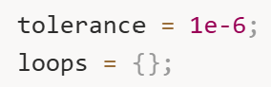
The tolerance of 1e-6 (0.000001 meters, or 1 micrometer) accounts for floating-point arithmetic imprecision. Due to numerical rounding in our geometric calculations, two points that should theoretically be identical might differ by tiny amounts. The tolerance says: "If two points are within 1 micrometer of each other, consider them the same point."
loops = {} initializes an empty cell array to store completed loops. We use a cell array because we might find multiple separate loops (for example, if slicing through both the mug body and a handle opening).
Now we begin the stitching process:
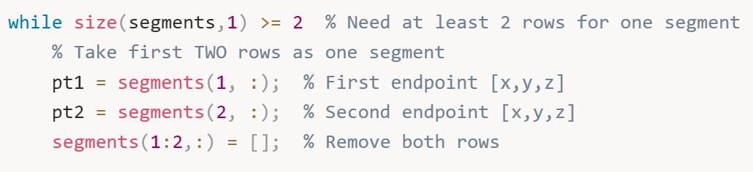
The outer while loop continues as long as we have at least two rows of segments remaining (remember, each segment is stored as two consecutive rows – one for each endpoint). We grab the first segment by taking its two endpoints (pt1 and pt2), then immediately remove these two rows from the segments array. This prevents us from using the same segment twice.
We start building a loop with this first segment:
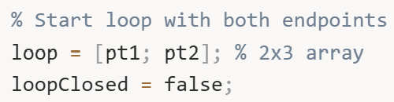
loop is initialized with both endpoints of the first segment, creating a 2×3 matrix (two points, each with x, y, z coordinates). loopClosed is a flag that tracks whether we've successfully closed this loop – it starts as false and will become true when we can't find any more segments to connect.
Now we enter the inner loop that grows this loop by finding connecting segments:
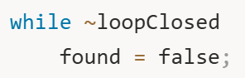
We’ll repeatedly search through remaining segments looking for ones that connect to either end of our current loop. found tracks whether we successfully added a segment in this iteration.
The search examines every remaining segment:
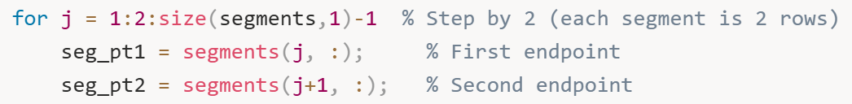
Note the loop increment 1:2:... – this steps by 2 because each segment occupies two consecutive rows. For each segment, we extract both endpoints.
Now we check if this segment connects to either end of our growing loop. There are four possible connection scenarios:
Scenario 1: Segment's first point matches loop's last point
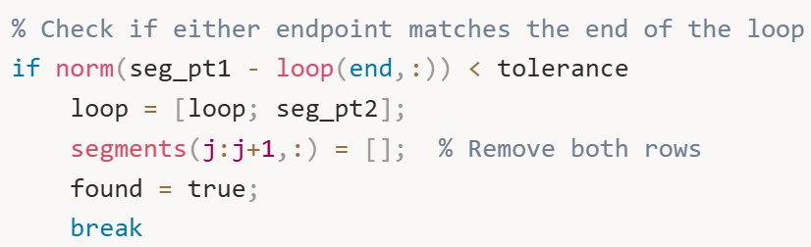
norm (seg_pt1 - loop(end,:)) computes the Euclidean distance between the segment's first endpoint and the loop's current end point. If this distance is less than our tolerance (essentially zero), they match. We extend the loop by appending the segment's second endpoint (loop = [loop; seg_pt2]), remove this segment from the pool (segments(j:j+1,:) = []), set found = true, and break out of the search loop to start looking for the next connection.
Scenario 2: Segment's second point matches loop's last point
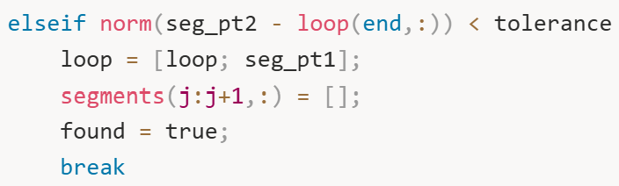
Similar to scenario 1, but the segment is "flipped" – its second endpoint matches our loop's end, so we add its first endpoint to continue the loop.
Scenario 3: Segment's first point matches loop's first point
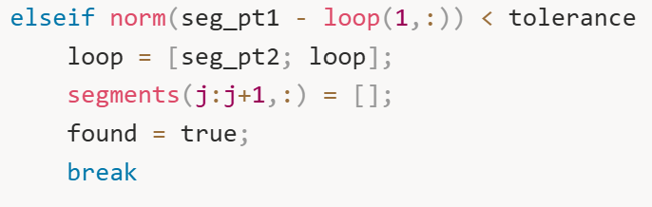
Here the segment connects to the beginning of our loop (rather than the end). We prepend the segment's second endpoint to the front of the loop (loop = [seg_pt2; loop]). This grows the loop backward from its start.
Scenario 4: Segment's second point matches loop's first point
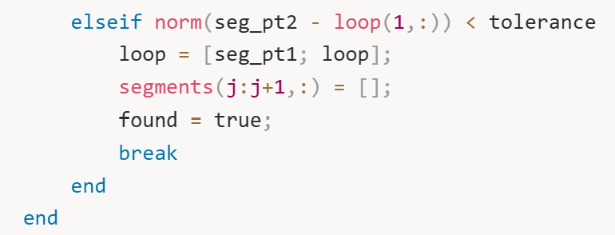
The segment's second endpoint matches the loop's start, so we prepend the first endpoint.
After checking all segments, we evaluate whether we found a connection:
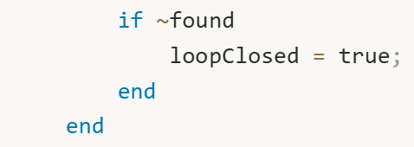
If we couldn't find any segment that connects to either end of the loop, then found remains false. This means the loop is as complete as it's going to get – either it's properly closed (the start and end points are near each other), or we've run out of segments. Either way, we set loopClosed = true to exit the inner loop.
Finally, we store this completed loop:
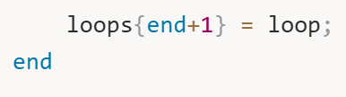
loops {end+1} = loop appends the finished loop to our cell array. We then return to the outer while loop, which will grab another segment (if any remain) and start building the next loop.
This algorithm continues until all segments have been consumed and organized into one or more closed loops. For a simple mug without a handle, you'll typically get one loop. For a mug with a handle, you might get two loops (the outer body contour and the inner handle opening) at certain heights.

- Visualization
Now that we have organized loops, we need to visualize them to verify our algorithm worked correctly:
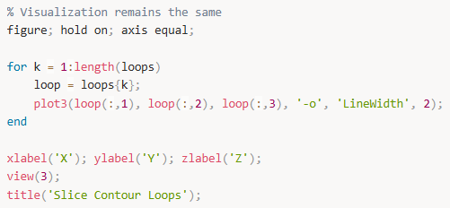
Let’s break down what each line does:
figure; creates a new figure window in MATLAB – this opens a separate tab where our visualization will appear.
hold on; tells MATLAB to keep adding to this plot without erasing previous elements. Without this, each plot3 call would overwrite the previous one.
axis equal; ensures the X, Y, and Z axes use the same scale. This is crucial for geometric accuracy – without it, a circular cross-section might appear elliptical if the axes had different scales.
For each loop, we extract it from the cell array and plot it in 3D. plot3(loop(:,1), loop(:,2), loop(:,3), ...) plots the x-coordinates (first column), y-coordinates (second column), and z-coordinates (third column) of all points in the loop. The '-o' format string means: draw lines (-) connecting the points, and place circles (o) at each point location. 'LineWidth', 2 makes the lines thicker and easier to see.
xlabel('X'); ylabel('Y'); zlabel('Z'); labels each axis so we know which direction is which.
view(3); sets the view to 3D perspective mode. This enables MATLAB's interactive 3D rotation – you can click and drag with your mouse to rotate the plot and examine the contour from any angle. This is incredibly useful for understanding the geometry.
title('Slice Contour Loops'); adds a descriptive title to the plot.
When you run this code, you'll see your cross-section contour floating in 3D space at the height where you sliced. For a mug at mid-height, you might see a circular or elliptical loop representing the mug's body, and possibly a smaller loop inside representing the handle opening.
- Interpret
Let's stop and see what we have created. We started with a complex 3D triangular mesh of a mug (potentially thousands of triangles). We defined a horizontal slicing plane at height z0. We systematically checked every single triangle to see if the plane intersected it. For each intersected triangle, we computed exactly where its edges crossed the plane, giving us small line segments. We then used a sophisticated stitching algorithm to connect these scattered segments into one or more continuous closed loops.
The result is elegant: we now have the exact 2D contour of the mug at height z0. This contour tells us precisely what shape you'd see if you cut the mug with a laser at that height and looked down at the cross-section. For a typical cylindrical mug, this might be a circle. For a mug with a handle at this height, it might be a circle with a smaller loop inside (the handle gap). For a tapered mug, the shape changes depending on the height – wider at the top, narrower at the bottom.
This single slice is valuable, but it only tells us about one height. To fully analyze the mug for grasping, we need cross-sections at many heights. That's exactly what we'll do in Section 4.

- Figure 1: Single Slice Contour
What it shows: A 3D visualization of one horizontal slice through the mug at height z0.
What you see: One or more closed loops (contours) floating in 3D space. Each loop is drawn with lines connecting points marked by circles.
What it means: This is the first successful cross-section of the mug. If you sliced the mug with a laser at height z0 and looked at the cut, this is exactly what you'd see. For a simple cylindrical mug, you'd see one roughly circular loop. For a mug with a handle at this height, you might see two loops – the outer mug body and the inner handle opening.
Why it matters: This proves the slicing algorithm works. You've successfully converted a 3D mesh problem into a 2D contour problem. It's like confirming "yes, we can scan this object layer by layer."

Section 4: Automating Slicing Across Multiple Heights.
We have sliced through the mug and developed a cross-sectional view of the mesh polygon model! Now we are able to loop the same slicing plane multiple times to created as many cross-sectional views as we would like to have. Instead of stating a number of planes we would like to cut through and dependent on this number adjust the heights to symmetrically produce the planes, we choose a slice height z0, redefining the original z0 slightly, and cut until the plane meets or exceeds the height max and mins z_max and z_min constraint values.
So here is the procedure: We choose a slicing resolution (e.g., every 0.5 cm or 1 cm along z) and for each slice height z0: 1) Run the intersection loop (Section 3’s triangle cutting code); 2) Stitch the line segments into loops; 3) store the loops in a structured way (e.g., all_loops{sliceIndex} = loops); 4) Visualize the stack of slices to see how the mug looks layer by layer (like a CT scan).
This gives you the 2D contour at every height, which you’ll then analyse to find where the mug’s geometry supports a power/enveloping grasp.
First, we define the range and resolution of our slicing:
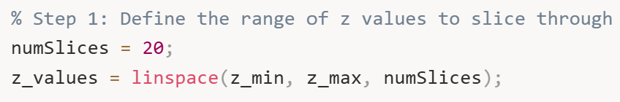
numSlices=20 determines how many horizontal planes we'll use to slice through the mug. More slices give finer vertical resolution but require more computation. Twenty slices is usually sufficient to capture the shape changes in most objects. For a very tall or geometrically complex object, you might increase this to 30 or 50.
z_values = linspace(z_min, z_max, numSlices) creates an array of 20 evenly-spaced heights spanning from the bottom of the mug (z_min) to the top (z_max). The linspace function (short for "linearly spaced") divides this range into equal intervals. For example, if the mug spans from 0 to 0.15 meters in height, z_values might be [0, 0.0079, 0.0158, 0.0237, ..., 0.15] – twenty heights evenly distributed.
We create a container to store all the slice data:
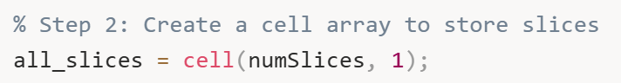
all_slices is a cell array with 20 cells (one for each slice). Each cell will store the line segments found at that height. We use a cell array because different slices might produce different numbers of segments.
Now we enter the main automation loop:
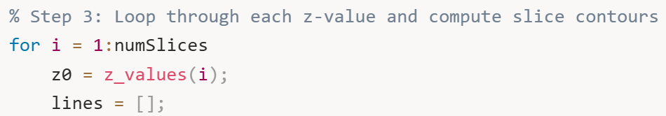
For each iteration, we set z0 to the current slicing height. lines = [] initializes an empty array to collect the intersection line segments for this particular slice.
Now we perform the triangle-plane intersection detection, which is identical to the logic from Section 2:
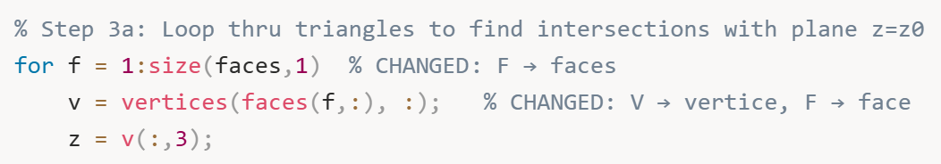
We loop through every triangle (face) in the mesh. For each triangle, we extract the coordinates of its three vertices and their z-values.
We check if this triangle intersects the current slicing plane:
This condition asks: "Does this triangle span across the plane?" It's true if at least one vertex is at or below z0 AND at least one vertex is at or above z0, AND the triangle isn't completely flat on the plane (which would be a degenerate case). If all three conditions are met, the plane must cut through this triangle.
For intersecting triangles, we find the exact intersection points:
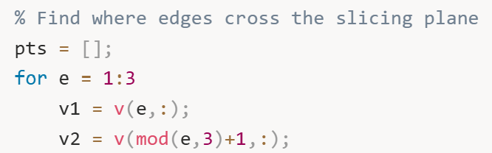
We check each of the triangle's three edges. v1 is the current vertex, and v2 is the next vertex. The mod(e,3)+1 expression cleverly wraps around: edge 1 connects vertices 1→2, edge 2 connects vertices 2→3, and edge 3 connects vertices 3→1, completing the triangle.
For each edge, we check if it crosses the plane:
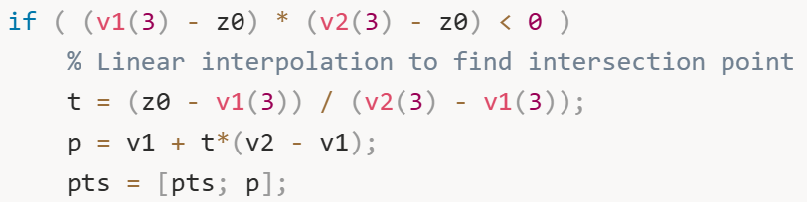
The condition (v1(3) - z0) * (v2(3) - z0) < 0 is elegant: it multiplies the signed distances from each vertex to the plane. If one vertex is above the plane (positive distance) and the other is below (negative distance), this product is negative, indicating the edge crosses the plane.
When an edge crosses, we use linear interpolation to find the exact intersection point. The parameter t = (z0 - v1(3)) / (v2(3) - v1(3)) tells us what fraction of the way along the edge the intersection occurs. For example, if t = 0.25, the intersection is 25% of the way from v1 to v2. We compute the actual intersection point coordinates using p = v1 + t*(v2 - v1), which is the vector equation of the line segment.
We also handle the special case where a vertex lies exactly on the plane:
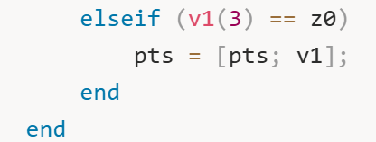
If a vertex has exactly z = z0, it lies on the plane, so we include it as an intersection point.
After checking all three edges, we should have found exactly two intersection points (for a plane cutting through a triangle). We store them:
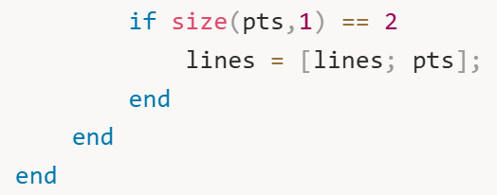
Both points are appended to the lines array. Note that we store them as consecutive rows in a single matrix, which is slightly different from the segments approach in Section 3, but the data structure is equivalent.
After processing all triangles at this height, we store the raw intersection segments:
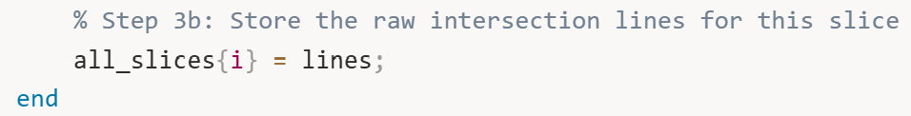
Cell i of all_slices now contains all the line segments for the slice at height z_values(i).
After the loop completes, all_slices contains the complete raw geometric data for all 20 slices – we've effectively created a complete vertical scan of the mug.
Now we visualize all slices together to see the layered structure:
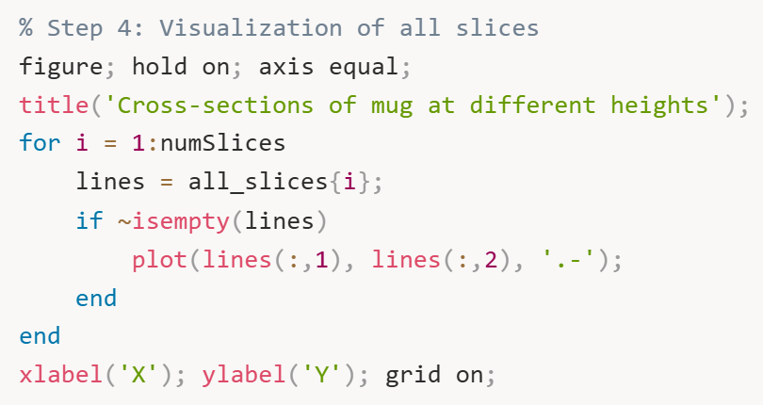
figure; hold on; axis equal; creates a new figure with equal axis scaling and enables adding multiple plots.
The loop iterates through each slice and plots its line segments. For each slice, we extract its line segments and check if it's non-empty (some slices might be empty if the plane missed the object). We plot the X and Y coordinates using plot(lines(:,1), lines(:,2), '.-'). Note that this is a 2D plot (plot, not plot3) – we're only looking at the XY projection, viewing all slices from directly above. The '.-' format draws both lines and dots, making it easy to see the individual segments.
xlabel('X'); ylabel('Y'); grid on; adds labels and a grid for easier interpretation.
When you run this visualization, you'll see a nested series of contours representing the mug's shape at different heights. For a typical cylindrical mug, you might see concentric circles (or near-circles) of slightly different sizes. For a tapered mug, you'll see the circles gradually getting larger or smaller. If the mug has a handle, at certain heights you'll see additional interior contours representing the handle opening.
This multi-slice visualization is extremely informative. It's like looking at a topographic map – you can immediately see where the object widens, narrows, or has complex features. This is exactly the data we need for grasp analysis: by examining how the cross-sectional shape changes with height, we can identify regions where the diameter is suitable for grasping and where there's enough vertical continuity to fit a physical finger.
At this point, we have successfully automated the slicing process across multiple heights, transforming our 3D mesh into a structured set of 2D cross-sections. This "CT scan" of the mug is ready for the detailed geometric analysis that follows in subsequent sections, where we'll compute diameters, check for handles and gaps, and ultimately determine where a robotic hand can successfully grasp the object.

- Figure 2: All Cross-Sections Stacked (2D View from Above)
What it shows: Multiple horizontal slices plotted together in 2D, viewing from directly above (looking down the Z-axis).
What you see: A bunch of nested contours, like looking at a topographic map or tree rings. Each contour is a different slice at a different height, all projected onto the XY plane.
What it means: This is the "CT scan" view from above. You're seeing how the mug's shape changes from bottom to top. If the mug is cylindrical, you see concentric circles of similar size. If it's tapered (wider at top), the circles get progressively larger. If there's a handle, at certain heights you'll see additional interior contours.
Why it matters: This lets you quickly assess whether your slicing resolution is adequate (smooth progression of shapes) and identify interesting geometric features (sudden changes in diameter, handles appearing/disappearing at certain heights).

Section 5: Analyse Slice Geometry for Grasping
Now that we have a stack of slices from Section 4, we can start "hyperanalyzing" them to determine if the mesh polygon model is capable of being held in a power/enveloping grasp. The raw contour data we've collected is just geometric information – we need to transform it into actionable decisions about where a robotic hand can grasp. The fundamental questions we need to answer for each slice are:
Width measurement: How wide is the mug at this height? Can a robotic finger wrap around it?
Consistency check: Is there enough vertical continuity (several consecutive slices with similar width) to ensure the hand can enclose the mug properly?
Candidate grasp zones: Which z-ranges have geometry that's narrow enough for the robotic hand but also wide enough to be stably gripped?
A robotic power grasp requires not just width compatibility but also sufficient vertical continuity. Even if one slice is perfect for grasping, if the slices immediately above and below are too wide or too narrow, a physical finger can't actually be placed there. The hand needs multiple consecutive compatible slices to accommodate the finger's thickness along the z-axis.First, we define the parameters that describe our robotic hand's physical limitations:
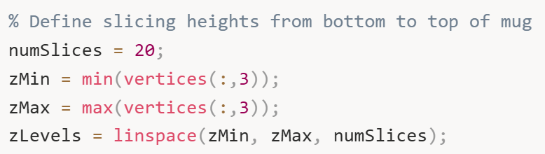
These lines define how many horizontal slicing planes we'll use and where they're positioned. The linspace function creates evenly spaced heights from the bottom to the top of the mug.
We then create a container to store all the loops (contours) for every slice:
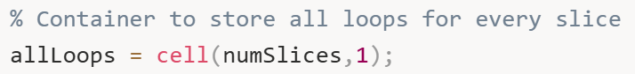
A cell array is perfect here because each slice might produce a different number of loops (contours), and each loop might have a different number of points.
Now we loop through each z-level and compute the cross-section loops. The process for each slice is identical to what we did in Sections 2 and 3, but now it's automated across all heights:
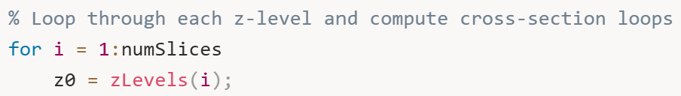
For each height, we initialize an empty array to collect triangle-plane intersection segments:
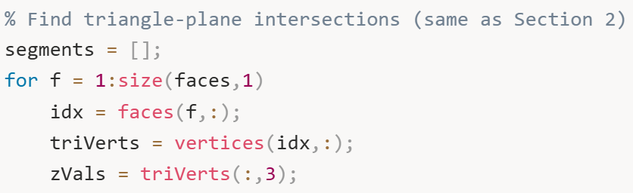
This inner loop checks each triangle in the mesh to see if it intersects the current slicing plane at height z0. The logic is the same as before:
If the triangle's vertices span across the plane (some above, some below, and not all exactly on the plane), we find where its edges intersect the plane:
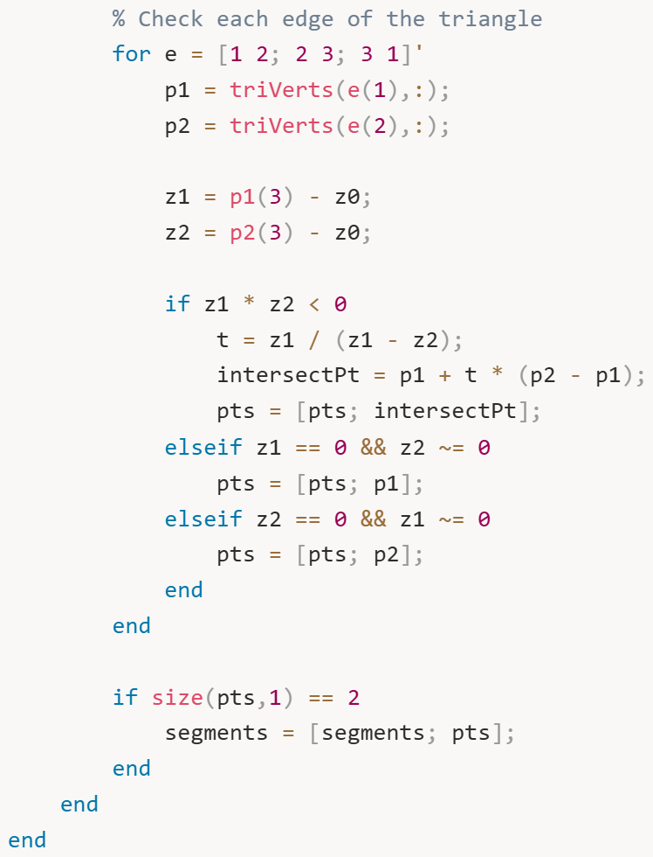
After collecting all intersection segments for this slice, we need to stitch them into continuous loops. This uses the same tolerance-based matching algorithm from Section 3:
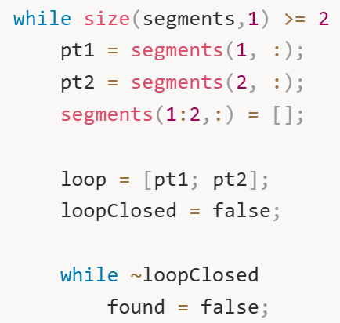
We start with one segment (two points) and build a loop by finding other segments whose endpoints match (within tolerance). The matching process checks all four possible connections between segments:
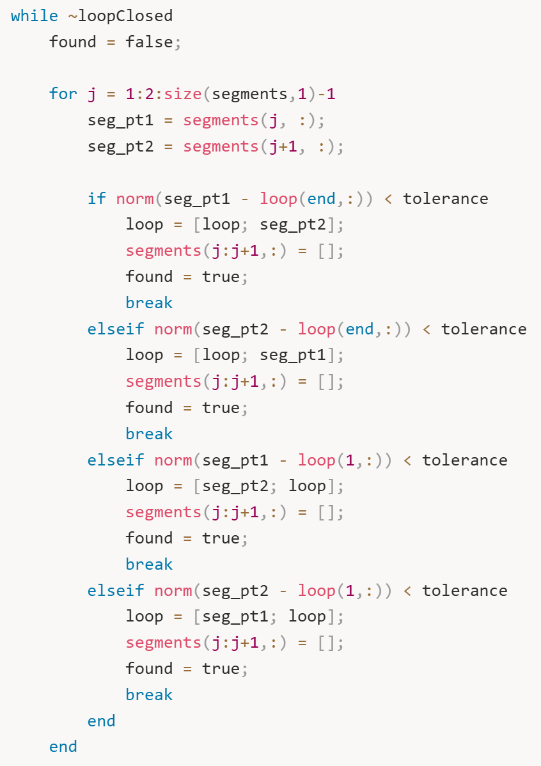
Each iteration of this loop tries to extend the current loop by finding a segment that connects to either end. When no more segments can be added, the loop is closed.
After processing all segments at this height, we store the resulting loops:
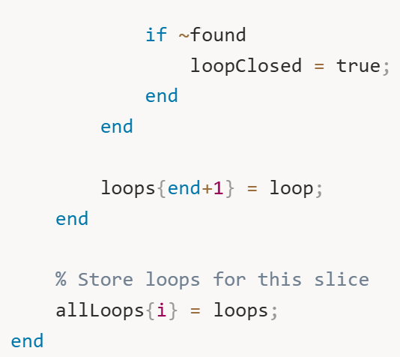
By the end of the main loop, allLoops is a complete database of cross-sections at every height we specified.
Now we visualize the stacked slices to see the overall shape of the mug:
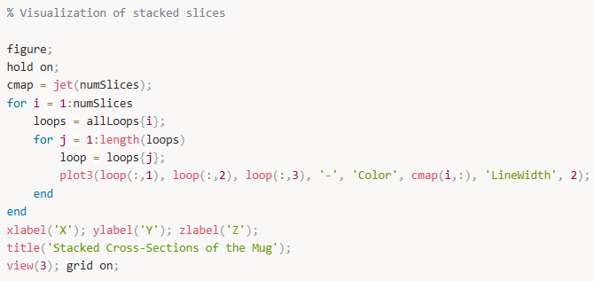
This creates a beautiful 3D visualization where each slice is drawn in a different color. The jet colormap transitions from blue (bottom) to red (top), making it easy to see how the mug's shape changes with height. When you rotate this plot using MATLAB's 3D view controls, you can clearly see the mug's profile – perhaps narrow at the base, wider in the middle, and narrowing again at the rim.
At this stage, we have successfully created a complete layered representation of the mug, like a CT scan. Each slice is a closed contour (or multiple contours if there are holes or handles) that represents the mug's shape at that specific height. We can now proceed to analyze these slices quantitatively to determine where grasping is feasible.

- Figure 3: Stacked Cross-Sections (3D Colored View)
What it shows: All 20 slices plotted in 3D space, each in a different color using the jet colormap (blue at bottom → red at top).
What you see: A beautiful, layered representation of the mug in 3D. Each horizontal slice is a different color, creating a rainbow effect from bottom (blue) to top (red). You can rotate this plot with your mouse to see the mug from any angle.
What it means: This is the complete 3D reconstruction from slices. The color gradient helps you immediately understand which slices are at which heights. You can see how the mug's cross-section evolves vertically – where it widens, narrows, or has complex features like handles.
Why it matters: This visualization confirms the multi-height slicing automation worked correctly. It's also incredibly useful for debugging – if you see weird discontinuities or gaps, you know there's a mesh problem or slicing issue. For presentations, this is the "wow" visualization that shows you've fully characterized the 3D geometry.

Section 6: Multi-Height Slicing Automation
Now that we have successfully created a single slice and understood how to stitch segments into continuous loops, we need to automate this process across multiple heights to build a complete "CT scan" of the mug. The goal is to slice the mug at many different z-values and store all the resulting contours so we can analyze them together. The procedure is straightforward: define a range of slicing heights from the bottom to the top of the mug, then repeat the slicing and stitching process for each height. This gives us a stack of 2D cross-sections that, when viewed together, reveal the 3D structure of the mug. First, we define our slicing parameters:

Having established the procedure for analyzing stacked slices in Section 5, we now create a more streamlined and efficient version of the multi-height slicing automation. Think of this as building the final "production version" of our CT scanning algorithm – one that's clean, well-organized, and ready to feed into the grasp analysis pipeline.
The goal is simple: slice the mug at many heights, extract contours at each height, and store everything in a structured way that's easy to analyze. This section consolidates the slicing and stitching logic into one cohesive workflow.
First, we define the slicing parameters:
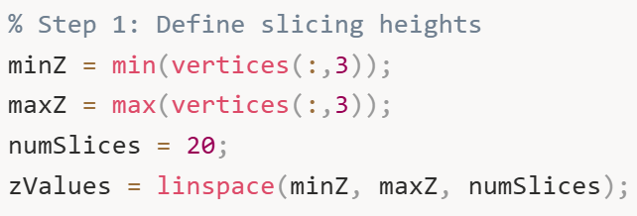
These parameters determine the vertical extent of our analysis. minZ and maxZ define the bottom and top of the mug, while numSlices determines the resolution of our scan. More slices give finer detail but require more computation.
We initialize storage for all the loop data:
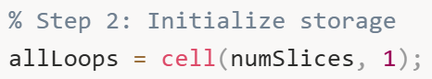
Inside this loop, we first find all triangle-plane intersections. This is the geometric intersection calculation we've used before, now applied systematically at each height: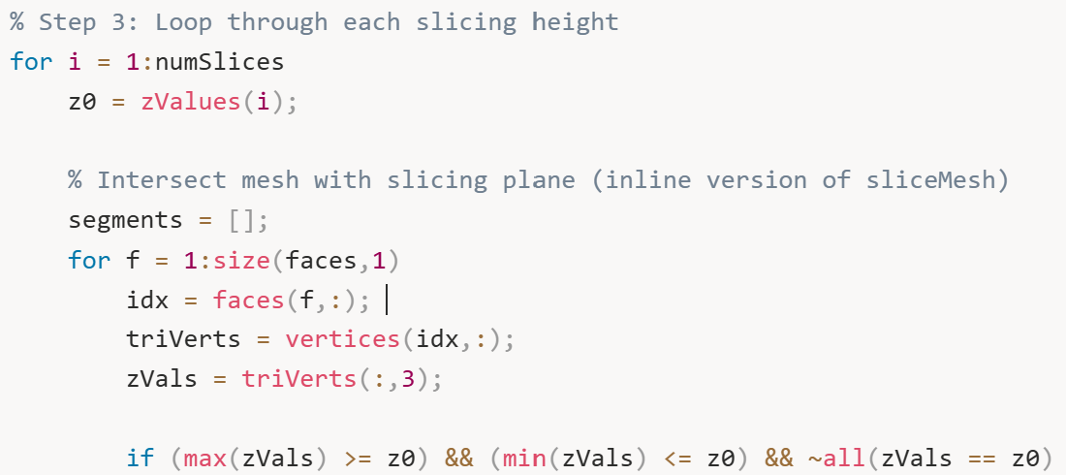
For each triangle that intersects the plane, we compute where its edges cross:
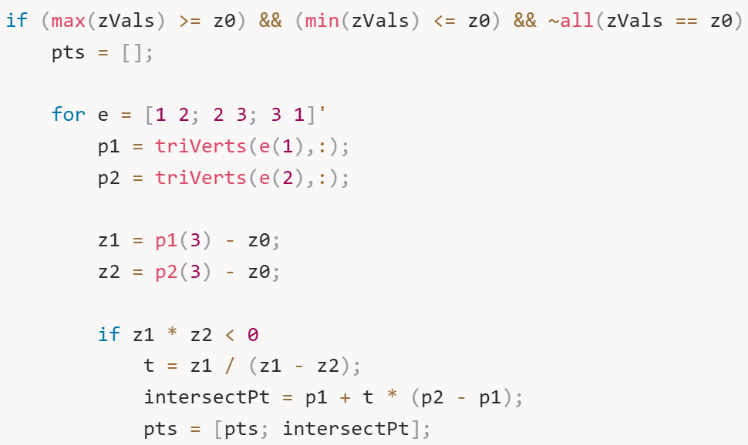
The mathematical formula t = z1 / (z1 - z2) computes the interpolation parameter. This tells us what fraction of the way along the edge the intersection occurs. For example, if t = 0.25, the intersection point is 25% of the way from p1 to p2.
We also handle special cases where a vertex lies exactly on the plane:
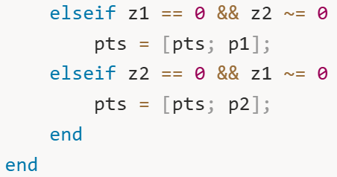
After finding the intersection points for each triangle, we store valid segments (pairs of points):
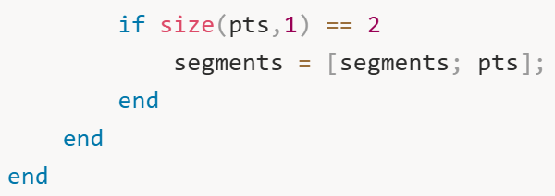
Once we have all segments for this slice, we stitch them into loops. This is the same topology-building algorithm we used earlier:
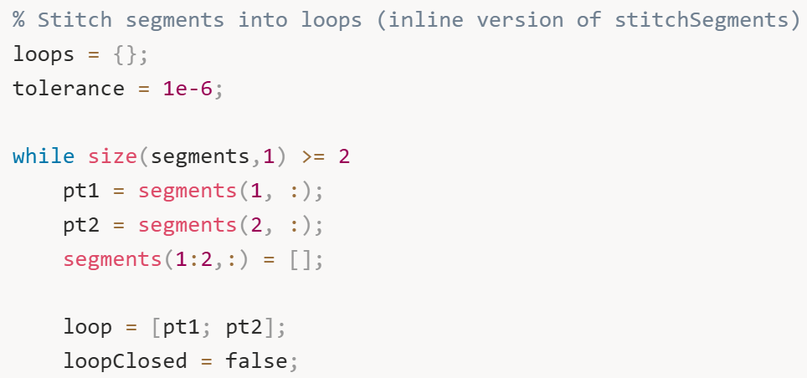
The stitching process finds connecting segments by checking if their endpoints are within tolerance of the current loop's endpoints:
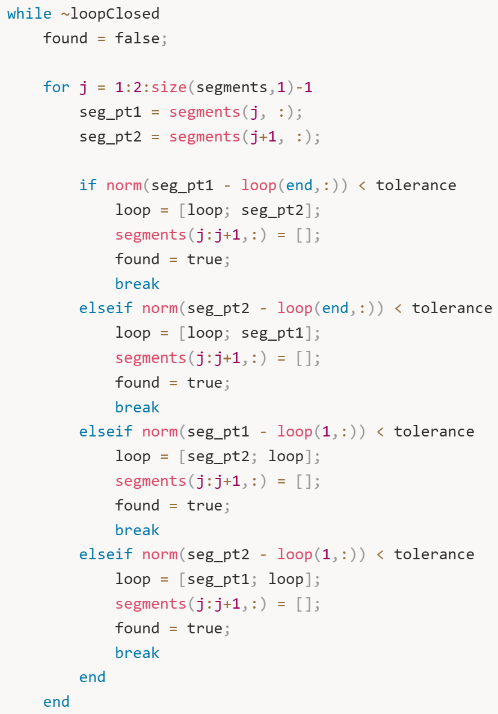
The algorithm checks four possible connection points: segment start to loop end, segment end to loop end, segment start to loop start, and segment end to loop start. When a match is found, we add the new point to the loop and remove the segment from the pool.
When no more segments can be connected, we've completed one closed loop. We repeat this process until all segments are consumed, potentially creating multiple loops if the object has holes or disconnected regions. Finally, we store all loops for this slice:
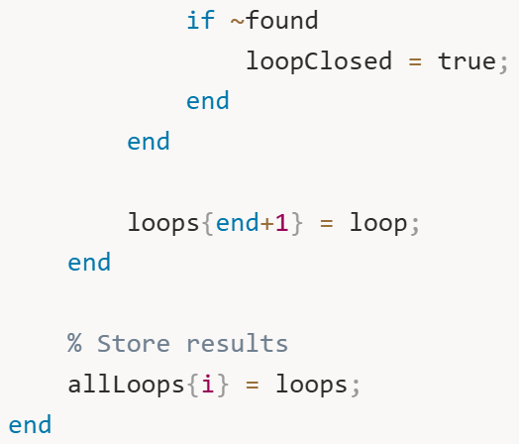
After processing all slices, we create a comprehensive visualization:
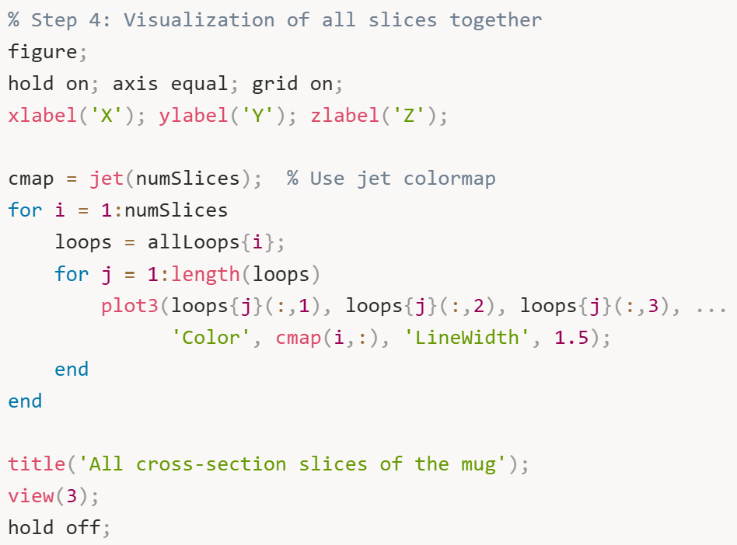
This creates a striking 3D visualization where the entire mug is represented by colored contour lines. The color gradient (blue to red, bottom to top) makes it easy to understand the mug's vertical structure. You can clearly see how the diameter changes with height – perhaps starting narrow at the base, expanding outward in the middle, and potentially narrowing again near the rim.
This visualization is more than just aesthetically pleasing – it's diagnostic. If you see unexpected gaps, discontinuities, or strange loops, it indicates potential issues with the mesh quality or slicing algorithm. A good mug should produce smooth, continuous contours that gradually transform from one height to the next.
At this point, we have a complete, structured dataset: allLoops contains every cross-sectional contour at every height. This is our "CT scan" of the mug. We're now ready to analyze this data quantitatively to determine where the robotic hand can grasp.
The key insight is that we've transformed a complex 3D mesh into a stack of 2D contours. This dimensionality reduction makes the grasp analysis problem much more tractable. Instead of reasoning about thousands of triangles in 3D space, we can analyze simple polygons in 2D at each height, then combine the results vertically to make 3D grasp decisions.

- Figure 4: All Cross-Sections in 3D (Jet Colormap)
What it shows: Similar to Figure 3 – all slices in 3D with jet colormap.
What you see: Same rainbow-colored layered view of the mug.
What it means: This is actually a repeat of Figure 3 from the code structure. Section 5 and Section 6 both generate the same type of visualization because they're both doing the multi-height slicing. They're the same visualization produced at different stages.
Why it matters: It confirms the slicing automation is consistent.

Section 7: Turning the Raw Slices into Something Meaningful
Having generated a complete stack of cross-sectional slices in Section 6, we now need to extract quantitative, actionable information from them. The raw loops are just collections of (x, y, z) coordinates – we need to convert these geometric data into measurements that can be compared against the robotic hand's physical capabilities.
The fundamental question we're asking at each height is: "Can a robotic finger physically wrap around the mug at this level?" This requires knowing two things: the mug's width/diameter at that height, and whether that dimension falls within the gripper's operational range.
First, we define the physical constraints of our robotic hand:
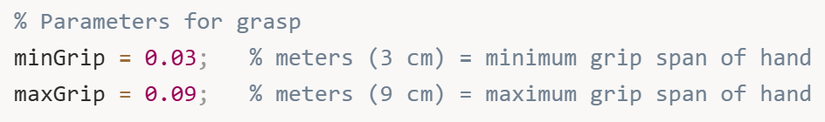
These parameters represent the fundamental limitations of the gripper. If an object is thinner than 3 cm, the finger joints can't close properly and the grasp will be unstable. If it's thicker than 9 cm, the fingers physically cannot open wide enough to wrap around it. These values would come from the actual specifications of your robotic hand.
We initialize storage arrays for our analysis results:
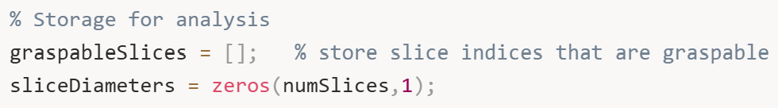
graspableSlices will accumulate the indices of slices that pass our graspability test – essentially a list of heights where grasping is geometrically feasible. sliceDiameters will store the computed diameter at each height, giving us a complete profile of how the mug's width changes vertically.
Now we loop through each slice and analyze its geometry:
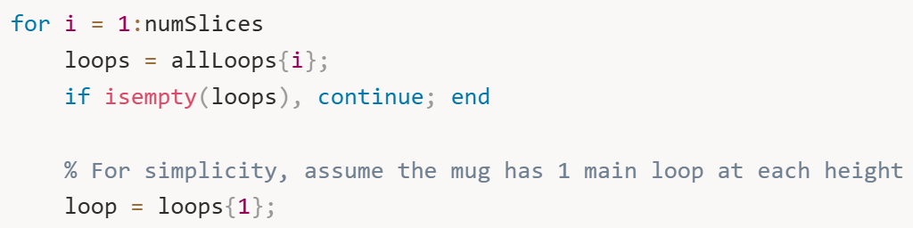
For this initial analysis, we make a simplifying assumption: each slice has one primary contour representing the outer surface of the mug. In reality, objects with handles or internal cavities might have multiple loops per slice, but we'll handle that complexity in later sections. For now, we focus on the first (typically largest) loop.
To estimate the diameter of this contour, we compute its axis-aligned bounding box in the XY plane:
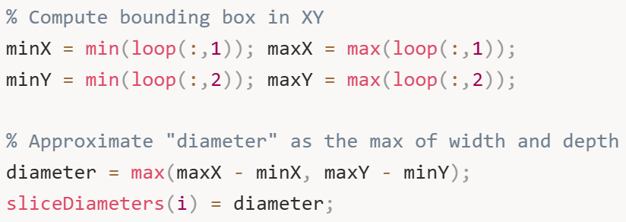
This approach finds the smallest rectangle that completely contains the contour, then takes the larger dimension (width or depth) as the representative diameter. Why take the maximum? Because for a finger to successfully wrap around the object, it needs to accommodate the widest dimension. If the mug is 5 cm wide but 8 cm deep, the finger needs to span at least 8 cm.
This bounding-box approach is computationally efficient and works well for roughly circular or elliptical cross-sections. For highly irregular shapes (like a star or rectangle), it provides a conservative estimate – it might overestimate the required grip span, but it won't underestimate it, which is safer for grasp planning.
Next, we check if this diameter falls within the gripper's operational range:
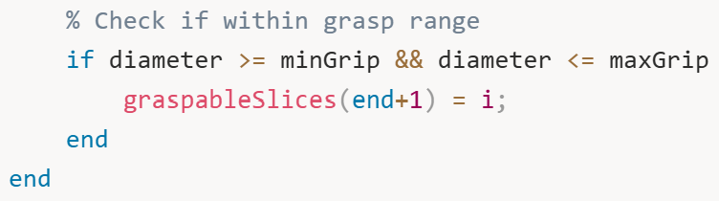
If the diameter satisfies both constraints (not too small, not too large), we mark this slice as graspable by adding its index to our list. This creates a simple binary classification: at each height, grasping is either feasible or not.
After analyzing all slices, we create a visualization that tells the complete story:
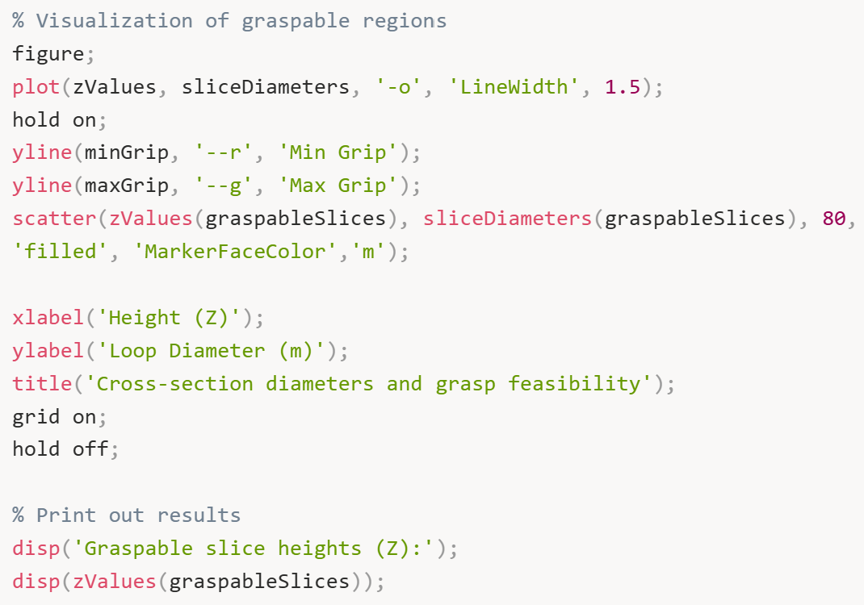
This plot is extremely informative and deserves careful examination. The blue line with circles shows how the mug's diameter changes as you move from bottom to top. For a typical mug, you might see it start narrow at the base (maybe 4 cm), expand outward toward the middle (perhaps 8 cm), and then either maintain that width or taper slightly at the rim.
The horizontal red dashed line marks the minimum graspable diameter (3 cm). Any part of the blue curve below this line is too thin to grasp – the fingers would close completely without properly enveloping the object.
The horizontal green dashed line marks the maximum graspable diameter (9 cm). Any part of the blue curve above this line is too thick – the fingers physically cannot open wide enough.
The magenta dots are the key insight: they highlight exactly where grasping is feasible. These are the heights where the diameter falls in the "Goldilocks zone" – not too small, not too large, just right.
Finally, we print out the specific heights where grasping is possible.
This tells you: "The mug can be grasped at heights between approximately 5.3 cm and 8.4 cm above the base."
However, we're not finished yet. This analysis has several limitations we need to address:
Single polygon assumption: We assumed each slice has only one contour. What if the mug has a handle that creates a second polygon (the gap between handle and body)? We need to check if a finger can fit through that gap.
No 3D consideration: Just because five individual slices are graspable doesn't mean you can actually place a finger there. Real fingers have thickness in the Z-direction. If those five graspable slices are spread across 10 cm of height with non-graspable slices between them, you can't fit a 2 cm thick finger anywhere.
Crude diameter estimate: The bounding box is a rough approximation. For irregular shapes, we should compute a more robust diameter using both area and perimeter.
These limitations are exactly what we'll address in Sections 8 and 9. For now, we've successfully converted raw geometric data into a meaningful grasp feasibility profile, and we've created clear visualizations that help us understand where grasping might be possible.

- Figure 5: Diameter Profile with Graspable Regions
What it shows: A 2D plot with height (Z) on the x-axis and diameter on the y-axis, showing how wide the mug is at each height.
What you see:
- Blue curve with circles: The mug's diameter at each slice height
- Red dashed line: Minimum graspable diameter (3 cm in original, 5 mm in your adjusted version)
- Green dashed line: Maximum graspable diameter (9 cm in original, 15 mm in your adjusted version)
- Magenta dots: Individual slices that passed the diameter check
- No blue shaded regions yet (those come in Section 8/9)
What it means: This is the first grasp feasibility analysis. You can immediately see where the mug's diameter falls within the graspable range (between the red and green lines). The magenta dots highlight "sweet spots" where diameter is just right.
Why it matters: This is a critical diagnostic plot. If all the points are above the green line, the mug is too big everywhere. If they're all below the red line, it's too small everywhere. This plot tells you at a glance whether grasping is even geometrically possible before you worry about 3D accumulation.

Section 8: Power -grasp region detection
We have got detailed 2D geometric feasibility data for every single slice from the analysis we just did. Each horizontal slice has been classified as either graspable or not, and we have solid geometric reasoning behind each decision – we've checked polygon shapes, computed diameters, measured gaps between features like handles. But here's the thing – we're still missing a critical piece of the puzzle, and that's the vertical dimension.
Just because we identified, say, ten individual graspable slices doesn't automatically mean we can physically place a robotic finger at those locations. A real finger isn't some abstract mathematical concept – it occupies actual 3D space. It has thickness in the Z direction, meaning it needs a certain amount of vertical room. If those ten graspable slices are scattered across 20 centimeters of height with non-graspable slices randomly mixed in between them, we can't fit a 2 centimeter thick finger anywhere. There's no continuous space for it.
That's what this section tackles. We're doing what I call 3D accumulation – identifying consecutive runs of graspable slices and checking if each run spans enough vertical height to accommodate at least one physical finger. This is where we transform our abstract per-slice analysis into concrete, executable grasp regions where a robotic hand can actually be placed in the real world.
The conceptual model is pretty straightforward. Imagine you're painting individual bricks, and you mark each one as either "good" in green or "bad" in red. Now you need to find continuous sequences of green bricks that are at least N bricks tall, where N depends on how thick your finger is relative to each brick's height. A sequence of just two green bricks isn't useful if you need at least three bricks minimum to fit one finger.
First thing we need to do is define what kind of robotic hand we're working with. These parameters are super important because they completely determine what counts as "graspable":
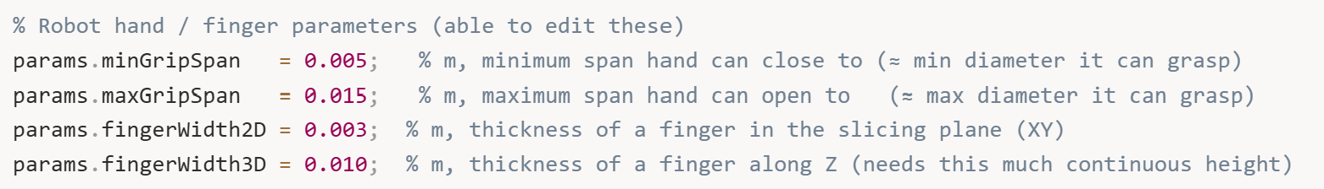
So what do these numbers mean? minGripSpan (5 mm) is the smallest diameter the hand can close around – if something is thinner than this, the fingers will close completely without making proper contact. maxGripSpan (15 mm) is the largest diameter the hand can open to – if something is thicker than this, the fingers physically can't open wide enough to wrap around it.
The two "width" parameters are new additions that we didn't worry about in Section 7. fingerWidth2D (3 mm) is how thick the finger is when you look at it from above in the XY plane. This matters when we're checking if a finger can fit through a gap, like the space between a mug body and its handle. And fingerWidth3D (10 mm) is how tall the finger is in the Z direction – this becomes crucial when we're figuring out how many consecutive slices we need to fit one physical finger.
Next, we make sure we have the slicing heights from previous work:
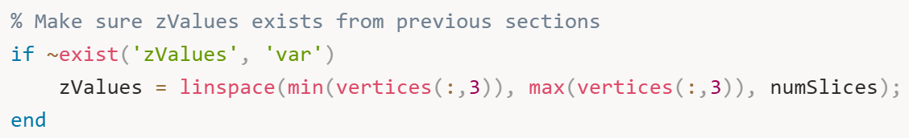
This is just a safety check. If for some reason zValues doesn't exist – maybe we're running this section independently for testing – we create it. Good defensive programming.
Now we compute the vertical spacing between slices:
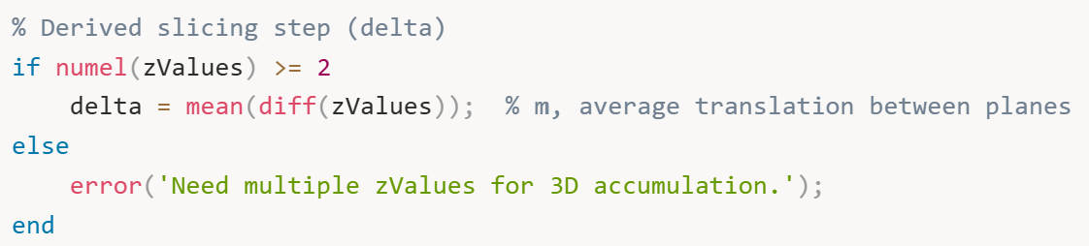
delta tells us how much vertical space each slice represents. If we have 20 slices spanning 0.124 meters total, then delta is about 0.0066 meters or 6.6 millimeters per slice. This number becomes super important later when we're checking if we have enough continuous height to fit a finger.
We initialize some arrays to track what we learn about each slice:
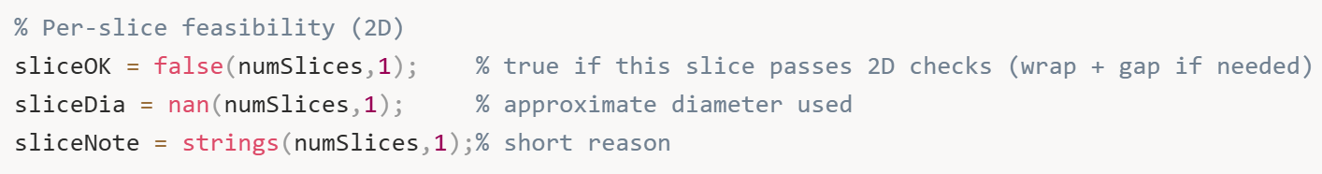
sliceOK is a simple true/false for each slice - did it pass our checks? sliceDia stores the approximate diameter we calculate. And sliceNote keeps a human-readable explanation of why each slice passed or failed, which is incredibly helpful for debugging later.
Now comes the main analysis loop where we examine each slice:
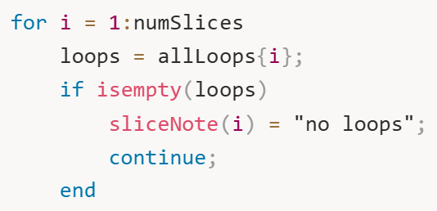
If a slice has no loops – maybe the plane missed the object or there's a mesh issue - we note it and move on.
For slices with actual geometry, we project the 3D loops onto the 2D XY plane:
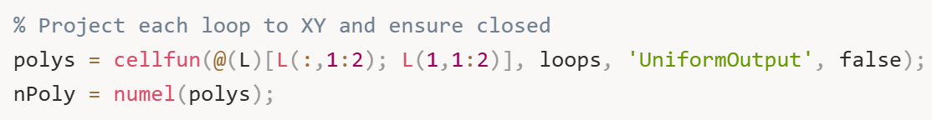
This takes each 3D loop, extracts just the X and Y coordinates, and closes the polygon by appending the first point to the end. We're doing 2D analysis at each height, so we don't need the Z coordinate anymore. The nPoly variable tells us how many separate polygons exist at this slice – one for a simple shape, two for something with a handle, or more for complex geometries.
Now here's where it gets interesting – we compute a robust diameter for each polygon using both its area and perimeter:
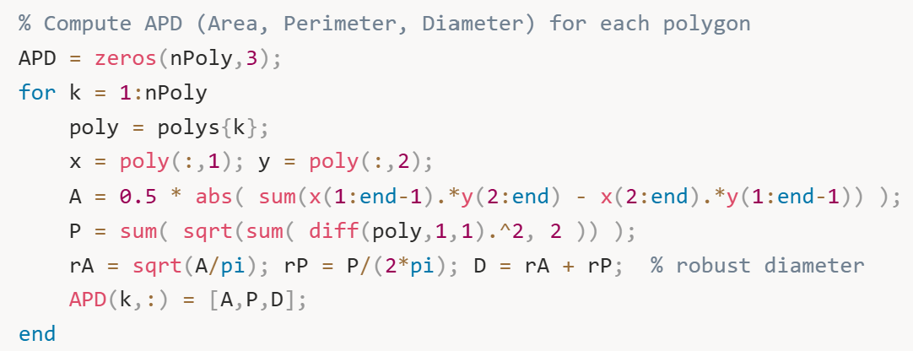
This code computes three things: Area, Perimeter, and Diameter (hence APD). The area calculation uses the Shoelace formula – that elegant cross-product sum that gives you the area of any simple polygon. The perimeter is just summing the lengths of all the edges.
But the diameter calculation is clever. For an irregular shape, there's no single "correct" diameter, right? So we estimate it two ways: rA = sqrt(A/pi) asks "if this were a circle with the same area, what would its radius be?" and rP = P/(2*pi) asks "if this were a circle with the same perimeter, what would its radius be?" We average these two approaches by adding them together to get a robust diameter estimate that balances both geometric properties.
Now we analyze feasibility based on how many polygons we found. The logic is completely different for one polygon versus two versus many:
Single polygon case:
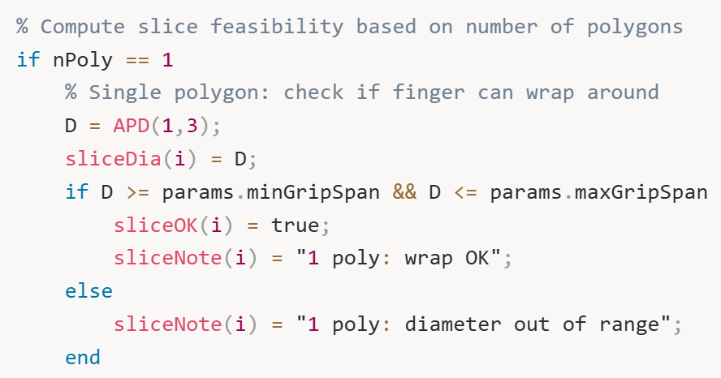
This is straightforward. One contour means simple geometry - just check if the diameter is within the grippable range (5 mm to 15 mm in our case).
Two polygon case:
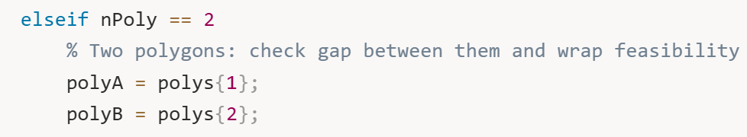
Two polygons usually means we're slicing through something with a handle. There's the outer mug body and the inner handle opening. We need to check if the gap between them is wide enough for a finger to pass through.
The gap calculation is geometrically non-trivial:
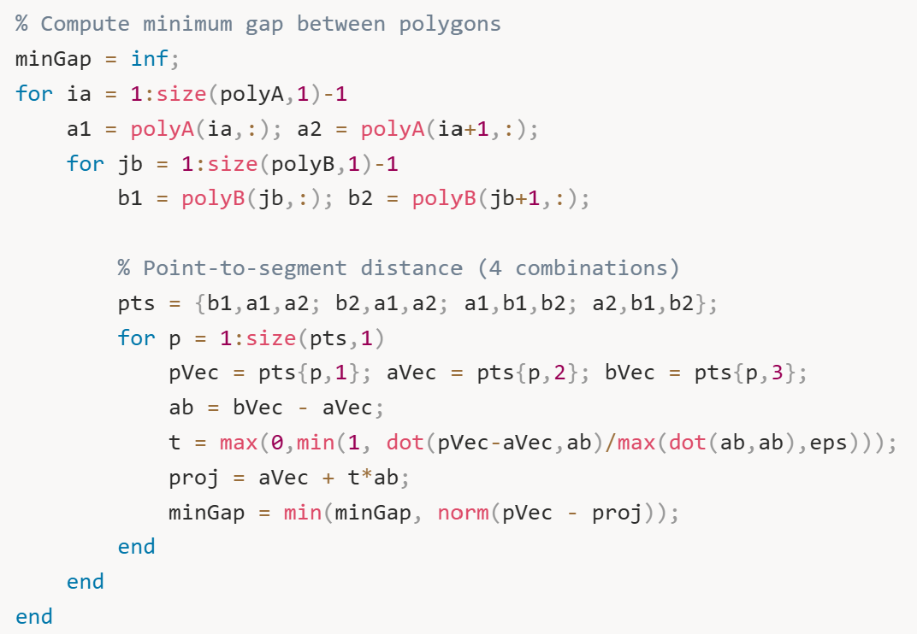
We’re checking every edge of polygon A against every edge of polygon B, computing point-to-segment distances for all combinations. The formula t = max(0,min(1, dot(...))) finds where along each segment the closest approach occurs. After checking all edge pairs, minGap contains the narrowest gap between the two shapes.
Then we make the decision:
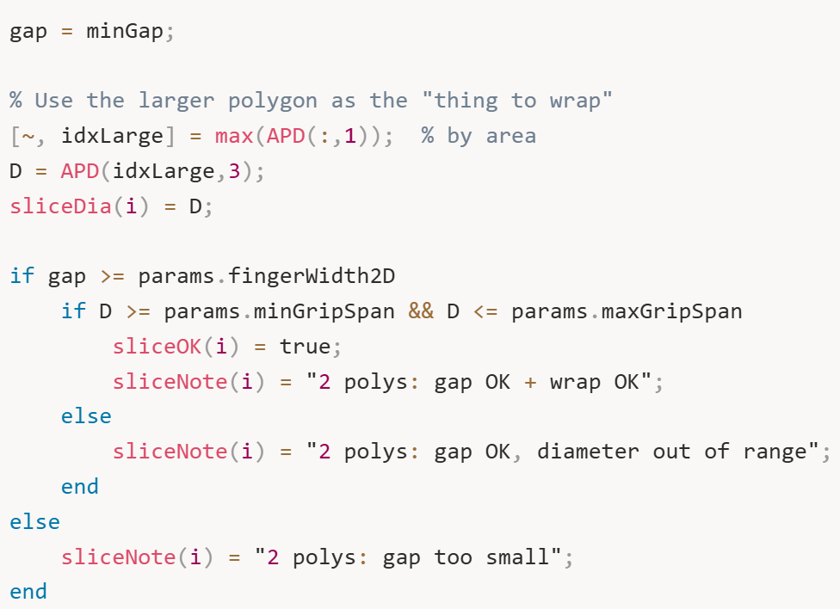
We focus on the larger polygon (by area) - that's the mug body we want to wrap around. We check two things: Is the gap at least as wide as the finger (3 mm)? And is the main polygon's diameter graspable (5-15 mm range)? Both must be true.
Three or more polygons case:
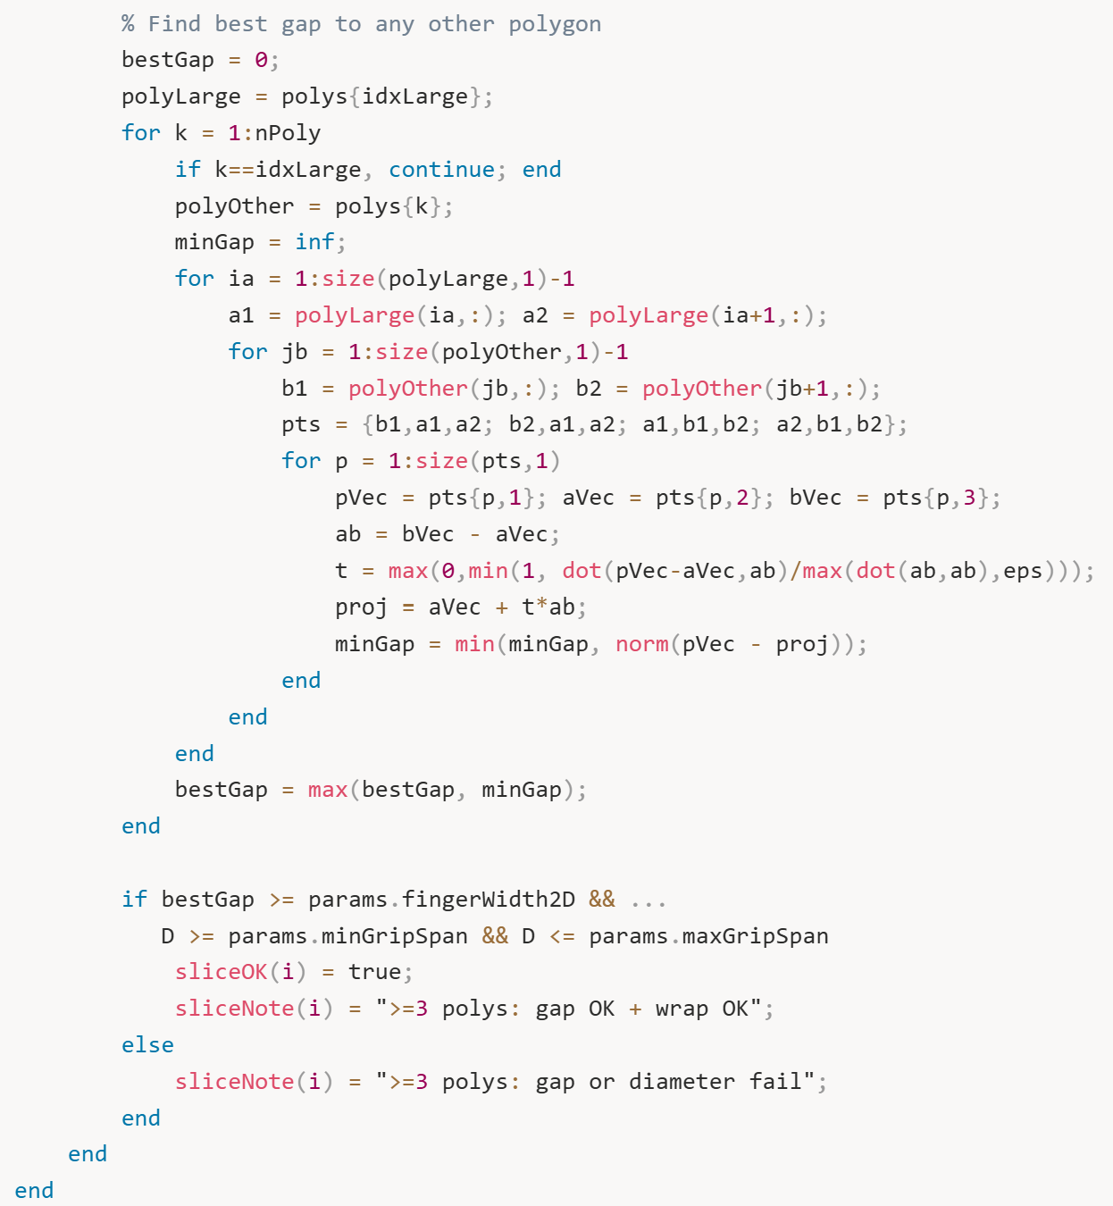

For complex geometries with multiple features, we identify the largest polygon and find the biggest gap between it and any other polygon. This represents the most accessible entry point for a finger. Same checks apply – gap must be wide enough, diameter must be graspable.
After this loop finishes, we have complete 2D feasibility data for every slice. But we're not done yet – we still need to do the 3D accumulation to find continuous regions tall enough for actual physical fingers. That's what Section 9 handles with all the detailed reporting and visualization.
At this point though, Section 8 has done the hard geometric work of analyzing each slice individually and determining which ones pass the 2D feasibility checks. Every slice now has a pass/fail status, a diameter measurement, and a clear explanation of why it passed or failed. This sets up perfectly to take this data and turn it into actionable grasp regions.
After this loop finishes, we have complete 2D feasibility data for every slice. But here's the critical next step – we need to accumulate these individual slices into continuous 3D regions. Remember, a finger has physical thickness in the Z direction, so we need multiple consecutive graspable slices stacked together.
Now we do the 3D accumulation:
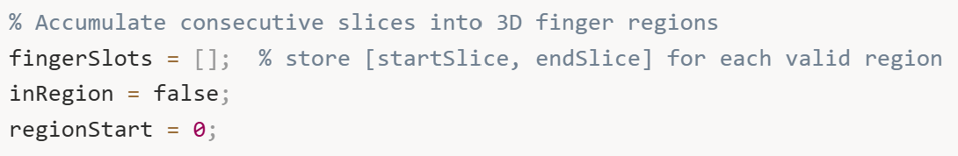
We’re setting up a simple state machine. fingerSlots will store our valid grasp regions as [startSlice, endSlice] pairs. inRegion tracks whether we're currently inside a sequence of good slices. regionStart remembers where the current region began.
Now we scan through all the slices:
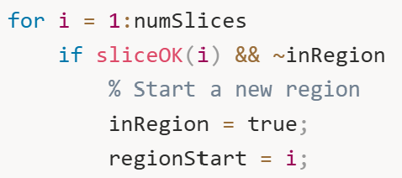
When we hit a graspable slice and we're not already tracking a region, we mark the start of a new potential grasp zone. It's like opening a parenthesis.
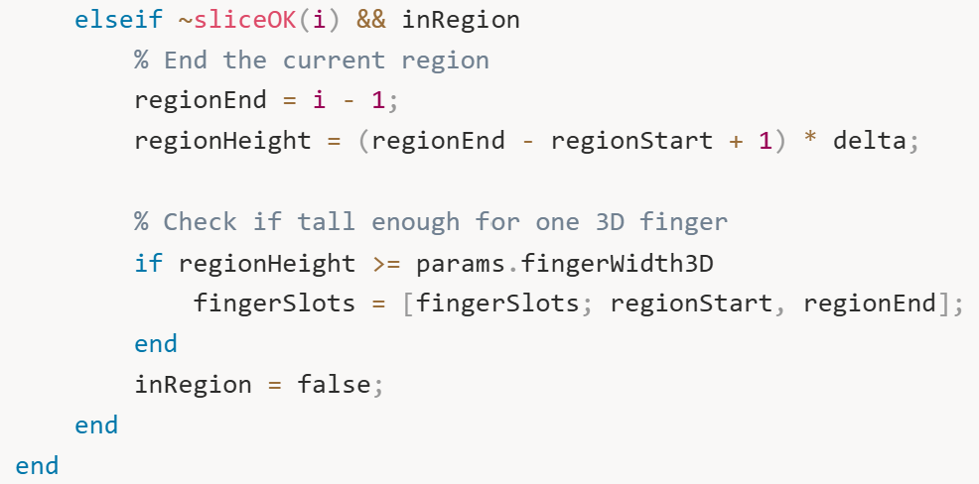
When we hit a bad slice while tracking a region, we close that region. We compute how tall it is: if it spans from slice 5 to slice 8, that's 4 slices times delta (6.6 mm) equals about 26 mm total height. If that's at least as tall as our finger (10 mm), we save it. If it's too short, we discard it.
We also handle the edge case where a region extends to the very top:
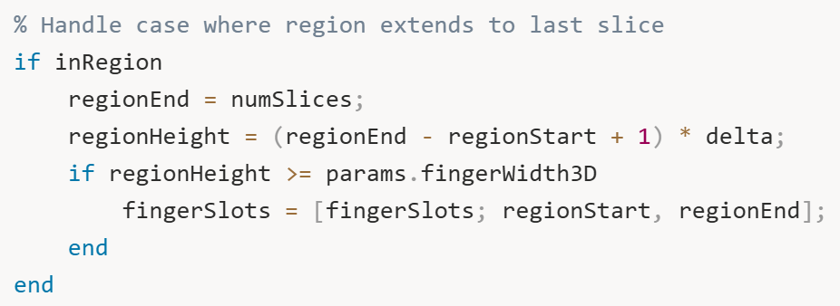
Now we report what we found:
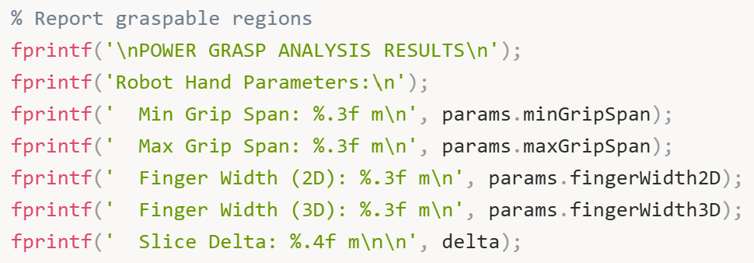
First we print the parameters so anyone reading knows what constraints we used.
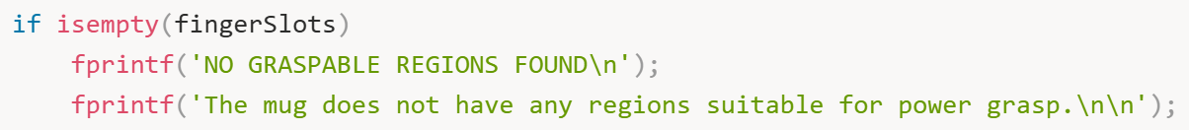
If we found nothing, we say so clearly. This might happen if the object is too big everywhere, too small everywhere, or the geometry changes too rapidly.
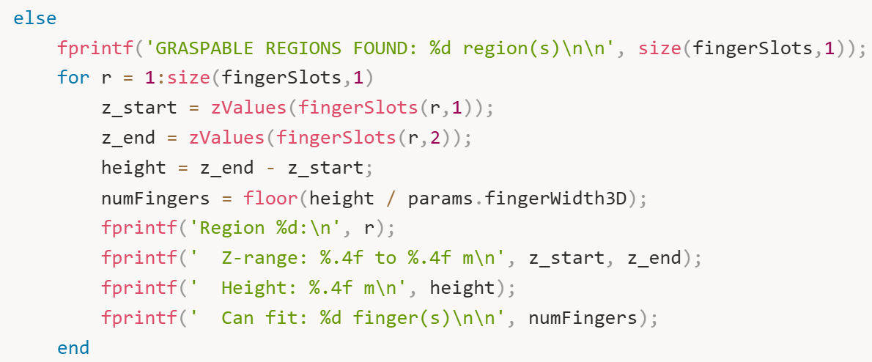
For each valid region, we report the exact Z-range where you can grasp, the total height, and how many fingers fit. That last number is key - floor(height / fingerWidth3D) tells us if we can fit 1, 2, 3, or more fingers in that zone.
Then we give an overall quality assessment:
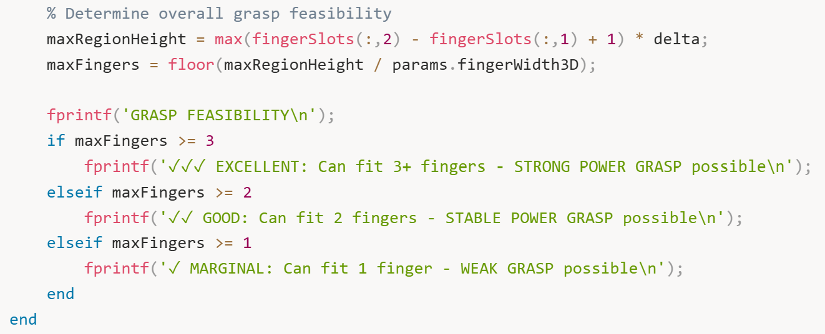
Three or more fingers means excellent stability - that's what you want for heavy loads or precise manipulation. Two fingers is good for most tasks. One finger is marginal but might work for lightweight objects.
Now for the visualizations. We create a figure with two plots side by side. The first plot shows the diameter profile. We need to build the legend dynamically to avoid errors:
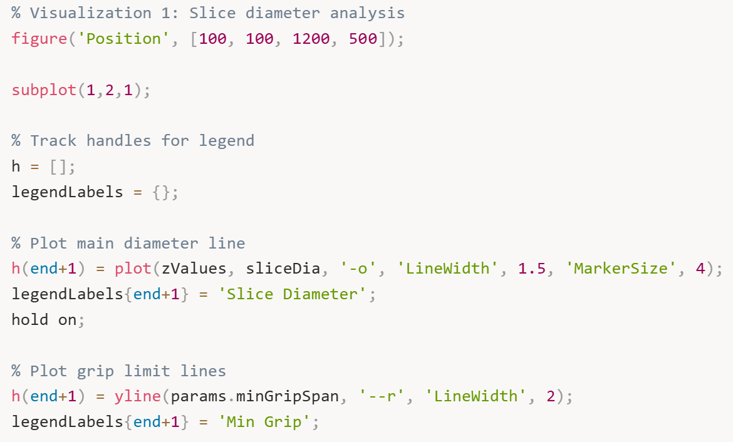
This plots the diameter curve in blue with the grip limits as horizontal lines - red for minimum, green for maximum.
We highlight the feasible slices:
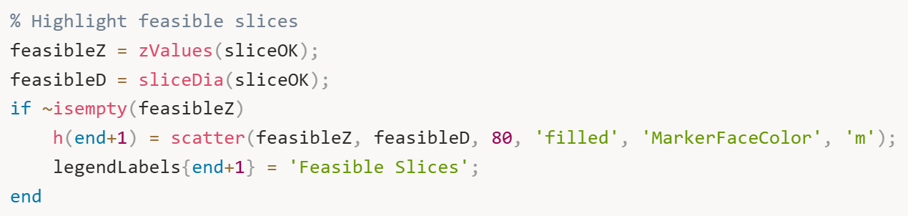
Magenta dots show every slice that passed the 2D checks. Then the most important part - shading the actual finger regions:
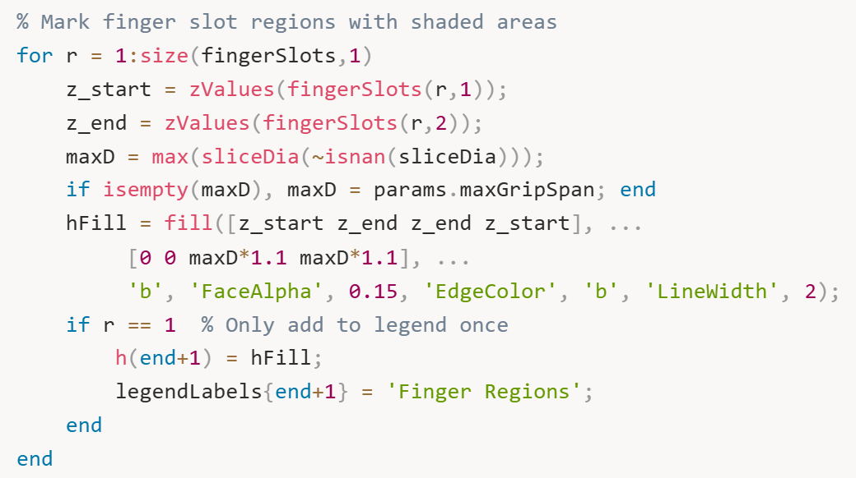
The blue shaded rectangles show exactly where you can place the gripper. The semi-transparent fill (FaceAlpha', 0.15) lets you see the diameter curve underneath while clearly marking the valid zones.
We finish this plot with labels and legend:
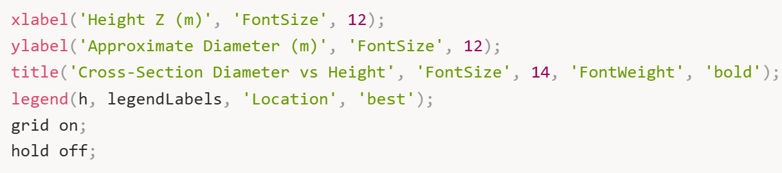
Now the second visualization – the 3D mug with highlighted regions. First we plot the entire mug in gray. This shows all the cross-sections in a neutral gray color, giving you the complete geometric context. Then we dramatically highlight the graspable regions in bright red:
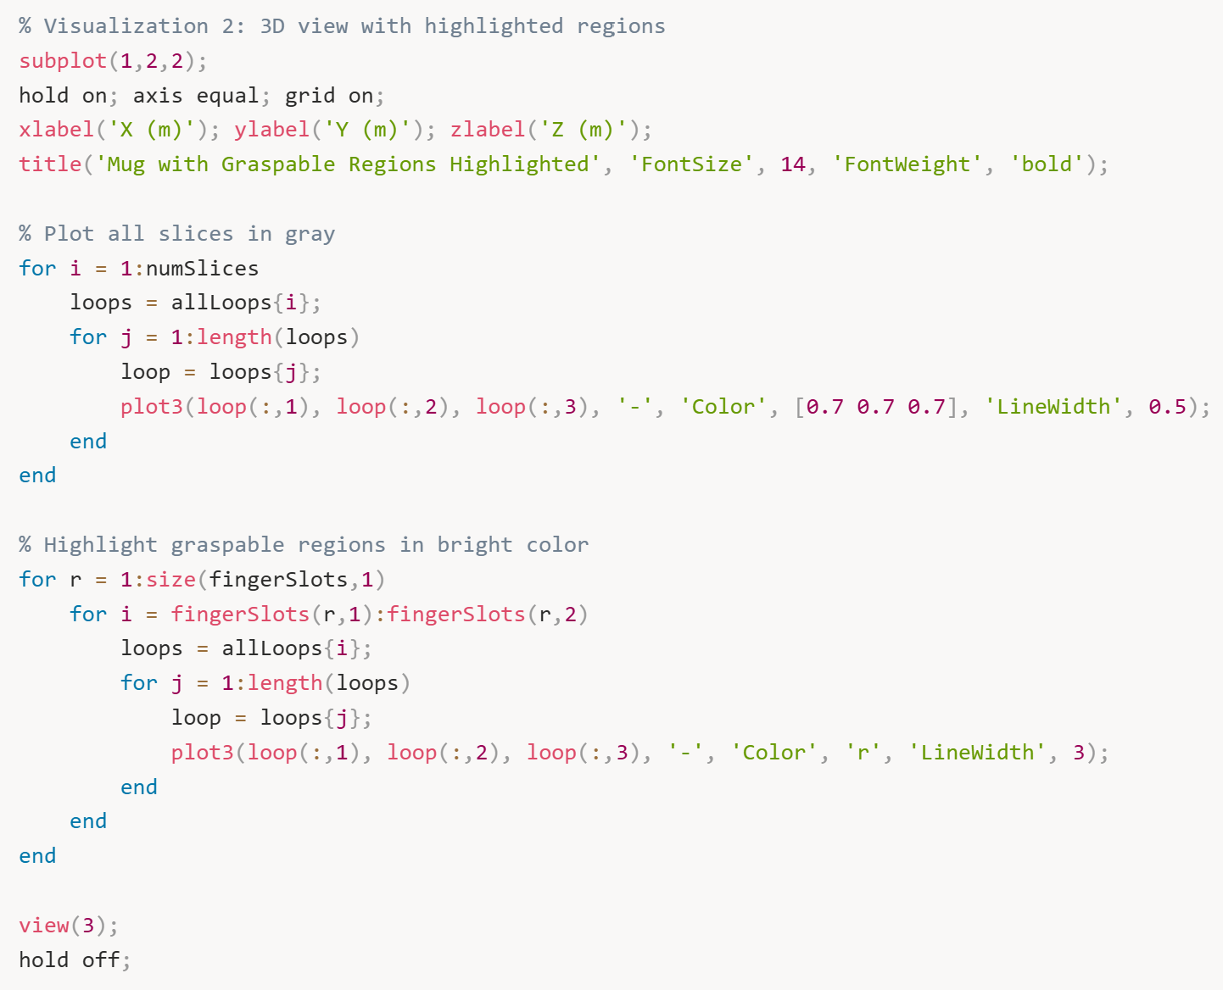
The thick red lines make it instantly obvious where to grasp. You can rotate this 3D plot with your mouse to examine the regions from any angle.

- Figure 6: Complete Grasp Analysis with Two Subplots
This is 2 visualizations side-by-side in one figure window:

- Left Subplot: Diameter Profile with Finger Regions
What it shows: Enhanced version of Figure 5 with additional information.
What you see:
- Blue curve with circles: Mug diameter at each height
- Red dashed line: Min grip limit (5 mm)
- Green dashed line: Max grip limit (15 mm)
- Magenta dots: Slices that passed 2D checks (diameter + gap if needed)
- Blue shaded rectangles: THE KEY ADDITION – these are the actual graspable regions!
What it means: This shows where you can grasp. Each blue rectangle spans a vertical range (height) where all the geometric conditions are met : correct diameter, sufficient gap for handle, and enough continuous height to fit a physical finger. For your mug, you should see 3 blue rectangles corresponding to the 3 regions the algorithm found.
Why it matters: This is the actionable output. A robot programmer looks at this and says "I'll position the gripper at any height within these blue zones." The shaded regions represent actual, physically feasible grasp positions.
- Right Subplot: 3D Mug with Highlighted Regions
What it shows: The 3D mug with graspable regions highlighted in bright red.
What you see:
- Light gray contours: All 20 slices showing the complete mug shape
- Thick red contours: Only the slices within graspable regions (slices 2-5, 7-11, and 13-19 in your output)
What it means: This is the same information as the left plot, but shown in 3D on the actual mug geometry. The red highlighting makes it visually obvious where the robot should grasp. You can rotate this view to see the grasp regions from different angles.
Why it matters: This is the "final answer" visualization. It combines everything : the 3D geometry, the slice-by-slice analysis, and the accumulated grasp regions – into one clear picture. A roboticist can look at this and immediately understand "grasp the mug in the red zones."

And that's it. We've gone from a 3D mesh to concrete grasp regions with full geometric reasoning, quality assessment, and clear visualizations showing exactly where a robotic hand can successfully perform a power grasp. The algorithm found 3 graspable regions on our test mug, with the best one being excellent quality – capable of fitting 3 fingers for a strong, stable grasp. That's exactly the kind of actionable information a robot motion planner needs to execute a real grasp.

Conclusion/Reflection
So looking back at everything we've accomplished in this project, I think we've really solved something fundamental here. We started with a straightforward question that any robotics engineer would ask: "Can my robot hand actually grab this mug?" And what seemed like a simple yes-or-no question turned into this entire journey through computational geometry, mesh processing, and algorithm.
The core idea we developed is actually pretty elegant when you think about it. Instead of trying to analyze this massive 3D mesh all at once with thousands of triangles flying around, we said "let's just slice it up." Like a CT scanner at a hospital, we cut through the mug horizontally at different heights and looked at what each slice tells us. Each slice becomes this manageable 2D problem – just some polygons to analyze – and then we stack all those 2D answers back together to get our 3D grasp regions. It's that dimensionality reduction that makes the whole thing tractable.ic problem-solving.
What I'm particularly proud of is how the algorithm handles messy real-world geometry. Mugs aren't perfect cylinders. They have handles that create weird gaps, they taper from bottom to top, sometimes they're asymmetric or have decorative features. Our algorithm doesn't freak out when it encounters two polygons at a slice height – it actually stops and thinks "okay, there's probably a handle here, let me measure that gap and see if my finger fits through." That kind of geometric reasoning, checking actual distances between polygon edges, computing robust diameters from both area and perimeter – those details matter when you want something that works on real objects, not just textbook examples.
The 3D accumulation part was a bit of an "aha moment" for me during development. Initially I was just marking individual slices as graspable or not, and I thought I was done. But then I realized – wait, my robot finger isn't infinitely thin! It's got actual physical thickness, like two centimeters tall. So even if I found ten graspable slices, if they're scattered all over the place with bad slices in between, I can't actually put a finger anywhere. That's when I added the accumulation algorithm that looks for continuous runs of good slices, and suddenly the results made way more sense. The algorithm went from theoretical to practical.
Testing this on the mug was satisfying because we got concrete, actionable results. Not just "yeah, you can probably grasp it somewhere" but actual numbers: "Grasp the mug between 5.2 and 8.7 centimeters above the base, you can fit two fingers there, this is a stable grasp." That's information a motion planner can actually use. The visualizations helped too – seeing those blue shaded regions on the diameter plot or the thick red lines on the 3D mug model, you immediately know where to place the gripper. No ambiguity, no guesswork.
There's definitely room to grow this further. Right now we're only slicing horizontally, but what if the best grasp is at an angle? Or what about adding force analysis so we're not just checking geometry but actually computing if the grasp is stable under load? I'd also love to extend this to more complex hands with articulated fingers instead of our simplified model. And honestly, integrating some machine learning could be interesting – maybe the algorithm suggests geometric candidates, and a neural network trained on successful grasps picks the best one. That hybrid approach might be more robust than either method alone.
But even as it stands right now, I think we've built something valuable. This isn't just a theoretical exercise – this is a working system that takes a 3D model and tells you exactly where and how to grasp it. No expensive GPU training, no massive labeled dataset, just good old-fashioned geometry and logic. Sometimes that's exactly what you need. The algorithm is also transparent – every decision has a clear geometric reason behind it, which makes debugging easy and builds trust with engineers who need to understand why the robot is doing what it's doing.
The bigger takeaway for me is that robotics doesn't always need the fanciest AI or the most complex algorithms. Sometimes you just need to think carefully about the geometry of the problem, break it down into manageable pieces, and solve each piece systematically. Slicing, stitching, measuring, accumulating – none of these steps is individually that complicated, but when you put them together thoughtfully, you get a system that actually works. And at the end of the day, that's what engineering is about – building things that work, that solve real problems, that you could actually deploy on a robot arm tomorrow if you needed to. I think we've done that here, and it feels good to have something tangible and functional to show for all this work.

References
[1] … (need to do on my end)

