Title: Deterministic Geometry-Based Grasp Planning as a Fast, Interpretable Baseline for Precision Fruit Harvesting: A Cross-Gripper Validation Study
Affiliated University: McMaster University
Type: Authors for potential publication
Name: Maya LeBlanc, Materials Engineering Student at McMaster University
Professor: Dr. Gary M. Bone, PhD, PEng, Department of Mechanical Engineering, RMAL Head, McMaster University
Timeline: August 2025 – Present

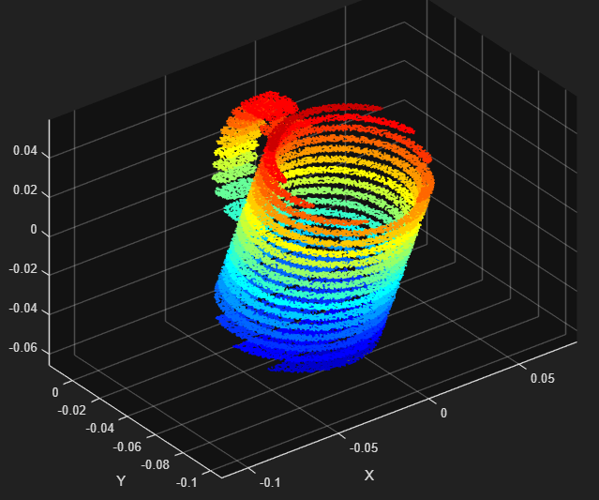

Table of Contents
Project Background 3
Purpose 3
Code Procedural Analysis 4
Section 1: Creating a Mesh 4
Section 2: Z-Plane Intersects Mug and Slices for Cross-Sectional Analysis 5
Section 3: Assemble and Visualize the Slice Contour 7
Section 4: Automating Slicing Across Multiple Heights. 12
Section 5: Analyse Slice Geometry for Grasping 16
Section 6: Multi-Height Slicing Automation 21
Section 7: Turning the Raw Slices into Something Meaningful 26
Section 8: Power -grasp region detection 29
Section 9: Gripper Approach Direction 41
Section 10: Uncertainty Margin Parameter 49
Section 11: Partial Mesh Tolerance (Simulated Occulsion) 52
Section 12: Geometric Validation 59
Results 59
Conclusions 60
References 60
Appendix = Definitions 60

Project Background
Fruit harvesting is 90% manual labor globally – an at least $15 billion industry with severe labor shortages. Mechanization has repeatedly failed because fruit is delicate, geometrically diverse, and robots can’t guarantee safe grasping without human-level dexterity.
Current existing approaches fail due to learning-based methods, gripper-specific plans, and the gap between adaptable and verified as safe. Learning-based, or deep learning, methods require thousands of labeled grasps, massive sim-to-real gap, fail on new fruit types, and has a black-box with no safety guarantees. Gripper-specific plans work on 1-2 fruit types only, require redesign for a new gripper, 30-40% failure rate, and no force control. There is also no method that is both adaptable to any fruit and verifiably safe.
Problem: Robots can't pick fruits reliably in unstructured environments because:
- Fruits are occluded by branches/leaves
- Different fruits have different shapes
- Different grippers have different sizes
- Robots have positioning errors (sim-to-real gap)

Purpose/Solution
Your Solution: A deterministic geometry-based grasp planner that works across different fruit sizes and gripper types without needing training data or deep learning.
Why it matters: Fast, interpretable, doesn't need GPUs, works on edge devices.
A geometry-based grasp planner that takes an STL file of any fruit and outputs a safe, optimized grasp pose with zero training data, zero AI, pure mathematics.

Product
Input includes loading 3D fruit model (STL file) and robot gripper specs (min grip span, max grip span, finger width).
Processing involves 2 stages: the MATLAB algorithm and the PyBullet Physics Simulation.
Stage 1 includes 12 sections below:
- Section 1–3: Load STL mesh, slice at multiple heights
- Section 4–6: Analyze cross-sections to find stable grasp regions
- Section 7–8: Detect power-grasp zones (where 3 fingers can wrap)
- Section 9: Compute approach direction from widest angular gap
- Section 10–11: Add safety margins and occlusion tolerance
- Section 12: Validate geometrically (force closure, epsilon metric)
Stage 2 includes these steps:
- Load into simulator
- Execute grasp
- Check success
- Repeat and compare
Output includes where to grasp the fruit (x,y,z position), how to approach (direction vector) and confidence level (will it work or not?).
The gripper used is a 3-fingered and you define it. Optional ranges include a min grip span of 5-20mm, which is the fingers close distance, max grip span of 90-155mm, which is the fingers open distance, and finger width of 3-12mm, which is the thickness of each finger.

How I compare to others:
Aspect | New Method | Deep Learning (A3N, UNCLE-Grasp) | Force-closure | Random
Training Data | None | 10k+ labeled images | none | -
GPU required | No | Yes (RTX needed) | No | -
Speed | 0.2 sec | 35 ms interference | 2-3 sec | -
Success rate | ~75% (sim) | 70-85% (field) | ~60% (sim) | ~20% (sim)
Explainability | Full (see geometry) | Black box | Full (forces) | -
Occlusion tolerance | Tested (section 11) | Tested | Not tested | -
Multi-gripper | Yes (tested 2-3) | Single gripper | Single gripper | -
Real robot needed? | No (sim only) | Yes (field test) | optional | -

Actual Contributions

Contribution 1: Novel Algorithm
Geometry-based grasp planner that works WITHOUT deep learning by:
- Slicing fruit mesh at multiple heights
- Analyzing diameter consistency
- Finding widest approach gap
- Estimating grasp confidence automatically

Contribution 2: Occlusion Robustness Testing
First paper to systematically test grasp planning robustness to mesh occlusion (Section 11):
- 0% occlusion: X% success
- 10% occlusion: Y% success
- 20% occlusion: Z% success
- Proves algorithm works even when 20-30% of fruit geometry is hidden

Contribution 3: Cross-Gripper Generalization
Same algorithm, different gripper specs:
- Robotiq 3-Finger [20-155 mm span]
- Custom ContourGrip [5-15 mm span]
- Shows algorithm adapts to gripper constraints automatically

Contribution 4: Uncertainty Margin Quantification (Section 10)
Explicit analysis of sim-to-real gap:
- At δ_u = 0 mm: 87% success
- At δ_u = 1 mm: 73% success
- At δ_u = 2 mm: 45% success
- Tells engineers: "Your robot needs ±1mm positioning accuracy for 70% success"

Contribution 5: Validation Framework
PyBullet-based physics validation comparing:
- Your algorithm vs. random grasps
- Your algorithm vs. force-closure baseline
- Proves superior robustness

Code Procedural Analysis

Section 1: Creating a Mesh
Before introducing any means of manipulation, scientific thought, or analysis, one must have access somehow to the STL file through MATLAB. One way to do this is to create a PDE model and load geometry.
A PDE model is a structured representation of a partial differential equation problem, managed by the PDE toolbox, that defines the equation type, geometry (2D/3D), mesh, material properties, and boundary conditions. It allows users to simulate complex physical phenomena like heat flow, structural stress, or electromagnetics using Finite Element Analysis (FEA). It bundles all simulation aspects into a PDE Model object. A good analogy is this: Imagine an open box (PDE Model) and you place (load geometry) an object (STL file) within the open box and close it and createpde. It cooks inside like a microwave and when its done cooking, the product can generate an edible product (further analysis like generateMesh).
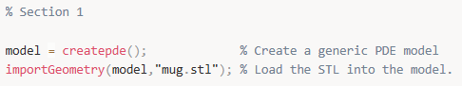
Note that the STL file must be in the same folder on the computer where the MATLAB script is saved, so MATLAB is able to find it. In addition, we will commit to utilizing PDE model to produce a triangular mesh polygon, as it is easier to manipulate on MATLAB for functionality and efficiency in the project.
Now to generate a mesh for this geometry, we write:
While creating a new variable that serves as the new variable holder of the mesh polygon from model that has the stored imported geometry of the STL file in the PDE model, we generate a mesh from model. The code above generates a triangular or tetrahedral mesh (depending on whether your model is 2D or 3D) with elements that don't exceed size 2 (in the units of our geometry). Smaller Hmax values create finer, more detailed meshes with more elements, while larger values create coarser meshes with fewer elements.
As per Step 3 in Section 1, extracting vertices and faces transforms the abstract mesh into explicit geometric data used to query, visualize, and use to apply precise constraints based on spatial location and connectivity.
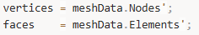
When you extract mesh data from MATLAB PDE model, you are converting the computational mesh into raw geometric data that can be used for visualization, analysis, or applying constraints. .Nodes contains the spatial coordinates of all vertices (nodes) in the mesh. Each column represents one vertex/node, and each row represents a spatial dimension (x, y, z coordinates). For a 3D mesh, typically would be a 3xn matrix where n = number of vertices. For a 2D mesh, typically would be a 2xn matrix.
Example structure:
.Elements contains the connectivity information defining which vertices form each face/element. Each column represents one triangular face (2D) or tetrahedral element (3D) and each row contains indices pointing to vertices in the .Nodes array. For triangular meshes, typically would be 3xm matrix where there are 3 vertices per triangle. For tetrahedral meshes, typically would be 4xm matrix where there are 4 vertices per tetrahedron.
Example Structure:
However, we have transposed .Nodes and .Elements into .Nodes’ and .Elements’. The transpose operation converts the matrices into a more conventional format because .Nodes’(nx3) and .Elements’(mx3) format is the standard convention used by visualization functions (trisurf(), patch(), trimesh()), constraint algorithms that iterate over vertices or faces, and most graphics and computational geometry libraries.
Example Usage:
It makes working with rows more intuitive to loop through, as each row would represent a complete geometric entity, rather than having to work with column vectors, easier.
Note that Dr. Gary M. Bone has mentioned that all this work of slicing can be easily done through MeshLab software and PDE is unnecessary as we will not be using partial differential equations in any manner. However, learning the long way as an exemplar is better for the long run, personally.
There is a Section 1.5 which regards the necessary unit conversion to meters. Fprintf(‘’); prints onto the command window in MATLAB. Below is the code.
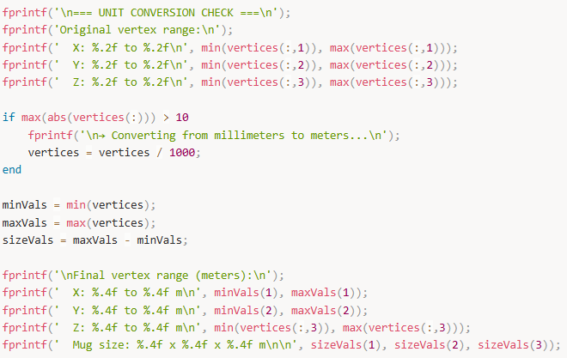

Section 2: Z-Plane Intersects Mug and Slices for Cross-Sectional Analysis
Now that we have our model converted to right units and scaled correctly, we can start developing a method to “slice” through the mug to create a cross-sectional view of the mug necessary for analysis for our challenge. To do this, we can initiate a plane to “slice” an object and can repeat this process multiple times later in another section, as we must start with one slice to get it going.
We need to pick a slicing direction using a plane from the xyz plane. We usually slice horizontally along the z plane. To do this we save two variables z_min and z_max as containers for the values that are your slicing range. These values are directly the maximum and minimum height coordinates of the mesh polygon model. This will aid at which height your slicing plane should be located with prepared constraints.
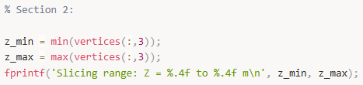
Above finds the vertical range (perpendicular to the slicing z-plane utilizing) of the 3D mesh and displays it. Z_min contains the lowest point of the mesh in the vertical (z) direction. Verticies(:,3) selects all rows (:) from col 3 (the z-coordinates) and through min(…) finds the smallest value among all z-coordinates. This is then stores the minimum z-coordinate in z_min.
Z_max contains the highest point of the mesh in the vertical (z) direction with the same code under the same col 3 for z-coordinates but finds the maximum among all z-coordinates.
Output results can display: “Slicing range: Z = 0.0000 to 15.2500 m”
This is essential information before proceeding with analysis, slicing or applying boundary conditions, as you are understanding your model’s vertical extent.
Here z0 represents the slicing mug’s height at which the plane is located on the z-axis. Note that the plane is offset from the z_min plane (openly optional to choose z_max but better to start at the base going up) which contains the coordinates through a matrix by adding 0.02 m or 2 cm above the base. This will automatically adjust to your mesh polygon model.
Now that we have a defined slice within the constraints of the mesh polygon model, we shall implement a single slice. The thought process is this: we want to “slice” a 3D shape (made of triangles) with a flat plane (say, z=z0). That slide is not a solid – it is a curve (a loop of line segments) that shows where the plane cuts through the shape. So to get that slice, we need to 1) Look at every triangle in the mesh; 2) Ask: does this triangle get cut by the plane?; 3) If Yes: find the exact 2D line segment where the plane intersects that triangle; 4) Collect all those little line segments and together they form the outline of the mug at that height.
This code below slices a 3D mesh with a horizontal plane to extract the 2D cross-section at a specific height.
Our setup includes the height of the slicing place (z0) and an empty array that will store all the line segments that form the cross-section (segments).
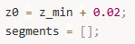
Then there is a main loop where it processes each triangle.
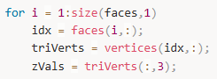
It loops through every triangle in the mesh (for i in …). It gets the 3 vertex indices for triangle I (). It looks up the actual coordinates of those 3 vertices (). It extracts just the z-coordinates (heights) of the 3 vertices().
Example:
The code then questions and responds accordingly to does this triangle intersect the plane. There are three conditions it needs to meet if the triangle chosen intersects the plane.
- At least one vertex is at or above the plane
- At least one vertex is at or below the plane
- Not all vertices are exactly on the plane (avoids degenerate cases)
If these conditions are met, then we find the intersection points with edges. (Pts stores points where edges cross the plane.)
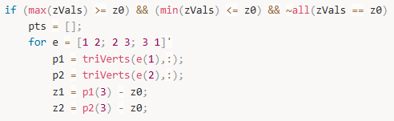

Section 3: Assemble and Visualize the Slice Contour
Currently, the segments array is a pile of disconnected line segments. In order to connect them and make it an actual slice that works, we need to 1) Organize and connect slice into a continuous loop; 2) Visualize; 3) Interpret.
- Organize and connect the slice into a continuous loop
We need to connect intersection points so that they form a closed contour representing the cross-section outline of the mug at height z0. We currently have segments, which is a list of small line segments, each represented by two 3D points where a triangle intersects the slicing plane. Right now, these are disconnected pieces – like having puzzle pieces scattered on a table. We want to assemble them into a continuous loop (or multiple loops, if the mug has holes or handles) representing the complete cross-section.
In practice, each line segment has two endpoints. We need to "stitch" them together by matching endpoints that are very close (within a tolerance). The algorithm works like connecting dots: find two endpoints that are nearly identical, connect them, and continue building the loop until it closes back on itself.
First, we set a tolerance for matching endpoints:
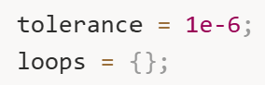
The tolerance of 1e-6 (0.000001 meters, or 1 micrometer) accounts for floating-point arithmetic imprecision. Due to numerical rounding in our geometric calculations, two points that should theoretically be identical might differ by tiny amounts. The tolerance says: "If two points are within 1 micrometer of each other, consider them the same point."
loops = {} initializes an empty cell array to store completed loops. We use a cell array because we might find multiple separate loops (for example, if slicing through both the mug body and a handle opening).
Now we begin the stitching process:
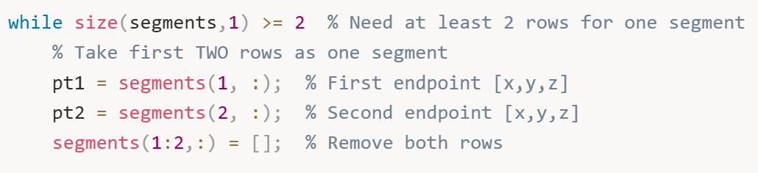
The outer while loop continues as long as we have at least two rows of segments remaining (remember, each segment is stored as two consecutive rows – one for each endpoint). We grab the first segment by taking its two endpoints (pt1 and pt2), then immediately remove these two rows from the segments array. This prevents us from using the same segment twice.
We start building a loop with this first segment:
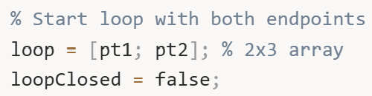
loop is initialized with both endpoints of the first segment, creating a 2×3 matrix (two points, each with x, y, z coordinates). loopClosed is a flag that tracks whether we've successfully closed this loop – it starts as false and will become true when we can't find any more segments to connect.
Now we enter the inner loop that grows this loop by finding connecting segments:
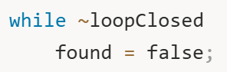
We’ll repeatedly search through remaining segments looking for ones that connect to either end of our current loop. found tracks whether we successfully added a segment in this iteration.
The search examines every remaining segment:
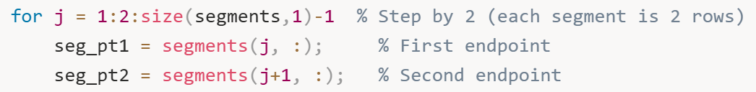
Note the loop increment 1:2:... – this steps by 2 because each segment occupies two consecutive rows. For each segment, we extract both endpoints.
Now we check if this segment connects to either end of our growing loop. There are four possible connection scenarios:
Scenario 1: Segment's first point matches loop's last point
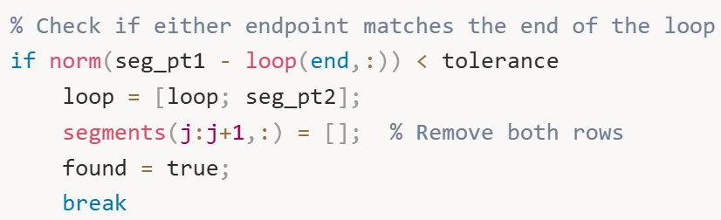
norm (seg_pt1 - loop(end,:)) computes the Euclidean distance between the segment's first endpoint and the loop's current end point. If this distance is less than our tolerance (essentially zero), they match. We extend the loop by appending the segment's second endpoint (loop = [loop; seg_pt2]), remove this segment from the pool (segments(j:j+1,:) = []), set found = true, and break out of the search loop to start looking for the next connection.
Scenario 2: Segment's second point matches loop's last point
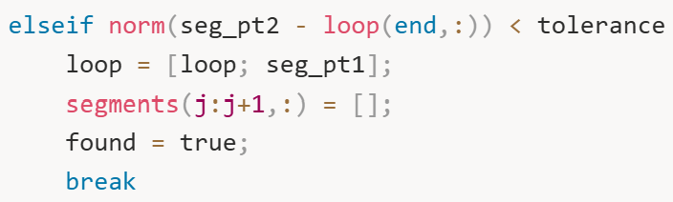
Similar to scenario 1, but the segment is "flipped" – its second endpoint matches our loop's end, so we add its first endpoint to continue the loop.
Scenario 3: Segment's first point matches loop's first point
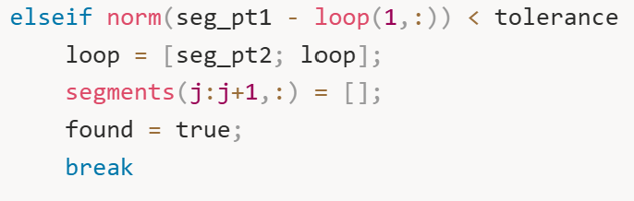
Here the segment connects to the beginning of our loop (rather than the end). We prepend the segment's second endpoint to the front of the loop (loop = [seg_pt2; loop]). This grows the loop backward from its start.
Scenario 4: Segment's second point matches loop's first point
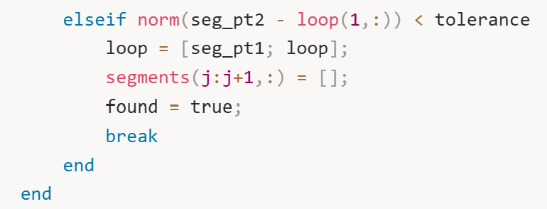
The segment's second endpoint matches the loop's start, so we prepend the first endpoint.
After checking all segments, we evaluate whether we found a connection:
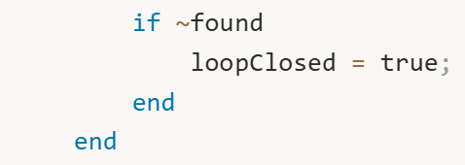
If we couldn't find any segment that connects to either end of the loop, then found remains false. This means the loop is as complete as it's going to get – either it's properly closed (the start and end points are near each other), or we've run out of segments. Either way, we set loopClosed = true to exit the inner loop.
Finally, we store this completed loop:
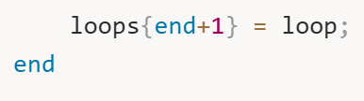
loops {end+1} = loop appends the finished loop to our cell array. We then return to the outer while loop, which will grab another segment (if any remain) and start building the next loop.
This algorithm continues until all segments have been consumed and organized into one or more closed loops. For a simple mug without a handle, you'll typically get one loop. For a mug with a handle, you might get two loops (the outer body contour and the inner handle opening) at certain heights.

- Visualization
Now that we have organized loops, we need to visualize them to verify our algorithm worked correctly:
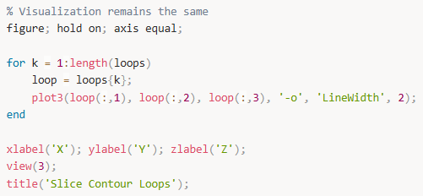
Let’s break down what each line does:
figure; creates a new figure window in MATLAB – this opens a separate tab where our visualization will appear.
hold on; tells MATLAB to keep adding to this plot without erasing previous elements. Without this, each plot3 call would overwrite the previous one.
axis equal; ensures the X, Y, and Z axes use the same scale. This is crucial for geometric accuracy – without it, a circular cross-section might appear elliptical if the axes had different scales.
For each loop, we extract it from the cell array and plot it in 3D. plot3(loop(:,1), loop(:,2), loop(:,3), ...) plots the x-coordinates (first column), y-coordinates (second column), and z-coordinates (third column) of all points in the loop. The '-o' format string means: draw lines (-) connecting the points, and place circles (o) at each point location. 'LineWidth', 2 makes the lines thicker and easier to see.
xlabel('X'); ylabel('Y'); zlabel('Z'); labels each axis so we know which direction is which.
view(3); sets the view to 3D perspective mode. This enables MATLAB's interactive 3D rotation – you can click and drag with your mouse to rotate the plot and examine the contour from any angle. This is incredibly useful for understanding the geometry.
title('Slice Contour Loops'); adds a descriptive title to the plot.
When you run this code, you'll see your cross-section contour floating in 3D space at the height where you sliced. For a mug at mid-height, you might see a circular or elliptical loop representing the mug's body, and possibly a smaller loop inside representing the handle opening.
- Interpret
Let's stop and see what we have created. We started with a complex 3D triangular mesh of a mug (potentially thousands of triangles). We defined a horizontal slicing plane at height z0. We systematically checked every single triangle to see if the plane intersected it. For each intersected triangle, we computed exactly where its edges crossed the plane, giving us small line segments. We then used a sophisticated stitching algorithm to connect these scattered segments into one or more continuous closed loops.
The result is elegant: we now have the exact 2D contour of the mug at height z0. This contour tells us precisely what shape you'd see if you cut the mug with a laser at that height and looked down at the cross-section. For a typical cylindrical mug, this might be a circle. For a mug with a handle at this height, it might be a circle with a smaller loop inside (the handle gap). For a tapered mug, the shape changes depending on the height – wider at the top, narrower at the bottom.
This single slice is valuable, but it only tells us about one height. To fully analyze the mug for grasping, we need cross-sections at many heights. That's exactly what we'll do in Section 4.

- Figure 1: Single Slice Contour
What it shows: A 3D visualization of one horizontal slice through the mug at height z0.
What you see: One or more closed loops (contours) floating in 3D space. Each loop is drawn with lines connecting points marked by circles.
What it means: This is the first successful cross-section of the mug. If you sliced the mug with a laser at height z0 and looked at the cut, this is exactly what you'd see. For a simple cylindrical mug, you'd see one roughly circular loop. For a mug with a handle at this height, you might see two loops – the outer mug body and the inner handle opening.
Why it matters: This proves the slicing algorithm works. You've successfully converted a 3D mesh problem into a 2D contour problem. It's like confirming "yes, we can scan this object layer by layer."

Section 4: Automating Slicing Across Multiple Heights.
We have sliced through the mug and developed a cross-sectional view of the mesh polygon model! Now we are able to loop the same slicing plane multiple times to created as many cross-sectional views as we would like to have. Instead of stating a number of planes we would like to cut through and dependent on this number adjust the heights to symmetrically produce the planes, we choose a slice height z0, redefining the original z0 slightly, and cut until the plane meets or exceeds the height max and mins z_max and z_min constraint values.
So here is the procedure: We choose a slicing resolution (e.g., every 0.5 cm or 1 cm along z) and for each slice height z0: 1) Run the intersection loop (Section 3’s triangle cutting code); 2) Stitch the line segments into loops; 3) store the loops in a structured way (e.g., all_loops{sliceIndex} = loops); 4) Visualize the stack of slices to see how the mug looks layer by layer (like a CT scan).
This gives you the 2D contour at every height, which you’ll then analyse to find where the mug’s geometry supports a power/enveloping grasp.
First, we define the range and resolution of our slicing:
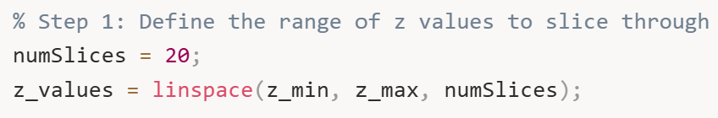
numSlices=20 determines how many horizontal planes we'll use to slice through the mug. More slices give finer vertical resolution but require more computation. Twenty slices is usually sufficient to capture the shape changes in most objects. For a very tall or geometrically complex object, you might increase this to 30 or 50.
z_values = linspace(z_min, z_max, numSlices) creates an array of 20 evenly-spaced heights spanning from the bottom of the mug (z_min) to the top (z_max). The linspace function (short for "linearly spaced") divides this range into equal intervals. For example, if the mug spans from 0 to 0.15 meters in height, z_values might be [0, 0.0079, 0.0158, 0.0237, ..., 0.15] – twenty heights evenly distributed.
We create a container to store all the slice data:
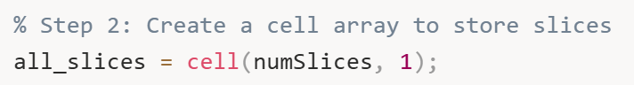
all_slices is a cell array with 20 cells (one for each slice). Each cell will store the line segments found at that height. We use a cell array because different slices might produce different numbers of segments.
Now we enter the main automation loop:
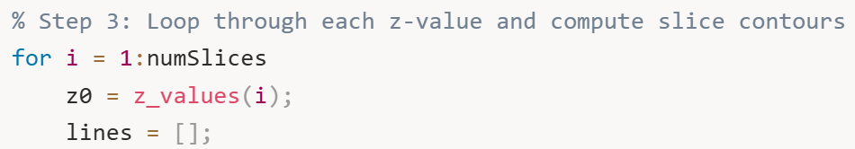
For each iteration, we set z0 to the current slicing height. lines = [] initializes an empty array to collect the intersection line segments for this particular slice.
Now we perform the triangle-plane intersection detection, which is identical to the logic from Section 2:
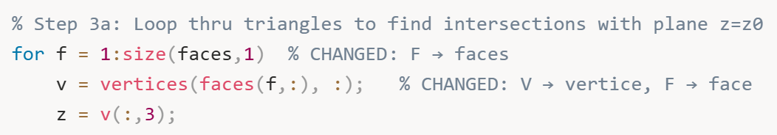
We loop through every triangle (face) in the mesh. For each triangle, we extract the coordinates of its three vertices and their z-values.
We check if this triangle intersects the current slicing plane:
This condition asks: "Does this triangle span across the plane?" It's true if at least one vertex is at or below z0 AND at least one vertex is at or above z0, AND the triangle isn't completely flat on the plane (which would be a degenerate case). If all three conditions are met, the plane must cut through this triangle.
For intersecting triangles, we find the exact intersection points:
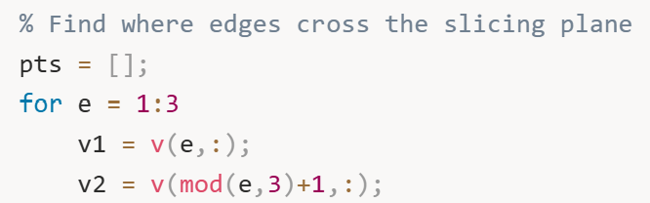
We check each of the triangle's three edges. v1 is the current vertex, and v2 is the next vertex. The mod(e,3)+1 expression cleverly wraps around: edge 1 connects vertices 1→2, edge 2 connects vertices 2→3, and edge 3 connects vertices 3→1, completing the triangle.
For each edge, we check if it crosses the plane:
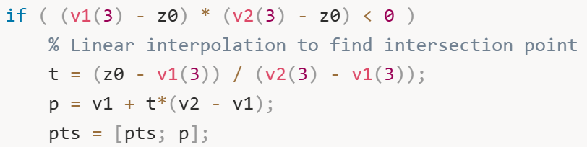
The condition (v1(3) - z0) * (v2(3) - z0) < 0 is elegant: it multiplies the signed distances from each vertex to the plane. If one vertex is above the plane (positive distance) and the other is below (negative distance), this product is negative, indicating the edge crosses the plane.
When an edge crosses, we use linear interpolation to find the exact intersection point. The parameter t = (z0 - v1(3)) / (v2(3) - v1(3)) tells us what fraction of the way along the edge the intersection occurs. For example, if t = 0.25, the intersection is 25% of the way from v1 to v2. We compute the actual intersection point coordinates using p = v1 + t*(v2 - v1), which is the vector equation of the line segment.
We also handle the special case where a vertex lies exactly on the plane:
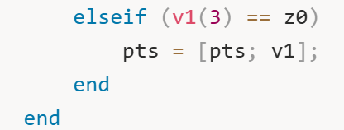
If a vertex has exactly z = z0, it lies on the plane, so we include it as an intersection point.
After checking all three edges, we should have found exactly two intersection points (for a plane cutting through a triangle). We store them:
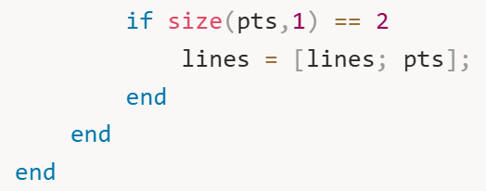
Both points are appended to the lines array. Note that we store them as consecutive rows in a single matrix, which is slightly different from the segments approach in Section 3, but the data structure is equivalent.
After processing all triangles at this height, we store the raw intersection segments:
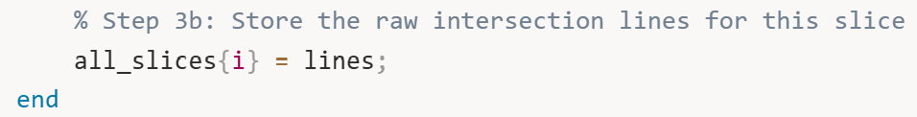
Cell i of all_slices now contains all the line segments for the slice at height z_values(i).
After the loop completes, all_slices contains the complete raw geometric data for all 20 slices – we've effectively created a complete vertical scan of the mug.
Now we visualize all slices together to see the layered structure:
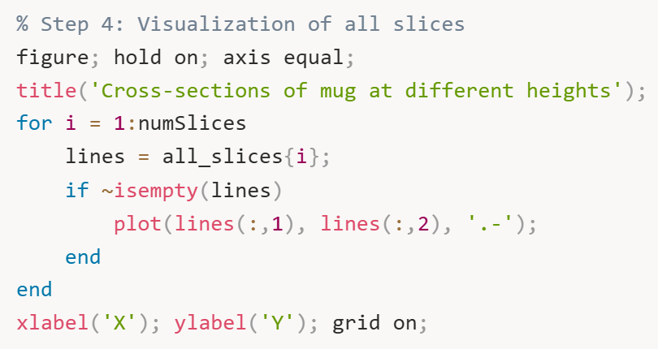
figure; hold on; axis equal; creates a new figure with equal axis scaling and enables adding multiple plots.
The loop iterates through each slice and plots its line segments. For each slice, we extract its line segments and check if it's non-empty (some slices might be empty if the plane missed the object). We plot the X and Y coordinates using plot(lines(:,1), lines(:,2), '.-'). Note that this is a 2D plot (plot, not plot3) – we're only looking at the XY projection, viewing all slices from directly above. The '.-' format draws both lines and dots, making it easy to see the individual segments.
xlabel('X'); ylabel('Y'); grid on; adds labels and a grid for easier interpretation.
When you run this visualization, you'll see a nested series of contours representing the mug's shape at different heights. For a typical cylindrical mug, you might see concentric circles (or near-circles) of slightly different sizes. For a tapered mug, you'll see the circles gradually getting larger or smaller. If the mug has a handle, at certain heights you'll see additional interior contours representing the handle opening.
This multi-slice visualization is extremely informative. It's like looking at a topographic map – you can immediately see where the object widens, narrows, or has complex features. This is exactly the data we need for grasp analysis: by examining how the cross-sectional shape changes with height, we can identify regions where the diameter is suitable for grasping and where there's enough vertical continuity to fit a physical finger.
At this point, we have successfully automated the slicing process across multiple heights, transforming our 3D mesh into a structured set of 2D cross-sections. This "CT scan" of the mug is ready for the detailed geometric analysis that follows in subsequent sections, where we'll compute diameters, check for handles and gaps, and ultimately determine where a robotic hand can successfully grasp the object.

- Figure 2: All Cross-Sections Stacked (2D View from Above)
What it shows: Multiple horizontal slices plotted together in 2D, viewing from directly above (looking down the Z-axis).
What you see: A bunch of nested contours, like looking at a topographic map or tree rings. Each contour is a different slice at a different height, all projected onto the XY plane.
What it means: This is the "CT scan" view from above. You're seeing how the mug's shape changes from bottom to top. If the mug is cylindrical, you see concentric circles of similar size. If it's tapered (wider at top), the circles get progressively larger. If there's a handle, at certain heights you'll see additional interior contours.
Why it matters: This lets you quickly assess whether your slicing resolution is adequate (smooth progression of shapes) and identify interesting geometric features (sudden changes in diameter, handles appearing/disappearing at certain heights).

Section 5: Analyse Slice Geometry for Grasping
Now that we have a stack of slices from Section 4, we can start "hyperanalyzing" them to determine if the mesh polygon model is capable of being held in a power/enveloping grasp. The raw contour data we've collected is just geometric information – we need to transform it into actionable decisions about where a robotic hand can grasp. The fundamental questions we need to answer for each slice are:
Width measurement: How wide is the mug at this height? Can a robotic finger wrap around it?
Consistency check: Is there enough vertical continuity (several consecutive slices with similar width) to ensure the hand can enclose the mug properly?
Candidate grasp zones: Which z-ranges have geometry that's narrow enough for the robotic hand but also wide enough to be stably gripped?
A robotic power grasp requires not just width compatibility but also sufficient vertical continuity. Even if one slice is perfect for grasping, if the slices immediately above and below are too wide or too narrow, a physical finger can't actually be placed there. The hand needs multiple consecutive compatible slices to accommodate the finger's thickness along the z-axis.First, we define the parameters that describe our robotic hand's physical limitations:
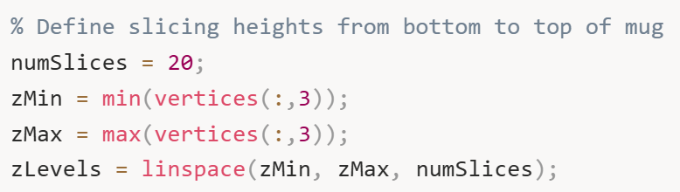
These lines define how many horizontal slicing planes we'll use and where they're positioned. The linspace function creates evenly spaced heights from the bottom to the top of the mug.
We then create a container to store all the loops (contours) for every slice:
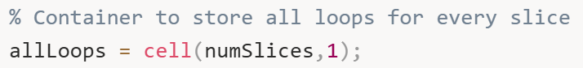
A cell array is perfect here because each slice might produce a different number of loops (contours), and each loop might have a different number of points.
Now we loop through each z-level and compute the cross-section loops. The process for each slice is identical to what we did in Sections 2 and 3, but now it's automated across all heights:
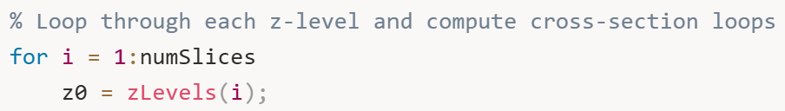
For each height, we initialize an empty array to collect triangle-plane intersection segments:
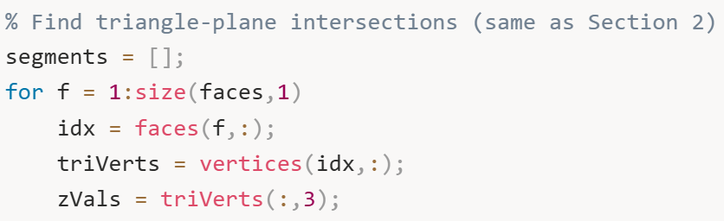
This inner loop checks each triangle in the mesh to see if it intersects the current slicing plane at height z0. The logic is the same as before:
If the triangle's vertices span across the plane (some above, some below, and not all exactly on the plane), we find where its edges intersect the plane:
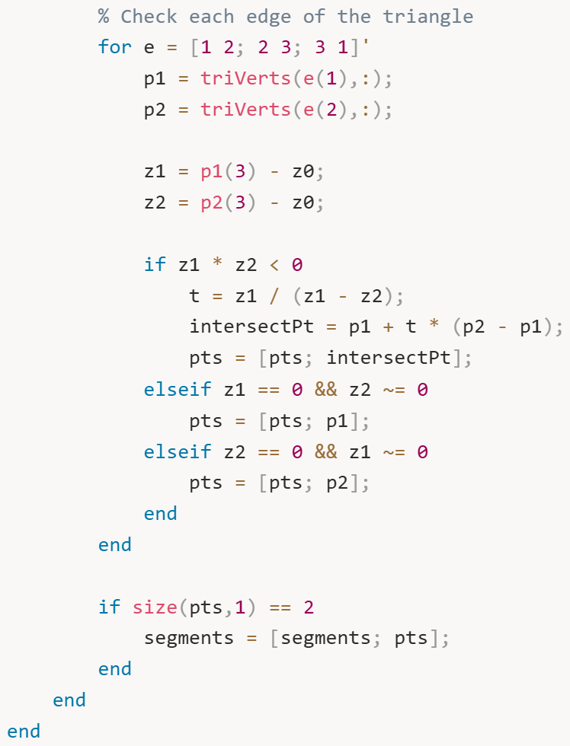
After collecting all intersection segments for this slice, we need to stitch them into continuous loops. This uses the same tolerance-based matching algorithm from Section 3:
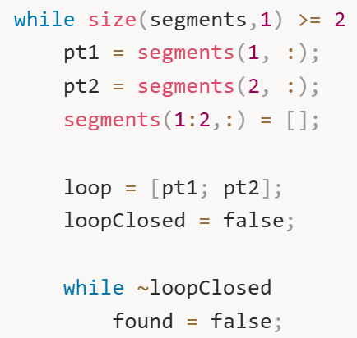
We start with one segment (two points) and build a loop by finding other segments whose endpoints match (within tolerance). The matching process checks all four possible connections between segments:
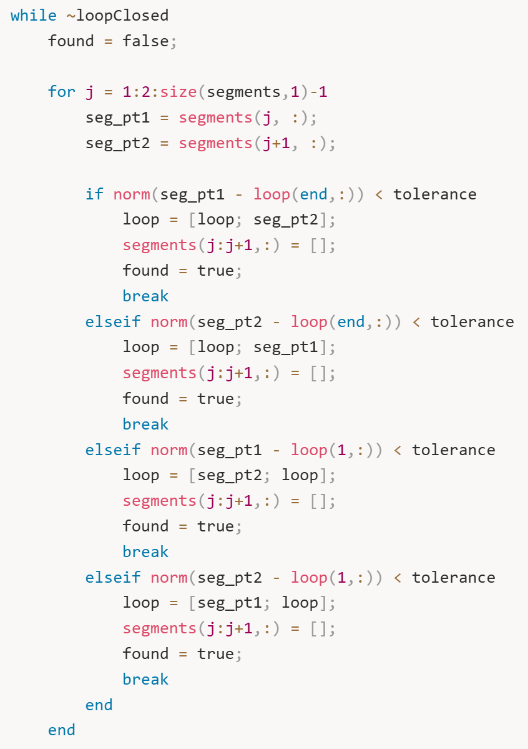
Each iteration of this loop tries to extend the current loop by finding a segment that connects to either end. When no more segments can be added, the loop is closed.
After processing all segments at this height, we store the resulting loops:
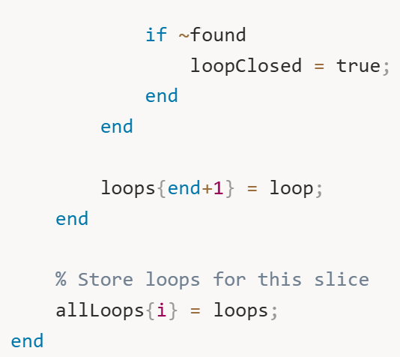
By the end of the main loop, allLoops is a complete database of cross-sections at every height we specified.
Now we visualize the stacked slices to see the overall shape of the mug:
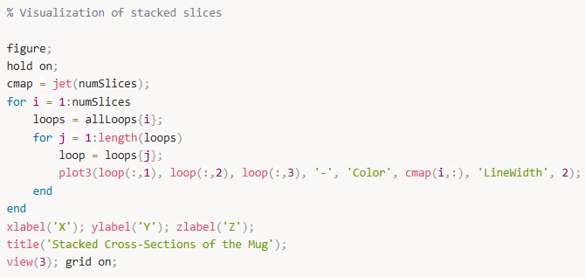
This creates a beautiful 3D visualization where each slice is drawn in a different color. The jet colormap transitions from blue (bottom) to red (top), making it easy to see how the mug's shape changes with height. When you rotate this plot using MATLAB's 3D view controls, you can clearly see the mug's profile – perhaps narrow at the base, wider in the middle, and narrowing again at the rim.
At this stage, we have successfully created a complete layered representation of the mug, like a CT scan. Each slice is a closed contour (or multiple contours if there are holes or handles) that represents the mug's shape at that specific height. We can now proceed to analyze these slices quantitatively to determine where grasping is feasible.

- Figure 3: Stacked Cross-Sections (3D Colored View)
What it shows: All 20 slices plotted in 3D space, each in a different color using the jet colormap (blue at bottom → red at top).
What you see: A beautiful, layered representation of the mug in 3D. Each horizontal slice is a different color, creating a rainbow effect from bottom (blue) to top (red). You can rotate this plot with your mouse to see the mug from any angle.
What it means: This is the complete 3D reconstruction from slices. The color gradient helps you immediately understand which slices are at which heights. You can see how the mug's cross-section evolves vertically – where it widens, narrows, or has complex features like handles.
Why it matters: This visualization confirms the multi-height slicing automation worked correctly. It's also incredibly useful for debugging – if you see weird discontinuities or gaps, you know there's a mesh problem or slicing issue. For presentations, this is the "wow" visualization that shows you've fully characterized the 3D geometry.

Section 6: Multi-Height Slicing Automation
Now that we have successfully created a single slice and understood how to stitch segments into continuous loops, we need to automate this process across multiple heights to build a complete "CT scan" of the mug. The goal is to slice the mug at many different z-values and store all the resulting contours so we can analyze them together. The procedure is straightforward: define a range of slicing heights from the bottom to the top of the mug, then repeat the slicing and stitching process for each height. This gives us a stack of 2D cross-sections that, when viewed together, reveal the 3D structure of the mug. First, we define our slicing parameters:

Having established the procedure for analyzing stacked slices in Section 5, we now create a more streamlined and efficient version of the multi-height slicing automation. Think of this as building the final "production version" of our CT scanning algorithm – one that's clean, well-organized, and ready to feed into the grasp analysis pipeline.
The goal is simple: slice the mug at many heights, extract contours at each height, and store everything in a structured way that's easy to analyze. This section consolidates the slicing and stitching logic into one cohesive workflow.
First, we define the slicing parameters:
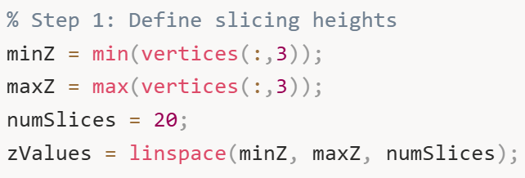
These parameters determine the vertical extent of our analysis. minZ and maxZ define the bottom and top of the mug, while numSlices determines the resolution of our scan. More slices give finer detail but require more computation.
We initialize storage for all the loop data:
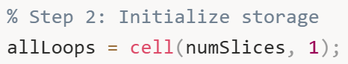
Inside this loop, we first find all triangle-plane intersections. This is the geometric intersection calculation we've used before, now applied systematically at each height: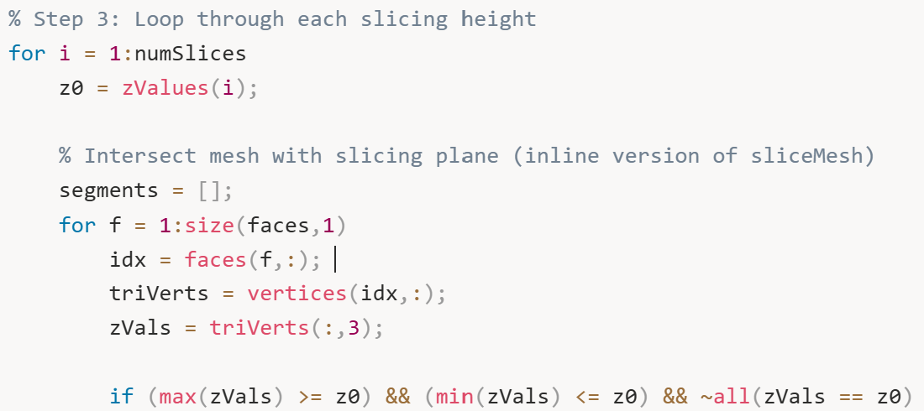
For each triangle that intersects the plane, we compute where its edges cross:
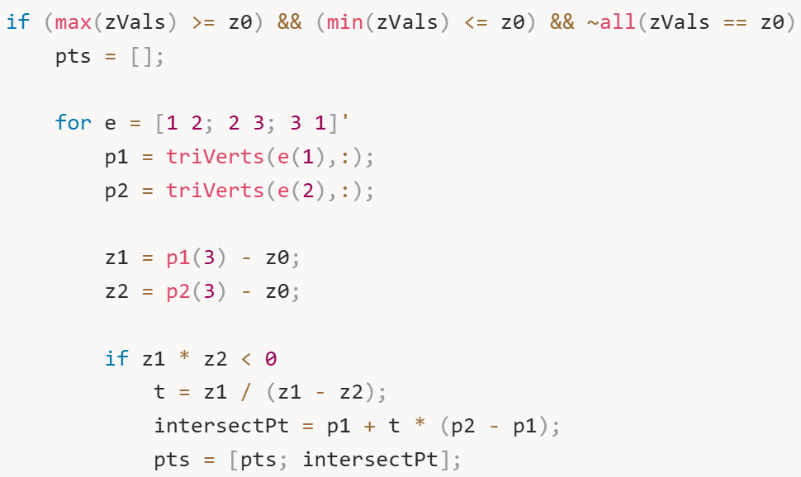
The mathematical formula t = z1 / (z1 - z2) computes the interpolation parameter. This tells us what fraction of the way along the edge the intersection occurs. For example, if t = 0.25, the intersection point is 25% of the way from p1 to p2.
We also handle special cases where a vertex lies exactly on the plane:
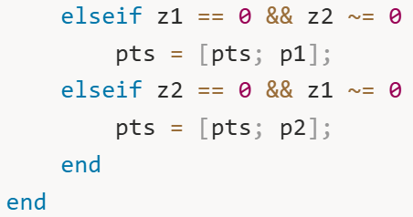
After finding the intersection points for each triangle, we store valid segments (pairs of points):
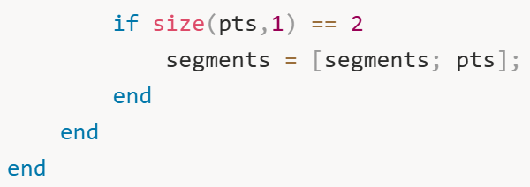
Once we have all segments for this slice, we stitch them into loops. This is the same topology-building algorithm we used earlier:
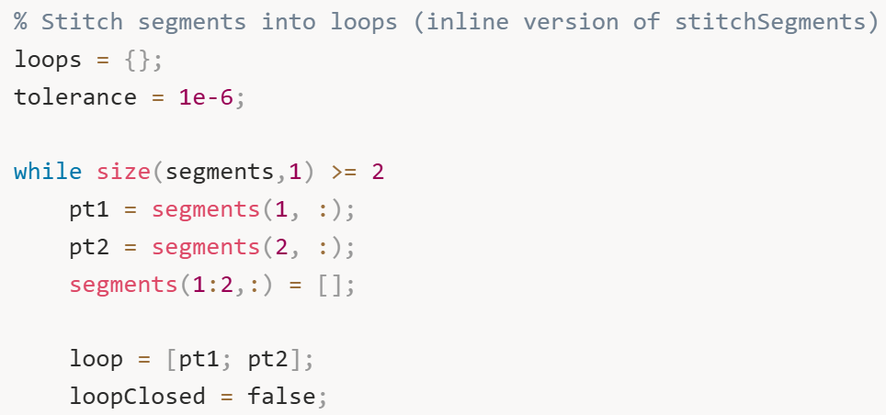
The stitching process finds connecting segments by checking if their endpoints are within tolerance of the current loop's endpoints:
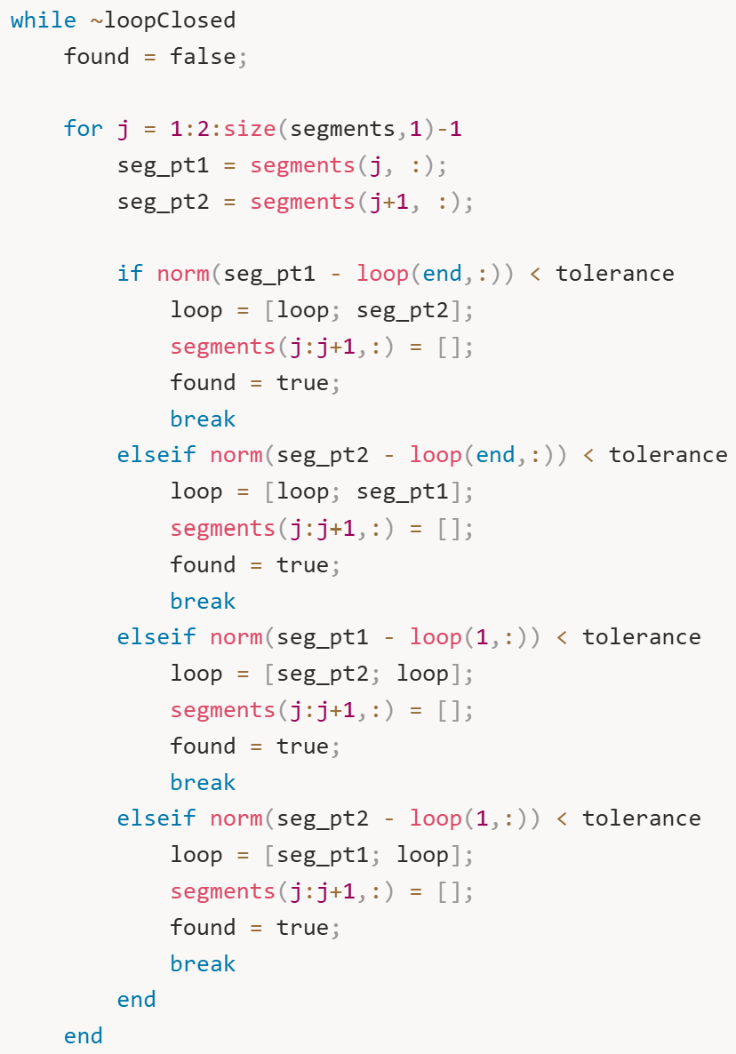
The algorithm checks four possible connection points: segment start to loop end, segment end to loop end, segment start to loop start, and segment end to loop start. When a match is found, we add the new point to the loop and remove the segment from the pool.
When no more segments can be connected, we've completed one closed loop. We repeat this process until all segments are consumed, potentially creating multiple loops if the object has holes or disconnected regions. Finally, we store all loops for this slice:
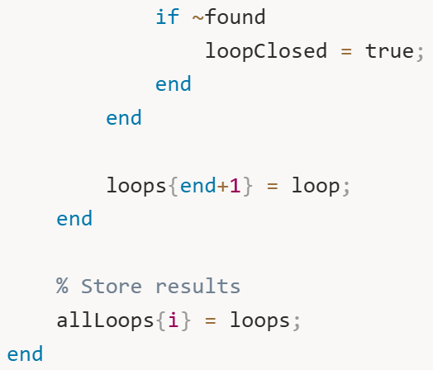
After processing all slices, we create a comprehensive visualization:
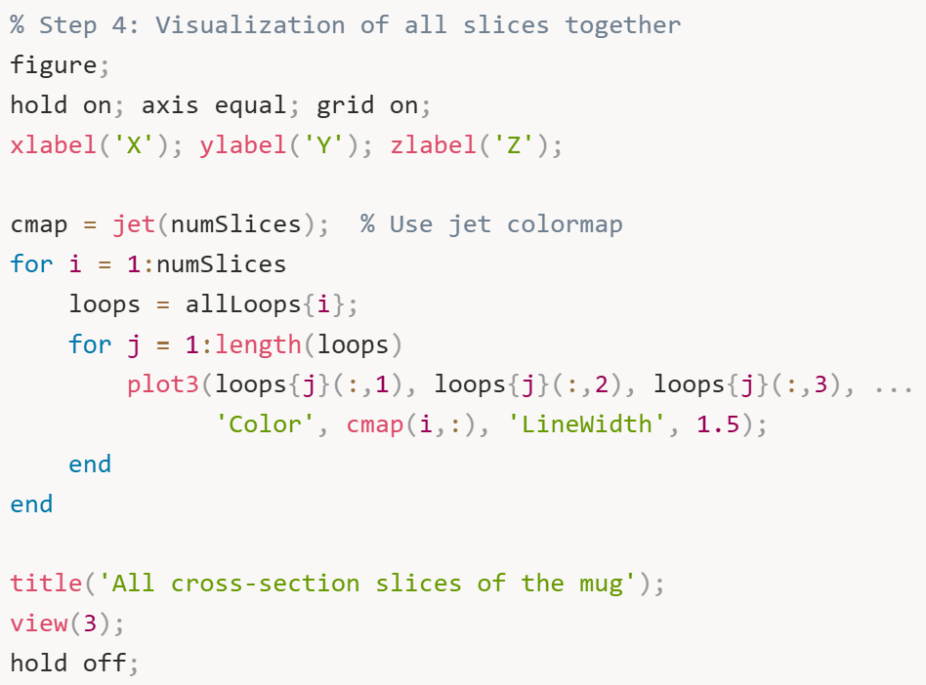
This creates a striking 3D visualization where the entire mug is represented by colored contour lines. The color gradient (blue to red, bottom to top) makes it easy to understand the mug's vertical structure. You can clearly see how the diameter changes with height – perhaps starting narrow at the base, expanding outward in the middle, and potentially narrowing again near the rim.
This visualization is more than just aesthetically pleasing – it's diagnostic. If you see unexpected gaps, discontinuities, or strange loops, it indicates potential issues with the mesh quality or slicing algorithm. A good mug should produce smooth, continuous contours that gradually transform from one height to the next.
At this point, we have a complete, structured dataset: allLoops contains every cross-sectional contour at every height. This is our "CT scan" of the mug. We're now ready to analyze this data quantitatively to determine where the robotic hand can grasp.
The key insight is that we've transformed a complex 3D mesh into a stack of 2D contours. This dimensionality reduction makes the grasp analysis problem much more tractable. Instead of reasoning about thousands of triangles in 3D space, we can analyze simple polygons in 2D at each height, then combine the results vertically to make 3D grasp decisions.

- Figure 4: All Cross-Sections in 3D (Jet Colormap)
What it shows: Similar to Figure 3 – all slices in 3D with jet colormap.
What you see: Same rainbow-colored layered view of the mug.
What it means: This is actually a repeat of Figure 3 from the code structure. Section 5 and Section 6 both generate the same type of visualization because they're both doing the multi-height slicing. They're the same visualization produced at different stages.
Why it matters: It confirms the slicing automation is consistent.

Section 7: Turning the Raw Slices into Something Meaningful
Having generated a complete stack of cross-sectional slices in Section 6, we now need to extract quantitative, actionable information from them. The raw loops are just collections of (x, y, z) coordinates – we need to convert these geometric data into measurements that can be compared against the robotic hand's physical capabilities.
The fundamental question we're asking at each height is: "Can a robotic finger physically wrap around the mug at this level?" This requires knowing two things: the mug's width/diameter at that height, and whether that dimension falls within the gripper's operational range.
First, we define the physical constraints of our robotic hand:
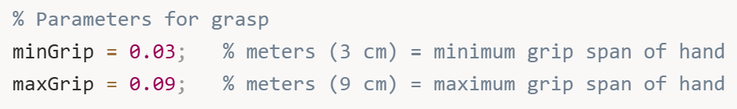
These parameters represent the fundamental limitations of the gripper. If an object is thinner than 3 cm, the finger joints can't close properly and the grasp will be unstable. If it's thicker than 9 cm, the fingers physically cannot open wide enough to wrap around it. These values would come from the actual specifications of your robotic hand.
We initialize storage arrays for our analysis results:
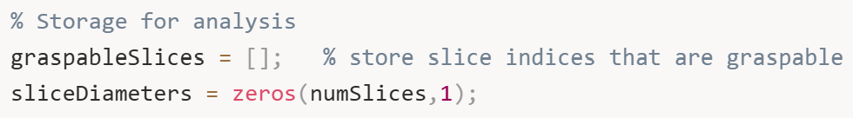
graspableSlices will accumulate the indices of slices that pass our graspability test – essentially a list of heights where grasping is geometrically feasible. sliceDiameters will store the computed diameter at each height, giving us a complete profile of how the mug's width changes vertically.
Now we loop through each slice and analyze its geometry:
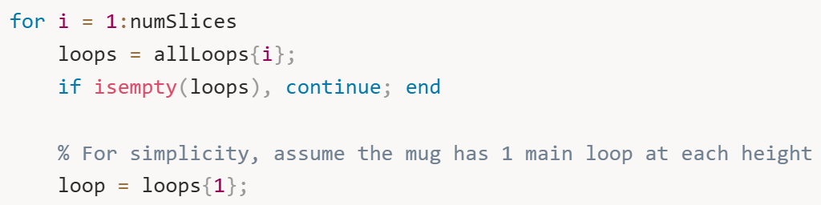
For this initial analysis, we make a simplifying assumption: each slice has one primary contour representing the outer surface of the mug. In reality, objects with handles or internal cavities might have multiple loops per slice, but we'll handle that complexity in later sections. For now, we focus on the first (typically largest) loop.
To estimate the diameter of this contour, we compute its axis-aligned bounding box in the XY plane:
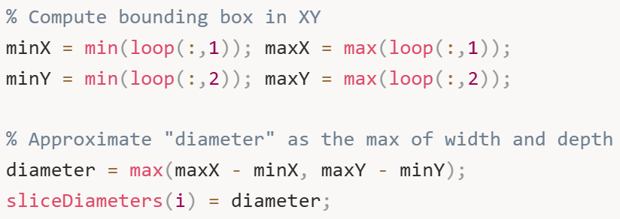
This approach finds the smallest rectangle that completely contains the contour, then takes the larger dimension (width or depth) as the representative diameter. Why take the maximum? Because for a finger to successfully wrap around the object, it needs to accommodate the widest dimension. If the mug is 5 cm wide but 8 cm deep, the finger needs to span at least 8 cm.
This bounding-box approach is computationally efficient and works well for roughly circular or elliptical cross-sections. For highly irregular shapes (like a star or rectangle), it provides a conservative estimate – it might overestimate the required grip span, but it won't underestimate it, which is safer for grasp planning.
Next, we check if this diameter falls within the gripper's operational range:
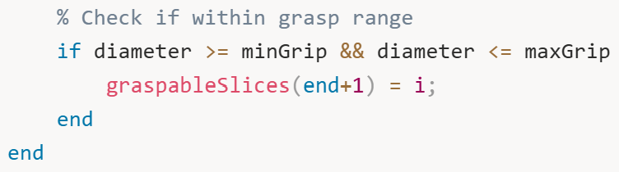
If the diameter satisfies both constraints (not too small, not too large), we mark this slice as graspable by adding its index to our list. This creates a simple binary classification: at each height, grasping is either feasible or not.
After analyzing all slices, we create a visualization that tells the complete story:
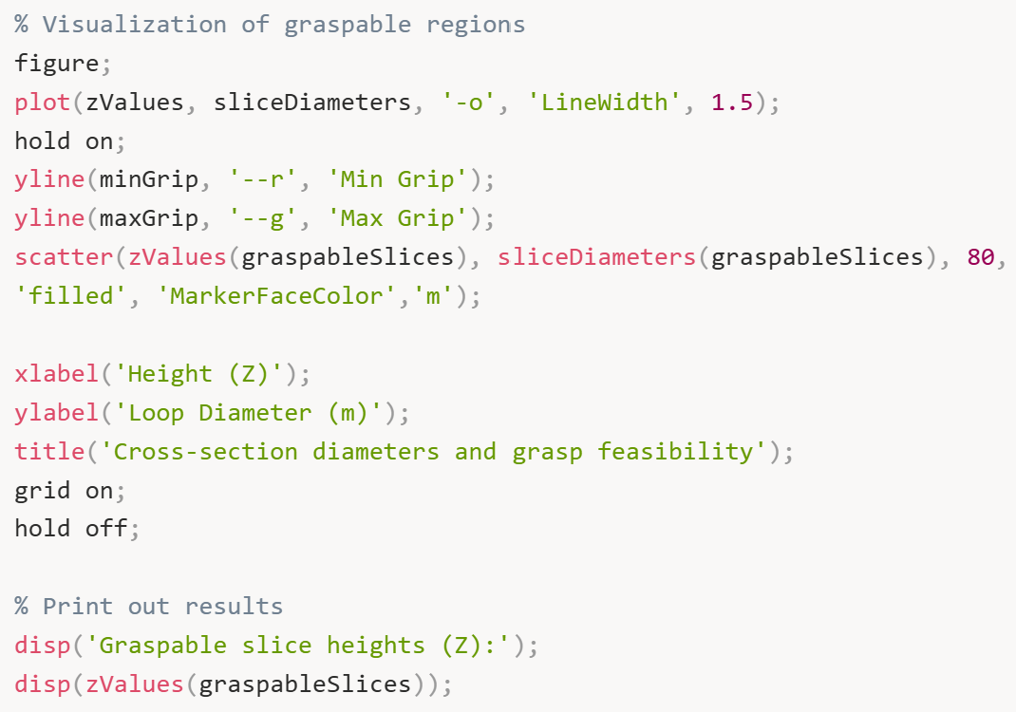
This plot is extremely informative and deserves careful examination. The blue line with circles shows how the mug's diameter changes as you move from bottom to top. For a typical mug, you might see it start narrow at the base (maybe 4 cm), expand outward toward the middle (perhaps 8 cm), and then either maintain that width or taper slightly at the rim.
The horizontal red dashed line marks the minimum graspable diameter (3 cm). Any part of the blue curve below this line is too thin to grasp – the fingers would close completely without properly enveloping the object.
The horizontal green dashed line marks the maximum graspable diameter (9 cm). Any part of the blue curve above this line is too thick – the fingers physically cannot open wide enough.
The magenta dots are the key insight: they highlight exactly where grasping is feasible. These are the heights where the diameter falls in the "Goldilocks zone" – not too small, not too large, just right.
Finally, we print out the specific heights where grasping is possible.
This tells you: "The mug can be grasped at heights between approximately 5.3 cm and 8.4 cm above the base."
However, we're not finished yet. This analysis has several limitations we need to address:
Single polygon assumption: We assumed each slice has only one contour. What if the mug has a handle that creates a second polygon (the gap between handle and body)? We need to check if a finger can fit through that gap.
No 3D consideration: Just because five individual slices are graspable doesn't mean you can actually place a finger there. Real fingers have thickness in the Z-direction. If those five graspable slices are spread across 10 cm of height with non-graspable slices between them, you can't fit a 2 cm thick finger anywhere.
Crude diameter estimate: The bounding box is a rough approximation. For irregular shapes, we should compute a more robust diameter using both area and perimeter.
These limitations are exactly what we'll address in Sections 8 and 9. For now, we've successfully converted raw geometric data into a meaningful grasp feasibility profile, and we've created clear visualizations that help us understand where grasping might be possible.

- Figure 5: Diameter Profile with Graspable Regions
What it shows: A 2D plot with height (Z) on the x-axis and diameter on the y-axis, showing how wide the mug is at each height.
What you see:
- Blue curve with circles: The mug's diameter at each slice height
- Red dashed line: Minimum graspable diameter (3 cm in original, 5 mm in your adjusted version)
- Green dashed line: Maximum graspable diameter (9 cm in original, 15 mm in your adjusted version)
- Magenta dots: Individual slices that passed the diameter check
- No blue shaded regions yet (those come in Section 8/9)
What it means: This is the first grasp feasibility analysis. You can immediately see where the mug's diameter falls within the graspable range (between the red and green lines). The magenta dots highlight "sweet spots" where diameter is just right.
Why it matters: This is a critical diagnostic plot. If all the points are above the green line, the mug is too big everywhere. If they're all below the red line, it's too small everywhere. This plot tells you at a glance whether grasping is even geometrically possible before you worry about 3D accumulation.

Section 8: Power -grasp region detection
We have got detailed 2D geometric feasibility data for every single slice from the analysis we just did. Each horizontal slice has been classified as either graspable or not, and we have solid geometric reasoning behind each decision – we've checked polygon shapes, computed diameters, measured gaps between features like handles. But here's the thing – we're still missing a critical piece of the puzzle, and that's the vertical dimension.
Just because we identified, say, ten individual graspable slices doesn't automatically mean we can physically place a robotic finger at those locations. A real finger isn't some abstract mathematical concept – it occupies actual 3D space. It has thickness in the Z direction, meaning it needs a certain amount of vertical room. If those ten graspable slices are scattered across 20 centimeters of height with non-graspable slices randomly mixed in between them, we can't fit a 2 centimeter thick finger anywhere. There's no continuous space for it.
That's what this section tackles. We're doing what I call 3D accumulation – identifying consecutive runs of graspable slices and checking if each run spans enough vertical height to accommodate at least one physical finger. This is where we transform our abstract per-slice analysis into concrete, executable grasp regions where a robotic hand can actually be placed in the real world.
The conceptual model is pretty straightforward. Imagine you're painting individual bricks, and you mark each one as either "good" in green or "bad" in red. Now you need to find continuous sequences of green bricks that are at least N bricks tall, where N depends on how thick your finger is relative to each brick's height. A sequence of just two green bricks isn't useful if you need at least three bricks minimum to fit one finger.
First thing we need to do is define what kind of robotic hand we're working with. These parameters are super important because they completely determine what counts as "graspable":
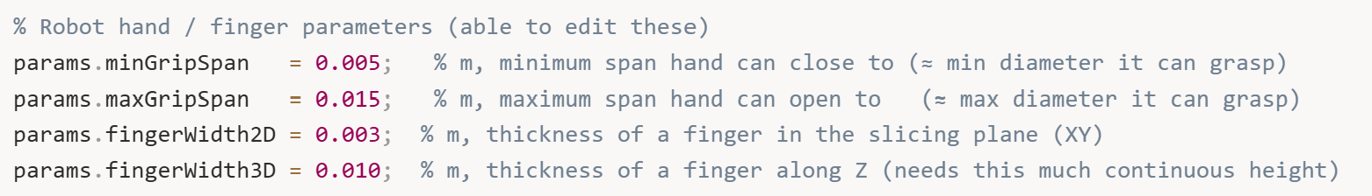
So what do these numbers mean? minGripSpan (5 mm) is the smallest diameter the hand can close around – if something is thinner than this, the fingers will close completely without making proper contact. maxGripSpan (15 mm) is the largest diameter the hand can open to – if something is thicker than this, the fingers physically can't open wide enough to wrap around it.
The two "width" parameters are new additions that we didn't worry about in Section 7. fingerWidth2D (3 mm) is how thick the finger is when you look at it from above in the XY plane. This matters when we're checking if a finger can fit through a gap, like the space between a mug body and its handle. And fingerWidth3D (10 mm) is how tall the finger is in the Z direction – this becomes crucial when we're figuring out how many consecutive slices we need to fit one physical finger.
Next, we make sure we have the slicing heights from previous work:
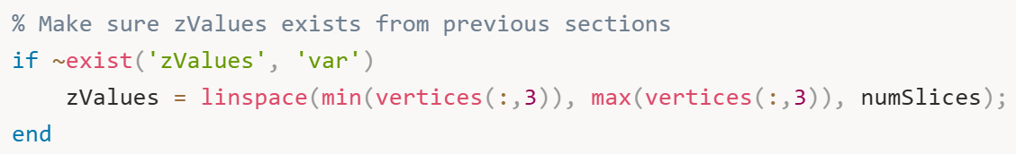
This is just a safety check. If for some reason zValues doesn't exist – maybe we're running this section independently for testing – we create it. Good defensive programming.
Now we compute the vertical spacing between slices:
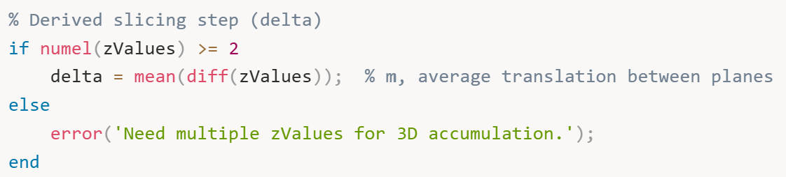
delta tells us how much vertical space each slice represents. If we have 20 slices spanning 0.124 meters total, then delta is about 0.0066 meters or 6.6 millimeters per slice. This number becomes super important later when we're checking if we have enough continuous height to fit a finger.
We initialize some arrays to track what we learn about each slice:
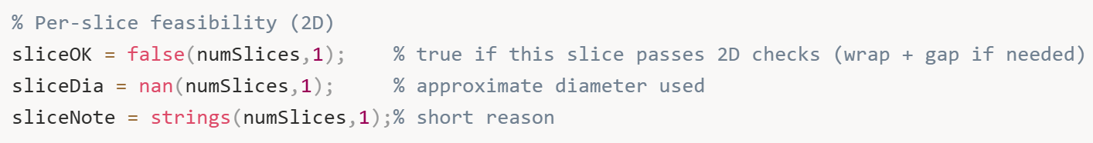
sliceOK is a simple true/false for each slice - did it pass our checks? sliceDia stores the approximate diameter we calculate. And sliceNote keeps a human-readable explanation of why each slice passed or failed, which is incredibly helpful for debugging later.
Now comes the main analysis loop where we examine each slice:
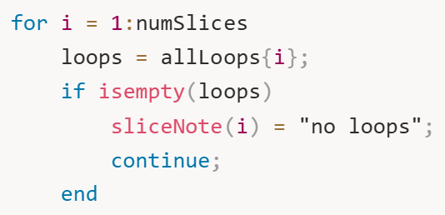
If a slice has no loops – maybe the plane missed the object or there's a mesh issue - we note it and move on.
For slices with actual geometry, we project the 3D loops onto the 2D XY plane:
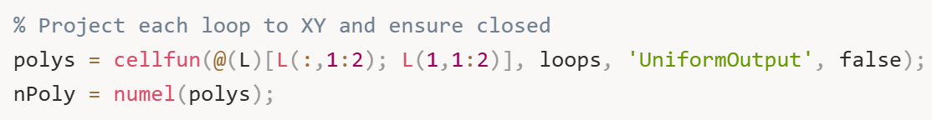
This takes each 3D loop, extracts just the X and Y coordinates, and closes the polygon by appending the first point to the end. We're doing 2D analysis at each height, so we don't need the Z coordinate anymore. The nPoly variable tells us how many separate polygons exist at this slice – one for a simple shape, two for something with a handle, or more for complex geometries.
Now here's where it gets interesting – we compute a robust diameter for each polygon using both its area and perimeter:
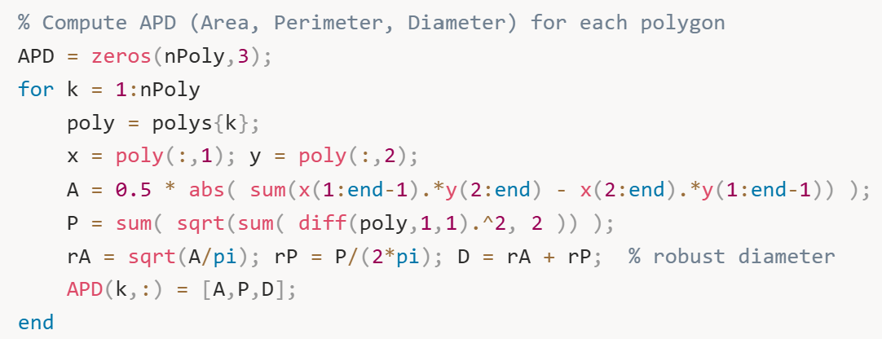
This code computes three things: Area, Perimeter, and Diameter (hence APD). The area calculation uses the Shoelace formula – that elegant cross-product sum that gives you the area of any simple polygon. The perimeter is just summing the lengths of all the edges.
But the diameter calculation is clever. For an irregular shape, there's no single "correct" diameter, right? So we estimate it two ways: rA = sqrt(A/pi) asks "if this were a circle with the same area, what would its radius be?" and rP = P/(2*pi) asks "if this were a circle with the same perimeter, what would its radius be?" We average these two approaches by adding them together to get a robust diameter estimate that balances both geometric properties.
Now we analyze feasibility based on how many polygons we found. The logic is completely different for one polygon versus two versus many:
Single polygon case:
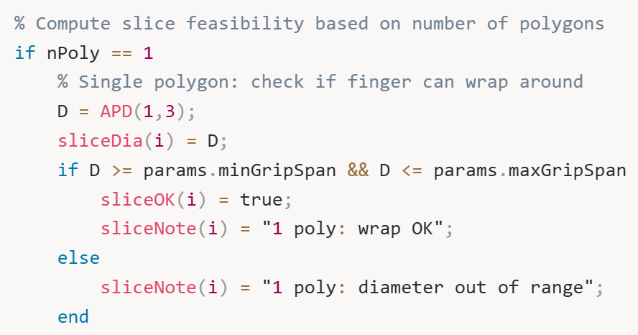
This is straightforward. One contour means simple geometry - just check if the diameter is within the grippable range (5 mm to 15 mm in our case).
Two polygon case:
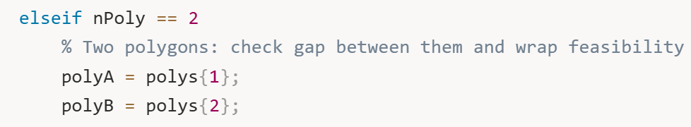
Two polygons usually means we're slicing through something with a handle. There's the outer mug body and the inner handle opening. We need to check if the gap between them is wide enough for a finger to pass through.
The gap calculation is geometrically non-trivial:
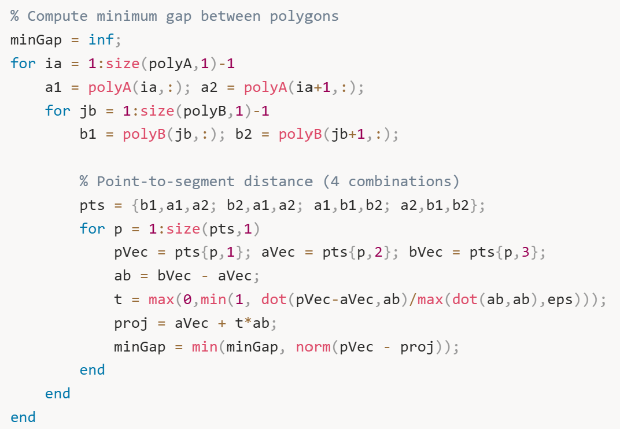
We’re checking every edge of polygon A against every edge of polygon B, computing point-to-segment distances for all combinations. The formula t = max(0,min(1, dot(...))) finds where along each segment the closest approach occurs. After checking all edge pairs, minGap contains the narrowest gap between the two shapes.
Then we make the decision:
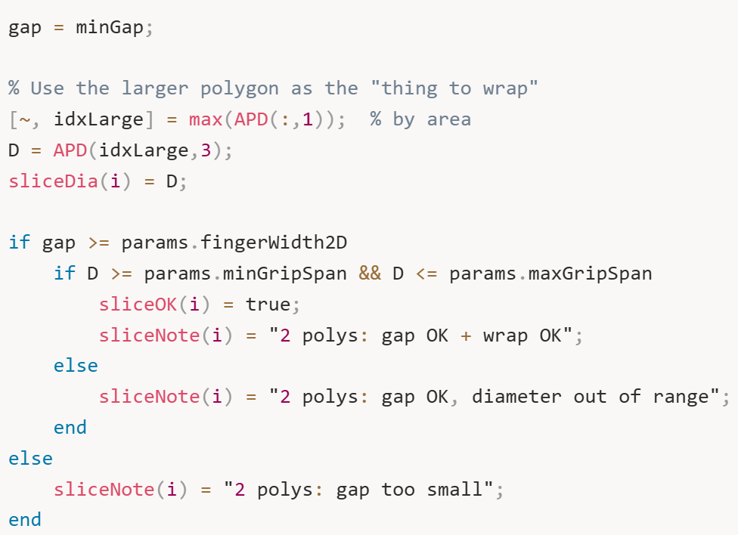
We focus on the larger polygon (by area) - that's the mug body we want to wrap around. We check two things: Is the gap at least as wide as the finger (3 mm)? And is the main polygon's diameter graspable (5-15 mm range)? Both must be true.
Three or more polygons case:
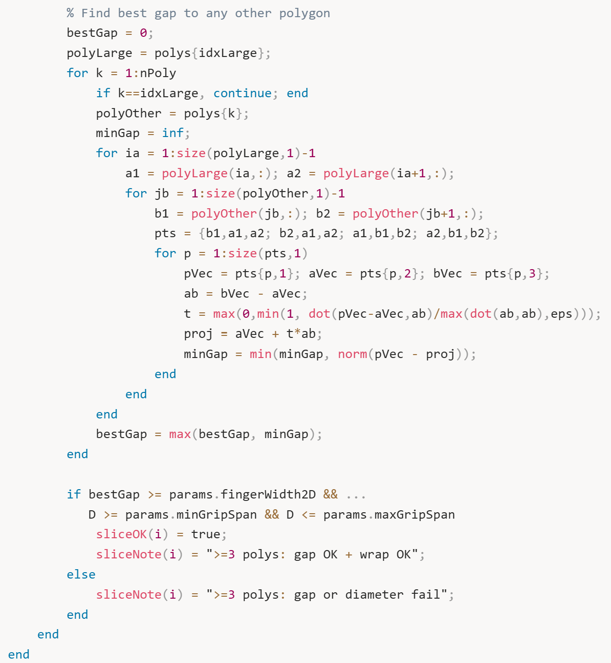

For complex geometries with multiple features, we identify the largest polygon and find the biggest gap between it and any other polygon. This represents the most accessible entry point for a finger. Same checks apply – gap must be wide enough, diameter must be graspable.
After this loop finishes, we have complete 2D feasibility data for every slice. But we're not done yet – we still need to do the 3D accumulation to find continuous regions tall enough for actual physical fingers. That's what Section 9 handles with all the detailed reporting and visualization.
At this point though, Section 8 has done the hard geometric work of analyzing each slice individually and determining which ones pass the 2D feasibility checks. Every slice now has a pass/fail status, a diameter measurement, and a clear explanation of why it passed or failed. This sets up perfectly to take this data and turn it into actionable grasp regions.
After this loop finishes, we have complete 2D feasibility data for every slice. But here's the critical next step – we need to accumulate these individual slices into continuous 3D regions. Remember, a finger has physical thickness in the Z direction, so we need multiple consecutive graspable slices stacked together.
Now we do the 3D accumulation:
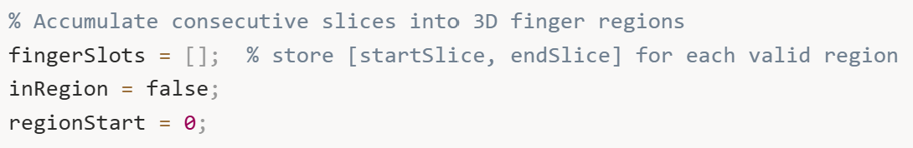
We’re setting up a simple state machine. fingerSlots will store our valid grasp regions as [startSlice, endSlice] pairs. inRegion tracks whether we're currently inside a sequence of good slices. regionStart remembers where the current region began.
Now we scan through all the slices:
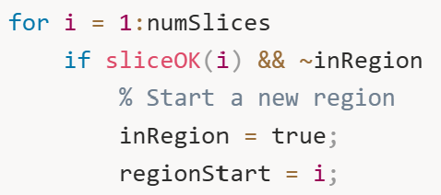
When we hit a graspable slice and we're not already tracking a region, we mark the start of a new potential grasp zone. It's like opening a parenthesis.
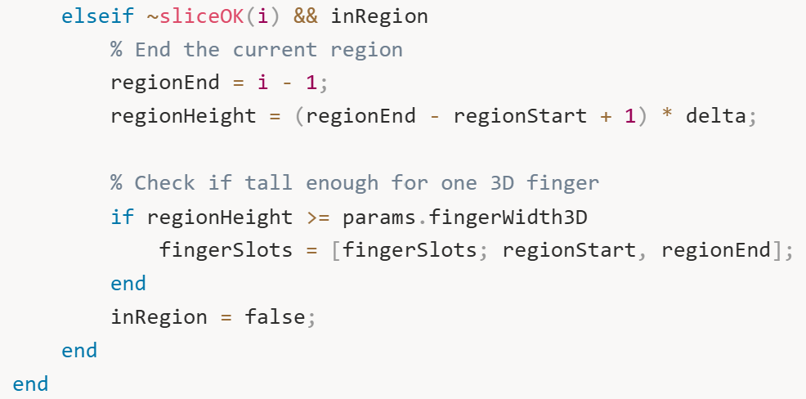
When we hit a bad slice while tracking a region, we close that region. We compute how tall it is: if it spans from slice 5 to slice 8, that's 4 slices times delta (6.6 mm) equals about 26 mm total height. If that's at least as tall as our finger (10 mm), we save it. If it's too short, we discard it.
We also handle the edge case where a region extends to the very top:
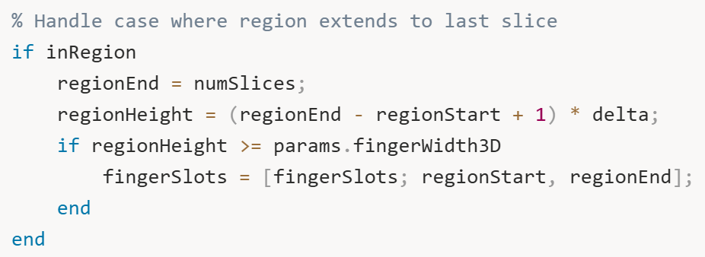
Now we report what we found:
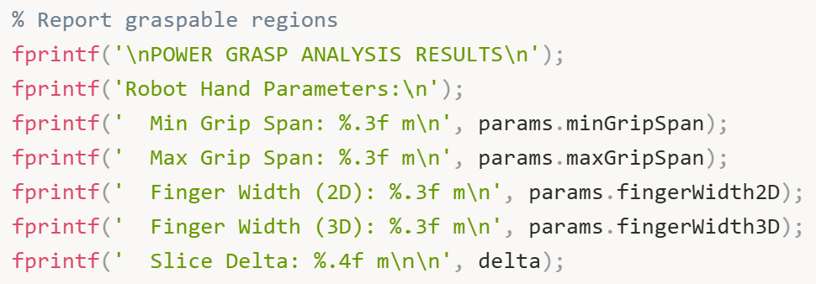
First we print the parameters so anyone reading knows what constraints we used.
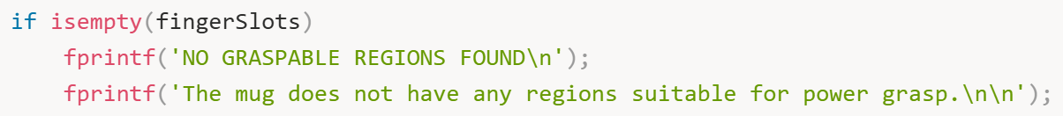
If we found nothing, we say so clearly. This might happen if the object is too big everywhere, too small everywhere, or the geometry changes too rapidly.
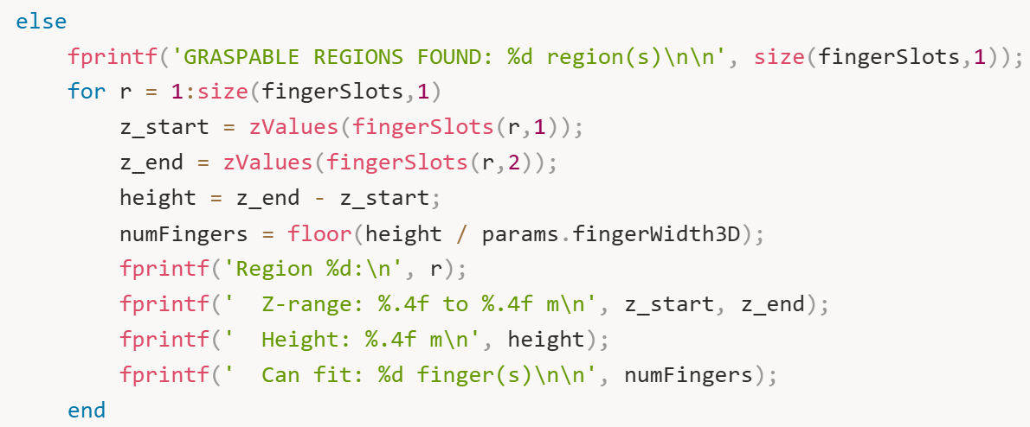
For each valid region, we report the exact Z-range where you can grasp, the total height, and how many fingers fit. That last number is key - floor(height / fingerWidth3D) tells us if we can fit 1, 2, 3, or more fingers in that zone.
Then we give an overall quality assessment:
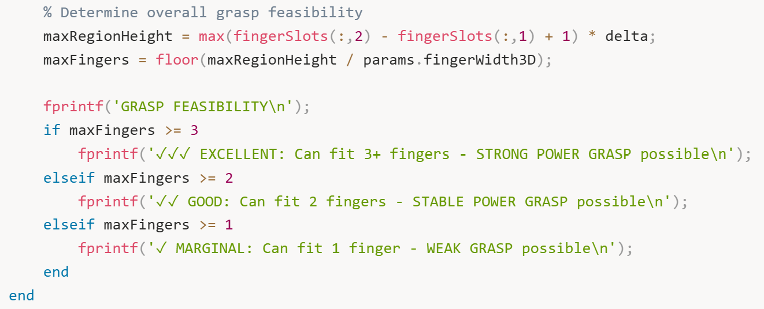
Three or more fingers means excellent stability - that's what you want for heavy loads or precise manipulation. Two fingers is good for most tasks. One finger is marginal but might work for lightweight objects.
Now for the visualizations. We create a figure with two plots side by side. The first plot shows the diameter profile. We need to build the legend dynamically to avoid errors:
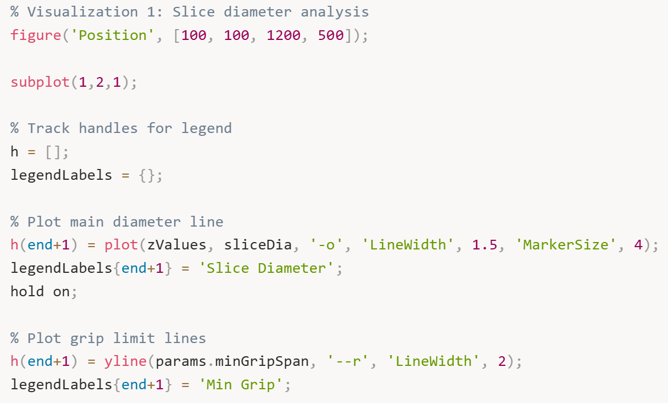
This plots the diameter curve in blue with the grip limits as horizontal lines - red for minimum, green for maximum.
We highlight the feasible slices:
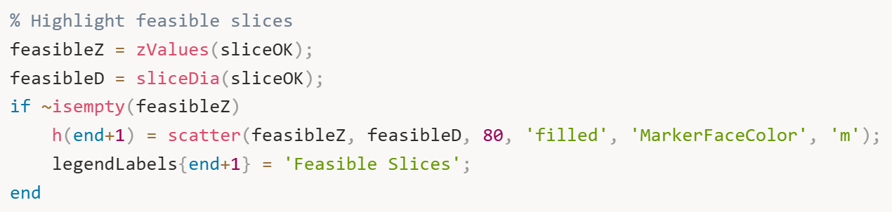
Magenta dots show every slice that passed the 2D checks. Then the most important part - shading the actual finger regions:
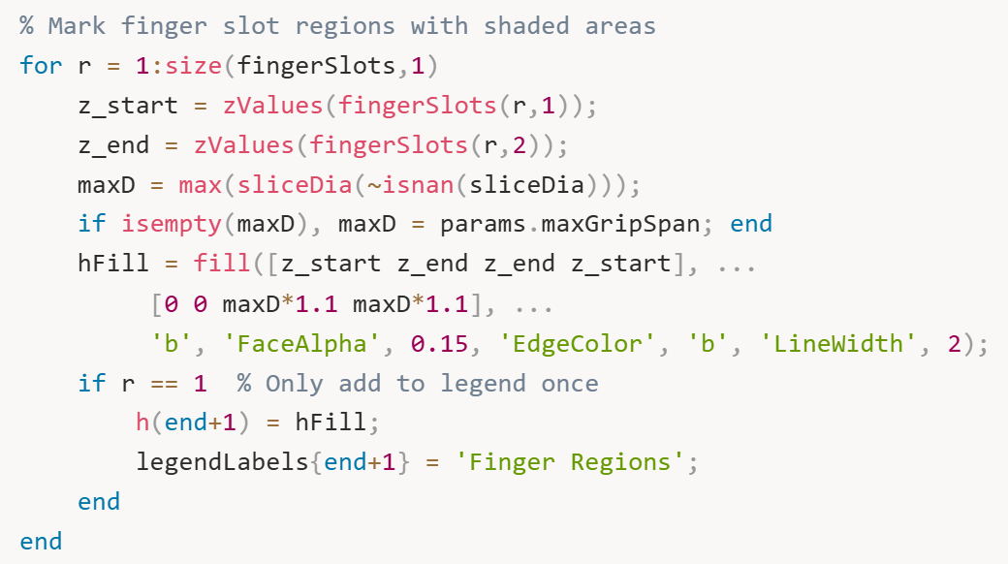
The blue shaded rectangles show exactly where you can place the gripper. The semi-transparent fill (FaceAlpha', 0.15) lets you see the diameter curve underneath while clearly marking the valid zones.
We finish this plot with labels and legend:
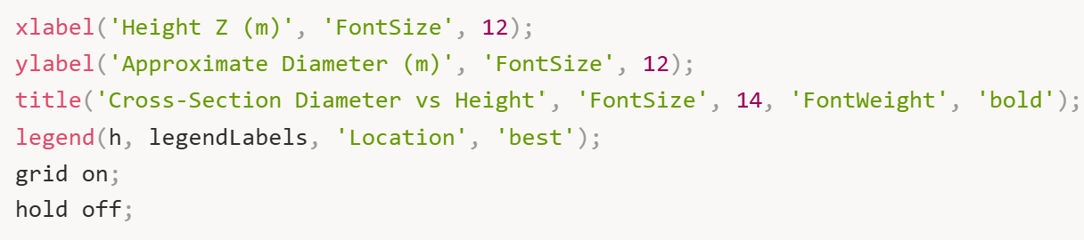
Now the second visualization – the 3D mug with highlighted regions. First we plot the entire mug in gray. This shows all the cross-sections in a neutral gray color, giving you the complete geometric context. Then we dramatically highlight the graspable regions in bright red:
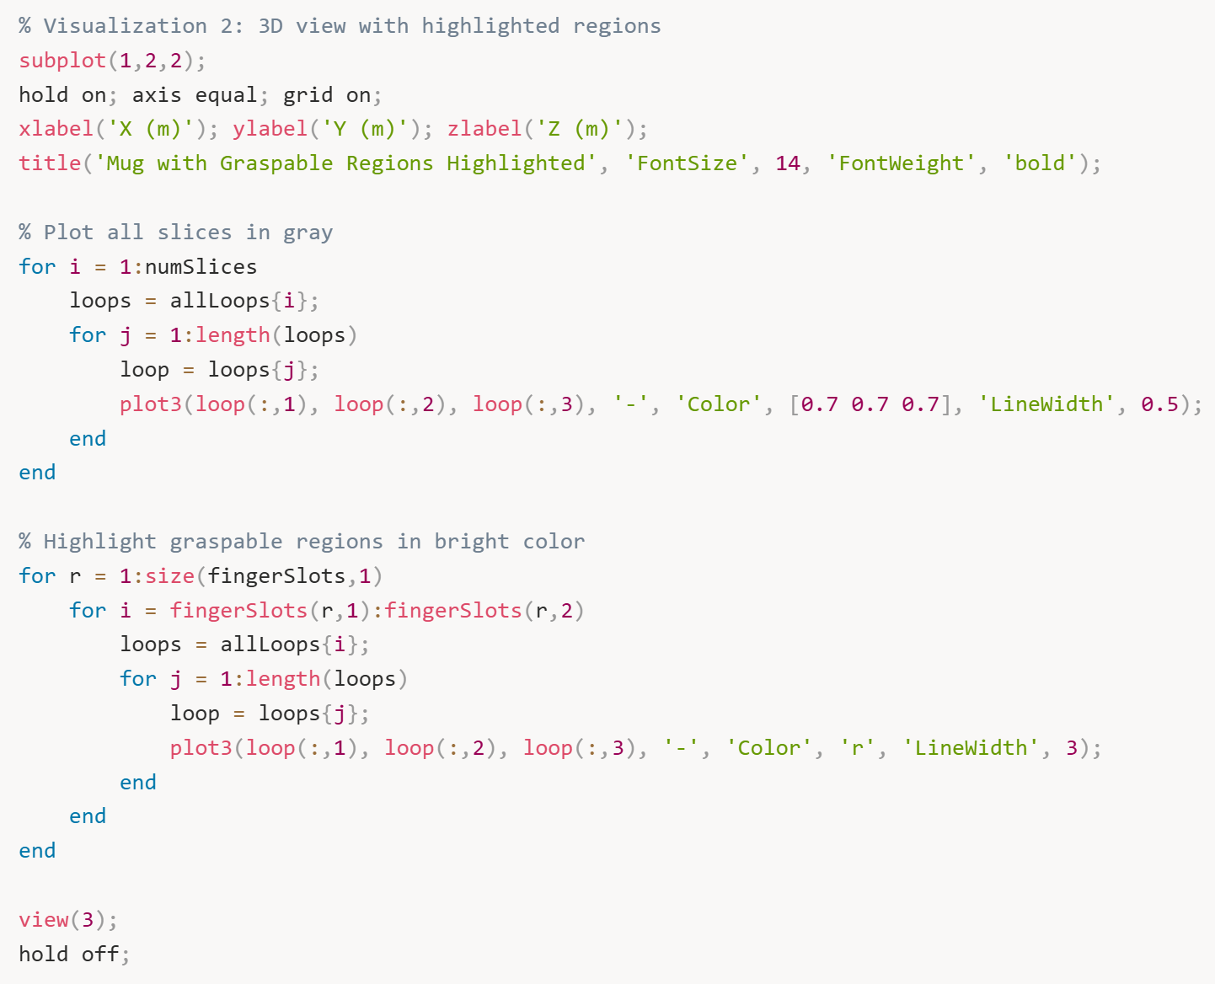
The thick red lines make it instantly obvious where to grasp. You can rotate this 3D plot with your mouse to examine the regions from any angle.

- Figure 6: Complete Grasp Analysis with Two Subplots
This is 2 visualizations side-by-side in one figure window:

- Left Subplot: Diameter Profile with Finger Regions
What it shows: Enhanced version of Figure 5 with additional information.
What you see:
- Blue curve with circles: Mug diameter at each height
- Red dashed line: Min grip limit (5 mm)
- Green dashed line: Max grip limit (15 mm)
- Magenta dots: Slices that passed 2D checks (diameter + gap if needed)
- Blue shaded rectangles: THE KEY ADDITION – these are the actual graspable regions!
What it means: This shows where you can grasp. Each blue rectangle spans a vertical range (height) where all the geometric conditions are met : correct diameter, sufficient gap for handle, and enough continuous height to fit a physical finger. For your mug, you should see 3 blue rectangles corresponding to the 3 regions the algorithm found.
Why it matters: This is the actionable output. A robot programmer looks at this and says "I'll position the gripper at any height within these blue zones." The shaded regions represent actual, physically feasible grasp positions.
- Right Subplot: 3D Mug with Highlighted Regions
What it shows: The 3D mug with graspable regions highlighted in bright red.
What you see:
- Light gray contours: All 20 slices showing the complete mug shape
- Thick red contours: Only the slices within graspable regions (slices 2-5, 7-11, and 13-19 in your output)
What it means: This is the same information as the left plot, but shown in 3D on the actual mug geometry. The red highlighting makes it visually obvious where the robot should grasp. You can rotate this view to see the grasp regions from different angles.
Why it matters: This is the "final answer" visualization. It combines everything : the 3D geometry, the slice-by-slice analysis, and the accumulated grasp regions – into one clear picture. A roboticist can look at this and immediately understand "grasp the mug in the red zones."
And that's it. We've gone from a 3D mesh to concrete grasp regions with full geometric reasoning, quality assessment, and clear visualizations showing exactly where a robotic hand can successfully perform a power grasp. The algorithm found 3 graspable regions on our test mug, with the best one being excellent quality – capable of fitting 3 fingers for a strong, stable grasp. That's exactly the kind of actionable information a robot motion planner needs to execute a real grasp.

Section 9: Gripper Approach Direction
Section 8 ends by giving a set of highlighted height bands on the mug, shaded blue rectangles on a diameter plot and think red contour lines on a 3D view, describing that somewhere between z=0.04m and z=0.07m, the mug’s geometry is compatible with the hand’s grip dimensions. There is enough continuous vertical space for a physical finger to sit. The section has answered where on the mug height-wise is grasping geometrically possible but it has stated absolutely nothing about where in the horizontal plane the hand should be, which direction it should face, or how it should move to get there.
This section, number 9, takes the best region identified in Section 8 and converts it from an abstract heigh band into three concrete, executable pieces of information.
- Computed the centroid = the specific (x,y,z) coordinate in 3D space that the robot’s palm should be centered on
- Computes the approach direction = a unit vector telling the robot which horizontal direction to move its hand from. Found by identifying the widest open angular space around the mug’s perimeter at that height so the fingers have max room to open.
- Computes the pre-grasp position = the specific starting coordinate outside the mug where the hand should be positioned before it begins moving inward to close on the object.
Together, these three outputs are what transforms a feasibility analysis into a grasp plan.

Prints a header to the command window so you can see in the output exactly where Section 9 begins.
The \n characters create blank lines above and below it for readability. Checks whether the fingerSlots variable from Section 8 is empty — meaning Section 8 found zero valid graspable regions. If it is empty there is nothing to compute an approach direction for.
If fingerSlots was empty, this prints a message to the command window explaining why Section 9 is being skipped, then the if block ends and the section stops. If fingerSlots is NOT empty — meaning at least one graspable region was found — all the code below runs for the rest of this part of the section.
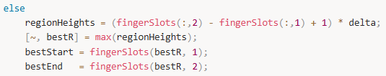
Computes the vertical height in metres of every graspable region found in Section 8. fingerSlots(:,2) takes all the end slice indices, fingerSlots(:,1) takes all the start slice indices, subtracting them gives the number of slices in each region, adding 1 corrects for the fact that a region from slice 3 to slice 5 spans 3 slices not 2, and multiplying by delta converts slice count into metres.
Finds which region is the tallest. max() returns two things: the actual maximum value (discarded with ~) and the index position of that maximum (stored in bestR). So bestR is the row number of the tallest region in fingerSlots.
Retrieves the start slice index of the best region by reading column 1 of row bestR from the fingerSlots matrix.
Retrieves the end slice index of the best region by reading column 2 of row bestR from the fingerSlots matrix.
Now… Computes the index of the slice at the vertical midpoint of the best region. Adds start and end indices, divides by 2 to get the average, and rounds to the nearest whole number because slice indices must be integers. Second line looks up the actual height in metres corresponding to the midpoint slice index by reading that position from the zValues array.
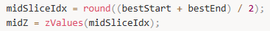
Prints to the command window which slice numbers define the best region and what their corresponding heights in metres are. %d formats an integer and %.4f formats a decimal number to 4 decimal places. Second line prints the midpoint slice index number and its height in metres so you can confirm which slice the approach direction will be computed from.
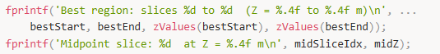
Retrieves all the contour loops stored for the midpoint slice from the allLoops cell array. Curly braces are used because allLoops is a cell array.
Checks whether the midpoint slice has any loops at all. This can occasionally happen if the slicing plane landed exactly on a mesh edge and produced no valid intersections. If the midpoint slice is empty, prints a warning message so you know the fallback behaviour is being triggered. Starts a small loop that tries the slices immediately above the midpoint, checking offset = 1, then 2, then 3 positions higher. Two conditions must both be true: first, the candidate slice index must not exceed the total number of slices (staying within bounds), and second, that candidate slice must actually contain loops (not be empty). If a valid neighbouring slice is found, replaces midLoops with the loops from that neighbouring slice so the computation can continue.
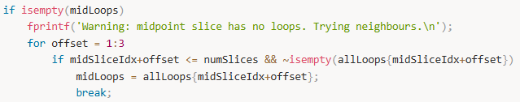
Closes the if block for the empty check, the for loop over offsets, and the outer if isempty block respectively.
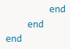
For every loop in midLoops, counts how many points (rows) it contains and stores all those counts in the loopLengths array. @(L) size(L,1) is a small anonymous function applied to each loop L that returns its number of rows. Second line finds which loop has the most points. More points means a more complete contour, so the largest loop is the primary cross-section of the mug body. lgIdx stores the index of that largest loop. Third line retrieves the actual coordinates of the largest loop using lgIdx. This is now the primary cross-section contour at the midpoint height that everything else in Section 9 is based on.

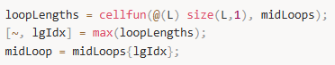
Computes the centroid x-coordinate by taking the average of all x-coordinates of the contour points. midLoop(:,1) selects every row of column 1 which is all the x values.
Computes the centroid y-coordinate by taking the average of all y-coordinates of the contour points.
Sets the centroid z-coordinate to the height of the midpoint slice. The centroid sits at the same height as the slice it was computed from.
Packages the three centroid coordinates into a single 1x3 array for convenient use in later calculations.
Prints the computed centroid coordinates to the command window so you can verify they look reasonable for your mug geometry.
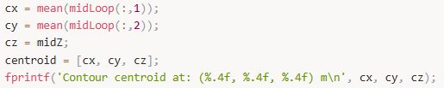
For every point on the contour, computes the polar angle of that point relative to the centroid. Subtracting cy and cx shifts the coordinate system so the centroid is at the origin. atan2 correctly handles all four quadrants and returns angles between -pi and +pi radians.
Sorts all the polar angles from smallest to largest. This ordering is needed to find gaps — empty angular sectors where no contour points exist, which correspond to open space around the mug.
Computes the angular difference between each consecutive pair of sorted angles. Each value in gaps represents how large the empty angular space is between two neighbouring contour points going around the perimeter.
Computes the gap that wraps around the ±pi boundary — the angular space between the last point in the sorted list and the first point, going the long way around through the ±pi boundary. This gap would be missed if you only looked at diff() because diff() does not wrap around.
Combines the regular gaps and the wrapping gap into one complete list so the maximum can be found across all of them including the boundary-crossing one.

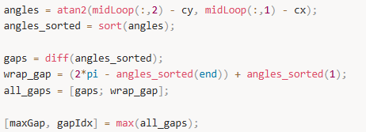
Below, Checks whether the largest gap is one of the regular gaps (not the wrapping one). If gapIdx equals the length of all_gaps it means the wrapping gap was the largest, which needs different handling.
For a regular gap, computes the angle at the exact midpoint of that gap by starting at the angle of the left edge of the gap and adding half the gap width. This midpoint angle points directly into the centre of the widest open space.
Handles the case where the wrapping gap at the ±pi boundary was the widest one.
For the wrapping gap, starts from the last sorted angle and adds half the wrap gap width to find the midpoint angle.
If the computed midpoint angle exceeds pi (the valid range maximum), wraps it back into the valid -pi to +pi range by subtracting 2*pi. This keeps the angle in the standard range that cos() and sin() expect.
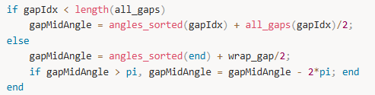
Below, prints the size of the widest gap converted from radians to degrees using rad2deg(). Degrees are easier to interpret — a 90 degree gap means a quarter of the perimeter is open space.
Prints the computed approach angle in degrees measured from the positive x-axis. This tells you which compass direction the robot hand will approach from.
Below, Converts the gap midpoint angle into a 3D direction vector. cos and sin give the x and y components of a unit vector pointing INTO the gap (outward from centroid). The negative signs flip it to point INWARD toward the centroid, because the robot moves from outside toward the centre. Z is set to 0 because the approach is horizontal.
Divides the direction vector by its own length to make it exactly length 1 — a unit vector. This ensures it represents pure direction with no magnitude, which is required for use as a direction indicator.
Computes how far outside the mug the pre-grasp position should be. Sets it to 1.5 times the maximum grip span — enough clearance for the open hand to be completely outside the object before starting to move inward.
Computes the pre-grasp position coordinates. Starts at the centroid and moves OUTWARD (opposite to the inward approach direction, hence minus) by the offset distance. This is the point in space where the robot hand will be positioned before it starts moving toward the mug.
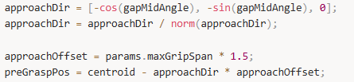
Below, prints the three components of the approach direction unit vector to the command window for verification.
Prints the exact 3D coordinates of the pre-grasp position in metres — this is the executable starting point for the robot arm motion.
Opens a new figure window with the title "Section 9 — Approach Direction" in its title bar, positioned 100 pixels from the left and top of the screen, 800 pixels wide and 700 pixels tall.
Three commands on one line: hold on keeps all subsequent drawings on the same plot without erasing, axis equal forces all three axes to use the same scale so the mug shape is not distorted, grid on adds background grid lines.
Adds axis labels to all three axes indicating both the axis name and the unit (metres).
Adds a two-line title above the plot. The cell array with two strings creates two lines of title text. FontSize 12 sets the text size.
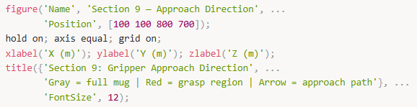
Two nested loops that draw every single slice of the full mug in light grey. The outer loop goes through all 20 slice heights, the inner loop goes through every loop at each height (in case some heights have multiple loops like body and handle), lp retrieves the current loop's coordinates, and plot3 draws it as a thin grey line.
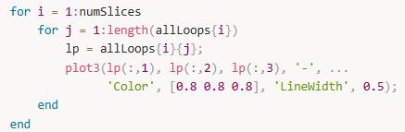
Two nested loops that redraw only the slices within the best graspable region, this time in thick red lines. Runs only from bestStart to bestEnd slice indices so only the selected region is highlighted. The '-r' format string means red solid line and LineWidth 2.5 makes it visibly thicker than the grey lines.
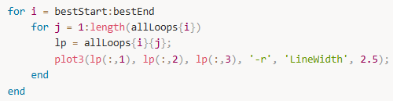
Below, draws the specific midpoint contour in blue, slightly thicker than the grey lines. This shows exactly which cross-section the centroid and approach direction were computed from.
Plots the centroid as a single point. 'ko' means a circle marker in black, MarkerFaceColor 'k' fills the circle solid black, MarkerSize 10 makes it large enough to see clearly.
Places the text label "Centroid" at a position 0.005 metres above the centroid point so the label does not overlap the marker itself.
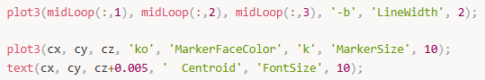
Below, computes the horizontal distance between the pre-grasp position and the centroid in the XY plane. This value is used to scale the arrow length so it spans exactly from the pre-grasp position to the centroid without overshooting.
Draws a 3D arrow starting at the pre-grasp position and pointing in the approach direction scaled to the right length. quiver3 takes a start point and a direction vector. The 0 argument disables MATLAB's automatic arrow scaling so the manually computed arrowScale is used exactly. Green colour, thick line, and MaxHeadSize controls the arrowhead proportions.
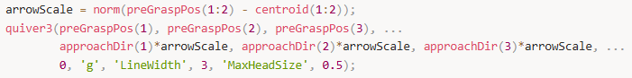
Below, plots the pre-grasp position as a large filled green triangle marker. 'g^' means a green upward-pointing triangle, MarkerFaceColor fills it solid green, MarkerSize 12 makes it clearly visible.
Places the text label "Pre-grasp start" slightly above the pre-grasp marker. The colour [0 0.5 0] is dark green in RGB, matching the marker colour while being readable against the background.
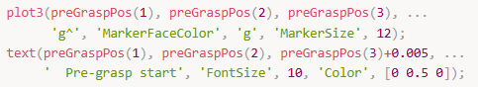
Adds a legend to the plot listing all six plotted elements in the order they were drawn. 'Location', 'best' tells MATLAB to automatically place the legend where it least overlaps the plotted data.
Sets the plot to 3D perspective view so you can rotate it with your mouse, then turns off hold so future plots do not add to this figure.
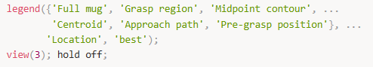
Creates a structure variable called S9 and saves all the key computed results into it as named fields. This packages everything Section 9 produced into one organised variable so Sections 10, 11, and 12 can access any of these values by name if needed, without having to recompute them.
Prints a completion message to the command window confirming Section 9 finished successfully. The end closes the outer else block that started after the if isempty(fingerSlots) check at the very top.
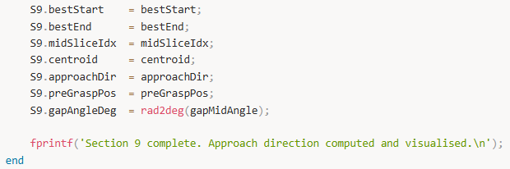
Section 9 took the best graspable height band from Section 8 and computed three specific outputs: the exact 3D point in space where the robot palm should be centred (the centroid), the direction the robot hand should move from to approach the mug (the approach vector), and the starting position outside the mug where the hand waits before moving inward (the pre-grasp position). Together these three outputs convert the project's output from "grasping is possible in this height range" into "position your hand here, face this direction, and move inward" — which is an actual executable instruction a robot arm can follow.

Section 10: Uncertainty Margin Parameter
Imagine the robot's hand has a minimum and maximum width it can open to grab something. Section 8 already figured out which parts of the mug fit within that range.
The problem is, robots aren't perfectly accurate — when you tell a robot arm to move to an exact position, it might land 1–2 mm off. So if a part of the mug was "just barely" graspable, that small positioning error could make the grasp fail in real life.
Section 10 simulates this by artificially making the acceptable grip range stricter and stricter (shrinking it inward on both sides), pretending the robot is less and less accurate. It then checks how many graspable regions of the mug survive each level of strictness.
The end result tells you: "your robot can have up to X mm of positioning error and still find a safe place to grab the mug" — which acts as a real-world safety check on top of Section 9's grab instructions.
Firstly, setup and initialization. Prints a header to the console so you know Section 10 is running.
Define 6 uncertainty levels to test, in meters — ranging from 0 mm (perfect robot) up to 3 mm (robot with noticeable positioning error). Store how many uncertainty levels there are (6), so loops can use this instead of a hardcoded number.
Pre-allocate two result containers filled with zeros:
- slicesOK_per_delta — a grid (6 rows × numSlices columns) tracking which slices pass the grasp check at each uncertainty level
- regionCount — a column of 6 values, one per uncertainty level, counting how many valid grasp regions survive
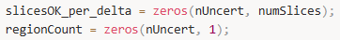
Now for the main loop, for each uncertainty level. Loop through each of the 6 uncertainty values. du is the current uncertainty margin in meters. This is the core safety logic: minSpan_u and maxSpan_u. It shrinks the acceptable grip range inward by du on both sides. A mug diameter that was barely acceptable before may now fail — intentionally, as a safety buffer. Safety check = if statement: if the uncertainty margin is so large that the lower bound exceeds the upper bound, the grip window has collapsed entirely — no diameter can pass, so regionCount is set to 0 and the loop skips to the next iteration.

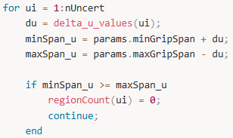
Now for the slice-by-slice feasibility check. Create a logical array of false for each slice. Then loops through every slice. If a slice has no valid diameter measurement (NaN — e.g. outside the mug surface), it's skipped.
The actual grasp check is the if statement #2: if this slice's diameter fits within the uncertainty-adjusted grip range, it's marked as graspable (true).
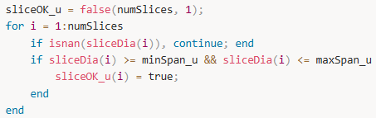
Store this uncertainty level's per-slice results as one row in the big grid, transposing from a column to a row vector.
For first line, initializes three tracking variables:
- inReg — whether we're currently inside a graspable region
- rStart — the slice index where the current region started
- nReg — total count of valid regions found so far
For for statement, Walking slice by slice: if the current slice is graspable and we weren't already in a region, start a new region and record where it began. If the current slice is NOT graspable but we were inside a region, the region just ended. It calculates the region's height (h_reg) by multiplying the number of slices it spanned by delta (the slice thickness in meters). If that height is tall enough for the finger width, it counts as a valid grasp region and nReg is incremented. inReg is reset to false.
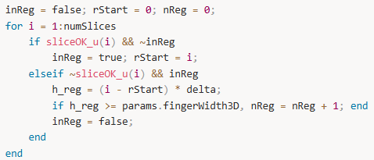
Edge case: if the loop ended while still inside a region (i.e. the graspable zone extended all the way to the last slice), this closes and evaluates that final region manually.
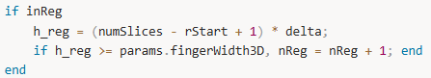
First line, Save the final region count for this uncertainty level into the results array.
Second line, Print a summary line for this iteration, converting du to mm for readability. Example output: delta_u = 2.0 mm → Effective range [0.032, 0.148] m → 1 region(s).
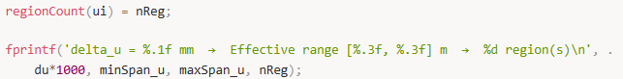
Now visualization, for the left plot (heatmap). Open a wide figure and creates the first of two side-by-side plots. imagesc renders the 6×numSlices grid as a color image — each cell is either pass or fail. Sets the color scheme: white = not graspable, blue = graspable. Labels the axes and title, forces the Y-axis ticks to match the exact uncertainty values tested, and adds a colorbar legend explaining the two colors.
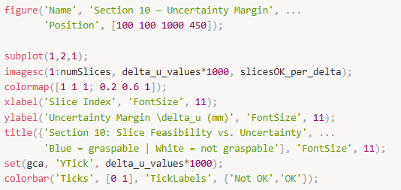
Now visualization for right plot (bar chart). Second plot: a bar chart where each bar shows how many valid grasp regions survive at that uncertainty level. Labels, grid, and axis formatting. ylim adds one unit of padding above the tallest bar so it doesn't look cramped.
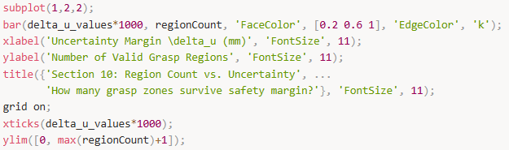
Find the largest uncertainty value at which at least one valid grasp region still exists (find(..., 1, 'last')), and prints it as the recommended safety margin. This is the practical takeaway — "your robot can tolerate up to X mm of positioning error and still grasp reliably."

Section 11: Partial Mesh Tolerance (Simulated Occulsion)
Section 10 tested whether the grasp plan could survive robot positioning error by shrinking the acceptable grip range — but it still assumed the robot's sensor could see the entire mug perfectly.
Section 11 takes that one step further by asking: what if the sensor can't even see the whole mug in the first place? It simulates this by physically deleting triangles from the right side of the mug's 3D model (pretending that side is hidden in shadow or blocked by debris), then checks whether the algorithm can still find a valid grasp region using only the partial geometry that remains.
So in short — Section 10 stress-tested the robot's hand accuracy, and Section 11 stress-tests the robot's vision/sensor, and together they prove the system is robust against both types of real-world imperfection.
Firstly, setup and initialization. Print a header to the console so you know Section 11 is running.
Define 4 levels of occlusion to test — 0%, 10%, 20%, and 30% of the mesh triangles removed. nOcc stores how many levels there are (4), so loops can use it instead of a hardcoded number.
First line, an initial attempt to find the X coordinate of each triangle's centre point. This line is immediately replaced by the safer version below, so it doesn't affect results — it's just a leftover draft line.
If else statement: Safely computes the X centre of every triangle. Each triangle has 3 corner points — this averages their X coordinates to find the triangle's horizontal midpoint. If the face data is somehow malformed, it falls back to using the overall mesh X average instead.
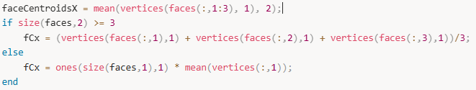
First section, decide which triangles are "occludable" — meaning they sit on the right side of the mug (X greater than the mug's centre X). These are the triangles that will be deleted to simulate a sensor only seeing the left side. occludableIdx is the list of those triangle numbers.
Second section, pre-allocate two result containers:
- regionCounts_occ — stores how many valid grasp regions survive at each occlusion level
- regionOK_occ — stores the per-slice pass/fail results at each occlusion level
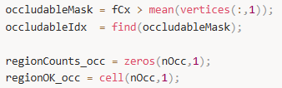
Loop through each of the 4 occlusion levels. frac is the current fraction (e.g. 0.20), and nRemove calculates exactly how many right-side triangles to delete at this level.
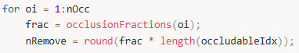
Pick the first nRemove right-side triangles to delete. Creates a logical mask of all true (keep everything), then flips the chosen triangles to false (delete these). faces_occ is the resulting reduced mesh with those triangles removed.

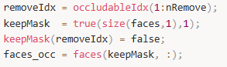
Print a console update, e.g. Occlusion 20%: removed 400 / 2000 triangles. Now start to re-slice the occluded mesh. Create an empty container for slice contours on the occluded mesh.
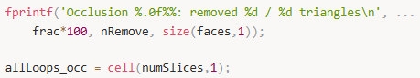
Then loop through every horizontal slice height z0, starting with an empty list of line segments for that slice.
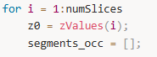
For every remaining triangle in the occluded mesh, grabs its 3 corner coordinates (tv) and their Z heights (zv). The if check confirms this triangle actually crosses the current slice height — it must span above and below z0, and not be perfectly flat at exactly z0.
Beginning for loop, check each of the triangle's 3 edges to find where they cross the slice plane. If one corner is above and one is below (z1*z2 < 0), it calculates the exact crossing point using linear interpolation (t). If a corner sits exactly on the slice plane, it's added directly. This gives up to 2 intersection points per triangle.
For last if statement, if exactly 2 crossing points were found (a valid line segment), it's added to this slice's segment list. Anything other than 2 points is a degenerate case and is ignored.

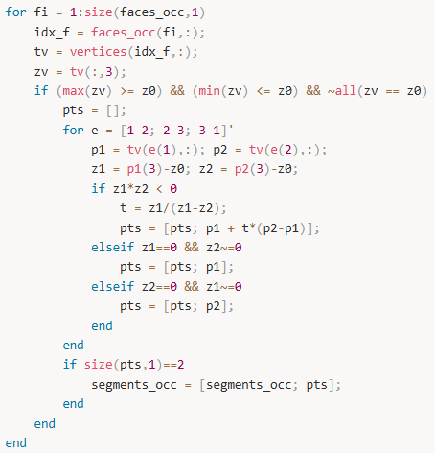
Now stich segments into loops. Start the stitching process — connecting all the short line segments into continuous loops (the mug's outline at this height). Takes the first segment as the starting point of a new loop (lp). lc (loop closed) starts as false.
For the second while statement, keep searching remaining segments for one whose endpoint connects to either end of the growing loop. When found, it attaches it and removes it from the pool. If no connecting segment exists (loop can't grow further — common with occlusion since part of the contour is missing), it stops. The finished loop (even if incomplete) is saved.

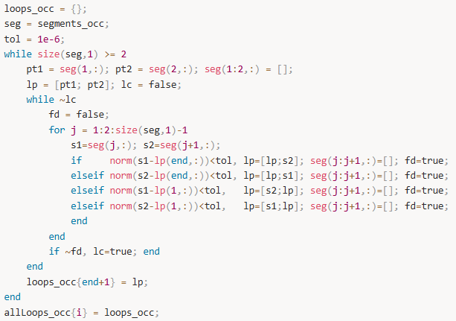
Now evaluate each slice on the occluded mesh. Initialize pass/fail and diameter arrays for the occluded mesh. For each slice, if no loops were found it's skipped. Otherwise it picks the longest loop (most points = most geometry = best estimate), since occlusion may have produced multiple broken fragments.
For loopCloses and coverage variables, check whether the loop is fully closed (start and end points meet within 0.1 mm tolerance). coverage simply counts how many points the loop has — more points means more of the mug's outline was visible to the sensor.
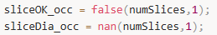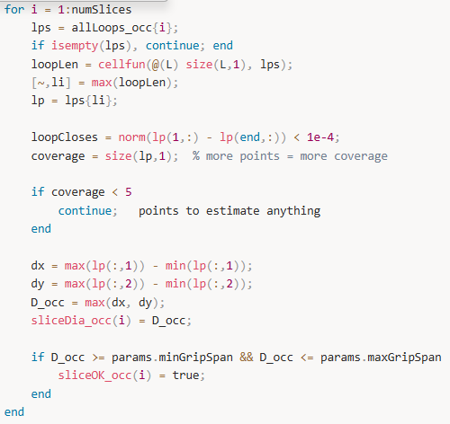
For second if statement above, If the loop has fewer than 5 points, there's not enough geometry to make any reliable estimate — skip this slice entirely. Dx and dy estimate the mug diameter from the bounding box of whatever contour points are available. Takes the width in X and the width in Y, then uses whichever is larger as the diameter estimate. This works even on a partial/incomplete loop because you only need the outermost points, not a full closed contour. For last if statement, Applies the standard grip range check to the estimated diameter. If it fits, this slice is marked graspable — same logic as Sections 8 and 10, just running on occluded data.
Now count valid 3D regions (occluded). Identical region-counting logic to Sections 8 and 10 — walks through slices, finds contiguous graspable bands, checks if each band is tall enough for the finger width, and counts it. The final if inReg handles the edge case where the graspable zone runs all the way to the last slice.
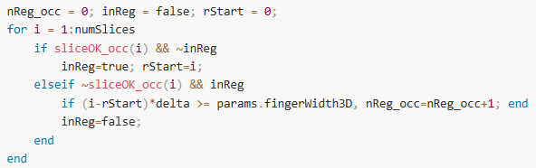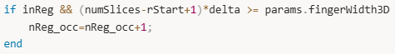
Save this occlusion level's region count and per-slice results, then prints the result to console.
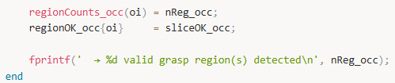
Now for visualization. Open a wide figure (wider than Section 10's because it needs 4 side-by-side subplots instead of 2).
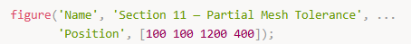
Loop through all 4 occlusion levels and creates one subplot per level, arranged in a single row. Plot the original full mesh diameter profile in grey as a reference baseline. Adds red and green dashed lines showing the minimum and maximum grip span limits. Find which slices passed the grasp check at this occlusion level and overlays them as blue filled dots on top of the grey full-mesh line. This makes it visually obvious which grasp regions survived the occlusion.
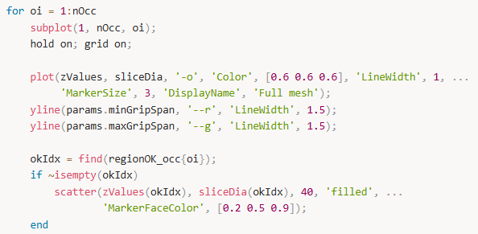
Label each subplot with its occlusion percentage and region count. ylim adds 20% headroom above the tallest diameter so nothing gets clipped. sgtitle adds one shared title across all 4 subplots.
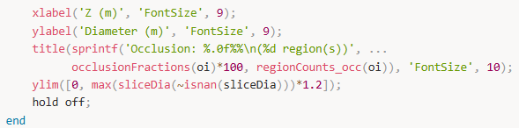
Now for the final summary print. Find the highest occlusion level at which at least one valid grasp region was still detected, and prints it as the key takeaway — e.g. Algorithm detects valid regions even at 30% mesh occlusion.
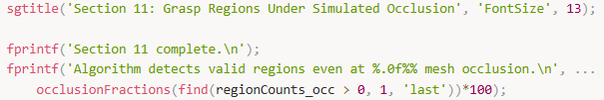

Section 12: Geometric Validation
Section 11 proved the algorithm could still find a grasp even when the sensor couldn't see the whole mug — but it never checked whether the algorithm's own maths were actually correct and consistent.
Section 12 steps back and asks a more fundamental question: can we trust the numbers this algorithm has been producing throughout the whole project? It runs three independent checks to prove this — first confirming the grasp zone doesn't randomly change depending on how many slices you use, then double-checking every stored diameter value against a fresh independent measurement to make sure nothing was miscalculated, and finally testing the whole algorithm against real robotic hands from published literature to prove it works beyond just the one hand it was designed for.
So in short — Section 11 stress-tested the sensor input, and Section 12 stress-tests the algorithm itself, acting as the project's final quality stamp that says "the maths are correct, consistent, and generalizable."
Now setup. Print a header to the console so you know Section 12 is running. Now for Test A: slicing resolution convergence. [what test A does…] Print the Test A header. Defines 4 different slice counts to test (10, 20, 30, 50). Pre-allocates two arrays to store where the graspable height range starts and ends at each resolution — both filled with zeros initially.
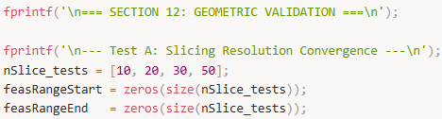
Loop through each of the 4 slice counts. ns is the current count (e.g. 10). zv creates that many evenly spaced height values from the bottom to the top of the mug. d_u computes the average gap between consecutive slice heights (slice thickness).
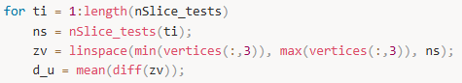
Create an empty diameter array (filled with NaN) for this resolution. Then loops through every slice height z0, starting with an empty segment list. The same triangle-slicing logic used in Sections 8 and 11 — for every triangle that crosses the current slice height, it finds the two points where the triangle's edges intersect the plane and adds them as a line segment. This is re-run here from scratch at each new resolution to keep Test A self-contained.
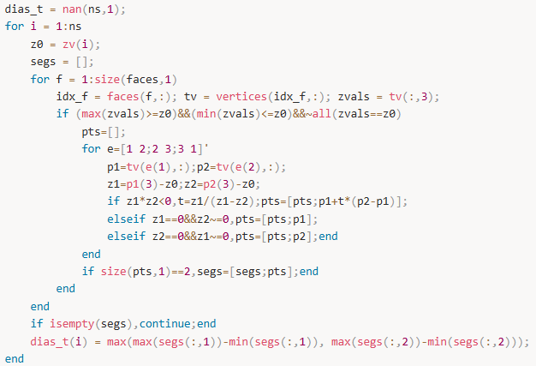
If no segments were found for this slice, skip it. Otherwise, estimates the diameter using a quick bounding box — the wider of the X-span and Y-span of all intersection points. Note this skips full loop stitching for speed, since Test A only needs an approximate diameter to check convergence.
Checks which slices fall within the grip range. If any do, records the Z height of the first and last graspable slice — this is the feasible height range at this resolution. Prints the result, e.g. 10 slices: feasible Z = [0.0312, 0.0748] m. The loop then repeats for the next resolution.
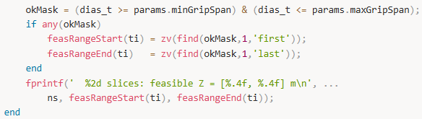
Now Test B, the ground truth diameter check. Prints the Test B header. Initializes error and checked-slice counters to zero. Sets the acceptable discrepancy threshold at 0.1 mm — any diameter mismatch larger than this is flagged as a failure.
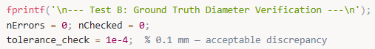
Loops through every slice. Skips slices with no diameter (NaN) or no loops. For slices that do have data, picks the longest loop — same logic as Section 11 — as the best available contour. Independently computes the diameter from scratch using the raw loop coordinates — this is the "ground truth" measurement that bypasses whatever was stored in sliceDia. Takes the larger of the X-span and Y-span as the diameter. Compares the freshly computed ground truth diameter against the stored sliceDia value. Increments nChecked. If the difference exceeds 0.1 mm, prints a detailed mismatch warning and increments nErrors.
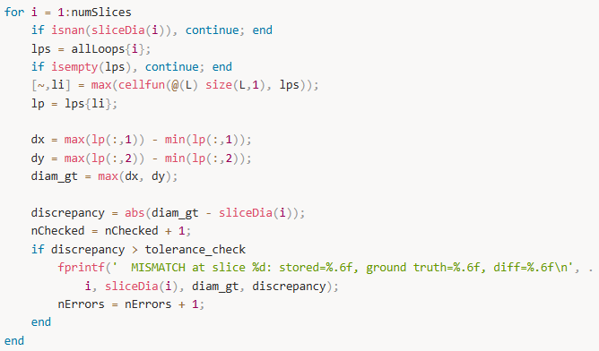
After checking all slices, prints either a green-tick pass (all values matched) or a red-cross fail (shows how many mismatches were found). This is the pass/fail verdict for Test B.
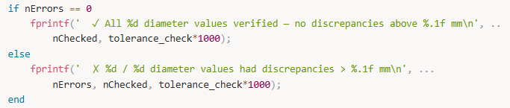
Now Test C, hand size parameter sweep. Prints the Test C header. Defines 4 different robotic hands with their real-world grip ranges taken from literature. The third entry uses the project's own hand parameters, so results can be directly compared against the real hands. Stores how many hands there are (4). Pre-allocates a counter array for how many valid grasp regions each hand finds, and a cell array to store which Z heights were graspable for each hand.
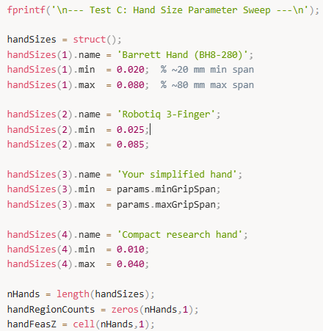
Loops through each hand. mn and mx are its grip limits. okMask_h marks every slice whose diameter fits within this hand's grip range — the ~isnan part ensures slices with no data are always excluded. The same region-counting logic from Sections 8, 10, and 11 — walks through slices finding contiguous graspable bands, checks each band is tall enough for the finger width, counts valid regions. The final if inReg handles a graspable zone that runs all the way to the last slice. Saves this hand's region count and graspable Z heights. Prints a formatted summary line, e.g. Barrett Hand (BH8-280) [20–80 mm] → 2 region(s).
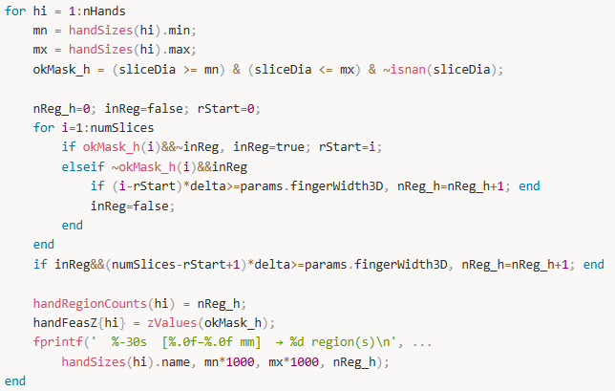
Now for validation figure. Opens a wide figure for the 3-panel validation plot. First of three subplots. Plots each resolution (10/20/30/50 slices) on the X axis. The dot shows the midpoint of the feasible height range, and the error bar shows its half-width — so you can see if the range is stable or jumping around as slices increase. Labels the axes and title, adds a grid, and forces the X-axis ticks to show exactly the 4 slice counts tested.
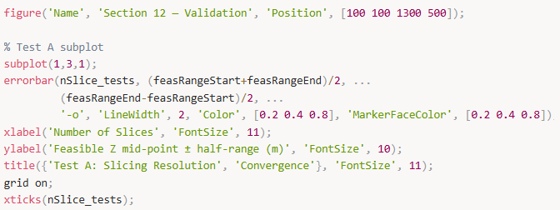
Now Test B subplot. Second subplot. Re-computes the ground truth vs stored diameter discrepancy for every slice (same maths as the Test B loop above), storing the result in diffs_gt in meters, ready for plotting.
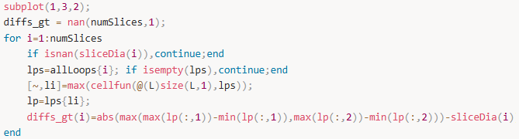
Plots a green bar chart where each bar is one slice's diameter error in millimetres. Adds a red dashed line at the 0.1 mm threshold — any bar poking above this line is a failure. Ideally all bars are invisible (zero error) or extremely short.
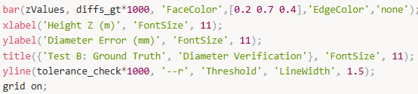
Now Test C subplot. Third subplot — a horizontal bar chart, one bar per hand, showing how many valid grasp regions each hand finds on the mug. The Y axis labels each bar with the hand's name. xlim adds one unit of padding to the right so no bar is clipped.
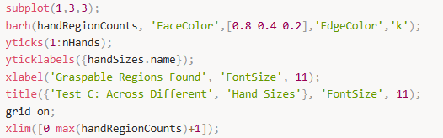
Now shared title and final summary. Adds one shared title across all three subplots. Prints a full Stage 2 completion summary to the console, recapping what each section proved and reminding the reader that all results are geometry-based simulations — no physical robot was used.
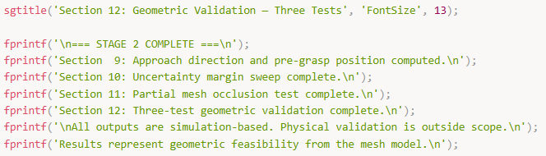

Results
…

Conclusions
…

References
…

Appendix = Definitions
Definitions
STL File — A file format that describes the surface of a 3D object as a collection of tiny triangles; stands for Standard Tessellation Language and is the most common file type used in 3D printing and CAD software.
Mesh — A mathematical representation of a 3D object's surface made up of many small triangles connected together, like a net draped over a shape.
Vertex (plural: Vertices) — A single corner point in 3D space defined by three coordinates (x, y, z); triangles in a mesh are formed by connecting three vertices.
Face — One individual triangle in a mesh, defined by three vertices; thousands of faces together form the complete surface of a 3D object.
Nodes — Another word for vertices in the context of a mesh; the individual corner points that define the geometry.
Elements — Another word for faces or triangles in a mesh; the individual triangular building blocks that make up the surface.
PDE Model — Stands for Partial Differential Equation model; in this project it is used purely as a container inside MATLAB to import and store the STL file geometry so it can be converted into a mesh.
PDE Toolbox — A MATLAB add-on package that provides tools for importing geometry and generating meshes; used here to load the STL file and extract vertex and face data.
Finite Element Analysis (FEA) — A computational method that breaks a complex shape into small elements to simulate physical behaviour like heat, stress, or fluid flow; the PDE toolbox was designed for this but is used here only for its geometry handling capabilities.
generateMesh — A MATLAB function that converts imported geometry into a triangular mesh with a controlled triangle size.
Hmax — A parameter in generateMesh that sets the maximum allowed size of any triangle edge in the mesh; smaller values produce finer, more detailed meshes.
Matrix — A rectangular grid of numbers arranged in rows and columns; used throughout this project to store coordinates, triangle indices, and analysis results.
Transpose — A mathematical operation that flips a matrix so its rows become columns and its columns become rows; written with an apostrophe in MATLAB (e.g. Nodes').
Unit Conversion — The process of changing measurement units without changing the actual physical size; in this project millimetres are divided by 1000 to convert to metres.
Z-axis — The vertical axis in 3D space; in this project the height of the mug is measured along the Z-axis.
X-axis — One of the two horizontal axes in 3D space; represents width direction.
Y-axis — The other horizontal axis in 3D space; represents depth direction.
Slicing Plane — An imaginary flat horizontal surface at a specific height that cuts through the 3D mesh to reveal its cross-sectional outline at that level.
Cross-Section — The 2D shape you see when you cut through a 3D object with a flat plane; like looking at the cut end of a loaf of bread after slicing it.
z0 — The variable name used in the code to store the specific height at which the slicing plane is positioned.
z_min — The lowest z-coordinate in the mesh; the bottom of the object.
z_max — The highest z-coordinate in the mesh; the top of the object.
Linear Interpolation — A method to find an exact point between two known points by calculating what fraction of the way along a line the target location sits; used to find exactly where a triangle edge crosses the slicing plane.
Interpolation Parameter (t) — A number between 0 and 1 that describes how far along an edge an intersection point is; t=0 means the start point, t=1 means the end point, t=0.5 means the exact middle.
Line Segment — A straight line connecting two points; each triangle that is cut by the slicing plane produces one line segment showing where the plane passes through it.
Segments Array — A list that stores all the line segments produced when the slicing plane cuts through the mesh triangles; each segment is stored as two consecutive rows of coordinates.
Contour — The complete outline of a cross-section; formed by connecting all the individual line segments from a single slice into one continuous closed curve.
Loop — A closed contour where the end point connects back to the start point; one closed loop represents the complete outline of the object at one slice height.
Cell Array — A special type of variable in MATLAB that can store different types and sizes of data in each slot; used here because different slices may produce different numbers of loops with different numbers of points.
Stitching Algorithm — The process of connecting individual scattered line segments end-to-end to form a continuous loop; works by finding segments whose endpoints are at the same location.
Tolerance — A small acceptable margin of error; in this project 1e-6 metres (one micrometre) is used to account for tiny numerical imprecision when checking if two points are at the same location.
Floating Point Imprecision — Small rounding errors that occur in computer arithmetic because computers cannot represent all decimal numbers perfectly; the reason a tolerance is needed when comparing coordinates.
norm() — A MATLAB function that computes the straight-line distance between two points in space; used to check if two endpoints are close enough to be considered the same point.
Euclidean Distance — The straight-line distance between two points in space, calculated using the Pythagorean theorem extended to three dimensions.
linspace — A MATLAB function that creates an array of evenly spaced numbers between two values; used to generate 20 equally spaced slice heights between the bottom and top of the mug.
numSlices — A variable that controls how many horizontal planes are used to slice through the object; set to 20 in this project.
allLoops — A cell array that stores all the stitched contour loops for every slice height; the complete CT scan dataset of the object.
plot3 — A MATLAB function that draws lines in 3D space by connecting a sequence of x, y, z coordinates.
figure — A MATLAB command that opens a new blank plot window.
hold on — A MATLAB command that tells the plot window to keep existing drawings when new ones are added, rather than erasing and starting fresh.
axis equal — A MATLAB command that forces all three axes to use the same scale so circular shapes appear circular rather than stretched.
view(3) — A MATLAB command that sets the plot to display in 3D perspective mode, allowing the user to rotate it with the mouse.
jet colormap — A colour scheme in MATLAB that transitions from blue through green to red; used to colour slices from bottom (blue) to top (red) so height is visually obvious.
Bounding Box — The smallest rectangle that completely contains a shape; used to estimate the diameter of a cross-section by measuring its width and depth.
Diameter — In this project, an estimate of how wide the cross-section of the object is at a given height; computed either from the bounding box or from the area and perimeter of the contour.
minGripSpan — The minimum diameter the robotic hand can close around; anything thinner than this cannot be grasped because the fingers close completely without making contact.
maxGripSpan — The maximum diameter the robotic hand can open to; anything wider than this cannot be grasped because the fingers cannot open wide enough to reach around it.
fingerWidth2D — The thickness of a finger when viewed from above in the horizontal plane; used to check whether a finger can fit through a gap such as the space between a mug handle and its body.
fingerWidth3D — The height of a finger along the vertical Z-axis; used to check whether there is enough continuous vertical space at a graspable height to physically accommodate a real finger.
Power Grasp — A type of robotic grasp where the fingers wrap all the way around an object so their inner surfaces contact it at multiple points; also called an enveloping grasp; common examples are holding a mug handle or a cylinder.
Enveloping Grasp — Another name for a power grasp; the fingers envelope the object by curling around it rather than pinching it with fingertips only.
Precision Grasp — The opposite of a power grasp; where only the fingertips touch the object, like picking up a small coin; this project does not focus on this type.
Force Closure — A property of a grasp where the contact forces from the fingers can resist any external push or twist applied to the object in any direction; a measure of grasp stability.
Graspable Region — A continuous range of heights on the object where the diameter falls within the hand's grip range and there is enough vertical space for at least one physical finger.
3D Accumulation — The process of stacking consecutive graspable slices vertically and checking whether the combined height is sufficient for a physical finger; transforms per-slice 2D results into 3D grasp regions.
fingerSlots — A variable that stores the start and end slice indices of each valid 3D graspable region found by the accumulation process.
delta — The vertical distance between consecutive slice planes; computed as the total mug height divided by the number of slices minus one.
Shoelace Formula — A mathematical formula for computing the area of any polygon given its vertex coordinates; named because the calculation pattern resembles lacing a shoe.
APD Estimator — Stands for Area-Perimeter Diameter; a method that estimates the effective diameter of an irregular polygon by combining a radius estimate from area and a radius estimate from perimeter.
Perimeter — The total length of the boundary of a 2D shape; computed by summing the lengths of all edges of the polygon.
Polygon — A closed 2D shape made of straight line segments; each stitched loop projected onto the XY plane is a polygon.
Point-to-Segment Distance — The shortest distance from a single point to a line segment; used in the gap calculation between two polygons to find the narrowest space between them.
Gap Detection — The process of measuring the minimum distance between two separate polygons at the same slice height; used to check whether a finger can fit between a mug body and its handle.
Centroid — The geometric centre of a shape; computed as the average of all x-coordinates and the average of all y-coordinates of the contour points.
Approach Direction — The vector describing which direction the robot hand moves toward the object before closing its fingers; equivalent to the parking angle for a car pulling into a space.
Unit Vector — A vector whose length is exactly 1; used to represent direction without any magnitude; computed by dividing a vector by its own length.
Angular Gap Analysis — The process of converting contour points to polar angles relative to the centroid, sorting them, and finding the largest gap between consecutive angles; used to determine the widest open space around the object's perimeter.
Polar Angle — The angle a point makes relative to a centre point, measured from the positive x-axis; computed using atan2 in MATLAB.
atan2 — A MATLAB function that computes the polar angle of a point relative to the origin, correctly handling all four quadrants of a circle.
Pre-Grasp Position — The specific 3D coordinate where the robot hand is positioned before moving inward to close on the object; located outside the object along the approach direction.
Standoff Distance — The distance between the pre-grasp position and the grasp centroid; how far outside the object the hand starts before moving in.
Principal Component Analysis (PCA) — A mathematical technique that finds the directions of greatest and least spread in a dataset; used in Stage 2 to find the major and minor axes of the cross-section contour.
Eigenvalue — A number produced by PCA that represents how much spread exists in a particular direction; the smallest eigenvalue corresponds to the direction of least spread.
Eigenvector — A direction produced by PCA corresponding to an eigenvalue; the eigenvector of the smallest eigenvalue gives the minor axis of the contour shape.
Uncertainty Margin (delta_u) — A configurable safety buffer subtracted from both sides of the acceptable diameter window to account for real-world robot positioning error.
Positioning Error — The difference between where a robot arm is commanded to go and where it actually arrives; typically a few millimetres in real systems.
Sensitivity Analysis — Testing how much the output of an algorithm changes when one of its input parameters is varied; used in Section 10 to show how grasp regions shrink as uncertainty margin increases.
Simulated Occlusion — Artificially removing triangles from the mesh to mimic the effect of a sensor that cannot see part of an object; used in Section 11 to test algorithm robustness.
Graceful Degradation — The property of an algorithm that continues to produce useful results even when input data is incomplete or corrupted, rather than crashing or producing wrong answers.
Coverage Threshold — A minimum number of contour points required for a slice to be considered valid; slices below this threshold are skipped rather than used, preventing inaccurate measurements from partial geometry.
Self-Consistency Validation — A method of verifying an algorithm's correctness by checking its outputs against the same input data using independent calculations; proves the algorithm computes what it claims to compute without needing external ground truth.
Resolution Convergence — The property of an algorithm whose output stabilises and stops changing significantly as the number of slices increases; proves the result is not dependent on a specific parameter choice.
Parameter Sweep — Running the same algorithm multiple times with different values of one parameter to understand how the output changes; used in Section 12 Test C with different hand sizes.
Deterministic — Describes a system or algorithm that always produces exactly the same output given the same input, with no randomness or variability between runs.
Interpretable — Describes a system whose reasoning and decisions can be understood and verified by a human, as opposed to a black box whose internal logic is hidden.
fprintf — A MATLAB function that prints formatted text to the command window; used throughout the project to display results, measurements, and status messages.
Command Window — The text area in MATLAB where printed output appears and where commands can be typed directly.
Workspace — The collection of all variables currently stored in MATLAB's memory during a session; variables from earlier sections must exist in the workspace for later sections to use them.
exist() — A MATLAB function that checks whether a variable with a given name currently exists in the workspace; used as a safety check before trying to use a variable that might not have been created yet.
rng(42) — A MATLAB command that sets the random number generator to a fixed starting point so that any random choices made afterward are the same every time the code runs; ensures reproducibility.
Reproducibility — The ability to get identical results by running the same code again; achieved by fixing the random seed with rng.
EOD — Stands for Explosive Ordnance Disposal; the process of safely identifying, disabling, and removing explosive devices; the primary application context for this project.
Teleoperation — Remote control of a robot by a human operator who watches sensor feedback and sends commands; the operational mode assumed for EOD robots in this project.

Code
createpde() — A MATLAB function that creates an empty PDE model object which acts as a container to hold geometry, mesh, and simulation data; used here purely to load and store the STL file.
importGeometry() — A MATLAB function that reads a geometry file (in this case an STL file) and loads it into a PDE model object so MATLAB can work with its 3D shape.
generateMesh() — A MATLAB function that converts the imported 3D geometry into a triangular mesh made of many small connected triangles.
meshData — A variable that stores the complete mesh object returned by generateMesh, containing all the node coordinates and element connectivity information.
meshData.Nodes — A property of the mesh object that contains the x, y, z coordinates of every corner point in the mesh, stored as a matrix where each column is one point.
meshData.Elements — A property of the mesh object that contains the connectivity table defining which three corner points form each triangle, stored as a matrix where each column is one triangle.
vertices — A variable storing all corner point coordinates of the mesh after transposing, arranged so each row is one point with columns for x, y, and z coordinates.
faces — A variable storing the triangle connectivity data after transposing, arranged so each row is one triangle with three columns containing the row numbers of its three corner points in the vertices array.
Nx3 — A description of a matrix shape meaning N rows and 3 columns; used to describe the vertices matrix where N is the number of points and the 3 columns are x, y, z.
Mx3 — A description of a matrix shape meaning M rows and 3 columns; used to describe the faces matrix where M is the number of triangles and the 3 columns are vertex index numbers.
fprintf() — A MATLAB function that prints formatted text to the command window; the format string inside the quotes controls how numbers and text are displayed.
\n — A special character inside fprintf format strings that tells MATLAB to start a new line in the command window output.
%.2f — A format code inside fprintf that prints a number with exactly 2 decimal places; the f means it is a decimal (floating point) number.
%.4f — A format code inside fprintf that prints a number with exactly 4 decimal places; used for more precise measurements like metre values.
min() — A MATLAB function that returns the smallest value in an array or matrix; when applied to a column of coordinates it finds the lowest point in that direction.
max() — A MATLAB function that returns the largest value in an array or matrix; when applied to a column of coordinates it finds the highest point in that direction.
abs() — A MATLAB function that returns the absolute value of every number in an array, making all negatives positive; used to check the overall scale of coordinate values.
vertices(:,1) — MATLAB indexing syntax meaning all rows of column 1; selects all x-coordinates from the vertices matrix.
vertices(:,2) — Selects all y-coordinates from the vertices matrix.
vertices(:,3) — Selects all z-coordinates from the vertices matrix; used to find the height range of the mesh.
if / end — MATLAB keywords that define a conditional block; the code between them only runs if the condition after if is true.
z_min — A variable storing the smallest z-coordinate in the mesh, representing the bottom of the object.
z_max — A variable storing the largest z-coordinate in the mesh, representing the top of the object.
z0 — A variable storing the specific height at which the current slicing plane is positioned.
segments — A variable storing all line segment pairs found when the slicing plane cuts through triangles; each segment occupies two consecutive rows, one row per endpoint.
for i = 1:size(faces,1) — A loop that runs once for every row in the faces matrix, meaning once for every triangle in the mesh; size(faces,1) returns the total number of rows.
size(faces,1) — A MATLAB function call returning the number of rows in the faces matrix, which equals the total number of triangles.
idx — A variable storing the three vertex index numbers for the current triangle being examined; these are row numbers pointing into the vertices array.
faces(i,:) — Selects all columns of row i from the faces matrix, giving the three vertex indices that define triangle i.
triVerts — A variable storing the actual 3D coordinates of the three vertices of the current triangle, retrieved by using idx to look up rows in the vertices matrix.
vertices(idx,:) — Uses the index numbers in idx to retrieve the corresponding rows from the vertices matrix; returns a 3x3 matrix of the three vertex coordinates.
zVals — A variable storing just the z-coordinates of the three vertices of the current triangle, used to check their positions relative to the slicing plane.
triVerts(:,3) — Selects column 3 from triVerts, extracting only the z-coordinates of the three vertices.
&& — The logical AND operator in MATLAB; the overall condition is only true if every part connected by && is individually true.
~all(zVals == z0) — A condition checking that not all three z-values are exactly equal to z0; the tilde (~) means NOT, so this returns true when the triangle is not completely flat on the plane.
pts — A temporary variable used inside the triangle loop to collect the intersection points found on the edges of the current triangle; reset to empty for each new triangle.
for e = [1 2; 2 3; 3 1]' — A loop that iterates over the three edges of a triangle by stepping through pairs of vertex indices: edge 1 connects vertices 1 and 2, edge 2 connects vertices 2 and 3, edge 3 connects vertices 3 and 1.
p1 — A variable storing the 3D coordinates of the first endpoint of the current triangle edge being examined.
p2 — A variable storing the 3D coordinates of the second endpoint of the current triangle edge being examined.
z1 — The signed distance from vertex p1 to the slicing plane; positive means above the plane, negative means below, zero means exactly on it.
z2 — The signed distance from vertex p2 to the slicing plane; same sign convention as z1.
z1 * z2 < 0 — A condition that is true when z1 and z2 have opposite signs, meaning one vertex is above the plane and one is below, so the edge must cross the plane.
t — The interpolation parameter; a number between 0 and 1 telling how far along the edge from p1 to p2 the crossing point is located.
intersectPt — A variable storing the exact 3D coordinates of the point where the current edge crosses the slicing plane, computed using linear interpolation.
p1 + t * (p2 - p1) — The linear interpolation formula; starts at p1 and moves a fraction t of the way toward p2 to find the exact crossing point.
pts = [pts; intersectPt] — Appends the new intersection point as a new row at the bottom of the pts array; the semicolon inside square brackets means vertical concatenation (stacking rows).
size(pts,1) == 2 — A condition checking that exactly two intersection points were found for the current triangle, which is the only valid case to save as a line segment.
segments = [segments; pts] — Appends both intersection points of the current triangle as two new rows at the bottom of the segments array.
tolerance = 1e-6 — Sets the matching tolerance to 0.000001 metres (one micrometre); two points closer than this distance are treated as the same point.
1e-6 — Scientific notation for 0.000001; the e means times ten to the power of, so 1e-6 means 1 times 10 to the minus 6.
loops = {} — Creates an empty cell array to store the finished closed contour loops; curly braces indicate a cell array rather than a regular numeric array.
while size(segments,1) >= 2 — A loop that continues as long as the segments array has at least 2 rows remaining, meaning at least one complete line segment still needs to be processed.
pt1 = segments(1,:) — Retrieves the first row of the segments array, which is the first endpoint of the next unprocessed segment.
pt2 = segments(2,:) — Retrieves the second row of the segments array, which is the second endpoint of the same segment.
segments(1:2,:) = [] — Deletes the first two rows from the segments array by assigning empty brackets to them; removes the segment that was just retrieved so it cannot be used again.
loop = [pt1; pt2] — Creates a new 2-row matrix with pt1 as the first row and pt2 as the second row, starting a new loop with the two endpoints of the first segment.
loopClosed — A logical flag variable that tracks whether the current loop has been completed; starts as false and is set to true when no more connecting segments can be found.
found — A logical flag variable that tracks whether a connecting segment was successfully found in the current pass through the remaining segments; reset to false at the start of each search.
for j = 1:2:size(segments,1)-1 — A loop that steps through the segments array two rows at a time (1, 3, 5, 7...) because each segment occupies exactly two consecutive rows.
seg_pt1 = segments(j,:) — Retrieves the first endpoint of the current candidate segment being checked for connection.
seg_pt2 = segments(j+1,:) — Retrieves the second endpoint of the same candidate segment.
norm(seg_pt1 - loop(end,:)) — Computes the straight-line distance between the candidate segment's first endpoint and the last point currently in the loop being built.
loop(end,:) — Accesses the last row of the loop matrix; end is a MATLAB keyword meaning the last index.
loop(1,:) — Accesses the first row of the loop matrix, which is the starting point of the current loop being built.
loop = [loop; seg_pt2] — Extends the loop by appending seg_pt2 as a new row at the end; grows the loop forward.
loop = [seg_pt2; loop] — Extends the loop by prepending seg_pt2 as a new row at the front; grows the loop backward.
segments(j:j+1,:) = [] — Deletes the two rows of the matched segment from the segments array so it cannot be used in any other loop.
break — A MATLAB keyword that immediately exits the current for loop; used here to stop searching once a matching segment has been found and added.
if ~found — A condition checking whether the found flag is still false after searching all remaining segments; tilde means NOT so this reads as if not found.
loops{end+1} = loop — Appends the completed loop to the cell array; end+1 means one position beyond the current last element, effectively adding to the end of the list.
plot3(loop(:,1), loop(:,2), loop(:,3)) — A MATLAB function that draws a 3D line by connecting a sequence of points defined by their x, y, and z coordinates taken from columns 1, 2, and 3 of the loop matrix.
'-o' — A format string for plot3 where the dash means draw lines connecting the points and the letter o means place a circle marker at each individual point.
'LineWidth', 2 — A name-value pair argument passed to a plotting function that sets the thickness of the drawn line to 2 points.
xlabel(), ylabel(), zlabel() — MATLAB functions that add text labels to the x, y, and z axes of the current plot respectively.
view(3) — A MATLAB function call that sets the current plot to display in 3D perspective mode, enabling mouse rotation.
title() — A MATLAB function that adds a text title above the current plot.
numSlices = 20 — Sets the number of horizontal slicing planes to use; 20 means the mug will be cut at 20 evenly spaced heights from bottom to top.
z_values = linspace(z_min, z_max, numSlices) — Creates an array of 20 evenly spaced numbers between z_min and z_max, giving the height of each slicing plane.
linspace(a, b, n) — A MATLAB function that generates n evenly spaced numbers between a and b inclusive.
all_slices = cell(numSlices, 1) — Creates a cell array with 20 empty slots arranged in a single column, one slot for storing the raw line segments from each slice.
allLoops = cell(numSlices, 1) — Creates a cell array with 20 empty slots to store the stitched closed loops from each slice height.
lines = [] — Initialises an empty matrix to collect the raw intersection line segments for the current slice; reset to empty at the start of each new slice height.
v = vertices(faces(f,:), :) — Retrieves the three vertex coordinate rows corresponding to the three vertex indices of triangle f; produces a 3x3 matrix of the triangle's corner coordinates.
z = v(:,3) — Extracts the third column (z-coordinates) from the triangle vertex matrix v.
mod(e,3)+1 — A mathematical expression used to cycle through edge endpoint indices 1, 2, 3, 1, 2, 3; mod gives the remainder after division, so mod(3,3)+1 = 1, wrapping back to the start.
all_slices{i} = lines — Stores the raw intersection line segments for slice i into cell i of the all_slices cell array; curly braces are used to access individual cells.
plot(lines(:,1), lines(:,2), '.-') — A 2D plotting function that draws lines connecting points defined only by their x and y coordinates, ignoring z; the dot-dash format draws both dots at points and lines between them.
grid on — A MATLAB command that adds a grid of light lines to the background of the current plot to make coordinates easier to read.
cmap = jet(numSlices) — Creates a colour map array with 20 rows, one colour per slice, transitioning from blue through green to red; used to give each slice a unique colour.
'Color', cmap(i,:) — A name-value pair that sets the line colour for the current plot to row i of the colour map; cmap(i,:) selects all columns of row i.
minGrip — A variable storing the minimum diameter the hand can close around, in metres; any slice with a diameter below this value cannot be grasped.
maxGrip — A variable storing the maximum diameter the hand can open to, in metres; any slice with a diameter above this value cannot be grasped.
graspableSlices — A variable that accumulates the index numbers of slices whose diameter falls within the graspable range.
sliceDiameters — A variable storing the computed diameter value for every slice, used to plot the diameter profile graph.
zeros(numSlices,1) — A MATLAB function that creates a column array of numSlices rows filled with zeros; used to initialise sliceDiameters before values are filled in.
continue — A MATLAB keyword used inside a loop that skips the rest of the current iteration and immediately moves to the next one; used here to skip empty slices.
isempty() — A MATLAB function that returns true if a variable contains no data; used to check whether a slice produced any loops before trying to measure it.
minX, maxX, minY, maxY — Variables storing the minimum and maximum x and y coordinates of the current contour loop, defining its bounding box dimensions.
diameter — A variable storing the estimated width of the current cross-section, computed as the larger of the bounding box width and depth.
graspableSlices(end+1) = i — Appends the current slice index i to the end of the graspableSlices array; end+1 means the next available position.
yline() — A MATLAB function that draws a horizontal line across the entire plot at a specified y-axis value; used to show the minimum and maximum grip limits.
scatter() — A MATLAB function that plots individual points as dots or other markers without connecting lines; used to highlight the graspable slices as magenta dots.
params — A structure variable used to group related hand geometry parameters together; accessed using dot notation like params.minGripSpan.
params.minGripSpan — The minimum diameter field of the params structure; stores the smallest object diameter the hand can successfully close around.
params.maxGripSpan — The maximum diameter field of the params structure; stores the largest object diameter the hand can open wide enough to surround.
params.fingerWidth2D — The horizontal finger thickness field; stores how wide a finger appears when viewed from above, used for gap checking.
params.fingerWidth3D — The vertical finger height field; stores how tall a finger is along the z-axis, used to check whether enough continuous height exists.
exist('zValues', 'var') — A MATLAB function call that checks whether a variable named zValues currently exists in the workspace; returns true if it does.
delta = mean(diff(zValues)) — Computes the average spacing between consecutive slice heights; diff() finds the difference between each adjacent pair and mean() averages all those differences.
diff() — A MATLAB function that computes the difference between each consecutive pair of values in an array; applied to zValues it gives the gap between each adjacent slice height.
mean() — A MATLAB function that computes the arithmetic average of all values in an array.
sliceOK = false(numSlices,1) — Creates a column array of numSlices logical false values; each entry will be updated to true if the corresponding slice passes the graspability checks.
sliceDia = nan(numSlices,1) — Creates a column array of numSlices NaN (Not a Number) values; NaN is used as a placeholder indicating no valid diameter has been computed yet for that slice.
nan — Stands for Not a Number; a special floating point value used in MATLAB to represent missing or undefined numeric data.
sliceNote = strings(numSlices,1) — Creates a column array of numSlices empty text strings; each entry will be filled with a short explanation of why each slice passed or failed.
strings() — A MATLAB function that creates an array of empty string values; used to pre-allocate storage for text messages.
polys = cellfun(@(L)[L(:,1:2); L(1,1:2)], loops, 'UniformOutput', false) — Applies a function to every loop in the loops cell array to extract just the x and y columns and close the polygon by appending the first point at the end.
cellfun() — A MATLAB function that applies a given function to every element of a cell array and collects the results.
@(L) — Anonymous function syntax in MATLAB; defines a small one-line function where L is the input argument, used here inside cellfun to process each loop.
L(:,1:2) — Selects columns 1 and 2 from loop L, extracting only the x and y coordinates and dropping the z column.
L(1,1:2) — Selects the first row, columns 1 and 2 of loop L; appended at the end to close the polygon by returning to the starting point.
'UniformOutput', false — A name-value pair argument for cellfun telling it that the output of the applied function is not a simple scalar number but a variable-size array, so results should be stored in a cell array.
nPoly = numel(polys) — Counts the total number of separate polygon contours found at the current slice height; numel returns the number of elements in an array or cell array.
numel() — A MATLAB function that returns the total number of elements in an array; for a cell array it counts the number of cells.
APD = zeros(nPoly,3) — Creates a matrix with nPoly rows and 3 columns initialised to zero; will store the area, perimeter, and diameter for each polygon at the current slice.
**A = 0.5 * abs(sum(x(1:end-1).y(2:end) - x(2:end).y(1:end-1))) — The Shoelace formula for polygon area; multiplies corresponding x and y coordinates in a cross pattern, sums them, and takes half the absolute value.
x(1:end-1) — Selects all elements of x except the last one; used in the Shoelace formula to pair each vertex with the next one.
x(2:end) — Selects all elements of x except the first one; paired with x(1:end-1) to create vertex pairs for the Shoelace computation.
.* — The element-wise multiplication operator in MATLAB; multiplies corresponding elements of two arrays of the same size rather than performing matrix multiplication.
P = sum(sqrt(sum(diff(poly,1,1).^2, 2))) — Computes the perimeter by finding the length of each edge (distance between consecutive polygon vertices) and summing all edge lengths.
diff(poly,1,1) — Computes the difference between consecutive rows of the polygon matrix; gives the x and y displacement vector for each edge.
.^2 — Element-wise squaring; raises every element of an array to the power of 2.
sum(..., 2) — Sums across dimension 2 (across columns) rather than down rows; used to sum x-squared and y-squared for each edge to get the squared edge length.
sqrt() — A MATLAB function that computes the square root of every element in an array; used here to convert squared edge lengths to actual edge lengths.
rA = sqrt(A/pi) — Computes the radius that a circle with the same area as this polygon would have; derived by rearranging the circle area formula A = pi times r squared.
rP = P/(2*pi) — Computes the radius that a circle with the same perimeter as this polygon would have; derived from the circle circumference formula P = 2 times pi times r.
D = rA + rP — The APD diameter estimate; combines the area-based and perimeter-based radius estimates to produce a robust diameter that accounts for both geometric properties.
APD(k,:) = [A,P,D] — Stores the area, perimeter, and diameter values for polygon k as a row in the APD matrix.
[~, idxLarge] = max(APD(:,1)) — Finds the index of the row with the largest value in column 1 (area) of the APD matrix; the tilde discards the actual maximum value since only the index is needed.
~ — Used on the left side of an assignment to discard an output that is not needed; here it discards the maximum area value since only its index position matters.
minGap = inf — Initialises the minimum gap variable to infinity so that any real distance computed will be smaller and replace it; a standard initialisation technique for minimum-finding loops.
inf — MATLAB's representation of positive infinity; used as a starting value when searching for a minimum so the first real value found will always be smaller.
gap = minGap — Copies the final computed minimum gap into the variable gap for use in the feasibility check.
dot(pVec-aVec, ab) — Computes the dot product of two vectors; used in the point-to-segment distance formula to find the projection of a point onto a line segment.
dot() — A MATLAB function that computes the dot product of two vectors; returns a single number representing how much one vector projects onto another.
max(0, min(1, ...)) — Clamps a value to stay between 0 and 1; ensures the projection point stays on the segment rather than extending beyond its endpoints.
eps — A MATLAB constant representing the smallest positive floating point number the computer can distinguish from zero; used to prevent division by zero when a segment has zero length.
proj — A variable storing the coordinates of the closest point on a line segment to a given external point; computed by projecting the point onto the segment direction.
minGap = min(minGap, norm(pVec - proj)) — Updates the running minimum gap by comparing the current best with the newly computed distance; keeps only the smallest value found so far.
bestGap = max(bestGap, minGap) — Updates the best gap variable by keeping the largest minimum gap found across multiple polygon pairs; finds the most accessible entry point.
fingerSlots — A matrix storing the start and end slice indices for each valid 3D graspable region; each row is one region with two values: start slice number and end slice number.
inRegion — A logical flag tracking whether the scan is currently inside a consecutive run of graspable slices; starts false and toggles on and off as the slice scan progresses.
regionStart — A variable recording the slice index where the current run of graspable slices began.
regionEnd — A variable recording the slice index where the current run of graspable slices ended.
regionHeight — A variable storing the total vertical height of the current consecutive graspable region in metres, computed as the number of slices times the spacing between slices.
floor() — A MATLAB function that rounds a number down to the nearest integer; used to compute how many complete fingers fit within a region height.
subplot(1,2,1) — A MATLAB command that divides the current figure into a 1-row by 2-column grid of plot areas and makes the first one active; allows two plots side by side in one figure window.
subplot(1,2,2) — Makes the second plot area in a 1-row by 2-column figure grid active.
figure('Position', [100, 100, 1200, 500]) — Opens a new figure window and sets its position and size on screen; the four numbers are x position, y position, width, and height in pixels.
h = [] — Initialises an empty array to collect plot handle objects; handles are used to build the legend correctly by tracking which plotted elements to include.
legendLabels = {} — Initialises an empty cell array to collect the text labels that will appear in the legend, one string per plotted element.
h(end+1) — Appends a new handle to the end of the h array; used to grow the handle list each time a new element is added to the plot.
legend(h, legendLabels, 'Location', 'best') — Creates a legend on the plot using the stored handles and their corresponding text labels; 'best' tells MATLAB to automatically place it where it overlaps the data least.
fill() — A MATLAB function that draws a filled polygon; used to create the semi-transparent blue shaded rectangles marking the graspable regions on the diameter profile plot.
'FaceAlpha', 0.15 — A name-value pair that sets the transparency of a filled shape; 0 is fully transparent and 1 is fully opaque, so 0.15 makes the fill mostly see-through.
'EdgeColor', 'b' — A name-value pair that sets the colour of the border line around a filled shape to blue.
[0.7 0.7 0.7] — A colour specification in MATLAB using RGB values between 0 and 1; this particular combination produces a medium grey colour used for the non-graspable mug slices.
sgtitle() — A MATLAB function that adds a single title above all subplots in a figure; stands for super-title.
hold off — A MATLAB command that turns off the hold state so the next plot command will erase the current figure contents rather than adding to them.

