University Management System

Analysis and Design Document : Assignment 2

Student: Mascasan Maya-Lorena
Group: 30431

Table of Contents
Contents
1. Requirements Analysis 3
1.1 Assignment Specification 3
1.2 Functional Requirements 3
1.3 Non-functional Requirements 3
2. Use-Case Model 4
3. System Architectural Design 5

1. Requirements Analysis

Assignment Specification
The objective of this project is to create a web-based application for managing university infrastructure, specifically focusing on the relationships between students, professors, courses, and their respective departments.

Functional Requirements
The application has the following functional requirements:
- Allow users to create new person entries (students or professors) with a name, email, age, password, and a dynamic role.
- Allow users to view all existing person records in a centralized list.
- Allow users to enroll or assign a person to specific courses by providing a list of course identifiers during the creation process.
- Allow users to create and manage academic departments and link them to courses to maintain organizational hierarchy.
- Allow users to delete existing records to keep the university database up to date

Non-functional Requirements

The application has the following non-functional requirements:
- Implement strict server-side validation to ensure that all inputs, such as email formats and password strength, are valid and adhere to the specified format.
- Use an ORM (Object-Relational Mapping) to handle all database interactions and entity relationships.
- Use a DI (Dependency Injection) container for managing the lifecycle of services, controllers, and repositories.
- Use a layered architecture (Controller, Service, Repository) for better organization and separation of concerns.
- Use a relational database to store all the data persistently.
- Implement a 3-tier system architectural design consisting of a Presentation Tier, Logic Tier, and Data Tier.

Use-Case Model

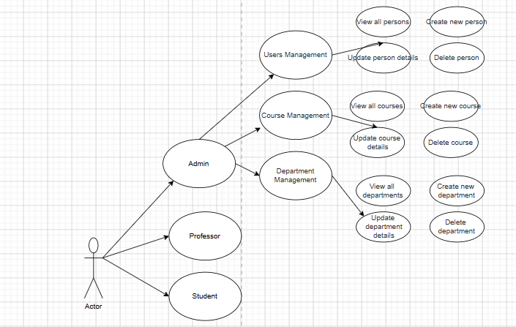

Use Case: View All Persons
- Use Case Goal: Retrieve a comprehensive list of all registered users (Students and Professors) from the database and present them in a structured management table.
- Primary Actor: Admin (and authorized roles like Professor/Student depending on permission levels).
- Main Success Scenario:
  - The Actor navigates to the "Users Management" section.
  - The Frontend issues a GET request to the /person endpoint.
  - The Logic Tier (Spring Boot) fetches the data via JPA from the PostgreSQL database.
  - The system displays the records in an Angular Material table, showing columns for Role, Name, Age, Email, and Enrolled Courses.
- Extensions:
  - Alternate Success (Empty State): The connection is successful, but the database returns an empty list. The management dashboard displays a "None" placeholder or a message suggesting the creation of the first user entry.
  - Failure (API/Database Error): If the database connection fails, the request times out, or the user is unauthorized, the system captures the HttpErrorResponse. The PersonListStore updates the hasError signal, and a specific error message (e.g., "Database connection fails") is displayed in the frontend dashboard.

System Architectural Design

Architectural Pattern Description
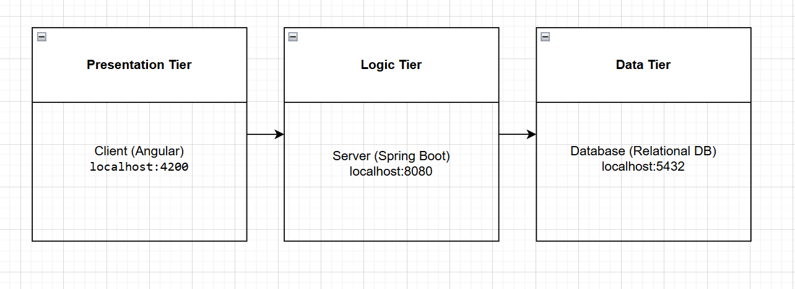

The application follows a 3-tier architectural pattern, separating the concerns of the user interface, business logic, and data storage.
- Presentation Tier (Client): This is the user-facing layer implemented using the Angular framework. It runs on the client's browser (typically at http://localhost:4200) and communicates with the logic tier via RESTful API calls using the HttpClient.
- Logic Tier (Server): This is the middle layer implemented using Spring Boot. It serves as the "Server" (running at http://localhost:8080) where all business rules, such as duplicate email validation or department-course linking, are processed.
- Data Tier (Database): This is the persistent storage layer using a PostgreSQL relational database. It stores the entities defined in the logic tier, such as Person, Course, and Department.

Diagrams

And architecture should be layered:
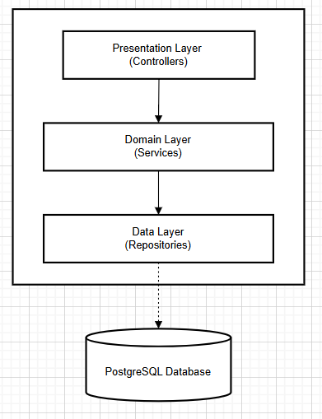

Layered Architecture
In addition to the 3-tier structure, the Logic Tier itself is organized into a layered architecture:
- Controller Layer: The entry point for requests (e.g., PersonController).
- Service Layer (Domain): Where the business logic resides (e.g., DepartmentService, CourseService).
- Repository Layer (Data): Handles the actual communication with the database using Spring Data JPA.

Class Design

Package + Class Diagram
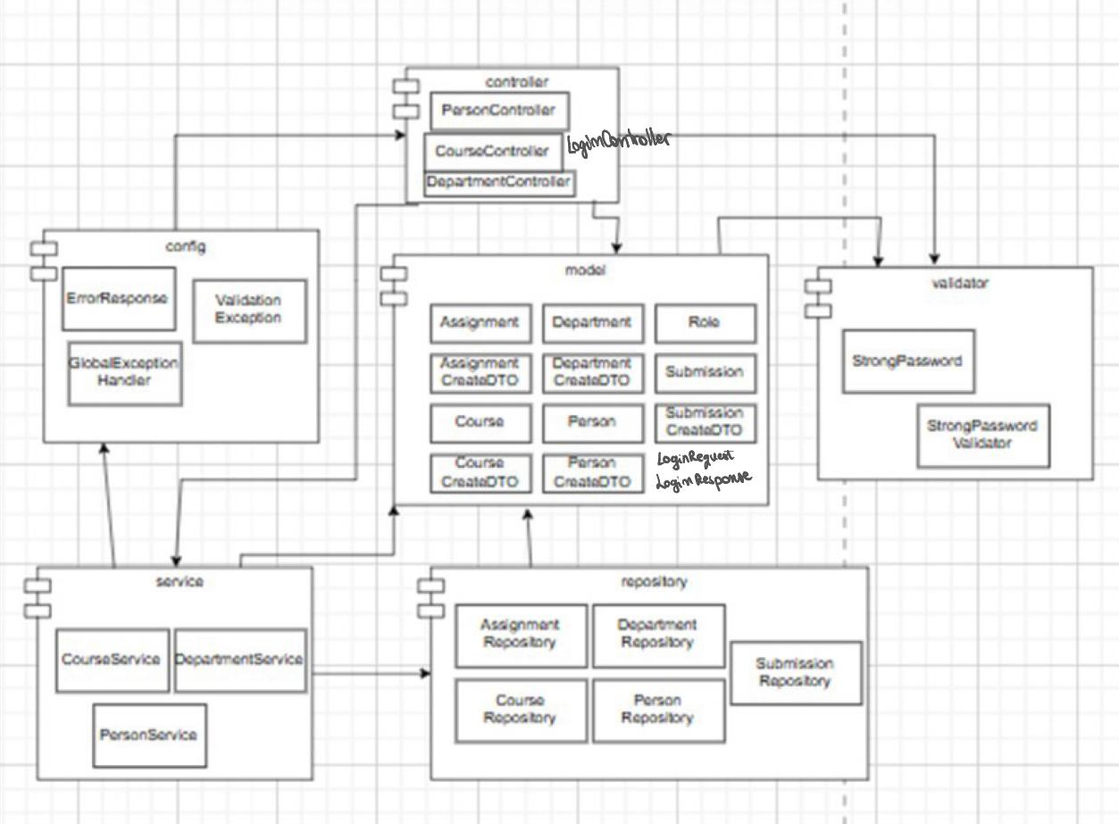

The application's backend architecture is organized into several key modules that enforce a clean separation of concerns. The modules are structured as follows:
- Controller Layer: This package contains the REST Controllers (PersonController, CourseController, DepartmentController, and LoginController) which act as the entry point for requests from the presentation tier. These controllers map HTTP verbs to specific backend logic.
- Service Layer: This module contains the business logic implementations (PersonService, CourseService, DepartmentService, and LoginService). It acts as an intermediary, processing data, handling authentication checks, and managing transactions before data is sent to the repository.
- Repository Layer: This module manages data access through JPA interfaces such as PersonRepository, CourseRepository, and LoginRepository (or UserCredentialsRepository), which interact directly with the PostgreSQL database.
- Model Layer: This central package defines the domain entities (e.g., Person, Course, Department) and the Data Transfer Objects (DTOs) used for communication. Specifically for authentication, it includes:
  - LoginRequest: A DTO containing the user's credentials (email and password) sent from the client.
  - LoginResponse: A DTO returned upon successful authentication, containing the user details and the assigned Role (Admin, Student, or Professor).
- Config & Validator:
  - Config: Contains global handlers like GlobalExceptionHandler to manage application-wide error responses and security configurations for CORS and authentication filters.
  - Validator: Contains custom validation logic, such as StrongPasswordValidator, to ensure data integrity and security before records are persisted to the database.

Data Model

The application’s data model is designed to manage complex university relationships through a normalized relational structure:
- Person Entity: This represents the central user of the system. It includes core attributes like name, email, age, and password, along with a Role.
- Department Entity: Acts as the primary organizational unit. It maintains a One-to-Many relationship with the Course entity, ensuring every course belongs to exactly one department.
- Course Entity: Stores academic details like title and credits. It maintains a Many-to-Many relationship with the Person entity, managed through a join table (visible in the diagram as enrolled_courses), allowing students and professors to be associated with multiple courses.
- Assignment & Submission Entities: These entities allow for the creation of academic tasks within a specific Course and track the work submitted by a Person.

