University Management System

Analysis and Design Document : Assignment 1

Student: Mascasan Maya-Lorena
Group: 30431

Table of Contents
Contents
1. Requirements Analysis 3
1.1 Assignment Specification 3
1.2 Functional Requirements 3
1.3 Non-functional Requirements 3
2. Use-Case Model 4
3. System Architectural Design 5

1. Requirements Analysis

Assignment Specification
The objective of this project is to create a web-based application for managing university infrastructure, specifically focusing on the relationships between students, professors, courses, and their respective departments.

Functional Requirements
The application has the following functional requirements:
- Allow users to create new person entries (students or professors) with a name, email, age, password, and a dynamic role.
- Allow users to view all existing person records in a centralized list.
- Allow users to enroll or assign a person to specific courses by providing a list of course identifiers during the creation process.
- Allow users to create and manage academic departments and link them to courses to maintain organizational hierarchy.
- Allow users to delete existing records to keep the university database up to date

Non-functional Requirements

The application has the following non-functional requirements:
- Implement strict server-side validation to ensure that all inputs, such as email formats and password strength, are valid and adhere to the specified format.
- Use an ORM (Object-Relational Mapping) to handle all database interactions and entity relationships.
- Use a DI (Dependency Injection) container for managing the lifecycle of services, controllers, and repositories.
- Use a layered architecture (Controller, Service, Repository) for better organization and separation of concerns.
- Use a relational database to store all the data persistently.
- Implement a 3-tier system architectural design consisting of a Presentation Tier, Logic Tier, and Data Tier.

Use-Case Model

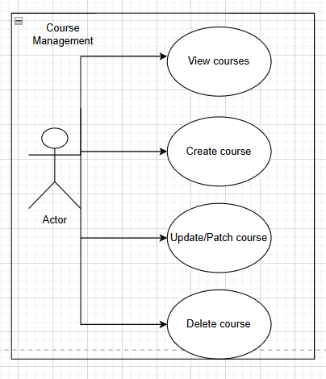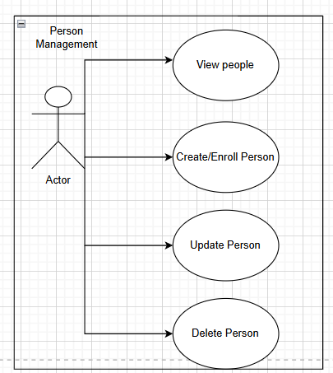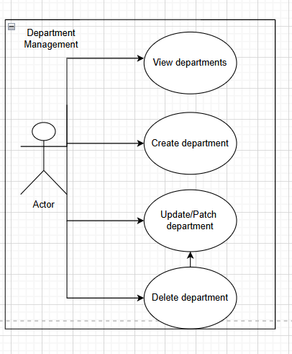

Description of the “View people” use-case:
- Use case goal: Fetching all of the recent person records and displaying them on screen using an intuitive table representation.
- Primary actor: The user of the application.
- Main success scenario: Database connection succeeds, person data is fetched correctly from the logic tier, and is displayed in an intuitive manner within the management dashboard.
- Extensions:
  - Alternate scenario of success: Database connection succeeds and data is fetched correctly, but no person records are contained in the response due to the database being empty; the management screen displays a message suggesting that the user should create their first person entry.
  - Failure: Either the database connection fails, the request times out, the data is corrupt, or the application crashes unexpectedly. The user will get a corresponding error message in the frontend.

System Architectural Design

Architectural Pattern Description
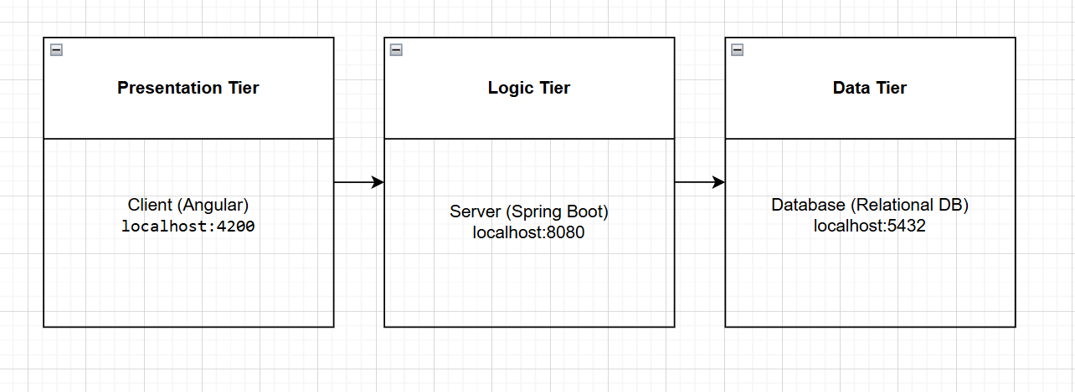

The application follows a 3-tier architectural pattern, separating the concerns of the user interface, business logic, and data storage.
- Presentation Tier (Client): This is the user-facing layer implemented using the Angular framework. It runs on the client's browser (typically at http://localhost:4200) and communicates with the logic tier via RESTful API calls using the HttpClient.
- Logic Tier (Server): This is the middle layer implemented using Spring Boot. It serves as the "Server" (running at http://localhost:8080) where all business rules, such as duplicate email validation or department-course linking, are processed.
- Data Tier (Database): This is the persistent storage layer using a PostgreSQL relational database. It stores the entities defined in the logic tier, such as Person, Course, and Department.

Diagrams

And architecture should be layered:
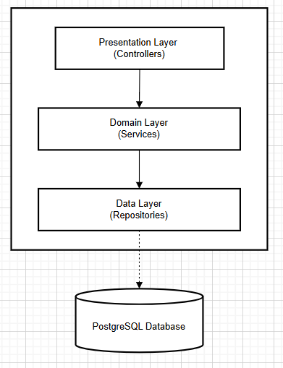

Layered Architecture
In addition to the 3-tier structure, the Logic Tier itself is organized into a layered architecture:
- Controller Layer: The entry point for requests (e.g., PersonController).
- Service Layer (Domain): Where the business logic resides (e.g., DepartmentService, CourseService).
- Repository Layer (Data): Handles the actual communication with the database using Spring Data JPA.

Class Design

Package + Class Diagram
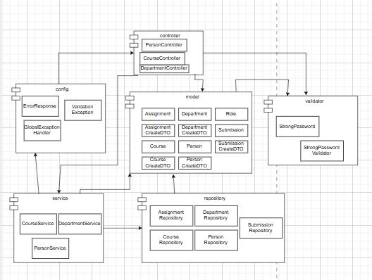

The application's backend architecture is organized into several key modules that enforce a clean separation of concerns. The diagram contains the high-level classes and modules as follows:
- Controller Layer: This package contains the REST Controllers (PersonController, CourseController, DepartmentController) which act as the entry point for requests from the presentation tier.
- Service Layer: This module contains the business logic implementations (PersonService, CourseService, DepartmentService). It acts as an intermediary, processing data before it is sent to the repository.
- Repository Layer: This module manages data access through interfaces such as PersonRepository and CourseRepository, which interact directly with the database.
- Model Layer: This central package defines the domain entities (e.g., Person, Course, Department) and the Data Transfer Objects (DTOs) used for creating and updating records.
- Config & Validator:
  - Config: Contains global handlers like GlobalExceptionHandler to manage application-wide error responses.
  - Validator: Contains custom validation logic, such as StrongPasswordValidator, to ensure data integrity before persistence.

Data Model

The application’s data model is designed to manage complex university relationships through a normalized relational structure:
- Person Entity: This represents the central user of the system. It includes core attributes like name, email, age, and password, along with a Role.
- Department Entity: Acts as the primary organizational unit. It maintains a One-to-Many relationship with the Course entity, ensuring every course belongs to exactly one department.
- Course Entity: Stores academic details like title and credits. It maintains a Many-to-Many relationship with the Person entity, managed through a join table (visible in the diagram as enrolled_courses), allowing students and professors to be associated with multiple courses.
- Assignment & Submission Entities: These entities allow for the creation of academic tasks within a specific Course and track the work submitted by a Person.

