Ministry of Education and Science of Ukraine
National Technical University of Ukraine
Igor Sikorsky Kyiv Polytechnic Institute

Educational and Scientific Institute of Nuclear and Thermal Power Engineering Department of Digital Technologies in Energy

Report
on computational graphic work
in the discipline "Visualization of graphic and geometric information"

Performed by:
Student of group TP-52mp
Maya Vadimivna Tkachenko

Checked by:
Demchyshyn Anatoliy Anatoliyovych

KYIV – 2025
Variant 15: Texture Coordinate Scaling
The primary objective of this assignment is to implement dynamic scaling of texture coordinates on a 3D model. The implementation must allow a user to specify a point on the texture's UV surface, which will serve as the center for the scaling operation.
Core Requirements:
1. Texture Scaling: Implement a mechanism to scale the texture applied to the model. The scaling should originate from a user-defined center point (u, v).
2. Interactive Center Point: The user must be able to move the center point (u, v) across the texture's surface using dedicated UI sliders for U and V coordinates.
3. Foundation: The implementation should build upon the existing WebGL project, reusing the texture mapping and rendering pipeline from the control task.
4. Technology Stack: The solution is implemented using WebGL, JavaScript for application logic, and GLSL (OpenGL Shading Language) for the shader programs.
Theoretical Background (Теоретичні Відомості)
Texture Mapping
Texture mapping is a technique used to add detail, surface texture, or color to a computer-generated graphic or 3D model. A texture is a 2D image that is "wrapped" around the 3D object. Each vertex of the model is assigned texture coordinates (commonly referred to as UV coordinates) that specify which point on the 2D texture corresponds to that vertex.
The u coordinate represents the horizontal position on the texture, and the v coordinate represents the vertical position. Both u and v are typically normalized, meaning they range from 0.0 to 1.0, where (0, 0) is one corner of the texture (e.g., bottom-left) and (1, 1) is the opposite corner (e.g., top-right).
Transformation of Texture Coordinates
To manipulate how a texture appears on a model, we can transform its texture coordinates before they are used to sample the texture image in the fragment shader. These transformations occur in UV space. For this assignment, the required transformation is scaling around an arbitrary point.
The mathematical formula for scaling a 2D point P(u, v) around a center point C(u_c, v_c) by a scale factor S is:
P' = (P - C) * S + C
Where:
- P' is the new, transformed coordinate.
- P is the original texture coordinate (u, v).
- C is the center point for scaling (u_c, v_c).
- S is the scaling factor.
Steps of transformation :
1. Translate to origin: First, we move the coordinate system so that the center point C is at the origin. This is done by subtracting the center point's coordinates from the original texture coordinate: P_translated = P - C.
2. Scale: Next, we scale the translated coordinate by the scaling factor S: P_scaled = P_translated * S. A value of S > 1.0 zooms in (enlarges the texture), while a value of S < 1.0 zooms out (shrinks the texture).
3. Translate Back: Finally, we move the coordinate system back to its original position by adding the center point's coordinates: P' = P_scaled + C.
This entire operation is efficiently performed in the vertex shader, which processes every vertex of the model. By modifying the a_texcoord attribute and passing it to the fragment shader, we change how the texture is sampled for every pixel on the model's surface.
Implementation details :
The implementation was divided into two main parts: the client-side JavaScript logic for user interaction and the shader program for performing the texture coordinate transformation on the GPU.
(main.js)
1.Global variables were introduced to store the state of the texture transformation:
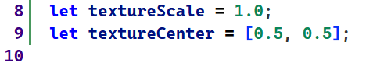
textureScale holds the current zoom level, and textureCenter stores the coordinates of the pivot point for scaling.
2.The interactive controls are implemented using HTML <input type="range"> (sliders) and <input type="number"> elements. Event listeners are attached to these elements to capture user input and update the textureCenter and textureScale variables.
- Separate sliders control the u and v coordinates of textureCenter.
- A dedicated slider controls the textureScale factor.
- A helper function setupSlider was created to encapsulate the logic for synchronizing the range slider and number input, and updating the corresponding JavaScript variable (textureCenter[0], textureCenter[1], or textureScale).
The values are clamped by the min and ma` attributes of the HTML input elements to ensure the center point stays within the [0, 1] range and the scale factor remains reasonable.

3. Uniforms: To pass these JavaScript values to the shader, we first need to get the memory location of the uniform variables from the shader program during initialization (initGL function).
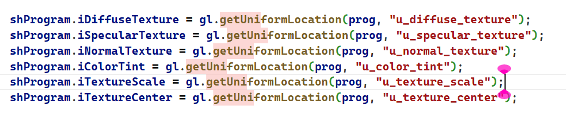
4. Passing Data to Shader: In the draw function, which is executed every frame, the updated values of textureScale and textureCenter are sent to the GPU using gl.uniform1f and gl.uniform2fv.
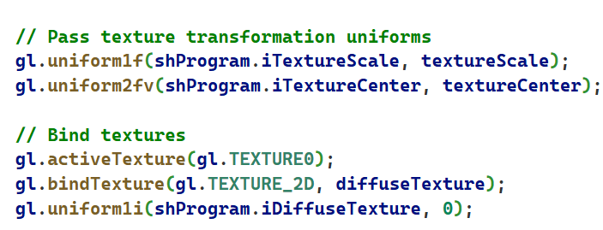

(shader.gpu)
The core transformation logic was implemented in the vertex shader for maximum efficiency.
1. Uniform Declaration: The shader was updated to accept the scale and center uniforms from the JavaScript code.
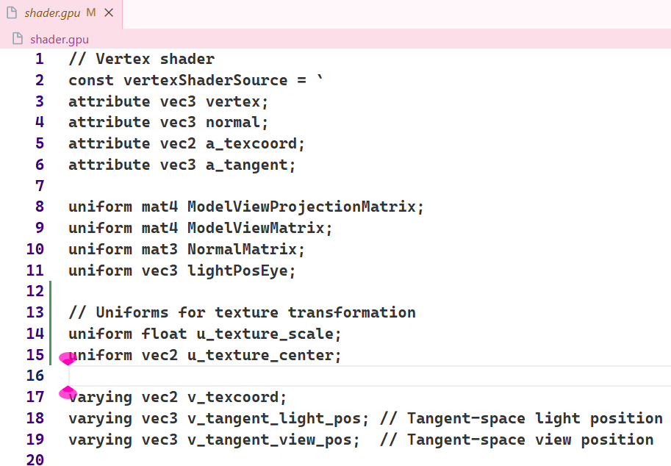
2. Coordinate Transformation: The main logic of the vertex shader was modified. Instead of passing the original texture coordinates (a_texcoord) directly to the fragment shader, we now apply the scaling formula. The result is then passed to the v_texcoord varying variable.
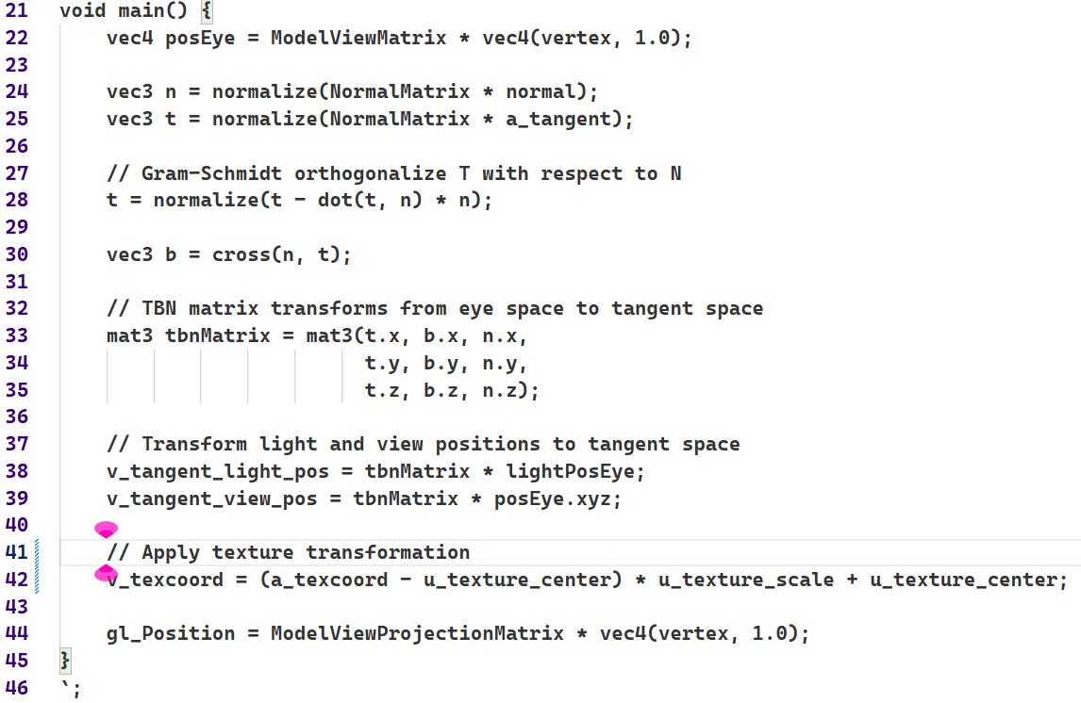
This single line executes the entire "translate-scale-translate" logic on the GPU for every vertex, resulting in a dynamic and smooth scaling effect controlled by the user. The fragment shader required no changes, as it transparently uses the transformed coordinates it receives.
User's Manual
This application demonstrates dynamic texture scaling on a 3D model in real-time.
Controls:
- Rotate the Model: Click and drag the mouse on the model to rotate it in any direction.
- Adjust Model Resolution: Use the sliders in the "Params" section to change the detail (polygon count) of the 3D model.
- Adjust Texture: Use the sliders in the "Texture Controls" section:
- U coordinate: Moves the scaling center horizontally across the texture.
- V coordinate: Moves the scaling center vertically across the texture.
- Scale: Zooms the texture in or out from the center point.
You can either drag the sliders or type a precise value into the number boxes.
The initial state of the model with the default texture and controls :
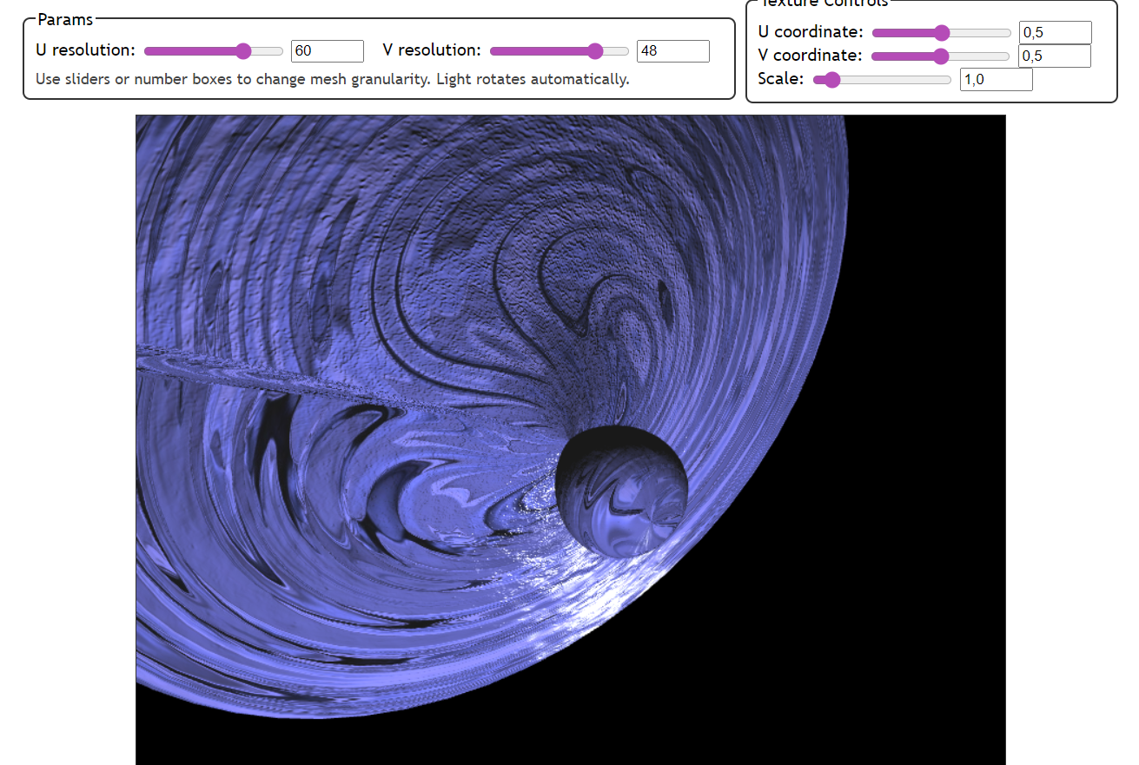
The model after moving the U and V sliders to a new position and increasing the scale :
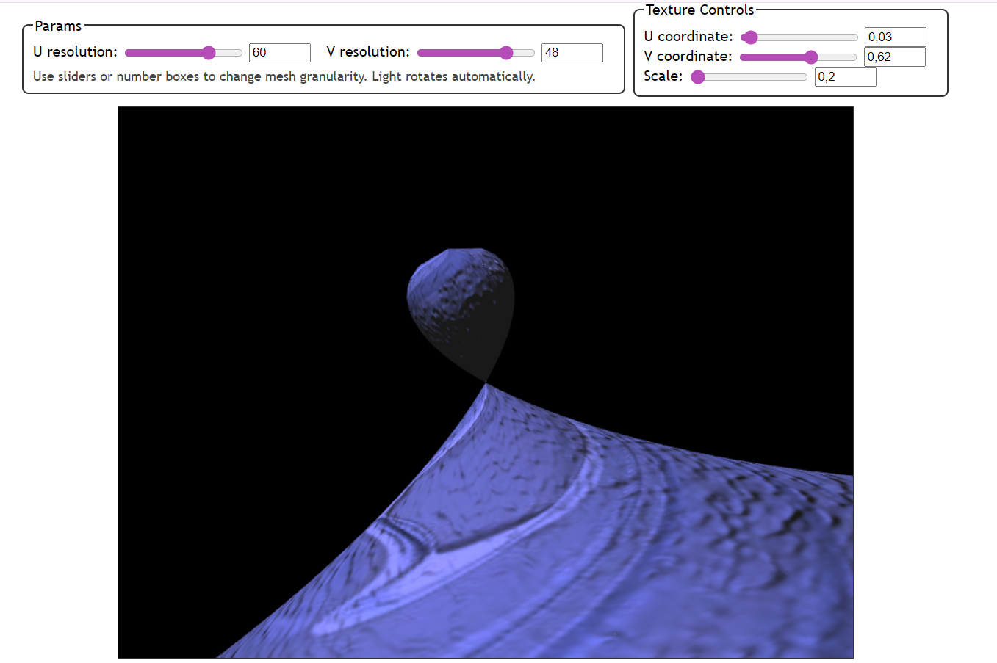
The model after decreasing the scale significantly :
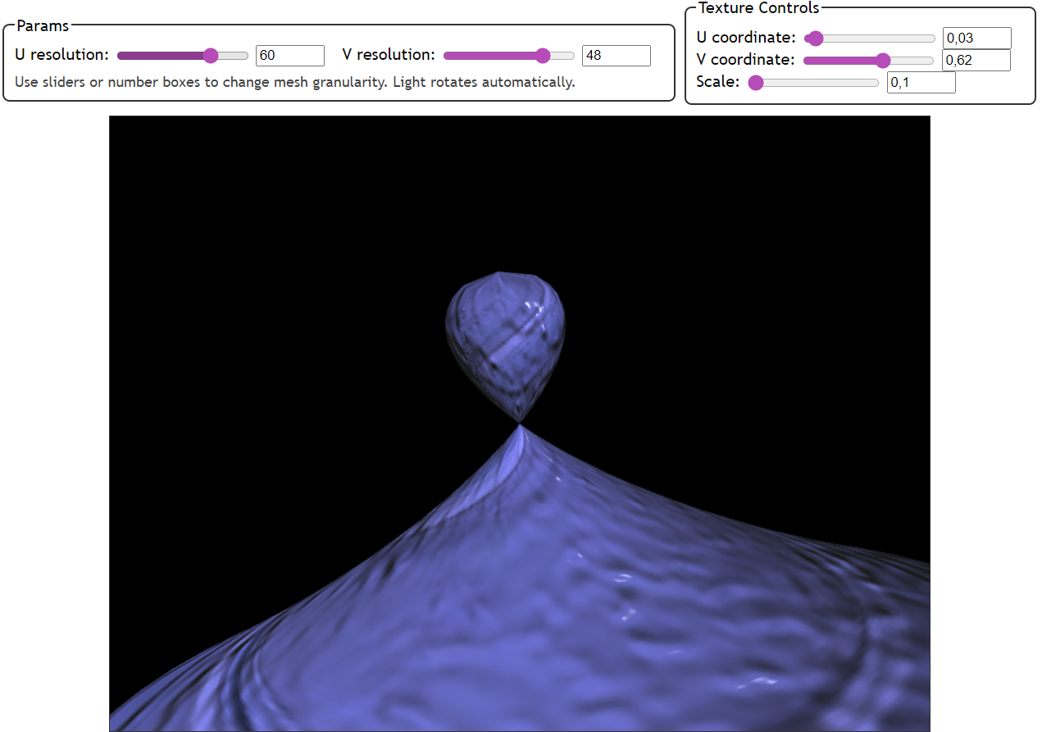
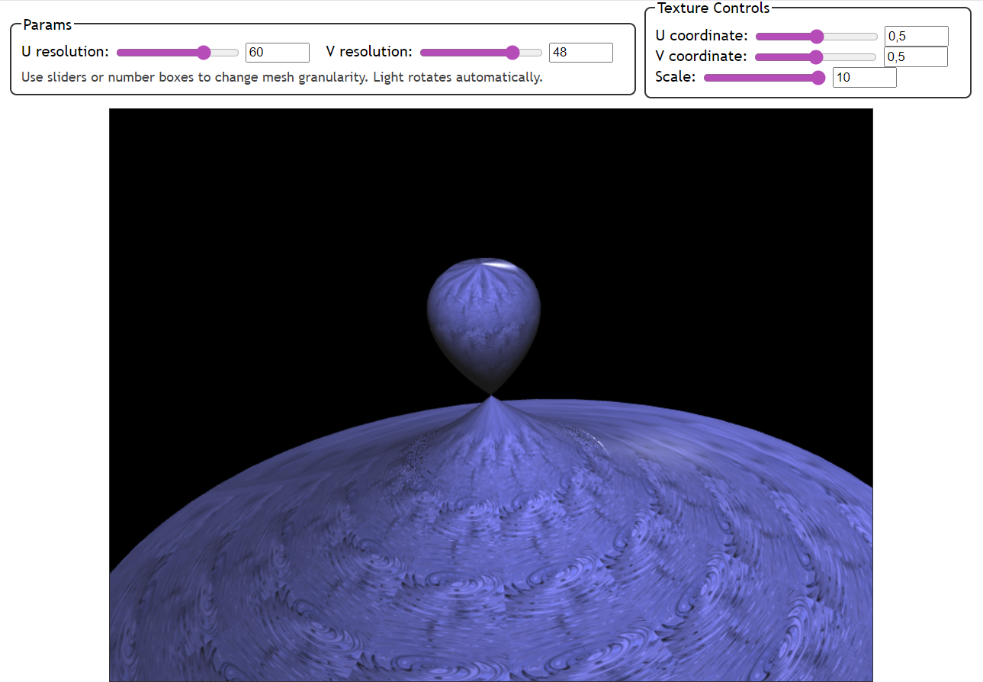
Source Code Sample :
main.js
'use strict';

let gl; // The webgl context.
let surface; // A surface model
let shProgram; // A shader program (wrapper)
let spaceball; // Trackball
let diffuseTexture, normalTexture, specularTexture; // Textures
let textureScale = 1.0;
let textureCenter = [0.5, 0.5];

function deg2rad(angle) { return angle * Math.PI / 180; }

function isPowerOf2(value) {
return (value & (value - 1)) === 0;
}

function loadTextureFromFile(gl, path) {
const texture = gl.createTexture();
gl.bindTexture(gl.TEXTURE_2D, texture);

const level = 0;
const internalFormat = gl.RGBA;
const width = 1;
const height = 1;
const border = 0;
const srcFormat = gl.RGBA;
const srcType = gl.UNSIGNED_BYTE;
const pixel = new Uint8Array([0, 0, 255, 255]);
gl.texImage2D(gl.TEXTURE_2D, level, internalFormat, width, height, border, srcFormat, srcType, pixel);

const image = new Image();
image.onload = () => {
gl.bindTexture(gl.TEXTURE_2D, texture);
gl.texImage2D(gl.TEXTURE_2D, level, internalFormat, srcFormat, srcType, image);

if (isPowerOf2(image.width) && isPowerOf2(image.height)) {

gl.generateMipmap(gl.TEXTURE_2D);
gl.texParameteri(gl.TEXTURE_2D, gl.TEXTURE_WRAP_S, gl.REPEAT);
gl.texParameteri(gl.TEXTURE_2D, gl.TEXTURE_WRAP_T, gl.REPEAT);
gl.texParameteri(gl.TEXTURE_2D, gl.TEXTURE_MIN_FILTER, gl.LINEAR_MIPMAP_LINEAR);
gl.texParameteri(gl.TEXTURE_2D, gl.TEXTURE_MAG_FILTER, gl.LINEAR);
} else {
gl.texParameteri(gl.TEXTURE_2D, gl.TEXTURE_WRAP_S, gl.CLAMP_TO_EDGE);
gl.texParameteri(gl.TEXTURE_2D, gl.TEXTURE_WRAP_T, gl.CLAMP_TO_EDGE);
gl.texParameteri(gl.TEXTURE_2D, gl.TEXTURE_MIN_FILTER, gl.LINEAR);
gl.texParameteri(gl.TEXTURE_2D, gl.TEXTURE_MAG_FILTER, gl.LINEAR);
}

draw(); // Перемалювати сцену після успішного завантаження
};
image.onerror = () => {
console.error(`Failed to load texture from: ${path}`);
};

image.src = path;

return texture;
}

function multiplyMat4Vec4(m, v) {
return [
m[0]*v[0] + m[4]*v[1] + m[8]*v[2] + m[12]*v[3],
m[1]*v[0] + m[5]*v[1] + m[9]*v[2] + m[13]*v[3],
m[2]*v[0] + m[6]*v[1] + m[10]*v[2] + m[14]*v[3],
m[3]*v[0] + m[7]*v[1] + m[11]*v[2] + m[15]*v[3]
];
}

function computeNormalMatrix3(modelView) {
const a00 = modelView[0], a01 = modelView[4], a02 = modelView[8];
const a10 = modelView[1], a11 = modelView[5], a12 = modelView[9];
const a20 = modelView[2], a21 = modelView[6], a22 = modelView[10];
const det = a00*(a11*a22-a12*a21) - a01*(a10*a22-a12*a20) + a02*(a10*a21-a11*a20);
const invDet = 1.0 / (det || 1e-9);
const r00 = (a11*a22 - a12*a21)*invDet, r01 = -(a01*a22-a02*a21)*invDet, r02 = (a01*a12-a02*a11)*invDet;
const r10 = -(a10*a22-a12*a20)*invDet, r11 = (a00*a22-a02*a20)*invDet, r12 = -(a00*a12-a02*a10)*invDet;
const r20 = (a10*a21-a11*a20)*invDet, r21 = -(a00*a21-a01*a20)*invDet, r22 = (a00*a11-a01*a10)*invDet;
return new Float32Array([r00,r10,r20, r01,r11,r21, r02,r12,r22]);
}

function rebuildSurfaceFromUI() {
let uCount = parseInt(document.getElementById('uCount')?.value) || 60;
let vCount = parseInt(document.getElementById('vCount')?.value) || 48;
if (uCount < 3) uCount = 3;
if (vCount < 2) vCount = 2;

const uNum = document.getElementById('uCountNum'), vNum = document.getElementById('vCountNum');
if (uNum) uNum.value = uCount;
if (vNum) vNum.value = vCount;

surface.createBuffersFromSurface(function(u,v){ return dingDong_param(u, v, 1.0); }, uCount, vCount);
surface.setMaterial([0.1, 0.1, 0.1], 64.0);
draw();
}

function draw() {
if (!gl) return;
gl.clearColor(0,0,0,1);
gl.clear(gl.COLOR_BUFFER_BIT | gl.DEPTH_BUFFER_BIT);

const projection = m4.perspective(Math.PI/8, gl.canvas.width / gl.canvas.height, 0.1, 100.0);
let view = (typeof spaceball !== 'undefined' && spaceball && typeof spaceball.getViewMatrix === 'function')
? spaceball.getViewMatrix()
: m4.identity();
const rotateToPointZero = m4.axisRotation([0.707,0.707,0], 0.7);
const translateToPointZero = m4.translation(0,0,-10);
const matAccum0 = m4.multiply(rotateToPointZero, view);
const modelView = m4.multiply(translateToPointZero, matAccum0);
const modelViewProjection = m4.multiply(projection, modelView);

shProgram.Use();

gl.uniformMatrix4fv(shProgram.iModelViewProjectionMatrix, false, modelViewProjection);
gl.uniformMatrix4fv(shProgram.iModelViewMatrix, false, modelView);
const normalMat3 = computeNormalMatrix3(modelView);
gl.uniformMatrix3fv(shProgram.iNormalMatrix, false, normalMat3);
gl.uniform3fv(shProgram.iColorTint, [0.5, 0.5, 1.0]);

const t = performance.now() * 0.001;
const radius = 6.0;
const lightWorld = [ radius * Math.cos(t), 2.0, radius * Math.sin(t), 1.0 ];
const lightEye = multiplyMat4Vec4(modelView, lightWorld);
gl.uniform3fv(shProgram.iLightPosEye, [lightEye[0], lightEye[1], lightEye[2]]);

// Pass texture transformation uniforms
gl.uniform1f(shProgram.iTextureScale, textureScale);
gl.uniform2fv(shProgram.iTextureCenter, textureCenter);

// Bind textures
gl.activeTexture(gl.TEXTURE0);
gl.bindTexture(gl.TEXTURE_2D, diffuseTexture);
gl.uniform1i(shProgram.iDiffuseTexture, 0);

gl.activeTexture(gl.TEXTURE1);
gl.bindTexture(gl.TEXTURE_2D, specularTexture);
gl.uniform1i(shProgram.iSpecularTexture, 1);

gl.activeTexture(gl.TEXTURE2);
gl.bindTexture(gl.TEXTURE_2D, normalTexture);
gl.uniform1i(shProgram.iNormalTexture, 2);

surface.Draw();
}

function initGL() {
const prog = createProgram(gl, vertexShaderSource, fragmentShaderSource);
shProgram = new ShaderProgram('NormalMapping', prog);
shProgram.Use();

shProgram.iAttribVertex = gl.getAttribLocation(prog, "vertex");
shProgram.iAttribNormal = gl.getAttribLocation(prog, "normal");
shProgram.iAttribTexCoord = gl.getAttribLocation(prog, "a_texcoord");
shProgram.iAttribTangent = gl.getAttribLocation(prog, "a_tangent");

shProgram.iModelViewProjectionMatrix = gl.getUniformLocation(prog, "ModelViewProjectionMatrix");
shProgram.iModelViewMatrix = gl.getUniformLocation(prog, "ModelViewMatrix");
shProgram.iNormalMatrix = gl.getUniformLocation(prog, "NormalMatrix");

shProgram.iLightPosEye = gl.getUniformLocation(prog, "lightPosEye");
shProgram.iAmbient = gl.getUniformLocation(prog, "ambientColor");
shProgram.iShininess = gl.getUniformLocation(prog, "shininess");

shProgram.iDiffuseTexture = gl.getUniformLocation(prog, "u_diffuse_texture");
shProgram.iSpecularTexture = gl.getUniformLocation(prog, "u_specular_texture");
shProgram.iNormalTexture = gl.getUniformLocation(prog, "u_normal_texture");
shProgram.iColorTint = gl.getUniformLocation(prog, "u_color_tint");
shProgram.iTextureScale = gl.getUniformLocation(prog, "u_texture_scale");
shProgram.iTextureCenter = gl.getUniformLocation(prog, "u_texture_center");

// --- ЗАВАНТАЖЕННЯ ТЕКСТУР З ПАПКИ textures/ ---
diffuseTexture = loadTextureFromFile(gl, "textures/diffuse.jpg");
specularTexture = loadTextureFromFile(gl, "textures/specular.jpg");
normalTexture = loadTextureFromFile(gl, "textures/normal.jpg");
// ---------------------------------------------

surface = new Model('Surface');
rebuildSurfaceFromUI();

const uRange = document.getElementById('uCount'), vRange = document.getElementById('vCount');
const uNum = document.getElementById('uCountNum'), vNum = document.getElementById('vCountNum');
if (uRange && uNum) {
uRange.addEventListener('input', () => { uNum.value = uRange.value; });
uNum.addEventListener('change', () => { uRange.value = uNum.value; });
}
if (vRange && vNum) {
vRange.addEventListener('input', () => { vNum.value = vRange.value; });
vNum.addEventListener('change', () => { vRange.value = vNum.value; });
}
uRange.addEventListener('input', rebuildSurfaceFromUI);
uNum.addEventListener('change', rebuildSurfaceFromUI);
vRange.addEventListener('input', rebuildSurfaceFromUI);
vNum.addEventListener('change', rebuildSurfaceFromUI);

const uPointRange = document.getElementById('uPoint'), vPointRange = document.getElementById('vPoint');
const scaleRange = document.getElementById('scale');
const uPointNum = document.getElementById('uPointNum'), vPointNum = document.getElementById('vPointNum');
const scaleNum = document.getElementById('scaleNum');

function setupSlider(rangeEl, numEl, isScale) {
rangeEl.addEventListener('input', () => {
const value = parseFloat(rangeEl.value);
numEl.value = value;
if(isScale) textureScale = value;
else {
if(rangeEl.id.startsWith('u')) textureCenter[0] = value;
else textureCenter[1] = value;
}
});
numEl.addEventListener('change', () => {
const value = parseFloat(numEl.value);
rangeEl.value = value;
if(isScale) textureScale = value;
else {
if(numEl.id.startsWith('u')) textureCenter[0] = value;
else textureCenter[1] = value;
}
});
}

setupSlider(uPointRange, uPointNum, false);
setupSlider(vPointRange, vPointNum, false);
setupSlider(scaleRange, scaleNum, true);

gl.enable(gl.DEPTH_TEST);
}

function ShaderProgram(name, program) {
this.name = name;
this.prog = program;
this.iAttribVertex = -1;
this.iAttribNormal = -1;
this.iAttribTexCoord = -1;
this.iAttribTangent = -1;
this.iModelViewProjectionMatrix = -1;
this.iModelViewMatrix = -1;
this.iNormalMatrix = -1;
this.iLightPosEye = -1;
this.iAmbient = -1;
this.iShininess = -1;
this.iDiffuseTexture = -1;
this.iSpecularTexture = -1;
this.iNormalTexture = -1;
this.iColorTint = -1;
this.iTextureScale = -1;
this.iTextureCenter = -1;
this.Use = function() { gl.useProgram(this.prog); };
}

function createProgram(gl, vShader, fShader) {
let vsh = gl.createShader(gl.VERTEX_SHADER);
gl.shaderSource(vsh,vShader);
gl.compileShader(vsh);
if (!gl.getShaderParameter(vsh, gl.COMPILE_STATUS)) {
throw new Error("Error in vertex shader: " + gl.getShaderInfoLog(vsh));
}
let fsh = gl.createShader(gl.FRAGMENT_SHADER);
gl.shaderSource(fsh, fShader);
gl.compileShader(fsh);
if (!gl.getShaderParameter(fsh, gl.COMPILE_STATUS)) {
throw new Error("Error in fragment shader: " + gl.getShaderInfoLog(fsh));
}
let prog = gl.createProgram();
gl.attachShader(prog,vsh);
gl.attachShader(prog, fsh);
gl.linkProgram(prog);
if (!gl.getProgramParameter(prog, gl.LINK_STATUS)) {
throw new Error("Link error in program: " + gl.getProgramInfoLog(prog));
}
return prog;
}

function init() {
let canvas;
try {
canvas = document.getElementById("webglcanvas");
gl = canvas.getContext("webgl");
if (!gl) throw "Browser does not support WebGL";
} catch(e) {
document.getElementById("canvas-holder").innerHTML = "<p>Sorry, could not get a WebGL graphics context.</p>";
return;
}
try {
initGL();
} catch(e) {
document.getElementById("canvas-holder").innerHTML = "<p>Sorry, could not initialize the WebGL graphics context: " + e + "</p>";
return;
}
spaceball = new TrackballRotator(canvas, draw, 0);

function animate() {
draw();
requestAnimationFrame(animate);
}
animate();
}

