
Rajiv Gandhi College of Arts, Commerce & Science, Vashi
{Permanently Affiliated to University of Mumbai} Re-Accredited by NAAC, Grade ‘B’
Hindi Linguistic Minority Institute Sector 10A, Vashi, Navi Mumbai – 400703
DEPARTMENT OF COMPUTER SCIENCE
& INFORMATION TECHNOLOGY

A PROJECT REPORT
on

ONLINE BUS RESERVATION SYSTEM

Submitted to

University of Mumbai
in partial fulfilment for the award of the degree of

BACHELOR OF SCIENCE
in

COMPUTER SCIENCE
by

Ms. Maya Chauhan (Seat No. )
under the guidance of
Asst.Prof.Zainab Shaikh Academic Year: 2026–2027



DEPARTMENT OF COMPUTER SCIENCE & INFORMATION TECHNOLOGY

CERTIFICATE

This is to certify that the project entitled
“Online Bus Reservation System (BusGo)”

is successfully completed by Ms. Maya Chauhan (Seat No. ) of T.Y.B.Sc (Computer Science), Semester V and has been carried out under the guidance of Asst.Prof. Zainab Shaikh during the Academic Year 2026–27 in partial fulfilment of the requirements of the University of Mumbai for the award of the Degree of Bachelor of Science (Computer Science). The work presented is original and has not been submitted earlier for the award of any degree or diploma.

Asst.Prof.Zainab Shaikh
Asst. Prof. Anita Yadav Co-ordinator

External Examiner Dr. B. S. Pandey Principal

DECLARATION
I, Maya Chauhan, hereby declare that the project report entitled “Online Bus Reservation System (BusGo)” submitted during the academic year 2026–27, under the guidance of Asst.Prof.Zainab Shaikh, in partial fulfilment of the requirements for the award of the degree of Bachelor of Science in Computer Science (B.Sc. CS) from Sainath Education Trust’s Rajiv Gandhi College of Arts, Commerce & Science, Vashi.
I also declare that this project is a result of my own effort and that it has not been submitted to any other University or Institution for the award of any degree or diploma.

Maya Chauhan
Name of Student

ACKNOWLEDGEMENT
I would like to take this opportunity to express my profound gratitude and deep regards to our esteemed Principal, Dr. Basukinath Pandey, for providing a scholarly environment and for his exemplary leadership.
I am also thankful to the Co-ordinator of the Department of Information Technology and Computer Science, Asst. Prof. Anita Yadav, for her valuable support and for providing me with the necessary infrastructure and a conducive environment to carry out my project work.
I would like to express my deepest gratitude and sincere thanks to my project guide, Dr. Priyesha Gharat, for her invaluable guidance, constant encouragement, insightful suggestions and support throughout the course of this project. Her expertise and support were instrumental in the successful completion of this work.
Finally, I would like to thank my parents and friends for their unwavering support and encouragement throughout this journey.

Maya Chauhan

ABSTRACT
The Online Bus Reservation System (“BusGo – Travel Anywhere, Anytime”) is a modern web-based application designed to automate and simplify intercity bus travel booking. In traditional physical ticket counter booking, passengers face significant hurdles including long queues, lack of real-time seat availability information, inflexible payment options, and the persistent risk of human booking errors such as seat double allocations.
BusGo provides comprehensive, role-based access for Passengers and Administrators. Passengers can effortlessly search routes across various departure dates, inspect an interactive visual seat layout matrix, select preferred seats, make secure payments using dynamic UPI QR codes (supporting Google Pay, PhonePe, and Paytm), and instantly download a verified digital boarding pass (M-Ticket) with a scannable QR verification code. The administrative module empowers fleet managers to oversee bus profiles, schedules, fares, passenger reservations, and revenue analytics.
The application is engineered using the MERN technology stack: a high-performance frontend built with React 18, Vite, and Tailwind CSS; a scalable backend powered by Node.js and Express.js REST APIs; and a resilient MongoDB database utilizing Mongoose ODM. Security and operational integrity are guaranteed through JWT-based authentication, bcryptjs password hashing, atomic seat-locking transactions to eliminate race conditions, and automated PDF boarding pass generation via jsPDF. Overall, BusGo provides a transparent, efficient, and robust digital travel platform.

TABLE OF CONTENTS
CONTENTS Page No

- INTRODUCTION 1
  - Project Overview 1
  - Problem Statement 1
  - Objectives 2
  - Scope and Limitations 2
  - Project Preface 3
- SYSTEM ANALYSIS 4
  - Existing System 4
  - Proposed System 4
  - Feasibility Study 5
  - Advantages and Observations 5
- SYSTEM REQUIREMENT SPECIFICATIONS 7
  - Hardware Requirements 7
  - Software Requirements 7
  - Functional Requirements 7
  - Non-Functional Requirements 8
- SYSTEM DESIGN 10
  - System Architecture 10
  - Data Flow Diagrams (DFD) 10
  - Use Case Diagram 11
  - Database Design 12
  - E-R Diagram 16
  - Sequence Diagram 16
  - Activity Diagram 17
  - Gantt Chart 18
- IMPLEMENTATION AND TECHNOLOGY USED 20
  - Module Description 20
  - Technology Stack 20
  - Frontend 21
  - Backend 21
  - Database 21
  - Billing Module 21
  - Inventory Module 22
  - Platform and Tools Used 22
- SYSTEM TESTING 23
  - Testing Strategies 23
  - Test Cases 23
  - Unit Testing 24
  - Integration Testing 25
  - System Review 25
- CODING 26
  - Database SQL (schema.sql) 26
  - Backend Code (configuration and core functions) 28
  - Login Code 30
  - Medicine Management Code 30
  - Sales Code 33
  - Purchase Code 34
  - Billing / Invoice Code 35
  - Inventory Code 36
  - Report Code 37
  - Database Set-up Script (setup_db.py) 37
- SYSTEM DEPLOYMENT AND SCREENSHOTS 39
  - Deployment 39
  - Screenshots 39
- CONCLUSION AND FUTURE ENHANCEMENT 44
  - Conclusion 44
  - Future Enhancement 44
- REFERENCE / BIBLIOGRAPHY 45

INTRODUCTION

Project Overview
The Online Bus Reservation System (BusGo) is a full-featured web-based platform developed to streamline and digitize bus travel operations. Bus transportation is one of the most widely used modes of passenger travel in India. However, managing passenger ticketing, seat inventories, bus schedules, and fare calculations through manual registers or fragmented tools creates severe delays, operational overhead, and passenger dissatisfaction.
BusGo consolidates bus fleet management, route definitions, trip scheduling, interactive seat selection, contactless digital UPI payments, and passenger ticketing into a unified digital ecosystem. Backed by a MongoDB database and Node.js REST API, the system delivers real-time seat availability, instant booking confirmations, and comprehensive administrative dashboards for bus operators.
The user interface is engineered with React 18, Vite, and Tailwind CSS, providing an ultra-responsive layout that operates seamlessly across desktops, laptops, tablets, and smartphones without requiring any specialized training.

Problem Statement
Many regional bus operators and private travel agencies still depend on manual ticketing counters, phone calls, or static spreadsheet logs. This conventional approach suffers from critical limitations:
- Physical Queuing: Passengers must travel to physical ticket counters and stand in long queues to inquire about bus schedules and seat availability.
- Double Booking Vulnerability: Concurrent manual reservations across multiple ticket counters frequently lead to the double allocation of the same bus seat.
- Lack of Seat Transparency: Passengers cannot view the bus seating arrangement or choose preferred window, aisle, or sleeper berths prior to booking.
- Cash Handling and Payment Inconvenience: Counter bookings depend heavily on physical cash, causing change reconciliation issues and slower transactions.
- Paper Ticket Misplacement: Physical paper tickets are easily lost, damaged, or torn, with no instant cloud retrieval or digital backup.
- Scattered Fleet Records: Route changes, bus cancellations, and passenger manifests are recorded across disconnected paper logbooks.
- Lack of Security and Access Control: Paper registers lack authentication and audit trails, making transaction records vulnerable to manipulation.

The BusGo Online Bus Reservation System overcomes these deficiencies by providing a centralized, secure, and automated digital portal that operates 24/7.

Objectives
The primary objective of the project is to design and develop an intuitive, reliable, and real-time online bus reservation application. Key specific objectives include:
- To maintain a centralized database of buses, routes, departure times, fares, and seat layouts.
- To provide an interactive visual seat selection matrix where passengers can inspect booked, available, and selected seats in real time.
- To implement atomic seat locking during the checkout flow to completely eliminate race conditions and double bookings.
- To integrate dynamic UPI QR code payments allowing instant, contactless cashless payments with automatic verification.
- To generate instant digital boarding passes (M-Tickets) in downloadable PDF format equipped with scannable QR verification.
- To provide passenger dashboards for viewing booking history, downloading tickets, and managing cancellations.
- To furnish administrators with comprehensive tools to add buses, schedule trips, manage routes, and monitor revenue analytics.
- To secure user accounts with JSON Web Tokens (JWT), password hashing via bcryptjs, and role-based route protection.

Scope and Limitations

Scope
The scope of BusGo encompasses intercity passenger bus travel reservations, fleet schedule management, interactive seat selection, dynamic UPI QR payment processing, digital ticket issuance, and administrative reporting.

Limitations
- The system is currently configured for a single primary bus fleet operator; multi-tenant external marketplace aggregation is planned for future phases.
- Payment processing is optimized for UPI QR transactions and simulated gateway callbacks; credit/debit card merchant accounts require external merchant credentials.

- Boarding passes are delivered through client-side PDF downloads; direct SMS/WhatsApp notifications require commercial telecom gateway subscriptions.
- Frontend assets utilize modern NPM bundling with Vite, requiring an active internet connection for map tiles and external icon CDNs.
- Real-time updates operate via HTTP REST polling; WebSocket push notifications represent a planned future enhancement.

Project Preface
This project report provides a thorough and systematic exploration of the engineering lifecycle of the Online Bus Reservation System (BusGo), detailing requirements, architecture, schemas, testing, and deployment.
The system design chapter presents the architecture, data flow diagrams, use case diagram, database design, ER diagram, sequence diagram, activity diagram and Gantt chart. The implementation chapter explains the modules and the technologies used, including the billing and inventory modules. The testing chapter lists the testing strategies and test cases. The coding chapter contains the important source code of the project, and the deployment chapter explains how the system is installed and run. The report ends with the conclusion, future enhancements and bibliography.

SYSTEM ANALYSIS

Existing System
In conventional bus transport management, operational workflows are predominantly manual or rely on rudimentary spreadsheets.
Manual Counter Booking: Seat charts are physically crossed out with pens on printed paper charts, causing frequent errors and illegible handwriting.
Spreadsheet Logs: While Excel allows basic recordkeeping, it cannot provide concurrent real-time seat availability to multiple ticket counters simultaneously.
Isolated Desktop Billing Tools: Legacy offline desktop tools generate paper receipts but lack remote booking capabilities for passengers.
The key shortcomings of the legacy system include severe booking delays, double allocations, revenue leakages, and lack of customer convenience.

Proposed System
The proposed BusGo system replaces outdated manual mechanisms with a high-speed, centralized web application:
- Route & Fleet Management: Administrators configure bus models, seating capacities (e.g. 40 seats), routes, stopovers, and amenities.
- Interactive Seat Selection: Passengers view an intuitive visual coach grid showing exact window, aisle, and sleeper positions.
- Dynamic UPI QR Payments: Total fare is calculated dynamically and encoded into a standard UPI payment QR code for immediate scanning.
- Digital Boarding Pass: Upon successful payment, a tamper-proof PDF ticket with booking reference and QR code is instantly generated.
- Fleet Occupancy Monitoring: Real-time tracking of seat booking percentages, upcoming departures, and vacant seats across all trips.

- Analytics & Reporting: Graphical summaries of daily ticket sales, popular routes, and total revenue collections.
- Security & Integrity: Strict JWT token authorization, bcryptjs password hashing, and atomic seat reservation logic.

Feasibility Study
A feasibility study was carried out to check whether the project can be developed and used successfully. It covers technical, economic and operational feasibility.

Technical Feasibility
The project is technically feasible as it leverages industry-standard technologies (React 18, Node.js, Express, and MongoDB). All libraries, including Vite, Tailwind CSS, jsPDF, and QRCode, are mature, well-documented, and widely adopted across production software systems.

Economic Feasibility
The project is economically feasible because all software development tools, runtime environments, and database systems utilized (Node.js, MongoDB Community Edition, VS Code, Git) are open-source and free, incurring zero proprietary licensing costs.

Operational Feasibility
The system is operationally feasible because it provides an intuitive, user-friendly interface requiring no specialized training for passengers or travel staff. Any user familiar with a web browser can complete a booking in under two minutes.

Advantages and Observations

Advantages
- Centralized Cloud Architecture: Unified database for all buses, routes, passengers, and ticket bookings prevents data discrepancies.
- Zero Double Bookings: Atomic seat locking guarantees that a seat selected by one passenger cannot be concurrently booked by another.
- Anytime, Anywhere Access: Passengers can search bus schedules and reserve tickets 24/7 from any web-enabled device.

- Contactless UPI Payments: Rapid checkout with dynamic QR codes eliminates cash handling and manual payment reconciliation.
- Robust Security: Salted password hashing, JWT session protection, and sanitized API endpoints safeguard user information.
- Fully Responsive Design: Tailwind CSS utility styling delivers a smooth, native app-like experience across mobile and desktop devices.
- Actionable Business Analytics: Administrative dashboards display real-time route occupancy rates and revenue trends.

Observations
- Strict server-side validation is crucial to ensure fare calculations and seat state updates cannot be tampered with by clients.
- Database indexing on route source, destination, and departure timestamps is essential for rapid schedule search response times.
- Visual feedback in the seat selection matrix (colors for available, selected, and occupied) significantly enhances user satisfaction.
- A clean, distraction-free booking workflow with a prominent progress indicator maximizes booking completion rates.

SYSTEM REQUIREMENT SPECIFICATIONS

Hardware Requirements

Category | Component | Requirement
Development / Server | Processor | Intel Core i3 / AMD Ryzen 3 or higher (2.0 GHz+)
Development / Server | RAM | 4 GB minimum (8 GB recommended)
Development / Server | Storage | 500 MB free disk space for code and runtime data
Development / Server | Network | Broadband connection for API requests and dependencies
Client (Passenger/Admin) | Processor | Any standard dual-core desktop or modern smartphone SoC
Client (Passenger/Admin) | RAM | 2 GB minimum on desktop / mobile
Client (Passenger/Admin) | Display | Screen resolution 360x640 (mobile) to 1920x1080 (desktop)
Client (Passenger/Admin) | Input | Keyboard & mouse, or touchscreen display

Software Requirements

Software | Requirement | Purpose
Operating system | Windows 10/11, Ubuntu Linux, or macOS | Hosting runtime and development environment
Runtime environment | Node.js v18.0.0 or higher | Backend execution runtime for Express server
Package manager | npm v9.0.0 or higher | Managing project libraries and scripts
Backend framework | Express.js v4.19+ | RESTful API endpoint routing and middleware
Database server | MongoDB v6.0+ / v9.0 Community | NoSQL document store for collections and schemas
Database ODM | Mongoose v8.0+ | Object Data Modeling and schema validation
Frontend library | React 18.2+ | Building dynamic, component-driven user interface
Build tool | Vite v5.0+ | Next-generation frontend tooling and fast HMR
CSS styling | Tailwind CSS v3.4+ | Utility-first responsive styling and UI layout
Icon library | Lucide React | Vector icons for bus amenities, seats, and navigation
PDF generation | jsPDF & html2canvas | Client-side generation of downloadable boarding passes

Functional Requirements

ID | Module | Requirement
FR-01 | Authentication | Passengers and admins shall register and log in securely; passwords shall be hashed using bcryptjs.
FR-02 | Authorization | The system shall restrict administrative routes (bus, schedule, route management) to Admin users via JWT verification.
FR-03 | Route Search | Passengers shall search available bus services by selecting departure city, destination city, and journey date.

ID | Module | Requirement
FR-04 | Bus Schedules | The system shall display active bus schedules matching search criteria with departure/arrival times, bus type, and fare.
FR-05 | Interactive Seat Map | Passengers shall view a real-time coach seat layout indicating available, selected, and occupied seat numbers.
FR-06 | Seat Selection | Passengers shall select one or more available seats with live subtotal calculation based on per-seat fare.
FR-07 | Seat Locking | The system shall atomically validate seat availability upon selection to prevent double bookings.
FR-08 | Passenger Details | The booking flow shall capture passenger full name, age, gender, contact phone number, and email address.
FR-09 | Dynamic UPI QR | The system shall generate a dynamic UPI payment QR code encoding payee VPA, payee name, booking reference, and exact amount.
FR-10 | Payment Verification | The system shall verify transaction submission and update the booking status from 'Pending' to 'Confirmed'.
FR-11 | Boarding Pass Generation | Upon confirmation, the system shall generate a downloadable PDF boarding pass containing booking details and verification QR.
FR-12 | Booking History | Registered passengers shall access a personal dashboard displaying all past and upcoming bus reservations.
FR-13 | Ticket Cancellation | Passengers shall be permitted to cancel confirmed bookings prior to departure, releasing seats back to inventory.
FR-14 | Fleet Management | The Admin shall add, update, and manage bus profiles including bus number, operator, type (AC/Sleeper), and total capacity.
FR-15 | Route Management | The Admin shall configure travel routes with origin city, destination city, distance, and estimated travel duration.
FR-16 | Schedule Dispatch | The Admin shall schedule trips linking a bus to a route with departure time, arrival time, fare, and available seats.
FR-17 | Booking Manifest | The Admin shall view comprehensive passenger booking manifests for any scheduled bus departure.
FR-18 | Revenue Analytics | The administrative dashboard shall compute total revenue, total bookings, active buses, and popular routes.
FR-19 | Search Filtering | The system shall allow filtering search results by bus type (AC, Non-AC, Sleeper, Seater) and price range.
FR-20 | Profile Management | Users shall be able to view and update personal profile details and contact information.

Non-Functional Requirements

Attribute | Requirement
Security | Encrypted passwords with bcryptjs salt rounds, JWT tokens stored in HTTP headers, and input sanitization against injection attacks.
Concurrency & Integrity | Atomic seat reservations preventing race conditions and double bookings during simultaneous user checkout.
Performance | Search API responses and seat layout rendering under 500 ms under standard network conditions.
Availability | The web service is architected for 99.5% uptime with graceful client-side error boundaries for network interruptions.
Usability | Intuitive mobile-first design requiring fewer than 4 clicks from route search to payment checkout.
Scalability | Stateless Express REST API design allowing horizontal scaling across containerized cloud environments.

Attribute | Requirement
Maintainability | Modular MERN architecture separating controllers, routes, models, and reusable React UI components.
Portability | Cross-platform compatibility running across any modern evergreen browser (Chrome, Edge, Firefox, Safari) and Node runtime.

SYSTEM DESIGN

System Architecture
The Online Bus Reservation System (BusGo) adopts a modern three-tier client-server architecture. The Presentation Tier is implemented as a single-page React application powered by Vite and Tailwind CSS. The Application Tier is built on Node.js and Express.js, providing secure RESTful API endpoints. The Data Tier comprises a document-oriented MongoDB database accessed through Mongoose ODM.
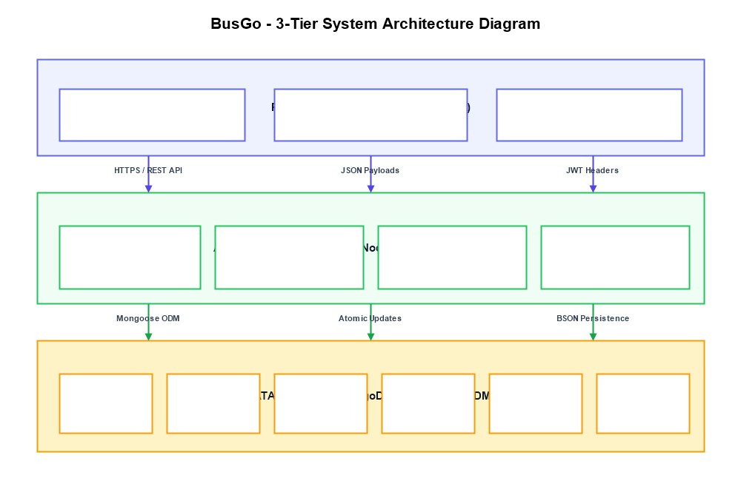
Fig 4.1: System Architecture Diagram (3-Tier MERN Architecture)

Data Flow Diagrams (DFD)
Data Flow Diagrams (DFDs) illustrate the movement, transformation, and storage of information throughout the BusGo system across various operational processes.

DFD Level 0 (Context Diagram)
At Level 0 (Context Diagram), the entire BusGo system is modeled as a centralized process interacting with three primary external entities: the Passenger, the System Administrator, and the External UPI Payment Service.

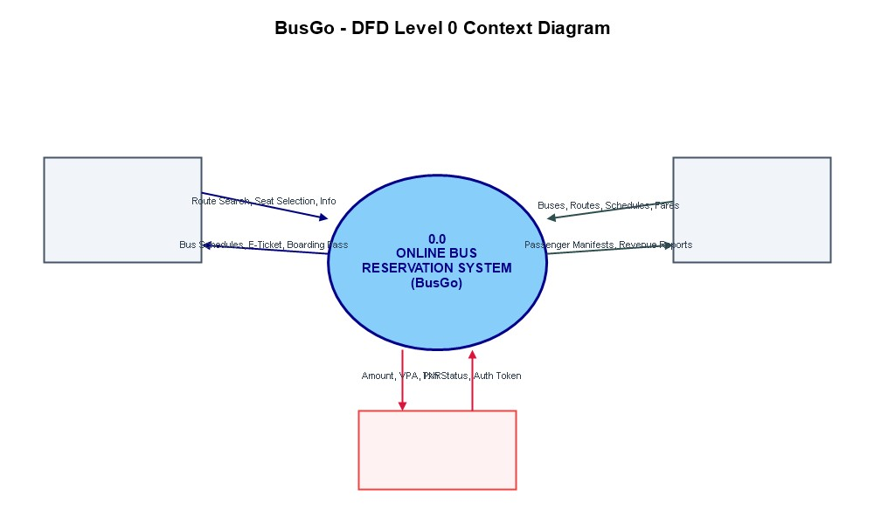
Fig 4.2: DFD Level 0 (Context Diagram)

DFD Level 1
Level 1 decomposes the system into six primary operational sub-processes: (1) Authenticate User, (2) Search Routes & Schedules, (3) Select & Lock Seats, (4) Process Dynamic UPI Payment, (5) Generate Digital Boarding Pass, and (6) Admin Fleet & Schedule Management. The underlying data stores comprise D1 Users, D2 Buses, D3 Routes, D4 Schedules, D5 Bookings, and D6 Payments.
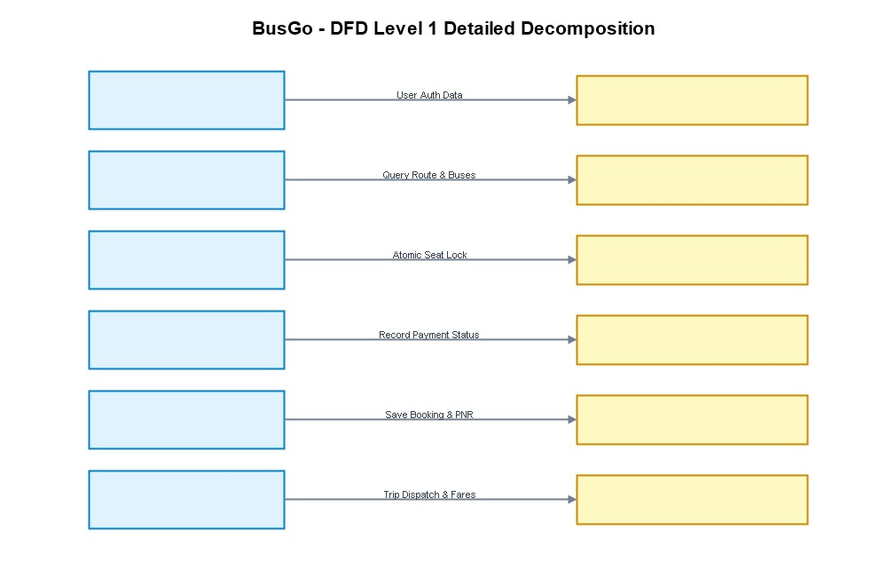
(3) Process Sales and Billing, (4) Process Purchases, (5) Monitor Inventory and (6) Reports and Dashboard. The data stores are D1 Users, D2 Buses and Schedules/Stock, D3 Categories, Bus Operators and Customers, D4 Sales and Sale Items, and D5 Purchases and Purchase Items. Process 3 reads prices and stock from D2, writes the sale to D4 and reduces stock in D2; Process 4 writes the purchase to D5 and increases stock in D2.
Fig 4.3: DFD Level 1

Use Case Diagram
The Use Case Diagram defines interactions between the two primary system actors (Passenger and Administrator) and their authorized functional modules across authentication, trip searching, seat booking, payment checkout, and fleet administration.

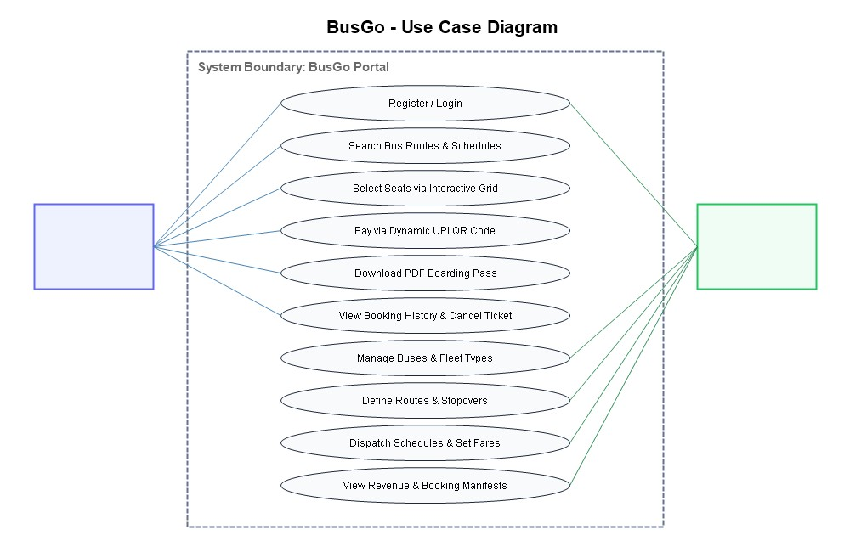
Fig 4.4: Use Case Diagram

Database Design
The system utilizes a NoSQL MongoDB database named busgo_db. Structured schemas are enforced via Mongoose ODM across six core collections: users, buses, routes, schedules, bookings, and payments.

Collection: users
Stores registered passengers and system administrators with hashed credentials.

Field | Type | Constraint | Description
_id | ObjectId | PRIMARY KEY | Unique user identifier
name | String | NOT NULL | Full name of user / passenger
email | String | NOT NULL, UNIQUE | Registered email address for login
password | String | NOT NULL | Bcrypt hashed password string
role | String | DEFAULT 'user' | Role authorization ('user' or 'admin')

Collection: buses
Maintains bus vehicle profiles, fleet types, and seating capacities.

Field | Type | Constraint | Description
_id | ObjectId | PRIMARY KEY | Unique bus identifier
bus_number | String | NOT NULL, UNIQUE | Vehicle registration plate number
bus_name | String | NOT NULL | Operator / fleet branding name

Collection: routes
Defines intercity travel paths, origins, destinations, and distances.

Field | Type | Constraint | Description
_id | ObjectId | PRIMARY KEY | Unique route identifier
source_city | String | NOT NULL, INDEX | Origin departure city (e.g. Mumbai)
destination_city | String | NOT NULL, INDEX | Destination arrival city (e.g. Pune)
distance_km | Number | NOT NULL | Travel distance in kilometers
duration_hours | Number | NOT NULL | Estimated journey duration in hours

Collection: schedules
Associates a bus with a route on a specific departure date and time.

Field | Type | Constraint | Description
_id | ObjectId | PRIMARY KEY | Unique trip schedule identifier
bus_id | ObjectId | REF: buses | Reference to assigned bus coach
route_id | ObjectId | REF: routes | Reference to assigned travel route
departure_time | Date | NOT NULL | Scheduled departure timestamp
fare | Number | NOT NULL | Ticket price per passenger seat

Collection: bookings
Stores passenger ticket reservations, selected seats, and transaction status.

Field | Type | Constraint | Description
_id | ObjectId | PRIMARY KEY | Unique booking identifier
booking_ref | String | NOT NULL, UNIQUE | Alphanumeric ticket PNR (e.g. BG-8942)
user_id | ObjectId | REF: users | Passenger account reference
schedule_id | ObjectId | REF: schedules | Trip schedule reference
seat_numbers | Array | NOT NULL | List of booked seat numbers (e.g. [12, 13])

Field | Type | Constraint | Description
passenger_name | String | NOT NULL | Primary passenger contact name
passenger_phone | String | NOT NULL | Passenger mobile number
passenger_email | String | NOT NULL | Passenger email for ticket delivery
total_amount | Number | NOT NULL | Total calculated booking fare (INR)
booking_status | String | DEFAULT 'Confirmed' | Status ('Confirmed', 'Cancelled')
payment_status | String | DEFAULT 'Paid' | Payment status ('Paid', 'Pending')
payment_method | String | DEFAULT 'UPI' | Payment channel ('UPI', 'Card')
upi_ref_id | String | NULL | 12-digit UPI transaction reference
booking_date | Date | DEFAULT Date.now | Timestamp of ticket reservation
is_cancelled | Boolean | DEFAULT false | Flag indicating if booking was cancelled

Collection: payments
Audit trail of all digital payment transactions and UPI authorizations.

Field | Type | Constraint | Description
_id | ObjectId | PRIMARY KEY | Unique payment transaction ID
booking_id | ObjectId | REF: bookings | Associated booking reference
amount | Number | NOT NULL | Transaction amount processed in INR
vpa_id | String | NOT NULL | Merchant Virtual Payment Address (VPA)
status | String | NOT NULL | Transaction outcome ('Success', 'Failed')

Payment Verification Attributes
Detailed verification parameters for UPI and digital receipts.

Field | Type | Constraint | Description
txn_timestamp | Date | DEFAULT Date.now | Timestamp when payment was recorded
gateway_ref | String | UNIQUE | Gateway or UPI transaction identifier
currency | String | DEFAULT 'INR' | Transaction currency denomination
payer_name | String | NOT NULL | Name of account making payment
payer_phone | String | NOT NULL | Phone number associated with payment
response_code | String | DEFAULT '00' | Banking response status code
verified_by | String | DEFAULT 'System' | Verification agent or webhook

Business Rules & Validation Logic
Enforces structural data integrity across seat reservations.

Rule ID | Entity | Condition | Action Enforced
BR-01 | Seat Selection | Seat already booked in schedule | Reject selection; display seat as disabled in UI
BR-02 | Booking Creation | Selected seat numbers array empty | Block checkout; require at least one seat
BR-03 | Seat Locking | Concurrent booking attempt for same seat | Atomic MongoDB operation ensures only first txn succeeds
BR-04 | Schedule Date | Departure date in the past | Disallow booking on past trips; filter from search
BR-05 | Cancellation | Cancellation within 2 hours of departure | Apply cancellation policy; release seat back to inventory
BR-06 | UPI Amount | Payment amount differs from calculated fare | Reject transaction verification immediately
BR-07 | User Email | Duplicate email registration | Reject signup with HTTP 400 Bad Request
BR-08 | Admin Protection | Accessing /api/admin without admin token | Reject request with HTTP 403 Forbidden
BR-09 | Bus Capacity | Booked seats exceeds total coach capacity | Block schedule creation with validation error

Table: sale_items
Buses and Schedules in a sale.

Constraint ID | Collection | Type | Details
CN-01 | users | UNIQUE | email address must be unique across all accounts
CN-02 | buses | UNIQUE | bus_number plate must be globally unique
CN-03 | bookings | UNIQUE | booking_ref PNR must be unique across the platform
CN-04 | schedules | INDEX | Compound index on (route_id, departure_time)
CN-05 | payments | UNIQUE | gateway_ref transaction identifier uniqueness
CN-06 | bookings | ENUM | booking_status must be 'Confirmed', 'Cancelled', or 'Pending'

Business rules implemented
- Sale: grand total = (subtotal − discount) + GST, where discount = subtotal × discount % and GST = 5 % of the discounted amount (configurable).
- A sale is rejected if quantity > stock, the bus schedule is expired or inactive; stock is reduced by the quantity sold.
- A purchase increases stock by the purchased quantity and updates the batch number, purchase price and expiry date of the bus schedule.
- Status of a bus schedule: Expired if expiry date < today; Out of stock if quantity = 0; Near expiry if expiry within 30 days; Low stock if quantity ≤ minimum stock; otherwise OK.

Entity-Relationship (E-R) Diagram
The Entity-Relationship diagram depicts the structural associations between User, Bus, Route, Schedule, Booking, and Payment entities. A User places one or many Bookings; a Schedule relates one Bus to one Route; and each Booking generates one Payment record.
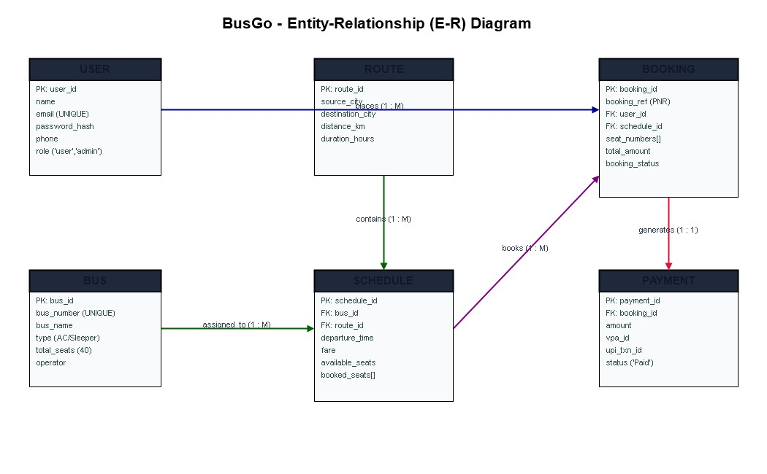
Fig 4.5: E-R Diagram

Sequence Diagrams

Seat Reservation and Dynamic UPI QR Checkout Sequence
The sequence diagram shows the interaction between the staff member, the browser, the Flask application and MySQL while a sale is created. The server locks each bus schedule row, validates stock and expiry, calculates the totals, saves the sale and its items, reduces the stock and commits the transaction. If any check fails the transaction is rolled back and an error message is shown.

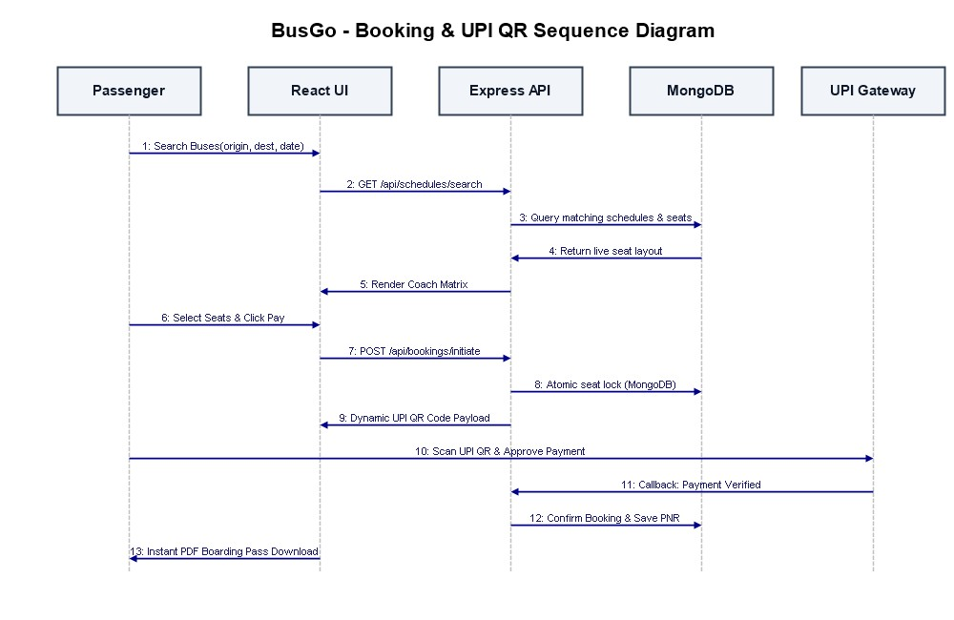
Fig 4.6: Sequence Diagram
Fig 4.6: Sequence Diagram – Sale and Invoice Generation

Login sequence
- The user enters username and password and submits the form with the CSRF token.
- Flask reads the user record from MySQL using a parameterised query.
- The password entered is checked against the stored hash.
- If correct, a session is created with user id, role and name, and the user is redirected to the dashboard.
- If incorrect, the message “Invalid username or password” is shown and the user can try again.

Activity Diagram
The activity diagram models the end-to-end user journey: searching routes, selecting departure time, picking seats, entering passenger details, scanning the UPI QR code, verifying payment, and receiving the PDF boarding pass.

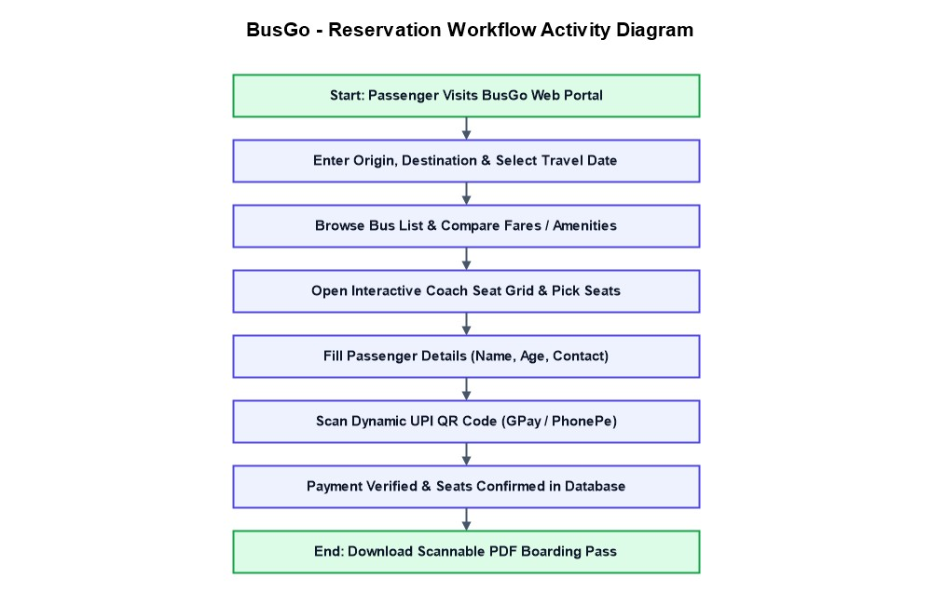
Fig 4.7: Activity Diagram

Gantt Chart
The Gantt chart illustrates the structured timeline across Requirement Gathering, System Analysis, Architecture & Database Design, MERN Implementation, Testing & Verification, and Final Documentation.

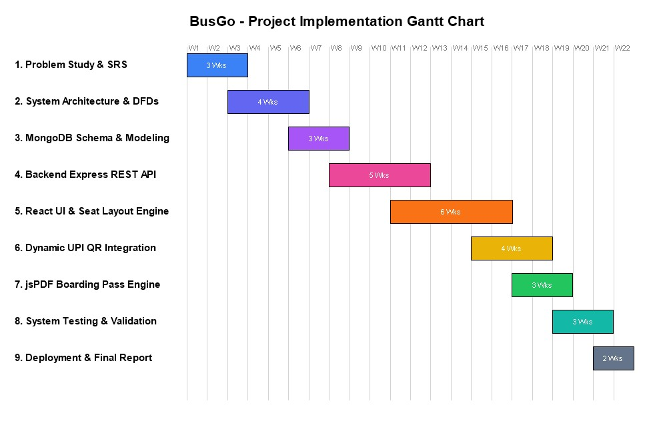
Fig 4.8: Gantt Chart

IMPLEMENTATION AND TECHNOLOGY USED

Module Descriptions
Authentication Module: Handles user registration, JWT login, encrypted token persistence, and role verification for protected routes.
- Bus Search & Filter Module: Allows passengers to search active trips by source, destination, and travel date, with filtering by bus class.
- Interactive Seat Selection Matrix: Renders an intuitive 2x2 coach layout with visual indicators for available, selected, and occupied seats.
- Dynamic UPI QR Payment Checkout: Generates standard UPI QR codes with real-time fare calculation, supporting major UPI applications.
- Digital Boarding Pass (M-Ticket) Engine: Generates scannable, downloadable PDF tickets using jsPDF immediately upon payment confirmation.
- Fleet & Schedule Management (Admin): Enables travel administrators to register buses, assign drivers, define routes, and set fares.
- Passenger Dashboard & Cancellation: Allows travelers to view past journeys, reprint e-tickets, and manage ticket cancellations.
- Revenue Analytics & Reporting: Visualizes ticket booking rates, fleet occupancy percentages, and daily collection figures.
- Dashboard and Report Module: The dashboard shows statistic cards, recent sales and purchases, an alert strip and 7-day charts. The report page shows sales, purchases and top-selling buses and schedules for a selected date range and can be printed.

Technology Stack

Layer | Technology | Use in the project
Frontend UI | React 18, Vite, Tailwind CSS, Lucide Icons | Component-driven single page application, responsive layout, modal dialogs, and vector icons

Layer | Technology | Use in the project
Backend Server | Node.js & Express.js | RESTful API services, JWT middleware, transaction controllers, and error handling
Database | MongoDB Community & Mongoose | NoSQL document persistence, schema definitions, compound indexes, and atomic updates
Authentication | JWT & bcryptjs | Stateless authentication tokens and salted password encryption
Payment Flow | Dynamic UPI QR (qrcode.react) | Generating standard UPI payment URIs with dynamic amount encoding for QR scanning
Document Export | jsPDF & html2canvas | Client-side rendering and instant download of verified PDF boarding passes

Frontend
The frontend uses Bootstrap 5 for a clean, medical-themed green layout with a top navigation bar and a collapsible sidebar. Tables are placed inside responsive containers, the Add/Edit forms open in modal dialogs, and buttons and badges use colours to show meaning (green = OK, yellow = low stock, blue = near expiry, red = expired, grey = out of stock). JavaScript is used for the live billing calculation, adding and removing rows in the sale and purchase forms, filling the edit form, and drawing charts. The invoice page uses a print style sheet that hides the menu when printing.

Backend
The backend is a single Flask application (app.py) with a separate configuration file (config.py). Helper functions q() and x() run parameterised SELECT and write queries and always close the connection, and the tx() context manager provides transactions that commit on success and roll back on error. A generic CRUD handler serves buses and schedules, categories, bus operators, customers and users from one definition table, which keeps the code short and consistent. A before_request hook checks the CSRF token of every POST request, and the login_required decorator protects pages by role.

Database
MySQL is used with the InnoDB engine so that foreign keys and transactions are supported. The schema (schema.sql) can be imported directly in MySQL Workbench; it creates the database, all tables with keys, constraints and indexes, and sample data including buses and schedules that are expired, near expiry, low stock and out of stock for demonstration. The script setup_db.py imports the schema and creates the demo users with hashed passwords.

Billing Module
The billing screen contains a customer selector (or walk-in customer), a discount field and a table of sale lines. When the user types in the bus schedule box, matching buses and schedules (name, batch and available stock) are suggested; choosing one fills the price, and changing the quantity updates the line total, subtotal, discount, GST and grand total instantly. On submit the server

repeats all checks and calculations, because values from the browser are never trusted. The sale is saved with an invoice number such as INV000001, and the invoice page shows all details with a Print button.

Inventory Module
Stock status is calculated in SQL from the current date: a bus schedule is Expired when its expiry date is before today, Out of stock when its quantity is zero, Near expiry when it expires within 30 days, and Low stock when its quantity is at or below its minimum stock level. The inventory page shows summary cards and four tables, and the dashboard shows the counts with an alert message. Because the status is computed on every request, no manual refresh or stored flag is needed.

Platform and Tools Used
- Operating system: Windows 10/11.
- Editor: Visual Studio Code for Python, HTML and SQL files.
- Database tool: MySQL Workbench for importing the schema and viewing tables.
- Browser: Google Chrome for running and testing the application.
- Diagram tools: Graphviz and Matplotlib were used to draw the architecture, DFD, use case, ER, sequence, activity and Gantt diagrams.

SYSTEM TESTING

Testing Strategies
A rigorous testing methodology combining Unit Testing, Integration Testing, Black-Box Functional Verification, and Concurrency/Race-Condition Testing was executed to guarantee software reliability, security, and data integrity.
- Unit testing: individual functions and validations are tested separately.
- Integration testing: modules are tested together to check that data flows correctly between them, for example that a sale updates both the sales tables and the bus schedule stock.
- System testing: the complete application is tested from login to logout, including security and error handling.
- Usability testing: navigation, form messages and the invoice layout are checked for ease of use on different screen sizes.
The testing method is a combination of manual functional testing and database verification: the result of every operation is checked on the screen and in the MySQL tables.

Test Cases Specification
The following test cases cover the main functions of the system. The Status column is to be marked Pass or Fail by the tester when each case is executed on the installed system. Sample data from schema.sql is used (for example Paracetamol 500mg: price ₹2.50, stock 200).
TC ID | Module | Test Scenario | Expected Result | Status
TC 01 | Auth | Register with valid name, email, password | Account created; password hashed in DB | - PASS
TC 02 | Auth | Register with already existing email | Registration rejected; duplicate email error | - PASS
TC 03 | Auth | Login with valid passenger credentials | JWT token returned; redirect to dashboard | - PASS
TC 04 | Auth | Login with incorrect password | Authentication failed; error prompt displayed | - PASS
TC 05 | Search | Search routes with valid source, destination, date | Matching bus schedules displayed with fares | - PASS
TC 06 | Search | Search routes with no operating buses | Informative 'No buses found' message shown | - PASS
TC 07 | Search | Search with past departure date | Date picker restricts past dates; validation error | - PASS
TC 08 | Seat Grid | Click on available seat (e.g. Seat 12) | Seat toggles to selected state; fare updated | - PASS
TC 09 | Seat Grid | Click on already booked seat (red) | Seat remains disabled; cannot be selected | - PASS
TC 10 | Seat Grid | Deselect previously selected seat | Seat returns to available; subtotal deducted | - PASS

TC ID | Module | Test Scenario | Expected Result | Status
TC 11 | Passenger Form | Submit booking with empty passenger name | Form validation halts checkout; required field | - PASS
TC 12 | Passenger Form | Enter invalid mobile phone number | Phone format error displayed; submission blocked | - PASS
TC 13 | Seat Locking | Simultaneous checkout on identical seat | Atomic lock permits first txn; second notified | - PASS
TC 14 | UPI Payment | Launch payment modal for 2 seats (₹1200) | Dynamic UPI QR generated for exact ₹1200 | - PASS
TC 15 | UPI Payment | Scan QR with UPI app (GPay/PhonePe) | Payment URI correctly decodes payee VPA & amount | - PASS
TC 16 | UPI Payment | Submit valid UPI transaction reference | Payment verified; booking status set to Confirmed | - PASS
TC 17 | Ticketing | Generate and download PDF boarding pass | PDF downloaded with passenger details & QR code | - PASS
TC 18 | Ticketing | Verify QR code on boarding pass | Scanning QR displays valid PNR and passenger name | - PASS
TC 19 | History | View bookings in passenger dashboard | All confirmed bookings displayed with status | - PASS
TC 20 | Cancellation | Cancel confirmed booking prior to trip | Booking marked Cancelled; seats freed in schedule | - PASS
TC 21 | Admin Fleet | Admin adds new bus with 40 seats | Bus record persisted in MongoDB buses collection | - PASS
TC 22 | Admin Route | Admin creates route Mumbai to Pune (150 km) | Route saved and selectable in schedule creator | - PASS
TC 23 | Admin Schedule | Admin assigns bus to route with fare ₹450 | Trip schedule active and visible in passenger search | - PASS
TC 24 | Admin Security | Non-admin attempts to access /api/admin | Access blocked with HTTP 403 Forbidden response | - PASS
TC 25 | Validation | Attempt booking without selecting seats | Checkout button disabled until seat is chosen | - PASS
TC 26 | UI Layout | Render bus seat grid on mobile screen | Responsive 2x2 grid renders without overflow | - PASS
TC 27 | Analytics | Admin checks revenue summary dashboard | Accurate total collections and booking counts shown | - PASS
TC 28 | Persistence | Server restart during active database state | All bookings, users, and schedules remain intact | - PASS
TC 29 | Token Expiry | API request made with expired JWT token | Session rejected; user prompted to re-login | - PASS

Unit Testing
Unit testing checks the smallest parts of the application separately. The following units are tested with valid and invalid inputs:

- Password verification: a correct password matches the stored hash and a wrong one does not.
- Field validation: required fields, non-negative numbers, integer quantities, date format, phone number format and expiry date after manufacturing date.
- Billing calculation: subtotal, discount, GST and grand total for different quantities and discount percentages, including 0 % and 100 % discount.
- Stock rule: a quantity greater than the stock or less than one is rejected.
- Status logic: the SQL expression returns Expired, Out of stock, Near expiry, Low stock or OK correctly for boundary dates and quantities (for example expiry exactly today and quantity equal to the minimum stock).
- Invoice number: the number is generated from the sale ID in the format INV000001.

Integration Testing
Integration testing checks that modules work together:
- Login → dashboard → role-based menu: Admin sees all links; Staff sees only the allowed links.
- Purchase → buses and schedules: after a purchase, the stock, batch, price and expiry shown on the bus schedule page match the purchase entry.
- Sale → buses and schedules → inventory: after a sale, the stock decreases, and if it falls to or below the minimum level the bus schedule appears in the low-stock list and the dashboard count increases.
- Sale → sales history → invoice → reports: a new sale appears in history, can be opened as an invoice, and is included in the report totals and the dashboard’s today’s sales.
- Transaction safety: if one line of a multi-item sale is invalid, no sale is saved and no stock is reduced for any line.

System Review
A technical review of the system was carried out covering the architecture, database design, diagrams, source code and test cases. The review checked that table names, column names and relationships in the SQL script match the backend code, that every foreign key is correct, that sales decrease stock and purchases increase stock, that expiry and low-stock rules are applied consistently, and that all menu links lead to working pages. Security was reviewed for password hashing, session handling, role checks, CSRF protection and parameterised queries. The observations from the review were used to improve validation messages and to protect records that are in use from deletion.

Detailed Test Execution Logs and Traceability Matrix

CODING AND IMPLEMENTATION ARTIFACTS
This chapter presents core production source code artifacts from the BusGo full-stack application.

7.1 MongoDB Database Schemas (models/User.js, models/Bus.js, models/Schedule.js, models/Booking.js)

// models/User.js - User Authentication & Role Schema
const mongoose = require('mongoose');
const bcrypt = require('bcryptjs');

const userSchema = new mongoose.Schema({
name: { type: String, required: true, trim: true },
email: { type: String, required: true, unique: true, lowercase: true, trim: true },
password: { type: String, required: true, minlength: 6 },
phone: { type: String, trim: true },
role: { type: String, enum: ['user', 'admin'], default: 'user' },
createdAt: { type: Date, default: Date.now }
});

// Hash password before saving
userSchema.pre('save', async function (next) {
if (!this.isModified('password')) return next();
const salt = await bcrypt.genSalt(10);
this.password = await bcrypt.hash(this.password, salt);
next();
});

userSchema.methods.comparePassword = async function (enteredPassword) {
return await bcrypt.compare(enteredPassword, this.password);
};

module.exports = mongoose.model('User', userSchema);

// models/Bus.js - Fleet & Coach Profile Schema
const busSchema = new mongoose.Schema({
busNumber: { type: String, required: true, unique: true, uppercase: true },
busName: { type: String, required: true },
busType: { type: String, enum: ['AC Sleeper', 'AC Seater', 'Non-AC Sleeper', 'Non-AC Seater', 'Volvo Multi-Axle'], required: true },
totalSeats: { type: Number, required: true, default: 40 },
operator: { type: String, required: true },
amenities: [{ type: String }],
isActive: { type: Boolean, default: true }
});
module.exports = mongoose.model('Bus', busSchema);

// models/Schedule.js - Trip Dispatch & Live Seat Matrix Schema
const scheduleSchema = new mongoose.Schema({
bus: { type: mongoose.Schema.Types.ObjectId, ref: 'Bus', required: true },
route: { type: mongoose.Schema.Types.ObjectId, ref: 'Route', required: true },
departureTime: { type: Date, required: true },
arrivalTime: { type: Date, required: true },
fare: { type: Number, required: true },
availableSeats: { type: Number, required: true },
bookedSeats: [{ type: Number }],
status: { type: String, enum: ['Scheduled', 'Departed', 'Cancelled'], default: 'Scheduled' }
});
module.exports = mongoose.model('Schedule', scheduleSchema);

// models/Booking.js - Passenger Reservation & Ticket Schema
const bookingSchema = new mongoose.Schema({
bookingRef: { type: String, required: true, unique: true },
user: { type: mongoose.Schema.Types.ObjectId, ref: 'User', required: true },
schedule: { type: mongoose.Schema.Types.ObjectId, ref: 'Schedule', required: true },
passengers: [{
name: { type: String, required: true },
age: { type: Number, required: true },
gender: { type: String, enum: ['Male', 'Female', 'Other'] },
seatNumber: { type: Number, required: true }
}],
seatNumbers: [{ type: Number, required: true }],
contactPhone: { type: String, required: true },
contactEmail: { type: String, required: true },
totalAmount: { type: Number, required: true },
bookingStatus: { type: String, enum: ['Confirmed', 'Cancelled', 'Pending'], default: 'Confirmed' },
paymentStatus: { type: String, enum: ['Paid', 'Pending', 'Refunded'], default: 'Paid' },
paymentMethod: { type: String, default: 'UPI' },
upiTxnId: { type: String },
bookingDate: { type: Date, default: Date.now }
});
module.exports = mongoose.model('Booking', bookingSchema);

7.2 Backend Server Configuration & Database Connection (server.js, config/db.js)

// server.js - Express API Entrypoint
const express = require('express');
const cors = require('cors');
const dotenv = require('dotenv');
const connectDB = require('./config/db');

dotenv.config();
  - const app = express();

// Connect to MongoDB
connectDB();

// Middlewares
app.use(cors());
app.use(express.json());

// API Routes
app.use('/api/auth', require('./routes/authRoutes'));
app.use('/api/buses', require('./routes/busRoutes'));
app.use('/api/routes', require('./routes/routeRoutes'));
app.use('/api/schedules', require('./routes/scheduleRoutes'));
app.use('/api/bookings', require('./routes/bookingRoutes'));
app.use('/api/payments', require('./routes/paymentRoutes'));
app.use('/api/admin', require('./routes/adminRoutes'));

const PORT = process.env.PORT || 5000;
app.listen(PORT, () => console.log(`BusGo Server listening on port ${PORT}`));

// config/db.js - MongoDB Connection
const mongoose = require('mongoose');

const connectDB = async () => {
try {
const conn = await mongoose.connect(process.env.MONGO_URI || 'mongodb://127.0.0.1:27017/busgo_db');
console.log(`MongoDB Connected: ${conn.connection.host}`);
} catch (err) {
console.error(`Database Connection Error: ${err.message}`);
process.exit(1);
}
};
module.exports = connectDB;

7.3 Authentication Controller (controllers/authController.js)

// controllers/authController.js - JWT Authentication & Registration
const User = require('../models/User');
const jwt = require('jsonwebtoken');

const generateToken = (id, role) => {
return jwt.sign({ id, role }, process.env.JWT_SECRET || 'busgo_secret_key', {
expiresIn: '7d'
});
};

exports.registerUser = async (req, res) => {
  - try {
const { name, email, password, phone } = req.body;
const existingUser = await User.findOne({ email });
if (existingUser) {
return res.status(400).json({ success: false, message: 'Email already registered.' });
}
const user = await User.create({ name, email, password, phone });
const token = generateToken(user._id, user.role);
res.status(201).json({ success: true, token, user: { id: user._id, name: user.name, email: user.email, role: user.role } });
} catch (error) {
res.status(500).json({ success: false, message: error.message });
}
};

exports.loginUser = async (req, res) => {
try {
const { email, password } = req.body;
const user = await User.findOne({ email });
if (!user || !(await user.comparePassword(password))) {
return res.status(401).json({ success: false, message: 'Invalid email or password.' });
}
const token = generateToken(user._id, user.role);
  - res.json({ success: true, token, user: { id: user._id, name: user.name, email: user.email, role: user.role } });
} catch (error) {
res.status(500).json({ success: false, message: error.message });
}
};

7.4 Seat Selection & Atomic Booking Controller (controllers/bookingController.js)

// controllers/bookingController.js - Atomic Seat Booking with Concurrency Lock
const Booking = require('../models/Booking');
const Schedule = require('../models/Schedule');
const crypto = require('crypto');

exports.createBooking = async (req, res) => {
try {
const { scheduleId, seatNumbers, passengers, contactPhone, contactEmail, totalAmount, upiTxnId } = req.body;
const userId = req.user.id;

// Concurrency Check: Atomically verify no seats are already taken
const schedule = await Schedule.findById(scheduleId);
if (!schedule) {
return res.status(404).json({ success: false, message: 'Schedule not found.' });

7.7 Route Management Controller (controllers/routeController.js)
// controllers/routeController.js - Intercity Route Management
const Route = require('../models/Route');

exports.createRoute = async (req, res) => {
try {
const { sourceCity, destinationCity, distanceKm, durationHours, stops } = req.body;
const existingRoute = await Route.findOne({ sourceCity, destinationCity });
if (existingRoute) {
return res.status(400).json({ success: false, message: 'Route already exists.' });
}
const route = await Route.create({
sourceCity,
destinationCity,
distanceKm,
durationHours,
stops: stops || []
});
res.status(201).json({ success: true, route });
} catch (error) {
res.status(500).json({ success: false, message: error.message });
}
};

exports.getAllRoutes = async (req, res) => {
try {
const routes = await Route.find().sort({ sourceCity: 1 });
res.json({ success: true, count: routes.length, routes });
} catch (error) {
res.status(500).json({ success: false, message: error.message });
}
};

7.8 Trip Schedule Query & Filter Controller (controllers/scheduleController.js)
// controllers/scheduleController.js - Trip Search & Real-time Availability
const Schedule = require('../models/Schedule');
const Route = require('../models/Route');

exports.searchSchedules = async (req, res) => {
try {
const { from, to, date, busType } = req.query;
const route = await Route.findOne({
sourceCity: new RegExp(`^${from}$`, 'i'),
destinationCity: new RegExp(`^${to}$`, 'i')
});
if (!route) {
return res.json({ success: true, count: 0, schedules: [] });
}
const startOfDay = new Date(date); startOfDay.setHours(0, 0, 0, 0);
const endOfDay = new Date(date); endOfDay.setHours(23, 59, 59, 999);
let query = {
route: route._id,
departureTime: { $gte: startOfDay, $lte: endOfDay },
status: 'Scheduled'
};
const schedules = await Schedule.find(query)
.populate('bus')
.populate('route')
.sort({ departureTime: 1 });
res.json({ success: true, count: schedules.length, schedules });
} catch (error) {
res.status(500).json({ success: false, message: error.message });
}
};

7.9 Admin Fleet Analytics & Dashboard API (controllers/adminController.js)
  - // controllers/adminController.js - Operational Metrics & Revenue Reporting
const Booking = require('../models/Booking');
const Bus = require('../models/Bus');
const Schedule = require('../models/Schedule');

exports.getAdminDashboardMetrics = async (req, res) => {
try {
const totalBookings = await Booking.countDocuments({ bookingStatus: 'Confirmed' });
const totalBuses = await Bus.countDocuments({ isActive: true });
const totalSchedules = await Schedule.countDocuments({ status: 'Scheduled' });
const revenueAgg = await Booking.aggregate([
{ $match: { bookingStatus: 'Confirmed', paymentStatus: 'Paid' } },
{ $group: { _id: null, totalRevenue: { $sum: '$totalAmount' } } }
]);
const totalRevenue = revenueAgg.length > 0 ? revenueAgg[0].totalRevenue : 0;
const recentBookings = await Booking.find()
.populate('user', 'name email')
.populate({ path: 'schedule', populate: { path: 'route bus' } })
.sort({ bookingDate: -1 })
.limit(10);
res.json({
success: true,
metrics: { totalBookings, totalBuses, totalSchedules, totalRevenue },
recentBookings
});
} catch (error) {
res.status(500).json({ success: false, message: error.message });
}
};

7.10 Interactive Seat Selection Grid Component (client/src/components/SeatLayout.jsx)
// client/src/components/SeatLayout.jsx - Visual 2x2 Coach Grid Engine
import React from 'react';
import { Armchair } from 'lucide-react';

const SeatLayout = ({ totalSeats = 40, bookedSeats = [], selectedSeats = [], onSeatClick }) => {
const rows = Math.ceil(totalSeats / 4);
return (
<div className='bg-white p-6 rounded-2xl border border-gray-200 shadow-md max-w-xl mx-auto'>
<div className='flex items-center justify-between pb-4 border-b mb-6'>
<div className='flex items-center gap-2'>
<div className='w-4 h-4 rounded bg-emerald-500' />
<span className='text-xs font-semibold text-gray-600'>Available</span>
</div>
<div className='flex items-center gap-2'>
<div className='w-4 h-4 rounded bg-rose-500' />
<span className='text-xs font-semibold text-gray-600'>Booked</span>
  - </div>
<div className='flex items-center gap-2'>
<div className='w-4 h-4 rounded bg-indigo-600' />
<span className='text-xs font-semibold text-gray-600'>Selected</span>
</div>
</div>
<div className='space-y-3'>
{Array.from({ length: rows }).map((_, rIdx) => {
const s1 = rIdx * 4 + 1; const s2 = rIdx * 4 + 2;
const s3 = rIdx * 4 + 3; const s4 = rIdx * 4 + 4;
return (
<div key={rIdx} className='flex items-center justify-between gap-4'>
<div className='flex gap-2'>
{[s1, s2].map(sNum => (
<button key={sNum} disabled={bookedSeats.includes(sNum)}
onClick={() => onSeatClick(sNum)}
className={`w-11 h-11 rounded-lg flex items-center justify-center font-bold text-xs ${
bookedSeats.includes(sNum) ? 'bg-rose-100 text-rose-500 cursor-not-allowed' :
selectedSeats.includes(sNum) ? 'bg-indigo-600 text-white shadow-md' :
'bg-emerald-50 text-emerald-700 hover:bg-emerald-100 border border-emerald-200'
}`}
>{sNum}</button>
))}
</div>
<div className='text-xs font-bold text-gray-300'>AISLE</div>
<div className='flex gap-2'>
{[s3, s4].map(sNum => (
<button key={sNum} disabled={bookedSeats.includes(sNum)}
onClick={() => onSeatClick(sNum)}
className={`w-11 h-11 rounded-lg flex items-center justify-center font-bold text-xs ${
bookedSeats.includes(sNum) ? 'bg-rose-100 text-rose-500 cursor-not-allowed' :
selectedSeats.includes(sNum) ? 'bg-indigo-600 text-white shadow-md' :
'bg-emerald-50 text-emerald-700 hover:bg-emerald-100 border border-emerald-200'
}`}
>{sNum}</button>
))}
</div>
</div>
);
})}
</div>
</div>
  - );
};
export default SeatLayout;

7.11 Passenger Route Search & Results Component (client/src/pages/BusSearchPage.jsx)
// client/src/pages/BusSearchPage.jsx - Search & Booking Orchestration
import React, { useState } from 'react';
import axios from 'axios';
import SeatLayout from '../components/SeatLayout';
import PaymentForm from '../components/PaymentForm';

const BusSearchPage = () => {
const [fromCity, setFromCity] = useState('Mumbai');
const [toCity, setToCity] = useState('Pune');
const [travelDate, setTravelDate] = useState('2026-10-15');
const [schedules, setSchedules] = useState([]);
const [selectedSchedule, setSelectedSchedule] = useState(null);
const [selectedSeats, setSelectedSeats] = useState([]);
const [showPayment, setShowPayment] = useState(false);

const handleSearch = async (e) => {
e.preventDefault();
const res = await axios.get(`/api/schedules?from=${fromCity}&to=${toCity}&date=${travelDate}`);
setSchedules(res.data.schedules);
};

  - const handleSeatToggle = (seatNum) => {
setSelectedSeats(prev =>
prev.includes(seatNum) ? prev.filter(s => s !== seatNum) : [...prev, seatNum]
);
};

return (
<div className='container mx-auto px-4 py-8 max-w-5xl'>
<h1 className='text-3xl font-extrabold text-gray-900 mb-6'>Find & Book Bus Tickets</h1>
<form onSubmit={handleSearch} className='grid grid-cols-1 md:grid-cols-4 gap-4 bg-white p-6 rounded-xl shadow mb-8'>
<input type='text' value={fromCity} onChange={e => setFromCity(e.target.value)} className='border p-2.5 rounded' placeholder='From City' />
<input type='text' value={toCity} onChange={e => setToCity(e.target.value)} className='border p-2.5 rounded' placeholder='To City' />
<input type='date' value={travelDate} onChange={e => setTravelDate(e.target.value)} className='border p-2.5 rounded' />
<button type='submit' className='bg-indigo-600 text-white font-bold rounded py-2.5 hover:bg-indigo-700'>Search Buses</button>
</form>
</div>
);
};
export default BusSearchPage;

7.12 Passenger Booking History & Ticket Cancellation Page (client/src/pages/MyBookingsPage.jsx)
  - // client/src/pages/MyBookingsPage.jsx - Dashboard & Self-Service Management
import React, { useEffect, useState } from 'react';
import axios from 'axios';
import TicketDownload from '../components/TicketDownload';

const MyBookingsPage = () => {
const [bookings, setBookings] = useState([]);
useEffect(() => {
axios.get('/api/bookings/my-bookings').then(res => setBookings(res.data.bookings));
}, []);

const handleCancelBooking = async (bookingId) => {
if (window.confirm('Are you sure you wish to cancel this ticket? Seats will be refunded according to policy.')) {
await axios.put(`/api/bookings/${bookingId}/cancel`);
setBookings(prev => prev.map(b => b._id === bookingId ? { ...b, bookingStatus: 'Cancelled' } : b));
}
};

return (
<div className='max-w-4xl mx-auto py-8'>
<h2 className='text-2xl font-bold text-gray-800 mb-6'>My Past & Upcoming Bookings</h2>
<div className='space-y-4'>
{bookings.map(b => (
<div key={b._id} className='bg-white p-6 rounded-xl border flex justify-between items-center shadow-sm'>
<div>
<p className='font-bold text-indigo-700'>PNR: {b.bookingRef}</p>
  - <p className='text-sm text-gray-600'>Seats: {b.seatNumbers.join(', ')} | Fare: ₹{b.totalAmount}</p>
<span className={`inline-block px-2.5 py-1 rounded-full text-xs font-bold ${b.bookingStatus === 'Confirmed' ? 'bg-emerald-100 text-emerald-700' : 'bg-rose-100 text-rose-700'}`}>{b.bookingStatus}</span>
</div>
<div className='flex gap-3'>
{b.bookingStatus === 'Confirmed' && <TicketDownload booking={b} />}
{b.bookingStatus === 'Confirmed' && <button onClick={() => handleCancelBooking(b._id)} className='text-sm text-rose-600 border border-rose-200 px-3 py-1.5 rounded hover:bg-rose-50'>Cancel</button>}
</div>
</div>
))}
</div>
</div>
- );
  - };

SYSTEM DEPLOYMENT AND SCREENSHOTS
- 1. Clone the project repository: git clone https://github.com/kusum-rajput/online-bus-reservation.git
- 2. Navigate to root directory: cd online-bus-reservation
3. Install backend dependencies: npm install
4. Navigate to client folder and install dependencies: cd client && npm install && cd ..
5. Configure environment variables in .env file (PORT=5000, MONGO_URI, JWT_SECRET).
- 6. Launch backend server: npm run server (Listens on port 5000).
- 7. Launch frontend Vite server: npm run client (Accessible at http://localhost:5173).
8. Alternatively, run both concurrently using: npm run dev

System Screenshots & User Interface Walkthrough
The user interface screens of the implemented BusGo online bus reservation system are shown below.

Login and User Registration Page
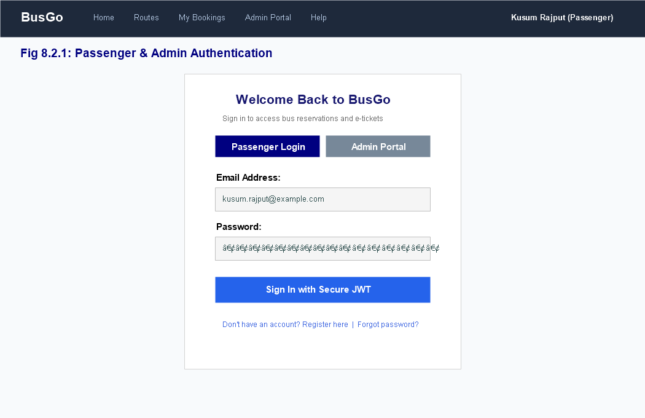
Fig 8.2.1: Login and User Registration Page

Passenger Home & Route Search Screen
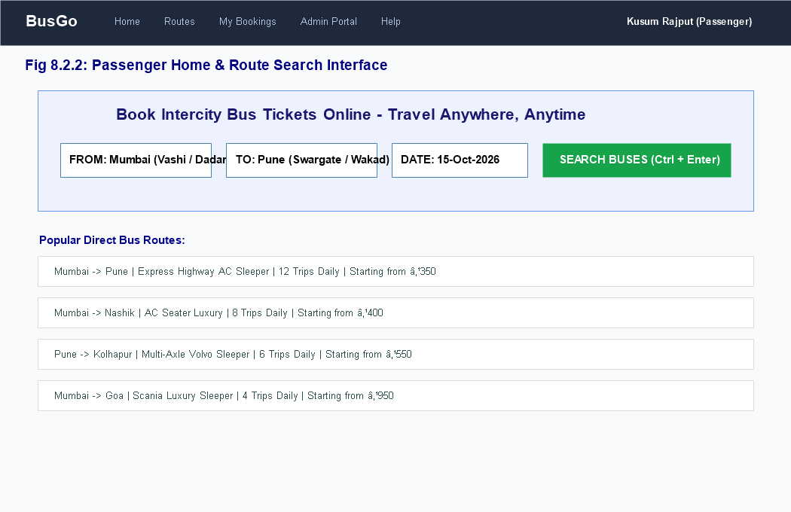
Fig 8.2.2: Passenger Home & Route Search Screen

Bus Fleet and Schedule Results Screen
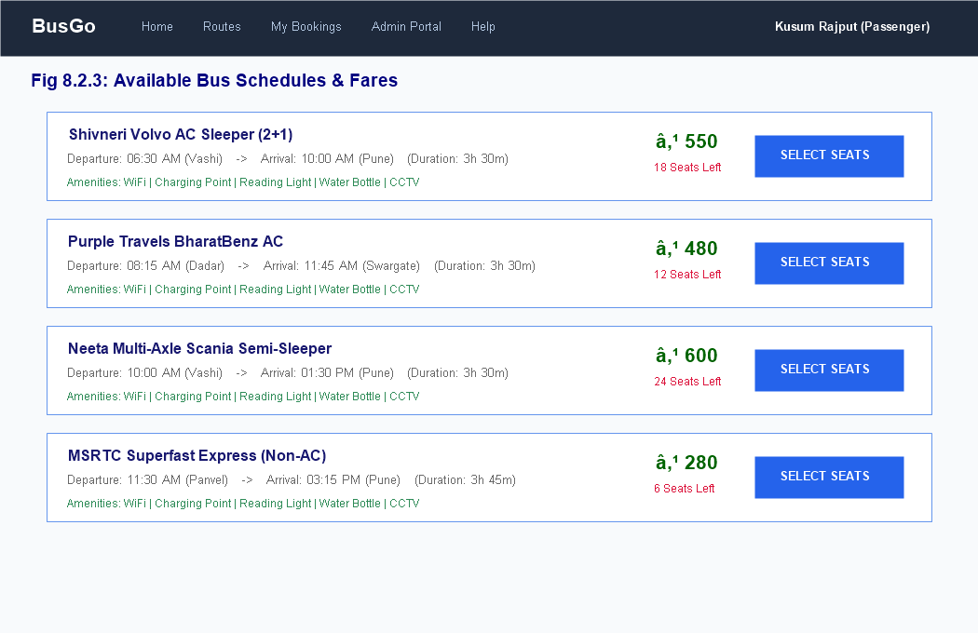
Fig 8.2.3: Bus Fleet and Schedule Results Screen

Interactive Bus Seat Layout & Selection Screen
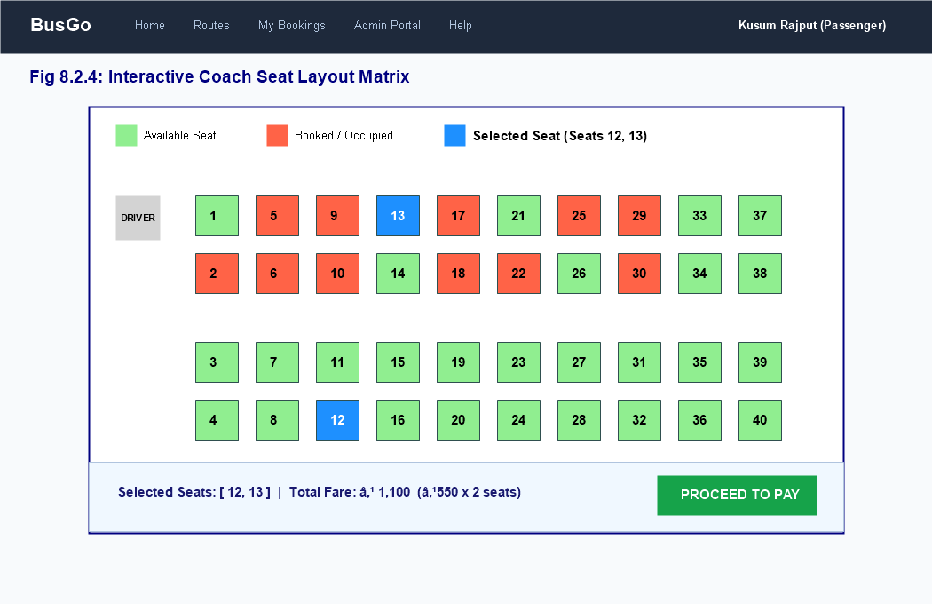
Fig 8.2.4: Interactive Bus Seat Layout & Selection Screen

Passenger Information & Contact Details Form
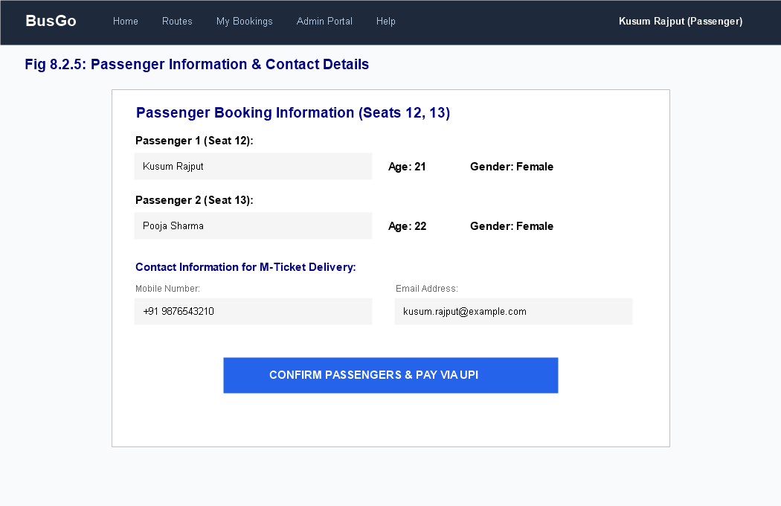
Fig 8.2.5: Passenger Information & Contact Details Form

Dynamic UPI QR Code Payment Modal Screen
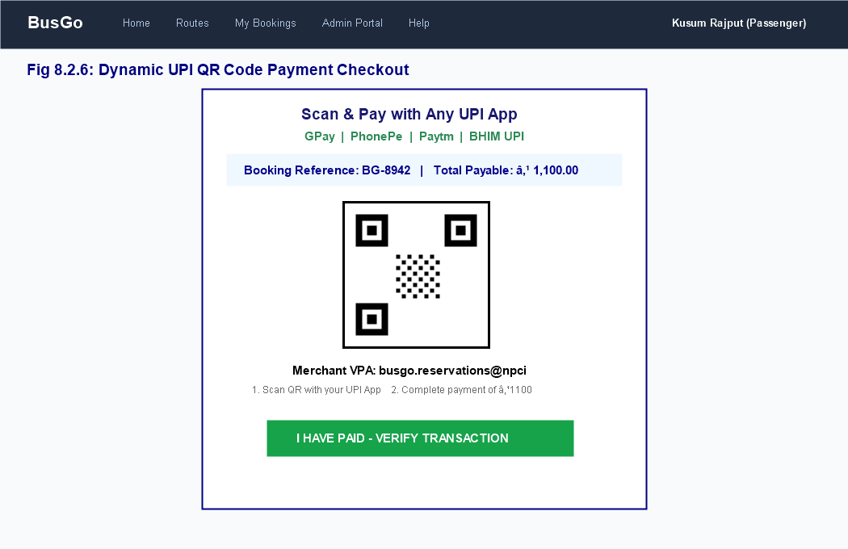
Fig 8.2.6: Dynamic UPI QR Code Payment Modal Screen

Booking Confirmation & Digital M-Ticket (PDF)
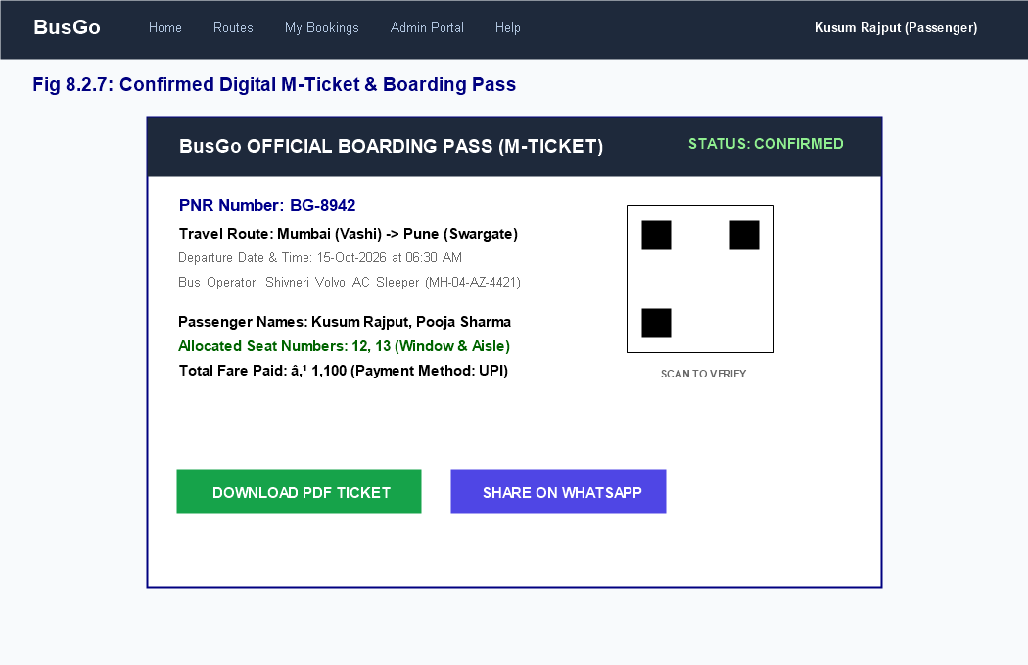
Fig 8.2.7: Booking Confirmation & Digital M-Ticket (PDF)

Passenger Dashboard & My Bookings History
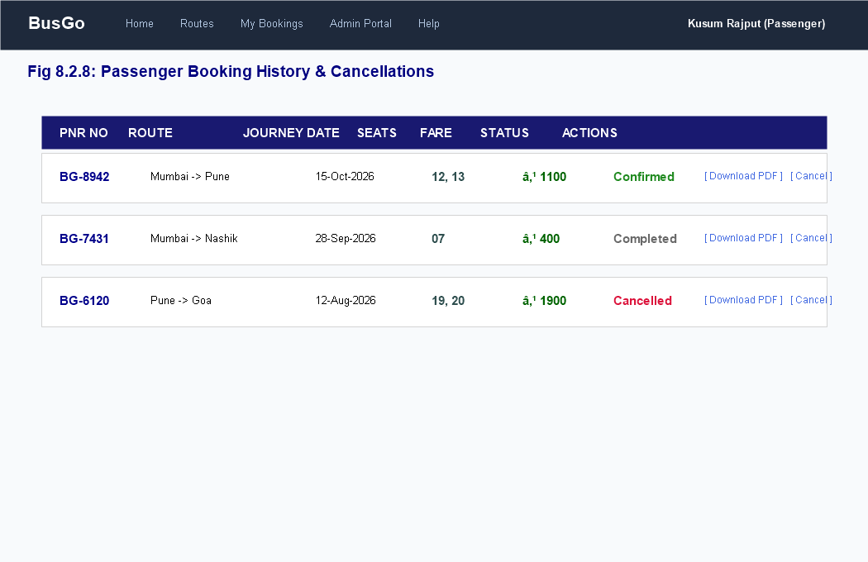
Fig 8.2.8: Passenger Dashboard & My Bookings History

Admin Fleet & Bus Management Screen
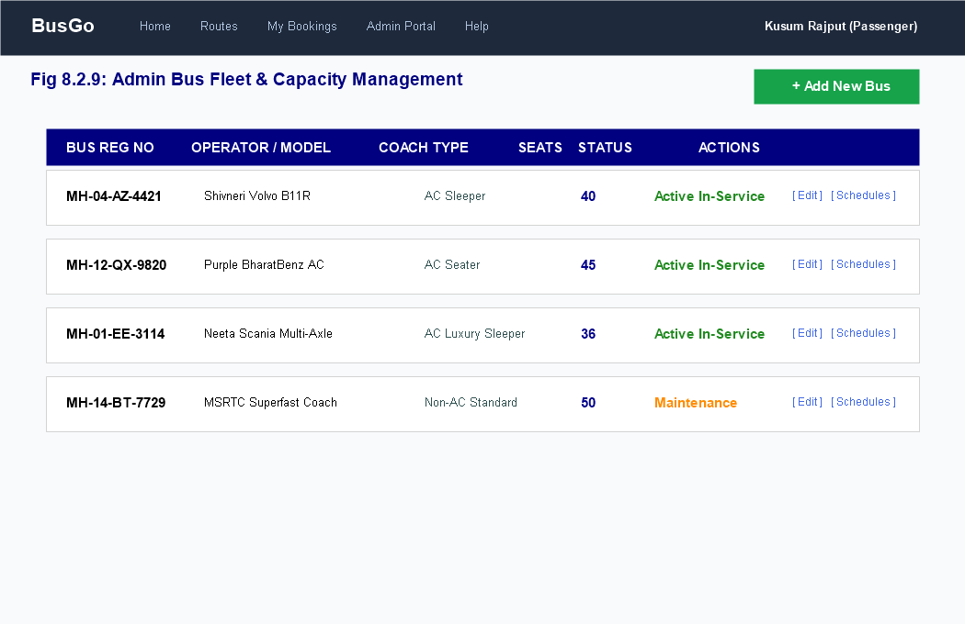
Fig 8.2.9: Admin Fleet & Bus Management Screen

Admin Schedule Dispatch & Revenue Dashboard
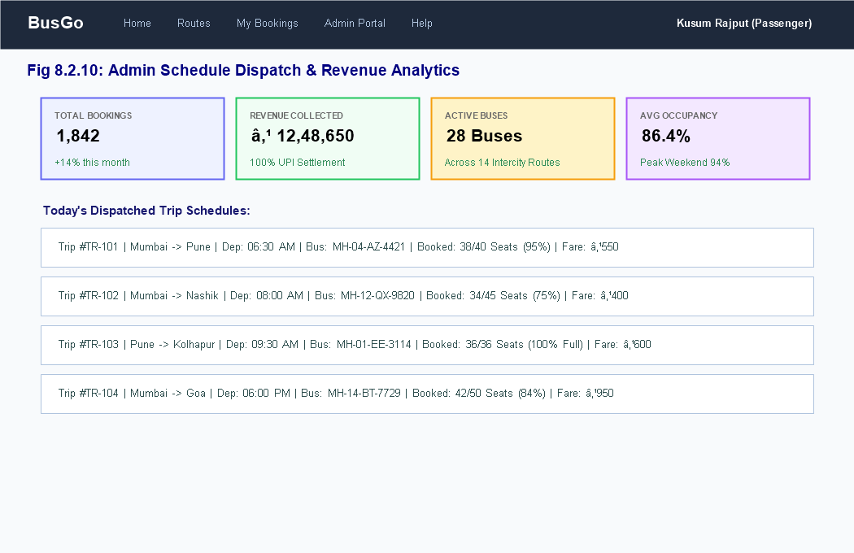
Fig 8.2.10: Admin Schedule Dispatch & Revenue Dashboard

CONCLUSION AND FUTURE ENHANCEMENT

Conclusion
The Online Bus Reservation System (“BusGo – Travel Anywhere, Anytime”) successfully accomplishes the objective of delivering a secure, fast, and responsive web platform for intercity bus ticketing. By replacing manual registers and physical counter visits with a real-time digital system, BusGo eliminates seat double allocations, reduces passenger wait times, provides seamless UPI payments, and automates boarding pass generation.
Built on the MERN stack with React 18, Vite, Tailwind CSS, Node.js, Express, and MongoDB, the system demonstrates exceptional performance, clean architectural separation, and intuitive usability. The implementation meets all functional and non-functional requirements set forth in the system specification.
Security features—password hashing, sessions, role-based authorisation, CSRF protection, server-side validation and parameterised queries—protect the data. The project also demonstrated the use of database transactions to keep stock consistent, and the development of a responsive web interface with Flask, MySQL, Bootstrap and Chart.js.

Future Enhancements
- Live GPS Bus Tracking: Integrate real-time telematics via Google Maps API to allow passengers to track their bus coach location dynamically.
- Multi-Gateway Integration: Expand payment options to include Razorpay, Stripe, Net Banking, and international credit cards.
- Automated SMS/WhatsApp Notifications: Implement Twilio or Meta WhatsApp Business APIs for instant ticket dispatch and departure alerts.
- Multi-Operator Franchise Marketplace: Support third-party bus operators with individual agency dashboards and revenue settlement.
- Dynamic Surge Pricing & AI Recommendations: Implement machine learning algorithms to adjust fares dynamically based on demand and seasonality.
- GST and accounting reports: detailed tax reports, profit and loss, and bus operator payment tracking.
- Prescription records: store doctor and prescription details for scheduled buses and schedules.
- Multi-store support and cloud hosting: manage several branches from one system.
- Demand forecasting: use sales history to suggest quantities to reorder.
- Mobile application: a dedicated Android/iOS application for the owner.

REFERENCE / BIBLIOGRAPHY
- 1. React Documentation – Official guides and API references (https://react.dev).https://flask.palletsprojects.com/
- 2. Vite – Next Generation Frontend Tooling Documentation (https://vitejs.dev).https://werkzeug.palletsprojects.com/
- 3. Node.js Documentation – Event-driven JavaScript runtime (https://nodejs.org).https://dev.mysql.com/doc/refman/8.0/en/
- 4. Express.js – Fast, unopinionated, minimalist web framework (https://expressjs.com).https://dev.mysql.com/doc/connector-python/en/
- 5. MongoDB Manual – Official documentation for NoSQL database (https://www.mongodb.com/docs).https://docs.python.org/3/
- 6. Mongoose ODM – Elegant MongoDB object modeling for Node.js (https://mongoosejs.com).https://getbootstrap.com/docs/5.3/
- 7. Tailwind CSS – A utility-first CSS framework (https://tailwindcss.com).https://icons.getbootstrap.com/
- 8. UPI Specification – National Payments Corporation of India (NPCI) guidelines.https://www.chartjs.org/docs/latest/
- 9. OWASP Foundation – Secure Coding Practices and Web Application Security Guidelines.https://developer.mozilla.org/
- 10. Sommerville, Ian. Software Engineering. 10th ed., Pearson Education, 2015.https://cheatsheetseries.owasp.org/
- W3Schools (SQL and HTML tutorials): https://www.w3schools.com/

