Genome Analysis

Unit 2 Deliverable B

Aligning Another Set of Reads

For this example we will be working with the lambda phage data obtained from this tutorial <https://bowtie-bio.sourceforge.net/bowtie2/manual.shtml#getting-started-with-bowtie-2-lambda-phage-example>

1. To begin I indexed the files using the bowtie tool (bowtie/2.3.5.1)



This generates files ending in .1.bt2, .2.bt2, etc



1. Next I use the bowtie tool to align the reads, this will create an egl.sam fileA black screen with white text

   Description automatically generated
2. I then examined the lines of the sam file using the head command A black screen with white text

   Description automatically generated
3. Next I aligned the paired end reads using bowtie

1. Next I also aligned the long reads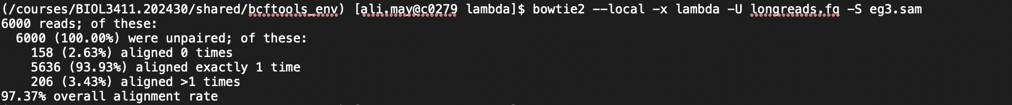
2. Now I had sam files that I converted to bam files (compressed version) using samtools 
3. Once converted to bam I again used samtools to convert the file into a sorted bam file

This format makes the files nice for long term storage and easier for variant discovery

1. To generate variant calls I need to use bcftools. I had to access this tool from a shared environment and activate it. Also need to load Anaconda

module load anaconda3/2022.05



1. Call variants



1. Finally to view the variants I used this command and bcftools 

This is what the command should generate.

