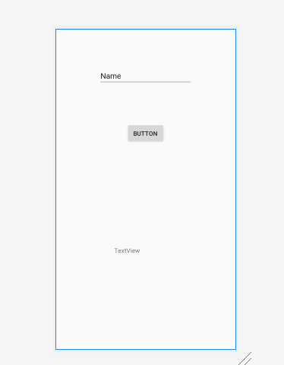

**package** com.example.apeksha;  
  
**import** androidx.appcompat.app.AppCompatActivity;  
  
**import** android.os.Bundle;  
**import** android.view.View;  
**import** android.widget.Button;  
**import** android.widget.EditText;  
**import** android.widget.TextView;  
  
**public class** MainActivity **extends** AppCompatActivity {  
 **private** EditText **e1**;  
 **private** Button **b2**;  
 **private** TextView **t1**;  
  
 @Override  
 **protected void** onCreate(Bundle savedInstanceState) {  
 **super**.onCreate(savedInstanceState);  
 setContentView(R.layout.***activity_main***);  
 **e1**=(EditText) findViewById(R.id.***editText1***);  
 **b2**=(Button) findViewById(R.id.***button2***);  
 **t1**=(TextView) findViewById(R.id.***textView1***);  
  
 **b2**.setOnClickListener(**new** View.OnClickListener() {  
 @Override  
 **public void** onClick(View v) {  
 String s=**e1**.getText().toString();  
 **t1**.setText(**"Hello "**+s);  
 }  
 });  
 }  
}

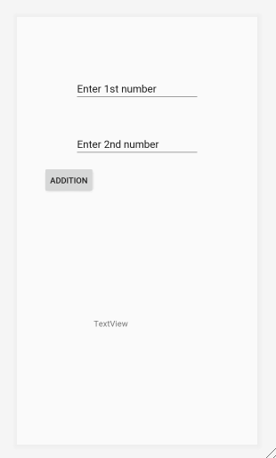

**package** com.example.cal;  
  
**import** androidx.appcompat.app.AppCompatActivity;  
  
**import** android.os.Bundle;  
**import** android.view.View;  
**import** android.widget.Button;  
**import** android.widget.EditText;  
**import** android.widget.TextView;  
  
**public class** MainActivity **extends** AppCompatActivity {  
 **private** EditText **e1**;  
 **private** EditText **e2**;  
 **private** Button **b1**;  
 **private** TextView **t1**;  
 **int i**;  
 **double num1**,**num2**,**sum**;  
  
 @Override  
 **protected void** onCreate(Bundle savedInstanceState) {  
 **super**.onCreate(savedInstanceState);  
 setContentView(R.layout.***activity_main***);  
 **e1** = (EditText)findViewById(R.id.***editText1***);  
 **e2** = (EditText)findViewById(R.id.***editText2***);  
 **t1** = (TextView)findViewById(R.id.***textView1***);  
 **b1** = (Button) findViewById(R.id.***button1***);  
  
 **b1**.setOnClickListener(**new** View.OnClickListener() {  
 @Override  
 **public void** onClick(View v) {  
 **num1** = Double.*parseDouble*(**e1**.getText().toString());  
 **num2** = Double.*parseDouble*(**e2**.getText().toString());  
 **sum** = **num1** + **num2**;  
 **t1**.setText(Double.*toString*(**sum**));  
  
 }  
 });  
 }  
}