**USER MANUAL**

Event.ly is the perfect application to help you find a musical event of your choice, and features to prepare to the concert.

How to find an event:

1. *Event by “Fresh” artists:*

A “fresh” event is an event whose artist performed at most “x” times in the 30 days beforehand.

You can choose how “fresh” you want the event to be by inserting the maximum number of events the artist participated in, in the 30 days before the event.

1. *Event by “Latest” Artists:*

This feature allows you to choose an event of one of the “latest” artists.

The “latest” artists are ones that released at least “x” albums in the last “y” years.

1. *Event by “Top” Artists:*

A “top artist” of a specific genre is an artist with at least “x” number of tracks and at least “y” listeners. You can insert the artist genre, the minimal number of tracks of the artist, and the minimal number of listeners of the artist. This feature displays all the events of the “top artists” of the genre of your choice and in the country which you specified.

Once you found an event you may enjoy various features to help you get ready for the event.

Relevant Playlists: We provided two features to help you build playlists relevant to the event of your choice, to listen to on the way to the concert.

1. *Kid-Friendly Playlists:*

If you are a worried parent, and do not want to play a playlist containing “bad words”, this is the perfect feature for you. This feature allows you to insert up to three “bad words”, and builds a playlist containing 20 songs by the artist whose songs are most “kid friendly”.

“Kid friendly” artist – the percentage of the artist’s songs containing at least one of the inserted words is the lowest.

1. *Playlist by Duration:*

This feature lets you enter the duration of the drive to the concert, and creates a playlist of the event’s artist’s songs along with their lyrics, so you can learn the songs on the way. The duration of the returned playlist will be shorter or equal to the duration inserted by the user.

Trivia Games: We provide two trivia games for you and your friends, just in case you get bored on the way to the event.

1. *Trivia 1: Which album contains what words?*

This trivia game allows you to challenge your friends by inserting a given word and a number, and have your friends guess:

Which of the chosen event’s artist’s album is the most popular, which also contains at least that number of tracks with the given word?

1. *Trivia 2: Which city loves the genre most?*

This game allows you to insert a name of a genre, and find out the city who loves that genre the most!

The city that loves the genre the most is the one that had the highest percentage of events of the said genre?

**APPLICATION NAVIGATION**

**Home screen:**

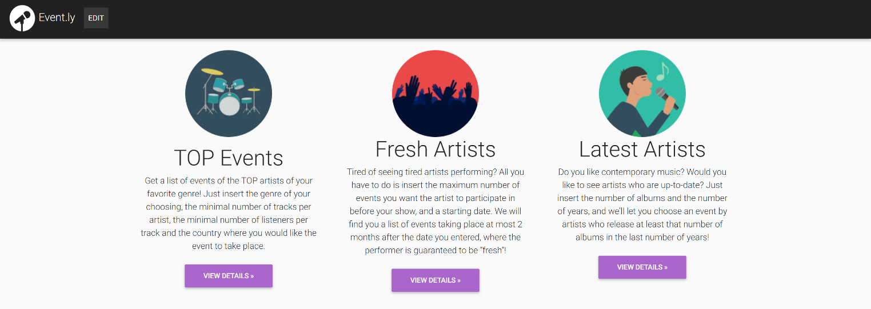In this screen you can find and event on your liking, based on one of the three queries listed above.

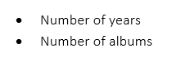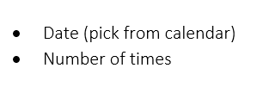 **Top Events query input: Fresh Artists query input: Latest Artists query input:**

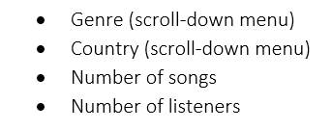

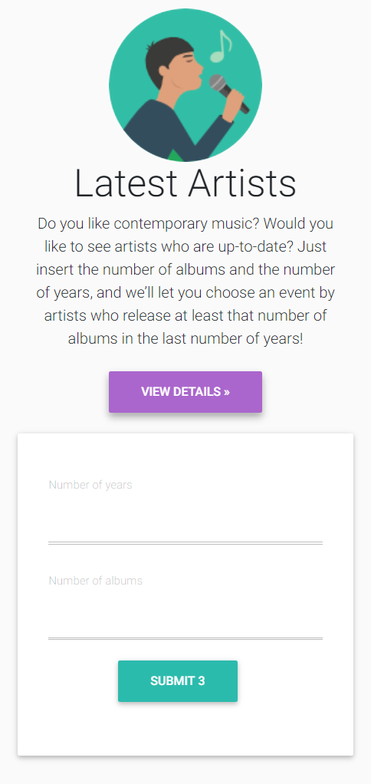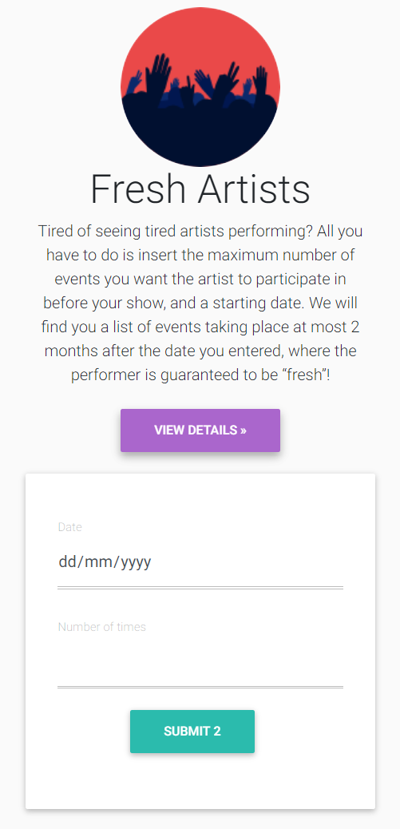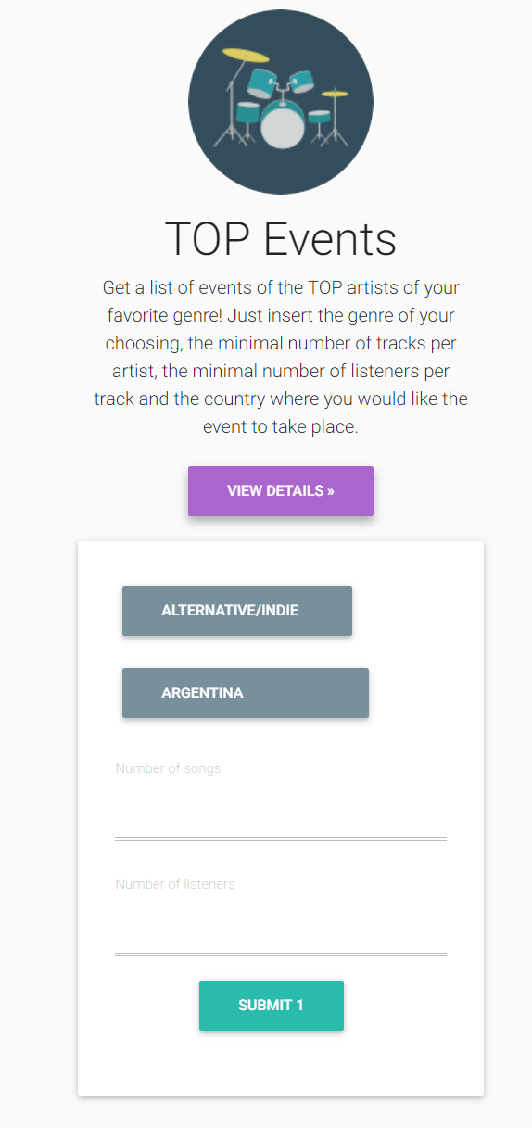

**Pick an event** (after submitting parameters for one of the three queries in the previous page)

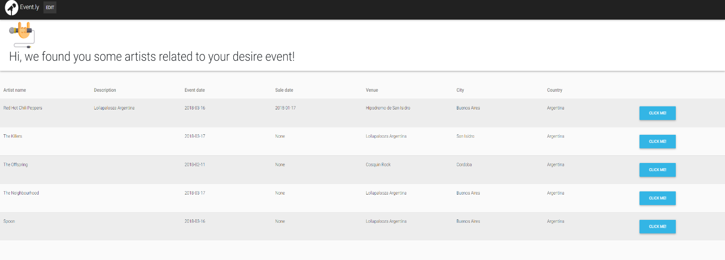

Here you can pick an event based on:

* Artist – name of the artist performing at the event
* Description – description of the event
* Event date – when does the event take place.
* Sale date – date of the start of ticket sales
* Venue – name of venue of the event
* City – name of the city where the event takes place
* Country – name of country where the event takes place

After you have decided on an event, click on it!

**Event-based features**

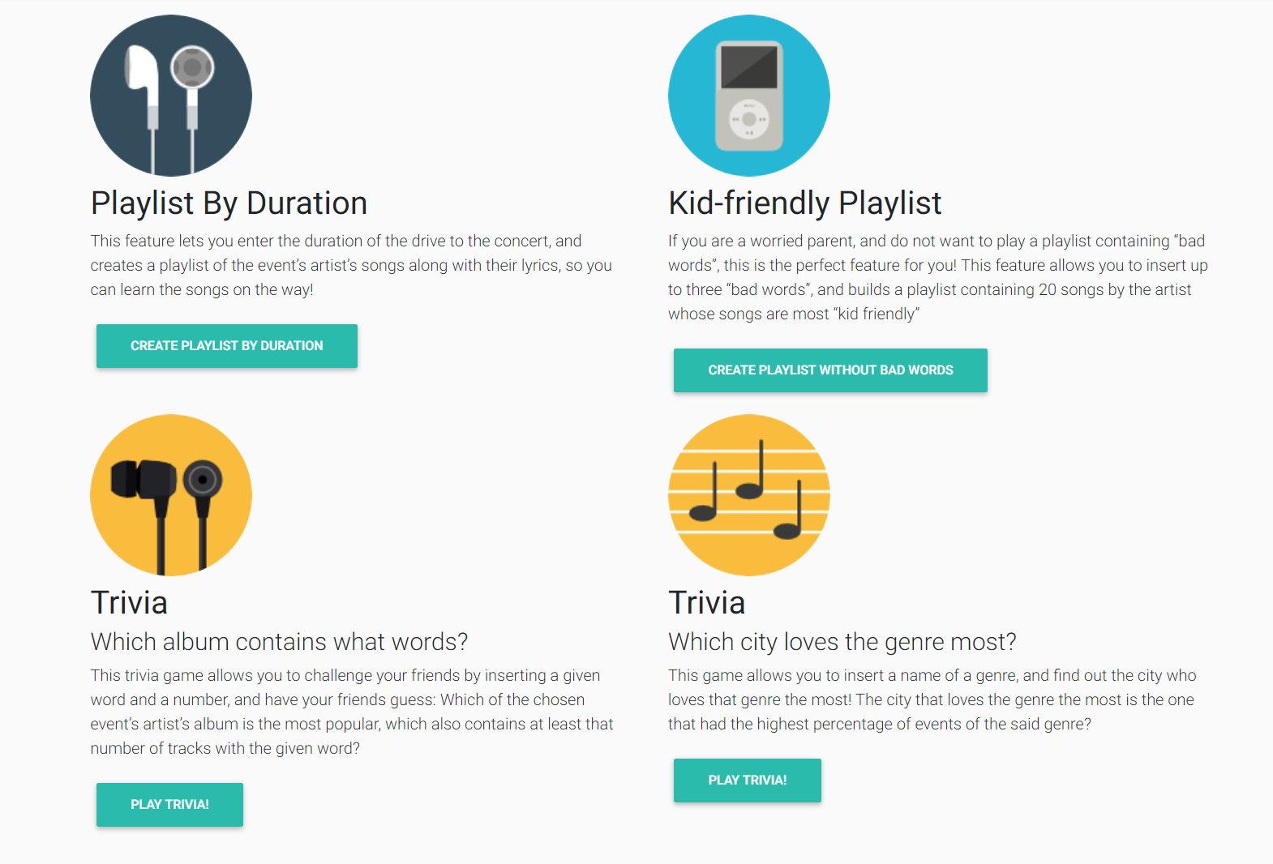

This page lets you access one of our four event-based features.

We have two features for creating playlists:

1. Playlist by duration - Insert the duration of the drive to the concert:

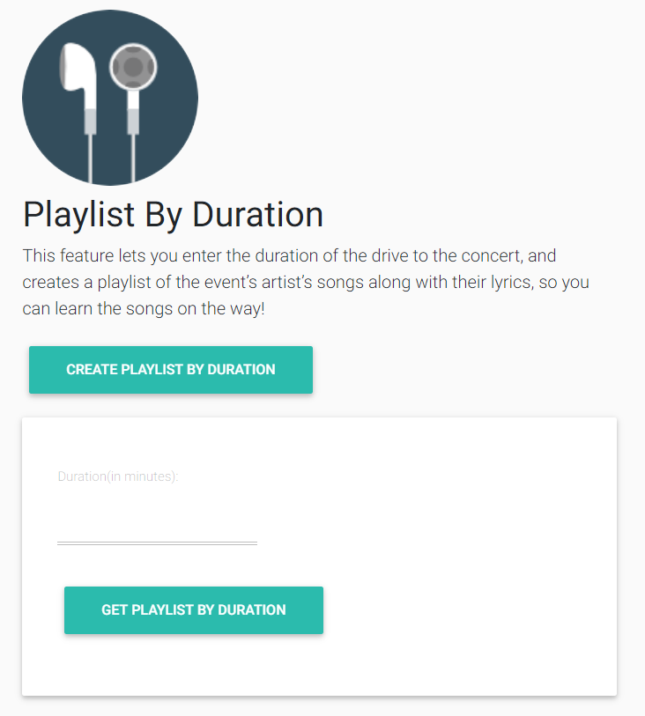

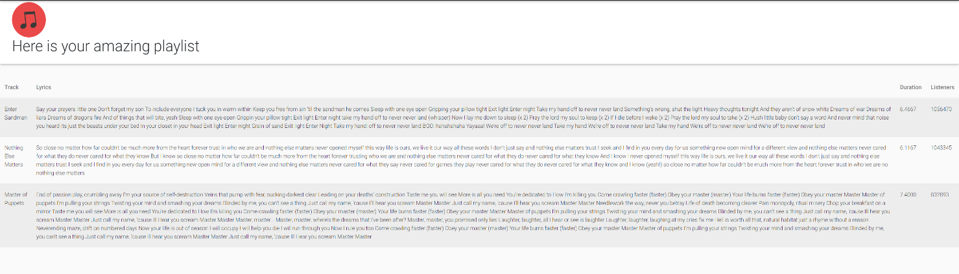Playlist by duration output screen:

Your playlist includes:

* + Track – name of the track
  + Lyrics – the track’s lyrics
  + Duration – the duration of the track (in minutes)
  + Listeners – number of listeners of the track

1. Kid-friendly playlist – Insert up to three “bad words” (must enter at least “bad word”):

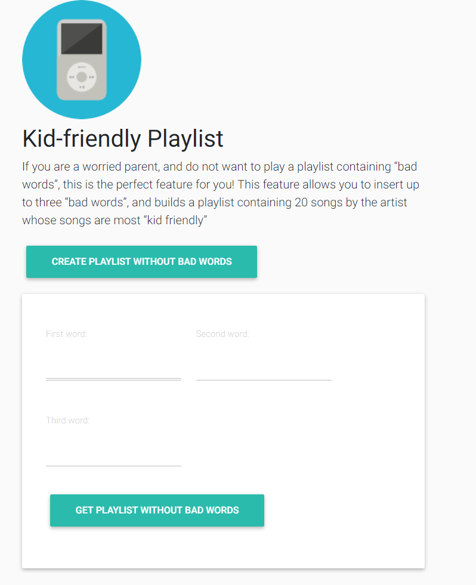

Kid-friendly playlist output screen:

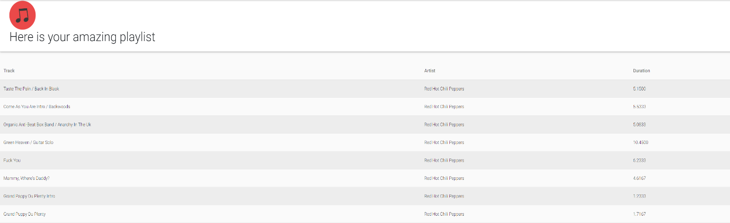

Your playlist includes:

* + Track – name of the track
  + Artist – name of the artists
  + Duration – the duration of the track (in minutes)

We have two trivia features:

1. Which album contains what words? Insert a word and number of tracks:

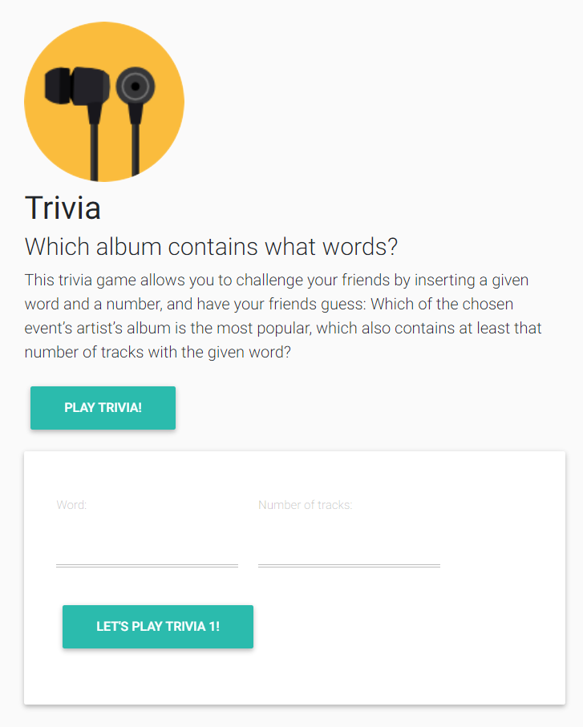

Trivia answer screen:

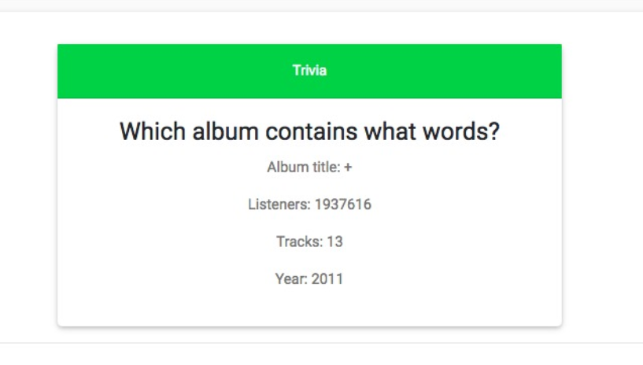

1. Which city loves the genre the most? Pick a genre (via scroll-down menu):

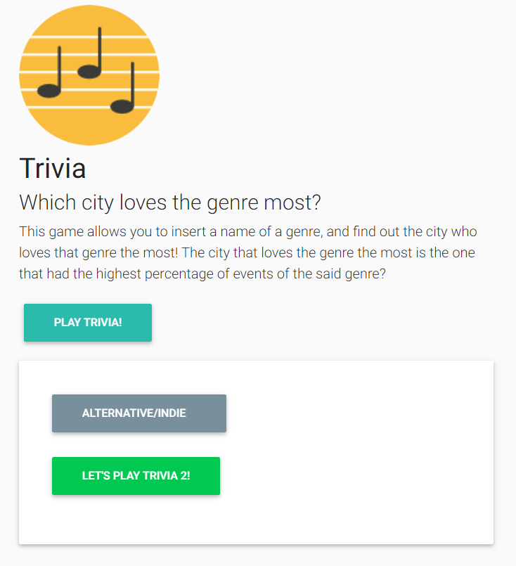

Trivia answer screen:

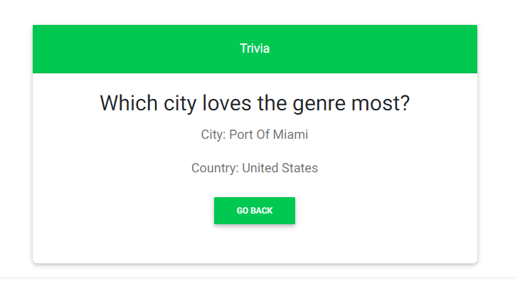

**EDIT DATABASE**

Enter editing page:

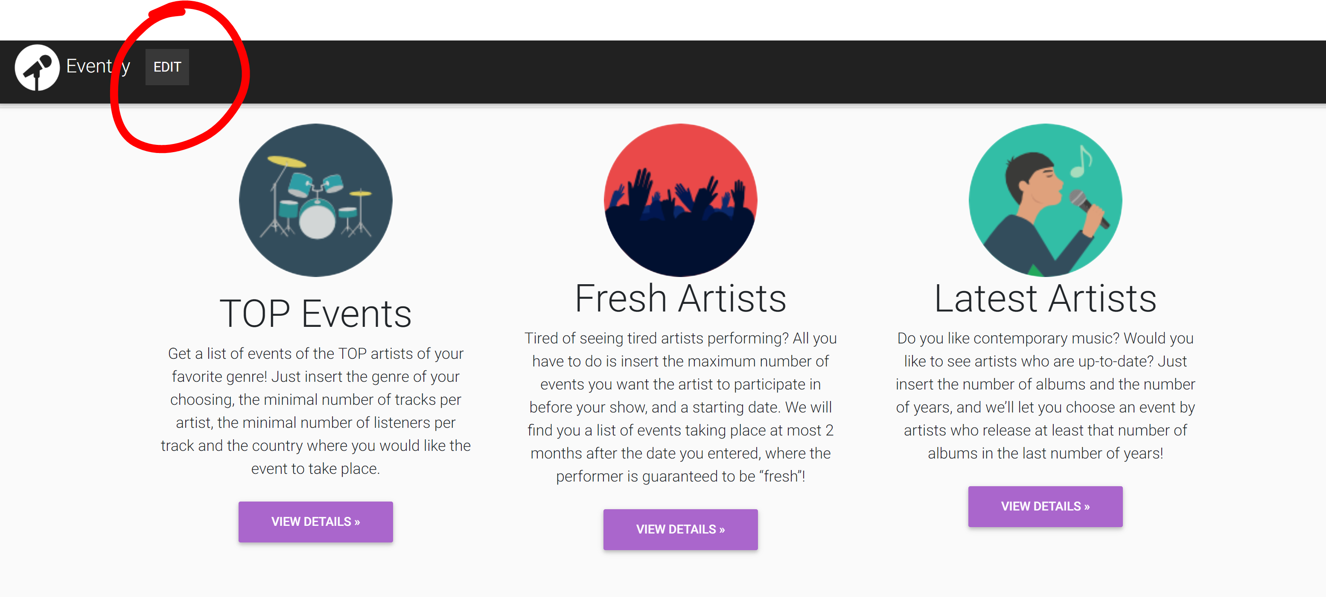

Once the user clicks on “EDIT”, he has 3 options:

1. 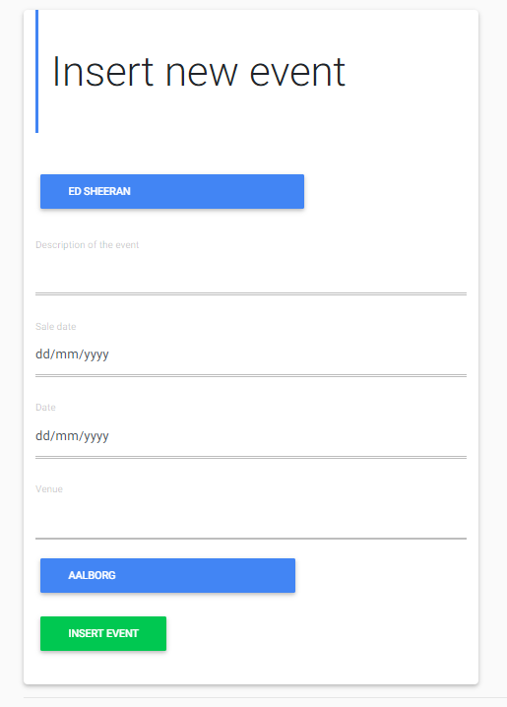Inserting new event. The user must pick the event’s artist (via a scroll-down menu), and insert the following details:

* Description of event
* Sales date (pick from calendar)
* Date (of event, pick from calendar)
* Venue

1. 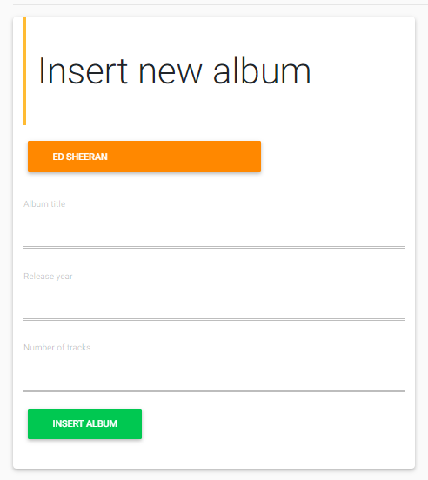Inserting new album. The user must pick the album’s artist (via a scroll-down menu), and insert the following details:
   * Album title
   * Release year
   * Number of tracks
2. 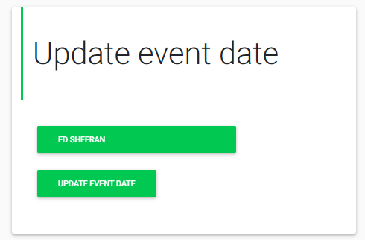Updating an existing event. The user must pick the event’s artist (via a scroll-down menu).

Once the artist was chosen, the user is navigated to a page displaying all of the artist’s events. The user must then pick the event they wish to update:

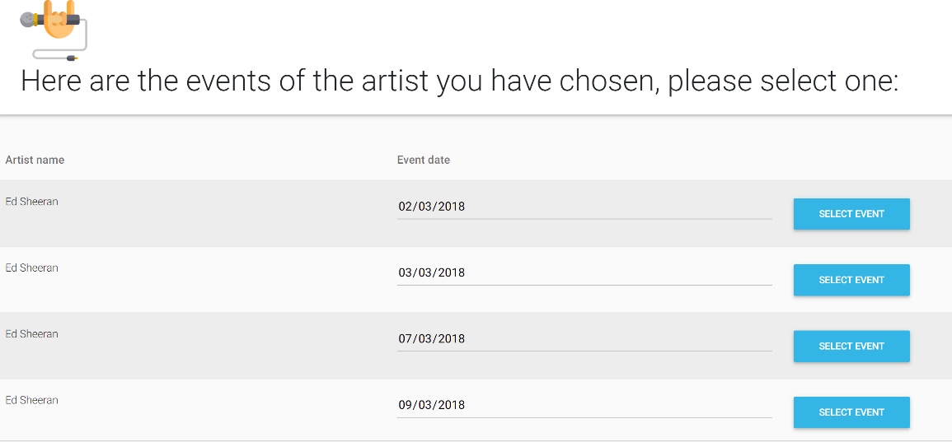

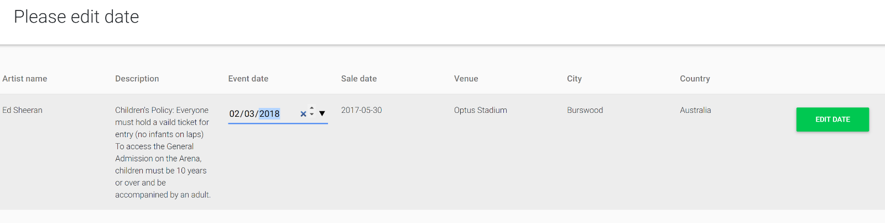After selecting an event, the user is then navigated to a page displaying the event’s details in which the user can change the date of the event. After the new date is chosen, the user must click on “EDIT DATE”.