Lab 3

Maya

2024-04-03

## Section 1

ota_data<- read.csv("/Users/mayacasper/Desktop/EDLD 652/EDLD/Labs/Lab3/oregon_traffic_accidents.csv")  
  
ota_data$acc <- ifelse(ota_data$Sunrise_Sunset=='Night',1,0)  
  
accident_proportions <- ota_data %>%  
 group_by(County) %>%  
 summarise(Total = n(),  
 At_Night = sum(acc, na.rm = TRUE),  
 Proportion= At_Night / Total)  
accident_proportions

# A tibble: 36 × 4  
 County Total At_Night Proportion  
 <chr> <int> <dbl> <dbl>  
 1 Baker 1560 799 0.512  
 2 Benton 430 139 0.323  
 3 Clackamas 4237 1071 0.253  
 4 Clatsop 1212 350 0.289  
 5 Columbia 750 242 0.323  
 6 Coos 986 391 0.397  
 7 Crook 423 145 0.343  
 8 Curry 447 157 0.351  
 9 Deschutes 2710 920 0.339  
10 Douglas 2476 998 0.403  
# ℹ 26 more rows

#Tigris fipscodes for OR   
  
or <- counties(state='41',year=2022)

or <- or %>%  
 rename(County = NAME)  
  
map_plot <- left_join(accident_proportions, or)

ggplot() +  
 geom_sf(data = map_plot, aes(fill = Proportion, geometry = geometry), color = "grey")+   
 labs(title = 'Proportion of Accidents During Night (between Sunset and Sunrise)   
 in Oregon Counties', subtitle = 'Driving during night is most dangerous in Eastern Oregon  
 Baker County has the highest proportion of night accidents', x = '', y = '')+  
 theme(plot.title= element_markdown(margin = margin(b=5),hjust=0, size = 10),  
 plot.subtitle = element_markdown(margin= margin (b= 5), hjust= 0, size= 8),  
 panel.background = element_rect(fill='white',colour='white'),  
 axis.ticks= element_blank(),   
 axis.text.x = element_blank(),   
 axis.text.y = element_blank(), legend.position = "top", legend.box = "horizontal", legend.title = element_text(size = 3), legend.text = element_text(size = 3))+  
 annotate ( 'text',  
 y = as.numeric(map_plot$INTPTLAT),   
 x = as.numeric(map_plot$INTPTLON),   
 label = map_plot$County,   
 size= 1.5,   
 color = 'black',   
 fontface = 'bold')+   
 scale_fill_continuous(  
 limits = c (0,0.55),   
 breaks = c (0, 0.15, 0.30, 0.45),   
 labels = c('0%', '14%', '30%', '45%'),   
 name = '',   
 type = 'viridis')+   
 annotate('segment',  
 y = 44.6,   
 yend = 44.6,   
 x= -117,   
 xend= -116.6,   
 arrow = arrow (length= unit(0.02, 'inches')))+   
 annotate('text',   
 y = 44.6,   
 x = -116.5,   
 label = '61.2%',   
 size = 1)

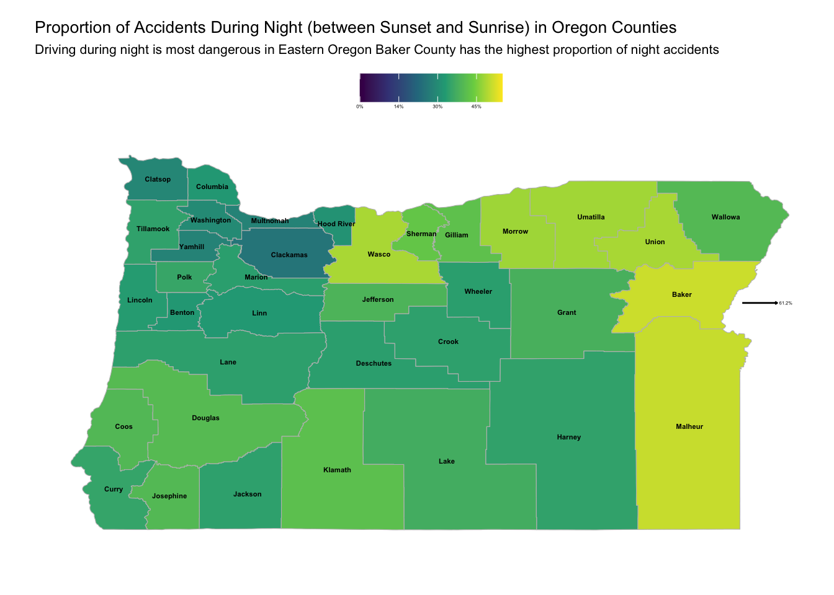

## Section 2

or<- read.csv("/Users/mayacasper/Desktop/EDLD 652/EDLD/Labs/Lab3/oregon_traffic_accidents.csv")  
  
eug <- subset(or,  
 subset = City == "Eugene")  
  
install.packages('leaflet')  
  
leaflet() %>%  
 addTiles()  
  
eugcity<- osmdata::getbb(place_name = 'Eugene')   
rowMeans(eugcity)  
  
leaflet() %>%  
 addTiles() %>%   
 setView(lng =-123.1197,   
 lat =44.0599,  
 zoom=11.3)%>%  
 addCircles(lng = eug$Start_Lng,  
 lat = eug$Start_L,   
 radius = 45)

