GLYPH-IT
COOPERATIVE DEDUCTION GAME · GAME RULES

COOPERATIVE — YOU ALL WIN OR LOSE TOGETHER
The Goal
Each of the three teams begins knowing four of the six glyphs and not knowing two. Working together over an agreed number of rounds, the teams must reveal the meaning of every glyph so that all three teams achieve full knowledge. There is no score and no winner among the teams — you succeed or fail as a table.
COMPONENTS AT A GLANCE
The Six Glyphs & the Shared Glyph
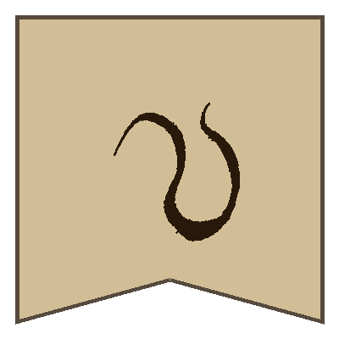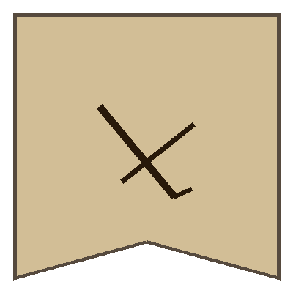 | 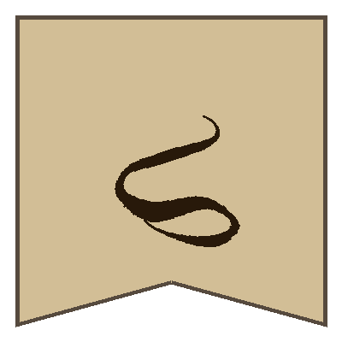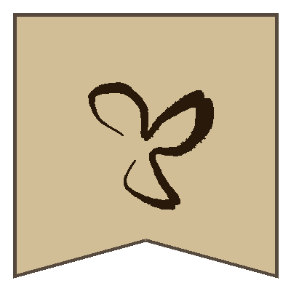 | 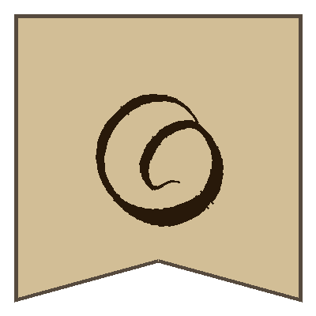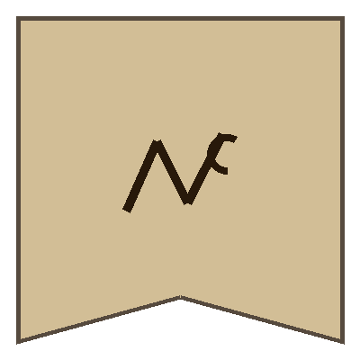 | 
YELLOW BLOCK | RED BLOCK | BLUE BLOCK | SHARED

Six glyphs are split into three colour blocks of two (Yellow, Red, Blue). A seventh shared glyph is known to every team. The app assigns a random word to each glyph from a shared 4-digit code; each team sees its four block words plus the shared word (five words in total).
THE KNOWLEDGE MAP
Who Knows What
TEAM | KNOWS (4 GLYPHS) | SEES IN APP | MUST DISCOVER
Orange | Yellow + Red blocks | 4 words + shared word | the 2 Blue glyphs
Green | Yellow + Blue blocks | 4 words + shared word | the 2 Red glyphs
Purple | Red + Blue blocks | 4 words + shared word | the 2 Yellow glyphs

Cards (18 total). Twelve team cards each show two glyphs from different blocks; each team holds the four cards pairing the two blocks it knows. Six shared cards each pair the shared glyph with one other glyph and sit face-up in the centre.

BEFORE YOU BEGIN
Setup
1. One player taps New Game in the app to get a 4-digit code; everyone enters the same code to see the identical word assignment.
2. Each team reads its five known words (its four block words + the shared word) and writes them on its board.
3. Deal each team the four team cards that match the two blocks it knows. Place the six shared cards face-up in the centre of the table.
4. Agree on a difficulty: the number of rounds you allow yourselves to learn everything. Fewer rounds is harder.
PLAY PASSES CLOCKWISE; A ROUND IS ONE TURN PER TEAM
A Turn
1. The active team plays one card — from its hand or a shared card from the centre — and says a single clue word that links the two glyphs on it. The team must know both glyphs it plays.
2. Each other team that is missing one of the glyphs on the card may offer one guess for that glyph.
3. The team that played the card confirms or denies each guess. Every team updates its board with what it learned or now suspects.
4. The played card is removed and cannot be used again. Play passes to the next team.

THE SHARED GLYPH · 6 CENTER CARDS
Each shared card pairs the shared glyph (its word is known to everyone) with one other glyph. On its turn, a team may play a shared card instead of one of its own. Because the shared word is common knowledge, these six center cards act as a pooled, extra supply of clues that any team can draw on to teach a glyph to the team that is missing it. Like every card, each shared card is used only once.

REACHING FULL KNOWLEDGE
Winning & Difficulty
If all three teams know all six glyphs within the agreed number of rounds, you win together. If you run out of rounds — or out of cards — before that, you lose. Tune the challenge by lowering the round limit, or by holding some cards back so fewer clues are available.
EXAMPLE TURN
Orange plays a card showing a Yellow glyph + a Red glyph and says the clue “storm”. Green (missing Red) guesses the Red glyph; Purple (missing Yellow) guesses the Yellow glyph. Orange confirms or denies, and every team records the new meaning. One card has just taught both other teams at once.

