Scope
This document defines and outlines the requirements of XXX.

System Overview
The system is Situational Awareness system and its goal is to enhance the operators situational awareness with the use of AI-enabled exploitation capabilities, improve speed and accuracy in detecting and identifying threats in day/night and all-weather operations.
Machine Learning, AI and rule-engines provides a mission-critical alerts during the mission.

System Description
Enable the display of the intelligence situational picture based on real‑time detections from sensors, and additionally provide visualization of SAR images from satellites (Capella) to allow investigation and interpretation, with the ability to mark interesting detections for the detection engine (FS).
The main system Components are:
- Data Bus - Provides a mechanism to control the information flow in the system, and serve as a common data exchange interface between the internal components including:
  - Receiving the detections from the payloads
  - Convert the inputs to formats that the system works with.
  - Publishing the detections to the internal components
- Data Repositories – Used for storing and catalog the various data elements required, including GIS material, detections , Alerts and sites
- Rule Engine - Apply a mission specific (decision-making) rules in geographic locations (sites, regions) on the received detections from different on-board sensors. It alerts the operator on occurrence of events of interest, and enables additional investigation of the events by the relevant sensor/s. It provides set of rules, such as "Deployment Changes", "Gate Keeping", "No Entry Zones", "Routine Break" and Correlation rules.
- Alerts Management - Manages the alerts that were generated by the rule engine whenever the received detections meet specific rule criterion. It includes an alert presentation to the operator of event occurrence in the area under surveillance.
- Situational Awareness Application (SA) - Provides a user-interface, together with interrogation and forensic investigation tools. It gives the operators a view and awareness over the area of interest and assists them in reviewing high priority Alerts, locating the most valuable events and entities identified by the system. It presents the operator with all detections, Alerts and PIRs over a map using meaningful symbology, including filter tools.
- FS\FMLT -
The following figure describes the main components:
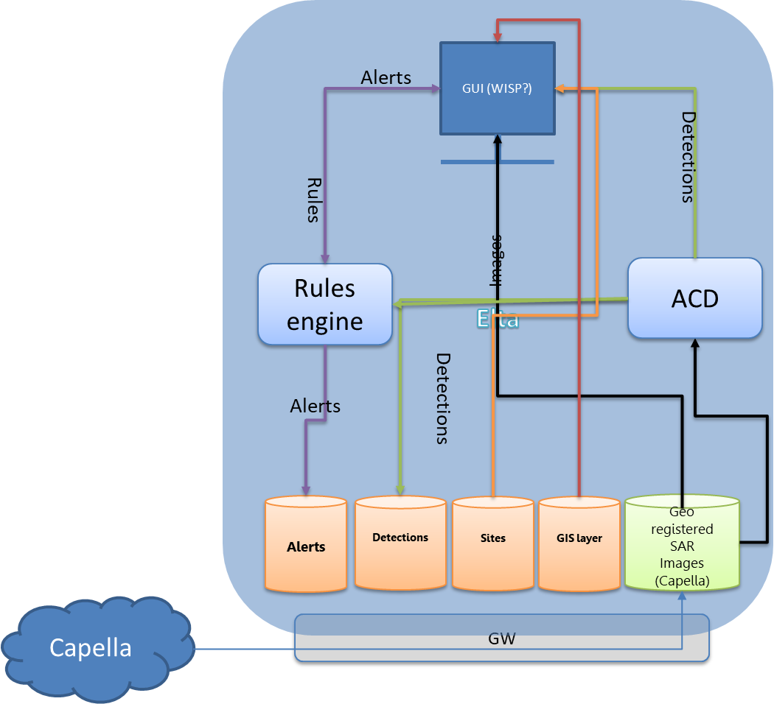
Figure 1: XXX Main Components

This document presents the operational requirements of the different forms, screens and functions, as presented in the following diagram.
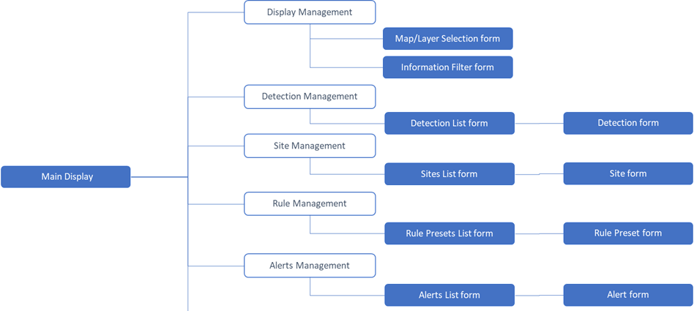
Figure 2: STARLIGHT Forms Tree

Main display (map) General Description
main display (map), including operation buttons and main map display.

Navigation Schema
The main system display appears on Application start-up

Graphical Description
The following figure describes the main form and the application general function

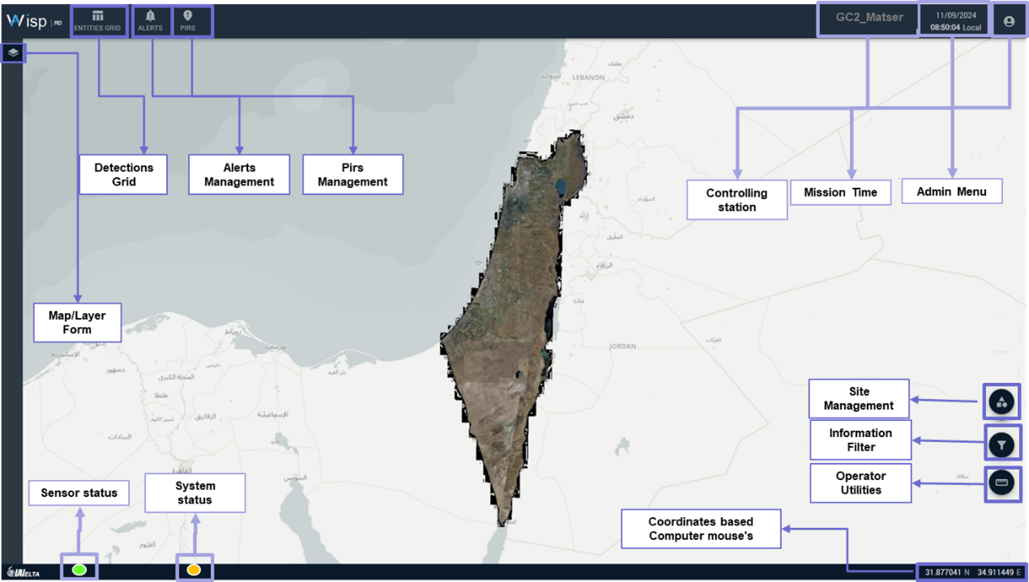

Figure 3: XXX main form description

Toolbars
Following is a description of toolbars on the main display:
- Top Toolbar:
  - Display Management
  - Tables
  - Rules
  - Alerts
  - Mission Time – Current time in local time-zone, appears at the top Right Corner on the display.
  - Admin Menu
- Right side Toolbar:
  - Sites creation and management
  - Information Filter
  - Operator utilities
- Down Toolbar:
  - Coordinates – World coordinates based on the mouse marker location over the map, appears at the bottom Right corner on the display.
  - Sensor & System status

Indications
- on the main map the system will display Current platform location with agreed icon will appear on the map. Following parameter will be available: Name, ID Number, Coordinates, Velocity, Altitude, Time in the mission, Sensor configuration.

MAP Management
This paragraph describes the forms in the UI that allow the operator to define and arrange the maps/layers of the display and to select the types of data that he wants to see on the main map.
Map/Layer Form allows the operator to define the Maps and Layers to be displayed in the main display.

Navigation Schema
The operator clicks the "Map Management" icon in the top toolbar of the main display.

Form Type
Data Tree display form.

Graphical Description
The following figure describes the Map Management form.
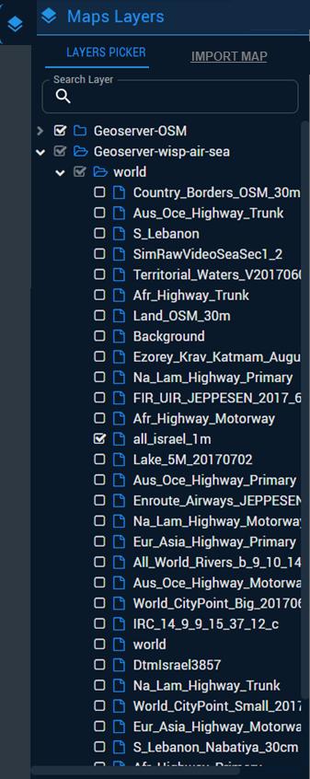
Figure 4: Map Management form illustration

Pre-Conditions
Map/Layers were imported to the system.

Post-Conditions
None.

Basic Flow
Following are the basic operational user interactions with this form:
- The operator checks Check-Box next to the chosen map/layer to display it in the main system display
- The operator is able to Cancel the presentation of a certain map/layer by unchecking the Check-Box next to the chosen map/layer.
- The operator is able to define a chosen map(s)/layer(s) as the Default maps/layers.
- The operator is able to search a map/layer by its name in the search bar.
- Maps/Layers are displayed in the main display in the order of operator selection, i.e. the last selected map/layer is displayed on top of the previously selected ones.

Form fields
The form is displayed as a Tree of maps and layers
- The Tree will contain all maps and layers existing in the system.
- Every map/layer is presented with the map/layer full name field.
- Default map has the addition '(Default)' to its name.
- Favorite maps/layers have a star marker next to their name.
- The search bar will appear above the map tree.
Form Actions (Buttons)
The following list describes the Actions an Operator may perform in the form:
- Favorite –
  - Marking a map/layer as favorite, will mark the line as favorite and will allow the operator to focus on the map/layer line faster and simpler.
  - Marking a map/layer as favorite will not present the map/layer on the display, only checking the map/layer checkbox will.
- Importing map/layer - The operator will be able to import an external map/layer based on an agreed format.
- Exit – Clicking of Close (or X on the right up corner) will close the form.

Information filter General Description
This form enables the operator to filter the types of data to be displayed on the main display based on the system sensor disciplines.

Navigation Schema
The operator clicks on the "filter" icon at the bottom of the main display.

Form Type
Data display form

Graphical Description
The following figure describes the Information Filter form.

Figure 5: Information Filter form illustration
Pre-Conditions
None
Post-Conditions
None
Basic Flow
Following are the basic operational user interactions with this form:
- The operator opens the form.
- The form displays a list of all available sensor disciplines
- The list will be displayed in a hierarchical structure (tree) with a Check-Box next to each filter line
- Checking V in the box next to an information detail will display the relevant detections on the display (including any sub-information details they contain).
- Removing the V in the Check-Box next to an information detail will remove the relevant detections from the display (including any sub-information details they contain).

Form fields
The possible filters will be based on system configuration, correlating with the relevant platforms and sensors.
Following are the details of the possible filters to be displayed in the form:
  - SAR
  - Sigint detections
  - FS dectections
- Sites
- Targets/Favorites
(*) Note: By default, all Check-Boxes will be marked in the list.

Form Actions (Buttons)
The following list describes the Actions an Operator may perform in the form:
- Check - Checking V in the box next to an information detail will display the relevant detections on the main map display (including any sub-information details they contain).
- Uncheck - Removing the V in the Check-Box next to an information detail will remove the relevant detections from the display (including any sub-information details they contain).
- Toggle Button "Open Alerts" - Show only detections with Open alerts - Clicking the 'open alerts' option will guide the system to display only detections that have an alert connected to them in an 'open' status on the display.
- Select all – will mark V in all the list.
- Clear all - will remark V from all the list.
- Exit – Clicking Close (or X on the right up corner) will close the form.
Detections Management
General Description
The system monitors and investigates detections from different disciplines, where detections from each discipline has different parameters and a unique representation icon on the map. This chapter describes the forms and lists that display the detection details to the operator.

Detection display General Description
This form enables the operator to display parameters of a single detection.

Navigation Schema
To open the form:
- The operator double clicks on the " detection" icon on the main display map.
Form Type
Data display form
Graphical Description
The following figure describes an example of a Detection
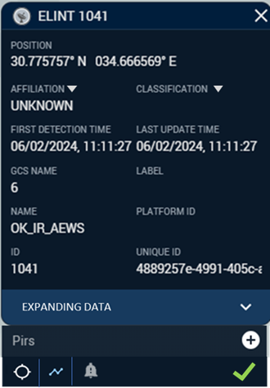
Figure 6: Detection form illustration (GMTI)

Pre-Conditions
None.

Post-Conditions
None.

Basic Flow
Following are the basic operational user interactions with this form:
- The operator opens the form.
- The operator sees the current parameters for an existing detection from the map

Form fields
The following list describes the possible Parameters for the detection:
Parameter | Type | Editable | Default | Mandatory | Comments
ID | Numeric | No | - | Yes | Updated automatically
Associated platform | Text | No | - | Yes | Updated automatically
GCS Number | Numeric | No | - | Yes | Updated automatically
Initial discovery time | Datetime | No | - | Yes | Updated automatically
Last Updated time | Datetime | No | None | Yes | Updated automatically
Coordinates | Numeric | No | - | Yes | Updated automatically
Affiliation | Text | Yes | None | Yes | Combo-Box
Classification | Text | Yes | None | Yes | Combo-Box
Target | Text | Yes | No | Yes | Combo-Box
Size | Numeric | No | None | No | Updated automatically
New/Gone status | Text | No | None | No | Updated automatically
Velocity | Numeric | No | None | No | Updated automatically
Direction | Numeric | No | None | No | Updated automatically
Frequency | Numeric | No | None | No | Updated automatically
Table 3: Detection Form Field list
(*) Notes: Additional properties of each discipline will be detailed

Form Actions (Buttons)
The following list describes the Actions an Operator may perform in the form:
- Save – Clicking Save will save the detection parameters and exit the form.
- Jump To – Jump to (focus) the current updated location of the detection on the map.
- History – Present a trail of the detection movement from the first time it was detected
- Favorite –
  - Mark a star next to detection icon
  - Display the detection on the map until the mission is finished
- Alerts –
  - The number of alerts that are connected to a detection will be displayed over the alert's icon.
  - Pressing the alert's icon will open the Alert form with the alert information. (see details in the Alerts chapter)
- Cancel – Clicking of Close (or X on the right up corner) will close the form without saving. If the operator changed data in the form, a warning message will be displayed before exiting the form.

Table of detection General Description
This form enables the operator to view a list of all detections within the current system mission in a tabular view.

Navigation Schema
To open the Detection List form:
- The operator clicks the table's icon in the top toolbar in the main display.

Pre-Conditions
None.

Post-Conditions
None.

Basic Flow
Following are the basic operational user interactions with this form:
- The operator opens the form.
- The operator may define the types of disciplines that are displayed in the list, including:
- GCS/Platform
  - GCS/Platform A
  - GCS/Platform B
- Detection Type
  - SAR
  - Elint
  - FS
- The operator sees the current parameters for every existing detection within the mission.

Form fields
The following list details the Parameters (columns) of the list:
Parameter | Type | Editable | Default | Mandatory | Comments
ID | Numeric | No | - | Yes | Updated automatically
Detection Type | Text | No | - | Yes | Updated automatically
Initial discovery time | Date/Time | No | - | Yes | Updated automatically
Last Updated time | Date/Time | No | - | Yes | Updated automatically
Coordinates | Coordinates | No | - | Yes | Updated automatically
Classification | Text | Yes | None | Yes | ComboBox
Affiliation | Text | Yes | Unknown | Yes | ComboBox
Table 4: Detection List Form Parameters

Form Actions (Buttons)
The following list describes the Actions an Operator may perform in the form:
- Sort/Filter – standard list columns sort/filter actions.
- Jumping to a selected detection – The operator can double click a row in the list, and the focus (center & zoom) on the map display will be on the selected and lighten detection that is connected to that information.
- Export – By clicking the 'Export' button, A file will be generated containing the selected display data from the list.
- Save - Clicking Save will save the detection parameters.
- Cancel – Clicking of Close (or X on the right up corner) will close the form without saving. If the operator changed data in the form, a warning message will be displayed before exiting the form.

Detection on a map general description
Each detection shall be presented on the main map/layer with a specific icon.
The examples of the graphic design of the icons are attached in a specific appendix.
Information types the system will present:
- SAR
- Elint
- FS
Detections that reports position ellipse (unlike detections that reports a central coordinate position) – will present an ellipse with the icon.
Moving detection (GMTI&OMTI) – the system will display a "tail" of the last 30 seconds of the detection (will be defined in configuration).
Default color for all icons will be grey (Unknown classification).
Icon color will change if needed, according to change in the detection Affiliation –
- Unknown – grey
- Hostile – red
- Friendly – blue
- Neutral - green

Sites Management General Description
Site management function allows the operator to define or import the areas of interest (sites).
After creating the sites in the system, the operator may assign Rule presets to the sites, thus creating Rules for the Rule Engine.

General Description
This Form enables the operator to create and manage sites in the system.

Navigation Schema
To open the Site form:
- the operator clicks on the "sites" icon in the top toolbar of the main display. This will open the Sites List form (see below)
- From the Site List form the operator:
  - Clicks on the New icon to open the Site form and Create a new Site
  - Clicks on a specific Site to open the Site form and Edit it

Form Type
- Data Entry form

Graphical Description
The following figure describes the Site form:
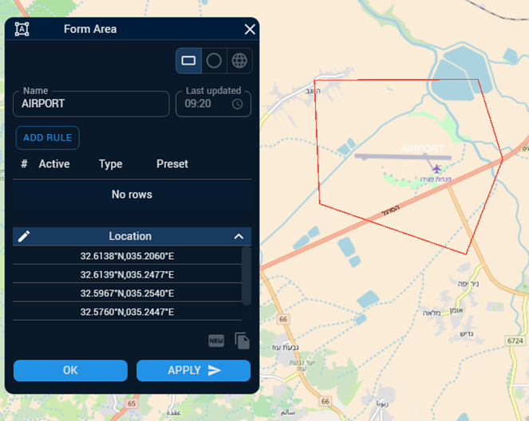
Figure 8: Site form illustration

Pre-Conditions
None.

Post-Conditions
None.

Basic Flow
Following are the basic operational user interactions with this form:
- The operator draws the site area (a closed polygon) on the main map.
- The operator sets the site parameters.
- The operator may link a Rule-Preset to the site and create a Rule
- The operator presses the Save button.

Form fields
The following list describes the sites parameters:
Parameter | Type | Editable | Default | Mandatory | Comments
Name | Text | Yes | - | Yes
Creation time | Datetime | No | - | Yes | Updated automatically
Coordinates | Coordinates | No | - | Yes | Updated automatically
Affiliation | Text | Yes | Unknown | Yes | ComboBox
Type | Text | Yes | - | No | ComboBox
Description | Text | Yes | - | No
Priority | Text | Yes | Regular | Yes | ComboBox
Table 5: Site parameters list

Form Actions (Buttons)
The following list describes the Actions an Operator may perform in the form:
- Link a Rule-Preset to a Site (Rule creation) –
  - "Link a Preset"
    - The operator clicks the "Rule" icon
    - A list of 'Rule Type' is displayed and he operator selects a specific 'Rule-type'
    - A Selection box will display all the existing Presets that are linked to the selected Rule-Type.
    - The operator Chose a specific Preset. This will link the Preset to the current Site and present all the Preset's relevant parameters to this rule.
    - When the operator links the preset to the system will define the Priority of the rule on the specific site. (the system will choose the higher priority between the Preset priority an the site priority)
    - The relevant parameters of the Preset can be edited, but it will be executed only on the chosen Site and won't change the Preset parameters in the Preset's management form.
    - If the operator will change the Preset's parameters, the operator will be required to fill a new name for the Preset and it will be added to the Preset's management form as a new Preset.
  - Edit an existing Preset link
    - The operator selects the Preset
    - The parameters can be edited as described above
  - Remove a Preset link
    - The operator can remove a Preset from the site
- Coordinates editing – the operator will be able to redefine the site's coordinates.
- Active - the operator will be able to define for each rule whether it is active or not
- Save – Clicking of Save will save the preset parameters and exit the form.
- Delete – Clicking of Delete will delete the site from the system
- Exit – Clicking of Close (or X on the right up corner) will close the form without saving. If the operator changed data in the form, a warning message will be displayed before exiting the form.

Sites list General Description
The form displays a list of all the sites in the system.

Navigation Schema
The operator clicks on the "sites" icon in the top toolbar in the main display

Form Type
Data List form.

Graphical Description
The following figure describes the Sites List form:
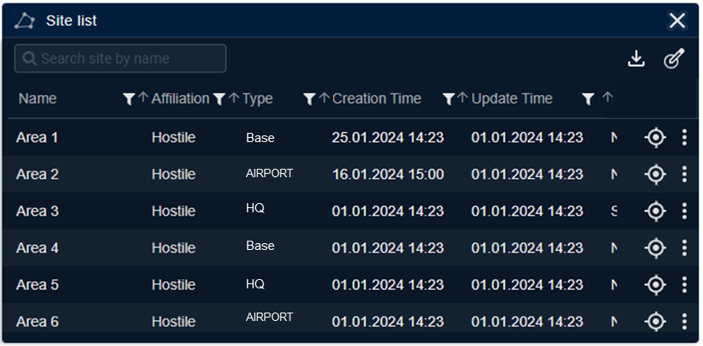
Figure 9: Sites List form illustration

Pre-Conditions
None.

Post-Conditions
None.

Basic Flow
Following are the basic operational user interactions with this form:
- The operator opens the form.
- The operator sees a list of all sites.
- The operator can sort/filter the list
- The operator can create a new site
- The operator can edit an existing site
- The operator can delete a site
- The operator can link Rule Preset to Sites
- The operator exits the form

Form fields
The following list details the Parameters (columns) of the list:
Parameter | Type | Editable | Default | Mandatory | Comments
Name | Text | Yes | - | Yes
Creation Time | Datetime | No | - | Yes | Updated automatically
Last Update Time | Datetime | No | - | Yes | Updated automatically
Affiliation | Text | Yes | Unknown | Yes | ComboBox
Type | Text | Yes | - | No | ComboBox
Description | Text | Yes | - | No
Rule define | Text | No | - | No | List
Table 6: Sites list parameters list
Form Actions (Buttons)
The following list describes the Actions an Operator may perform in the form:
- New – Clicking the New icon in the bottom of the form will open the new site form.
- Linking a Rule Preset to a number of sites –
- Click the "linking rules" icon
- Select Multiple lines
- A new linking form will be opened with:
  - A selection box with the existing Rule Types in the system
  - Clicking the Rule Type will display the Rule Preset names that are linked to that Rule Type
  - The operator selects a specific Rule Preset
  - When the operator links the preset to the system will define the Priority of the rule on the specific site. (the system will choose the higher priority between the Preset priority an the site priority)
  - The relevant parameters of the Preset can be edited, but it will be executed only on the chosen Site and won't change the Preset parameters in the Preset's management form.
  - If the operator will change the Preset's parameters, then the system will require a new name for that new Preset. And this Preset will be added to the Preset's management form as a new Preset.
- Sort/Filter – standard List columns sort/filter actions.
- Export – By clicking the 'Export' button, A file will be generated containing the display data from the list.
- Delete – Delete the selected line(s) Site
- Import - The operator will be able to import an external sites layer based on an agreed format and existing information in the system.
- Exit – Clicking of Close (or X on the right up corner) will close the form without saving. If the operator changed data in the form, a warning message will be displayed before exiting the form.

Each site shall be presented on the main map/layer as a polygon on the map.
The site will be displayed in a color according to the affiliation parameter.
A site that has an activate rules will be marked with a continuous line, and a site that does not have an activated rule will be marked with dashed line.

Rules Management General Description
Rules are set of thresholds and parameters assigned for a specific site and generate Alerts whenever detections of the platform sensors meet the predefined parameters.
The thresholds and parameters and arranged in Rule Presets that are assigned for a specific Rule-Type. These allow the operator to create standard Presets (templates) for the Rule Engine in the system (for example – routine-break during weekends in logistic areas).
The form enables the operator to create/modify a Preset.

Navigation Schema
To open the Rule Preset form, the operator clicks on the "Rule Presets" icon on the main display. This will open the Presets List form (see below).
From the Presets List form the operator:
- Clicks on a specific Preset to Edit it.
- Clicks on the New icon to Create a new Preset.

Form Type
- Data Entry form

Graphical Description
The following figure describes the Rule Preset form :
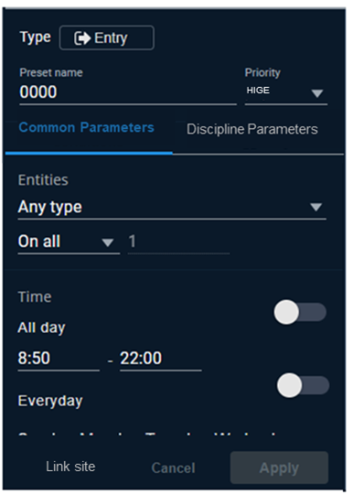
Figure 10: Rule Preset form illustration

Pre-Conditions
None.

Post-Conditions
None.

Basic Flow
Following are the basic operational user interactions with this form:
- The operator opens the form.
- The operator sees the current Preset parameters for an existing Preset or defaults for a new Preset.
- The operator sets a name and a Rule-Type
- According to the Rule-Type, the system automatically displays the relevant Rule-Type parameters with their default parameters (as set in a configuration file)
- The operator sets the Preset parameters.
- The operator presses the Save button.

Form fields
The following list describes the Rule Preset form fields:
Parameter | Type | Editable | Default | Mandatory | Comments
Name | Text | Yes | - | Yes
Time of creation | Datetime | No | - | Yes | Updated automatically
Rule type | Text | Yes | - | Yes | ComboBox
Snooze | Numeric | Yes | - | No
Priority | Text | Yes | Regular | Yes | ComboBox
Day of week | Text | Yes | All | No
Time of day | Datetime | Yes | All | No
The following parameters are derived from the rule-type:
Velocity | Numeric | Yes | - | No | = < >  From - to
Quantity | Numeric | Yes | - | No | = < >  From - to
Size | Numeric | Yes | - | No | = < >  From - to
Length | Numeric | Yes | - | No | = < >  From - to
Frequency | Numeric | Yes | - | No | = < >  From - to
New/Drop | Text | Yes | - | No | ComboBox
Classification | Text | Yes | - | No | Combobox  Multi select
Transmission Only? | boolean | Yes | - | No | Checkbox
Launch Only? | boolean | Yes | - | No | Checkbox
Use AND between discipline | boolean | Yes | - | No | Checkbox
Confidence | Numeric | Yes | - | No | = < >  From - to
Direction | Numeric | Yes | - | No | = < >  From - to
Section | Numeric | Yes | - | No | = < >  From - to
Section - To | Numeric | Yes | - | No | = < >  From - to
Pulse Repetition Interval | Numeric | Yes | - | No | = < >  From - to
Pulse Width | Numeric | Yes | - | No | = < >  From - to
Frequncey | Numeric | Yes | - | No | = < >  From - to
Radar Status | Enum | Yes | - | No
Table 7: Rule Preset Form Parameters list
(*) Notes:
- There will be a configuration file that defines the relevant parameters to every rule type.
- Additional information of rule parameters according to rule types is elaborated in different document.

Form Actions (Buttons)
The following list describes the Actions an Operator may perform in the form:
- Save – saves the preset parameters and exit the form
- Reset – resets the form back to default values
- Cancel (or X on the right up corner) - close the form without saving. If the operator changed data in the form, a warning message will be displayed before exiting the form.

Rules preset General Description
The form displays a list of all presets in the system.

Navigation Schema
The operator clicks on the "Rule Presets" icon on the main display.

Form Type
Data List form.

Graphical Description
The following figure describes the Rules Presets List form:
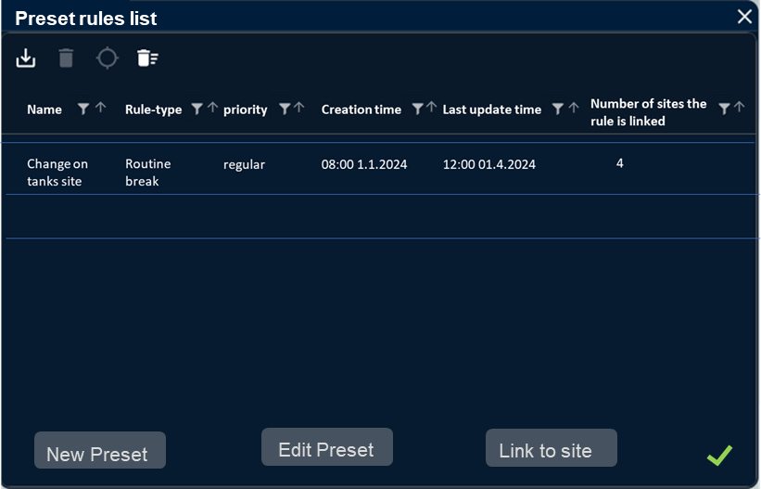
Figure 11: Rules Presets List form illustration

Pre-Conditions
None.

Post-Conditions
None.

Basic Flow
Following are the basic operational user interactions with this form:
- The operator opens the form.
- The operator sees a list of all presets. Default order in by descending "number of sites"
- The operator can create a new preset
- The operator can edit an existing preset
- The operator can see all sites attached to a preset
- The operator can delete a preset
- The operator exits the form

Form fields
The following List describes the list of preset columns:
Parameter | Type | Editable | Default | Mandatory | Comments
Name | Text | Yes | - | Yes
Rule-Type | Text | No | - | Yes
Priority | Text | Yes | Regular | Yes | ComboBox
Number of sites the rule is linked to | Numeric | No | - | Yes | Updated automatically
Creation Time | Date/time | No | - | Yes | Updated automatically
Last Update Time | Date/time | No | - | Yes | Updated automatically
Table 8: Rule preset Parameters list

Form Actions (Buttons)
The following list describes the Actions an Operator may perform in the form:
- Mark– Clicking on a row of rule preset will mark all the sites that are linked to that specific rule preset
- Sort/Filter – standard List columns sort/filter actions
- New– Open a new Preset form (see above)
- Edit –
- The operator will click a rule preset row in the List
- The operator will click the editing icon
- An editing form of the chosen rule preset will be opened with all the preset's parameters
- After editing and saving, all the sites that are linked to that rule preset will change
- Delete–
- The operator will click on the desired row in the List (The operator will be able to choose a multiple selection)
- The operator will click the deletion icon
- This action will remove rule preset from the system and from all the sites that were linked to it
- Export – By clicking the 'Export' button, a file will be generated containing the displayed data from the list.
- Cancel – Clicking of Close (or X on the right up corner) will close the form without saving. If the operator changed data in the form, a warning message will be displayed before exiting the form.

Rules Presets on Map
NA.

Alerts Management General Description
Whenever a rule criteria is met, the system automatically creates an alert.
The system provides tools for the operator to view and manage the alerts.
This form presents alert details to the operator.

Navigation Schema
There are several options to open an Alert form:
- When an Alert is created there will be a pop-up message on the top right corner of the main display for 5 seconds. Clicking on the message will open the alert Form.
- Clicking an alert on the Alert list form (see below)
- Clicking an alert from the Detection form (see above)

Form Type
Data display form

Graphical Description
The following figure describes the Alert form:
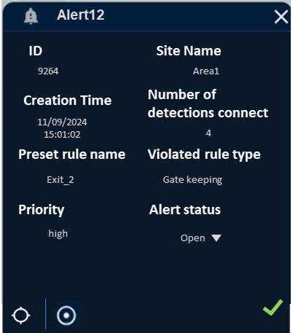
Figure 12: Alert form illustration

Pre-Conditions
The Rule Engine created an Alert

Post-Conditions
None

Basic Flow
Following are the basic operational user interactions with this form:
- The operator clicks an alert to view its details. The Alert form will open.
- The system will Zoom the map to fit to all alert detections and will mark the detections on the map including the site.
- The Operator may change the alert status.

Form fields
The following List describes the fields of the Alert form:
Parameter | Type | Editable | Default | Mandatory | Comments
ID | Numeric | No | - | Yes | Updated automatically
Alert's number of detections | Numeric | No | - | Yes | Updated automatically
Site name | Text | No | - | Yes | Updated automatically
Creation time | Date/time | No | - | Yes | Updated automatically
Preset rule name | Text | No | - | Yes | Updated automatically
Violated rule type | Text | No | - | Yes | Updated automatically
Priority | Text | No | - | Yes | Updated automatically
Alert status | Text | Yes | - | Yes | Updated automatically
Table 9: Alert form Parameters list
(*) Note:
If the user navigated to the Alert form from a Detection details form, and the detection has more than one alert – the Alert form will show all the alerts in a continuous Alert form (latest first).

Form Actions (Buttons)
The following list describes the Actions an Operator may perform in the form:
- detection icon- Clicking the icon will open the detection form (and zoom the map to the detection)
- Save – Clicking of Save will save the Alert status and exit the form
- Cancel – Clicking of Close (or X on the right up corner) will close the form without saving. If the operator changed data in the form, a warning message will be displayed before exiting the form.

Alerts List General Description
The form displays a list of all alert in the current mission.

Navigation Schema
The operator clicks on the "Alert" icon in the top toolbar on the main display.

Form Type
Data display form.

Graphical Description
The following figure describes the Alerts List form
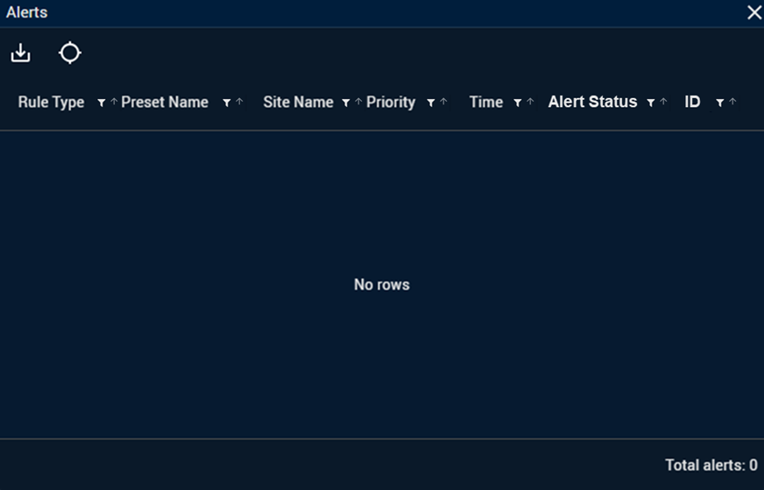
Figure 13: Alerts List form illustration

Pre-Conditions
None.

Post-Conditions
None.

Basic Flow
Following are the basic operational user interactions with this form:
- The operator opens the form.
- The operator sees a list of all alerts.
- The operator can close alert.
- The operator can open an alert.
- The operator exits the form.

Form fields
The following List describes alerts list parameters:
Parameter | Type | Editable | Default | Mandatory | Comments
ID | Numeric | No | - | Yes | Updated automatically
Site name | Text | No | - | Yes | Updated automatically
Alert's number of detections | Numeric | No | - | Yes | Updated automatically
Creation time | Date/Time | No | - | Yes | Updated automatically
Rule Preset name | Text | No |  |  | Updated automatically
Violated rule type name | Text | No | - | Yes | Updated automatically
Alert status | Text | No | - | Yes | Updated automatically
Priority | Text | No | - | Yes | Updated automatically
Table 10: Alerts Parameters list

Form Actions (Buttons)
The following list describes the Actions an Operator may perform in the form:
- Sort/Filter – Standard List columns sort/filter actions
- Close – To close on or more alerts:
- The operator selects the relevant row(s).
- Click the 'Close' icon.
- Alerts will be closed.
- Open – The operator selects a row in the List and double-click it, the Alert form will open.
- Export – The operator clicks the 'Export' button, the system will produce a file based on the displayed data.
- Exit – Clicking of Close (or X on the right up corner) will close the form.

Alerts on Map
Active alerts are represented on the main display map, as follows:
- There will be a bright red aura around detections that have an active alert linked to them.
  - The aura around the detection will be displayed until the alert will be changed to 'Closed' status.
- When the rule-engine creates an alert, a pop-up message will appear on the top right corner of the main display for 5 seconds.
- The pop-up message will contain the following information –
  - Site name
  - Number of detection that the alert is linked to
  - Rule type name
  - Priority

Basic Utilities
Following is a list of basic user utilities:
- Measuring size and distance - The operator can define the measurement format – meter/km/inch.
- Annotating – The operator will be able to draw annotations on the display and change their color. The drawing style will be – square/circle/line/polygon.
- Jump to – The operator will be able to enter coordinates manually and focus the main display to that location.
- Coordinates System - The operator will be able to change the coordinate system to one of the supported coordinate systems. All coordinates in the system will change accordingly.

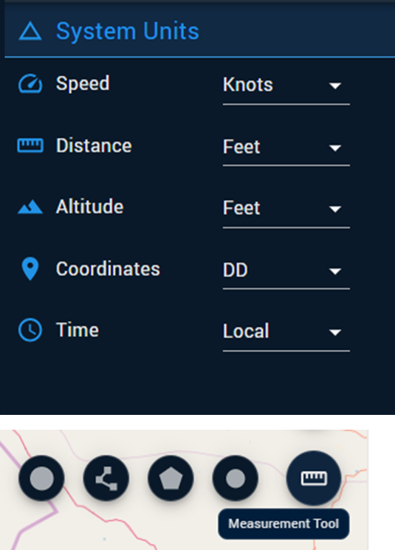Figure 16: Basic Utilities illustration

Advanced Utilities
Navigation Schema -
As part of the operator’s toolkit, there will be a TIME-LINE button. When the operator pressed a new TAB will open for investigation in OFFLINE mode.

Main Buttons:
- New Investigation – The operator can define an area of interest, time (date and hour), and the sensors relevant for the investigation. After pressing the execution button, all information will be displayed on the main screen.
- Update Query – After submitting a query, the operator can update it by modifying the geography, timeframe, and relevant data points.
- Point Investigation – The operator can click on a single detection and view its full behavior over the duration of the query.
- Timeline Bar – The operator will be able to navigate along the question’s timeline and view the progression of events. The timeline will include buttons for Play, Stop, Forward, Backward, and Playback Speed.
Graphical Description
The following figure describes the Time-Line form:
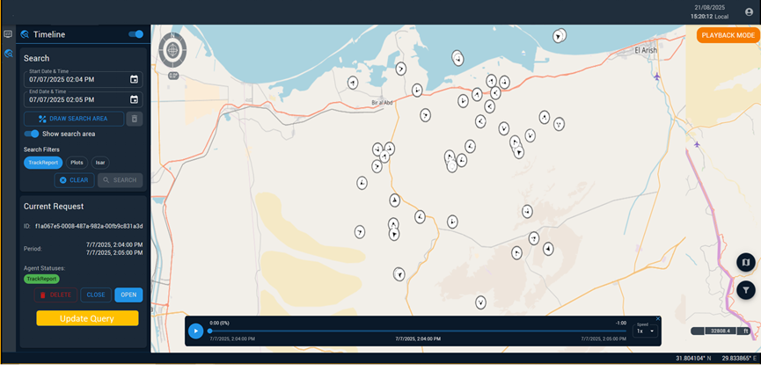
Figure 16: Time-Line form illustration
ADMIN:

General Description
The Admin is the system manager from the technical side, with responsibility and access to system configurations, troubleshooting, and overall system status

Navigation Schema
From the main screen, on the right-hand side, the admin icon will be available. Clicking the icon will open a panel providing access to the various functions.

Main Functions
- System Configuration -The panel shall display the sensor configuration to which the system is currently connected. All sensors defined in the project shall be listed in text. Above each sensor name, a circular indicator shall be displayed:
  - Connected sensors shall be shown in green.
  - Disconnected sensors shall be shown in gray.
- Configuration C-2 – System Version - Under the ADMIN tab, an operator will have access to a button that allows selecting which GCS (Ground Control Stations) the system will listen to during the mission. When the button is clicked, a list view window will open, displaying all available GCSs by GCS Name and ID. Next to each carriage, a checkbox will be displayed for selection (✓). At any given time, up to two carriages can be selected for system listening. The operator defines the selection at the start of the mission, but may also modify the selection during the mission. After selecting the two carriages and clicking the “Save Selection” button, icons representing the related platforms will be displayed on the main map.
- Server Storage Management – The panel shall display all active servers in the system, supporting one or more servers. For each server, the storage utilization shall be shown as a percentage from 1% to 100%, where 100% indicates the server is full. Below each server, a Clear Server button shall be provided. When the operator clicks the button, the system shall display a confirmation message asking whether they are sure they want to clear the storage of the selected server. If multiple servers are displayed, in addition to the individual Clear Server button for each server, the operator will be able to clear all servers using "clear all" button.
- Classification – This screen shall allow the operator to define and manage classification categories within the system. The operator shall be able to create and edit. The screen shall support the ability to map and organize classifications into a hierarchical structure.
- System status - This button shall allow the operator to access an external application displaying the system’s technical status. Upon activation, the button shall automatically open a new tab within the system.

קטלוג תמונות וחיפוש (מעל קפלה)
- יכולת חיפוש.
- סינון לפי זמן, מיקום גאוגרפי,וחתכים רלוונטיים נוספים.
- תצוגת תוצאות ברורה הכוללת פרטי מטא־דאטה בסיסיים.

פתיחת תמונות והטלה על גבי המפה
- תמיכה בפתיחת תמונות SAR, EO ו-IR לפי הסדר הזה.
- הטלה של תמונות על מפת העולם בהתאם למיקום ולעיגון.
- פתיחת תמונה ישירות מתוך הקטלוג ותצוגה על המפה.

כלי פענוח בסיסיים
- כלי מדידה - מרחקים, שטחים, קווים.
- שינוי היסטוגרמה, בהירות, קונטרסט וצבעים.
- Flicker בין תמונות לצורך השוואה.

מאגרים
תמונות?, גילויים , אלרטים, חוקים.

שירותים

ACD

מנוע חוקים

FS (לא ברמת בסיס)

פיוזן אלינט וFS (לא ברמת בסיס)

