**Wet 2**

**Yagel Maimon**

**Saar Gablinger**

**Q1.** 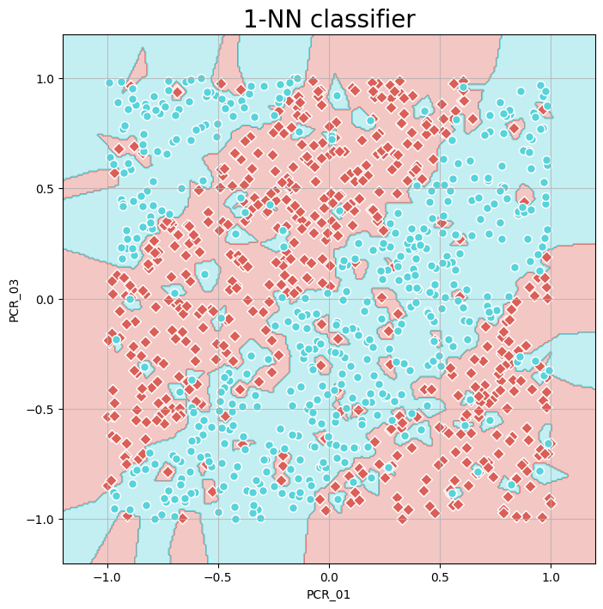

**The best k value is 9**

**Mean train score: 1.0**

**mean Validation score: 0.869**

**by the figure The k values that cause overfitting is about from 1 to 5 because this is the lowest k values that make the training accuracy be the much highest and we can see that in those numbers the difference between the validation accuracy and the training accuracy is the biggest. and the k values that cause underfitting is about 130 and above that’s happends because we look at too many neighbors and from 130 k we can see that the accuracy is lower then 0.7 and get lower exponential when we go forther.**

Q3.

And the tests accuracy is 0.8

Q4.

In Q1 we can see that because of the overfitting the bounderies looks dissaster and its not smooth like the bounderies in k=9 because the in k=9 we look at the best number of neighbors that will make the training look good.

Q5.

Accuracy : 0.696

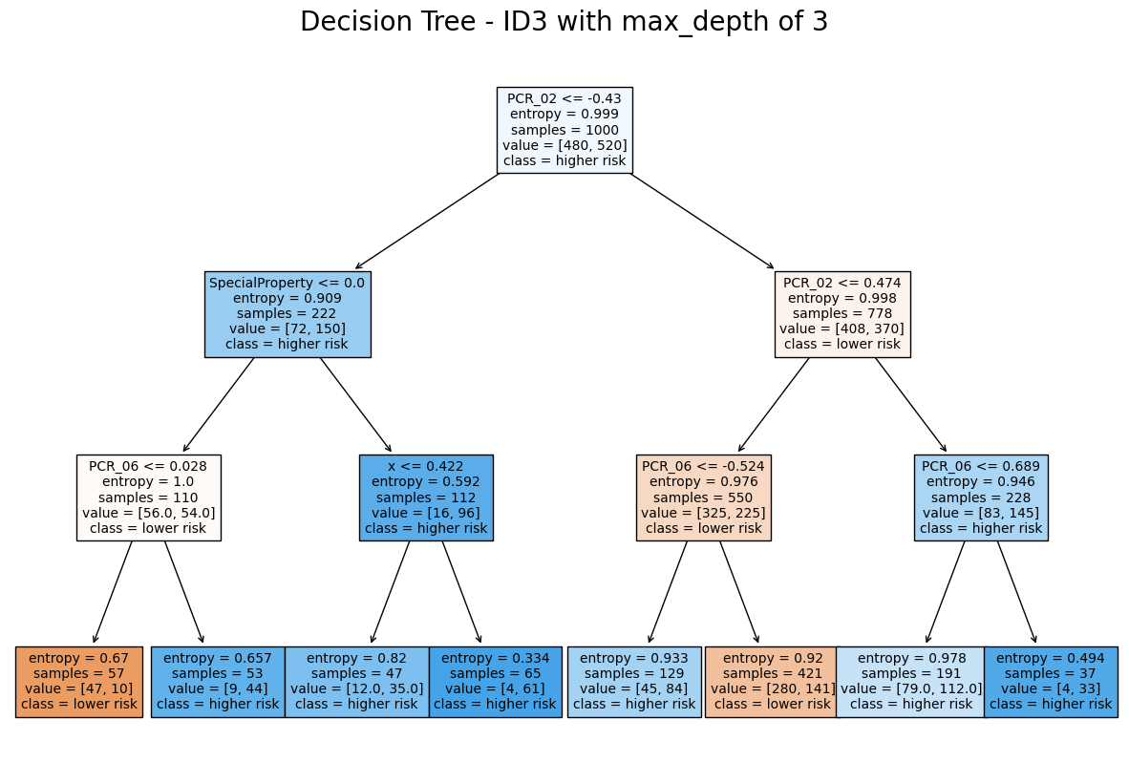

Q6.

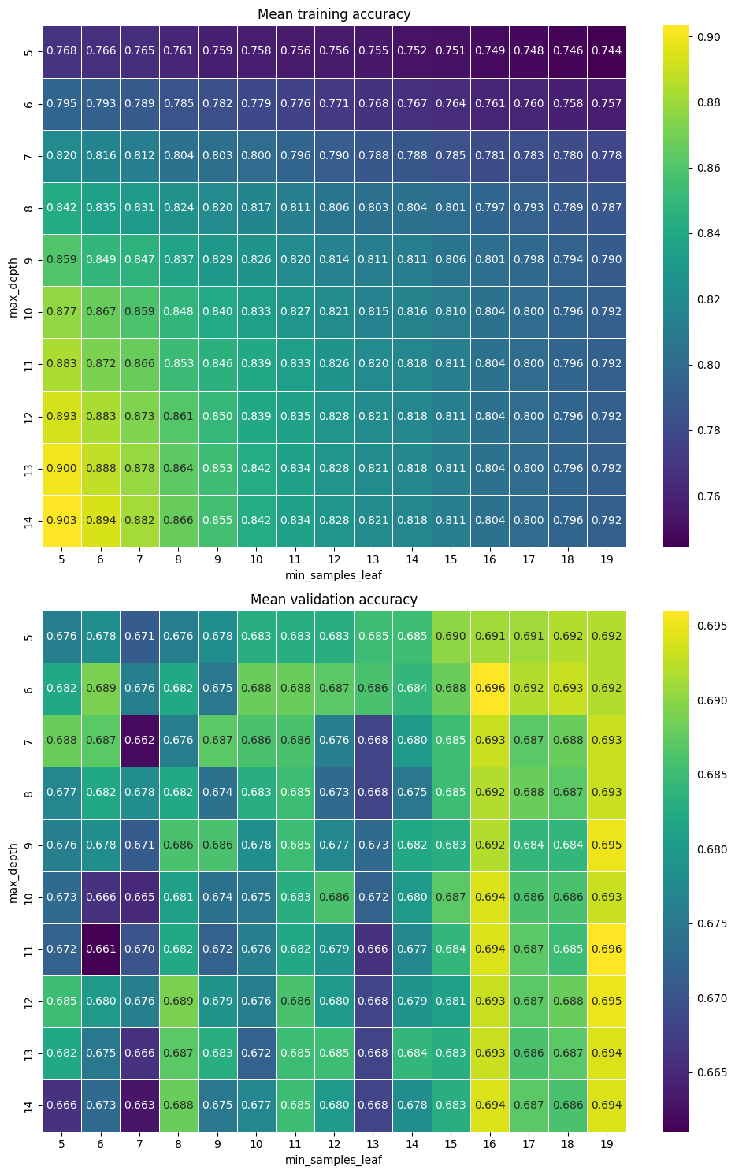

According to the "Mean validation accuracy" plot, the optimal hypermeter combination is: min_samples_leaf = 16 or 19, max_depth = 6 or 11.

A hyperparameter-combination that causes underfitting, according to the "mean validation accuracy" plot, is: min_samples_leaf = 7, regardless of the value of max_depth. This happens because for the above value of min_samples_leaf, it's hard to discern the classification.

A hyperpameter-combination that causes overfitting, according to both plots, is: min_samples_leaf = 5, max_depth = 14. This is because the training accuracy is very high, but the validation accuracy is very low.

Q7.The number of hyperparameter combinations that were evaluated in our grid search is 15* 10 = 150. Had we wished to tune a third hyperparameter, that would affect the number of combinations by multiplying it by the number of the values of this third hyperparameter. Searching over additional hyperparameters affects the total number of possible combinations by multiplying them by the number of values of each additional hypermeter.

Q8. The test accuracy of this model is: 0.736.

Q9. 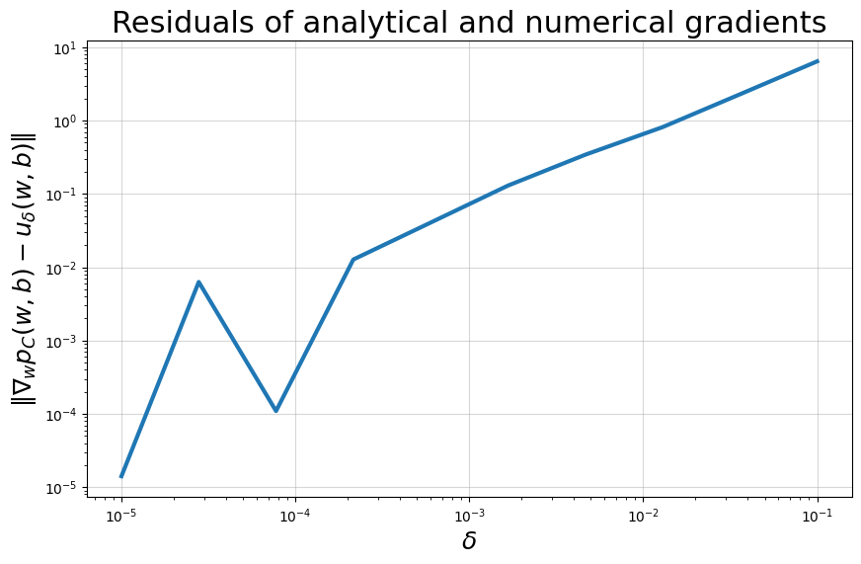

The demonstrated behavior of the plot is that from large δ's, the residuals grow. This is justified because when δ is large, the numeric approximation is less accurate, as we can see in the given formula of the derivative. But when δ is small, the numeric approximation behaves more like the derivative. On the other hand, when δ's value is very small, the numeric approximation behaves less like the derivative. This happens because of computational errors that are caused by δ's extremely small value.

Q10. The interaction matches our expectations: We expect that for large values of C (i.e., a very regularized classifier), we get overfitting. For very small values of lr (i.e, a very regularized classifier), we also get overfitting.

Q11.