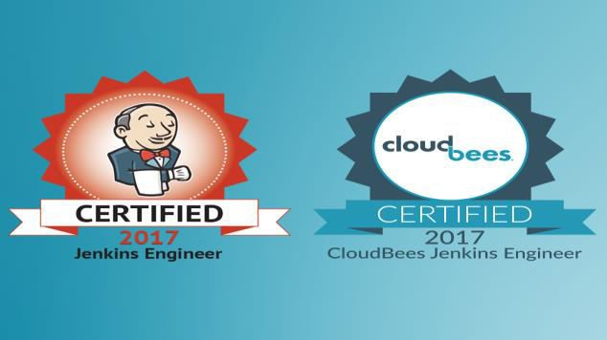
Contents
- Who can do this course
- Prerequisite
- Course Deliverables
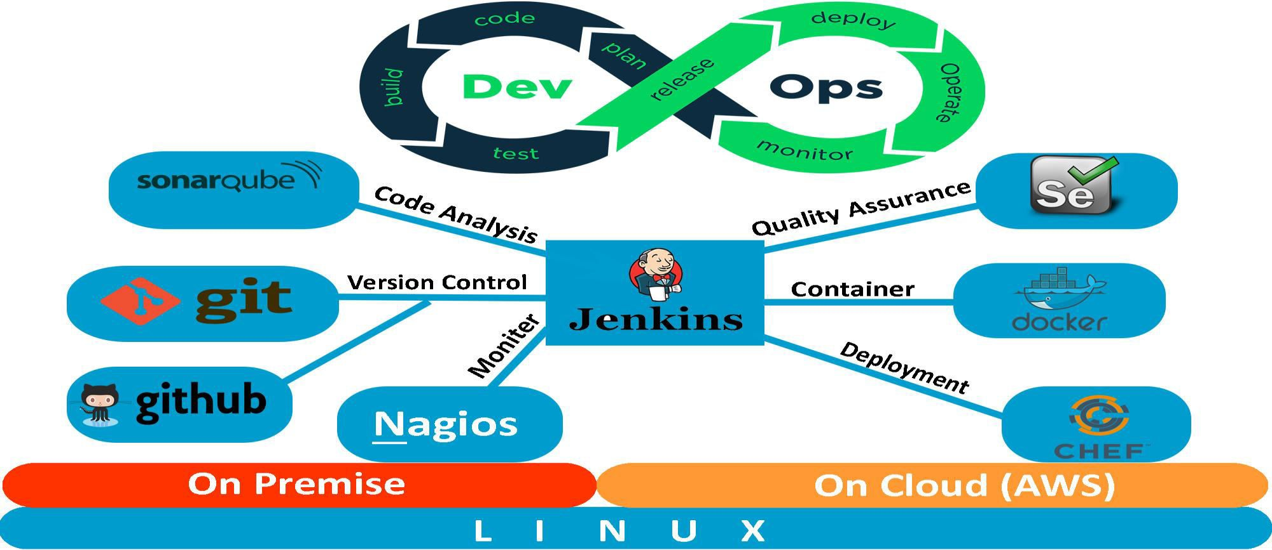
- Course Description

- Who can do this course
- Cloud engineers Network administrators Automation Engineers
- Quality Analysts System administrators software developers
- DevOps consultants Stakeholder

- Prerequisites

There are no prerequisites for this course but professionals having experience in IT (Development, Operations) will be beneficial.

- Course Deliverables
On completions student should be able to do:
  - Setup a distributed version control environment using GIT.
  - Design and implement branching and merging strategies.
  - Create a Dockerized environment.
  - Create automation scripts and deploy various environments (development, test staging, Production etc.) using Chef.
  - Explain what cloud computing is and provision AWS services.
  - Design and implement a CI pipeline using Jenkins for both cloud and non-cloud environment.
  - Design and configure Continuous Delivery/Deployment pipeline using Jenkins for both cloud and non-cloud environment.
  - Certification covered Jenkins Certified Engineer.
  - Student can also think of Docker Certified Associate, Certified Chef Developer and AWS Certified DevOps Engineer.

Course Description
Module1: Introduction  About this course,  Introduction,  What is DevOps? Q & A  What is Continuous Integration?  What is Continuous Delivery? | Module4: Version Control System( Gits)  Introduction, Versioning, Branches & More  Rollback, Git Ssh Login, Git Tags, Semantic Versioning & More  Setup GitHub Copilot Git Commands
Module2: Prerequisites Info and Set Up  Tools Prerequisite Information  Chocolatey for Windows  Homebrew for MacOS  Installing Software’s  Tools Prerequisites for Centos 9, RHEL9 & Rocky Linux  Tools Prerequisites for Ubuntu 24  Signups  AWS Setup  Outro | Module 5: Linux  Introduction to Linux, Quiz 3: Linux Intro questions  Commands and File systems, Quiz 4: Test Basic Command in Linux  More Commands ( mkdir, cp, mv, touch etc)  Vim editor, Quiz 5: Test vim editor  File Types, Quiz 6: Test File types,Filters,Quiz 7: Test filters command,Redirections,Quiz 8: Test Redirection, Users and Groups, Quiz 9: Test Users & Group, File permissions, Quiz 10: Test File Permissions ,Sudo,Quiz 11: Sudo quiz  Package Management, Quiz 12: Package Management Quiz  Services, Quiz 13: Services Quiz,Processes,Quiz 14: Processes quiz  Archiving, Ubuntu commands, Quiz 15: Linux OS Quiz  Linux Commands
Module3: VM Set Up  Welcome to virtualization  What is Virtualization?  Introduction  VM-Manually (Windows & MacOS Intel chip)  VM-Automatically (Windows & MacOS Intel chip)  VM on MacOS M1 chip  Quiz 2: Vagrant & Virtual box | Module 6: Vagrant and Linux Servers  Vagrant-vms ,Vagrant IP, RAM & CPU, Vagrant Sync Directories  Provisioning, Website Setup, WordPress Setup  Automate Website setup, Automate WordPress Setup  Copilot AI for Coding, Multi VM Vagrant file  Systemctl & Tomcat 10

Module 7: Variables, JSON and YAML  Introduction, Variables & Python DS,  JSON & YAML | Module 10: Introducing Containers  What are containers? Quiz 19: Container Quiz  What is Docker ,Quiz 20: Docker Intro Quiz  Hands on Docker Containers  Quiz 21: Docker Quiz  Vprofile Project on Containers, Micro services  Micro service Project
Module 8: V-Profile Project Set up Manual and Automated  Welcome to the Project , Introduction  VM Setup, MySQL Setup, Memcache Setup  RabbitMQ Setup, App setup, Nginx Setup  Validate, Automated - Introduction  Automated – Code, Automated – Execution  Quiz 17: Vprofile Project quiz | Module 11: Bash Scripting  Bash Scripts, Introduction, VM Setup, First Script  Sample Script,ChatGPT,Variables, Quiz 22: Variables Quiz  Command line arguments, System Variables  Quiz 23: Arguments Quiz, Quotes  Command Substitution, Quiz 24: Quote quiz  Exporting Variables, Quiz 25: Variable Quiz  User Input, Decision Making part1,Decision Making part2  Quiz 26: Conditions Quiz, Script For Monitoring  Loops, Quiz 27: For loop quiz  While Loops, Remote Command Execution  SSH Key Exchange  Finale Part1  Finale Part2
Module 9: Networking  ISO  Understanding Networks & IP  Protocols, ports etc.  Networking Commands  Quiz 18: Networking Quiz | Module 12: AI for Scripting  Autocomplete feature,  Apply Best Practices  AI Suggestions,  Write entire code with AI

Module 13: AWS part-1  What is Cloud Computing, Introduction  Ec2 Introduction, Ec2 Quick Start  More In Ec2 Part1, More in Ec2 Part2  AWS CLI,EBS,EBS Snapshots,ELB Introduction  ELB Hands On, Cloudwatch Introduction,  Cloudwatch Hands On,EFS,Autoscaling Group Introduction  Auto scaling Group Hands On, S3 Introduction  S3 Website Hosting, More in S3, RDS | Module 16 : Build Tools  Introduction  Maven Hands-on  Maven, NodeJS & AI
Module 14: : AWS cloud for Project set-up  Introduction, Security Group & Key pairs, EC2 Instances  DNS Route 53,Build and Deploy Artifacts, Load Balancer & DNS,Autoscaling Group, Validate & Summarize | Module 17: Continuous Integration and Delivery with Jenkins  Introduction, Installation, Freestyle Vs Pipeline As A Code  Installing tools in Jenkins, First Job, First Build Job  Plugins, Versioning & more, Disk Space Issue  Flow of Continuous Integration Pipeline, Steps for Continuous Integration Pipeline, Jenkins, Nexus & Sonarqube Setup, Plugins for CI,Pipeline As A Code, Introduction, Code Analysis, Code Analysis Demonstration  Quality Gates, Software Repositories Intro (Nexus)  Nexus PAAC Demo, Notification, Slack  CI for Docker | Intro, Docker PAAC Prereqs info  Docker PAAC Demo, Docker CICD Intro  Docker CICD Code,AWS ECS Setup  Docker CICD Demonstration, Cleanup  Build Triggers Intro,Build Triggers Demo  Agent/Node/Slave in Jenkins, Using Agent/Node/Slave  Authentication & Authorization
Module 15: Re-Architecting Web App on AWS cloud  Introduction, Security Group And Key pairs  RDS,Elastic Cache, Amazon MQ,DB Initialization  Beanstalk Update on Security Group & ELB  Build & Deploy Artifact, Cloud front  Validate and Summarize | Module18: GitHub Actions  Introduction  Quick start Part1  Quick start Part2  Triggers and Inputs  Artifacts, Conditions & Repo Permissions  Security Scan  Secrets & Docker  Build & Publish Job

Module 19: GitLab  Introduction, Python on Linux, Versions & Indentation  Quotes and Comments, Variables, Print Format  Slicing,Operators,Conditions  Loops, Break & Continue, Built-in Functions or Methods  Functions part-1, Functions part-2,Modules  OS Tasks, Python Fabric, Exception Handling  Cloud Interaction with Boto3,AI for Cloud Automation  Copilot AI for Cloud Automation, Python Scripts | Module 22: Ansible  Introduction, Setup Ansible & Infra,Inventory & Ping Module, Inventory Part 2,YAML & JSON  Ad Hoc Commands, Playbook & Modules  Modules - Find, Use, Troubleshoot & Repeat  Ansible Configuration, Variables & Debug  Group & Host Variables, Fact Variables  Decision Making, Loops  File, copy & template modules, Handlers  Roles, Ansible for AWS, Vprofile code
Module 20: Python  Introduction, Python on Linux, Versions & Indentation  Quotes and Comments, Variables, Print Format  Slicing,Operators,Conditions  Loops, Break & Continue, Built-in Functions or Methods  Functions part-1, Functions part-2,Modules  OS Tasks, Python Fabric, Exception Handling  Cloud Interaction with Boto3,AI for Cloud Automation  Copilot AI for Cloud Automation, Python Scripts | Module 23: Monitoring And Observability  Introduction to Monitoring  Why Monitoring is Essential for DevOps  Monitoring and Observability Tools  Setting Up the Monitoring Environment  Loki and Web Server Setup  Adding a Node to Prometheus  Understanding PromQL (Prometheus Query Language)  Connecting Grafana & Prometheus  Integrating Slack for Notifications  PromQL for Grafana Dashboards  Building Grafana Panels and Dashboards  Creating Alerts and Thresholds  Integrating Loki and Alloy for Logs and Metrics
Module 21: Learn Terraform  Introduction, Basics of Terraform  Code Structure, Code Structure Part 2  Plan, Apply, Update & Destroy, Variables  Provisioners, Outputs, Backend, What Next? | Module 24: AWS Part-2  VPC Introduction ,VPC Design & Components  VPC Setup Details, Default VPC, Create VPC  Subnets, Internet Gateway, Route Tables, NAT Gateway  Bastion Host, Website in VPC  Peering, Terraform for VPC Setup, Ec2 Logs  Links, buildspec, Links, S3 policy

Module 25 : AWS CI/CD Project  Introduction  Beanstalk  RDS & App Setup on Beanstalk  Code Commit  Code build  Build, Deploy & Code Pipeline | Module28: Containerization  Introduction ,Overview of Base Image  Dockerhub Setup, Setup Docker Engine  Dockerhub & Dockerfile References  App Image Dockerfile, DB Image Dockerfile  Web Image Dockerfile, Docker Compose  Build and Run, Summarize  Containerizing Microservice Project  Build & Run Microservice App
Module 26: Project On Google Cloud  Introduction to the GCP vProfile Project  Project Architecture Overview  Setting Up Your GCP Account & Project  Commands in the Source Code  Configuring Project Variables  VPC, Subnets & Network Setup  Firewall Rules & VM Deployment  Configuring Cloud SQL & Memorystore  Setting Up Cloud DNS  Creating a Custom VM Image  Building a Managed Instance Group (MIG)  Configuring the Global HTTP/HTTPS Load Balancer  SSL Certificates, HTTPS & Final DNS Setup  Summary and Cleanup | Module 29: Kubernetes  Introduction, Minikube for K8s Setup,Kops for K8s Setup  Objects and Documentation, Kube Config  Pods, Namespace, Different levels of Logging  Service, Replica Set, Deployment  Command and Arguments, Volumes  Config Map, Secret, Ingress, Kubectl CLI & Cheatsheet, Extras, Helm Introduction,  Helm Hands On, Helm with AI, Lens  Terraform For EKS Setup
Module 27: Docker  Introduction  Docker Setup  Docker commands & concepts  Docker Logs  Docker volumes  Building images  Entrypoint and CMD  Docker Compose  Multi Stage Dockerfile | Module 30: App Deployments On Kubernetes Cluster  Introduction  Architecture  Source Code Overview  Secret  Persistent Volume for DB [PVC]  MySQL App,MySQL Service  Memcache App & Service  RabbitMQ App & Service  Tomcat App & Service  IngressK8s Cluster Setup & Source Code  Deploy App on K8s Cluster  Summarize

Module 31 : GitOps Project  GitOps Introduction  Project Architecture  Prepare GitHub Repo  GitHub Secrets  Terraform Code  Staging Workflow for Terraform code  Main Workflow for Terraform code  Workflow for Vprofile app code  Docker Build & Publish  Deploy to EKS  Clean up | Mock Exams (Full Length)  - Guidelines for exam  - Practice Test 1: - Full Length Mock Exam I  - Practice Test 2: - Full Length Mock Exam II
PROJECT 1:  Resume preparation, Interview Preparation support is included as part of the course. Each student will be assign one individual project to ensure hands-on practical experience. | PROJECT 2:

