ENOSIS LEARNING –SQL SERVER BOOK

Contents
CHAPTER 1: Introduction to SQL Server 4
Lesson 1: Understanding the SQL Server 5
Lesson 2: SQL Server Version History 6
Lesson 3: WHAT IS DATABASE 11
LESSON 4 : SQL SERVER ARCHITECTURE 12
CHAPTER 1: SUMMARY / CHEAT SHEET 14
CHAPTER 1: EXERCISE (ASSIGNMENTS) 14
CHAPTER 1: QUESTIONS 14
CHAPTER 2: TableS and SQL Statements 15
Lesson 1: Table creation 16
Lesson 2: SQL Statements/COMMANDS 18
CHAPTER 2: SUMMARY / CHEAT SHEET 23
CHAPTER 2: EXERCISE (ASSIGNMENTS) 24
CHAPTER 2: QUESTIONS 25
chapter 3: DATA INTEGRITY & CONSTRAINTS 26
Lesson 1: Constraints. 26
CHAPTER 3: SUMMARY / CHEAT SHEET 31
CHAPTER 3: EXERCISE (ASSIGNMENTS) 31
CHAPTER 3: QUESTIONS 32
chapter 4: CLAUSES 33
Lesson 1: IN-BUILT FUNCTIONS 33
LESsON 2: CLAUSES DEFINATION WITH EXAMPLES 41
CHAPTER 4: SUMMARY / CHEAT SHEET 51
CHAPTER 4: EXERCISE 1(ASSIGNMENTS) 52
CHAPTER 4: questions 54
CHAPTER 5: RELATIONAL DATABASE 55
LESSON 1: RELATIONAL DATABASE 55
LESSON 2: TYPES OF RELATIONSHIP 60
Implementing one-to-one relation 61
Lesson 3: Normalization 63
Lesson 4: Types Of Joins 65
CHAPTER 5: SUMMARY / CHEAT SHEET 69
CHAPTER 5: EXERCISE (ASSIGNMENTS) 70
CHAPTER 5: EXERCISE (ASSIGNMENTS) 72
CHAPTER 5: EXERCISE (ASSIGNMENTS) 74
CHAPTER 5: QUESTIONS 75
CHAPTER 6: advance OPERATOR in SQL server 76
Lesson 1: union, EXcept & intersect 76
Lesson 2: pivot / unpivot 79
CHAPTER 6: SUMMARY / CHEAT SHEET 81
CHAPTER 6: QUESTIONS 81
CHAPTER 7 : Operators, Identifiers Variables & STATEMENTS 82
Lesson 1: Operators 82
Lesson 2: Identifiers 83
Lesson 3: Variables 83
Lesson 4: IF-ELSE STATEMENT 84
Lesson 5: CASE STATEMENT 85
Lesson 6: LOOP STATEMENT 86
CHAPTER 7: SUMMARY / CHEAT SHEET 87
CHAPTER 7: exercise(assignments) 88
CHAPTER 7: QUESTIONS 88
CHAPTER 8: STORED PROCEDURE & FUNCTIONS 89
Lesson 1: Implementing Stored Procedures 89
Lesson 2: Implementing User-Defined Functions 99
CHAPTER 8: summary / CHEATSHEET 101
CHAPTER 8: EXERCISE 1 (ASSIGNMENT) 101
CHAPTER 8: EXERCISE 2 (ASSIGNMENT) 102
chapter 8: QUESTIONS 105
CHAPTER 9: IMPLEMENTING Transactions, Error handling 105
LESSON 1: IMPLEMENTING ERROR HANDLING 105
Lesson 2: Managing Transactions 113
CHAPTER 9: summary / cheatsheet 116
CHAPTER 9:questions 116
CHAPTER 10: TABLE TYPES 117
Lesson 1: Temporary Tables 117
LESsON 2: Table Variable 120
Lesson 3: CTE 120
Lesson 4: subquery 121
CHAPTER 10: summary / CHEATSHEET 124
CHAPTER 10: EXERCISE (ASSIGNMENTS) 126
CHAPTER 10: questions 128
CHAPTER 11: Indexes 128
Lesson 1: Indexes 128
Lesson 2: Creating an index 131
CHAPTER 11 : SUMMARY / CHEATSHEET 133
CHAPTER 11: QUESTIONS 133
CHAPTER 12 : Views 134
Lesson 1: Creating and Implementing View 134
Chapter 12: SUMMARY / cheatsheet 137
Chapter 12: QUESTIONs 137
CHAPTER 13: Triggers 138
Lesson 1: Trigger 138
CHAPTER 13 : summary /cheatsheet 147
CHAPTER 13 : ASSIGNMENTS 147
CHAPTER 13 : questions 149

CHAPTER 1

CHAPTER 1: Introduction to SQL Server
S QL Server is database server invented by Microsoft in the year 1989.It is a software to store and retrieve data. These software’s are also called as Database Management System (DBMS).
The database management system is a software product which is used to stores and retrieves data requested by the user.
Lessons in this chapter:
- Lesson 1: Understanding the SQL server
- Lesson 2: Database
- Lesson 3: Version of Sql Server
- Lesson 4: Architecture

Lesson 1: Understanding the SQL Server
A database server (SQL SERVER) is a computer program that provides database services to other programs or computers, as defined by the client-server model. The database server will have a server which will store the data and it will be accessed by clients through different interfaces likes management studio, application etc. Therefore, a SQL Server is a database server that implements the Structured Query Language (SQL). SQL is a special-purpose programming language designed to handle data in a relational database management system.
Database Management system (DBMS)
A DBMS makes it possible for end users to create, read, update and delete data in a database.
The DBMS essentially serves as an interface between the database and end users or application programs, ensuring that data is consistently organized and remains easily accessible.
DBMS is that it lets end users and application programmers access and use the same data while managing data integrity. Data is better protected and maintained when it can be shared using a DBMS instead of creating new iterations of the same data stored in new files for every new application. The DBMS provides a central store of data that can be accessed by multiple users in a controlled manner.
Why Database Management System.
- It stores data in centralized server. [ e.g. : single data server]
- Client – Server architecture – single server – multiple clients.
Examples : Mail server, Banking, Reservation: centralized
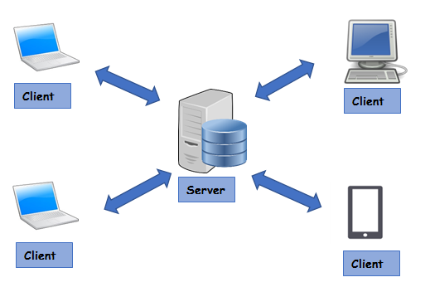
- Data is being updated instantly.
- It supports disaster recovery. We can back up the data in remote locations.
- We can backup and restore the data instantly.
- Security: we can give access to different users depending upon roles.
- Transactions: data can be rolled back. Either all the tasks should be completed or it should be rolled back to the original position.
Examples of Database Management System :-> Oracle, My-SQL, SQL SERVER, MongoDB
Use of Database Management System in Application
Application cannot store the data permanently, so either the application will use the file system or database to store the data permanently. Since file-system have lots of drawback to store the data so application mostly use database for storing the data.
To use SQL SERVER, we need to install the server component and the client component. Whenever we install sql server on the machine, an instance of the server is installed on the machine.

SQL SERVER have different versions and editions which are explained in details in Lesson 2.

Lesson 2: SQL Server Version History
In this Lesson we will discuss different versions of SQL SERVER. It started in the year 1989 and released it next versions subsequently.
1st Generation
SQL Server Version | Features
SQL Server 1.0 (1989) | Developed by Microsoft, Sybase, and Ashton-Tate for OS/2.
SQL Server 4.2 (1992) | Developed for Windows NT 3.1.
SQL 6.0/6.5 (1995) | First version designed specifically for Windows NT.
2ND Generation
SQL Server Version | Features
SQL Server 7.0 (1999) | - Restructure of Relational Server.  - Data Transformation Services.  - Online Analytical Processing.
SQL2000 | - Focus on Performance and Scalability  - XML support  - Data Mining  - Reporting Services
3rd Generation (From SQL 2005 to SQL2022)
SQL Server Version | Features
SQL 2005 | - High Availability (includes Database Mirroring).  - Security Enhancements.  - Integration Services.  - Developer Productivity and CLR.  - Native XML and Web services supports.
SQL 2008/SQL2008 R2 | - Multi-Server Queries.  - Compressions.  - Database Encryption.  - Spatial Data Types.
SQL 2012 | - SQL Server Always On.  - Power View.  - Always on Failover Cluster Instance
SQL 2014 | - In-memory OLTP Engine.  - Always on Enhancements.  - Buffer pool Extension.  - Power view for multidimensional Model.  - Integration to Azure  - Memory Optimized Table
SQL 2016 | - New security Features.  - Dynamic data masking.  - Stretch database.  - Real time operational analysis.  - Introduction of Polybase support  - JSON Support
SQL 2017 | - Can be installed in Linux and Docker  - Resumable online index builder.  - Automatic database tuning.  - New graph database capabilities.
2019 | - Memory-optimized TempDB Metadata  - Accelerated Database Recovery (ADR)  - Intelligent Query Processing (IDQ) Improvements  - Replication in Linux  - Always Encrypted with Secure Enclaves
2022 | - Parameter Sensitive Plan Optimization  - Query Store enhancements  - Link to Azure SQL Managed Instance  - Contained Availability Groups  - Azure Synapse Link for SQL  - Multi-Write Replication  - Azure Active Directory authentication  - Azure Purview integration  - SQL Server Ledger  - AWS S3 storage integration
Microsoft SQL SERVER also has multiple editions available within each version. There are 5 edition levels and each of the levels are geared towards different sized companies/applications. Below is a short description of each edition.
- Enterprise - contains all features with high end datacentre capabilities needed in large enterprises
- Standard - has basic data management which is geared towards departments or small companies
- Web - is a low cost option that web hosting companies can offer to their customers
- Developer - contains all of the functionality in enterprise edition, but is only licensed for development and test systems. This is an ideal version for developers who build applications.
- Express - free entry level database ideal for learning how to build a data driven application or for very small databases
The following table shows some examples of this.
Feature | Enterprise | Standard | Web | Express
Max Compute Capacity | OS max | Lesser of 4 sockets  or 24 cores | Lesser of 4 sockets  or 16 cores | Lesser of 1 socket  or 4 cores
Max Buffer Pool Memory | OS max | 128 GB | 64 GB | 1410 MB
Max Database Size | 524 PB | 524 PB | 524 PB | 10 GB

SQL SERVER EDITIONS FEATURES & LIMITATIONS
Free editions
Express | Express edition is a free lightweight/lite edition of SQL Server with some limitations, that can be used in production environment.  Main limitations:  • Limited to lesser of 1 physical CPU or 4 cores.  • No single database (.MDF file) can be over 10 GB.
Developer | Developer edition is a fully-functional Enterprise Edition of SQL Server, licensed for use as a development and test database in a non-production environment.
Evaluation | Evaluation edition is a fully-functional trial Enterprise Edition of SQL Server but is limited to 180 days, after which the tools will continue to run, but the server services will stop.
Paid editions
Enterprise | Enterprise edition is the top-end edition with a full feature set.
Enterprise Core | Enterprise edition with the Core-based Licensing. The plain Enterprise one is limited to just 20 CPU cores.
Standard | Standard edition has less features than Enterprise, when there is no requirement of advanced features.
Azure SQL Database | Azure SQL Database is the cloud-based version of SQL Server, presented as a platform as a service (PaaS) offering on Microsoft Azure.
Specialized editions
Web | Web edition is a low total-cost-of-ownership option for Web hosters.
Business Intelligence | Business Intelligence edition includes the Standard Edition capabilities and Business Intelligence tools.
Analytics Platform System (APS) | Formerly Parallel Data Warehouse (PDW). A massively parallel processing (MPP) SQL Server appliance optimized for large-scale data warehousing such as hundreds of terabytes.
Big Data Clusters (BDC) | Starting with SQL Server 2019, SQL Server Big Data Clusters allow you to deploy scalable clusters of SQL Server, Spark, and HDFS (Hadoop Distributed File System) containers running on Kubernetes.
LocalDB | SQL Server Express LocalDB is a lightweight version of Express that has all of its programmability features, runs in user mode and has a fast, zero-configuration installation and a short list of prerequisites.
Discontinued editions
MSDE | Microsoft Data Engine or Microsoft Desktop Engine. Express edition predecessor.
Personal | Express edition predecessor.
Compact | Embedded database.
Workgroup | Cheaper version of the Standard edition with some limitations.
Datacenter | Datacenter edition was a full-featured edition of SQL Server and was designed for datacenters that need high levels of application support and scalability.

Lesson 3: WHAT IS DATABASE
SQL SERVER IS A COLLECTION OF DATABASES. SQL SERVER STORES THE DATA IN A DATABASE.
A database is a collection of information that is organized so that it can be easily accessed, managed and updated. In database the data is stored in the form of tables. Table is nothing but the collection of rows and columns.
The structure of table is defined in the form of columns and data is defined in the form of rows.
Whenever we create a database it creates two files to store the data.
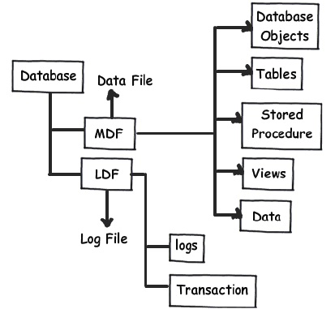
Quick Facts
We can create 32767 databases in single instance
You can install 50 instances of SQL SERVER on a single machine.

- .MDF (MASTER DATA FILE): [This is where the actual data is stored]
- .LDF (LOG DATA FILE): [This stores the user queries, logs]
Note: While creating database, we have to specify the name of the file, location and size of the file.
- The MDF file is the heart of the database. All the data is stored in the MDF file.
- The MDF file is divided into no of pages, each page size is of 8 KB.
- 1MB: 128 PAGES. The MDF file is divided into pages.

Databases are different types
User Defined Database | System Defined Database
The user defined databases are created by users to store data in tables etc | The system defined database are already created by sql server to stored system related information.
System Databases (System Defined Database)
SQL Server mainly contains four System Databases
MASTER | MODEL | MSDB | TEMPDB

Master Database : Master Database contains information about SQL server configuration. Without Master database, server can’t be started. This will store the metadata information about all other objects (Databases, Stored Procedure, Tables, Views, etc.) which is Created in the SQL Server. It will contain login information of users. It is the heart of SQL SERVER.
Model Database : The model database sets a template for every database that was newly created. It serves as a template for the SQL server in order to create a new database. When we create a new database, the data present in model database are moved to new database to create its default objects which include tables, stored procedures, etc. Primarily, the requirement of model database is not specific to creation of new database only. Whenever the SQL server starts, the Tempdb is created by using model database in the form of a template. By default it does not contain any data.
Msdb : The msdb database is used mainly by the SQL server Management Studio, SQL Server Agent to store system activities like SQL server jobs, mail, service broker, maintenance plans, user and system database backup history, Replication information, log shipping.
TempDB : It can be accessed by all the users in the SQL Server Instance. The tempdb is a temporary location for storing temporary tables (Global and Local) and temporary stored procedure that hold intermediate results during the sorting or query processing. This Database will be created by SQL Server instance when the SQL Server service starts. This database is created using model database. We cannot take a backup of temp Database.

LESSON 4 : SQL SERVER ARCHITECTURE
Like all database systems, the SQL Server performs extremely complex tasks like memory management, optimum CPU utilization, query optimization, execution planning etc. at a lightning fast speed.
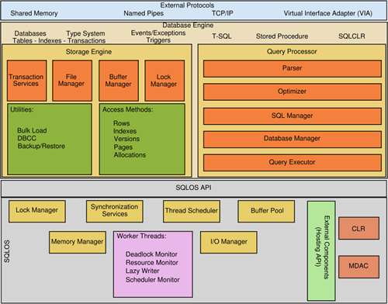
The diagram gives you an overview of what the SQL Server architecture looks like.
There are 3 important items:
- Database Engine: Performs the storage and query processing tasks.
- SQL Operating System: Works on I/O and other higher level management tasks.
- Interfaces: The External Protocols and SQL Operating System API connect the dots.
The Database engine is the heart of Microsoft SQL Server
It contains 2 major components:
- Query processor: optimizes and executes the query.
- Storage engine: Manages buffer and access methods
Going with the motorcycle analogy, the SQL Operating System API and External Protocols are the wires and dials. They connect the speedometer to the front wheel, show you the speed. This speed can then be reduced or increased using the accelerator. They simply provide ways to connect internal and external components together and manipulate the operations.
The major components of SQL Server are:
- Relational Engine
- Storage Engine
- SQL OS
1) Relational Engine: Also called as the query processor, Relational Engine includes the components of SQL Server that determine what your query exactly needs to do and the best way to do it. It manages the execution of queries as it requests data from the storage engine and processes the results returned.
Different Tasks of Relational Engine:
- Query Processing
- Memory Management
- Thread and Task Management
- Buffer Management
- Distributed Query Processing

2) Storage Engine: Storage Engine is responsible for storage and retrieval of the data on tothe storage system (Disk, SAN etc.). There are 2 types of files that are created at the disk level
Data file and Log file. Data file physically stores the data in data pages. Log files that are also known as write ahead logs, are used for storing transactions performed on the database.

CHAPTER 1: SUMMARY / CHEAT SHEET
SQL SERVER is a software for storing and retrieving data.
Once the sql server software is installed, it creates an instance which is called as server which can be used to stored and retrieve data.
We can install multiple instances (server) in a single physical machine.
In the instance we create multiple databases.
We can install 50 instances of SQL SERVER on a single machine.
A database is a collection of Sql Objects like Tables, Views , Stored Procedures etc
A database stores the data in mdf file internally.
A database stores the logs in ldf file internally.
We can create 32767 databases in single instance.

CHAPTER 1: EXERCISE (ASSIGNMENTS)
1 | Install SQL SERVER COMPONENTS AND MANAGEMENT STUDIO are create a default instance or named instance.
2 | Create a Database with an Initial Size of MDF file as 100 MB.
3 | Create a Database with a Max Size of MDF file as 200 MB.
4 | Create a Database by defining two file groups and separate Data file for each file.

CHAPTER 1: QUESTIONS
1 | What is DBMS ?
2 | What is Sql Server ?
3 | What is different between DBMS, RDBMS & ORDBMS ?
4 | What is an Instance?
5 | What is the difference between default instance and named instance ?
6 | What is MDF in database ?
7 | What is LDF in database ?
8 | What is Client Server Architecture ?

CHAPTER 2

CHAPTER 2: TableS and SQL Statements
Tables are used to store the data in Microsoft SQL server. Tables are created inside DATABASE of SQL SERVER to store data. In tables, data is logically organized in row and column format. Each row represents a new records and each column represents fields in that records. In this chapter, you will learn how to create and alter tables.
Types of Tables:
- User Defined Table
These tables are created by the user for storing data.
- System Defined Tables
These tables are already created by sql server which stores system related information.
- Memory optimized tables.
The main benefit of memory-optimized tables are that rows in the table are read from and written to memory which results in non-blocking transactions at super-fast speed. The second copy of the data is stored on the disk and during database recovery, data is read from the disk-based table. Memory-optimized tables are for specific types of workloads such as high volume OLTP applications.
- Temporal table.
A system-versioned temporal table is a type of user table designed to keep a full history of data changes and allow easy point in time analysis. This type of temporal table is referred to as a system-versioned temporal table because the period of validity for each row is managed by the system (i.e. database engine). Every temporal table has two explicitly defined columns, each with a datetime2 data type. These columns are referred to as period columns. These period columns are used exclusively by the system to record period of validity for each row whenever a row is modified.
- External Table.
External Tables in SQL Server 2016 are used to set up the new Polybase feature with SQL Server. With this new feature (Polybase), you can connect to Azure blog storage or Hadoop to query non-relational or relational data from SSMS and integrate it with SQL Server relational tables.
- File Table.
The FileTable feature brings support for the Windows file namespace and compatibility with Windows applications to the file data stored in SQL Server. FileTable lets and application integrate its storage and data management components, and provides integrated SQL Server services - including full-text search and semantic search - over unstructured data and metadata.
Apart from this Sql Server also have some temporary tables like Local Temp Table, Global Temp Table, Table Variable etc. which are created temporarily and dropped automatically.
Lessons in this chapter:
- Lesson 1: Table creation.
- Lesson 2: SQL Statements/ COMMANDS

Lesson 1: Table creation
A table represents the structure of the data. In SQL server, first we have to define the structure. (First we have to create the table and then we can insert values into the table.) So in this lesson you learn about how to create table.
In SQL server tables are the database object that contains all the data in a database. For example ,a table that contain students data for a class it contain a row for each students and columns representing student information such as roll number, name, gender, math’s marks, and science marks.
Creating a Table: You can create a table in SQL server in two ways.
- By using the CREATE TABLE statement.
- By using SELECT INTO statement.

- By using the CREATE TABLE statement.
Using create table command you can create new table. Basic syntax for creating a table is:
CREATE TABLE TABLE_NAME
Quick Facts
A table can have up to 1,024 columns.

(
Column_name1 datatype,
Column_name2 datatype,
Column_name3 datatype
)
What is a Datatype?
A Datatype is used to define the type of data to be used by the column.
SQL Server has a predefined set of datatypes.

SQL Server | Data Precision
BIT | Integer: 0 or 1
TINYINT | Positive Integer 0 -> 255
SMALLINT | Signed Integer -32,768 -> 32,767
INT | Signed Integer -2^31 -> 2^31-1
BIGINT | Signed Integer -2^63 -> 2^63-1
REAL | Floating precision -1.79E + 308 -> 1.79E + 308
FLOAT | Floating precision -3.40E + 38 -> 3.40E + 38
MONEY | 4 decimal places, -2^63/10000 -> 2^63-1/10000
SMALLMONEY | 4 decimal places, -214,748.3648 -> 214,748.3647
DECIMAL | Fixed precision -10^38 + 1 -> 10^38 – 1
NUMERIC | Fixed precision -10^38 + 1 -> 10^38 – 1
DATETIME | Date+Time 1753-01-01 -> 9999-12-31, accuracy of 3.33 ms
SMALLDATETIME | Date+Time 1900-01-01 -> 2079-06-06, accuracy of one minute
CHARn | Fixed-length non-Unicode string to 8,000 characters
NCHARn | Fixed-length Unicode string to 4,000 characters
VARCHARn | Variable-length non-Unicode string to 8,000 characters
NVARCHARn | Variable-length Unicode string to 4,000 characters
TEXT | Variable-length non-Unicode string to 2,147,483,647 characters
NTEXT | Variable-length Unicode string to 1,073,741,823 characters
BINARY | Fixed-length binary data up to 8,000 characters
VARBINARY | Variable-length binary data up to 8,000 characters
ROWVERSION | hexadecimal binary data up to 8 bytes
HIERARCHYID | Variable-length fanouts (0-7) the typical storage is about 6 x Log A * n bits
UNIQUEIDENTIFIER | Variable length binary data up to 16 byte
GEOMETRY | Variable-length binary data up to 8 Bytes

EXAMPLE OF A TABLE STRUCTURE: CREATE A TABLE EMPLOYEE

COLUMNNAME | DATATYPE | SQL SERVER TABLE CREATION
EMPID | INT | CREATE TABLE EMPLOYEE ( EMPID INT,  EMPNAME VARCHAR(100),  SALARY FLOAT,  DEPARTMENT VARCHAR(100),  DESIGNATION VARCHAR(100),  JOININGDATE DATETIME,  STATUS BIT )
EMPNAME | VARCHAR(100)
SALARY | FLOAT
DEPARTMENT | VARCHAR(100)
DESIGNATION | VARCHAR(100)
JOININGDATE | DATETIME
STATUS | BIT

Other data types: There are few data types as well that can be used as per the requirement:
- Cursor: It is useful for variables or stored procedure OUTPUT parameter referencing to a cursor
- Rowversion: It returns automatically generated, unique binary numbers within a database
- Hierarchyid: it is a system data type with variable length. We use it to represent a position in a hierarchy
- Uniqueidentifier: It provides 16 bytes GUID
- XML: It is a special data type for storing the XML data in SQL Server tables
- Spatial Geometry type: We can use this for representing data in a flat (Euclidean) coordinate system
- Spatial Geography Types: We can use Spatial Geography type for storing ellipsoidal (round-earth) data, such as GPS latitude and longitude coordinates. It represents data in a round-earth coordinate system
- Table: It is a special data type useful for storing result set temporarily in a table-valued function. We can use data from this for processing later. It can be used in functions, stored procedures, and batches
- By using SELECT INTO statement.
The SELECT INTO statement creates a new table and populates it with the result set of the SELECT statement. SELECT INTO can be used to combine data from several tables or views into one table. It can also be used to create a new table base upon existing table.
SYNTAX | SELECT INTO New_table_name FROM Old_table_name.
EXAMPLE | SELECT INTO Employee_new FROM Employee  This will create a new table and copy the data from the existing table  Select * from Employee_New

Lesson 2: SQL Statements/COMMANDS
SQL server provides two types of statements.
- DML (Data Manipulation Language)
- DDL (Data Definition Language)
DML is used for selecting/storing /updating/deleting the data. DDL command is used for creating structure. In this lesson you will learn how to do the operations like- create, select, insert, delete, update, truncate, alter and drop.
DDL | DML
CREATE | INSERT
ALTER | UPDATE
DROP | DELETE
 | TRUNCATE
 | SELECT

DML commands are insert, update, delete, select and truncate. (SYNTAX & EXAMPLES)
COMMAND | DESCRIPTION
INSERT | To add a new record into the table  - SYNTAX: INSERT INTO table_name values(value1, value2, value3)  - To insert values into all the columns  EXAMPLE :  INSERT INTO EMPLOYEE VALUES(1,'SAMIR',20000,'IT','MANAGER','10/10/2022',1)  INSERT INTO table_name(colname1, colname2, colname3) values(value1, value2, value3)  To insert values into selected columns  EXAMPLE :  INSERT INTO EMPLOYEE(EMPID,EMPNAME) VALUES (2,'RAJESH')  INSERT INTO EMPLOYEE(EMPNAME,SALARY,STATUS) VALUES ('KAPIL',60000,1)
UPDATE | To update the values in the table  SYNTAX  UPDATE table_name set col_name1 = newvalue1,col_name2=newvalue2  where condition  EXAMPLE :  Update Employee set Salary= 50000 where EMPID=1  Update Employee set DEPARTMENT='IT',DESIGNATION='DEVELOPER' where EMPID=2  (IF WE SKIP WHERE CONDITION THEN ALL THE RECORDS WILL BE UPDATED)  Update Employee set Salary= 0
DELETE | To remove the records from the table  SYNTAX : Delete from table_name where condition  It will delete those records which matches the condition.  Delete from table_name: It will delete all the records.  EXAMPLE :  DELETE FROM EMPLOYEE WHERE EMPID =1  NOTE :[ IF WE SKIP WHERE CONDITION ,IT will delete all the records in the table]  DELETE FROM EMPLOYEE
SELECT | To view the records of the table  SYNTAX  Select * from table_name where condition  Select colname1, colname2, colname3 from table_name where condition  EXAMPLE :  SELECT * FROM EMPLOYEE  SELECT EMPID,EMPNAME,SALARY FROM EMPLOYEE  Full Syntax  SELECT [ DISTINCT ] [ TOP n [ PERCENT ]] select list  FROM table_source  [ WHERE search_condition]  [ GROUP BY group_by_expression]  [ HAVING search_condition]  [ ORDER BY order_expression [ ASC | DESC ] ]
TRUNCATE | Removes all rows from a table  SYNTAX: TRUNCATE TABLE table_name  Example: To delete all the rows from employee table, the query would be like:  TRUNCATE TABLE employee;

DDL commands are create, drop and alter.(SYNTAX & EXAMPLES)
COMMAND | DESCRIPTION
CREATE | Is used to create. Like table, database, views, stored procedure, triggers.  SYNTAX: CREATE TABLE TABLE_NAME ( Column_name1 datatype, Column_name2 datatype, Column_name3 datatype ) Example: CREATE TABLE EMPLOYEE ( EMPID INT, EMPNAME VARCHAR(100), SALARY FLOAT, DEPARTMENT VARCHAR(100), DESIGNATION VARCHAR(100), JOININGDATE DATETIME, STATUS BIT
ALTER | Is used to make changes to the structures in the existing table.  - To add a new column.  - To drop existing column.  - To alter a column.
Alter Syntax
COMMANDS | SYNTAX & Example | Description
ADD COLUMN | SYNTAX  ALTER TABLE TABLE_NAME ADD COLUMN_NAME DATATYPE  EXAMPLE  ALTER TABLE EMPLOYEE ADD GENDER VARCHAR(100) | Adding a new column to the existing table
DROP COLUMN | SYNTAX  ALTER TABLE TABLE_NAME DROP COLUMN COLUMN_NAME  EXAMPLE  ALTER TABLE EMPLOYEE DROP COLUMN GENDER | Drop a column from the table
ALTER COLUMN | SYNTAX  ALTER TABLE TABLE_NAME ALTER COLUMN COLUMN_NAME DATATYPE  EXAMPLE  ALTER TABLE EMPLOYEE ALTER COLUMN EMPID VARCHAR(50) | MAKING CHANGES INTO THE EXISTING COLUMNS

DROP | Removes all rows along with structure of table.  SYNTAX: DROP TABLE table_name  Example: DROP TABLE employee;
Quick Facts / NOTE : Difference between Delete, Truncate and Drop.
DELETE | TRUNCATE | DROP
IN DELETE WE CAN DELETE A SINGLE RECORD OR MULTIPLE RECORDS BASED UPON CONDITIONS.  Eg : Delete from table_name | TRUNCATE IS USED TO DELETE THE COMPLETE DATA, WE CANNOT SPECIFY ANY CONDITIONS FOR IT.  Eg : Truncate table table_name | DROP WILL REMOVE THE STRUCTURES ALONG WITH THE DATA.  Eg : Drop table table_name
DELETE Statement: This command deletes only the rows from the table based on the condition given in the where clause or deletes all the rows from the table if no condition is specified. But it does not free the space containing the table.
TRUNCATE statement: This command is used to delete all the rows from the table and free the space containing the table.

IMP : CREATE A TABLE STRUCTURE SIMILAR TO THIS
EMPID | EMPNAME | GENDER | DATEOFBIRTH | DATEOFJOINING | SALARY | TAX | DEPARTMENT | DESIGNATION | CITY

CREATE THE TABLE STRUCTURE AND RUN THE INSERT SCRIPTS FOR SAMPLE DATA, WHICH WILL BE USED IN NEXT CHAPTERS
CREATE TABLE EMPLOYEES
(
EMPID INT, EMPNAME VARCHAR(100), GENDER VARCHAR(10),
DATEOFBIRTH DATETIME, DATEOFJOINING DATETIME,
SALARY FLOAT, TAX FLOAT,
DEPARTMENT VARCHAR(100), DESIGNATION VARCHAR(100), CITY VARCHAR(100)
)
SELECT * FROM EMPLOYEES
INSERT INTO EMPLOYEES VALUES(1,'SANDEEP','MALE','01/15/1999','01/18/2021',20000,1000,
'IT','DEVELOPER','MUMBAI')
INSERT INTO EMPLOYEES VALUES(2,'KAILASH','MALE','05/20/1998','01/18/1999',30000,1000,
'IT','DEVELOPER','PUNE')
INSERT INTO EMPLOYEES VALUES(3,'SONALI','FEMALE','08/21/1999','01/20/2021',15000,1000,
'ADMIN','OFFICER','MUMBAI')
INSERT INTO EMPLOYEES VALUES(4,'ROSHINI','FEMALE','05/20/1997','01/21/2000',16000,1000,
'ADMIN','OFFICER','NASHIK')
INSERT INTO EMPLOYEES VALUES(11,'UMESH','MALE','02/25/1996','04/11/2021',25000,1000,
'HR','EXECUTIVE','MUMBAI')
INSERT INTO EMPLOYEES VALUES(12,'JAYESH','MALE','05/11/1995','01/18/2018',35000,1000,
'HR','MANAGER','PUNE')
INSERT INTO EMPLOYEES VALUES(13,'ISHITA','FEMALE','07/07/1999','01/20/2011',18000,1000,
'FINANCE','ACCOUNTANT','MUMBAI')
INSERT INTO EMPLOYEES VALUES(14,'KAVITA','FEMALE','09/08/1997','01/21/2012',19000,1000,
'FINANCE','MANAGER','PUNE')
INSERT INTO EMPLOYEES VALUES(15,'RADHA','FEMALE','05/25/1998','01/19/1999',16500,1000,
'ADMIN','OFFICER','NASHIK')

SYSTEM DEFINED TABLES
There are some predefined system tables already created in sql server which stores informations about the databases, files, tables etc.

Some of the important tables are as follow
TABLE NAME | DESCRIPTION
SELECT * FROM sys.databases | Contains information about all sql server databases.
SELECT * FROM sys.all_objects | Contains information about all sql objects like tables, constraints etc
SELECT * FROM sys.database_files | Contains information about mdf / ldf files of the database
SELECT * FROM sys.tables | Contains information about tables of sql server.  Contains a row for each user table in SQL Server.
SELECT * FROM sys.all_columns | Contains information about each columns of sql server. Contains a row for each column of the table in SQL Server.
SELECT * FROM sys.check_constraints | Contains information about check constraints added in the tables of sql server. Contains a row for each check constraints in SQL Server.
SELECT * FROM sys.procedures | Contains information about all procedures in the databases

CHAPTER 2: SUMMARY / CHEAT SHEET
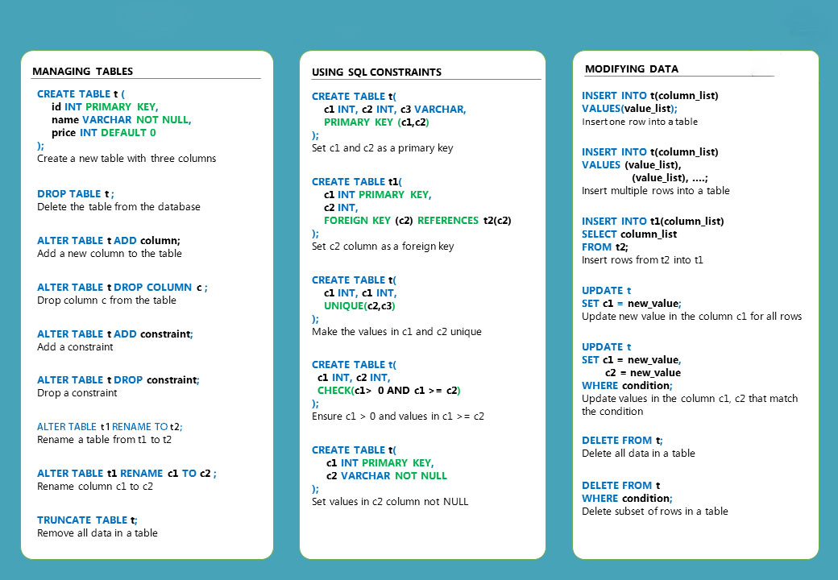

CHAPTER 2: EXERCISE (ASSIGNMENTS)
CREATE A TABLE FOR COMPANY

COLUMN_NAME | DATATYPE
COMPANYID | INT
COMPANYNAME | VARCHAR(100)
WEBSITE | VARCHAR(100)
EMAIL | VARCHAR(100)

ADD TWO COMPANY RECORDS TO THE TABLE using INSERT STATEMENTS
CREATE A TABLE FOR DEPT
COLUMN_NAME | DATATYPE
DEPTID | INT
DEPTNAME | VARCHAR(100)
DEPTLOCATION | VARCHAR(100)

ADD FIVE DEPT RECORDS TO THE TABLE using INSERT STATEMENTS
CREATE A TABLE FOR DESIGNATION
COLUMN_NAME | DATATYPE
DESGID | INT
DESGNAME | VARCHAR(100)
CREATEDDATE | DATETIME

ADD FIVE DESIGNATION RECORDS TO THE TABLE using INSERT STATEMENTS

CREATE A TABLE FOR EMPLOYEE
COLUMN_NAME | DATATYPE
EMPID | INT
EMPNAME | VARCHAR(100)
BASICSALARY | FLOAT
INCENTIVE | FLOAT
BONUS | FLOAT
DOB | DATETIME
DOJ | DATETIME
GENDER | VARCHAR(100)
EMAIL | VARCHAR(100)
MOBILE | VARCHAR(10)
CREATEDDATE | DATETIME

ADD 10 EMPLOYEES RECORDS TO THE TABLE USING INSERT STATEMENTS

CREATE A STUDENT TABLE SIMILAR TO THIS

ROLLNO | NAME | ENGMARKS | SCNMARKS | MATHMARKS

ADD AROUND 10 STUDENTS WITH ALL THE DETAILS
THE ALTER THE TABLE AND ADD SOME NEW COLUMNS AS SHOWN BELOW TO THE STUDENTS TABLE.
TOTALMARKS | PERCENTAGE | GRADE

UPDATE THE STUDENTS TO CALULATE THE TOTALMARKS, PERCENTAGES & GRADE.

CHAPTER 2: QUESTIONS
What is the difference between DDL statements and DML statements
What is the difference between DELETE and TRUNCATE? Which one is faster?
What is the difference between varchar and nvarchar datatype ?
How to copy one table into another table?
Which command is used to change the datatype of an existing table?
How many columns can be there in a table?

CHAPTER 3

chapter 3: DATA INTEGRITY & CONSTRAINTS
Data integrity refers to the accuracy, consistency, and reliability of data that is stored in the database. Both database designers and database developers are responsible for implementing data integrity within one or a set of related databases.
There are four types of data integrity:
- Row integrity
- Column integrity
- Referential integrity
- User-defined integrity
Data Integrity is implemented by creating constraints on the columns of the table.
This lesson covers the types of constraints that you can create on tables that help you enforce data integrity.
Lessons in this chapter:
- Lesson 1: Constraints

Lesson 1: Constraints.
The best way to enforce data integrity in SQL Server tables is by creating or declaring constraints on tables. You apply these constraints to a table and its columns by using the CREATE TABLE or ALTER TABLE statements.
Constraint are the rules enforced on the data columns of a table. These are used to limit the type of data that can go into a table.
SQL server provides the following constraints.
- Primary Key, Composite Primary Key
- Unique
- Check
- Default
- Foreign key
- Not Null

Primary Key Constraint
This will make the column as unique and cannot accept null value. When you specify a primary key constraint for a table, the Database Engine enforces data uniqueness by automatically creating a unique index for the primary key columns.
This index also permits fast access to data when the primary key is used in queries. If a primary key constraint is defined on more than one column, values may be duplicated within one column, but each combination of values from all the columns in the primary key constraint definition must be unique.
To create a primary key on a column, there are a number of requirements:
- The column or columns cannot allow NULL. If the column or columns allow NULL, the constraint command will fail.
- Any data already in the table must have unique values in the primary key column or columns. If there are any duplicates, the ALTER TABLE statement will fail.
- There can be only one primary key constraint at a time in a table. If you try to create two primary key constraints on the same table, the command will fail.
Quick Facts
Only one primary key is allowed in a table.

SYNTAX to create a primary key constraint is:
Column_name1 datatype constraint constraint_name PRIMARY KEY
Example: Empid int constraint pk_empid PRIMARY KEY
ADDING / DROPING CONSTRAINTS USING ALTER COMMAND
Another way of declaring a column as a primary key is to use the ALTER TABLE statement, which you could write as follows. Alter statement can be used for adding or dropping any type of constraints.
- ALTER TABLE TABLE_NAME ADD CONSTRAINT
Add a constraint to the table, if the table is already defined.
SYNTAX:
Alter table table_name add constraint constraint_name CONSTRAINT_TYPE (column name)
EXAMPLE:
Alter table EMPLOYEE add constraint pk_empid PRIMARY KEY (EMPID)

- ALTER TABLE TABLE_NAME DROP CONSTRAINT
Drop a constraint from the table.
SYNTAX:
ALTER TABLE TABLE_NAME DROP CONSTRAINT constraint_name
EXAMPLE:
Alter table EMPLOYEE drop constraint pk_empid

COMPOSITE PRIMARY KEY
Composite key, or composite primary key, refers to cases where more than one column is used to specify the primary key of a table. In such cases, all foreign keys will also need to include all the columns in the composite key. Note that the columns that make up a composite key can be of different data types.

SYNTAX | EXAMPLE
CREATE TABLE table_name  (  column_name1 data_type(size) NOT NULL,  column_name2 data_type(size) NOT NULL,  CONSTRAINT Constraint_name PRIMARY KEY (column_name1, column_name2)  etc…  ); | CREATE TABLE EMPLOYEE (  EMPID INT NOT NULL,  EMPNAME VARCHAR (100) NOT NULL,  CONSTRAINT EMPIDNAME PRIMARY KEY (EMPID, NAME)  )  alter table EMPLOYEE add CONSTRAINT CPK_EMP PRIMARY KEY (EMPID, NAME)

Unique Key Constraint
This will make the column as unique and can accept one null value. In a table there can be multiple unique columns. The Database Engine automatically creates a UNIQUE index to enforce the uniqueness requirement of the UNIQUE constraint.
Therefore, if an attempt to insert a duplicate row is made, the Database Engine returns an error message.
Quick Facts
A Table can have multiple unique key constraints but can have only one primary key

SYNTAX: Column_name1 datatype constraint constraint_name UNIQUE
EXAMPLE: EMPNAME NVARCHAR (100) constraint u_name UNIQUE
Another way of declaring a column as a unique key is to use the
ALTER TABLE statement, which you could write as follows.
- ALTER TABLE TABLE_NAME ADD CONSTRAINT
Add a constraint to the table, if the table is already defined.
SYNTAX:
Alter table table_name add constraint constraint_name CONSTRAINT_TYPE (column name)
EXAMPLE:
Alter table EMPLOYEE add constraint uk_empname (empname)

- ALTER TABLE TABLE_NAME DROP CONSTRAINT
Drop a constraint from the table.
SYNTAX:
ALTER TABLE TABLE_NAME DROP CONSTRAINT constraint_name
EXAMPLE:
Alter table EMPLOYEE drop constraint uk_empname
Check Constraint
Check will put a limit/condition on the column that it should accept only those values defined in the check condition.
The values are already constrained by the data type, so a check constraint adds some additional constraints on the ranges, or set of allowable values. When you create a check constraint, you specify some expression so that SQL Server can constrain the valid values.
SYNTAX: Column_name datatype constraint constraint_name CHECK (condition)
EXAMPLE:
GENDER NVARCHAR (100) constraint C_GENDER CHECK (GENDER IN (‘M’,’F’))
SALARY FLOAT constraint C_SAL CHECK (SALARY > 10000)
Another way of declaring a column as a check constraint is to use the ALTER TABLE statement, which you could write as follows.
- ALTER TABLE TABLE_NAME ADD CONSTRAINT
Add a constraint to the table, if the table is already defined.
SYNTAX:
Alter table table_name add constraint constraint_name CONSTRAINT_TYPE (condition)
EXAMPLE:
Alter table EMPLOYEE add constraint ck_salary empname (salary>5000)

- ALTER TABLE TABLE_NAME DROP CONSTRAINT
Drop a constraint from the table.
SYNTAX: ALTER TABLE TABLE_NAME DROP CONSTRAINT constraint_name
EXAMPLE: Alter table EMPLOYEE drop constraint ck_salary

Default Constraint
Default will put a default value on the column if user is not inserting any values.
SYNTAX: Column name datatype constraint constraint_name DEFAULT (value)
EXAMPLE: Joining_Date Datetime constraint d_def default (‘10/10/2014’)
- ALTER TABLE TABLE_NAME ADD CONSTRAINT
Add a constraint to the table, if the table is already defined.
SYNTAX:
Alter table table_name add constraint constraint_name CONSTRAINT_TYPE (value) FOR (Colum_name)
EXAMPLE:
Alter table EMPLOYEE add constraint df_employee DEFAULT 100 FOR (Salary)

- ALTER TABLE TABLE_NAME DROP CONSTRAINT
Drop a constraint from the table.
SYNTAX:
ALTER TABLE TABLE_NAME DROP CONSTRAINT constraint_name
EXAMPLE:
Alter table EMPLOYEE drop constraint df_employee.
Example using constraints
IMP: CREATE A TABLE STRUCTURE SIMILAR TO THIS
CREATE TABLE EMPLOYEE
(
EMPID INT CONSTRAINT PK_EMP PRIMARY KEY,
EMPNAME VARCHAR(100) CONSTRAINT U_NAM UNIQUE,
GENDER VARCHAR(10) constraint C_GENDER CHECK (GENDER IN (‘MALE’,’FEMALE’)),
DATEOFBIRTH DATETIME,
DATEOFJOINING DATETIME CONSTRAINT D_DJ DEFAULT GETDATE(),
SALARY FLOAT constraint C_SAL CHECK (SALARY > 10000),
TAX FLOAT CONSTRAINT D_DT DEFAULT 100,
DEPARTMENT VARCHAR(100),
DESIGNATION VARCHAR(100),
CITY VARCHAR(100)
)
INSERT INTO EMPLOYEE VALUES(1,'SANDEEP','MALE','01/15/1999','01/18/2021',20000,1000,
'IT','DEVELOPER','MUMBAI')
INSERT INTO EMPLOYEE VALUES(2,'KAILASH','MALE','05/20/1998','01/18/1999',30000,1000,
'IT','DEVELOPER','PUNE')
INSERT INTO EMPLOYEE VALUES(3,'SONALI','FEMALE','08/21/1999','01/20/2021',15000,1000,
'ADMIN','OFFICER','MUMBAI')
INSERT INTO EMPLOYEE VALUES(4,'ROSHINI','FEMALE','05/20/1997','01/21/2000',16000,1000,
'ADMIN','OFFICER','NASHIK')
INSERT INTO EMPLOYEE VALUES(11,'UMESH','MALE','02/25/1996','04/11/2021',25000,1000,
'HR','EXECUTIVE','MUMBAI')
INSERT INTO EMPLOYEE VALUES(12,'JAYESH','MALE','05/11/1995','01/18/2018',35000,1000,
'HR','MANAGER','PUNE')
INSERT INTO EMPLOYEE VALUES(13,'ISHITA','FEMALE','07/07/1999','01/20/2011',18000,1000,
'FINANCE','ACCOUNTANT','MUMBAI')
INSERT INTO EMPLOYEE VALUES(14,'KAVITA','FEMALE','09/08/1997','01/21/2012',19000,1000,
'FINANCE','MANAGER','PUNE')
INSERT INTO EMPLOYEE VALUES(15,'RADHA','FEMALE','05/25/1998','01/19/1999',16500,1000,
'ADMIN','OFFICER','NASHIK')

CHAPTER 3: SUMMARY / CHEAT SHEET

CHAPTER 3: EXERCISE (ASSIGNMENTS)
CREATE A TABLE FOR COMPANY

COLUMN_NAME | DATATYPE | CONSTRAINT
COMPANYID | INT | PRIMARY KEY, IDENTITY(1,1)
COMPANYNAME | VARCHAR(100)
WEBSITE | VARCHAR(100)
EMAIL | VARCHAR(100)

ADD TWO COMPANY RECORDS TO THE TABLE using INSERT STATEMENTS

CREATE A TABLE FOR DEPT

COLUMN_NAME | DATATYPE | CONSTRAINT
DEPTID | INT | PRIMARY KEY, IDENTITY(1,1)
DEPTNAME | VARCHAR(100)
DEPTLOCATION | VARCHAR(100)
ADD FIVE DEPT RECORDS TO THE TABLE using INSERT STATEMENTS

CREATE A TABLE FOR DESG
COLUMN_NAME | DATATYPE | CONSTRAINT
DESGID | INT | PRIMARY KEY
DESGNAME | VARCHAR(100)
CREATEDDATE | DATETIME | DEFAULT - GETDATE()

ADD FIVE DESG RECORDS TO THE TABLE using INSERT STATEMENTS

CREATE A TABLE FOR EMPLOYEE
COLUMN_NAME | DATATYPE | CONSTRAINT
EMPID | INT | PRIMARY KEY
EMPNAME | VARCHAR(100) | UNIQUE
BASICSALARY | FLOAT
INCENTIVE | FLOAT
BONUS | FLOAT
DOB | DATETIME
DOJ | DATETIME | DEFAULT GETDATE()
GENDER | VARCHAR(100)
EMAIL | VARCHAR(100) | UNIQUE
MOBILE | VARCHAR(10)
CREATEDDATE | DATETIME | DEFAULT GETDATE()
ADD 10 EMPLOYEE RECORDS TO THE TABLE USING INSERT STATEMENTS

CREATE A STUDENT TABLE SIMILAR TO THIS
ROLLNO | NAME | ENGMARKS | SCNMARKS | MATHMARKS

Add around 10 records into the table USING INSERT STATEMENTS.

After adding the records add the following constraints to the table
COLUMN_NAME | CONSTRAINTS
ROLLNO | PRIMARY KEY
NAME | UNIQUE
ENGMARKS | CHECK CONSTRAINT TO ALLOW ONLY VALUES BETWEEN 0 TO 100
SCNMARKS | CHECK CONSTRAINT TO ALLOW ONLY VALUES BETWEEN 0 TO 100
MATHMARKS | CHECK CONSTRAINT TO ALLOW ONLY VALUES BETWEEN 0 TO 100

CHAPTER 3: QUESTIONS
What is the difference between Primary Key and Unique Constraint?
How to add a Constraint into an existing table?
Can we add multiple constraint into a single column of a table?
How to drop a constraint from a table?

CHAPTER 4

chapter 4: CLAUSES
SQL server provides the different types of clauses. These are mention below.
Lesions in this chapter
- Lesson 1 : InBuilt Functions
- Lesson 2 : Clauses definition with example

Lesson 1: IN-BUILT FUNCTIONS
There are lots of functions which are already created in sql – server which can be used for different purpose.
IN-BUILT FUNCTIONS are broadly categorized into the following fields:
- Aggregate Functions
- Numeric Functions
- Date Functions
- String Functions
Aggregate Functions
- AVG - Calculates the arithmetic mean (average) of the data values contained within a column. The column must contain numeric values.
- MAX and MIN - Calculate the maximum and minimum data value of the column, respectively. The column can contain numeric, string, and date/time values.
- SUM - Calculates the total of all data values in a column. The column must contain numeric values.
- COUNT - Calculates the number of (non-null) data values in a column. The only aggregate function not being applied to columns is COUNT (*). This function returns the number of rows (whether or not particular columns have NULL values)
EXAMPLE : SELECT AVG(SALARY) FROM EMPLOYEE
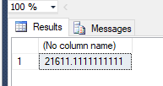
SELECT SUM(SALARY),COUNT(EMPID),AVG(SALARY), MIN(SALARY),MAX(SALARY) FROM EMPLOYEE
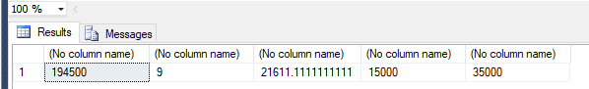
Numeric Functions
Numeric functions within Transact-SQL are mathematical functions for modifying numeric values. The following numeric functions are available:
Function | Explanation
ABS(n) | Returns the absolute value (i.e., negative values are returned as positive) of the numeric expression n. Example:  SELECT ABS(–5.767) = 5.767, SELECT ABS(6.384) = 6.384
ACOS(n) | Calculates arc cosine of n. n and the resulting value belong to the FLOAT data type.
ASIN(n) | Calculates the arc sine of n. n and the resulting value belong to the FLOAT data type.
ATAN(n) | Calculates the arc tangent of n. n and the resulting value belong to the FLOAT data type.
ATN2(n, m) | Calculates the arc tangent of n/m. n, m, and the resulting value belong to the FLOAT data type.
CEILING(n) | Returns the smallest integer value greater or equal to the specified parameter. Examples:  SELECT CEILING(4.88) = 5  SELECT CEILING(–4.88) = –4
COS(n) | Calculates the cosine of n. n and the resulting value belong to the FLOAT data type.
COT(n) | Calculates the cotangent of n. n and the resulting value belong to the FLOAT data type.
DEGREES(n) | Converts radians to degrees. Examples:  SELECT DEGREES(PI()/2) = 90.0  SELECT DEGREES(0.75) = 42.97
EXP(n) | Calculates the value e^n. Example: SELECT EXP(1) = 2.7183
FLOOR(n) | Calculates the largest integer value less than or equal to the specified value n. Example:  SELECT FLOOR(4.88) = 4
LOG(n) | Calculates the natural (i.e., base e) logarithm of n. Examples:  SELECT LOG(4.67) = 1.54  SELECT LOG(0.12) = –2.12
LOG10(n) | Calculates the logarithm (base 10) for n. Examples:  SELECT LOG10(4.67) = 0.67  SELECT LOG10(0.12) = –0.92
PI() | Returns the value of the number pi (3.14).
POWER(x,y) | Calculates the value x^y. Examples: SELECT POWER(3.12,5) = 295.65  SELECT POWER(81,0.5) = 9
RADIANS(n) | Converts degrees to radians. Examples:  SELECT RADIANS(90.0) = 1.57  SELECT RADIANS(42.97) = 0.75
RAND | Returns a random number between 0 and 1 with a FLOAT data type.
ROUND(n, p,[t]) | Rounds the value of the number n by using the precision p. Use positive values of p to round on the right side of the decimal point and use negative values to round on the left side. An optional parameter t causes n to be truncated. Examples:  SELECT ROUND(5.4567,3) = 5.4570  SELECT ROUND(345.4567,–1) = 350.0000  SELECT ROUND(345.4567,–1,1) = 340.0000
ROWCOUNT_BIG | Returns the number of rows that have been affected by the last Transact-SQL statement executed by the system. The return value of this function has the BIGINT data type.
SIGN(n) | Returns the sign of the value n as a number (+1 for positive, –1 for negative, and 0 for zero).  Example:  SELECT SIGN(0.88) = 1
SIN(n) | Calculates the sine of n. n and the resulting value belong to the FLOAT data type.
SQRT(n) | Calculates the square root of n. Example:  SELECT SQRT(9) = 3  SELECT EMPNAME, ROUND(SQRT(SALARY),2) AS SAL FROM EMPLOYEE  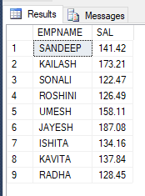
SQUARE(n) | Returns the square of the given expression. Example:  SELECT SQUARE(9) = 81
TAN(n) | Calculates the tangent of n. n and the resulting value belong to the FLOAT data type.

Date Functions
Date functions calculate the respective date or time portion of an expression or return the value from a time interval. Transact-SQL supports the following date functions:
Function | Explanation
GETDATE() | Returns the current system date and time. Example:  SELECT GETDATE() = 2008-01-01 13:03:31.390
DATEPART(item, date) | Returns the specified part item of a date date as an integer. Examples:  SELECT DATEPART(month, '01.01.2005') = 1 (1 = January)  SELECT DATEPART(weekday, '01.01.2005') = 7 (7 = Sunday)
DATENAME(item, date) | Returns the specified part item of the date date as a character string. Example:  SELECT DATENAME(weekday, '01.01.2005') = Saturday
DATEDIFF(item,dat1,dat2) | Calculates the difference between the two date parts dat1 and dat2 and returns the result as an integer in units specified by the value item. Example:  SELECT DATEDIFF (year, BirthDate, GETDATE ()) AS age FROM employee; -> returns the age of each employee.  SELECTDATEDIFF(YEAR,'05/10/1984',GETDATE())  SELECTDATEDIFF(MONTH,'05/10/1984',GETDATE())  SELECTDATEDIFF(DAY,'05/10/1984',GETDATE())  SELECTDATEDIFF(HOUR,'05/10/1984',GETDATE())  SELECTDATEDIFF(MINUTE,'05/10/1984',GETDATE())
DATEADD(i,n,d) | Adds the number n of units specified by the value i to the given date d. Example:  SELECT DATEADD(DAY,3,HireDate) AS age FROM employee; -> adds three days to the starting date of employment of every employee (see the sample database).
DAY() | This function returns an integer representing the day part of the specified date.  select DAY(<date>)
MONTH() | This function returns an integer representing the month part of the specified date. select MONTH(<date>)
YEAR() | This function returns an integer representing the year part of the specified date.  select YEAR(<date>)

String Functions
String functions are used to manipulate data values in a column, usually of a character data type. Transact-SQL supports the following string functions:
Function | Explanation
ASCII(character) | Converts the specified character to the equivalent integer (ASCII) code. Returns an integer. Example:  SELECT ASCII('A') = 65
CHAR(integer) | Converts the ASCII code to the equivalent character. Example:  SELECT CHAR (65) = 'A'.
CHARINDEX(z1,z2) | Returns the starting position where the partial string z1 first occurs in the string z2. Returns 0 if z1 does not occur in z2. Example:  SELECT CHARINDEX ('bl', 'table') = 3.
DIFFERENCE(z1,z2) | Returns an integer, 0 through 4, that is the difference of SOUNDEX values of two strings z1 and z2. (SOUNDEX returns a number that specifies the sound of a string. With this method, strings with similar sounds can be determined.) Example:  SELECT DIFFERENCE('spelling', 'telling') = 2 (sounds a little bit similar, 0 = doesn't sound similar)
LEFT(z, length) | Returns the first length characters from the string z.  Select left(‘Ravi Singh’,4)
LEN(z) | Returns the number of characters, instead of the number of bytes, of the specified string expression, excluding trailing blanks.  Select Len(‘Ravi Singh’,4)
LOWER(z1) | Converts all uppercase letters of the string z1 to lowercase letters. Lowercase letters and numbers, and other characters, do not change. Example:  SELECT LOWER('BIG') = 'big'
LTRIM(z) | Removes leading blanks in the string z. Example:  SELECT LTRIM(' String') = 'String'
NCHAR(i) | Returns the Unicode character with the specified integer code, as defined by the Unicode standard.
QUOTENAME(char_string) | Returns a Unicode string with the delimiters added to make the input string a valid delimited identifier.
PATINDEX(%p%,expr) | Returns the starting position of the first occurrence of a pattern p in a specified expression expr, or zeros if the pattern is not found. Examples:  1) SELECT PATINDEX('%gs%', 'longstring') = 4;  2) SELECT RIGHT(ContactName, LEN(ContactName)-PATINDEX('% %',ContactName)) AS First_name FROM Customers;  (The second query returns all first names from the customers column.)
REPLACE(str1,str2,str3) | Replaces all occurrences of the str2 in the str1 with the str3. Example:  SELECT REPLACE('shave' , 's' , 'be') = behave
REPLICATE(z,i) | Repeats string z i times. Example:  SELECT REPLICATE('a',10) = 'aaaaaaaaaa'
REVERSE(z) | Displays the string z in the reverse order. Example:  SELECT REVERSE('calculate') = 'etaluclac'
RIGHT(z ,length) | Returns the last length characters from the string z. Example:  SELECT RIGHT('Notebook',4) = 'book'
RTRIM(z) | Removes trailing blanks of the string z. Example:  SELECT RTRIM('Notebook ') = 'Notebook'
SOUNDEX(a) | Returns a four-character SOUNDEX code to determine the similarity between two strings.  Example:  SELECT SOUNDEX('spelling') = S145
SPACE(length) | Returns a string with spaces of length specified by length. Example:  SELECT SPACE = ' '
STR(f,[len [,d]]) | Converts the specified float expression f into a string. Len is the length of the string including decimal point, sign, digits, and spaces (10 by default), and d is the number of digits to the right of the decimal point to be returned. Example:  SELECT STR(3.45678,4,2) = '3.46'
STUFF(z1,a,length,z2) | Replaces the partial string z1 with the partial string z2 starting at position a, replacing length characters of z1. Examples:  SELECT STUFF('Notebook',5,0, ' in a ') = 'Note in a book'  SELECT STUFF('Notebook',1,4, 'Hand') = 'Handbook'
SUBSTRING(z,a,length) | Creates a partial string from string z starting at the position with a length of length.  Example:  SELECT SUBSTRING('wardrobe',1,4) = 'ward'
UNICODE | Returns the integer value, as defined by the Unicode standard, for the first character of the input expression.
UPPER(z) | Converts all lowercase letters of string z to uppercase letters. Uppercase letters and numbers do not change. Example:  SELECT UPPER('loWer') = 'LOWER'

CONVERT ()
Explicitly converts an expression of one data type to another.
CAST and CONVERT provide similar functionality.
SYNTAX:
CONVERT ( data_type [ ( length ) ] , expression [ , style ] )
Here 'expression' can be any valid expression, 'data_type' is the target data type and 'length' is an optional integer that specifies the length of the target data type. The default value is 30. Style is an integer expression that specifies how the CONVERT function is to translate expression. If style is NULL then NULL is returned. The range is determined by data_type.
Example: Converting DATETIME to VARCHAR
SELECTCONVERT (VARCHAR, GETDATE (), 0)
Output-- May 4 2013 2:14PM

Example: Converting VARCHAR to DATETIME
The style code is equally important when converting a VARCHAR to a DATETIME value. I'm using the output from the previous SQL code and different style codes, let’s see how it works.
SELECT CONVERT (DATETIME, ‘May 4 2013 2:14PM’, 0)
Output-- 2013-05-04 14:14:00.000

SELECT CONVERT (DATETIME, ‘May 4 2013 2:14PM’, 130)
Output -- Conversion failed when converting date and/or time from character string.
Date Format | Standard | SQL Statement | Sample Output
Mon DD YYYY ¹  HH:MIAM (or PM) | Default | SELECT CONVERT(VARCHAR(20), GETDATE(), 100) | Jan 1 2005 1:29PM ¹
MM/DD/YY | USA | SELECT CONVERT(VARCHAR(8), GETDATE(), 1) AS [MM/DD/YY] | 11/23/98
MM/DD/YYYY | USA | SELECT CONVERT(VARCHAR(10), GETDATE(), 101) AS [MM/DD/YYYY] | 11/23/1998
YY.MM.DD | ANSI | SELECT CONVERT(VARCHAR(8), GETDATE(), 2) AS [YY.MM.DD] | 72.01.01
YYYY.MM.DD | ANSI | SELECT CONVERT(VARCHAR(10), GETDATE(), 102) AS [YYYY.MM.DD] | 1972.01.01
DD/MM/YY | British/French | SELECT CONVERT(VARCHAR(8), GETDATE(), 3) AS [DD/MM/YY] | 19/02/72
DD/MM/YYYY | British/French | SELECT CONVERT(VARCHAR(10), GETDATE(), 103) AS [DD/MM/YYYY] | 19/02/1972
DD.MM.YY | German | SELECT CONVERT(VARCHAR(8), GETDATE(), 4) AS [DD.MM.YY] | 25.12.05
DD.MM.YYYY | German | SELECT CONVERT(VARCHAR(10), GETDATE(), 104) AS [DD.MM.YYYY] | 25.12.2005
DD-MM-YY | Italian | SELECT CONVERT(VARCHAR(8), GETDATE(), 5) AS [DD-MM-YY] | 24-01-98
DD-MM-YYYY | Italian | SELECT CONVERT(VARCHAR(10), GETDATE(), 105) AS [DD-MM-YYYY] | 24-01-1998
DD Mon YY ¹ | - | SELECT CONVERT(VARCHAR(9), GETDATE(), 6) AS [DD MON YY] | 04 Jul 06 ¹
DD Mon YYYY ¹ | - | SELECT CONVERT(VARCHAR(11), GETDATE(), 106) AS [DD MON YYYY] | 04 Jul 2006 ¹
Mon DD, YY ¹ | - | SELECT CONVERT(VARCHAR(10), GETDATE(), 7) AS [Mon DD, YY] | Jan 24, 98 ¹
Mon DD, YYYY ¹ | - | SELECT CONVERT(VARCHAR(12), GETDATE(), 107) AS [Mon DD, YYYY] | Jan 24, 1998 ¹
HH:MM:SS | - | SELECT CONVERT(VARCHAR(8), GETDATE(), 108) | 03:24:53
Mon DD YYYY HH:MI:SS:MMMAM (or PM) ¹ | Default +  milliseconds | SELECT CONVERT(VARCHAR(26), GETDATE(), 109) | Apr 28 2006 12:32:29:253PM ¹
MM-DD-YY | USA | SELECT CONVERT(VARCHAR(8), GETDATE(), 10) AS [MM-DD-YY] | 01-01-06
MM-DD-YYYY | USA | SELECT CONVERT(VARCHAR(10), GETDATE(), 110) AS [MM-DD-YYYY] | 01-01-2006
YY/MM/DD | - | SELECT CONVERT(VARCHAR(8), GETDATE(), 11) AS [YY/MM/DD] | 98/11/23
YYYY/MM/DD | - | SELECT CONVERT(VARCHAR(10), GETDATE(), 111) AS [YYYY/MM/DD] | 1998/11/23
YYMMDD | ISO | SELECT CONVERT(VARCHAR(6), GETDATE(), 12) AS [YYMMDD] | 980124
YYYYMMDD | ISO | SELECT CONVERT(VARCHAR(8), GETDATE(), 112) AS [YYYYMMDD] | 19980124
DD Mon YYYY HH:MM:SS:MMM(24h) ¹ | Europe default + milliseconds | SELECT CONVERT(VARCHAR(24), GETDATE(), 113) | 28 Apr 2006 00:34:55:190 ¹
HH:MI:SS:MMM(24H) | - | SELECT CONVERT(VARCHAR(12), GETDATE(), 114) AS [HH:MI:SS:MMM(24H)] | 11:34:23:013
YYYY-MM-DD HH:MI:SS(24h) | ODBC Canonical | SELECT CONVERT(VARCHAR(19), GETDATE(), 120) | 1972-01-01 13:42:24
YYYY-MM-DD HH:MI:SS.MMM(24h) | ODBC Canonical  (with milliseconds) | SELECT CONVERT(VARCHAR(23), GETDATE(), 121) | 1972-02-19 06:35:24.489
YYYY-MM-DDTHH:MM:SS:MMM | ISO8601 | SELECT CONVERT(VARCHAR(23), GETDATE(), 126) | 1998-11-23T11:25:43:250
DD Mon YYYY HH:MI:SS:MMMAM ¹ | Kuwaiti | SELECT CONVERT(VARCHAR(26), GETDATE(), 130) | 28 Apr 2006 12:39:32:429AM ¹
DD/MM/YYYY HH:MI:SS:MMMAM | Kuwaiti | SELECT CONVERT(VARCHAR(25), GETDATE(), 131) | 28/04/2006 12:39:32:429AM

SELECT EMPID, CONVERT(VARCHAR(20),DATEOFBIRTH,100) AS DOB FROM EMPLOYEE

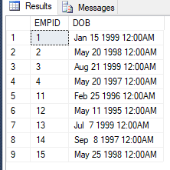
Here are some more date formats that does not come standard in SQL Server as part of the CONVERT function.
Date Format | SQL Statement | Sample Output
YY-MM-DD | SELECT SUBSTRING(CONVERT(VARCHAR(10), GETDATE(), 120), 3, 8) AS [YY-MM-DD]  SELECT REPLACE(CONVERT(VARCHAR(8), GETDATE(), 11), '/', '-') AS [YY-MM-DD] | 99-01-24
Mon-YY ¹ | SELECT REPLACE(RIGHT(CONVERT(VARCHAR(9), GETDATE(), 6), 6), ' ', '-') AS [Mon-YY] | Sep-02 ¹

LESsON 2: CLAUSES DEFINATION WITH EXAMPLES
This List below shows important clauses of SQL SERVER with syntax and examples.
(Note: Will use the EMPLOYEE TABLE created in previous chapters for the examples of clauses)
CLAUSES | Description
SELECT | Is used to view the columns values of the table.  Syntax : Select * from table_name  Select * from EMPLOYEE
WHERE | Is used to apply filter to the select clause  Note : The WHERE clause is evaluated before the SELECT clause  SYNTAX : SELECT * FROM TABLE_NAME WHERE CONDITION  EXAMPLE : SELECT * FROM EMPLOYEE WHERE SALARY > 20000
ORDER BY | To sort the table based upon a column value in ascending or descending order.  SYNTAX : SELECT * FROM TABLE_NAME ORDER BY COLUMN_NAME (ASC/DESC) (DEFAULT ASC)  EXAMPLE : SELECT * FROM EMPLOYEE ORDER BY SALARY DESC
AS | Used to add an alias name(new name) to the column in the query  SYNTAX : SELECT COLUMNNAME AS NEW-COLUMNNAME FROM TABLENAME  EXAMPLE : SELECT EMPID, FIRSTNAME + ' ' + LASTNAME AS FULLNAME FROM EMPLOYEES;  SELECT EMPID,EMPNAME AS EMPLOYEENAME,SALARY,CITY FROM EMPLOYEE
IN | To search multiple values in where condition.  SYNTAX : SELECT * FROM TABLE_NAME WHERE COL IN(VALUE,VALUE2)  EXAMPLE : SELECT * FROM EMPLOYEE WHERE DEPARTMENT IN('IT','HR')
DISTINCT | Used to select distinct values of the rows / column from the table.  SYNTAX : SELECT DISTINCT * from table_name / SELECT DISTINCT colname from table_name  EXAMPLE : SELECT DISTINCT DEPARTMENT FROM EMPLOYEE
TOP | Is used to find top number of records from the query  SYNTAX : SELECT TOP [N] * FROM TABLENAME  EXAMPLE : SELECT TOP 3 * FROM EMPLOYEE ORDER BY SALARY DESC
OFFSET & FETCH | OFFSET and FETCH clause is used to skip certain number of rows from the query and fetch certain number of rows resultset generated by the query.  The OFFSET and FETCH clauses appear right after the ORDER BY clause.You first specify the OFFSET clause indicating how many rows you want to skip (0 if you don’t want to skip any); you then optionally specify the FETCH clause indicating how many rows you want to filter.  SYNTAX : SELECT * FROM TABLENAME ORDER BY COLNAME OFFSET N ROWS FETCH NEXT N ROWS ONLY;  EXAMPLE : GET THE 3rd & 4th Highest Salary Holder  SELECT * FROM EMPLOYEE ORDER BY SALARY DESC OFFSET 2 ROWS FETCH NEXT 2 ROWS ONLY;
LIKE | Is used to search string patterns in the query.  Wildcard Meaning Example  % (percent sign) Any string including an empty one.  'D%': string starting with D  _ (underscore) A single character  '_D%': string where second character is D  [<character list>] A single character from a list  '[AC]%': string where first character is A or C  [<character range>] A single character from a range  '[0-9]%': string where first character is a digit  [^<character list or range>] A single character that is not in the list or range  '[^0-9]%': string where first character is not a digit  SYNTAX : SELECT * FROM TABLE_NAME WHERE COLNAME LIKE ‘STRINGPATTERN’  EXAMPLE : Show all name starting K  SELECT * FROM EMPLOYEE WHERE EMPNAME LIKE 'K%'  Show all name starting K or S  SELECT * FROM EMPLOYEE WHERE EMPNAME LIKE '[KS]%'  Show all names not ending with A.  SELECT * FROM EMPLOYEE WHERE EMPNAME LIKE '%[^A]'  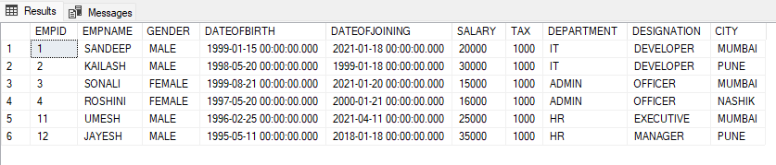
GROUP BY | Used to group the summation based up a column.  SYNTAX : SELECT COLNAME, AGGREGRATE_FUNCTION FROM TABLE_NAME GROUP BY COLNAME  EXAMPLE : TOTAL EMPLOYEE COUNT GROUPED BY GENDER  SELECT GENDER,COUNT (EMPID) AS EMPLOYEECOUNT FROM EMPLOYEE  GROUP BY GENDER  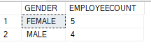  SELECT GENDER,SUM(SALARY) AS TOTALSALARY FROM EMPLOYEE GROUP BY GENDER  SELECT DEPARTMENT,SUM(SALARY) AS TOTALSALARY FROM EMPLOYEE GROUP BY DEPARTMENT
HAVING | USED TO APPLY FILTER AFTER GROUP BY.MOSTING SOME CONDITIONS ARE NOT POSSIBLE IN WHERE CLAUSES LIKE FOR EG(AGGREGRATE FUNCTIONS) , FOR THIS WE HAVE TO USE HAVING CLAUSE.  SYNTAX : SELECT COLNAME, AGGREGRATE_FUNCTION FROM TABLE_NAME GROUP BY COLNAME HAVING CONDITION  NOTE : WE CAN GIVE AGGREGRATE_FUNCTION CONDITION IN HAVING CLAUSE  EXAMPLE : SELECT DEPARTMENT,SUM(SALARY) AS TOTALSALARY FROM EMPLOYEE GROUP BY DEPARTMENT HAVING SUM(SALARY) > 40000
ROLLUP CLAUSE | ROLLUP generates a result set that shows aggregates for a hierarchy of values in the selected columns.It is used with Group by clause.  SYNTAX : SELECT COLNAME, AGGREGRATE_FUNCTION FROM TABLE_NAME GROUP BY COLNAME  WITH ROLLUP  EXAMPLE : SELECT DEPARTMENT,DESIGNATION,SUM(SALARY) AS TOTALSALARY FROM EMPLOYEE  GROUP BY DEPARTMENT,DESIGNATION WITH ROLLUP  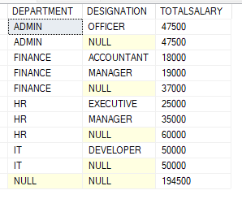
CUBE CLAUSE | CUBE generates a result set that shows aggregates for all combinations of values in the selected columns.It is used with GROUP BY.  SYNTAX : SELECT COLNAME, AGGREGRATE_FUNCTION FROM TABLE_NAME GROUP BY COLNAME  WITH CUBE  SELECT DEPARTMENT,DESIGNATION,SUM(SALARY) AS TOTALSALARY FROM EMPLOYEE  GROUP BY DEPARTMENT,DESIGNATION WITH CUBE  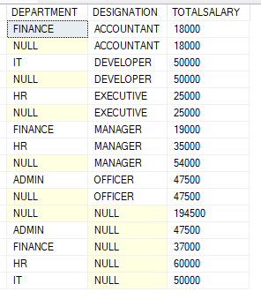
OVER CLAUSE | To add aggregate functions on the query  OVER allows you to get aggregate information without using a GROUP BY. In other words, you can retrieve detail rows, and get aggregate data alongside it.  SYNTAX : SELECT COLNAME,AGG-FUNCTIONS OVER () AS NEWCOLUMNNAME FROM TABLENAME  EXAMPLE SELECT EMPNAME,CITY,SUM(SALARY) OVER () AS TotalSal FROM EMPLOYEE  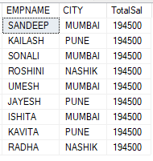  OVER (PARTITION BY) ; OVER, as used in our previous example, exposes the entire resultset to the aggregation…”Salary” was the sum of all [Sal] in the result set. We can break up that result set into partitions with the use of PARTITION BY:  SELECT EMPNAME,CITY,DEPARTMENT,SUM(SALARY) OVER (PARTITION BY DEPARTMENT) AS TotalSal FROM EMPLOYEE  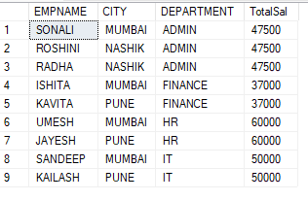
ROW_NUMBER () | TO SPECIFY THE ROW NUMBER OF THE TABLE IN A INCREMENT FASHION FOR EACH ROW  SYNTAX : SELECT COLUMNAME, ROW_NUMBER() over(order by COLNAME desc) AS  'RowID' FROM TABLENAME  EXAMPLE : SELECT EMPID,EMPNAME,SALARY,ROW_NUMBER() over(order by Salary desc) AS 'RowID' FROM EMPLOYEE  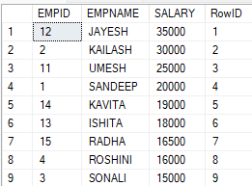
PARTITION BY | PARTITION BY – If you supply this parameter, then the row number will reset based on the value changing in the columns supplied. This is kind of like using a GROUP BY.  ORDER BY – This is the specified order of the row number that you would like. If you wanted the order of the row number to increment by an employee name (alphabetically), you do that here.  SELECT COLNAME1 ,ROW_NUMBER() over(partition by COLUMNNAME order by COLUMNNAME) FROM TABLENAME  SELECT EMPID,EMPNAME,SALARY,ROW_NUMBER() over(partition by DEPARTMENT order by Salary desc) AS 'RowID' FROM EMPLOYEE  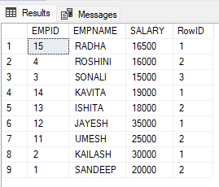
Rank | This function will assign a unique number to each distinct row, but it leaves a gap between the groups.  Syntax :  SELECT Col_Value, Rank() OVER (ORDER BY Col_Value) AS 'RowID' FROM @Table;  SELECT EMPID,EMPNAME,SALARY,RANK() over(order by Salary desc) AS  'RankNo' FROM EMPLOYEE  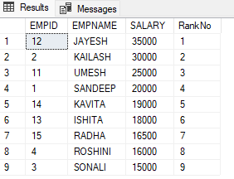
DENSE_RANK () | This function is similar to Rank with only difference, this will not leave gaps between groups.  SELECT Col_Value, DENSE_RANK() OVER (ORDER BY Col_Value) AS 'RowID' FROM @Table;  SELECT EMPID,EMPNAME,SALARY,DENSE_RANK() over(order by Salary desc) AS  'RankNo' FROM EMPLOYEE  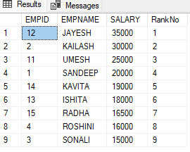

SEQUENCE OBJECTS IN SQL SERVER
Sequence objects are used to sequentially generate numeric values. They were introduced in SQL Server 2012. Sequence objects are similar to the IDENTITY column in any SQL table. However, unlike the IDENTITY column, they are independent and are not attached to any table. Sequence objects are used both independently and within the DML statements i.e. INSERT, UPDATE and DELETE.
SYNTAX
CREATE SEQUENCE [schema].[Name_of_Sequence] [ AS <data type> ]
[ START WITH <value> ] [ INCREMENT BY <value> ] [ MINVALUE <value > | NO MINVALUE ] [ MAXVALUE <value> | NO MAXVALUE ] [ CYCLE | NO CYCLE ] [ CACHE value | NO CACHE ];
CREATE SEQUENCE [dbo].[NewCounter] AS INT START WITH 5 INCREMENT BY 5
SELECT NEXT VALUE FOR [dbo].[NewCounter]
PARAMETER | DESCRIPTION
CREATE SEQUENCE | Used to create a sequence followed by a database schema and the name of the sequence
AS | Specifies the data type of the sequence. Data types can be Decimal, Int, SmallInt, TinyInt, and BigInt. The default value for the data type is BigInt
START WITH | Sets the starting value for the sequence object
INCREMENT BY | Sets the amount that you want your sequence object to increment by
MIN VALUE | This is an optional parameter that specifies the minimum value for the sequence object
MAX VALUE | This is an optional parameter that sets the maximum value for the sequence object
CYCLE | This specifies if the sequence object should be restarted once it has reached its maximum or minimum value.  It is an optional parameter for which the default value is NO CYCLE
CACHE | This is used to cache sequence object values.  It is also optional parameter with the default value of NO CACHE

SYNTAX & EXAMPLE
Using a sequence object in a single table example
CREATE A TABLE | CREATE A SEQUENCE : order_number that starts with 1 and is incremented by 1:
CREATE TABLE purchase_orders( order_id INT PRIMARY KEY, vendor_id int NOT NULL,  order_date date NOT NULL ); | CREATE SEQUENCE order_number AS INT START WITH 1 INCREMENT BY 1
After that, insert three rows into the procurement.purchase_orders table and uses values generated by the order_number sequence:
INSERT INTO purchase_orders (order_id, vendor_id, order_date) VALUES
(NEXT VALUE FOR order_number,1,'2019-04-30');

INSERT INTO purchase_orders (order_id, vendor_id, order_date)
VALUES (NEXT VALUE FOR order_number,2,'2019-05-01');

INSERT INTO purchase_orders (order_id, vendor_id, order_date) VALUES (NEXT VALUE FOR order_number,3,'2019-05-02');
Finally, view the content of the purchase_orders table:
SELECT order_id, vendor_id, order_date FROM purchase_orders;
A sequence object once created can also be used with multiple tables.
Sequence vs. Identity columns : Sequences, different from the identity columns, are not associated with a table. The relationship between the sequence and the table is controlled by applications. In addition, a sequence can be shared across multiple tables.
The following table illustrates the main differences between sequences and identity columns:
Property/Feature | Identity | Sequence Object
Allow specifying minimum and/or maximum increment values | No | Yes
Allow resetting the increment value | No | Yes
Allow caching increment value generating | No | Yes
Allow specifying starting increment value | Yes | Yes
Allow specifying increment value | Yes | Yes
Allow using in multiple tables | No | Yes

When to use sequences (Use sequence in following cases):
- The application requires a number before inserting values into the table.
- The application requires sharing a sequence of numbers across multiple tables or multiple columns within the same table.
- The application requires to restart the number when a specified value is reached.
- The application requires multiple numbers to be assigned at the same time. Note that you can call the stored procedure sp_sequence_get_range to retrieve several numbers in a sequence at once.
- The application needs to change the specification of the sequence like maximum value.
Getting sequences information
You use the view sys.sequences to get the detailed information of sequences.
SELECT * FROM sys.sequences;

CHAPTER 4: SUMMARY / CHEAT SHEET
Different Types of clauses :
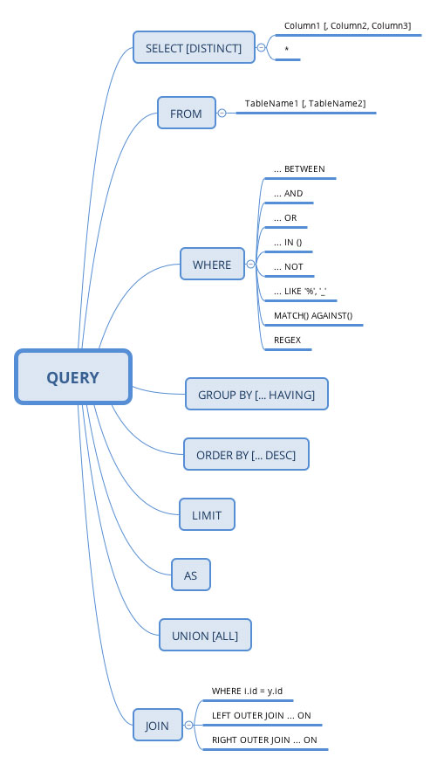

The order of clause is as follows:

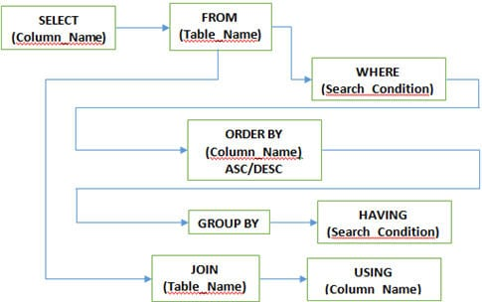

CHAPTER 4: EXERCISE 1(ASSIGNMENTS)
CREATE An EMPLOYEE TABLE BY EXECUTING THE BELOW SQL CREATE TABLE COMMAND AND INSERT DATA USING THE INSERT QUERIES.WRITE ANSWERS(USING SELECT QUERIES) FOR THE BELOW QUESTIONS USING THE ABOVE TABLE
CREATE TABLE [dbo].[EMPLOYEES](
[EMPID] [int] IDENTITY(1,1) NOT NULL,
[EMPNAME] [varchar](100) NULL,
[SALARY] [float] NULL,
[TAX] [float] NULL,
[DOJ] [datetime] NULL,
[DEPT] [varchar](100) NULL,
[DESG] [varchar](100) NULL,
[DEPTMANAGERNAME] [varchar](100) NULL,
[DEPTLOCATION] [varchar](100) NULL, CONSTRAINT [pk_empid] PRIMARY KEY CLUSTERED
( [EMPID] ASC ))
GO
SET IDENTITY_INSERT [dbo].[EMPLOYEES] ON
GO
INSERT [dbo].[EMPLOYEES] VALUES (1, N'AKASH', 70000, 2000, CAST(N'2017-05-20' AS DateTime), N'IT', N'SOFTWARE DEVELOPER', N'SURESH', N'PUNE')
INSERT [dbo].[EMPLOYEES] VALUES (2, N'AKSHAY', 69000, 1900, CAST(N'2017-07-14' AS DateTime), N'IT', N'ARCHITECT', N'SURESH', N'PUNE')
INSERT [dbo].[EMPLOYEES] VALUES (3, N'ASHWIN', 77000, 2100, CAST(N'2017-09-14' AS DateTime), N'IT', N'ARCHITECT', N'SURESH', N'PUNE')
INSERT [dbo].[EMPLOYEES] VALUES (4, N'CHINMAY', 88000, 2900, CAST(N'2017-09-10' AS DateTime), N'HR', N'MANAGER', N'ANITA', N'MUMBAI')
INSERT [dbo].[EMPLOYEES] VALUES (5, N'DEBAYAN', 65000, 2100, CAST(N'2017-10-18' AS DateTime), N'HR', N'EXECUTIVE', N'ANITA', N'MUMBAI')
INSERT [dbo].[EMPLOYEES] VALUES (6, N'MANGESH', 99000, 2900, CAST(N'2017-10-10T00:00:00.000' AS DateTime), N'HR', N'MANAGER', N'ANITA', N'MUMBAI')
INSERT [dbo].[EMPLOYEES] VALUES (7, N'NIKHIL', 56000, 2100, CAST(N'2017-07-18T00:00:00.000' AS DateTime), N'HR', N'EXECUTIVE', N'ANITA', N'MUMBAI')
INSERT [dbo].[EMPLOYEES] VALUES (10, N'SANDEEP', 45000, 460, CAST(N'2017-07-25T00:00:00.000' AS DateTime), N'IT', N'SOFTWARE DEVELOPER', N'SURESH', N'PUNE')
INSERT [dbo].[EMPLOYEES] VALUES (11, N'NIRAJ', 48000, 460, CAST(N'2017-07-25T00:00:00.000' AS DateTime), N'ADMIN', N'MANAGER', N'DELHI', NULL)
INSERT [dbo].[EMPLOYEES] VALUES (12, N'VIVEL', 89000, 2000, CAST(N'2017-01-20T00:00:00.000' AS DateTime), N'SECURITY', N'MANAGER', N'KOLKATTA', NULL)
INSERT [dbo].[EMPLOYEES] VALUES (13, N'DILLIP', 47000, 400, CAST(N'2017-09-25T00:00:00.000' AS DateTime), N'IT', N'TRAINER', N'SURESH', N'PUNE')
SET IDENTITY_INSERT [dbo].[EMPLOYEES] OFF
GO

THE ABOVE SCRIPTS WILL CREATE A TABLE LIKE THIS
EMPID | EMPNAME | SALARY | TAX | DOJ | DEPT | DESG | DEPT  MANAGERNAME | DEPTLOCATION
1 | AKASH | 70000 | 2000 | 20-05-2017 | IT | SOFTWARE  DEVELOPER | SURESH | PUNE
2 | AKSHAY | 69000 | 1900 | 14-07-2018 | IT | ARCHITECT | SURESH | PUNE
3 | ASHWIN | 77000 | 2100 | 14-09-2017 | IT | ARCHITECT | SURESH | PUNE
4 | CHINMAY | 88000 | 2900 | 10-09-2017 | HR | MANAGER | ANITA | MUMBAI
5 | DEBAYAN | 65000 | 2100 | 18-10-2017 | HR | EXECUTIVE | ANITA | MUMBAI
6 | MANGESH | 99000 | 2900 | 10-10-2017 | HR | MANAGER | ANITA | MUMBAI
7 | NIKHIL | 56000 | 2100 | 18-07-2018 | HR | EXECUTIVE | ANITA | MUMBAI
10 | SANDEEP | 45000 | 460 | 25-07-2017 | IT | SOFTWARE  DEVELOPER | SURESH | PUNE
11 | NIRAJ | 48000 | 460 | 25-07-2017 | ADMIN | MANAGER | DELHI | NULL
12 | VIVEL | 89000 | 2000 | 20-01-2019 | SECURITY | MANAGER | KOLKATTA | NULL
13 | DILLIP | 47000 | 400 | 25-09-2017 | IT | TRAINER | SURESH | PUNE

WRITE ANSWERS (USING SELECT QUERIES) FOR THE BELOW QUESTIONS USING THE ABOVE TABLE
1 | WRITE A QUERY TO FIND THE details of employee having the 3rd Higher Salary from the table
2 | WRITE A QUERY TO FIND THE employee having the second lowest salary from the table.
3 | WRITE A QUERY TO FIND THE details of employees having the 5th & 6th Higher Salary from the table.
4 | Write a query to find the details of employee having the highest salary in each department
5 | Write a query to find the details of employee having the 3rd highest salary in each department
6 | Write a query to find the details of employee having the lowest salary in each department
7 | Write a query to find the details of employee having 2nd highest salary holder in each department.
8 | Write a query to find the number of employees in each department and designation
9 | Write a query find the percentage of salary for each employee. (Calculate the total salary and calculate each one percentage)
10 | Write a query to calculate the experience of each employee in terms of years and months.

CHAPTER 4: questions
What is the difference between RANK() and DENSE_RANK() ?
What is the use of Having Clause ?
What is default sorting order of Order By Clause (ASC or DESC)?
Can we order a table based upon multiple columns?
What is the use of OFFSET clause?

CHAPTER 5: RELATIONAL DATABASE
Lessons in this chapter
- Lesson 1: Relational Database
- Lesson 2: Types of Relationship
- Lesson 3: Normalization
- Lesson 4: Types of Joins

LESSON 1: RELATIONAL DATABASE
WHAT IS RELATIONAL DATABASE
If we store data in single table, then it create duplicate data which take extra space which increases the size of the database.
For Example, if we store country and state data together then there will be duplicate data as shown below : COUNTRYDETAILS TABLE
COUNTRYID | COUNTRY_NAME | CAPITAL | CONTINENT | STATEID | STATE_NAME | STATE_CAPITAL
1 | INDIA | DELHI | ASIA | 1 | MH | MUMBAI
1 | INDIA | DELHI | ASIA | 2 | UP | LUCKNOW
1 | INDIA | DELHI | ASIA | 1 | GUJURAT | AHMEDABAD
So it better to divide in multiple tables to increase efficiency.
Advantages of Relational Database
- Saving of Data
- Consistency of Data
WE CAN BREAK THE STRUCTURE INTO COUNTRY & STATE TABLE AS SHOWN BELOW
Parent table: COUNTRY (NEED TO DEFINE THE PRIMARY KEY)

COUNTRYID | COUNTRY_NAME | COUNTRY_CAP | CONTINENT
1(PRIMARY KEY | INDIA | DELHI | ASIA

The Primary of the Parent table will become the Foreign Key of the child table to create a relationship.
Child table: STATE
STATEID | STATE_NAME | STATE_CAPITAL | COUNTRY_ID(FOREIGNKEY)
1 | MH | MUMBAI | 1
2 | UP | LUCKNOW | 1
3 | GUJURAT | AHMEDABAD | 1

FOREIGN KEY CONSTRAINTS:
SQL server is a relational database management system. Foreign Key is used to create relationship between two tables. We can have relation between two tables. That relation is done by putting a common column between two tables.
A parent child relationship is created between two tables By having the primary key column in the parent table and the same column as Foreign key column in child table.
Rules of Foreign Key
- Only those values which are there in parent table can be inserted in child table.
- The parent record cannot be deleted until and unless all its children have been deleted.
SYNTAX:
Column_name datatype constraint constraint_name FOREIGN KEY references PRIMARY TABLE (column_name).
EXAMPLES: Primary Key & Foreign Key
CREATE THE FOLLOWING TABLE FOR DOING PRACTICALS (VERY IMP)
CREATE TABLE COUNTRY  (  COUNTRY_ID INT CONSTRAINT  pk_country PRIMARY KEY,  COUNTRY_NAME NVARCHAR (100),  COUNTRY_CAPITAL NVARCHAR (100)  )  Note : We have created a country table with COUNTRY_ID AS PRIMARY KEY  INSERT INTO COUNTRY VALUES (1,'INDIA','DELHI'),  ('2','CHINA','BEIJING'),  (3,'U.S.A','WASHINGTON') | CREATE TABLE STATES  (  STATE_ID INT CONSTRAINT pk_state PRIMARY KEY,  STATE_NAME NVARCHAR (100),  STATE_CAPITAL NVARCHAR (100),  COUNTRY_ID INT CONSTRAINT FK_STATE FOREIGN KEY REFERENCES COUNTRY (COUNTRY_ID)  )  Note : We have created a STATES table with COUNTRY_ID AS FOREIGN KEY  INSERT INTO STATES VALUES (1,'MH','MUMBAI',1),(2,'MP','BHOPAL',1),  (3,'UP','LUCKNOW',1),  (4,'KARNATAKA','BANGALORE',1),(5,'ALASKA','JUNEAU',3),(6,'NEW YORK','ALBANY',3),(7,'BERLIN','BERLIN',NULL)
Create table CITY
(
CITY_ID INT PRIMARY KEY,
CITY_NAME NVARCHAR(100),
STATE_ID INT CONSTRAINT FK_CITY FOREIGN KEY REFERENCES STATES(STATE_ID)
)
Note : We have created a CITY table with STATE_ID AS FOREIGN KEY
INSERT INTO CITY VALUES(1,'PUNE',1)
INSERT INTO CITY VALUES(2,'NAGPUR',1)
ANOTHER EXAMPLE OF FOREIGN KEY:
CREATE TABLE SCHOOL  (  SCHOOLID INT CONSTRAINT  PK_SCHOOLID PRIMARY KEY,  SCHOOLNAME NVARCHAR(100),  LOCATION NVARCHAR(100),  WEBSITE NVARCHAR(100)  )  Insert into SCHOOL values(1,'JOSEPH SCHOOL','PUNE','www.joseph.com')  DELETE FROM SCHOOL WHERE SCHOOLID=1 | CREATE TABLE CLASS  (  CLASSID INT CONSTRAINT PK_CLASSID PRIMARY KEY,  CLASSNAME NVARCHAR(100),  SCHOOLID INT CONSTRAINT FK_SCHOOLID FOREIGN KEY REFERENCES SCHOOL(SCHOOLID)  )  Insert into CLASS values(1,'CLASS-I',NULL)  Insert into CLASS values(2,'CLASS-II',1)

ON DELETE CASCADE
ON DELETE CASCADE clause which tells SQL Server to delete the corresponding records in the child table when the data in the parent table is deleted. A foreign key with cascade delete means that if a record in the parent table is deleted, then the corresponding records in the child table will automatically be deleted. This is called a cascade delete in SQL Server.A foreign key with cascade delete can be created using either a CREATE TABLE statement or an ALTER TABLE statement.
Syntax : Create Foreign key with cascade delete - Using CREATE TABLE statement
CREATE TABLE child_table
(
column1 datatype [ NULL | NOT NULL ],
column2 datatype [ NULL | NOT NULL ],
...
CONSTRAINT fk_name FOREIGN KEY (child_col1, child_col2, ... child_col_n)
REFERENCES parent_table (parent_col1, parent_col2, ... parent_col_n)
ON DELETE CASCADE
[ ON UPDATE { NO ACTION | CASCADE | SET NULL | SET DEFAULT } ]
);
EXAMPLES OF ON DELETE CASCADE
CREATE TABLE Countries (  CountryID INT PRIMARY KEY,  CountryName VARCHAR(50),  CountryCode VARCHAR(3)  ) | CREATE TABLE StatesDetails  (  StateID INT PRIMARY KEY,  StateName VARCHAR(50),  StateCode VARCHAR(3),  CountryID INT  )
ALTER TABLE StatesDetails ADD CONSTRAINT [FK_States_Countries] FOREIGN KEY([CountryID]) REFERENCES Countries ([CountryID]) ON DELETE CASCADE

Insert some sample data using below T-SQL script.

INSERT INTO Countries VALUES (1,'United States','USA')
INSERT INTO Countries VALUES (2,'United Kingdom','UK')

INSERT INTO StatesDetails VALUES (1,'Texas','TX',1)
INSERT INTO StatesDetails VALUES (2,'Arizona','AZ',1)
Now I deleted a row in the parent table with CountryID =1 which also deletes the rows in the child table which has CountryID =1.
DELETE FROM COUNTRIES WHERE COUNTRYID = 1
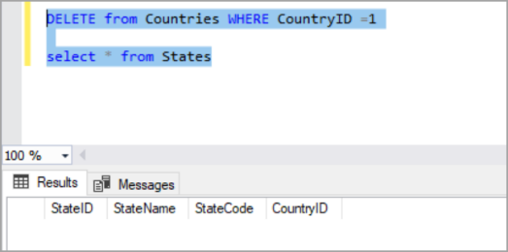
When we create a foreign key using this option, it deletes the referencing rows
in the child table when the referenced row is deleted in the parent table which has a primary key.

FOREIGN KEY WITH CASCADE UPDATE IN SQL SERVER

When we create a foreign key using UPDATE CASCADE the referencing rows are updated
in the child table when the referenced row is updated in the parent table which has a primary key.
Following is the T-SQL script which creates a foreign key with cascade as UPDATE and DELETE rules.
ALTER TABLE StatesDetails ADD CONSTRAINT FK_States_Countries FOREIGN KEY(CountryID) REFERENCES Countries (CountryID) ON UPDATE CASCADE ON DELETE CASCADE
ALTER TABLE [dbo].[States] CHECK CONSTRAINT [FK_States_Countries]

EXAMPLES OF ON UPDATE CASCADE
Now update CountryID in the Countries for a row which also updates the referencing rows in the child table States.
UPDATE Countries SET CountryID =3 where CountryID=1
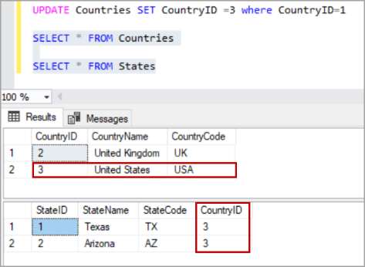
Relationship Terminology: The term relation is sometimes used to refer to a table in a relational database. However, it is more often used to describe the relationships that exist between the tables in a relational database.
A relationship between two database tables presupposes that one of them has a foreign key that references the primary key of another table.
Database entity—strictly speaking — is a person, place, thing, object, or any item about which data is stored in the database. However, the term is usually used to refer to the database table as tables are, in fact, the physical implementation of entities.
An entity-relationship diagram, also known as ERD, ER diagram, or ER model, comprises a graphical representation of how entities relate to each other within a database.
ER models are widely used in database design as they are fairly abstract and are easy to view and analyze.
How Data Integrity is implemented by database constraints.
IMP NOTES
Data integrity type | Enforced by database constraint
Row integrity | - Primary key constraint  - Unique constraint
Column integrity | - Foreign key constraint  - Check constraint  - Default constraint  - Data type constraint
Referential Integrity | - Foreign key constraint
User-defined integrity | - Check constraint

LESSON 2: TYPES OF RELATIONSHIP
There are 3 main types of relationship in a database:
- ONE-TO-ONE
- ONE-TO-MANY
- MANY-TO-MANY.
However, you may also encounter references to a many-to-one relationship which, in fact, is a special case of a one-to-many relationship and self-referencing relationship which occurs when only one table is involved.
One-to-many relationship
Let’s start with a one-to-many relationship as it is the most commonly used type. So, what is one-to-many relationship in SQL? A one-to-many relationship occurs when one record in table 1 is related to one or more records in table 2. However, one record in table 2 cannot be related to more than one record in table 1
Let’s query two SQL tables having one-to-many relationship.
SELECT * FROM country c INNER JOIN city c1 ON c.country_id = c1.country_id
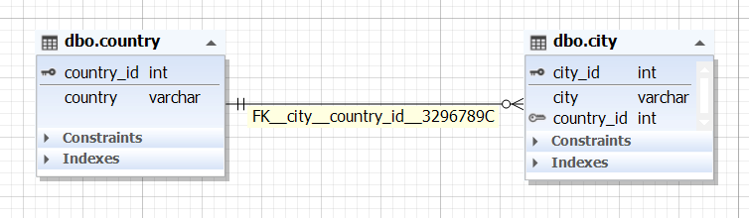
Example of one-to-many relation in SQL Server
How to implement one-to-many relationships when designing a database:
- Create two tables (table 1 and table 2) with their own primary keys.
- Add a foreign key on a column in table 1 based on the primary key of table 2. This will mean that table 1 can have one or more records related to a single record in table 2.
Step 1
CREATE TABLE dbo.city ( city_id int IDENTITY PRIMARY KEY, city varchar(50) NOT NULL,
country_id int NOT NULL )

CREATE TABLE dbo.country ( country_id int IDENTITY PRIMARY KEY, country varchar(50) NOT NULL )
Step 2
ALTER TABLE dbo.city WITH NOCHECK ADD FOREIGN KEY (country_id) REFERENCES dbo.country (country_id)

One-to-one relationship
A one-to-one relationship in a database occurs when each row in table 1 has only one related row in table 2. For example, a department may have only one head manager, a husband — only one wife, an employee — one company car, etc.
One-to-one relationship example in SQL:
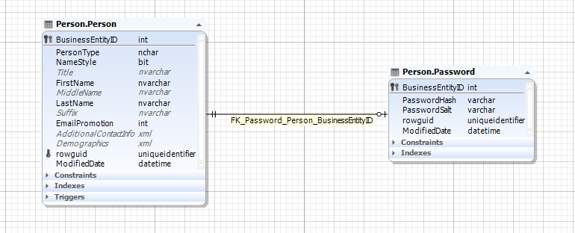

Implementing one-to-one relation
How to create one-to-one relationship in SQL Server? For this, you will need to create two tables, then define a simple primary foreign key relationship between them, and set the foreign key column to be unique.
CREATE TABLE Employee ( ID int PRIMARY KEY, Name VARCHAR(50) );

CREATE TABLE Salary ( EmployeeID int UNIQUE NOT NULL, SalaryAmount int );

ALTER TABLE Salary ADD CONSTRAINT FK_Salary_Employee FOREIGN KEY (EmployeeID)
REFERENCES Employee (ID);
Many-to-many relationship
A many-to-many relationship occurs when multiple records in one table are related to multiple records in another table. For example, products and suppliers: one supplier may deliver one or many products and at the same time, the company may order one product from one or many suppliers.
A many-to-many relationship example in SQL:
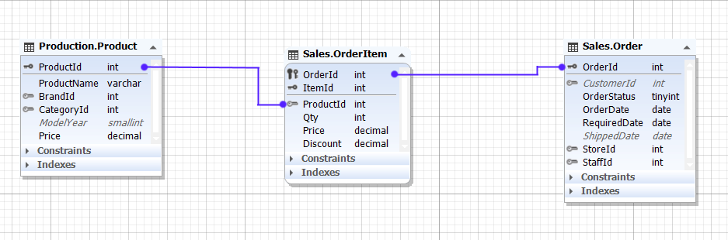
The relationship between the Product entity and Order entity is many-to-many, as one product may be in many orders and many orders may contain the same product.
Example of creating many-to-many relation in SQL
Relational databases don’t support direct many-to-many relationships between two tables. Then, how to implement many-to-many relationships in SQL? To create a many-to-many relationship in a database, you’ll need to create a third table to connect the other two. This new table (also known as a linking, joining, bridging, or junction table) will contain the primary key columns of the two tables you want to relate and will serve as an intermediate table between them.
Let’s consider the following example of how to create many-to-many relationship in SQL. Suppose, we want to establish a many-to-many relationship between two tables: films and category. First, we create the two tables.
CREATE TABLE films ( film_id INT PRIMARY KEY ,title VARCHAR(50) ,director VARCHAR(50)
,year_released DATETIME );

CREATE TABLE category ( category_id INT PRIMARY KEY ,name VARCHAR(50) );
Next, we create a junction table film_category that will map these two tables together by referencing the primary keys of both tables.
CREATE TABLE film_category ( film_id INT ,category_id INT
,CONSTRAINT film_cat_pk PRIMARY KEY (film_id, category_id)
,CONSTRAINT FK_film FOREIGN KEY (film_id) REFERENCES films (film_id)
,CONSTRAINT FK_category FOREIGN KEY (category_id) REFERENCES category (category_id)
);
A many-to-many relationship between the films and category tables has been successfully established.
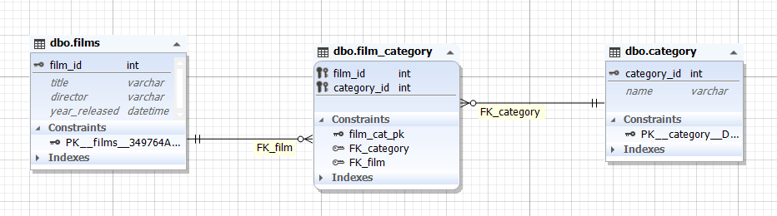

Lesson 3: Normalization
What is Normalization?
Normalization is a process of eliminating redundant data and storing the related information in a table.
1. Eliminating redundant data.
2. Faster update
3. Improve performance
4. Performance in indexes

Normalization forms
1. First Normal Form (1NF)

If a Table is said to be 1NF then it should satisfy following rules.
- Each cell must have one value
- Eliminating Duplicate Columns
- Create a separate table for group of related data and each row must be identify by primary key.
That means each cell must have single value and each row should be uniquely identified by Primary key

Name | Department | Phone Number
Rajesh | Computer | 3452342,1234563,2345612
Suresh | Electronics | 2398521,2323177,5302994
Praba | Civil | 3958218

In the above we can see the duplicate columns phone numbers have more than one value, we have to eliminate that and create a group of related data with unique row identification by specifying a primary key for the table

Rule 1. By applying above rule each cell must have one value above table changes like below
Name | Department | Phone Number | Phone Number | Phone Number
Rajesh | Computer | 3452342 | 1234563 | 2345612
Suresh | Electronics | 2398521 | 2323177 | 5302994
Praha | Civil | 3958218

Rule 2 &3. By applying second rule and third rule no more duplicate columns and each row must be unique is applied to above table.

Id | Name | Department | Phone Number
1 | Rajesh | Computer | 3452342
2 | Rajesh | Computer | 1234563
3 | Rajesh | Computer | 2345612
4 | Suresh | Electronics | 2398521
5 | Suresh | Electronics | 2323177
6 | Suresh | Electronics | 5302994
7 | Praha | Civil | 3958218
2.Second Normal Form (2NF)

The Table must be in second normal form, then it should satisfy the following rules.
- It should satisfy first normal form
- Separate the particular columns ,values are duplicated in each row should be place in separate table
- Create the relationship between the tables
From the above table we can see the column name and department are repeated in each row, this two columns can be maintained in another table and make a relationship between these two tables

EmpId | Name | Department | DeptLocation
1 | Rajesh | Computer
2 | Suresh | Electronics
3 | Praha | Civil
4 | Anil | Computer

Id | EmpId | PhoneNumber
1 | 1 | 3452342
2 | 1 | 1234563
3 | 1 | 2345612
4 | 2 | 2398521
5 | 2 | 2323177
6 | 2 | 5302994
7 | 3 | 3958218
In the above table Empid is played as Primary key for the first table and foreign key for the second table.

- Third Normal Form (3NF)

The table must be in 3NF, if it is satisfying the following rules
- Must be in 2NF
- Separate the columns that are not dependent upon the primary key of the table.
Product | Price | Tax
LED | 23000 | 20%
AC | 15000 | 10%
Fridge | 12000 | 15%
From the above table you can see that Tax Column is not dependent on Product Primary key column, it is dependent on Price so we separate that in to two different table.

Product | Price
LED | 23000
AC | 15000
Fridge | 12000

Price | Tax
23000 | 20%
15000 | 10%
12000 | 15%
4. Fourth Normal Form (4NF)
- It should be in 3NF
- The non key columns should be dependent on full primary key instead of partial key, if then separate it.
From the following table "EmployeeName" Non-Key column not dependent on full primary key "ManagerId, EmployeeId, TaskID" it depends upon the EmployeeId Partial Key so it can be separated.

ManagerId | EmployeeId | TaskID | EmployeeName
M1 | E1 | T1 | Rajesh
M2 | E1 | T1 | Rajesh

ManagerId | EmployeeId | TaskID
M1 | E1 | T1
M2 | E1 | T1

EmployeeId | EmployeeName
E1 | Rajesh

Lesson 4: Types Of Joins
Joins are used to get data from multiple tables. SQL server provides the following types of join these are
- Inner join
- Left outer join
- Right outer join
- Full outer join
- Self-join
- Cross join
A join condition defines the way two tables are related in a query by:
- Specifying the column from each table to be used for the join. A typical join condition specifies a foreign key from one table and its associated key in the other table.
- Specifying a logical operator (for example, = or <>,) to be used in comparing values from the columns.
In this lesion we will discuss about the types of joins.
INNER JOIN: It gets the common records from both the tables.
Syntax: Select * from table1 inner join table2 on table1.colname (p.k) = table2.colname (f.k)
Example: Select * from country inner join states on country.country_id = states.country_id
Output
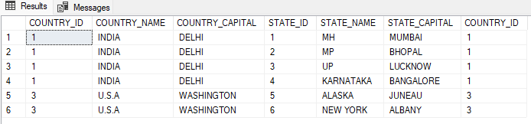
Syntax: For more than two tables
Select * from table1 inner join table2 on table1.colname (p.k) = table2.colname (f.k) inner join table3 on table2.colname = table3.colname
Example:
Select * from country inner join states on country.country_id = states.country_id inner join city on states.state_id=city.state_id

TYPES OF JOINS
INNER | LEFT OUTER | RIGHT OUTER | FULL OUTER | CROSS | SELF
INNER JOIN gets the Common records from both the tables. | LEFT OUTER JOIN gets the Common records from both the tables + all records from left tables. | RIGHT OUTER JOIN gets the Common records from both the tables + all records from right tables. | FULL OUTER JOIN gets the Common records from both the tables + all records from left tables and all records from right table. | In Cross join Each record of table1 joins all the records of table1 | self-Join : Joins the same table with itself.
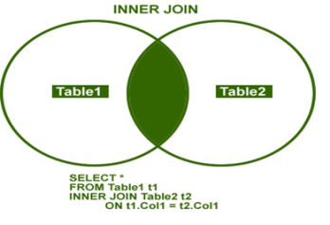 | 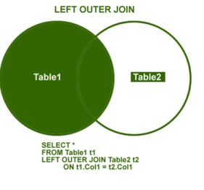 | 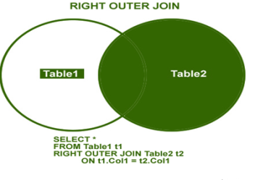 | 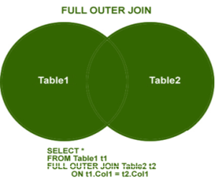
SELECT * FROM TABLE1(left)  INNER JOIN TABLE2(right) ON TABLE1.COLNAME(P.k) = TABLE2.COLNAME(f.K) | SELECT * FROM TABLE1(left)  LEFT OUTER JOIN TABLE2(right) ON TABLE1.COLNAME(P.k) = TABLE2.COLNAME(f.K) | SELECT * FROM TABLE1(left)  RIGHT OUTER JOIN TABLE2(right) ON TABLE1.COLNAME(P.k) = TABLE2.COLNAME(f.K) | SELECT * FROM TABLE1(left)  FULL OUTER JOIN TABLE2(right) ON TABLE1.COLNAME(P.k) = TABLE2.COLNAME(f.K) | SELECT *  FROM table1  CROSS JOIN table2 | SELECT *  FROM table1 t1  Join table1 t2  On t1.col=t2.col

EXAMPLES OF JOINS
LEFT OUTER JOIN
It gets the Common records from both the tables + all records from left tables.
Syntax:
Select * from Table1 (Left) LEFT OUTER JOIN Table2 ON Tabl1.Column_name (P.K.) = Table2.Column_name (F.K.)

Example:
Select * from COUNTRY left outer join STATES on COUNTRY.COUNTRY_ID = STATES.COUNTRY_ID
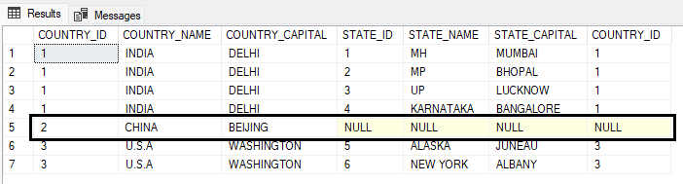
RIGHT OUTER JOIN
It gets the Common records from both the tables + all records from right tables.
Syntax: Select * from Table1 (Left) RIGHT OUTER JOIN Table2 ON Tabl1.Column_name (P.K.) = Table2.Column_name (F.K.)
Example: Select * from COUNTRY right outer join STATES on COUNTRY.COUNTRY_ID = STATES.COUNTRY_ID
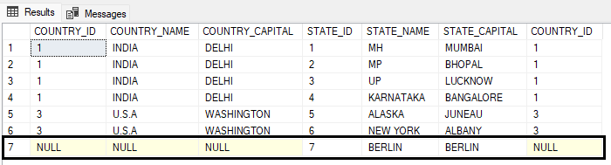
FULL OUTER JOIN
It gets the Common records from both the tables + all records from left tables and all records from right table.
Syntax: Select * from Table1 (Left) FULL OUTER JOIN Table2 ON Tabl1.Column_name (P.K.) = Table2.Column_name (F.K.)
Example:
Select * from COUNTRY full outer join STATES on COUNTRY.COUNTRY_ID = STATES.COUNTRY_ID
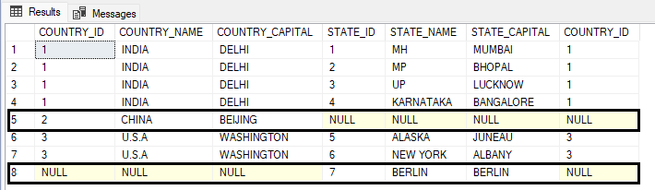
CROSS JOIN
In Cross join each record of table1 joins all the records of table1. This join is a Cartesian join that does not necessitate any condition to join. The result set contains records that are multiplication of record number from both the tables.
Syntax: Select * from Table1 CROSS JOIN Table2
Example: Select * from COUNTRY cross join STATE

SELF JOIN
In self join it joins the same table with itself.
Syntax: Select * from Table1 T1 JOIN Table1 T2 ON T1.table1=T2.table1
Example of SELF JOIN
Create table empmanagers  (  EMPID INT PRIMARY KEY,  EMPNAME VARCHAR (100),  SALARY FLOAT,  MGRID INT  ) | ALTER TABLE empmanagers ADD FOREIGN KEY (MGRID) REFERENCES EMPMANAGERS (EMPID)  INSERT INTO EMPMANAGERS VALUES (1,'AMIT', 30000, NULL)  INSERT INTO EMPMANAGERS VALUES (2,'SUNIL', 20000, 1)  INSERT INTO EMPMANAGERS VALUES (3,'KAPIL', 10000, 1)
QUERY TO JOIN ABOVE THREE TABLE USING DIFFERENT TYPES OF JOINT
WRITE A QUERY TO FIND THE NAME OF THE MANAGER FOR THE EMPLOYEE
SELECT E1.EMPID, E1.EMPNAME, E1.SALARY, E2.EMPNAME AS MANAGERNAME FROM empmanagers E1 INNER JOIN empmanagers E2 ON E1.MGRID= E2.EMPID
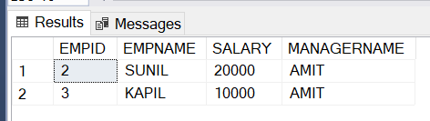

CHAPTER 5: SUMMARY / CHEAT SHEET
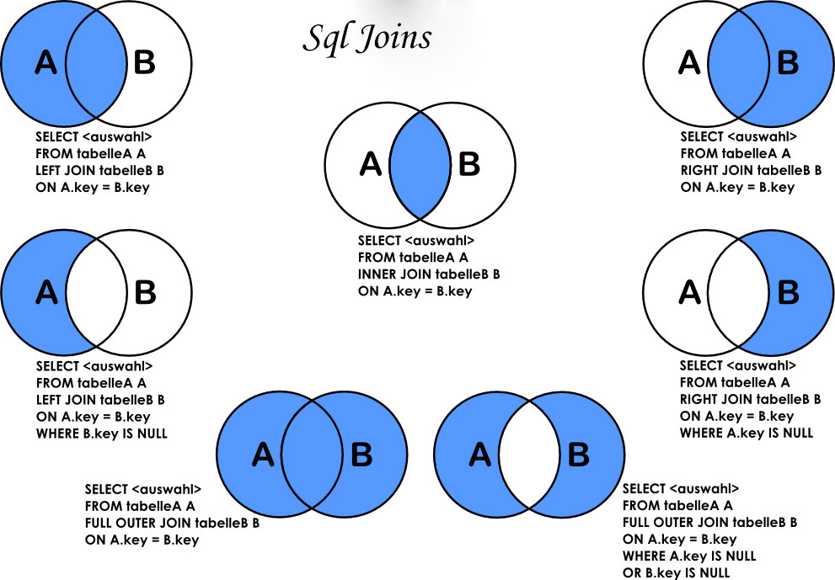

CHAPTER 5: EXERCISE (ASSIGNMENTS)
CREATE A TABLE FOR COMPANY
COLUMN_NAME | DATATYPE | CONSTRAINT
COMPANYID | INT | PRIMARY KEY, IDENTITY(1,1)
COMPANYNAME | VARCHAR(100)
WEBSITE | VARCHAR(100)
EMAIL | VARCHAR(100)

ADD TWO COMPANY RECORDS TO THE TABLE using INSERT STATEMENTS

CREATE A TABLE FOR DEPT
COLUMN_NAME | DATATYPE | CONSTRAINT
DEPTID | INT | PRIMARY KEY, IDENTITY(1,1)
DEPTNAME | VARCHAR(100)
DEPTLOCATION | VARCHAR(100)

ADD FIVE DEPT RECORDS TO THE TABLE using INSERT STATEMENTS

CREATE A TABLE FOR DESG
COLUMN_NAME | DATATYPE | CONSTRAINT
DESGID | INT | PRIMARY KEY
DESGNAME | VARCHAR(100)
CREATEDDATE | DATETIME | DEFAULT - GETDATE()

ADD FIVE DESG RECORDS TO THE TABLE using INSERT STATEMENTS

CREATE A TABLE FOR EMPLOYEE
COLUMN_NAME | DATATYPE | CONSTRAINT
EMPID | INT | PRIMARY KEY
EMPNAME | VARCHAR(100) | UNIQUE
BASICSALARY | FLOAT
INCENTIVE | FLOAT
BONUS | FLOAT
DOB | DATETIME
DOJ | DATETIME | DEFAULT GETDATE()
GENDER | VARCHAR(100)
EMAIL | VARCHAR(100) | UNIQUE
MOBILE | VARCHAR(10)
CREATEDDATE | DATETIME | DEFAULT GETDATE()
COMPANYID | INT | F.K
DEPTID | INT | F.K
DESGID | INT | F.K

ADD 10 EMPLOYEES RECORDS TO THE TABLE USING INSERT COMMAND

WRITE A QUERY TO DISPLAY THE TOTALSALARY FOR EACH DEPTNAME.

DEPTNAME | TOTALSALARY

WRITE A QUERY TO DISPLAY THE NOOFEMPLOYEES FOR EACH COMPANYNAME.'

COMPANYNAME | NOOFEMPLOYEES

WRITE A QUERY TO FIND HIGHEST SALARY HOLDER IN EMPLOYEE TABLE

WRITE A QUERY TO FIND 3RD HIGHEST SALARY HOLDER IN EMPLOYEE TABLE

WRITE A QUERY TO FIND FIFTH HIGHEST SALARY HOLDER IN EMPLOYEE TABLE

WRITE A QUERY TO DISPLAY THE DESGNAME,NOOFEMPS,TOTALSALARY

DESGNAME | NOOFEMPS | TOTALSALARY

CREATE A TABLE COUNTRY AND ADD THE VALUES AS SHOWN BELOW USING INSERT COMMAND

COUNTRYID(P.K) | COUNTRYNAME(UNIQUE) | COUNTRYCAPITAL
1 | INDIA | DELHI
2 | CHINA | BEIJING
3 | U.S.A | Washington

CREATE A TABLE STATE AND ADD THE VALUES AS SHOWN BELOW USING INSERT COMMAND

STATEID(P.K) | STATENAME | STATECAPITAL | COUNTRYID
1 | MH | MUMBAI | 1
2 | MP | BHOPAL | 1
3 | UP | LUCKNOW | 1
4 | KARNATAKA | BANGALORE | 1
5 | Alaska | Juneau | 3
6 | New York | Albany | 3
7 | Berlin | Berlin | NULL

CREATE A TABLE CITY AND ADD THE VALUES AS SHOWN BELOW USING INSERT COMMAND

CITYID(P.K) | CITYNAME | STATEID
1 | NASHIK | 1
2 | PUNE | 1
3 | NAGPUR | 1

WRITE THE QUERIES USING THE COUNTRY, STATES AND CITY TABLE
- WRITE A QUERY TO DO an INNER JOIN BETWEEN COUNTRY AND STATE TABLE.
- WRITE A QUERY TO DO an LEFT OUTER JOIN BETWEEN COUNTRY AND STATE TABLE.
- WRITE A QUERY TO DO an RIGHT OUTER JOIN BETWEEN COUNTRY AND STATE TABLE.
- WRITE A QUERY TO DO an FULL OUTER JOIN BETWEEN COUNTRY AND STATE TABLE.
- WRITE A QUERY TO DO A CROSS JOIN BETWEEN COUNTRY AND STATE TABLE
- WRITE A QUERY TO FIND THE NAME OF COUNTRIES WHICH ARE NOT PRESENT IN THE INNER JOIN. (HINT : USE LEFT JOIN EXCEPT INNER JOIN)
WRITE A QUERY TO FIND THE NUMBER OF STATES IN EACH COUNTRY

COUNTRYNAME | NOOFSTATES

SELF JOIN ASSIGNMENT
CREATE A TABLE EMPLOYEE AND ADD THE VALUES AS SHOWN BELOW
IN THE EXAMPLE, THE MANAGERID WILL BE FOREIGN KEY WHICH WILL HAVE REFERENCE TO THE PRIMARY KEY EMPID (PRIMARY KEY)

EMPID (PRIMARY KEY) | EMPNAME | SALARY | TAX | MANAGERID (FOREIGN KEY)
1 | SAMIR | 98000 | 1000 | NULL
2 | YOGESH | 88000 | 2000 | 1
3 | NEERAJ | 58000 | 2000 | 1
4 | KAMLESH | 48000 | 1000 | 2

WRITE A QUERY TO FIND THE MANAGERNAME OF THE EMPLOYEES. OUTPUT WILL BE
EMPNAME | EMPSALARY | MANAGERNAME | MANAGER_SALARY

CHAPTER 5: EXERCISE (ASSIGNMENTS)
CREATE THE FOLLOWING TABLE DESCRIBED BELOW AND INSERT THE DATA AS GIVE BELOW.
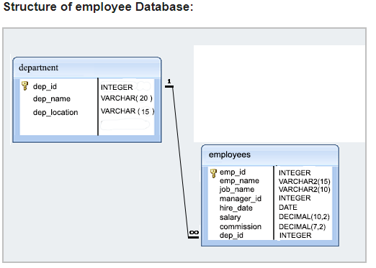
DROP TABLE DEPARTMENT
DROP TABLE EMPLOYEES
CREATE TABLE DEPARTMENT
(
DEPT_ID INT PRIMARY KEY,
DEPT_NAME VARCHAR(100),
DEPT_LOCATION VARCHAR(100)
)
INSERT INTO DEPARTMENT VALUES(1,'IT','PUNE')
INSERT INTO DEPARTMENT VALUES(2,'HR','MUMBAI')
INSERT INTO DEPARTMENT VALUES(3,'ADMIN','MUMBAI')
INSERT INTO DEPARTMENT VALUES(4,'SECURITY','PUNE')
INSERT INTO DEPARTMENT VALUES(5,'FINANCE','MUMBAI')

CREATE TABLE EMPLOYEES
(
EMP_ID INT PRIMARY KEY,
EMP_NAME VARCHAR(100),
JOB_NAME VARCHAR(100),
MANAGER_ID INT FOREIGN KEY REFERENCES EMPLOYEES(EMP_ID),
HIRE_DATE DATETIME,
SALARY DECIMAL(10,2),
COMMISSION DECIMAL(7,2),
DEPT_ID INT FOREIGN KEY REFERENCES DEPARTMENT(DEPT_ID)
)

INSERT INTO EMPLOYEES VALUES (1,'SUNIL','MANAGER',NULL,'10/10/2018',60001,1000,1)
INSERT INTO EMPLOYEES VALUES (2,'KAPIL','MANAGER',NULL,'05/10/2018',80012,1000,2)
INSERT INTO EMPLOYEES VALUES (3,'SAMIR','CLERK',2,'10/10/2018',11000,1000,2)
INSERT INTO EMPLOYEES VALUES (4,'KRUTIKA','CLERK',2,'05/10/2018',12000,1000,2)
INSERT INTO EMPLOYEES VALUES (5,'YASIKA','CLERK',2,'10/10/2019',13000,5000,2)
INSERT INTO EMPLOYEES VALUES (6,'SONAL','CLERK',2,'05/10/2019',14000,6000,2)

INSERT INTO EMPLOYEES VALUES (13,'RAJESH','CLERK',NULL,'10/10/2000',15000,1000,1)
INSERT INTO EMPLOYEES VALUES (14,'UMESH','CLERK',NULL,'05/10/1999',16000,1000,2)
INSERT INTO EMPLOYEES VALUES (15,'YAMIN','CLERK',NULL,'10/10/1998',17000,5000,1)
INSERT INTO EMPLOYEES VALUES (16,'KAMINI','CLERK',NULL,'05/10/1997',18000,6000,2)

INSERT INTO EMPLOYEES VALUES (113,'SUJANAN','CLERK',1,'10/10/2000',12500,1000,1)
INSERT INTO EMPLOYEES VALUES (114,'ANJANA','CLERK',1,'05/10/1999',13500,1000,1)
INSERT INTO EMPLOYEES VALUES (115,'TEJAL','CLERK',1,'10/10/1998',10500,5000,1)
INSERT INTO EMPLOYEES VALUES (116,'AKSHAY','CLERK',1,'05/10/1997',10600,6000,1)

INSERT INTO EMPLOYEES VALUES (213,'SUJANAN','CLERK',2,'10/10/2000',12001,1000,2)
INSERT INTO EMPLOYEES VALUES (214,'ANJANA','CLERK',2,'05/10/1999',13001,1000,2)
INSERT INTO EMPLOYEES VALUES (215,'TEJAL','CLERK',2,'10/10/1998',10001,5000,2)
INSERT INTO EMPLOYEES VALUES (216,'AKSHAY','CLERK',2,'05/10/1997',10045,6000,2)
INSERT INTO EMPLOYEES VALUES (313,'JAYESH','ANALYST',2,'10/10/2000',12011,1000,2)
INSERT INTO EMPLOYEES VALUES (314,'TAJESH','ANALYST',2,'05/10/1999',13011,1000,2)
INSERT INTO EMPLOYEES VALUES (315,'MANGESH','ANALYST',2,'10/10/1998',10451,5000,2)
INSERT INTO EMPLOYEES VALUES (316,'KALPESH','ANALYST',2,'05/10/1997',10565,6000,2)

SELECT * FROM EMPLOYEES

- Write a query in SQL to display the unique designations for the employees.
- Write a query in SQL to list the employees who joined before 1991
- Write a query in SQL to display the average salaries of all the employees who works as ANALYST
- Write a query in SQL to display all the details of the employees whose commission is more than their salary.
- Write a query in SQL to list the employees who are either CLERK or MANAGER.
- Write a query in SQL to list the employees who are working either MANAGER or ANALYST with a salary range between 2000 to 5000 without any commission
- Write a query to list average salaries per department, highest salary per department.
- Write a query to find departments having more than 20 employees.
- query in SQL to list the employees who joined
---before 2001
-- in month of Feb
- find employees having salary greater than avg salary of their dept and second letter of their name has 'a'.
- Find Highest Salary Holder Employee details of Each Dept in a single query
- Find Second Highest Salary Holder Employee details of Each Dept in a single query
- Find Top 3 Highest Salary Holder of Each Dept in a single query
- Find Top 5 Highest Salary of Each Dept in a single query
- Find Bottom 3 Highest Salary Holder of Each Dept in a single query

CHAPTER 5: EXERCISE (ASSIGNMENTS)
CREATE A COMPANY MANAGEMENT SYSTEM DATABASE SIMILAR TO THIS.
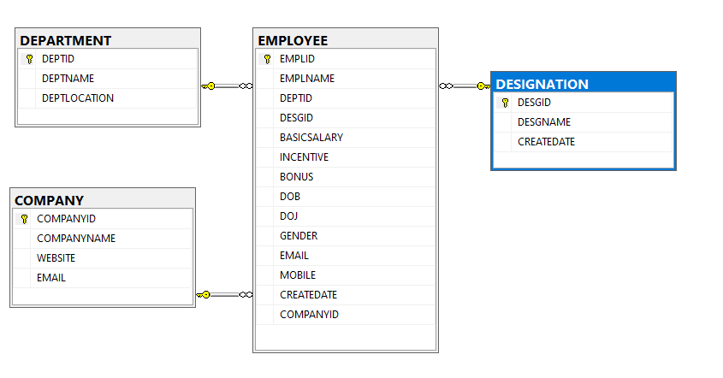
INSERT VALUES INTO ALL THE TABLES OF THE DATABASE DESIGNED
WRITE A QUERY TO JOIN ALL THE TABLES AND SHOW THE RESULTS
WRITE A QUERY TO COPY THE DATA OF ALL TABLES GENERATED USING JOINS INTO A NEW TABLE

CREATE A SALES MANAGEMENT SYSTEM DATABASE SIMILAR TO THIS.
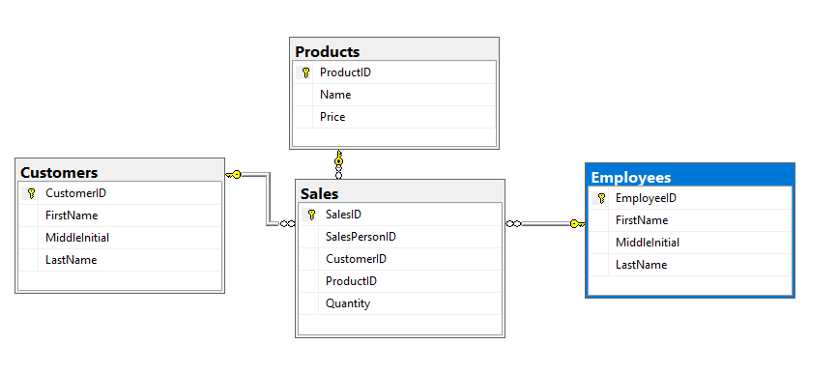

After Creating the Data Structures.
Add some Products into the tables.
Then add some Customers into the tables
Then add some employees into the tables
Then add sales data into the sales table.

CHAPTER 5: QUESTIONS
Can we put multiple foreign key in a single table ?
What is the advantage of Relational Database Model ?
What is Normalization ?
What is the difference between inner join and left outer join ?
What is Self Join ?

CHAPTER 6

CHAPTER 6: advance OPERATOR in SQL server
Lesions in this chapter
- Lesion 1 : Union, Except & intersect
- Lesson 2: Pivot & UnPivot

Lesson 1: union, EXcept & intersect
UNION & UNION ALL
SQL Server UNION is one of the set operations that allows you to combine results of two SELECT statements into a single result set which includes all the rows that belongs to the SELECT statements in the union.
The following illustrates the syntax of the SQL Server UNION: query_1 UNION query_2
The following are requirements for the queries in the syntax above:
- The number and the order of the columns must be the same in both queries.
- The data types of the corresponding columns must be the same or compatible.
UNION vs. UNION ALL :By default, the UNION operator removes all duplicate rows from the result sets. However, if you want to retain the duplicate rows, you need to specify the ALL keyword explicitly as shown below:
query_1 UNION ALL query_2
In other words, the UNION operator removes the duplicate rows while the UNION ALL operator includes the duplicate rows in the final result set.
CREATE TABLE EMP1  (  EMPID INT,  NAME VARCHAR(100),  SAL FLOAT  )  INSERT INTO EMP1 VALUES(1,'SUNIL',20000)  INSERT INTO EMP1 VALUES(2,'KAPIL',21000)  INSERT INTO EMP1 VALUES(3,'RAJESH',22000) | CREATE TABLE EMP2  (  EMPID INT,  NAME VARCHAR(100),  SAL FLOAT  )  INSERT INTO EMP2 VALUES(2,'KAPIL',21000)  INSERT INTO EMP2 VALUES(3,'UMESH',23000)  INSERT INTO EMP2 VALUES(4,'MANOJ',24000)  INSERT INTO EMP2 VALUES(5,'TUSHAR',25000) | CREATE TABLE EMP3  (  EMPID INT,  NAME VARCHAR(100),  SAL FLOAT,  DEPT VARCHAR(100)  )  INSERT INTO EMP3 VALUES(5,'TUSHAR',25000,'IT')  INSERT INTO EMP3 VALUES(6,'KAILASH',35000,'HR')  INSERT INTO EMP3 VALUES(7,'TEJAS',45000,'FINANCE')
SELECT * FROM EMP1 UNION SELECT * FROM EMP2
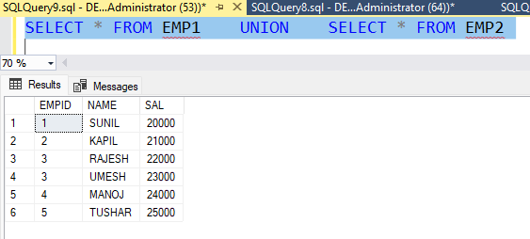

EXCEPT

The SQL Server EXCEPT compares the result sets of two queries and returns the distinct rows from the first query that are not output by the second query. In other words, the EXCEPT subtracts the result set of a query from another.

Except
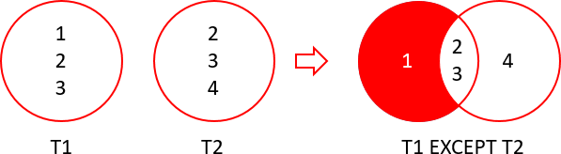
Select * from emp2 except (Select * from emp1)

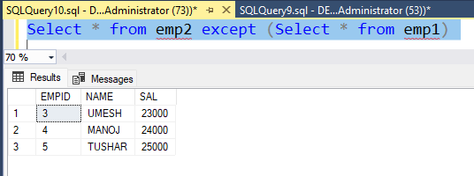

INTERSECT
The SQL Server INTERSECT combines result sets of two or more queries and returns distinct rows that are output by both queries.
Syntax : query_1 INTERSECT query_2
Intersect
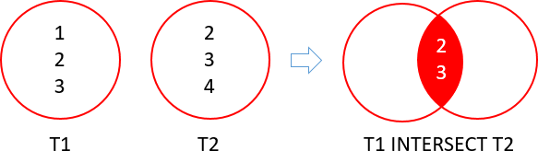

Select * from emp2 intersect (Select * from emp1)
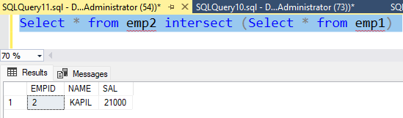

Lesson 2: pivot / unpivot
Pivot and Unpivot in SQL are two relational operators that are used to convert a table expression into another.
PIVOT in SQL is used when we want to transfer data from row level to column level and UNPIVOT in SQL is used when we want to convert data from column level to row level.
PIVOT and UNPIVOT relational operators are used to generate a multidimensional reporting.
PIVOT in SQL Server
PIVOT relational operator converts data from row level to column level.

PIVOT rotates a table-valued expression by turning the unique values from one column in the expression into multiple columns in the output.

Using PIVOT operator, we can perform aggregate operation where we need them.
Syntax
- SELECT <non-pivoted column>,
- <list of pivoted column> FROM (<SELECT query to produces the data>)
- AS <alias name>
- PIVOT ( <aggregation function>(<column name>)
- FOR
- [<column name that become column headers>] IN ( [list of pivoted columns])
- ) AS <alias name for pivot table>
(Create a Sample Table Employee_Pivot to understand the Pivot Examples)
CREATE TABLE Employee_Pivot  (  Name [nvarchar](max),  [Year] [int] ,  Sales [int]  )  INSERT INTO Employee_Pivot values  ('Pankaj',2010,72500),('Rahul',2010,60500),  ('Sandeep',2010,52000),('Pankaj',2011,45000),  ('Sandeep',2011,82500),('Rahul',2011,35600),  ('Pankaj',2012,32500),('Pankaj',2010,20500),  ('Rahul',2011,200500),('Sandeep',2010,32000) | 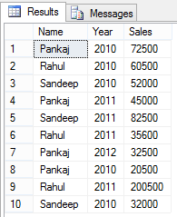

EXAMPLES OF PIVOT
select * from
(SELECT Name,Year,Sales FROM Employee_Pivot) t1
Pivot ( sum(Sales) for Name in(Pankaj,Rahul,Sandeep) ) t2
SELECT YEAR,[Pankaj],[Rahul],[Sandeep] from
(SELECT Name,Year,Sales FROM Employee_Pivot) Tab1
Pivot ( sum(sales) for name in (Pankaj,Rahul,Sandeep) )
as Tab2
Output
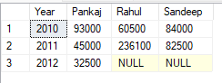
UNPIVOT
UNPIVOT relational operator is reverse process of PIVOT relational operator. UNPIVOT relational operator convert data from column level to row level.
Create a Employee_UnPivot table by copying the PIVOT results

SELECT YEAR,[Pankaj],[Rahul],[Sandeep] into Employee_UnPivot from
(SELECT Name,Year,Sales FROM Employee_Pivot) Tab1
Pivot ( sum(sales) for name in (Pankaj,Rahul,Sandeep) ) as Tab2


select * from
(select * from Employee_UnPivot) t1
UNPIVOT
(
Sales FOR Name IN (Pankaj,Rahul,Sandeep)
) AS TAb2
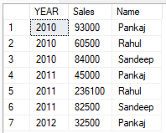

CHAPTER 6: SUMMARY / CHEAT SHEET

UNION IS USED TO COMBINE THE ROWS.
Union will give only the distinct records and union all with give all the records
JOINS ARE USED TO COMBINE THE COLUMNS
INTERSECT IS USED TO GET COMMON ROWS BETWEEN TWO TABLES.
PIVOT is used to convert the column values as row header.

CHAPTER 6: QUESTIONS
What is the difference between Union and Join ?
What is the difference between Union and Union All ?
What is the difference between Union and Intersect?
What is the use of PIVOT ?
Can we apply Union on more than 2 tables ?

CHAPTER 7

CHAPTER 7 : Operators, Identifiers Variables & STATEMENTS
In this lesion we will discuss about the operators, identifiers and variables. What they are and how we can use it in SQL server. SQL SERVER statements that you can use to control the flow of your code. These constructs can be used in T-SQL scripts, and they are commonly used in stored procedures.
This chapter consists of the following lessons :
- Lesson 1: Operators
- Lesson 2: Identifiers
- Lesson 3: Variables
- Lesson 4 : IF-ELSE STATEMENT
- Lesson 5 : CASE STATEMENT
- Lesson 6 : LOOP STATEMENT

Lesson 1: Operators
Operators are used to specify conditions in an SQL statement and to serve as conjunctions for multiple conditions in a statement. When a complex expression has multiple operators, operator precedence determines the sequence in which the operations are performed.
They are
- Arithmetic Operator
- Comparison Operator
- Logical Operator
Operators have the precedence levels shown in the following table. An operator on higher levels is evaluated before an operator on a lower level.
Level | Operators
1 | ~ (Bitwise NOT)
2 | * (Multiply), / (Division), % (Modulo)
3 | + (Positive), - (Negative), + (Add), (+ Concatenate), - (Subtract), & (Bitwise AND), ^ (Bitwise Exclusive OR), | (Bitwise OR)
4 | =, >, <, >=, <=, <>, !=, !>, !< (Comparison operators)
5 | NOT
6 | AND
7 | ALL, ANY, BETWEEN, IN, LIKE, OR, SOME
8 | = (Assignment)

Lesson 2: Identifiers
Identifiers are the names given to database objects such as such as tables, constraints, and stored procedures, views, columns, and data types.
All databases, servers, and database objects in SQL Server (such as tables, constraints, and stored procedures, views, columns, and data types) must have unique names, or identifiers.
They are assigned when an object is created, and used thereafter to identify the object. The identifier for the object may, if needed, be changed.
The following are the rules for creating identifiers:
- Identifiers may have between 1 and 128 characters.
- There are exceptions to this rule: certain objects are limited (for instance, temporary tables can have identifiers up to only 116 characters long).
- Before Microsoft SQL Server 7.0, identifiers were limited to 30 characters.
- The first character of the identifier must be a letter, underscore ( _ ), at sign ([])
There are two types of identifiers:
- Regular Identifiers.
- Delimited Identifiers.
Regular identifiers : They are not delimited when they are used in Transact-SQL statements.
For example: SELECT * FROM Table1 WHERE Id = 101
Delimited identifiers : Are enclosed in double quotation marks (") or brackets ([ ]). Identifiers that comply with the rules for the format of identifiers might not be delimited.
For example: SELECT * FROM [Table1] --Delimiter is optional.
WHERE [Id] = 101 --Delimiter is optional.

Lesson 3: Variables
A variable is an object that can hold a single data value of a specific type.
Declaring a Transact-SQL Variable
The DECLARE statement initializes a Transact-SQL variable by:
Assigning a name. The name must have a single @ as the first character.
- Assigning a system-supplied or user-defined data type and a length. For numeric variables, a precision and scale are also assigned. For variables of type XML, an optional schema collection may be assigned.
- Setting the value to NULL.
For example:
DECLARE @MyNumber int
DECLARE @First_Name varchar (10)

PROGRAMMING WITH OPERATORS
When two operators in an expression have the same operator precedence level, they are evaluated left to right based on their position in the expression. For example, in the expression that is used in the following SET statement, the subtraction operator is evaluated before the addition operator.
DECLARE @MyNumber int
SET @MyNumber = 4 - 2 + 27
- Evaluates to 2 + 27 which yields an expression result of 29.
- Then evaluate 4-29 which yields an expression result of -25
SELECT @MyNumber

Lesson 4: IF-ELSE STATEMENT
The IF/ELSE construct gives you the ability to conditionally execute code. You enter an expression after the IF keyword, and if the expression evaluates as true, the statement or block of statements after the IF statement will be executed. You can use the optional ELSE to add a different statement or block of statements that will be executed if the expression in the IF statement evaluates to false. The basic syntax of IF-ELSE statement is:
Example of IF-ELSE Statement
IF (Condition)  BEGIN  Statement  END  ELSE IF (Condition)  BEGIN  Statement  END  ELSE  BEGIN  Statement  END | Declare @Marks float  Set @Marks=70  IF (@Marks >75)  BEGIN  Print 'Distinction'  END  ELSE IF (@Marks>60)  BEGIN  Print 'First Class'  END  ELSE IF (@Marks>40)  BEGIN  Print 'Second Class'  END  ELSE  BEGIN  Print 'Fail'  END

Lesson 5: CASE STATEMENT
The CASE statement goes through conditions and return a value when the first condition is met (like an IF-THEN-ELSE statement). So, once a condition is true, it will stop reading and return the result. If no conditions are true, it returns the value in the ELSE clause.
The basic syntax for a simple CASE expressions is shown below:
CASE expression
WHEN expression1 THEN result1
WHEN expression2 THEN result2
ELSE expression
END
Example of Case Statements:
DECLARE @TestVal INT
SET @TestVal= 3
SELECT
CASE @TestVal
WHEN 1 THEN 'First'
WHEN 2 THEN 'Second'
WHEN 3 THEN 'Third'
ELSE 'Other'
END

CASE : SELECT empID, empname, CASE gender
WHEN 'MALE' THEN 'M'
WHEN 'FEMALE' THEN 'F'
ELSE 'NA'
END
FROM employee

SELECT STUDENTID,PERCENTAGE,
Grade=CASE WHEN PERCENTAGE >= 75 THEN ‘DISTINCTION’
WHEN PERCENTAGE >= 60 THEN ‘FIRST CLASS’
WHEN PERCENTAGE >= 40 THEN ‘SECOND CLASS’
ELSE ‘FAIL’
END
FROM STUDENT

Update using case statements

UPDATE STUDENT SET
Grade=CASE WHEN percentage >= 75 THEN 'DISTINCTION'
WHEN percentage >= 60 THEN 'FIRST CLASS'
WHEN percentage >= 40 THEN 'SECOND CLASS'
ELSE ‘FAIL’
END

Lesson 6: LOOP STATEMENT
With the WHILE construct, you can create loops inside T-SQL in order to execute a statement block as long as a condition continues to evaluate to true. The keyword WHILE is followed by a condition that evaluates to either true or false. If the condition evaluates to true when it’s first tested, the control of execution enters the loop, finishes the commands inside the loop the first time, and then tests the condition. Each time the loop is repeated, the WHILE condition is retested. As soon as the condition evaluates to false, the loop ends and execution control passes to the next statement following the WHILE loop. Is used to Iterate a statements multiple no of times.
Syntax:
Declaration  While(condition)  Begin  Statements  incrimination  end | Example  DECLARE @i INT  SET @i= 1  WHILE (@i <=5)  BEGIN  PRINT @i  SET @i = @i+ 1  END  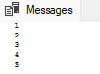
Example of table using while loop
Create table hospitals  (  ID int identity(1,1),  HospitalID int,  Email nvarchar(200),  Description nvarchar(200)  ) | CREATE PROCEDURE populateHospitals  AS  BEGIN  DECLARE @hid INT  SET @hid=16;  WHILE @hid< 100  BEGIN  INSERT INTO hospitals([HospitalID], Email, Description)  VALUES(@hid,'user'+LTRIM(STR(@hid))+'@mail.com','Sample Description'+LTRIM(STR(@hid)));  SET @hid=@hid+ 1;  END  END
EXEC populateHospitals  SELECT * FROM hospitals | 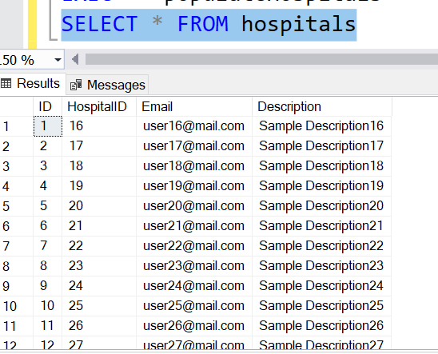
Example of While Loop

DECLARE @uniqueId int
DECLARE @TEMPTABLE(uniqueIdint)

-- Insert into the temporary table a list of the records to be updated
INSERT INTO @TEMP(uniqueId) SELECT uniqueId FROM myTable

-- Start looping through the records
WHILE EXISTS (SELECT* FROM@TEMP)
BEGIN
-- Grab the first record out
SELECT Top1 @uniqueId = uniqueId FROM @TEMP
PRINT 'Working on @uniqueId = '+ CAST(@uniqueId as varchar(100))
-- Perform some update on the record
UPDATE myTable SET myField = 'something or other' WHERE uniqueId = @uniqueId

-- Drop the record so we can move onto the next one
DELETE FROM @TEMP WHERE uniqueId = @uniqueId
END

CHAPTER 7: SUMMARY / CHEAT SHEET
Sql Server have various types of operators like arithmetic operator, conditional operator etc.
In Sql Server we can use variables to store data.
Sql Server support conditional statements like IF-ELSE statements and case-when statements.
Sql Server supports lopping statements like while loop.

CHAPTER 7: exercise(assignments)
T-SQL ASSIGNMENTS
- Write a SQL statement to display numbers from 1 to 10.
- Write a SQL statement to display even numbers from 1 to 10.
- Write a SQL statement to add numbers from 1 to 10 and display the result.
- Write a SQL statement to multiple numbers from 1 to 10 and display the result.
- Write a SQL statement to create a multiple table for a number (eg : 9).
- Write a SQL statement to generate a Triangle like this :
*
* *
* * *
* * * *
* * * * *

CHAPTER 7: QUESTIONS

1 | What are operators in SQL server?
2 | What are the different types of operator?
3 | Which is better temp table or table variable?
4 | What are identifiers in SQL server?

CHAPTER 8

CHAPTER 8: STORED PROCEDURE & FUNCTIONS
T-SQL code can be stored within Microsoft SQL Server databases by using T-SQL routines such as stored procedures, triggers, and functions. This helps make your T-SQL code more portable, because it stays with the database and these routines will be restored from a database backup along with the database data. These routines can then be executed from the database as well.
In this chapter, you learn about creating reusable T-SQL routines in stored procedures and user-defined functions.
Lessons in this chapter:
- Lesson 1: Implementing Stored Procedures
- Lesson 2: Implementing User-Defined Functions

Lesson 1: Implementing Stored Procedures
Sored Procedure is a group of SQL statements which is saved as program which can be reused when they required
Important features of stored procedures:
- They can be called from T-SQL code by using the EXECUTE command.
- You can pass data to them through input parameters, and receive data back through output parameters.
- They can return result sets of queries to the client application.
- They can modify data in tables.
SYNTAX FOR CREATE STORED PROCEDURE  Create procedure procedure_name  (  Parameter1,  Parameter2,  Parameter3  )  As  Begin  Statements  End  SYNTAX FOR CALLING STORED PROCEDURE:  Exec sp_name parameters. | STORED PROCEDURE TO ADD TWO NUMBERS AND SHOW THE RESULTS  Create procedure sp_add  (  @n1,  @n2  )  As  Begin  DECLARE @total int  SET @total =@n1 + @n2  PRINT @total  End  EXEC sp_add 20,10  OUTPUT : 30
WRITE A STORED PROCEDURE TO SHOW A MULTIPLICATION TABLE FOR A GIVEN NUMBER  CREATE PROCEDURE SP_MULTIPLYTBL  (  @NUM INT  )  AS  BEGIN  DECLARE @I INT = 1  DECLARE @T INT = 1  WHILE (@I <= 10)  BEGIN  SET @T =@NUM * @I  PRINT CAST(@NUM AS VARCHAR(10)) + '*' + CAST(@I AS VARCHAR(10)) + ' = ' + CAST(@T AS VARCHAR(10))  SET @I = @I +1  END  END | CALLING A STORED PROCEDURE  EXEC SP_MULTIPLYTBL 8  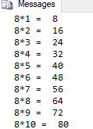
STORED PROCEDURE EXAMPLES
Step 1 : Create a Table
CREATE TABLE [STUDENTS]
(
[ROLLNO] [int] IDENTITY(1,1) CONSTRAINT [PK_ROLLNO] PRIMARY KEY,
[NAME] [nvarchar](100) NULL,
[GENDER] [char](1) NULL,
[ENG_MARKS] [float] NULL,
[SCIENCE_MARKS] [float] NULL,
[MATHS_MARKS] [float] NULL
)
Create a Procedure to Insert a student

CREATE PROCEDURE SP_INSERTSTUDENTS
(
@STUDNAME NVARCHAR(50),
@GEN CHAR(1),
@ENG FLOAT,
@SCN FLOAT,
@MATHS FLOAT
)
AS
BEGIN
INSERT INTO STUDENTS VALUES(@STUDNAME,@GEN,@ENG,@SCN,@MATHS)
SELECT * FROM STUDENTS
END

EXEC SP_INSERTSTUDENTS 'SURESH','M',78,99,67
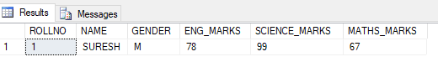
Step 2: Create a Procedure to Insert a student if the students does not exists
CREATE PROCEDURE SP_ADDSTUDENTS
(
@STUDNAME NVARCHAR(50),
@GEN CHAR(1),
@ENG FLOAT,
@SCN FLOAT,
@MATHS FLOAT
)
AS
BEGIN
DECLARE @COU INT= 0
SELECT @COU=COUNT(*) FROM STUDENTS WHERE NAME=@STUDNAME -- THIS WILL CHECK IF THE STUDENT IS ALREADY PRESENT

IF (@COU> 0)
BEGIN
PRINT 'STUDENT ALREADY PRESENT, PLEASE ENTER A NEW NAME,NAME='+@STUDNAME
END
ELSE
BEGIN
INSERT INTO STUDENTS VALUES(@STUDNAME,@GEN,@ENG,@SCN,@MATHS)
SELECT * FROM STUDENTS
END
END

CALLING A STORED PROCEDURE
Exec [SP_INSERTSTUDENTS] 'SAMPAD','M',89,76,67

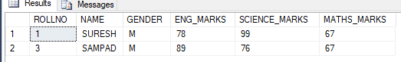
ALTER TABLE STUDENTS ADD TOTALMARKS FLOAT,PERCENTAGE FLOAT,GRADE VARCHAR(100)

CREATE PROCEDURE SP_SAVESTUDENTS
(
@STUDNAME NVARCHAR(50),
@GEN CHAR(1),
@ENG FLOAT,
@SCN FLOAT,
@MATHS FLOAT
)
AS
BEGIN
DECLARE @TOTAL FLOAT,@PER FLOAT
DECLARE @GRADE VARCHAR(100)
SET @TOTAL = @ENG + @SCN + @MATHS
SET @PER = @TOTAL /3
SET @GRADE = (CASE WHEN @PER >= 75 THEN 'DISTINCTION' WHEN @PER >= 60 THEN 'FIRST CLASS' WHEN @PER >= 40 THEN 'SECOND CLASS' ELSE 'FAIL' END)
INSERT INTO STUDENTS VALUES(@STUDNAME,@GEN,@ENG,@SCN,@MATHS,@TOTAL,@PER,@GRADE)

SELECT * FROM STUDENTS
END
EXEC SP_SAVESTUDENTS 'SUDHIR','M',88,99,56

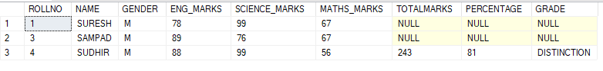

MORE EXAMPLES ON STORED PROCEDURES
FIRST CREATE THE TABLES (COUNTRY & STATE) AND THEN WILL DO AN EXAMPLE OF INSERTING VALUES INTO BOTH THE TABLES
CREATE TABLE COUNTRY  (  COUNTRY_ID INT IDENTITY(1,1) PRIMARY KEY,  COUNTRY_NAME NVARCHAR(100),  COUNTRY_CAPITAL NVARCHAR(100)  ) | CREATE TABLE STATE  (  STATE_ID INT IDENTITY(1,1) PRIMARY KEY,  STATE_NAME NVARCHAR(100),  STATE_CAPITAL NVARCHAR(100),  COUNTRY_ID INT CONSTRAINT FK_COUNTRY FOREIGN KEY REFERENCES COUNTRY(COUNTRY_ID)  )

SP –Examples: Create a Stored Procedure to insert a COUNTRY AND STATE.
CREATE PROCEDURE SP_INSERTCOUNTRY
(
@COUNTRYNAME NVARCHAR(100),
@COUNTRYCAPITAL NVARCHAR(100),
@STATENAME NVARCHAR(100),
@STATECAPITAL NVARCHAR(100)
)
AS
BEGIN
DECLARE @COUNTRYID INT
INSERT INTO COUNTRY VALUES (@COUNTRYNAME,@COUNTRYCAPITAL)
SET @COUNTRYID=@@IDENTITY
INSERT INTO STATE VALUES (@STATENAME,@STATECAPITAL,@COUNTRYID)
SELECT * FROM COUNTRY
SELECT * FROM STATE
END

Stored Procedure Example:
CREATE PROCEDURE [SP_INSERTCOUNTRY]
(
@COUNTRYNAME NVARCHAR(100),
@COUNTRYCAPITAL NVARCHAR(100),
@STATENAME NVARCHAR(100),
@STATECAPITAL NVARCHAR(100)
)
AS
BEGIN
DECLARE @COUNTRYID INT=0
Select @COUNTRYID=COUNTRY_ID FROM COUNTRY WHERE COUNTRY_NAME=@COUNTRYNAME
IF (@COUNTRYID= 0)
BEGIN
INSERT INTO COUNTRY VALUES(@COUNTRYNAME,@COUNTRYCAPITAL)
SET @COUNTRYID=@@IDENTITY
END
ELSE
BEGIN
PRINT 'COUNTRY ALREADY EXISTS'
END
INSERT INTO STATE VALUES(@STATENAME,@STATECAPITAL,@COUNTRYID)
SELECT * FROM COUNTRY
SELECT * FROM STATE
END

EXEC [SP_INSERTCOUNTRY] 'INDIA','DELHI','GUJURAT','AHMEDABAD'

EXEC [SP_INSERTCOUNTRY] 'INDIA','DELHI','MP','BHOPAL'

EXEC [SP_INSERTCOUNTRY] 'U.S.A','WASIGNTON','MS','BOSTON'

Output Parameters in Stored Procedures
Setting up output parameters for a stored procedure is basically the same as setting up input parameters, the only difference is that you use the OUTPUT clause after the parameter name to specify that it should return a value. The output clause can be specified by either using the keyword "OUTPUT" or just "OUT".

Example: Creating a Stored Procedure with output parameters

CREATE PROCEDURE SP_ADDITION
(
@n1 int,
@n2 int,
@t int output
)
as
BEGIN
set @t = @n1 + @n2
END
Calling the stored procedure with output parameters
DECLARE @tot int
exec SP_ADDITION 100,200 , @tot output
print @tot

Types of Stored Procedures
- User Defined Stored procedure: The user defined stored procedures are created by users and stored in the current database
- Temporary Stored procedures: The temporary stored procedures have names prefixed with the # symbol. Temporary stored procedures stored in the tempdb databases. These procedures are automatically dropped when the connection terminates between client and server.
Temporary stored procedures on Microsoft SQL Server are prefixed with a pound sign #. One pound sign means that it’s temporary within the session, two pound signs ## means it’s a global temporary procedure, which can be called by any connection to the SQL server during its lifetime.
Example of Temporary Stored Procedure:
CREATE PROC #SP_MULTIPLY
(
@N1 INT,
@N2 INT
)
AS
BEGIN
DECLARE @T INT = @N1 * @N2
PRINT @T
END

EXEC #SP_MULTIPLY 10,20

- Remote Stored Procedures: The remote stored procedures are procedures that are created and stored in databases on remote servers. These remote procedures can be accessed from various servers, provided the users have the appropriate permission
- Extended Stored Procedures: These are Dynamic-link libraries (DLL's) that are executed outside the SQL Server environment. They are identified by the prefix xp_
Creating Extended Stored Procedures
An extended stored procedure appears as a normal function with the following prototype:
sp_addextendedproc ‘xp_average’, ‘xp_average.dll’, where xp_ is optional and the xp name is case sensitive. All functions outside of the DLL must be exported, which can be done by listing its name in the EXPORTS section of .def file.
Let’s examine a code snippet to create an Extended stored procedure DLL in C# - compiled and stored in 'C: \Program Files\Microsoft SQL Server\MSSQL12.SQL2014\MSSQL\Bin\
- public class xp_sampleUser
- {
- Staticstring connection String = System.Configuration.ConfigurationManager.ConnectionString ["Connection String"].
- ConnectionString.ToString ();
- [Microsoft.SqlServer.Server.SqlProcedure]
- publicstaticvoid HelloWorld ()
- {
- SqlContext.Pipe.Send ("Hello world! The Time is" + System.DateTime.Now.ToString () + "\n");
- Using (SqlConnection connection = newSqlConnection (connection String))
- {
- Connection. Open ();
- SqlCommand command = newSqlCommand ("SELECT value FROM MSreplication_options where opt name='transactional'", connection);
- SqlDataReader reader = command.ExecuteReader ();
- SqlContext.Pipe.Send (reader);
- }
- }
- }
To add the procedure, we are prompted with sp_addextendedproc ‘xp_average’, ‘xp_average.dll’
Calling an XP is similar to calling a normal stored procedure, but it remains inside a master database. Therefore, a prefix ‘master’ DB name is mandatory. To demonstrate extended stored procedures, we’ll use an example.
Sample: To find the free space of a drive
Signature exec master..xp_fixeddrives
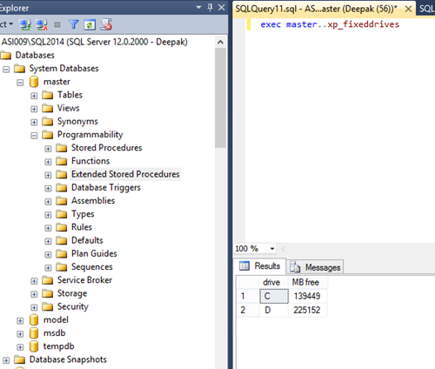

Advantages
- Create DLL routines as regular Stored Procedures for any SQL Server version.
- Since they use API-Request/Response formats, they are capable of running remotely.
- In the case of non–SQL Server based applications, we can create gateways to tie the two programs together.
- We can interface with various applications, and this function will deliver the result set as a whole.
Disadvantages
- The reliability of the server may get reduced by extended stored procedures, sometimes leading to memory leaks.
- Granting permission to other users is mandatory - system admin reviews are a must after each update.
- If user data was directly appended as an input, SQL Injection may possible.

SPs - Auto Executing-startup procedures
You can designate stored procedures to execute every time the SQL Server is started. These types of procedures cannot accept any input parameters and have to be owned by a member of SYSADMIN fixed server role. To designate stored procedures for automatic execution, use the sp_procoption system stored procedure.
The only option allowed by this procedure is 'startup'. The procedure to be started automatically MUST reside in the Master database. The following example makes the procedure execute automatically every time the server starts up: sp_procoption my_procedure,'startup', 'on'
- This option could be useful if you have specific processing requirements or tasks that need to be perform at server startup - for instance you might wish to backup all of your user databases every time SQL Server is started.
USE MASTER
CREATE TABLE LOGGEDINUSERDETAILS
(
ID INT IDENTITY(1,1),
USERNAME VARCHAR(100),
LOGGEDINTIME DATETIME
)
SELECT * FROM LOGGEDINUSERDETAILS
CREATE PROCEDURE SP_LOGIN
AS
BEGIN
INSERT INTO LOGGEDINUSERDETAILS VALUES(SUSER_NAME(),GETDATE())
END

sp_procoption 'SP_LOGIN','startup', 'on'
System Stored Procedure: The system stored procedure has names prefixed with sp_. Its manage SQL Server through administrative tasks. Which databases store system stored procedures are master and msdb database. E.g. : sp_rename
SYSTEM STORED PROCEDURES
System Stored Procedures are useful in performing administrative and informational activities in SQL Server. Here’s a bunch of System Stored Procedures that are used on a frequent basis (in no particular order):
System Stored Procedure | Description
sp_help | Reports information about a database object, a user-defined data type, or a data type
sp_helpdb | Reports information about a specified database or all databases
sp_helptext | Displays the definition of a user-defined rule, default, unencrypted Transact-SQL stored procedure, user-defined Transact-SQL function, trigger, computed column, CHECK constraint, view, or system object such as a system stored procedure
sp_helpfile | Returns the physical names and attributes of files associated with the current database. Use this stored procedure to determine the names of files to attach to or detach from the server
sp_spaceused | Displays the number of rows, disk space reserved, and disk space used by a table, indexed view, or Service Broker queue in the current database, or displays the disk space reserved and used by the whole database
sp_who | Provides information about current users, sessions, and processes in an instance of the Microsoft SQL Server Database Engine. The information can be filtered to return only those processes that are not idle, that belong to a specific user, or that belong to a specific session
sp_lock | Reports information about locks. This stored procedure will be removed in a future version of Microsoft SQL Server. Use the sys.dm_tran_locks dynamic management view instead.
sp_configure | Displays or changes global configuration settings for the current server
sp_tables | Returns a list of objects that can be queried in the current environment. This means any object that can appear in a FROM clause, except synonym objects.
sp_columns | Returns column information for the specified tables or views that can be queried in the current environment
sp_depends | Displays information about database object dependencies, such as the views and procedures that depend on a table or view, and the tables and views that are depended on by the view or procedure. References to objects outside the current database are not reported

Lesson 2: Implementing User-Defined Functions
They simply return a single value or a table value. They can only be use to select records. However, they can be called very easily from within standard SQL
Understanding User-Defined Functions
The purpose of a user-defined function (UDF) is to encapsulate reusable T-SQL code and return a scalar value or a table to the caller. Like stored procedures, UDFs can accept parameters, and the parameters can be accessed inside the function as variables.
- UDFs cannot be executed by using the EXECUTE command.
- UDFs access SQL Server data, but they cannot perform any DDL—that is, they cannot create tables, and they cannot make modifications to tables, indexes, or other objects, or change any data in permanent tables by using a DML statement.
Syntax of Function:
Create function function_name ( Parameter1 datatype, Parameter2 datatype )
RETURNS DATATYPE
AS
BEGIN
STATEMENTS
RETURN VALUE
END

SYNTAX FOR CALLING A FUNCTION
SELECT dbo.functionname('Parameter1')
OR
SELECT Name, dbo.Functionname('Parameter1') FROM sysObjects

Function Examples
Create function fn_add (@n1 int, @n2 int ) returns INT
AS
BEGIN
Declare @tot int
Set @tot= @n1 + @n2
Return @tot
End

CALLING A FUNCTION : SYNTAX : Select dbo.function_name(parameters)
EXAMPLE
Select dbo. fn_add (100,200)
For simple reusable select operations, functions can simply your code. Just be wary of using JOIN clauses in your functions. If your function has a JOIN clause and you call it from another select statement that returns multiple results that function call with JOIN those tables together for EACH line returned in the result set. So they can be helpful in sampling some logic, they can also be a performance bottleneck if they're not used properly.
There are two major types of UDFs:
- Scalar and table-valued.
- Table-valued function
The scalar function
Scalar function returns a single value back. . Scalar UDFs can consist of a single line of T-SQL code, or of multiple lines.
WRITE A FUNCTION TO GET THE NUMBER OF EMPLOYEES IN A DEPT
CREATE FUNCTION FN_GETEMPCOUNT
(
@DEPTNAME VARCHAR(100)
)
RETURNS INT
AS
BEGIN
DECLARE @COU INT
SELECT @COU = COUNT(*) FROM EMPLOYEE WHERE DEPARTMENT=@DEPTNAME
RETURN @COU
END

SELECT DBO.FN_GETEMPCOUNT('IT') AS EMPCOUNT

Table-Valued Functions
User-defined table-valued functions return a table data type. For an inline table-valued function, there is no function body; the table is the result set of a single SELECT statement.
The following example creates an inline table-valued function. The function takes one input parameter, a customer (store) ID, and returns the columns ProductID, Name, and the aggregate of year-to-date sales as YTD Total for each product sold to the store.
Example:
CREATE FUNCTION FN_GETEMP
(
@DEPTNAME VARCHAR(100)
)
RETURNS TABLE
RETURN (SELECT * FROM EMPLOYEE WHERE DEPARTMENT = @DEPTNAME)

SELECT * FROM FN_GETEMP('IT')

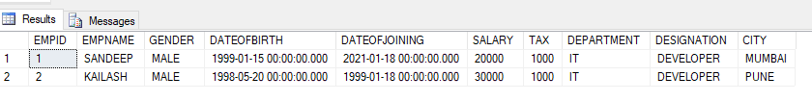
Note: Functions cannot be used to update, delete, or add records to the database.
Difference between stored procedures and functions.
- Unlike Stored Procedure, Function returns only single value.
- Unlike Stored Procedure, Function accepts only input parameters.
- Unlike Stored Procedure, Function is not used to Insert, Update, Delete data in database table(s).
- Like Stored Procedure, Function can be nested up to 32 levels.
- User Defined Function can have up to 1023 input parameters while a Stored Procedure can have up to 21000 input parameters.
- User Defined Function can't returns XML Data Type.
- User Defined Function doesn't support Exception handling.
- User Defined Function can call only Extended Stored Procedure.
- User Defined Function doesn't support set options like set ROWCOUNT etc.

CHAPTER 8: summary / CHEATSHEET
Stored Procedure is a set of sql statements which is stored as a program, which can be reused.
Stored are used to create business logic which can be called from different applications like front end applications, reporting applications etc.
A function is a set of sql statements which is used to create programs which returns a value.
A function cannot have INSERT,UPDATE OR DELETE statements, whereas a stored procedure can have insert, update and delete statements.
A stored procedure cannot be used in a select statement, whereas a function can be used inside the select statements.

CHAPTER 8: EXERCISE 1 (ASSIGNMENT)
PROCEDURE ASSIGNMENTS
- Write a PROCEDURE to display a multiplication table for a number. User will enter a number and it should display the multiplication table.
- Write a PROCEDURE to calculate the area of a rectangle. User will enter the length and breadth and it should display the area.
- Write a PROCEDURE to check whether the number is prime number or not. User will enter a number and it should display whether it is a prime number or not.
- Write a procedure which will bifurcate a fullname into firstname and lastname.User will enter fullname like Amit Patil and it should display FirstName : Amit and LastName : Patil
- Write a PROCEDURE to generate a triangle similar to this.
*
* *
* * *
* * * *
* * * * *

FUNCTION ASSIGNMENTS
- Write a function to add two numbers.
- Write a function to add /sub/mul/div based upon the mode passed. (Eg: user will pass two numbers and mode, (5, 6,”Add”) accordingly it should return value).
- Write a function to calculate the age in year. User will pass the Date of Birth and it should return the age in terms of number.
- Write a function to calculate the factorial of a number.
- Write a Function to calculate the square of a number and return the result.
- Write a Function to calculate the grade for the percentage enter. User will enter the percentage it should return the GRADE. (DISTINCTION >= 75, FIRSTCLASS>=60, SECONDCLASS>=40, FAIL)

CHAPTER 8: EXERCISE 2 (ASSIGNMENT)
CREATE A TABLE FOR COMPANY
COLUMN_NAME | DATATYPE | CONSTRAINT
COMPANYID | INT | PRIMARY KEY, IDENTITY(1,1)
COMPANYNAME | VARCHAR(100)
WEBSITE | VARCHAR(100)
EMAIL | VARCHAR(100)

Write a Stored procedure to add/insert a row and then display the company row added.
Write a Stored Procedure to delete a company by using CompanyId

CREATE A TABLE FOR DEPT
COLUMN_NAME | DATATYPE | CONSTRAINT
DEPTID | INT | PRIMARY KEY, IDENTITY(1,1)
DEPTNAME | VARCHAR(100)
DEPTLOCATION | VARCHAR(100)
Write a Stored procedure to add/insert a row and then display the department row added.
Write a Stored Procedure to delete a department by using DepartmentId

CREATE A TABLE FOR DESG

COLUMN_NAME | DATATYPE | CONSTRAINT
DESGID | INT | PRIMARY KEY
DESGNAME | VARCHAR(100)
CREATEDDATE | DATETIME | DEFAULT - GETDATE()

Write a Stored procedure to add/insert a row and then display the desg row added.
Write a Stored Procedure to delete a designation by using DesignationId

CREATE A TABLE FOR EMPLOYEE
COLUMN_NAME | DATATYPE | CONSTRAINT
EMPID | INT | PRIMARY KEY
EMPNAME | VARCHAR(100) | UNIQUE
BASICSALARY | FLOAT
INCENTIVE | FLOAT
BONUS | FLOAT
DOB | DATETIME
DOJ | DATETIME | DEFAULT GETDATE()
GENDER | VARCHAR(100)
EMAIL | VARCHAR(100) | UNIQUE
MOBILE | VARCHAR(10)
CREATEDDATE | DATETIME | DEFAULT GETDATE()
COMPANYID | INT | F.K
DEPTID | INT | F.K
DESGID | INT | F.K

Write a Stored procedure to add and display an Employee
Write a Stored Procedure to delete an Employee by using EmployeeId
CREATE A TABLE FOR STUDENT
COLUMN_NAME | DATATYPE | CONSTRAINT
ROLLNO | INT | PRIMARY KEY (IDENTITY(1,1)
NAME | VARCHAR(100) | UNIQUE
ENGMARKS | FLOAT
SCNMARKS | FLOAT
MATHMARKS | FLOAT
TOTALMARKS | FLOAT
PERCENTAGE | FLOAT
GRADE | VARCHAR(100)

CREATE TABLE STUDENTS
(
ROLLNO INT IDENTITY(1,1) PRIMARY KEY,
NAME VARCHAR(100) UNIQUE,
ENGMARKS FLOAT,
SCNMARKS FLOAT,
MATHMARKS FLOAT,
TOTAL FLOAT,
PERCENTAGE FLOAT,
GRADE VARCHAR(100)
)
- Part A

WRITE A PROCEDURE TO INSERT VALUES INTO STUDENTS
THE PROCEDURE SHOULD TAKE NAME, ENGMAKS, SCNMARKS, MATHMARKS AS INPUT PARAMETERS AND CALCULATE THE TOTALMARKS, PERCENTAGE & GRADE AND INSERT IT INTO THE STUDENTS TABLE

- Part B
IF THE NAME IS ALREADY PRESENT THEN IT SHOULD UPDATE THE VALUES INTO THE STUDENTS TABLE.

CREATE TWO TABLES COUNTRY & STATE

COUNTRY
COUNTRY_ID | COUNTRY_NAME | COUNTRY_CAPITAL
INT, IDENTITY, PRIMARY KEY | UNIQUE

STATE
STATE_ID | STATE_NAME | STATE_CAPITAL | COUNRTYID
INT, IDENTITY, PRIMARY KEY | UNIQUE |  | INT (FOREIGN KEY)

CREATE TABLE COUNTRY
(
COUNTRYID INT IDENTITY(1,1) PRIMARY KEY,
COUNTRYNAME VARCHAR(100),
COUNTRYCAPITAL VARCHAR(100)
)

CREATE TABLE STATES
(
STATEID INT IDENTITY(1,1) PRIMARY KEY,
STATENAME VARCHAR(100),
STATECAPITAL VARCHAR(100),
COUNTRYID INT FOREIGN KEY REFERENCES COUNTRY(COUNTRYID)
)

WRITE A SINGLE PROCEDURE TO INSERT VALUES INTO BOTH COUNTRY & STATE TABLE.
PROCEDURE PARAMETERS
COUNTRY_NAME | COUNTRY_CAPITAL | STATE_NAME | STATE_CAPITAL

1 | WRITE A PROCEDURE TO TAKE THE BACKUPS OF ALL THE DATABASES IN THE SERVER
2 | WRITE A PROCEDURE TO DISPLAY THE NAMES OF ALL THE TABLES IN THE DATABASE.  THE USER WILL ENTER THE DATABASE NAME AND IT SHOULD DISPLAY THE LIST OF TABLES IN THE DATABASE
3 | WRITE A PROCEDURE TO SEND A MAIL TO An EMAIL ID.  THE USER WILL ENTER THE EMAILID AND IT SHOULD SEND A MAIL TO THE EMAILID
4 | WRITE A PROCEDURE TO DISPLAY THE COLUMN NAMES OF A TABLE.  THE USER WILL ENTER THE TABLENAME AND IT SHOULD DISPLAY THE LIST OF COLUMNS OF THE TABLE
5 | WRITE A PROCEDURE TO DISPLAY THE SIZE OF EACH OF THE DATABASES IN THE SERVER

chapter 8: QUESTIONS
Define Stored Procedure along with its usage ?
What are the advantages of Stored Procedure ?
What are the disadvantages of Stored Procedure ?
What is a function in SQL Server?
What are the different types of functions in sql server ?
Advantages of functions in SQL SERVER ?
Difference between stored procedure and functions ?
Can we call stored procedure inside function ?
Can we call function inside stored Procedure ?

CHAPTER 9

CHAPTER 9: IMPLEMENTING Transactions, Error handling
Microsoft SQL Server is a relational database that strictly enforces transactional behavior on database changes in order to protect data integrity. This chapter presents the T-SQL code behind transactions, and extends that code to handling errors and using dynamic SQL.
Lessons in this chapter:
- Lesson 1: Implementing Error Handling
- Lesson 2: Managing Transactions

LESSON 1: IMPLEMENTING ERROR HANDLING
Exception handling are used to handle errors raised in the program while execution due to wrong data etc.
The error needs to be handled else the program will terminate abnormally.

All statements should be put inside the begin try and end try block to handle exceptions in SQL statements.

SYNTAX FOR HANDLING ERRORS
BEGIN TRY
{SQL_statement | statement_block}
END TRY
BEGIN CATCH
[{sql_statement | statement_block}]
END CATCH

In case of error in SQL statements, it will be redirected to the CATCH block.

sql_statement : Is any Transact-SQL statement.

statement_block : Any group of Transact-SQL statements in a batch or enclosed in a BEGIN…END block.

A TRY…CATCH construct catches all execution errors that have a severity higher than 10 that do not close the database connection.
A TRY block must be immediately followed by an associated CATCH block. Including any other statements between the END TRY and BEGIN CATCH statements generates a syntax error.
Errors encountered in a CATCH block are treated like errors generated anywhere else.
If the CATCH block contains a nested TRY…CATCH construct, any error in the nested TRY block will pass control to the nested CATCH block. If there is no nested TRY…CATCH construct, the error is passed back to the caller.
GOTO statements cannot be used to enter a TRY or CATCH block. GOTO statements can be used to jump to a label inside the same TRY or CATCH block or to leave a TRY or CATCH block.
Example:
BEGIN TRY
-- Generate divide-by-zero error.
SELECT 1/0;
END TRY
BEGIN CATCH
-- Execute error retrieval routine.
PRINT ‘ERROR OCCURRED’
END CATCH;
The TRY…CATCH construct cannot be used in a user-defined function.
Retrieving Error Information
In the scope of a CATCH block, the following system functions can be used to obtain information about the error that caused the CATCH block to be executed:
ERROR_NUMBER() | Returns the number of the error.
ERROR_SEVERITY() | Returns the severity.
ERROR_STATE() | Returns the error state number.
ERROR_PROCEDURE() | Returns the name of the stored procedure or trigger where the error occurred.
ERROR_LINE() | Returns the line number inside the routine that caused the error.
ERROR_MESSAGE() | Returns the complete text of the error message. The text includes the values supplied for any substitutable parameters, such as lengths, object names, or times.
These functions return NULL if they are called outside the scope of the CATCH block. Error information can be retrieved by using these functions from anywhere within the scope of the CATCH block.
CREATE PROCEDURE usp_GetErrorInfo
AS
BEGIN
BEGIN TRY
-- Generate divide-by-zero error.
SELECT 1/0;
END TRY
BEGIN CATCH
-- Execute error retrieval routine.
SELECT ERROR_NUMBER() AS ErrorNumber ,ERROR_SEVERITY() AS ErrorSeverity
,ERROR_STATE() AS ErrorState,ERROR_PROCEDURE() AS ErrorProcedure
,ERROR_LINE() AS ErrorLine,ERROR_MESSAGE() AS ErrorMessage;
END CATCH

END

EXEC usp_GetErrorInfo
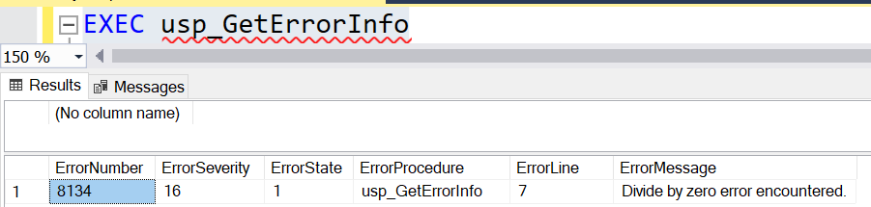

EXAMPLE OF ERROR HANDLING WHILE INSERT A VALUE INTO A TABLE THROUGH SP

CREATE TABLE EMP_EXP
(
EMPID INT PRIMARY KEY,
EMPNAME VARCHAR(100) UNIQUE,
SALARY FLOAT CHECK(SALARY > 25000)
)
CREATE A TABLE AND STORED PROCEDURE AND CALL IT
CREATE procedure [dbo].[esp_addemp]
(
@id int,
@name nvarchar(200),
@salary int
)
as
begin
begin try
insert into EMP_EXP values(@id,@name,@salary)
End try
Begin catch
SELECT ERROR_NUMBER()AS ErrorNumber,ERROR_MESSAGE()AS ErrorMessage
End catch
End
CALLING THE PROCEDURE WITH A VALUE LESS THAN 25000 WILL THROW AN ERROR SHOWN BELOW
exec esp_addemp 1,'amit',20000
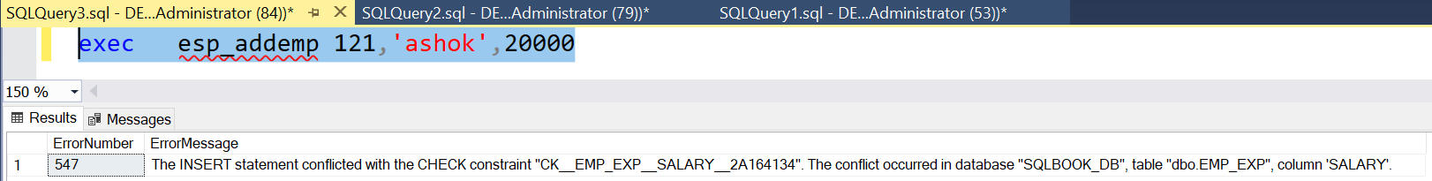

Logging Errors
CREATE TABLE ERRORDETAILS
(
ERRORID INT IDENTITY(1,1),
ERRORLINENUMBER INT,
ERRORMESSAGE VARCHAR(4000),
ERRORPROGRAMNAME VARCHAR(200),
ERRORSEVERITY INT,
ERRORDATETIME DATETIME,
ERRORGENERATEDBY VARCHAR(100)
)
CREATE PROCEDURE SP_DIV
(
@n1 int,
@n2 int
)
AS
BEGIN

BEGIN TRY
declare @t int = @n1 / @n2
print @t
END TRY
BEGIN CATCH
PRINT 'AN ERROR OCCURED, PLEASE CHECK THE INPUT VALUES'
SELECT ERROR_LINE() AS LINENUMBER,ERROR_MESSAGE(),ERROR_PROCEDURE() AS PROGRAMNAME,
ERROR_SEVERITY() AS SEVERITY

INSERT INTO ERRORDETAILS
SELECT ERROR_LINE() AS LINENUMBER,ERROR_MESSAGE(),ERROR_PROCEDURE() AS PROGRAMNAME,
ERROR_SEVERITY() AS SEVERITY,GETDATE(),SUSER_NAME()
END CATCH

END

EXEC SP_DIV 50,0

SELECT * FROM ERRORDETAILS

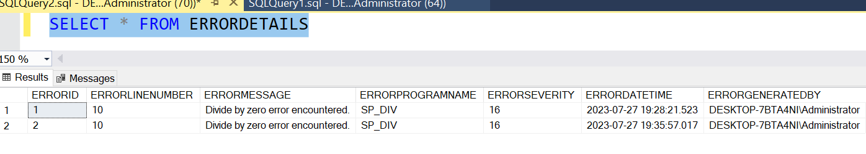

TRY…CATCH constructs do not trap the following conditions:
- Warnings or informational messages that have a severity of 10 or lower.
- Errors that have a severity of 20 or higher that stops the SQL Server Database Engine task processing for the session. If an error occurs that has severity of 20 or higher and the database connection is not disrupted, TRY…CATCH will handle the error.
- Attentions, such as client-interrupt requests or broken client connections.
- When the session is ended by a system administrator by using the KILL statement.
The following types of errors are not handled by a CATCH block when they occur at the same level of execution as the TRY…CATCH construct:
- Compile errors, such as syntax errors, that prevent a batch from running.
- Errors that occur during statement-level recompilation, such as object name resolution errors that occur after compilation because of deferred name resolution.
These errors are returned to the level that ran the batch, stored procedure, or trigger.
If an error occurs during compilation or statement-level recompilation at a lower execution level (for example, when executing sp_executesql or a user-defined stored procedure) inside the TRY block, the error occurs at a lower level than the TRY…CATCH construct and will be handled by the associated CATCH block.
The following example show how an object name resolution error generated by a SELECT statement is not caught by the TRY…CATCH construct, but is caught by the CATCH block when the same SELECT statement is executed inside a stored procedure.

BEGIN TRY
-- Table does not exist; object name resolution
-- Error not caught.
SELECT * FROM NonexistentTable;
END TRY
BEGIN CATCH
SELECT ERROR_NUMBER() AS ErrorNumber ,ERROR_MESSAGE() AS ErrorMessage;
END CATCH
The error is not caught and control passes out of the TRY…CATCH construct to the next higher level.
Running the SELECT statement inside a stored procedure will cause the error to occur at a level lower than the TRY block. The error will be handled by the TRY…CATCH construct.
-- Create a stored procedure that will cause an -- object resolution error.
CREATE PROCEDURE usp_ExampleProc
AS
SELECT * FROM NonexistentTable;
GO
BEGIN TRY
EXECUTE usp_ExampleProc;
END TRY
BEGIN CATCH
SELECT ERROR_NUMBER() AS ErrorNumber ,ERROR_MESSAGE() AS ErrorMessage;
END CATCH;

ADDING CUSTOM ERROR MESSAGES
SP_addmessage: We use the SP_admessage Stored Procedure to define a User Defined Custom Error Message.
This Stored Procedure adds a record to the sys.message system view.
A User Defined message should have a message number of 50000 or higher with a severity of 1 to 25.
Syntax:
sp_addmessage [ @msgnum = ] msg_id ,[ @severity = ] severity ,[ @msgtext = ] 'msg'[ , [ @lang = ] language' ][ , [ @with_log = ] 'with_log' ]
[ , [ @replace = ] 'replace' ]
Here mcg_id is the id of the message which can be between 50000 and 2147483647.
- The severity is the level of the message which can be between 1 and 25.
- For User Defined messages we can use it a value of 0 to 19.
- The severity level Between 20 to 25 can be set by the administrator. Severity levels from 20 through 25 are considered fatal.
- The actual error message is "msg", which uses a data type of nvarchar (255). The maximum characters limit is 2,047. Any more than that will be truncated.
The language is used if you want to specify any language. Replace is used when the same message number already exists, but you want to replace the string for that ID, you have to use this parameter.
RAISERROR
The RAISERROR statement generates an error message by either retrieving the message from the sys.messages catalog view or constructing the message string at runtime.
It is used to invoke the User Defined error message.
First we create a User Defined error message using sp_addmessage and after that we invoke that by the use of RAISERROR.
SYNTAX:
RAISERROR ( { msg_id }{ ,severity ,state }[ ,argument [ ,...n ] ] )[ WITH option [ ,...n ] ]
Example:
EXEC sp_addmessage 500021, 10,'THis error message is created by ENOSIS LEARNING'
Go
RAISERROR (500021, 10, 1)
Replacement of Message.
EXEC sp_addmessage 500021, 10,'Previous error message is replaced by ENOSIS LEARNING',
@lang='us_english', @with_log='false', @replace='replace'
GO
RAISERROR (500021, 10, 1)
Altering the message:
Exec sp_altermessage 500021, @parameter='with_log', @parameter_value='true'
Output:
Dropping the message:
Exec sp_dropmessage
500021
Output: USE master: Adding error messages
EXEC sp_addmessage 50001, 1,N'This message is not that big of a deal.
This is not caught by error handling, and prints this message to the screen.';
EXEC sp_addmessage 50002, 16,N'This actually causes an error,
and is caught by error-handling';
EXEC sp_addmessage 50003, 20,N'This causes an error, and stops any further
processing. This is not caught by error handling.';

Using custom error messages
Now that my custom error messages are defined, I can use them inside my database engine. To invoke these errors, I'll use the RAISERROR TSQL construct. RAISERROR accepts an error number, a severity level, and a state number.
Select * from sys.messages : To view the error messages.
The following snippet uses RAISERROR inside of a TRY...CATCH construct. I am including the WITH LOG option of the RAISERROR statement to write the error message to the application log so that I can review it later if necessary. (This particular error does not invoke the CATCH block due to the severity of the error.
BEGIN TRY
RAISERROR (50001, 1, 1) WITH LOG
END TRY
BEGIN CATCH
SELECT ERROR_MESSAGE (), ERROR_NUMBER ()
END CATCH
This statement invokes the second custom error message I define above. This message has a defined severity of 16, which will get caught by my CATCH statement. These types of error messages are some of the more commonly seen messages inside the SQL Server database engine.
BEGIN TRY
RAISERROR (50002, 16, 1) WITH LOG
END TRY
BEGIN CATCH
SELECT ERROR_MESSAGE (), ERROR_NUMBER ()
END CATCH

Msg 2745, Level 16, State 2, Line 2
Process ID 51 has raised user error 50003, severity 20. SQL Server is terminating this process.

Msg 50003, Level 20, State 1, Line 2
This causes an error, and stops any further processing. This is not caught by error handling.

Msg 0, Level 20, State 0, Line 0
A severe error occurred on the current command. The results, if any, should be discarded.

The error is marked as so severe that if I were to run the same statement again, I receive the following error:
Msg 233, Level 20, State 0, Line 0
A transport-level error has occurred when receiving results from the server. (Provider: Shared Memory Provider, error: 0 - No process is on the other end of the pipe.)
This error states that the connection has been terminated.

Example: (Create a stored procedure for inserting a value and if value is less than 25000 will call the custom error code though procedure)

First create a custom error code and then create a procedure and call it.
EXEC sp_addmessage 50005, 1,'SALARY SHOUBE BE GREATER THAN 25000’;
CREATE procedure [dbo].[esp_insert]
( @id int, @name nvarchar(200), @salary int )
as
begin
begin try
if (@salary <= 25000)
begin
RAISERROR (50005, 1, 1)WITH LOG
end
else
begin
insert into EMP_EXP values(@id,@name,@salary)
end
End try
Begin catch
SELECT ERROR_NUMBER()AS ErrorNumber,ERROR_MESSAGE()AS ErrorMessage
End catch
end

exec esp_insert 11,'jayesh',20000
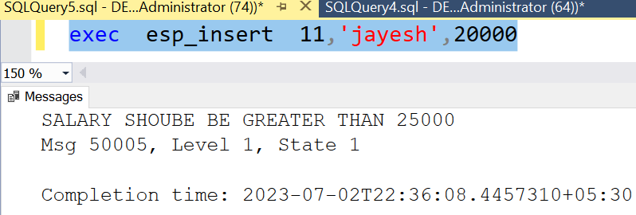

Lesson 2: Managing Transactions
- Transaction is a group of commands that is treated and executed as a single unit.
- If the one of the commands in the transaction fails, all the commands fail, and any data that was modified in the database is rolled back.
- Transaction maintain the integrity of data in a database.
For processing the transaction,steps are as follow :
- Begin the transaction.
- Process database commands
- Check for error
If error occurred,
Rollback the transaction
Else
Commit the transaction

Syntax to create transaction

BEGIN TRY
BEGIN TRAN
STATEMENTS
COMMIT TRAN
END TRY
BEGIN CATCH
ROLLBACK TRAN
END CATCH

EXAMPLE OF TRANSACTION
WITHOUT TRANSACTION | WITH TRANSACTION
CREATE TABLE EMP _T  (  EMPID INT PRIMARY KEY,  EMPNAME VARCHAR(100),  SAL FLOAT  )  Begin try  insert into EMP _T values(1,'Anil',51000)  insert into EMP _T values(2,’Sunil’,61000)  insert into EMP _T values(1,'Kapil',81000)  insert into EMP _T values(16,’Jay’,17000)  End try  Begin Catch  Select ERROR_MESSAGE() AS ErrorMessage  End Catch | Begin try  BEGIN TRAN  insert into EMP _T values(1,'Anil',51000)  insert into EMP _T values(2,’Sunil’,61000)  insert into EMP _T values(1,'Kapil',81000)  insert into EMP _T values(16,’Jay’,17000)  COMMIT TRAN  End try  Begin Catch  ROLLBACK TRAN  Select ERROR_MESSAGE() AS ErrorMessage  End Catch
It will insert the record 1 and 2 and go to the error block. | It will not commit any records since there is a error it will go the catch block and revert the transaction

Begin try
Begin tran
insert into EMP _T values(3,'ravi',56000)
insert into EMP _T values(4,'sandeep',66000)
save transaction s1
insert into EMP _T values(5,'anil',76000)
insert into EMP _T values(4,'rajdeep',36000)
insert into EMP _T values(6,'amitabh',26000)
commit tran
end try
begin catch
rollback transaction s1
SELECT ERROR_NUMBER() AS ErrorNumber,ERROR_SEVERITY() AS ErrorSeverity
,ERROR_STATE() AS ErrorState,ERROR_PROCEDURE() AS ErrorProcedure
,ERROR_LINE() AS ErrorLine,ERROR_MESSAGE() AS ErrorMessage
End catch

Additional Transaction Options
Additional remaining options for transactions are available that are
- Savepoints: These are locations within transactions that you can use to roll back a selective subset of work.
  - You can define a savepoint by using the SAVE TRANSACTION <savepoint name> command.
  - The ROLLBACK statement must reference the savepoint. Otherwise, if the statement is unqualified, it will roll back the entire transaction.
Keep in mind that SQL updates and rollbacks generally are expensive operations. So savepoints are useful only in situations where errors are unlikely and checking the validity of an update beforehand is relatively costly.

The syntax for typical server savepoint usage (where SAVE TRANSACTION permissions default to any valid user) is:

SAVE TRANSACTION SavepointName
IF @@error= some Error
BEGIN
ROLLBACK TRANSACTION SavepointName
COMMIT TRANSACTION
END

- Cross-database transactions: A transaction may span two or more databases on a single SQL Server instance without any additional work on the user’s part.
  - SQL Server preserves the ACID properties of cross-database transactions without any additional considerations.
  - However, there are limitations on database mirroring when using cross-database transactions. A cross-database transaction may not be preserved after a failover of one of the databases.
- Distributed transactions: It is possible to make a transaction span more than one server, by using a linked server. In that case, the transaction is known as a distributed (as opposed to local) transaction.
  - After a transaction spans multiple servers by using a linked server, the transaction is considered a distributed transaction and SQL Server invokes the Distributed Transaction Coordinator (MSDTC).
  - A transaction restricted to one database, or to a cross-database transaction, is considered a local transaction, as opposed to a distributed transaction, which crosses SQL Server instance boundaries.

CHAPTER 9: summary / cheatsheet
Error Handling is used to handle error generated in a program due to external conditions like wrong data, network failure etc. The error needs to be handled properly else the program will terminate abnormally.
Transaction is a group of commands that is treated and executed as a single unit.If the one of the commands in the transaction fails, all the commands fail, and any data that was modified in the database is rolled back.

CHAPTER 9:questions
Explain try and catch?
Define the usage of the following functions.
a. ERROR_NUMBER()
b. ERROR_SEVERITY()
c. ERROR_STATE()
d. ERROR_PROCEDURE()
e. ERROR_LINE()
f. ERROR_MESSAGE()
Can we use two or more catch block with associated one try block?
What is transaction?
What are the steps to write transaction?

CHAPTER 10: TABLE TYPES
This chapter covers two main topics. It starts with a lesson about the cursor. It then continues with a lesson about the use of temporary objects like local temporary tables and table variables, explaining when you should consider using each kind.
Lessons in this chapter:
- Lesson 1: Temporary Tables
- Lesson 2: Table Variable
- Lesson 3: CTE
- Lesson 4: Subquery

Lesson 1: Temporary Tables
SQL Server provides the concept of temporary table which helps the developer in a great way.
Temporary table are temporary in nature and are dropped automatically as soon as the sessions closes or disconnects. These tables can be created at runtime and can do the all kinds of operations that one normal table can do. But, based on the table types, the scope is limited. These tables are created inside tempdb database.
SQL Server provides two types of temp tables based on the behavior and scope of the table. These are:
LOCAL TEMP TABLE | GLOBAL TEMP TABLE
Local temp table are available only in the session of user. | Local temp table are available other users till the session of the user who have created the table is alive.

Local Temp Table
Local temp tables are available only in the current session of the user. and they are automatically deleted when the user disconnects or closes the session.
Local temporary table name is stared with hash ("#") sign.

The syntax given below is used to create a local Temp table:
CREATE TABLE #LocalTempTable
(
UserID int,
UserName varchar (50),
UserAddress varchar (150)
)
The above script will create a temporary table in tempdb database. We can insert or delete records in the temporary table similar to a general table like:
Insert into #LocalTempTable values (1, 'Abhijit’, ‘India');
Now select records from that table:
Select* from #LocalTempTable
After execution of all these statements, if you close the query window and again execute "Insert" or "Select" Command, it will throw the following error:
Msg 208, Level 16, State 0, Line 1 Invalid object name '#LocalTempTable'.
This is because the scope of Local Temporary table is only bounded with the current connection of current user.
Global Temp Table
Global Temporary tables name starts with a double hash ("##"). Global Temp tables and also available to other users till the session in which the table is created. Once the session disconnects or closes then the global temp table is dropped automatically. We need to put "##" with the name of Global temporary tables. Below is the syntax for creating a Global Temporary Table:
CREATE TABLE ##NewGlobalTempTable
(
UserID int, UserName varchar (50), UserAddress varchar (150)
)
The above script will create a temporary table in tempdb database. We can insert or delete records in the temporary table similar to a general table like:

Insert into ##NewGlobalTempTable values (1, 'Abhijit’, ‘India');
Now select records from that table: Select * from ##NewGlobalTempTable
Global temporary tables are visible to all SQL Server connections. When you create one of these, all the users can see it.
Storage Location of Temporary Table : Temporary tables are stored inside the Temporary Folder of tempdb. Whenever we create a temporary table, it goes to Temporary folder of tempdb database.
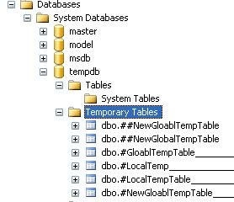
Now, if we deeply look into the name of Local Temporary table names, a 'dash' is associated with each and every table name along with an ID. Have a look at the image below:
SQL server does all this automatically; we do not need to worry about this; we need to only use the table name.
When to Use Temporary Tables?
Below are the scenarios where we can use temporary tables:
- When we are doing large number of row manipulation in stored procedures.
- This is useful to replace the cursor. We can store the result set data into a temp table, then we can manipulate the data from there.
- When we are having a complex join operation.

Points to Remember Before Using Temporary Tables
- Temporary table created on tempdb of SQL Server. This is a separate database. So, this is an additional overhead and can causes performance issues.
- Number of rows and columns need to be as minimum as needed.
- Tables need to be deleted when they are done with their work.
HIERARCHY STRUCTURE OF INSTANCES,LOGINS,SESSIONS,BATCH AND QUERIES
Instance (SERVER)
Login (UserLogins) [A INSTANCE/SERVER CAN HAVE MULTIPLE USERS]
Sessions (Temp Tables) [A USER /LOGINS CAN HAVE MULTIPLE SESSIONS]
Batch (A batch is a set of queries run as a single process in a session)
Queries(A query is single sql statement executed in a session)

LESsON 2: Table Variable
Table Variable is a variable which can stored a table as a variable. Its scope is limited to a batch.
We can do all operations on a table variable inside the batch.
Alternative of Temporary table is the Table variable which can do all kinds of operations that we can perform in Temp table. Below is the syntax for using Table variable.
SYNTAX
CREATE @table_variable TABLE
(
COLNAME1 DATATYPE,
COLNAME2 DATATYPE,
COLNAME3 DATATYPE
)
Declare @USERDETAIL TABLE
(
UserID int,
UserName varchar(50),
UserAddress varchar(150)
)
The below scripts are used to insert and read the records for Tablevariables:
insert into @USERDETAIL values ( 1, 'Abhijit’, ‘India');

Now select records from that table variable:
select * from @USERDETAIL
When to Use Table Variable over Temp Table
- Table variable is always useful for less data.
- If the result set returns a large number of records, we need to go for temp table.

Lesson 3: CTE
CTE (Common Table Expression)
A common table expression (CTE) can be thought of as a temporary result set that is defined within the execution scope of a single SELECT, INSERT, UPDATE, DELETE, or CREATE VIEW statement. A CTE is similar to a derived table in that it is not stored as an object and lasts only for the duration of the query. Unlike a derived table, a CTE can be self-referencing and can be referenced multiple times in the same query.
Syntax
With expression_name (columnname1, columnname2)
(
Cte query defination
)
Select columnname from expression_name
EXAMPLE OF CTE
WITH cte_emp(EMPID,EMPNAME,SALARY,TAX)
(
SELECT EMPID,EMPNAME,SALARY,TAX FROM EMPLOYEE
)
SELECT * FROM cte_emp

WRITE A CTE TO FINE THE TOP 5 EMPLOYEES
WITH EMP_TOP5(EMPID,EMPNAME,SALARY,TAX)
(
SELECT TOP 5 EMPID,EMPNAME,SALARY,TAX FROM EMPLOYEE ORDER BY SALARY DESC
)
SELECT * FROM EMP_TOP5
Advantages
- Can be used to create a recursive query.
- Can be substituted for a view.
- Allow grouping by a column which might be derived from a scalar subset.
- Can reference itself multiple times.
Disadvantages
- CTE’s members cannot use the following clauses of keywords Distinct, Group By, Having, Top, Joins limiting by this type of the queries that can be created and reducing their complexity.
- The Recursive member can refer to the CTE only once.
- Table Variables and CTE’s cannot be passed as parameters in stored procedures.

Lesson 4: subquery
When a query is included inside another query, the Outer query is known as Main Query, and Inner query is known as Subquery.
- Nested Query –
In Nested Query, Inner query runs first, and only once. Outer query is executed with result from Inner query.Hence, Inner query is used in execution of Outer query.
Example – Find details of customers who have ordered.
SELECT * FROM Customers WHERE
CustomerID IN (SELECT CustomerID FROM Orders);
- Correlated Query –
In Correlated Query, Outer query executes first and for every Outer query row Inner query is executed. Hence, Inner query uses values from Outer query.
Correlated subqueries are used for row-by-row processing. Each subquery is executed once for every row of the outer query.
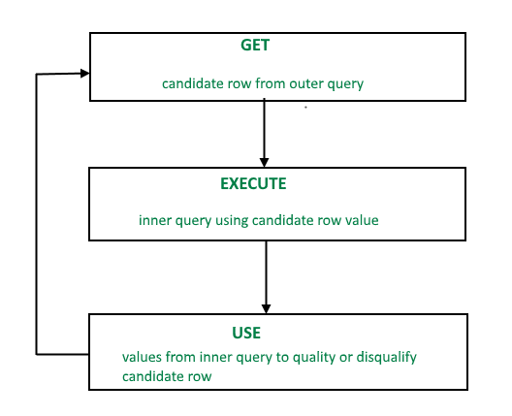
- A correlated subquery is evaluated once for each row processed by the parent statement. The parent statement can be a SELECT, UPDATE, or DELETE statement.
SELECT column1, column2, ....
FROM table1 outer
WHERE column1 operator (SELECT column1, column2
FROM table2
WHERE expr1 = outer.expr2);
- A correlated subquery is one way of reading every row in a table and comparing values in each row against related data. It is used whenever a subquery must return a different result or set of results for each candidate row considered by the main query. In other words, you can use a correlated subquery to answer a multipart question whose answer depends on the value in each row processed by the parent statement.
- With a normal nested subquery, the inner SELECT query runs first and executes once, returning values to be used by the main query.
- A correlated subquery, however, executes once for each candidate row considered by the outer query. In other words, the inner query is driven by the outer query.
NOTE : You can also use the ANY and ALL operator in a correlated subquery. EXAMPLE
SELECT empname, salary, department FROM employees e WHERE salary > (SELECT AVG(salary) FROM employees WHERE department = e.department);
SELECT empname, salary, department
FROM employees e
WHERE salary <
(SELECT AVG(salary)
FROM employees WHERE department = e.department);

Difference between Nested Query, Correlated Query and Join Operation
Parameters | Nested Query | Correlated Query | Join Operation
Definition | In Nested query, a query is written inside another query and the result of inner query is used in execution of outer query. | In Correlated query, a query is nested inside another query and inner query uses values from outer query. | Join operation is used to combine data or rows from two or more tables based on a common field between them.INNER JOIN, LEFT JOIN, RIGHT JOIN, FULL JOIN are different types of Joins.
Approach | Bottom up approach i.e. Inner query runs first, and only once. Outer query is executed with result from Inner query. | Top to Down Approach i.e. Outer query executes first and for every Outer query row Inner query is executed. | It is basically cross product satisfying a condition.
Dependency | Inner query execution is not dependent on Outer query. | Inner query is dependent on Outer query. | There is no Inner Query or Outer Query. Hence, no dependency is there.
Performance | Performs better than Correlated Query but is slower than Join Operation. | Performs slower than both Nested Query and Join operations as for every outer query inner query is executed. | By using joins we maximize the calculation burden on the database but joins are better optimized by the server so the retrieval time of the query using joins will almost always be faster than that of a subquery.

Nested Subqueries Versus Correlated SUBQUERIES
With a normal nested subquery, the inner SELECT query runs first and executes once, returning values to be used by the main query.
A correlated subquery, however, executes once for each candidate row considered by the outer query. In other words, the inner query is driven by the outer query.
NOTE : You can also use the ANY and ALL operator in a correlated subquery.

EXAMPLE of Correlated Subqueries :
Find all the employees who earn more than the average salary in their department.
SELECT last_name, salary, department_id
FROM employees outer
WHERE salary > (SELECT AVG(salary)
FROM employees
WHERE department_id = outer.department_id);
Other use of correlation are in UPDATE and DELETE
CORRELATED UPDATE :
UPDATE table1 alias1
SET column = (SELECT expression
FROM table2 alias2
WHERE alias1.column =
alias2.column);
Use a correlated subquery to update rows in one table based on rows from another table.
CORRELATED DELETE :
DELETE FROM table1 alias1
WHERE column1 operator
(SELECT expression
FROM table2 alias2
WHERE alias1.column = alias2.column);

CHAPTER 10: summary / CHEATSHEET
Temp tables are used to create tables which are temporary and which will be dropped automatically as soon as the session is closed.
Temp Tables are physically created in the Tempdb database. These tables act as the normal table and also can have constraints, index like normal tables.
CTE is a named temporary result set which is used to manipulate the complex sub-queries data. This exists for the scope of statement. This is created in memory rather than Tempdb database. You cannot create any index on CTE.
Table Variable acts like a variable and exists for a particular batch of query execution. It gets dropped once it comes out of batch. This is also created in the Tempdb database but not the memory.
SCOPE & COMPARISION OF TEMPORARY OBJECTS
 | Local Temp Tables | Global Temp Tables | CTE | TABLE VARIABLES | Derived Table/ SUBQUERY
Scope | Single user- session | Multiuser-session | Withinbatch | Within the batch | Within the query
Operations | Insert,update,  delete,select | Insert,update,  delete,select | Only select | Insert,update,  delete,select | Only select
Deciding which type of table to use
Things to be aware of when using temp tables versus table variables versus derived tables:
- Temp Tables are created in the SQL Server TEMPDB database and therefore require more IO resources and locking. Table Variables and Derived Tables are created in memory.
- Temp Tables will generally perform better for large amounts of data that can be worked on using parallelism whereas Table Variables are best used for small amounts of data (I use a rule of thumb of 100 or less rows) where parallelism would not provide a significant performance improvement.
- You cannot use a stored procedure to insert data into a Table Variable or Derived Table. For example, the following will work: INSERT INTO #MyTempTable EXEC dbo.GetPolicies_sp whereas the following will generate an error: INSERT INTO @MyTableVariable EXEC dbo.GetPolicies_sp.
- Derived Tables can only be created from a SELECT statement but can be used within an Insert, Update, or Delete statement.
- In order of scope endurance, Temp Tables extend the furthest in scope, followed by Table Variables, and finally Derived Tables.

CHAPTER 10: EXERCISE (ASSIGNMENTS)
EXECUTE THE SQL QUERIES AND CREATE An EMPLOYEE TABLE IN THE DATABASE.
CREATE TABLE [dbo].[EMPLOYEES](
[EMPID] [int] IDENTITY(1,1) NOT NULL,
[EMPNAME] [varchar](100) NULL,
[SALARY] [float] NULL,
[TAX] [float] NULL,
[DOJ] [datetime] NULL,
[DEPT] [varchar](100) NULL,
[DESG] [varchar](100) NULL,
[DEPTMANAGERNAME] [varchar](100) NULL,
[DEPTLOCATION] [varchar](100) NULL,
CONSTRAINT [pk_empid] PRIMARY KEY CLUSTERED
(
[EMPID] ASC
)) ON [PRIMARY]

GO
SET IDENTITY_INSERT [dbo].[EMPLOYEES] ON

GO
INSERT [dbo].[EMPLOYEES] VALUES (1, N'AKASH', 70000, 2000, CAST(N'2017-05-20' AS DateTime), N'IT', N'SOFTWARE DEVELOPER', N'SURESH', N'PUNE')
INSERT [dbo].[EMPLOYEES] VALUES (2, N'AKSHAY', 69000, 1900, CAST(N'2017-07-14' AS DateTime), N'IT', N'ARCHITECT', N'SURESH', N'PUNE')
INSERT [dbo].[EMPLOYEES] VALUES (3, N'ASHWIN', 77000, 2100, CAST(N'2017-09-14' AS DateTime), N'IT', N'ARCHITECT', N'SURESH', N'PUNE')
INSERT [dbo].[EMPLOYEES] VALUES (4, N'CHINMAY', 88000, 2900, CAST(N'2017-09-10' AS DateTime), N'HR', N'MANAGER', N'ANITA', N'MUMBAI')
INSERT [dbo].[EMPLOYEES] VALUES (5, N'DEBAYAN', 65000, 2100, CAST(N'2017-10-18' AS DateTime), N'HR', N'EXECUTIVE', N'ANITA', N'MUMBAI')
INSERT [dbo].[EMPLOYEES] VALUES (6, N'MANGESH', 99000, 2900, CAST(N'2017-10-10T00:00:00.000' AS DateTime), N'HR', N'MANAGER', N'ANITA', N'MUMBAI')
INSERT [dbo].[EMPLOYEES] VALUES (7, N'NIKHIL', 56000, 2100, CAST(N'2017-07-18T00:00:00.000' AS DateTime), N'HR', N'EXECUTIVE', N'ANITA', N'MUMBAI')
INSERT [dbo].[EMPLOYEES] VALUES (10, N'SANDEEP', 45000, 460, CAST(N'2017-07-25T00:00:00.000' AS DateTime), N'IT', N'SOFTWARE DEVELOPER', N'SURESH', N'PUNE')
INSERT [dbo].[EMPLOYEES] VALUES (11, N'NIRAJ', 48000, 460, CAST(N'2017-07-25T00:00:00.000' AS DateTime), N'ADMIN', N'MANAGER', N'DELHI', NULL)
INSERT [dbo].[EMPLOYEES] VALUES (12, N'VIVEL', 89000, 2000, CAST(N'2017-01-20T00:00:00.000' AS DateTime), N'SECURITY', N'MANAGER', N'KOLKATTA', NULL)
INSERT [dbo].[EMPLOYEES] VALUES (13, N'DILLIP', 47000, 400, CAST(N'2017-09-25T00:00:00.000' AS DateTime), N'IT', N'TRAINER', N'SURESH', N'PUNE')
SET IDENTITY_INSERT [dbo].[EMPLOYEES] OFF
GO
EMPID | EMPNAME | SALARY | TAX | DOJ | DEPT | DESG | DEPT  MANAGERNAME | DEPTLOCATION
1 | AKASH | 70000 | 2000 | 20-05-2017 | IT | SOFTWARE  DEVELOPER | SURESH | PUNE
2 | AKSHAY | 69000 | 1900 | 14-07-2018 | IT | ARCHITECT | SURESH | PUNE
3 | ASHWIN | 77000 | 2100 | 14-09-2017 | IT | ARCHITECT | SURESH | PUNE
4 | CHINMAY | 88000 | 2900 | 10-09-2017 | HR | MANAGER | ANITA | MUMBAI
5 | DEBAYAN | 65000 | 2100 | 18-10-2017 | HR | EXECUTIVE | ANITA | MUMBAI
6 | MANGESH | 99000 | 2900 | 10-10-2017 | HR | MANAGER | ANITA | MUMBAI
7 | NIKHIL | 56000 | 2100 | 18-07-2018 | HR | EXECUTIVE | ANITA | MUMBAI
10 | SANDEEP | 45000 | 460 | 25-07-2017 | IT | SOFTWARE  DEVELOPER | SURESH | PUNE
11 | NIRAJ | 48000 | 460 | 25-07-2017 | ADMIN | MANAGER | DELHI | NULL
12 | VIVEL | 89000 | 2000 | 20-01-2019 | SECURITY | MANAGER | KOLKATTA | NULL
13 | DILLIP | 47000 | 400 | 25-09-2017 | IT | TRAINER | SURESH | PUNE

WRITE ANSWERS TO THE QUERIES USING THE ABOVE TABLE
- Write a CTE to find the details of employee having the 4th Highest salary
- Write a Subquery to find the details of employee having the 4th Highest salary
- Write a query to find names of employee of the each department whose salary is greater than the average salary of the department.
- Write a query to find names of employee of the each department whose salary is less than the average salary of the department.

- Write a query to find the number of employees recruited in each department in different years.(Use Pivot if required)
DEPT / YEAR | 2017 | 2018 | 2019
IT
HR
ADMIN

- Write a stored procedure which will create two table from the single table (One is the department table and second is the employee table and create a relationship between them). [Hint : Use temp tables if required)
- Write a stored to create three tables from the single table and also move the data to each tables. (One is department, employee and salary details)
DimDept | DeptId(Primary Key)
DimEmployee | EmpId(PKey) DeptId(FKey)
FactSalary | EmpId(FKey)

CHAPTER 10: questions
What is temp table?
What are different types of temp table?
Where is temp tables stored?
Why CTE is used in SQL Server?
Is CTE faster than temp table?
Which is better CTE or temp table?
Advantages and disadvantages of CTE?
Can we use CTE multiple times?
Which is better CTE or subquery?
Can we use more than one CTE in a single select query?
What is difference between CTE and view?

CHAPTER 11

CHAPTER 11: Indexes
Indexes are necessary for good performance of your databases. In order to create appropriate indexes, you need to understand how Microsoft SQL Server stores data in tables and indexes, and how it then accesses this data.

Lessons in this chapter:
- Lesson 1: Indexes
- Lesson 2: Creating an index

Lesson 1: Indexes
An index is an on-disk structure associated with a table or views that speed retrieval of rows from the table or view. An index contains keys built from one or more columns in the table or view. These keys are stored in a structure (B-tree=) that enables SQL Server to find the row or rows associated with the key values quickly and efficiently.
An index is a database object created and maintained by DBMS. It is essentially a list of the contents of a column or group of columns. Indexes are ordered so that extremely first search can be computed through them to find data.
Why Use an Index? Use of SQL server indexes provide many facilities such as:
- Rapid access of information
- Efficient access of information
- Enforcement of uniqueness constraints
Correct use of indexes can improve the query performance.
Types of Indexes
SQL Server has two major types of indexes:
- Clustered Index
- Non-Clustered Index
The index type refers to the way the index is stored internally by SQL Server. So a table or view can contain the two types of indexes.

Clustered Index

An index defined as being clustered, defines the physical order that the data in a table is stored. Only one cluster can be defined per table. So it can be defined as:
Clustered indexes sort and store the data rows in the table or view based on their key values. These are the columns included in the index definition. There can be only one clustered index per table, because the data rows themselves can be sorted in only one order.
The only time the data rows in a table are stored in sorted order is when the table contains a clustered index. When a table has a clustered index, the table is called a clustered table. If a table has no clustered index, its data rows are stored in an unordered structure called a heap.
Internals of Clustered Index
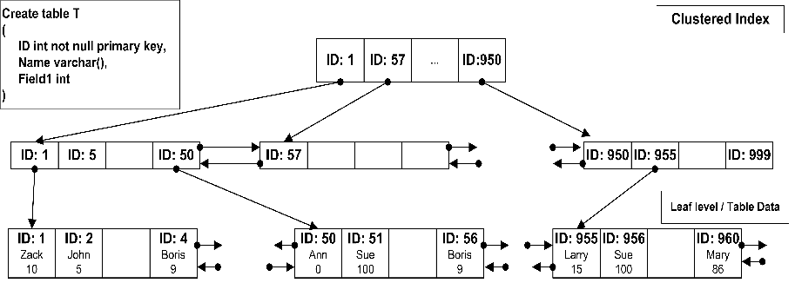

The image above shows a small table with ID as the primary key (and clustered index). As the side note, SQL Server creates clustered index on the primary key field by default.
Leaf level (the bottom one) contains actual table data sorted by ID. As you can see, the data pages are linked into the double-linked list so SQL Server can scan the index in both directions.
Levels above the leaf level called “intermediate levels”. Every index row on those levels points to the separate data pages in the level below. At the top level (root level) there is only one page. There could be several intermediate levels based on the table size. But the top root level of the index always has 1 data page.
So let’s see how it actually works: Assuming you want to select the record with ID = 50. SQL Server start from the root level and find that first row contains ID=1 and the second row contains ID=57. It means that the row with ID=50 would be located on the data page started with ID=1 on the next level of the index. So the next step is analyzing the first data page on the intermediate level which contains IDs from 1 to 50. So SQL Server finds the row with ID=50 and jump on the leaf level page with the actual data.
Note :SQL Server does not require you to create the clustered indexes - tables without such indexes called heap tables.
Non-Clustered index
As a non-clustered index is stored in a separate structure to the base table, it is possible to create the non-clustered index on a different file group to the base table. So it can be defined as:
Non-Clustered indexes have a structure separate from the data rows. A non-clustered index contains the non-clustered index key values and each key value entry has a pointer to the data row that contains the key value.
The pointer from an index row in a non-clustered index to a data row is called a row locator. The structure of the row locator depends on whether the data pages are stored in a heap or a clustered table. For a heap, a row locator is a pointer to the row. For a clustered table, the row locator is the clustered index key.
You can add non key columns to the leaf level of the Non-Clustered index to by-pass existing index key limits, 900 bytes and 16 key columns, and execute fully covered, indexed, queries.
Internals of Non- Clustered Index
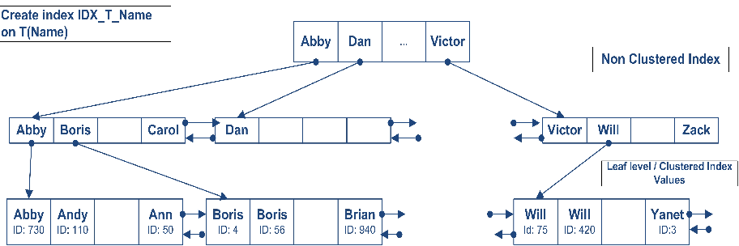
The structure of the index is exactly the same with the exception that leaf level does not contain table data but values for the clustered index. It does not really matter if you specify ID in the index definition, it would be there. For the heap tables, leaf level contains actual RID - Row id which consists of
- FileId:
- PageNumber:
- RowNumber.
Annotation at the end of the book is a good example. It does not include the actual paragraph from the book but the page # (clustered index)
Let’s see how SQL Server works when it uses non-clustered index for the lookups on the tables with clustered index. As you can see, first it needs to find ID of the row(s) and next perform clustered index lookup in order to obtain the actual table data. This operation called “Key lookup” or “Bookmark lookup”.
Uniqueness
An index can be defined either as unique or non-unique. A unique index ensures that the data contained within the unique index columns appear only once within the table, including “NULL”. A unique index is commonly implemented to support the constraints.
SQL Server automatically enforces the uniqueness of the columns contained within a unique index. If an attempt is made to INSERT a value/data that already exists in the table, then an error will be generated by the SQL Server and finally the attempt to INSERT the data will fail.
A non-unique index is also applicable as there can be duplicate data; a non-unique index has more overhead than a unique index when retrieving data.

Lesson 2: Creating an index
If we want to create an index by using Transact – SQL, we must know the columns detail for index creation. A sample syntax is given below.
Syntax:
CREATE [ UNIQUE ] [ CLUSTERED | NONCLUSTERED ] INDEX
index_name ON table ( column1, ... )

UNIQUE : Indicates that a unique index is to be created.
CLUSTERED : Indicates that the index created is a clustered index.
NONCLUSTERED : Indicates that the index created is a non-clustered index.
index_name : Is the name of the index.
Table : The name of the table on which the index is to be created.
column1 : The column or columns to which the index is to be applied.

Create a single clustered index
Syntax:
CREATE [ UNIQUE ] [ CLUSTERED ]
INDEX index_name ON table ( column1, ... )
Example:
CREATE CLUSTERED INDEX ix_empid ON EMPLOYEES (empid)

Create a single nonclustered index
Syntax:

CREATE [ UNIQUE ] [ NONCLUSTERED ]
INDEX index_name ON table ( column1, ... )
Example:

CREATE NONCLUSTERED INDEX ix_empname ON EMPLOYEES (EMPNAME)
Create a multi-column (composite) nonclustered index
Syntax:

CREATE [ UNIQUE ] [ NONCLUSTERED ]
INDEX index_name ON table ( column_name1, column_name2 )
Example:

CREATE UNIQUE NONCLUSTERD INDEX ix_nc_PresidentNumber, PresidentName ---specify index
ON dbo.Presidents (PresidentNumber, PresidentName) ---specify table and column names

Create a multi-column (composite) clustered index
Syntax:

CREATE [ UNIQUE ] [ CLUSTERED ]
INDEX index_name ON table ( column_name1, column_name2 )
Example:

CREATE UNIQUE CLUSTERD INDEX ix_nc_PresidentNumber, PresidentName ---specify index
ON dbo.Presidents (PresidentNumber, PresidentName) ---specify table and column names

Drop an Index
Removes one or more indexes from the current database. The DROP INDEX statement does not apply to indexes created by defining PRIMARY KEY or UNIQUE constraints (created by using the PRIMARY KEY or UNIQUE options of either the CREATE TABLE or ALTER TABLE statements, respectively). For more information about PRIMARY or UNIQUE KEY constraints, see "CREATE TABLE" or "ALTER TABLE" in this volume.
Syntax:
DROP INDEX 'table.index | view.index'[...n]
Example:
DROP INDEX ix_empid ON EMPLOYEES
You can also drop multiple indexes within a single transaction:
DROP INDEX IX_Product ON dbo.Product, IX_Customer ON dbo.Customer

CHAPTER 11 : SUMMARY / CHEATSHEET
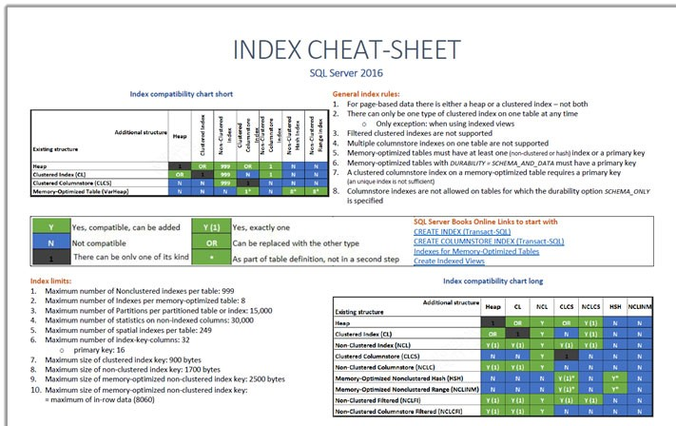

CHAPTER 11: QUESTIONS
Define Clustered Index ?
Define Non Clustered Index ?
How many clustered index can be created on a table ?
How many Non Clustered index can be created on a table ?

CHAPTER 12

CHAPTER 12 : Views
Microsoft SQL Server provides three different ways to present a logical view of a table to user queries without having to expose the physical base table directly. Views behave just like tables but can hide complex logic.
Lessons in this chapter:
- Lesson 1: Creating and Implementing View

Lesson 1: Creating and Implementing View
- A view is a virtual table that consists of columns from one or more tables.
- Though it is similar to a table, it is stored in the database.
- It is a query stored as an object.
- So a view is an object that derives its data from one or more tables.
- These tables are referred to as base or underlying tables.
- Once you have defined a view, you can reference it like any other table in a database.
A view serves as a security mechanism.
- This ensures that users are able to retrieve and modify only the data seen by them.
- Users cannot see or access the remaining data in the underlying tables.
A view also serves as a mechanism to simplify query execution. Complex queries can be stored in the form as a view, and data from the view can be extracted using simple queries.
- A view consists of a SELECT statement that stored with a database. Because views are stored as part of the database, they can be managed independently of the applications that use them.
- A view behaves like a virtual table. Since you can code a view name anywhere you can code a table name. A view is sometimes called a viewed table.
- Views can be used to restrict the data that a user is allowed to access or to present data in a form that is easy for the user to understand. In some database users may be allowed to access data only through views.

Types of User Defined Views
- User Defined Views
- Materialized View
- Indexed View
- Partitioned Views

User Defined Views
These types of view are defined by users. We have two types of user defined views.
- Simple View
- Complex View
Let’s create a sample table as shown below for doing practical examples on views.
CREATE TABLE Employee_Test  (  Emp_ID INT,  Emp_Name VARCHAR(100),  Emp_Designation VARCHAR(100)  )  INSERT INTO Employee_Test VALUES  (1,'Amit','SE'),(2,'Mohan','TL'),(3,'Avin','SE'),  (4,'Manoj','SSE'),(5,'Riyaz','TH'),(6,'Pawan','SSE') | SELECT * FROM Employee_Test  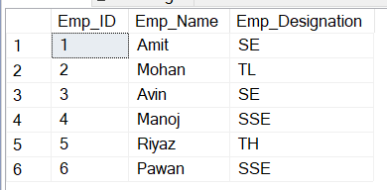
SIMPLE VIEW
When we create a view on a single table, it is called simple view.
Syntax:  Create VIEW view_name  AS  Select column_name From Table_name | Example:  Create VIEW vw_Employee_Test  AS Select Emp_ID ,Emp_Name ,Emp_Designation From Employee_Test
Syntax to call view :  Select * from view_name | Example :  Select * from vw_Employee_Test
In simple view we can insert, update, select and delete data.
We can only insert data in simple view if we have primary key and all not null fields in the view.
• Insert data to vw_Employee_Test
Insert into vw_Employee_Test (Emp_name, Emp_Designation) values (‘Shailu’, ’SSE’)
• To see the affected view
Select * from vw_Employee_Test
• Update data to vw_Employee_Test
Update vw_Employee_Test set Emp_Name = ‘Pawan’ where Emp_ID= 6
Result set of the above changes is:
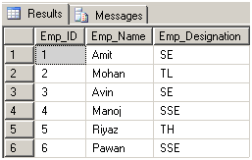
- Delete data from vw_Employee_Test
Delete from vw_Employee_Test where Emp_Id =6
Complex View
When we create a view on more than one table, it is called complex view.
Create table Personal_Info ( Emp_Name varchar (55), FName varchar (55), DOB varchar (55), Address varchar (55), Mobile int, State varchar (55) )
SELECT * FROM Personal_Info
--Now insert data
Insert into Personal_Info values ('Amit','Patil','22-10-1985','Ghaziabad',96548922,'UP');
Insert into Personal_Info values ('Mohan','Kar','02-07-1986','Haridwar', 96548200,'UK');
Insert into Personal_Info values ('Avin','Das','30-04-1987','Noida', 97437821,'UP');
Insert into Personal_Info values ('Manoj','Yadav','20-07-1986','Rampur', 80109747,'UP');
Insert into Personal_Info values ('Riyaz','Rai', '21-10-1985','Delhi', 96547954,'Delhi');
-- Now create view on two tables Employee_Test and Personal_Info
Create VIEW vw_Employee_Personal_Info as Select e.Emp_ID, e.Emp_Name, e.Emp_Designation, p.DOB, p.Mobile From Employee_Test e INNER JOIN Personal_Info p On e.Emp_Name = p. Emp_Name
-- Now Query view like as table
Select * from vw_Employee_Personal_Info
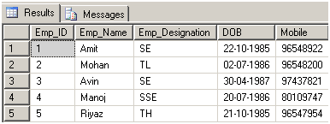
We can only update data in complex view. We can't insert data in complex view.
- Update View : Update vw_Employee_Personal_Info set Emp_Designation = ‘SSE’ where Empid = 3
- To see affected view : Select * from vw_Employee_Personal_Info
Difference between SIMPLE and COMPLEX view
SIMPLE VIEW | COMPLEX VIEW
Contains only one single base table or is created from only one table. | Contains more than one base tables or is created from more than one tables.
We cannot use group functions like MAX(),COUNT(), etc. | We can use group functions.
Does not contain groups of data. | It can contain groups of data.
DML operations could be performed through a simple view. | DML operations could not always be performed through a complex view.
INSERT, DELETE and UPDATE are directly possible on a simple view. | We cannot apply INSERT, DELETE and UPDATE on complex view directly.
Simple view does not contain group by, distinct, pseudocolumn like rownum, columns defined by expressions. | It can contain group by, distinct, pseudocolumn like rownum, columns defined by expressions.
Does not include NOT NULL columns from base tables. | NOT NULL columns that are not selected by simple view can be included in complex view.

Indexed View
Views allow you to create a virtual table by defining a query against one or more tables. With a standard view, the result is not stored in the database. Instead, the result set is determined at the time a query utilizing that view is executed.
Creating a unique clustered index on a view changes it to an indexed view. The clustered index is stored in SQL Server and updated like any other clustered index, providing SQL Server with another place to look to potentially optimize a query utilizing the indexed view.
CREATE TABLE MyBigTable
(
ItemID INT PRIMARY KEY,
ItemDsc VARCHAR (20),
QTY INT
)
CREATE VIEW MyView WITH SCHEMABINDING AS SELECT ItemID, QTY FROM dbo.MyBigTable
WHERE QTY > 10

Create unique clustered index idx_myview on myview (qty)

Chapter 12: SUMMARY / cheatsheet
A view is a virtual table that consists of columns from one or more tables.
It is a query stored as an VIEW, which can be used as a table.
View can be used to hide the complexity. We can store a complex query inside a view and use it as a table.
A view also serves as a security mechanism. You can hide critical information of the table by creating a view out of it.

Chapter 12: QUESTIONs
1What are the differences between a table and a view in SQL Server?
How many types of views are there in SQL Server?
Why do we need Views in SQL Server?
What are the limitations of a View in SQL Server?

CHAPTER 13

CHAPTER 13: Triggers
Lessons in this chapter:
In this chapter we will cover the following lessons.

Lesson 1: Trigger

Lesson 1: Trigger
What is a Trigger?
- A trigger is a special kind of a store procedure (set of sql statements) or program that executes in response to certain action on the table like insertion, deletion or updating of data.
- It is a database object which is bound to a table and is executed automatically.
- You can’t explicitly invoke triggers.
- The only way to do this is by performing the required action on the table that they are assigned to.

Types of Triggers:

- DML Triggers
- DDL Triggers
- CLR Triggers
- LOGON Triggers

Syntax for Trigger

CREATE TRIGGER trigger_name ON {table|view}
[WITH ENCRYPTION|EXECUTE AS]
{FOR|AFTER|INSTEAD OF} {[CREATE|ALTER|DROP|INSERT|UPDATE|DELETE]}
[NOT FOR REPLICATION]
AS
sql_statement [1...n]
END

DML Triggers

There are three action query types that you use in SQL which are INSERT, UPDATE and DELETE. So, there are three types of triggers and hybrids that come from mixing and matching the events and timings that fire them.

Triggers are classified into two main types:-
Instead Of Triggers : Instead of Triggers are executed instead of insert, update or delete statements on the table
After Triggers (For Triggers) : After Trigger are executed after insert,update or delete statements on the table.
INSTEAD OF TRIGGERS ARE OF THREE TYPES | AFTER TRIGGERS ARE OF THREE TYPES
- INSTEAD OF INSERT  This trigger will be invoked instead of the insert statements. | - AFTER INSERT  This trigger will be executed after the insert statements.
- INSTEAD OF UPDATE  This trigger will be invoked instead of the update statements. | - AFTER UPDATE  This trigger will be executed after the update statements.
- INSTEAD OF DELETE  This trigger will be invoked instead of the delete statements. | - AFTER DELETE  This trigger will be executed after the delete statements.

Examples: FIRST CREATE A TABLE Employee_Exp ON WHICH WE WILL CREATE A TRIGGER
CREATE TABLE EMPLOYEE_EXP
(
EMP_ID INT IDENTITY(1,1),
EMP_NAME VARCHAR (100),
EMP_SAL FLOAT,
TAX FLOAT
)
INSERT INTO EMPLOYEE_EXP VALUES ('AMIT', 1000,100),('SUNIL', 2000,200),('KAPIL', 5000,500)
INSTEAD OF TRIGGERS
- These can be used as an interceptor for anything that anyone tried to do on our table or view.
- These triggers are sometimes very dangerous as these will not allow that command to get executed and instead of that some other statements which is there inside the trigger will get executed.
- For Example If you define an Instead Of trigger on a table for the Delete operation, they try to delete rows, and they will not actually get deleted (unless you issue another delete instruction from within the trigger)
INSTEAD OF TRIGGERS can be classified further into three types as:
(a) INSTEAD OF INSERT Trigger.
(b) INSTEAD OF UPDATE Trigger.
(c) INSTEAD OF DELETE Trigger.
Syntax for Trigger

CREATE TRIGGER trigger_name ON {table|view}
{ AFTER|INSTEAD OF} {INSERT|UPDATE|DELETE]}
AS
BEGIN

END

EXAMPLE OF INSTEAD OF INSERT TRIGGER
WILL CREATE A INSTEAD OF INSERT TRIGGER ON THE TABLE EMPLOYEE_EXP.

CREATE TRIGGER TRGEMPEXP_INSERT ON EMPLOYEE_EXP INSTEAD OF INSERT
AS
BEGIN
PRINT 'EMPLOYEE CANNOT BE INSERTED'
END

ONCE THE TRIGGER HAVE BEEN CREATED, IT WILL BE INVOKED WHENEVER THE INSERT STATEMENT IS FIRED, AND WILL EXECUTE THE TRIGGERS STATEMENTS, INSTEAD OF INSERT STATEMENT.
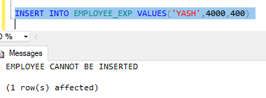

EXAMPLE OF INSTEAD OF DELETE TRIGGER
WILL CREATE A INSTEAD OF DELETE TRIGGER ON THE TABLE EMPLOYEE_EXP.
CREATE TRIGGER TRGEMPEXP_DEL ON EMPLOYEE_EXP INSTEAD OF DELETE
AS
BEGIN
PRINT 'EMPLOYEE CANNOT BE DELETED'
END
THIS TRIGGER WILL BE INVOKED WHENEVER USER WILL FIRE THE DELETE STATEMENT

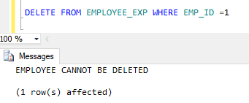

Note: Inside the Trigger we will get the data from INSERTED & DELETED TABLE
- INSERTED : WILL GIVE THE NEW DATA
- DELETED : WILL GIVE THE OLD DATA
EXAMPLE OF INSTEAD OF UPDATE TRIGGER
CREATE TRIGGER TRGEMPEXP_UPD ON EMPLOYEE_EXP INSTEAD OF UPDATE
AS
BEGIN

SELECT * FROM INSERTED
SELECT * FROM DELETED

END

Let’s execute a update statement and see the results
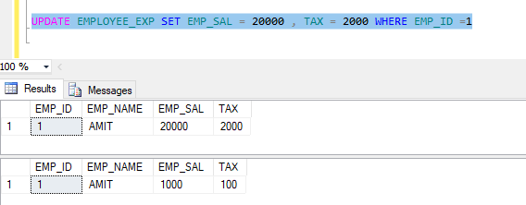

ENABLE / DISABLE TRIGGER
Specific Triggers can be enabled or disabled as:-

ALTER TABLE table_name {ENABLE| DISABLE} TRIGGER triggername

ALTER TABLE Employee_Test DISABLE TRIGGER trgAfterDelete
This disables the After Delete Trigger named trgAfterDelete on the specified table.

All the triggers can be enabled/disabled on the table using the statement
ALTER TABLE Employee_Test {ENABLE|DISBALE} TRIGGER ALL
ALTER TABLE EMPLOYEE_EXP DISABLE TRIGGER ALL
Dropping a DML trigger
DROP TRIGGER Trigger_name
Example:
DROP TRIGGER tr_employee
After Triggers
These triggers run after an insert, update or delete on a table. They are not supported for views. AFTER TRIGGERS can be classified further into three types as:
(a) AFTER INSERT Trigger.
(b) AFTER UPDATE Trigger.
(c) AFTER DELETE Trigger.
(a) AFTER INSERT Trigger EXAMPLE
This trigger is fired after an INSERT on the table. Let’s create the trigger as:-
This trigger will show the records of the table and print a message once the records are deleted.

CREATE TRIGGER TRG_ADDEMP ON EMPLOYEE_EXP AFTER INSERT
AS
BEGIN
SELECT * FROM INSERTED
SELECT * FROM EMPLOYEE_EXP

PRINT 'EMPLOYEE RECORD ADDED SUCCESSFULLY'
END

- The CREATE TRIGGER statement is used to create the trigger.
- THE ON clause specifies the table name on which the trigger is to be attached.
- The FOR INSERT specifies that this is an AFTER INSERT trigger.
- In place of FOR INSERT, AFTER INSERT can be used. Both of them mean the same.
In the trigger body, table named inserted has been used.
- This table is a logical table and contains the row that has been inserted.
- I have selected the fields from the logical inserted table from the row that has been inserted into different variables, and finally inserted those values into the Audit table.
To see the newly created trigger in action, let’s insert a row into the main table as:
INSERT INTO EMPLOYEE_EXP VALUES('RAVI',8000,800)

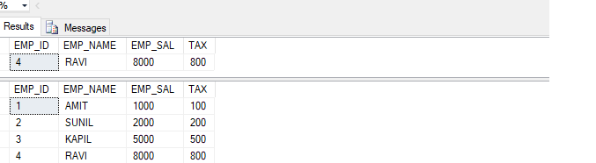

Now, a record has been inserted into the Employee_Test table.

(b) AFTER UPDATE Trigger
This trigger is fired after an update on the table. Let’s create the trigger as:-
In this example, we will see how we can use trigger to maintain audit(history) of a table.
Whenever a table is updated the previous value of the table will be moved into another table.

CREATE TABLE EMPLOYEE_EXP_AUDIT
(
EMP_ID INT,
EMP_NAME VARCHAR (100),
EMP_SAL FLOAT,
TAX FLOAT,
UPDATEDBY VARCHAR(100),
UPDATEDDATETIME DATETIME
)
CREATE TRIGGER TRG_UPEMP ON EMPLOYEE_EXP AFTER UPDATE
AS
BEGIN
INSERT INTO EMPLOYEE_EXP_AUDIT SELECT *,SUSER_NAME(),GETDATE() FROM DELETED
SELECT * FROM EMPLOYEE_EXP_AUDIT WHERE EMP_ID IN(SELECT EMP_ID FROM DELETED)
END

- The AFTER UPDATE Trigger is created in which the updated record is inserted into the audit table.
- There is no logical table updated like the logical table inserted.
- We can obtain the updated value of a field from the update (column name) function.
- In our trigger, we have used, if update (Emp_Name) to check if the column Emp_Name has been updated.
- We have similarly checked the column Emp_Sal for an update.
Let’s update a record column and see what happens.
UPDATE EMPLOYEE_EXP SET EMP_SAL = 75000,TAX = 1000 WHERE EMP_ID =1

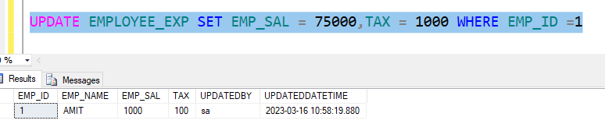

This inserts the row into the audit table as:-
(c) AFTER DELETE Trigger
This trigger is fired after a delete on the table.
Example : In this example we will create a after delete trigger to store the deleted records in a table for reference purpose.
Let’s create the trigger as:-

CREATE TABLE EMPLOYEE_EXP_DELETED
(
EMP_ID INT,
EMP_NAME VARCHAR (100),
EMP_SAL FLOAT,
TAX FLOAT,
DELETEDBY VARCHAR(100),
DELETEDDATETIME DATETIME
)
CREATE TRIGGER TRG_DELEMP ON EMPLOYEE_EXP AFTER DELETE
AS
BEGIN
INSERT INTO EMPLOYEE_EXP_DELETED SELECT *,SUSER_NAME(),GETDATE() FROM DELETED
SELECT * FROM EMPLOYEE_EXP_DELETED
END

In this trigger, the deleted record’s data is picked from the logical deleted table and inserted into the audit table.
Let’s fire a delete on the main table.
A record has been inserted into the audit as:-
DELETE FROM EMPLOYEE_EXP WHERE EMP_ID = 1
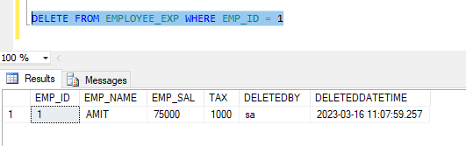

DDL Triggers
In SQL Server we can create triggers on DDL statements (like CREATE, Alter and Drop) and certain system defined stored procedures that perform DDL operations.
Example: If you are going to execute the CREATE LOGIN statement or the sp_addlogin stored procedure to create login user, then both these cases can execute/fire a DDL trigger that you can create on CREATE_LOGIN event of SQL Server.
We can use only FOR/ALTER clause in DDL triggers not INSTEAD OF clause means we can make only after trigger on DDL statements.
DDL triggers can be used to observe and control actions performed on the server, and to audit these operations. DDL triggers can be used to manage administrator task such as auditing and regulating database operations.
CREATE TRIGGER trigger1
ON DATABASE
FOR DROP_TABLE, ALTER_TABLE AS
PRINT ‘You cannot drop or alter this table.’
ROLLBACK

CREATE TRIGGER PreventDropTable
ON DATABASE
FOR DROP_TABLE
AS
PRINT 'Tables cannot be dropped'
ROLLBACK

DDL Trigger Examples
USE SqlHints DDLTriggersDemo
GO
CREATE TRIGGER DDLTriggerToBlockTableDDL
ON DATABASE
FOR DROP_TABLE,ALTER_TABLE
AS
BEGIN
PRINT 'Disable trigger DDLTriggerToBlockTableDDL to drop or alter tables'
ROLLBACK
END

How to disable a ddl Trigger
DISABLE TRIGGER DDLTriggerToBlockTableDDL ON DATABASE

ENABLE TRIGGER DDLTriggerToBlockTableDDL ON DATABASE

DROP TRIGGER DDLTriggerToBlockTableDDL ON DATABASE

CLR Triggers
CLR triggers are special type of triggers that based on the CLR (Common Language Runtime) in .net framework. CLR integration of triggers has been introduced with SQL Server 2008 and allows for triggers to be coded in one of .NET languages like C#, Visual Basic and F#.
We coded the objects (like trigger) in the CLR that have heavy computations or need references to objects outside the SQL Server. We can write code for both DDL and DML triggers, using a supported CLR language like C#, Visual basic and F#. I will discuss CLR trigger later.
LOGON TRIGGERS
Logon triggers are special type of trigger that fire when LOGON event of SQL Server is raised. This event is raised when a user session is being established with SQL Server that is made after the authentication phase finishes, but before the user session is actually established. Hence, all messages that we define in the trigger such as error messages, will be redirected to the SQL Server error log. Logon triggers do not fire if authentication fails. We can use these triggers to audit and control server sessions, such as to track login activity or limit the number of sessions for a specific login.
Syntax for Logon Trigger
CREATE TRIGGER trigger_name ON ALL SERVER [WITH ENCRYPTION]
{FOR|AFTER} LOGON
AS
sql_statement [1...n]
END

Example: /* Create Audit Database */
CREATE DATABASE AuditDb
USE AuditDb

/* Create Audit Table */
CREATE TABLE ServerLogonHistory
(SystemUser VARCHAR(512),
DBUser VARCHAR(512),
SPID INT,
LogonTime DATETIME)
GO

/* Create Logon Trigger */
CREATE TRIGGER Tr_ServerLogon
ON ALL SERVER FOR LOGON
AS
BEGIN
INSERT INTO AuditDb.dbo.ServerLogonHistory
SELECT SYSTEM_USER,USER,@@SPID,GETDATE()
END
GO

alter TRIGGER Tr_ServerLogon
ON ALL SERVER after LOGON
AS
BEGIN
INSERT INTO AuditDb.dbo.ServerLogonHistory
SELECT SYSTEM_USER,USER,@@SPID,GETDATE()
END

CHAPTER 13 : summary /cheatsheet
Trigger are set of sql statements which are executed on different commands of the table.
Triggers are categorized as INSTEAD OF TRIGGER and AFTER TRIGGER.
INSTEAD OF TRIGGER are executed instead of INSERT, UPDATE & DELETE. There are three types of INSTEAD OF TRIGGER.
- INSTEAD OF INSERT
- INSTEAD OF UPDATE
- INSTEAD OF DELETE
AFTER TRIGGER are executed after INSERT, UPDATE & DELETE. There are three types of AFTER TRIGGER.
- AFTER INSERT
- AFTER UPDATE
- AFTER DELETE

CHAPTER 13 : ASSIGNMENTS
Assignment1 - BankAccounts Assignment

- Create a Table BankAccounts in SQL SERVER.

CREATE A TABLE FOR BANKACCOUNT

COLUMN_NAME | DATATYPE | CONSTRAINT
ACCOUNTNO | INT | PRIMARY KEY, IDENTITY(1,1)
ACCOUNTNAME | VARCHAR(100)
BALANCE | FLOAT

- Part A

WRITE A TRIGGER TO MAINTAIN THE ACCOUNT HISTORY IN ACCOUNT_HISTORY TABLE

When there is any update into the Balance of the BankAccount table, it should be maintained in the history table like this
TABLENAME : ACCOUNTHISTORY
ACCOUNTNO | TRANSACTIONTYPE | AMT | LASTBALANCE | TRANSACTIONDATE
101 | DEBT | 100 | 6000 | 08/05/2020
101 | CREDIT | 500 | 6500 | 09/05/2020

- Part B

WHENEVER THERE IS AN UPDATE INTO THE BANKACCOUNT TABLE, IT SHOULD ALSO GENERATE ALSO GENERATE THE LAST 5 TRANSACTION DONE INTO THE ACCOUNT NO

Assignment2 - Employee Assignment

- Create a Table EMPLOYEE in SQL SERVER.
CREATE A TABLE FOR EMPLOYEE

COLUMN_NAME | DATATYPE | CONSTRAINT
EMPNO | INT | PRIMARY KEY, IDENTITY(1,1)
EMPNAME | VARCHAR(100)
SALARY | FLOAT
TAX | FLOAT
Designation | VARCHAR(100)

- Part A

WRITE A TRIGGER TO MAINTAIN THE updates IN EMPLOYEE TABLE
When there is any update in the EMPLOYEE table, it should be maintained in the history table like this
TABLENAME : EMPLOYEE_HISTORY
EMPNO | EMPNAME | SALARY | TAX | DESIGNATION | UPDATED_DATETIME | UPDATED_BY
 |  |  |  |  | Datetime at which the data have been updated | UserName who have updated the record
- Part B

WRITE A TRIGGER TO MAINTAIN THE deleted IN EMPLOYEE TABLE
When there is any delete in the EMPLOYEE table, it should be maintained in the deleted table like this
TABLENAME : EMPLOYEE_DELETE
EMPNO | EMPNAME | SALARY | TAX | DESIGNATION | DELETED_DATETIME | DELETED_BY
 |  |  |  |  | Datetime at which the data have been deleted | UserName who have DELETED the record

Assignment3 - StudentAssignment
CREATE A STUDENT TABLE SIMILAR TO THIS
ROLLNO | NAME | ENGMARKS | SCNMARKS | MATHMARKS | TOTALMARKS | PERCENTAGE | GRADE
IDENTITY(1,1)

WRITE A TRIGGER TO CALCULATE THE VALUES OF TOTALMARKS, PERCENTAGE AND GRADE AND INSERT INTO THE STUDENT TABLE.
THE USER WILL INSERT NAME,ENGMARKS,SCNMARKS,MATHMARKS.
THE TOTALMARKS,PERCENTAGE AND GRADE SHOULD BE CALCULATED THROUGH TRIGGER AND INSERT INTO THE TABLE.

CHAPTER 13 : questions
Define TRIGGER ?
Explain any real-time examples where trigger can be used ?
What is INSTEAD OF TRIGGER?
What is AFTER TRIGGER?
What is use of INSERTED table in Trigger ?
What is use of DELETED table in Trigger ?

