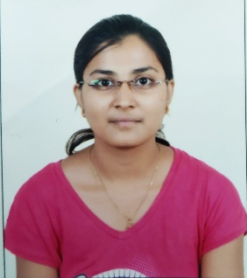
NIKITA PATIL
Diploma & B.E. (E&TC)

+91 8888215367
nikita255patil@gmail.com

CAREER OBJECTIVE

Seeking a position to utilize my skills and abilities in a technological industry that offers professional growth while being resourceful, innovative and flexible.

PROFILE SUMMARY

- Diploma in Software testing from MindScript with A+ Grade
- Well acquainted with Manual and Automation Testing concepts
- An enthusiastic fresher having Diploma and engineering degree in E&TC
- Executed In-Flow Inventory project at Mind Scripts creating Test Cases and Logged defects

ACADEMIC PROFILE

Year of Passing | Degree | College / School | Board / University | Result (%)
2015 | B.E. (E&TC) | D.N. Patel COE | N.M.U. Jalgaon | 62.42
2012 | Diploma (E&TC) | G.M.C. Polytechnic | M.S.B.T.E. Mumbai | 65.60
2009 | SSC | Madhyamik Vidya Mandir School | Nasik Board | 80.92

KEY ACADEMIC PROJECTS

In-Flow Inventory Management System
It is primarily used for specifying and identifying stocked goods, replenishing depleted stocks and tracking movement of stocked goods. The scope of IIMS involves replenishment lead time, carrying costs of inventory, Inventory valuation, inventory visibility, physical inventory, replenishment and demand forecasting.

Roles and Responsibilities
- Understanding the requirement specification for the product and deriving Test Cases
- Deriving and preparing test data
- Executing Test Cases and create Defect Logs
- Involved in Manual Testing of applications
- Defect Reporting & Tracking

KEY SKILLS AND ATTRIBUTES

Technical:
- Manual cum Automation Testing proficiency
- Proficiency in MS Office  
- Test management tools - TestLink
- Defect tracking tool - Mantis and Issue tracking tool- Jira
- Test automation tool-Selenium WebDriver with Java and Selenium IDE
- Well versed with C, SQL and ability to query DB for analysis and investigation

Non-technical:
- Ability to prioritize tasks and maintain calm under pressure
- Good Logical & Analytical Skills
- Strong attention to detail and accuracy & Efficient time management
- Team player and leader

EXTRA-CURRICULAR ACTIVITIES AND COMPETITIONS

- Participated in MSBTE Project competition held in 2012
- Participated in paper presentation in National Level TechFiesta held in 2014
- Coordinator of special events in National Level TechFiesta held in 2015

ADDITIONAL INFORMATION

- Certification: Software testing, Embedded system
- Hobbies: Listening to Music, travelling
- Languages Known: English, Hindi, Marathi

PERSONAL DETAILS

Date of Birth : 25th Feb, 1994
Marital status : Married
Correspondence Address : Castle Royale Society, Lohegaon, Pune - 411047

DECLARATION

I hereby affirm that the information in this document is accurate and true to the best of my knowledge.

Date: Nikita Patil

