Enosis Learning Login Page Test Report

List of Invalid or broken links are:

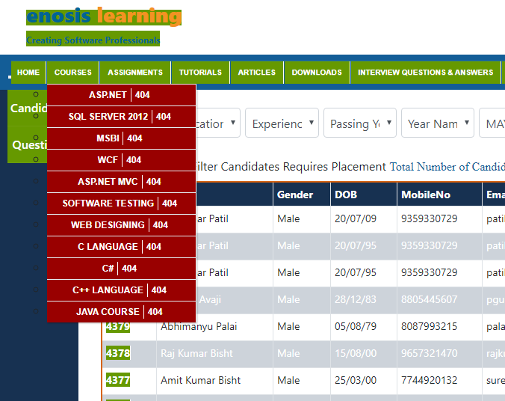

Background and foreground colors do not have a sufficient contrast ratio

Note: Low-contrast text is difficult or impossible for many users to read.

- For Example: Digambar patil , Prakash Avaji, Raj Kumar Bisht ext…( Change text white color)
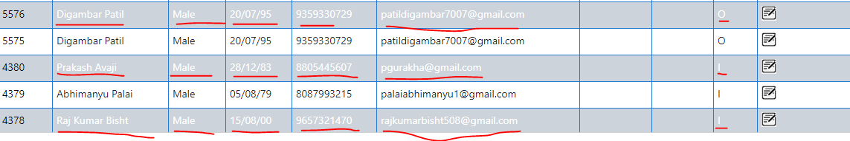
- Hard to read text mouse hover : On mouse hover, link address should be displayed at the bottom

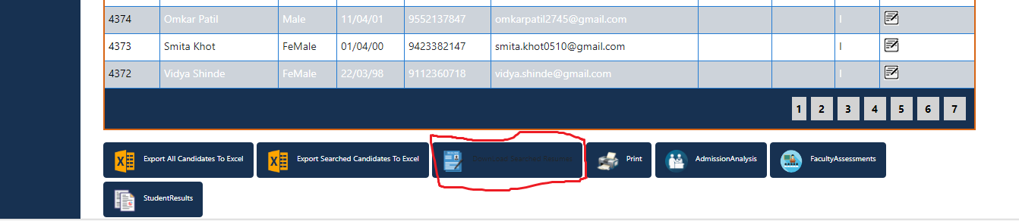

Website is not responding / website is not mobile responsive
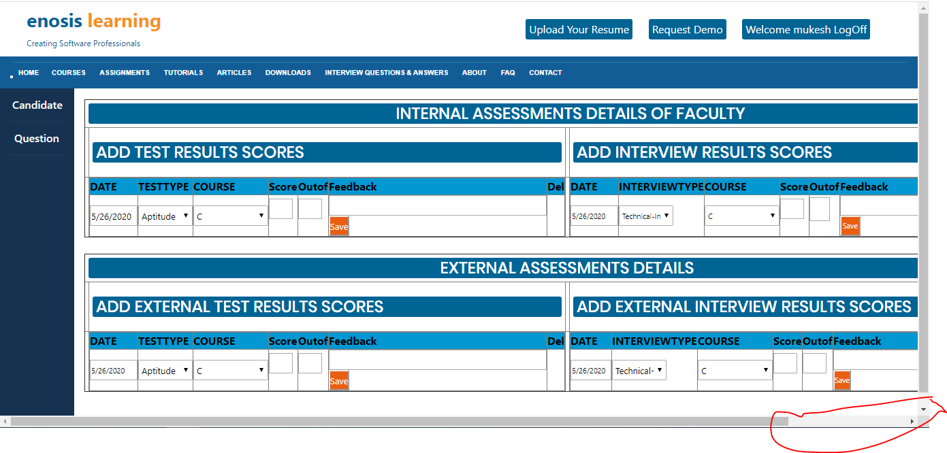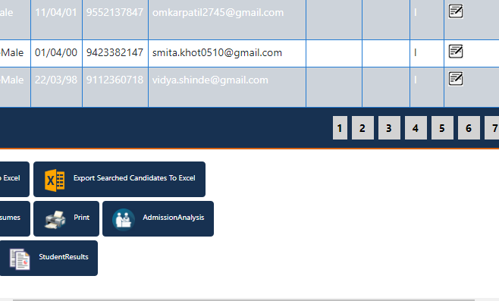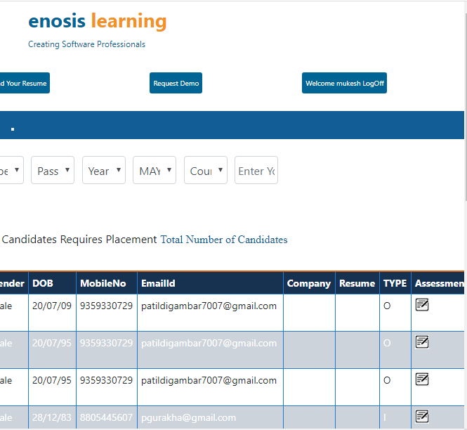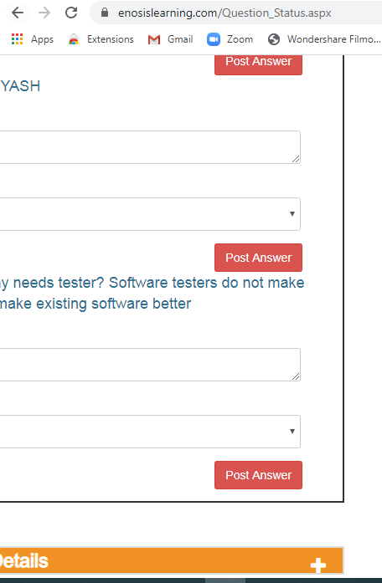

Remove unused CSS : Performance testing

Remove dead rules from stylesheets and defer the loading of CSS not used for above-the-fold content to reduce unnecessary bytes consumed by network activity.
URL | Size | Potential Savings
…css/style.css  (www.enosislearning.com) | 45 KB | 43 KB
…css/bootstrap.min.css  (www.enosislearning.com) | 35 KB | 33 KB

Text is not properly aligned in input textarea : GUI Testing

For Example:
Actual Result is: Experienc , Passing Y, Year Nam and Enter Your Sl
My Expected results is: Education, Experiences, Passing Year, Year Name, Enter Your Skills 

“Filter Candidates Requires Placement” is not working?

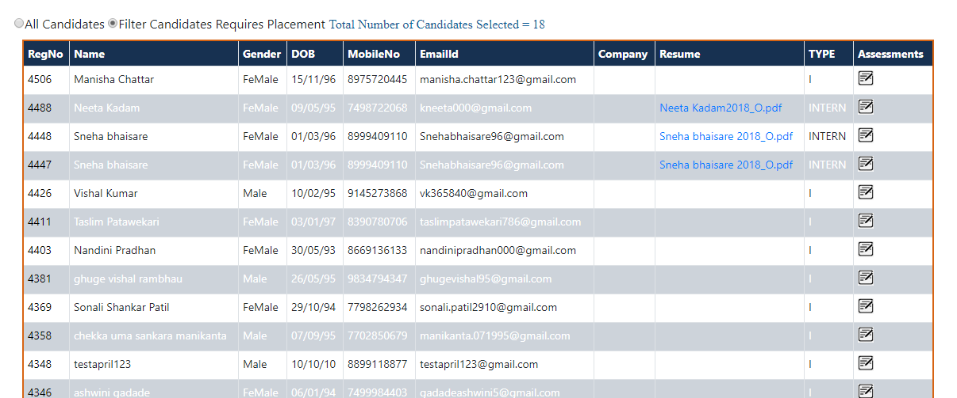

Duplicate elements or report in List

I got Duplicate data in this table; in spite of this Duplicate data I just want single data.
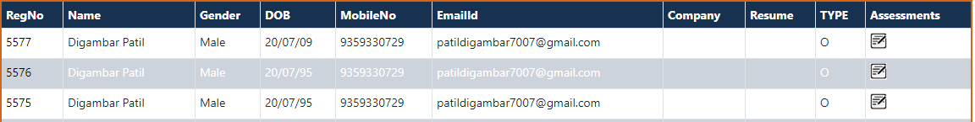

Delete operation on ASSESSMENTS DETAILS OF FACULTY: TEST RESULTS SCORES

Step1: Before deleting:
Test case: I want to delete course (ASP.Net) from following list:
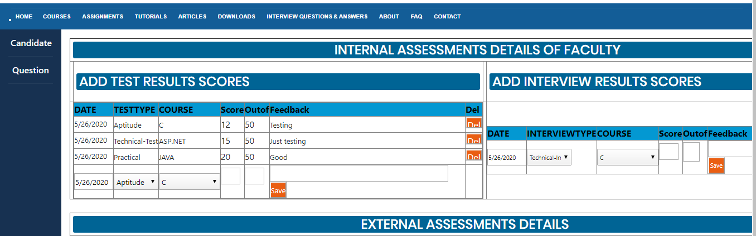

Step 2: After Deleting:
When I tried to delete the last or second record, always the first record gets deleted
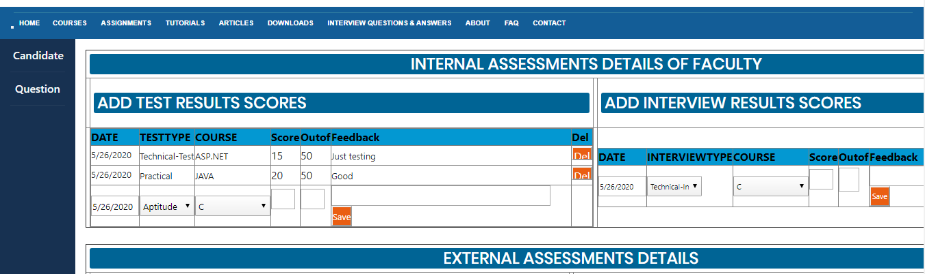

For Example:
My Expected results is: Delete course (ASP.Net) score
Actual Result is: The first course(c) score gets deleted.

I need some improvement in page or some help (https://www.enosislearning.com/Question_Status.aspx)

Improvement:
I need a delete button on Un-answered question details page. So I can delete un-necessary question from “Un-answered question details”.
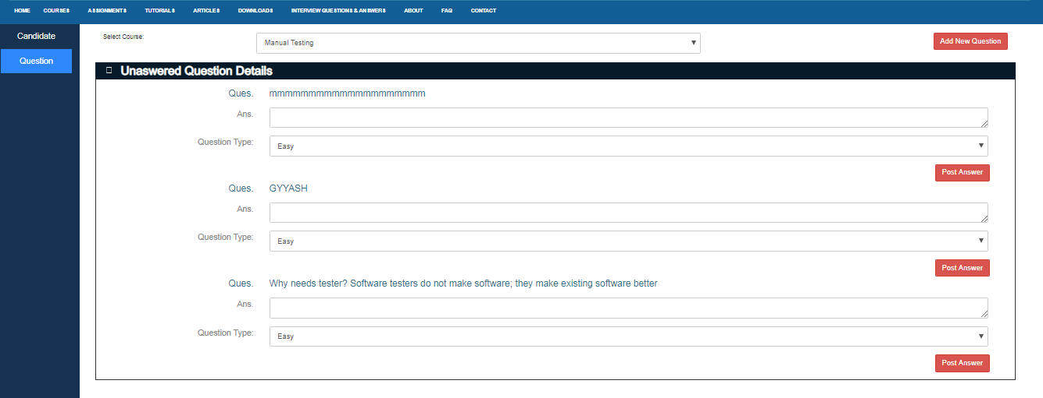

Help: What is use of Change Status button?

I need more information about “Change Status button” to test.
