In this Article, I will explain you how to prepare a Bar Chart. Also we will discuss the concept of category, values & series.

The database which I will be using for this example is AdventureWorksDW2008R2.

The query which I will using for this example is as follow

|  |
| --- |
| SELECT s.SalesTerritoryCountry,d.CalendarYear, sum(f.SalesAmount) as sales ,SUM(F.TaxAmt) AS TAX FROM FactInternetSales f inner join dimdate d on f.DueDateKey = d.DateKey inner join DimSalesTerritory s on f.SalesTerritoryKey = s.SalesTerritoryKey group by s.SalesTerritoryCountry,d.CalendarYear |

To Create a Chart Report the steps we will be using are as follow

1. Create a SSRS Report
2. Add a RDL report file.
3. Create a Data Source
4. Add a Dataset and execute the SQL Query to return the fields as follow
   * + SalesTerritoryCountry
     + CalendarYear
     + Sales
     + Tax
5. Insert Chart into the RDL file and select the Chart Type as Column
6. Once the chart is being selected go to the Chart Data Properties by double clicking the chart
7. In Chart Data Properties, In the Category Groups add the “SalesTerritoryCountry” field.
8. In Chart Data Properties, In the Values add the “sales” field.
9. Preview the Report

## Step 1 : Create a SSRS Report

Go to Microsoft SQL Server 2012 from Program Files, and select SQL Server Data Tools

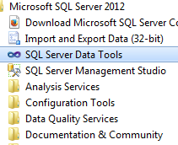

Start SQL Server Data Tools and select File : New Project

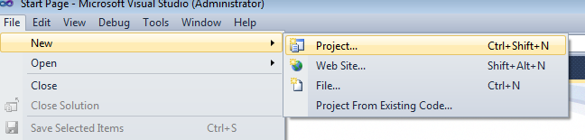

Select Reporting Services : Report Server Project

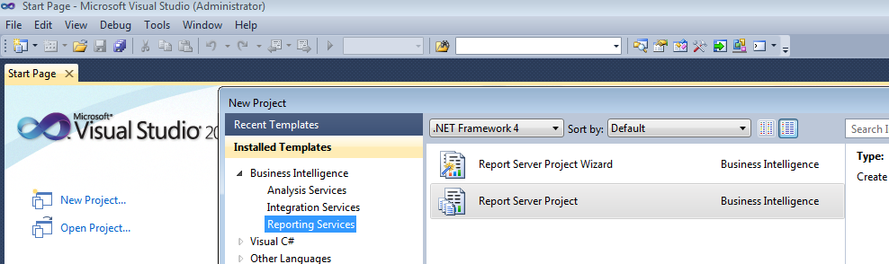

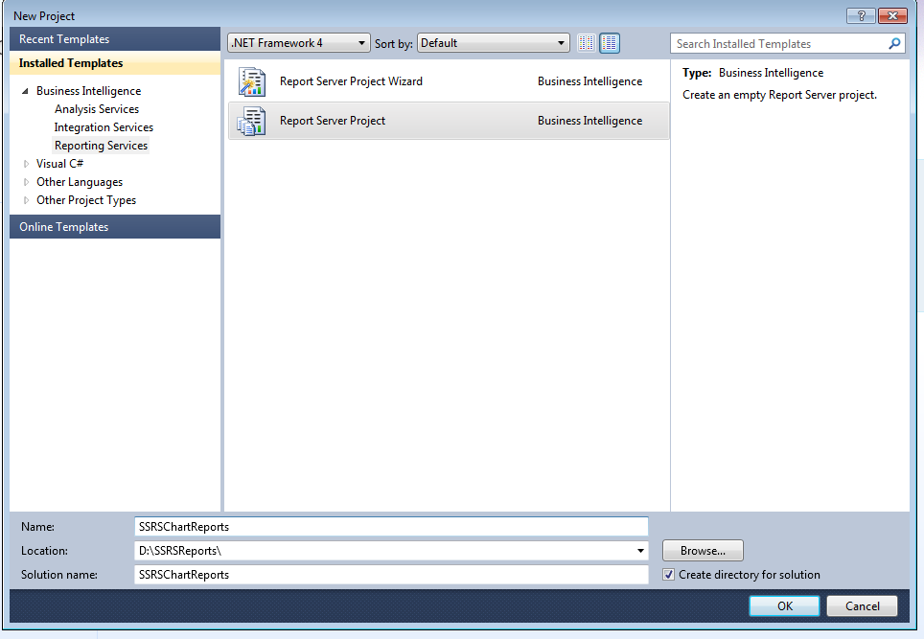

Give The Project Name as “SSRSChartReports” and select “OK” button.

## Step 2 : Add a RDL File

Go To the Solution Explorer and select **Reports -> Add New Item**

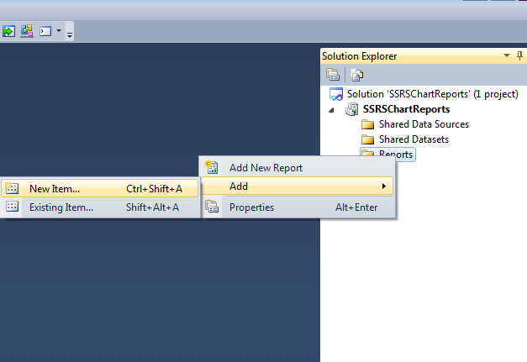

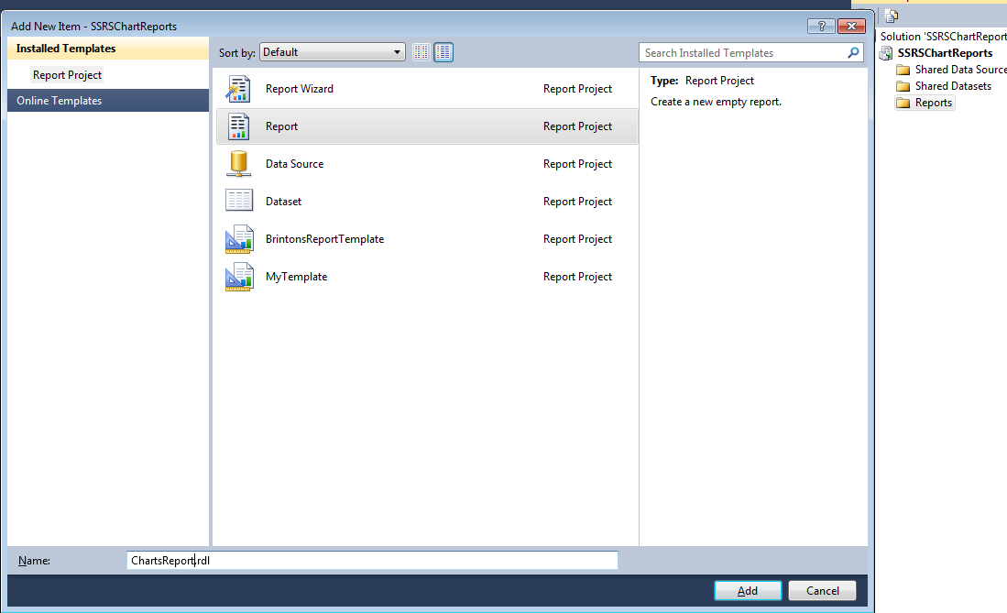

## Step 3 : Add a Data Source

Go to Report Data section and Right Click on the Data source and Add Data Source

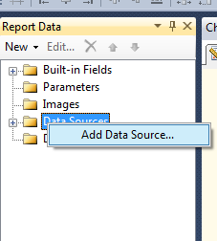

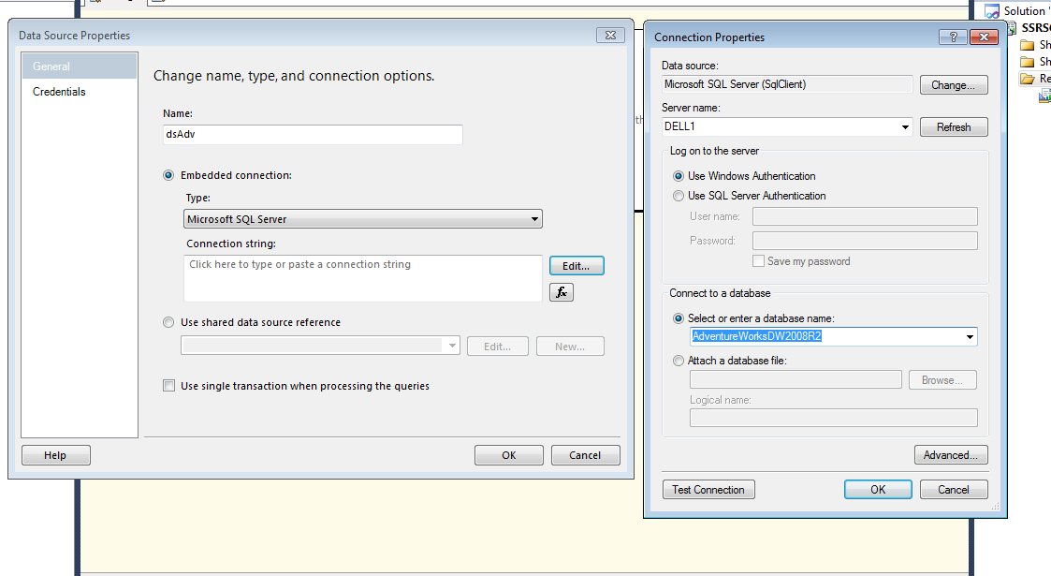

## Step 4 : Add a Data Set

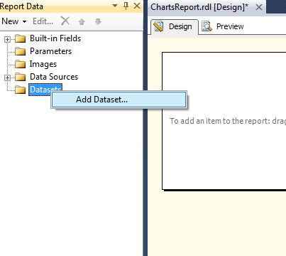

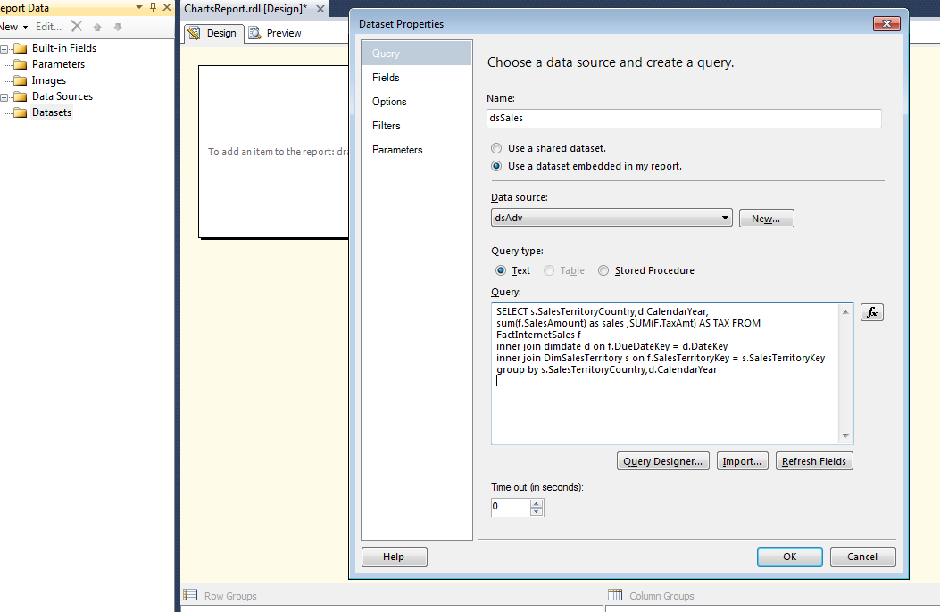

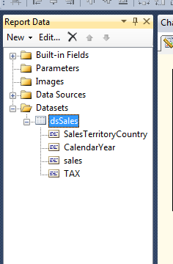

## Step 5 : Insert a Chart Into the Report

Right click on Report Designer and Insert -> Chart

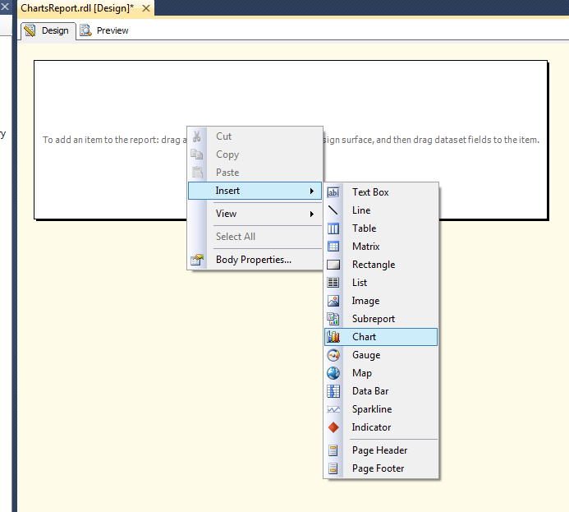

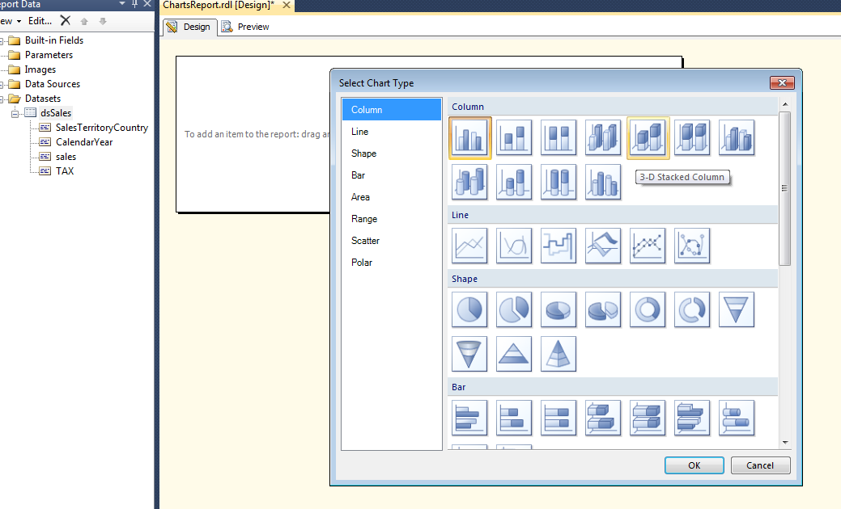

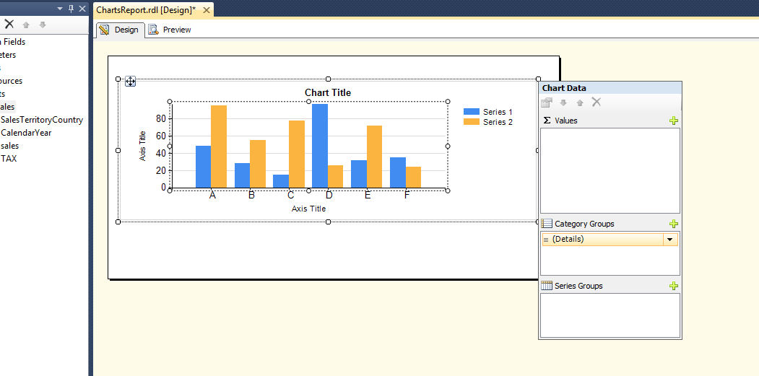

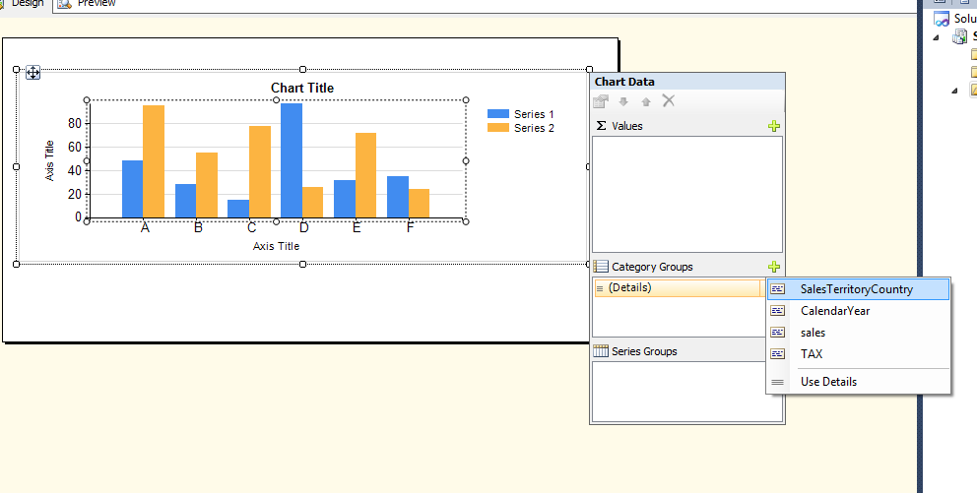

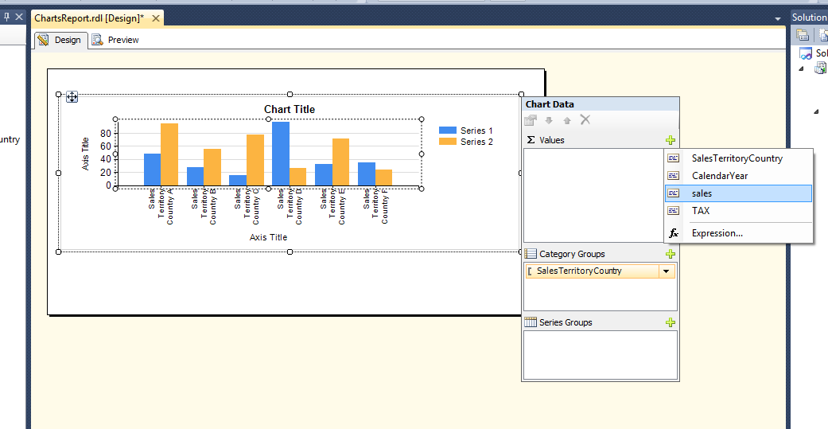

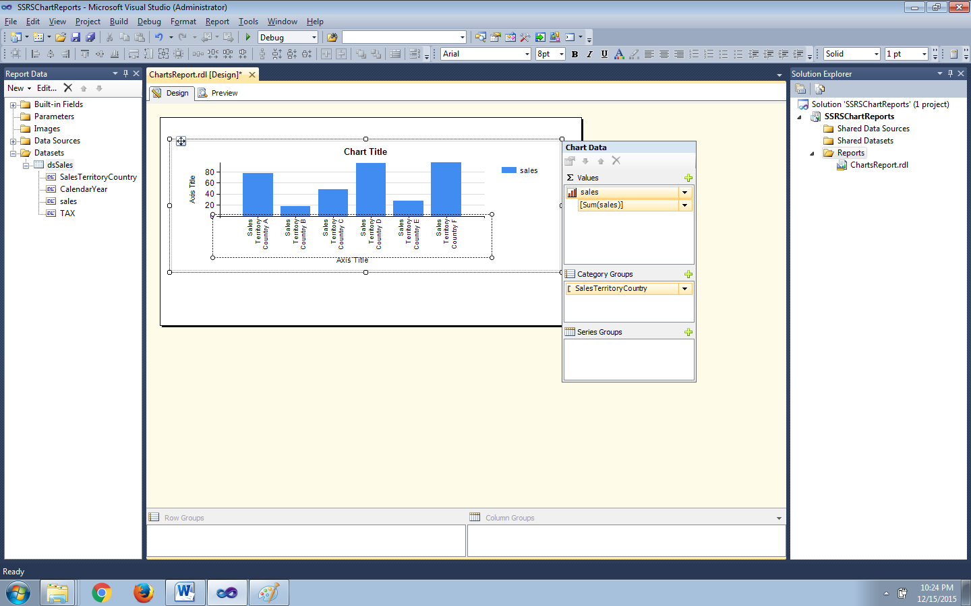

Preview the Report

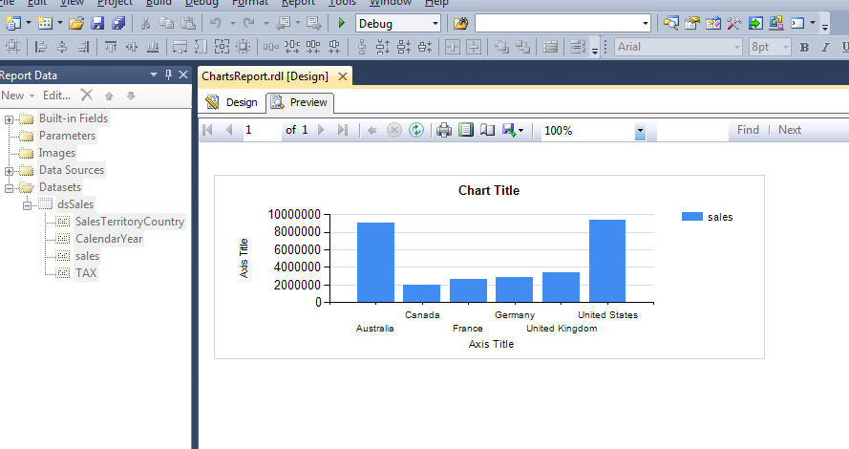

Now the Titles of the Reports are simple TextBoxes which can be changed as required.

Report after changing the Titles.

