Enosis Learning Login Page Test Report

# List of Invalid or broken links are:

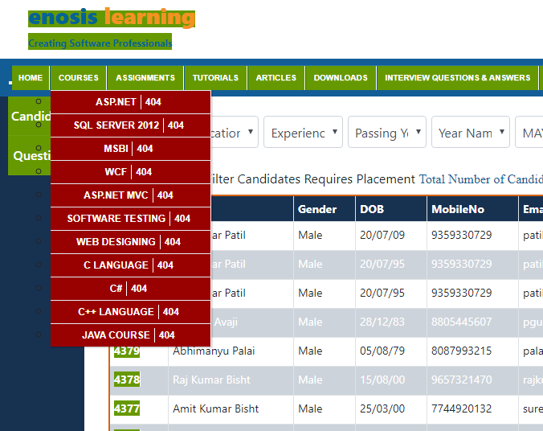

# Background and foreground colors do not have a sufficient contrast ratio

Note: Low-contrast text is difficult or impossible for many users to read.

1. For Example: Digambar patil , Prakash Avaji, Raj Kumar Bisht ext…( Change text white color)

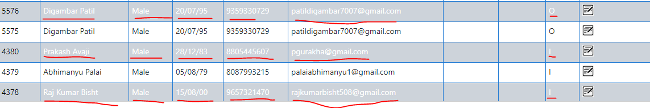

1. Hard to read text mouse hover : On mouse hover, link address should be displayed at the bottom

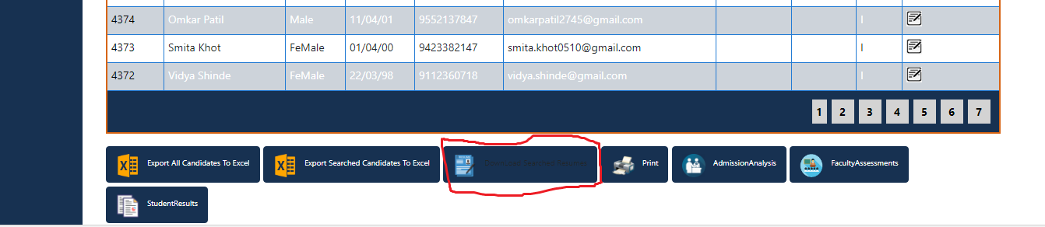

# Website is not responding / website is not mobile responsive

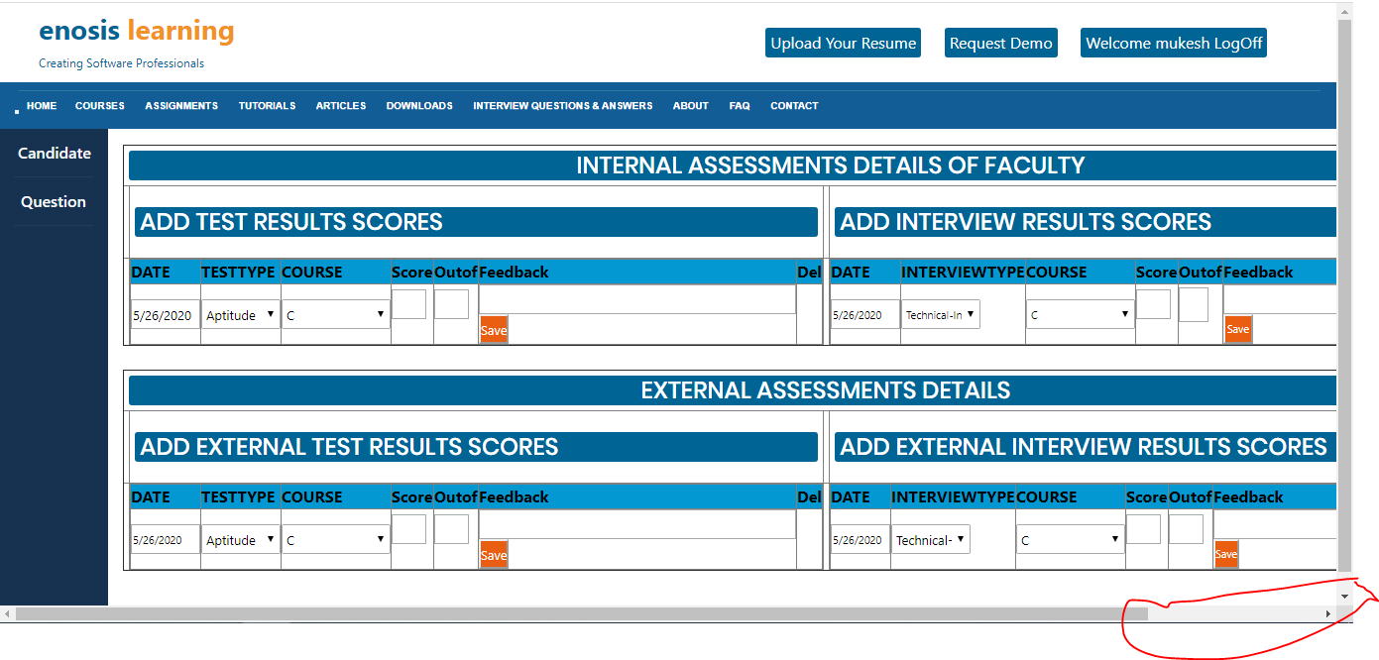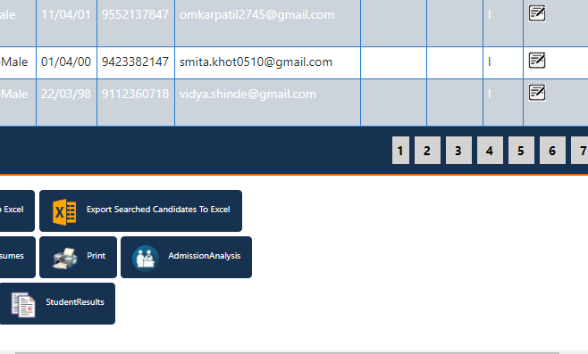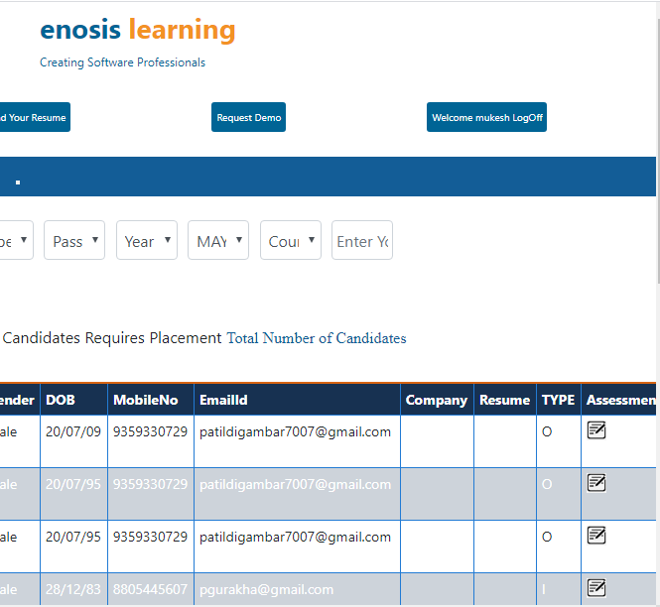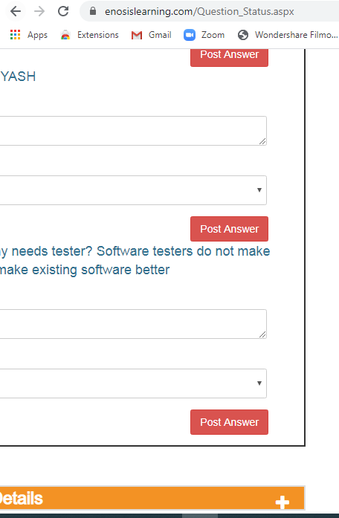

# Remove unused CSS : Performance testing

Remove dead rules from stylesheets and defer the loading of CSS not used for above-the-fold content to reduce unnecessary bytes consumed by network activity.

| URL | Size | Potential Savings |
| --- | --- | --- |
| […css/style.css](https://www.enosislearning.com/Dashboard_File/css/style.css)  (www.enosislearning.com) | 45 KB | 43 KB |
| […css/bootstrap.min.css](https://www.enosislearning.com/Dashboard_File/css/bootstrap.min.css)  (www.enosislearning.com) | 35 KB | 33 KB |

# Text is not properly aligned in input textarea : GUI Testing

For Example:

**Actual Result is:** Experienc , Passing Y, Year Nam and Enter Your Sl

**My Expected results is:** Education, Experiences, Passing Year, Year Name, Enter Your Skills 

# “Filter Candidates Requires Placement” is not working?

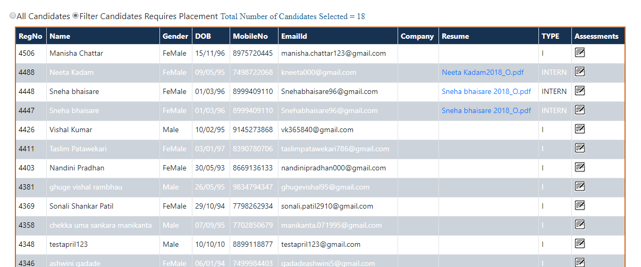

# Duplicate elements or report in List

I got Duplicate data in this table; in spite of this Duplicate data I just want single data.

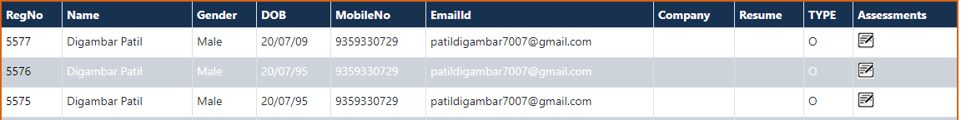

# Delete operation on ASSESSMENTS DETAILS OF FACULTY: TEST RESULTS SCORES

Step1: **Before deleting:**

**Test case:** I want to delete **course (ASP.Net)** from following list:

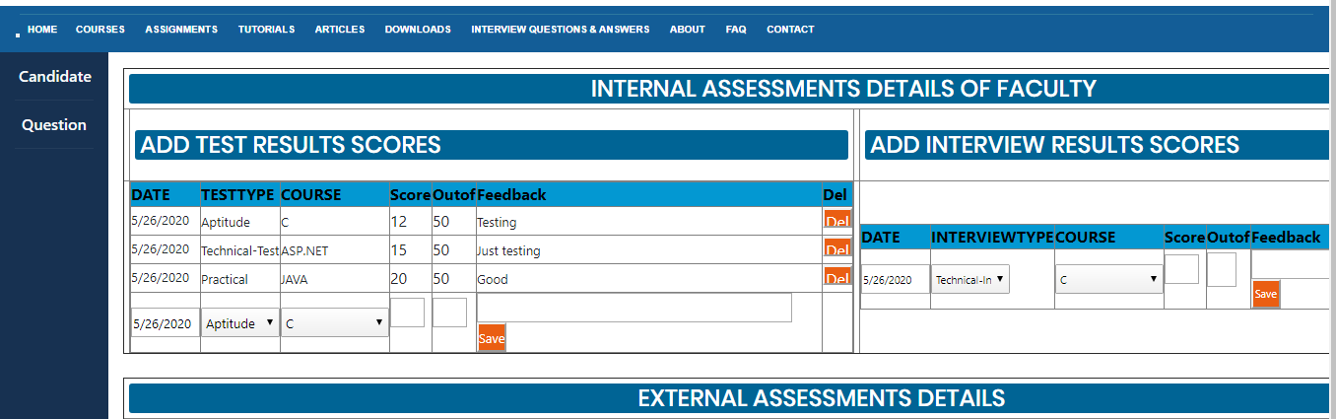

**Step 2: After Deleting:**

When I tried to delete the **last or second record**, always the **first record** gets deleted

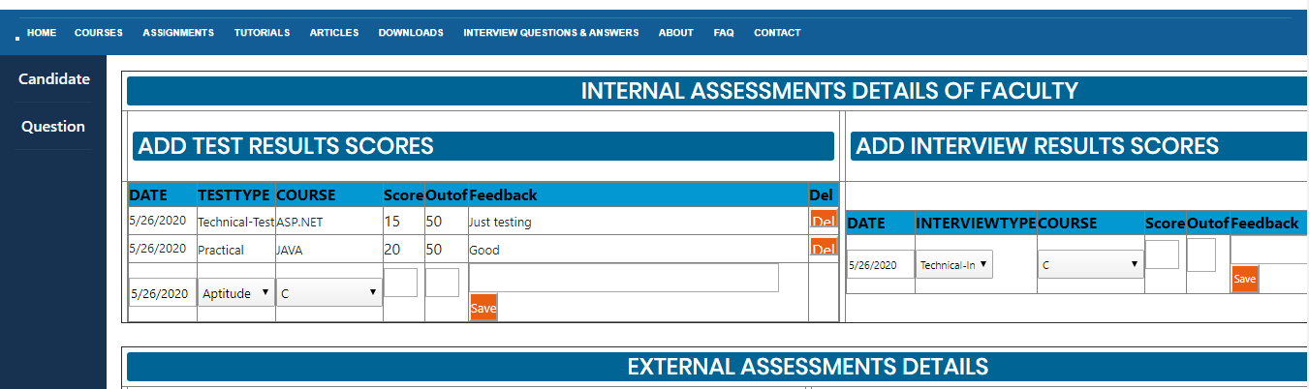

For Example:

**My Expected results is:** Delete **course (ASP.Net) score**

**Actual Result is**: The first **course(c)** score gets deleted.

# I need some improvement in page or some help (<https://www.enosislearning.com/Question_Status.aspx>)

## Improvement:

I need a delete button on Un-answered question details page. So I can delete un-necessary question from “Un-answered question details”.

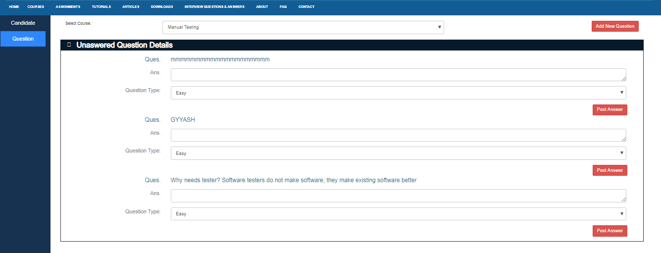

## Help: What is use of Change Status button?

I need more information about “Change Status button” to test.

