Console Application

Lab Practice Guide – 1

- Write a C# program to display a message “Wel come to Enosis”.

- Write a C# program to input Five Strings as command line input and display them in five lines.

- Design a menu based calculator program to perform following operation. (Addition, Subtraction, Multiplication and Division)

- What is boxing and unboxing? Write a program showing the use of boxing and unboxing.

- Input two numbers and list all the prime number between them.

- Write a C# program to input a Decimal number as command line input and display equivalent octal number of the Decimal number.

- Input name and mark in three subject, find total ‘%’ and grade of the student as per following formula.
If percentage >= 60 then Grade A
If percentage >= 50 and percentage < 60 then Grade B
If percentage >= 40 and percentage < 50 then Grade C
Else Fail.

- Write a program to add all odd numbers between 0 to 10.

- Admission to a professional course is subject to the following conditions. [ math >= 50] and
[Science >=50] and
[Chemistry >= 50]
Input mark in individual subject and display He/she is eligible or not as per as condition.

- Write a program to get following output.
[Floyd Triangle]
1
2 3
4 5 6
7 8 9 10

Lab Practice Guide – 2

- Write a program using while loop to reverse a number.

- Input weekday name from key board and print week day serial number using switch case statement.

- Explain the use of following jump statement (break, continue, goto) in a single program.

- Write a program to get following output.
1
2 2
3 3 3
4 4 4 4
5 5 5 5 5

- Write a program to get following output.
5
4 5
3 4 5
2 3 4 5
1 2 3 4 5

- Write a program to Sort and reverse an array.

- Write a program that accepts a shopping list of five items from the command line stores them in string type array and then prints the list in alphabetical order.

- Create an Arraylist of 5 odd numbers and count the elements and Capacity of the Arraylist. Now remove two elements from the beginning and replace them by two prime numbers.

Lab Practice Guide – 3

- Distinguish between String and StringBuilder class. Give an example of string concatenation or string addition.

- What are regular expressions and how use them in a program.

- Write a program to calculate number of occurance of a character in a string.

- Write a program that count number of words in sentence.

- What is a constructor and explain three characterstics.

- What is static constructor?

- Distinguish between constant and read only members by giving an example.

- How do you declare and invoke a method in C#. State the difference between instance method and static method.

- Write 4- difference ways to use main method. List them and state the significance of each of them.

- Distinguish between ref and out parameters with example.

- What is method overloading give an example of it?

Lab Practice Guide – 4

- Create an abstract class called shape, containing an abstract method called area(). Now declare circle class, triangle class, inherit them from abstract class.Implement the area () method in the classes for finding the area.

- Write a program showing the use of delegates.

- Write a multithreaded program in c#.

- Display list of all the drives in your system, directory structure of each drive using DriveInfo and DirectoreInfo class in System.IO namespace.

- Display all the classes, constructors, methods in your assembly using concept of reflection.

- Write a program that accepts Date of Birth of a Student and Display Years, months and Days between current date.

Windows Application

Lab Practice Guide – 5

Case Study 1

Create a form for entering Student roll number, name and marks in five different subjects. Declare a class containing methods to find total,percentage and grade of the student. In the click event of the submit button call the methods and display their result in the respective textboxes as shown in figure below.

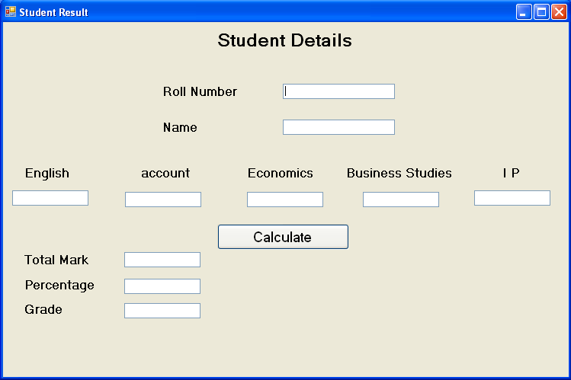

Case Study 2

TuduTudu electronics gives a 10% discount on every product. However, at the time of festival seasons, the store gives a further 7% festival discount after 10%.Write a windows application with a function to calculate the Net price for a product. Enter product name, list price and select the festival or not by clicking an option button as shown in the form. The form is as:

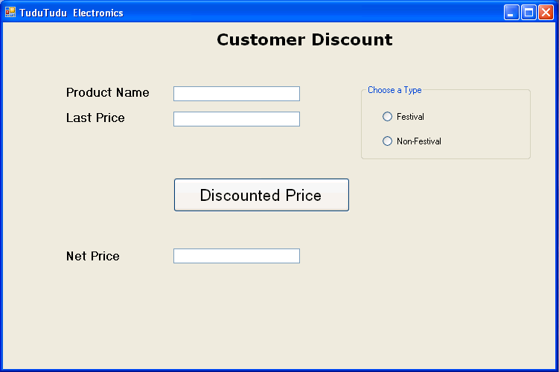

Case Study 3

In a company an employee is paid his salary as follows:
 | Salary | DA | HRA
i | Less than 2000 | 10% | 5%
ii | >=2000 and <4000 | 25% | 15%
iii | >=4000 and <8000 | 30% | 25%
Iv | >=8000 | 40% | 30%
Calculate the net salary of an employee as salary+DA+HRA. The function of net salary will pass salary as an argument. The form and object is as:

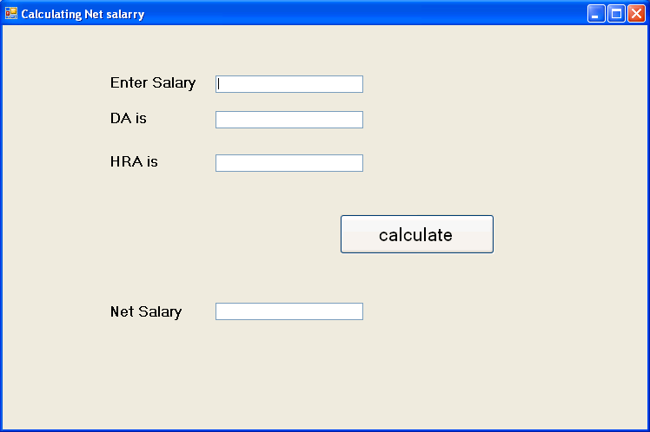

Case Study 4
Create a windows application to display list of all the drives in your system, directories and Files of each drive using DriveInfo and DirectoreInfo class in System.IO namespace. The form and object is as:

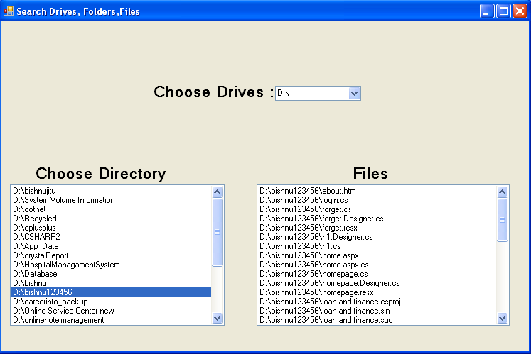

Case Study 5
Create a windows application to accept regdno, name, course, batchtime & Fee of a student. Add the record in the listview control in the click of the Add button. Also place two buttons, one to count number of rows and other to delete a selected row.

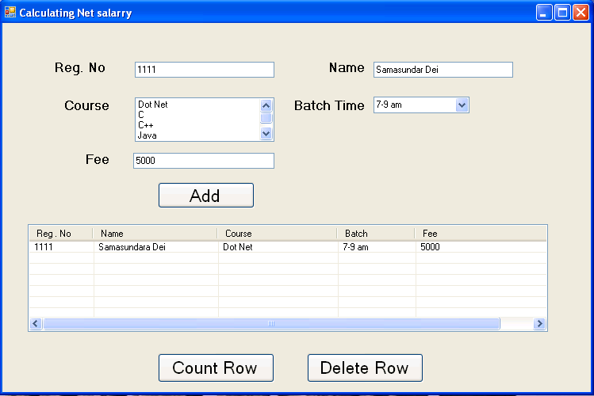

Case Study 6

Create a Text Editor program in C#.Net where make the use of common dialog controls.

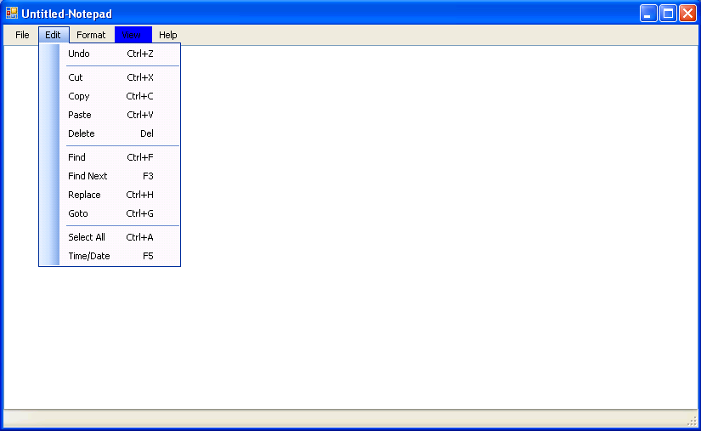

Case Study 7:

Design a Media player application in C#.Net as shown below.

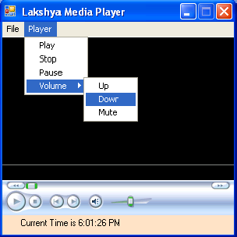

Case Study 8 :

Take a picture box control on the form. Add few image files into your application folder. Display them in the picture box control one by one using timer control.
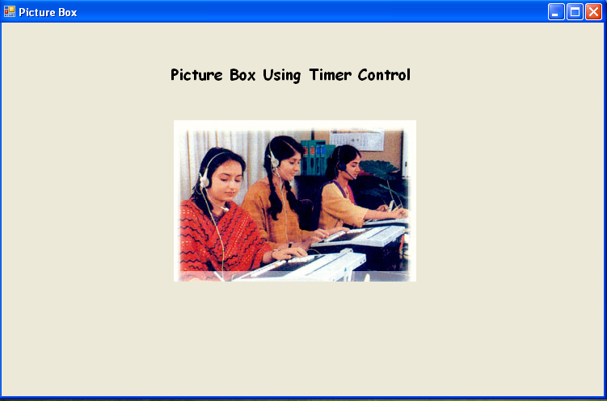

Case Study 9

Create a dataset object. Add a data table called studentdata into it. Add following fields into it - rollno (pk), name (string), age (int). Add few records into it. Display the table data in a datagridview control.
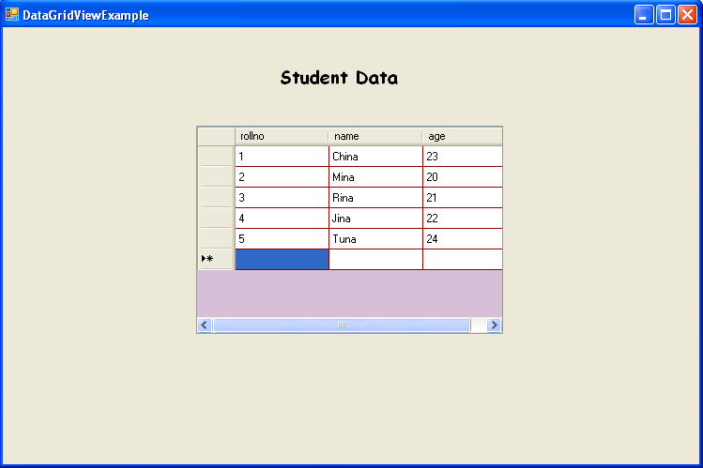

Case Study 10

Write a program to open a text file in a rich text box control, the text file contain data in following format.9937684298,9934588677, 9861098610, .Remove each (,) from it and create a new file containing each no in a separate line.
9937684298
9934588677
9861098610

Case Study 11 :

Suppose we have a database –airline. It contains a table –flightinfo having fields (fno, fname, source, destination, dtime, atime). Create an application to insert, select, delete and update records into it. User interface for the application is as shown:

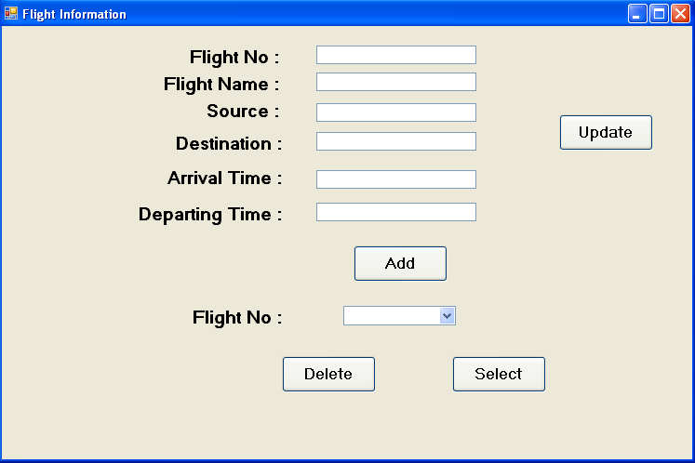

Web Application

Lab Practice Guide – 6

HTML
Case Study 1
Design a HTML page to display the following table in the page.

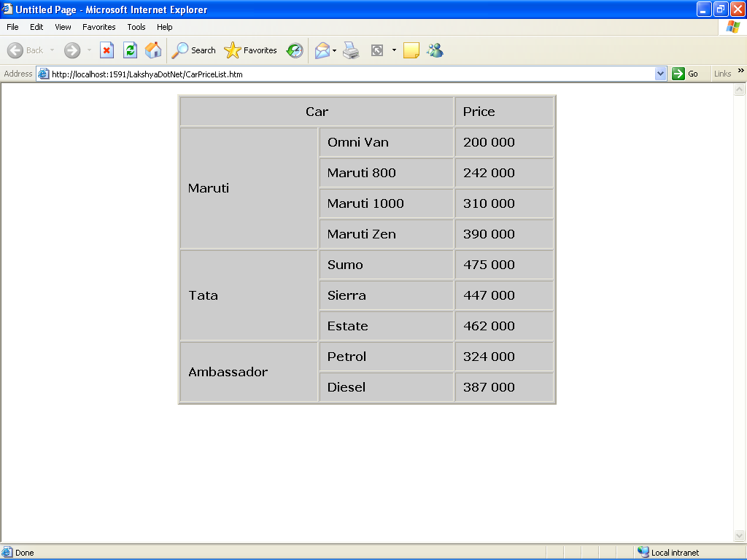

Case Study 2
Design a sample Form in html for the Training Annual Convention as follow.
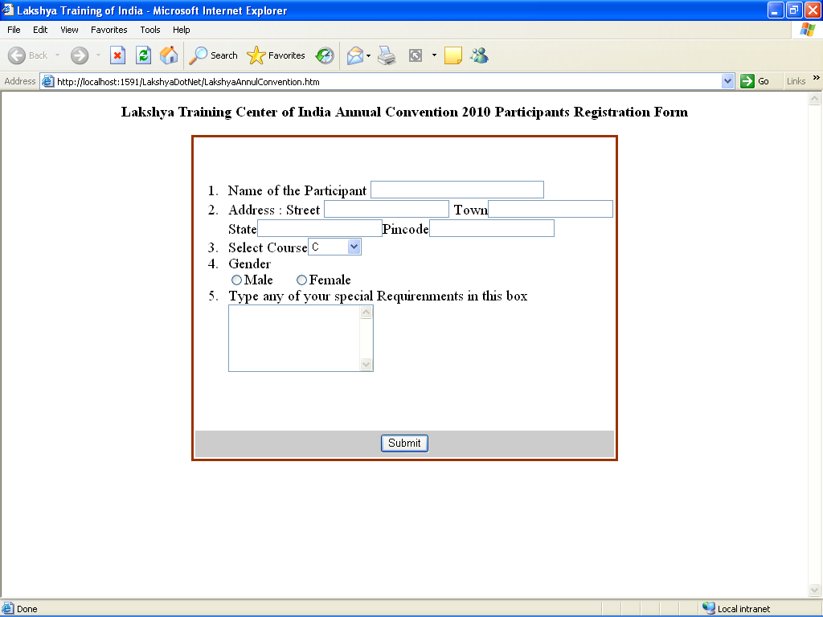

Case Study 3

Create a frameset page in html as follows. Display different pages or images in each frame.

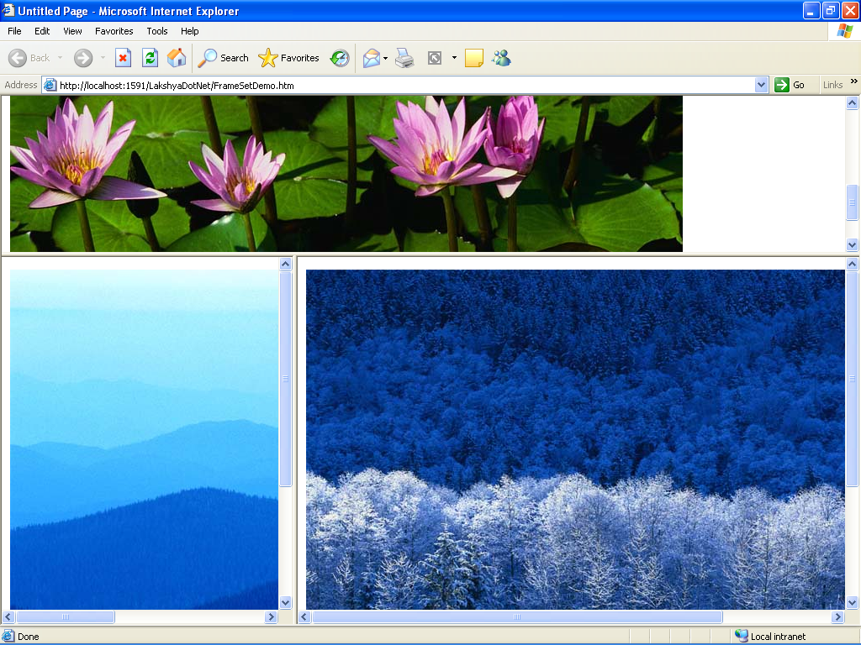

Java Script

Case Study 4
Write a program in java script to find the factorial of a number.

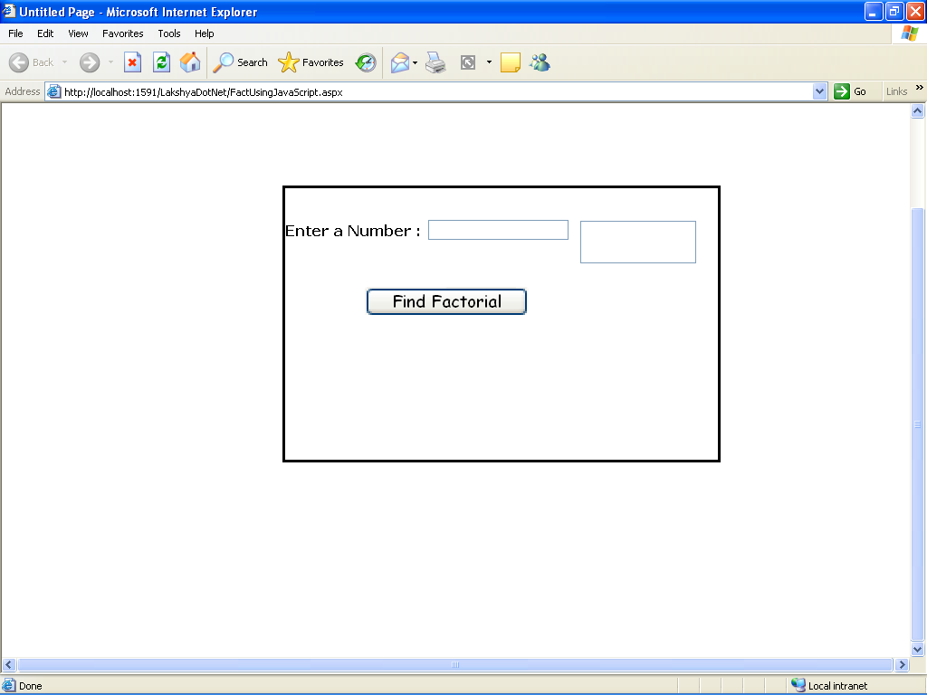

Case Study 5

Write a program in java script to accept only alphabets in textbox.

Case Study 6

Create a web form, place a Textbox control into it. When a user Enter data in the Textbox. It accepts only alphabets (a-z) .After insert data inside the text box it checked the first character of the string should be Uppercase. (Using JavaScript)

Case Study 7

Take a radio button list on the page containing color name as red, blue, black, green, etc. If user selects any option the background color of the page make be changed.

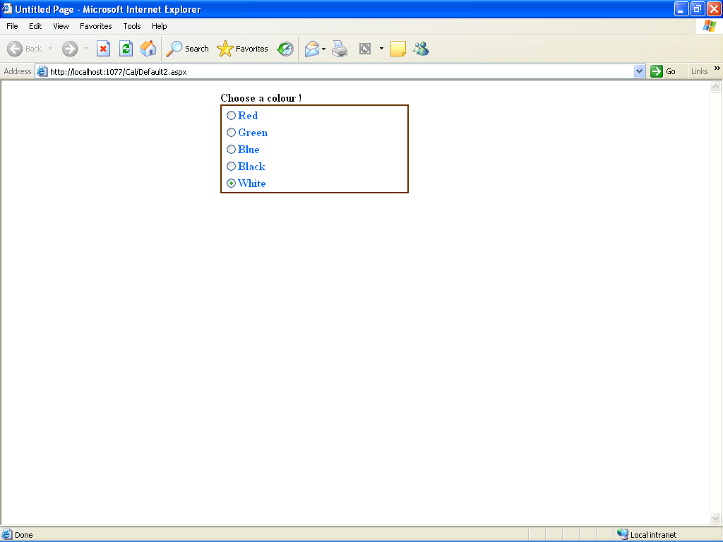

Case Study 8

Create a web form, place a gridview control into it. Display records from a database table in it. Also allow it to perform following operation:
- Select an entire Record
- Edit the Selected Record
- Delete the selected Record
- Insert a new Record

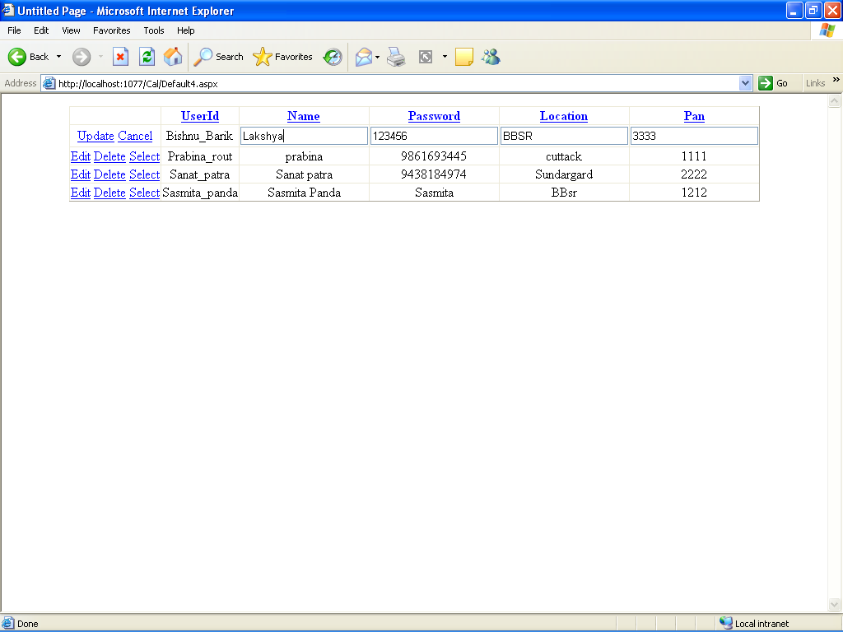

Case Study 11

Create a web application showing the use of validation controls i.e. required field validator, range validator, regular expression validator etc.

Case Study 12

Create a web page for Login using Login control. If the userid and password is valid than it redirect to another page where userid will be displayed in a label as Hello <userid>

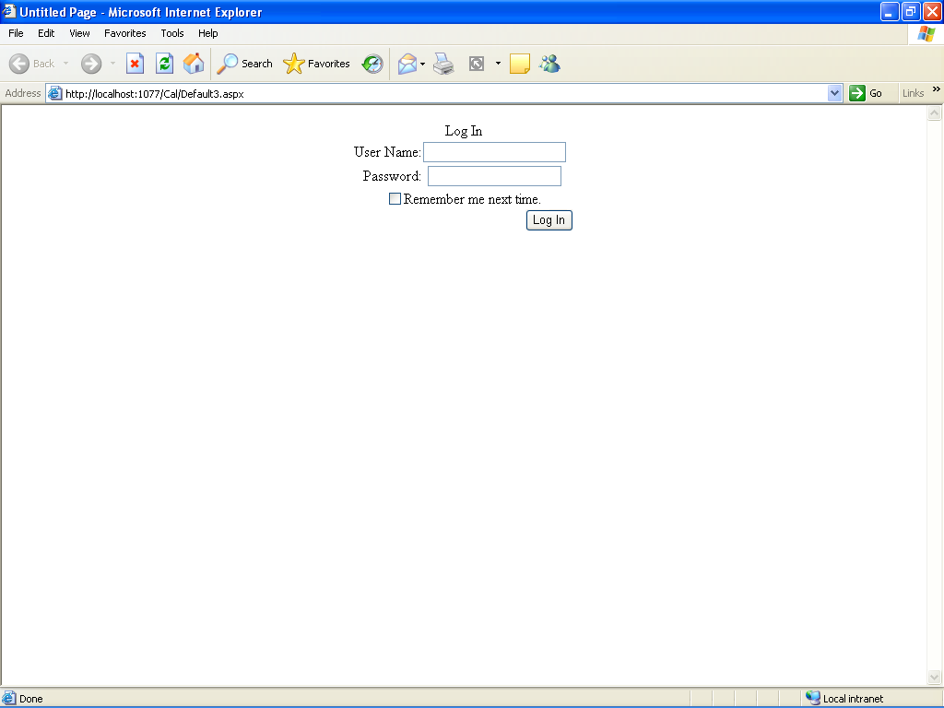

Case Study 13

Create a web application that uses Navigation controls (i.e. sitemap, tree view & menu navigator) for easy navigation among various pages of the web application.

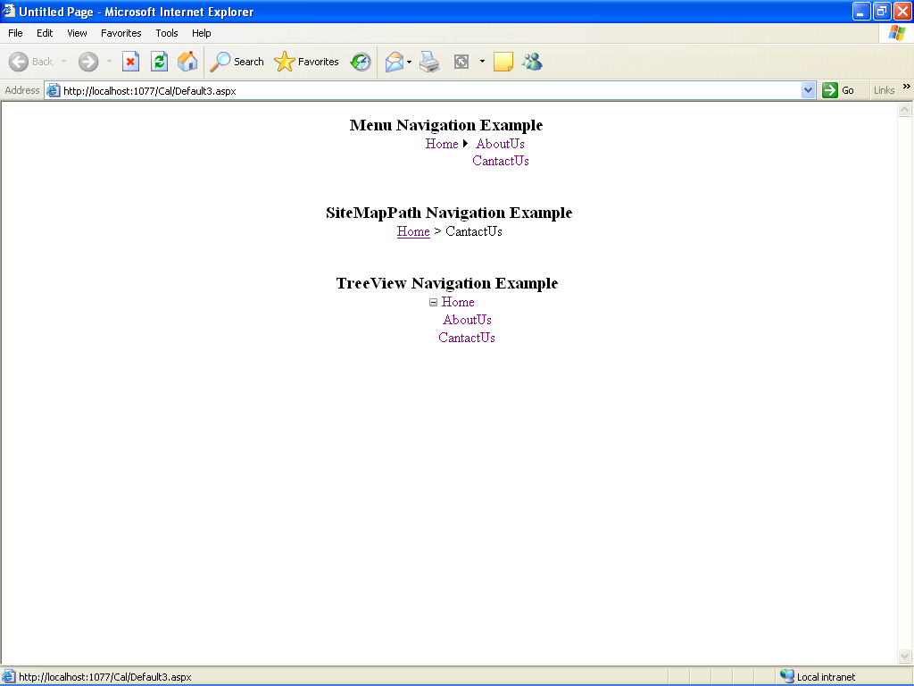

Case Study 14

Create a web service to find the factorial of a number. Implement it a web application by adding reference to it.

