**Ultra-Low Dose PET challenge**

**Name of Student**

Maya Fichmann Levital

**Date (month and year)** Sep 2022

# Abstract

# Methods

## Deep Neural Network approach

The general problem of output prediction with Deep Neural Network (DNN) given some input is formulated as:

|  |  |
| --- | --- |
| $$\hat{y}=f_{θ}(X)$$ | ( 1 ) |

Where $X$ is the input data, $\hat{y}$ is the DNN prediction, and $θ$ stands for the DNN parameters.

The exact meaning of the input $X$ and the DNN prediction $\hat{y}$ is different for each specific application. For example, in DNN-based low dose PET image reconstruction, $X$ consists of the low dose PET patient images ($I_{LD}$), and $\hat{y}$ is the predicted PET image in regular dose ($I_{RD}$).

The conventional supervised training process aimed to find the DNN parameters $θ$ is formulated as:

|  |  |
| --- | --- |
| $$\hat{Θ}=arg\min_{Θ}{L(f_{θ}(X),y)}$$ | ( 2 ) |

where $X,y$ represent matched pairs of inputs and expected outputs. The loss-function $L$ usually consists of a data term penalizes for the difference between the predicted output $f_{θ}\left(X\right)$ and the desired output. It may also include general regularization terms penalizing for the network parameters behavior and specific regularization terms related to the characteristics of the desired output.

From a probabilistic point-of-view, these formulations of the DNN training process yields a maximum-likelihood point estimate of the DNN parameters $Θ$. This may result in a potential over-fitting that yields sub-optimal results at inference phase, especially for small-size datasets commonly present in the medical imaging domain. Further, it lacks the ability to quantify the uncertainty of the deformation field parameter estimates.

In contrast, the Bayesian approach for DNN training aims to characterize the entire posterior distribution of the DNN parameters:

|  |  |
| --- | --- |
|  | ( 3 ) |

Since direct integration of the posterior distribution is intractable, several approaches proposed a domain-specific formulation of the prior $P\left(Θ\right)$ to achieve a maximum posterior estimation in a computationally feasible time such as a smoothness term rather than explicitly define the distribution of the predicted output. The specific formulation is given by:

|  |  |
| --- | --- |
|  | ( 4 ) |

While this can provide a maximum-a-posterior (MAP) point estimation of the DNN output, it cannot characterize the entire distribution of the DNN output, which is necessary to assess the confidence in the DNN prediction.

## The general NPB-DNN approach

To address this challenge, we propose adopting the Stochastic Gradient Langevin Dynamics (SGLD) approach (14), (15) for DNN training. During the training phase of the network, gaussian noise with adaptive variance is injected to the loss gradients during the iterations of the optimization process. In contrast to conventional training in which the DNN weights obtained at the last iteration are used as point-estimates, in SGLD-based training we continue to conduct several iterations after the DNN optimization process converges to its minima, and keep all the weights from those. The results of the DNN training process with the NPB-DNN approach is a set of network weights ${\left\{Θ_{t}\right\}}_{t_{b}}^{N}$ where $Θ_{t}$ are the DNN weights at iteration $t$ of the training process, $t_{b}$ is the iteration in which the training process converge to minima, and N is the number of overall iterations of the training process. Under some feasible constraints on the step size, the sampled weights converge to the posterior distribution (14), (15).

We estimate the posterior distribution of the DNN predictions during the inference phase by aggregating the predications obtained by the DNN with the weights form the different iterations. A confidence score, representing the certainty of the DNN in its prediction, can be computed by calculating the empirical variance of the prediction samples. Further, the SGLD-based training has additional benefits in training DNN beyond enabling efficient posterior sampling, including a better ability to cope with non-convex problems, improved generalization ability, and reduced over-fitting, among others (16).

## NPB-DNN for Low Dose PET reconstruction

The Low Dose PET reconstruction can be formulated as follows. Let us denote the pair of low dose PET and regular dose PET images by $I_{LD}$ and $I_{ND}$, respectively.

Then, the training of a DNN with weights $Θ$ to predict the normal dose PET image is defined as:

|  |  |
| --- | --- |
| $$\hat{Θ}=arg\min_{Θ}{L(f_{θ}(I_{CT}),I_{ND})}$$ | ( 5 ) |

where $L$ is the L1 norm.

Figure 1 illustrates the proposed framework for Low Dose PET reconstruction with uncertainty estimation. Our main building-block is a U-Net-based DNN (see Appendix B) which accepts $I_{LD}$ as an input, and reconstructs $I_{ND}$. Training the DNN with the proposed NPB-DNN approach will result in a set of DNN weights ${\left\{Θ_{t}\right\}}_{t_{b}}^{N}$. From these DNN weights we sample the reconstruction estimations ${\left\{Φ_{t}\right\}}_{t_{b}}^{N}$ from which we can estimate both an average reconstructed image field and the standard deviation of the images which can thereby serve as an indicator for the certainty of the DNN in the prediction.

|  |
| --- |
| Low Dose PET |
| **Figure 1: Block diagram of the proposed NPB-DNN Low Dose reconstruction system. After obtaining ${\left\{Θ_{t}\right\}}_{t_{b}}^{N}$, we calculate the mean and the standard-deviation (std.) $μ$ and $σ$, respectively. Only $μ$ is used in the reconstruction scheme, and $σ$ provides an estimate of the result uncertainty.** |

# Results

SSIM comparison:

We compared the results of two methods:

1. SGLD: upon training, the last 60 iterations of the SGLD network were saved. We inferred the image(s), found the mean and STD image over the number of iterations.
2. Inference Dropout: we used the Inference Dropout method to infer the resulted image on the final reconstruction network. We inferred the image(s), found the mean and STD image over the number of iterations.

As can be seen in Table 1, the SGLD network convergence dose not improve as a function of number of iterations. The Inference Dropout dose improve as a function of number of iterations, however with inferior performance compared to the SGLD.

|  |  |  |
| --- | --- | --- |
| Network | # Iterations | SSIM Network mean of iterations (baseline SSIM = 0.88) |
| SGLD | 1 | 0.94947 |
| SGLD | 20 | 0.94949 |
| SGLD | 40 | 0.94949 |
| SGLD | 60 | 0.94946 |
| Inference Dropout | 1 | 0.91378 |
| Inference Dropout | 20 | 0.94427 |
| Inference Dropout | 40 | 0.94526 |
| Inference Dropout | 60 | 0.94545 |

**Table 1: Median SSIM comparison**

Images:

SGLD

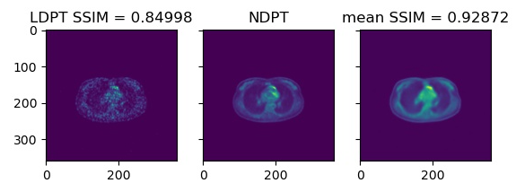

Standard

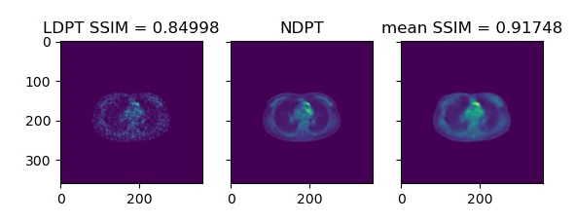

SGLD

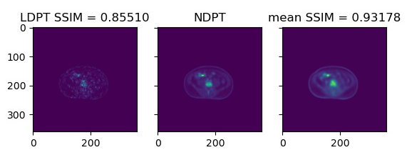

Standard

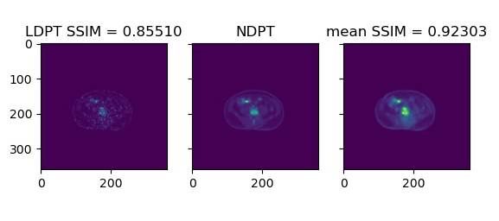

STD maps – 20 iterations:

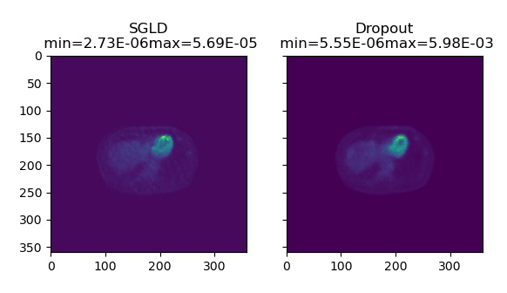

STD maps – 60 iterations:

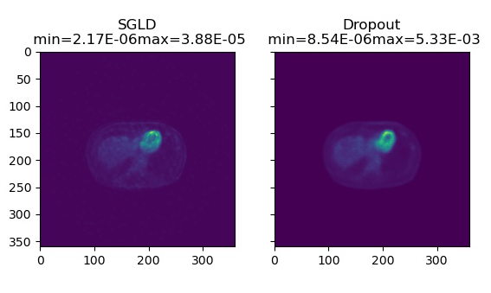

# References

1. E. Edmund Kim, Myung-Chul Lee Tomio Inoue, Wai-Hoi Wong: Clinical PET and PET/CT Principles and Applications; Second Edition
2. Biological Effects of Ionizing Radiation (BEIR VII),1
3. Ciprian Catana, MD, PhD: The Dawn of a New Era in Low-Dose PET Imaging
4. Shan Tong, Adam M Alessio, and Paul E Kinahan: Image reconstruction for PET/CT scanners: past achievements and future challenges
5. Gens R, Domingos P: Deep Symmetry Networks; Adv Neural Inf Process Syst 2014
6. He KM, Zhang XY, Ren SQ, Sun J. Delving Deep into Rectifiers: Surpassing Human-Level Performance on ImageNet Classification. 2015 IEEE International Conference on Computer Vision (ICCV), 2015; 1026–1034.
7. Chen H: Low-Dose CT with a Residual Encoder-Decoder Convolutional Neural Network (RED-CNN) 2017
8. Liu F, Jang H, Kijowski R, Bradshaw T, McMillan AB: Deep learning MR imaging-based attenuation correction for PET/MR imaging; Radiology 2018;286(2):676–684.
9. Shen D, Wu G, Suk HI: Deep learning in medical image analysis; Annu Rev Biomed Eng 2017;19(1):221–248.
10. Junshen Xu, Enhao Gong, John Pauly and Greg Zaharchuk: 200x Low-dose PET Reconstruction using Deep Learning
11. Kevin T. Chen, Enhao Gong, Fabiola Bezerra de Carvalho Macruz, Junshen Xu, Athanasia Boumis, Mehdi Khalighi, Kathleen L. Poston, Sharon J. Sha, Michael D. Greicius, Elizabeth Mormino, John M. Pauly, Shyam Srinivas, Greg Zaharchuk: Ultra–Low-Dose 18F-Florbetaben Amyloid PET Imaging Using Deep Learning with Multi-Contrast MRI Inputs
12. Amirhossein Sanaat , Hossein Arabi , Ismini Mainta, Valentina Garibotto and Habib Zaidi: Projection-space implementation of deep learning-guided low-dose brain PET imaging improves performance over implementation in image-space
13. Jiahong Ouyang, Kevin T. Chen, Enhao Gong, ,Greg Zaharchuka: Ultra-low-dose PET reconstruction using generative adversarial network with feature matching and task-specific perceptual loss
14. Zhilun Wanga, Haitao Jianga, Hongwei Dua, Jinzhang Xub, Bensheng Qiua S. Mandt, M. D. Hoffman, and D. M. Blei: Stochastic gradient descent as approximate Bayesian inference; J. Mach. Learn. Res., vol. 18, pp. 1–35, 2017.
15. M. Welling and Y. W. The: Bayesian learning via stochastic gradient langevin dynamics; in Proceedings of the 28th International Conference on Machine Learning, ICML 2011, 2011, pp. 681–688.
16. A. Neelakantan, L. Vilnis, Q. V Le, I. Sutskever, L. Kaiser, K. Kurach, and J. Martens: Adding Gradient Noise Improves Learning for Very Deep Networks; arXiv. 2015.
17. Z. Wang, A. C. Bovik, H. R. Sheikh, and E. P. Simoncelli: Image quality assessment: from error visibility to structural similarity; IEEE transactions on image processing, vol. 13, no. 4, pp. 600–612, 2004.
18. Z. Wang, E. P. Simoncelli, and A. C. Bovik: Multiscale structural similarity for image quality assessment,” in Signals, Systems and Computers, 2004; Conference Record of the Thirty-Seventh Asilomar Conference on, vol. 2, pp. 1398–1402, 2003.
19. MURALI RAVI, ANGU SEWA, SHASHIDHAR T. G, AND SIVA SANKARA SAI SANAGAPATI: FPGA as a Hardware Accelerator for Computation Intensive Maximum Likelihood Expectation Maximization Medical Image Reconstruction Algorithm
20. Duncan White and Richard S Lawson 2015: A Poisson resampling method for simulating reduced counts in nuclear medicine images; Phys. Med. Biol. 60 N167

# Appendix B – U-net for Low Dose PET reconstruction (11)

# 

LD PET Input

# The network consists of an encoder path on the left side and decoder path on the right side. The encoder portion is composed of layers that perform two-dimensional convolutions, batch normalization, and rectified linear unit activation operations. Two-by-two max pooling is used to reduce the dimensionality of the data. In the decoder portion, the data in the encoder layers are concatenated with those in the decoder layers. Linear interpolation is performed to restore the data to its original dimensions.

# Appendix C – Poisson Resampling for PET sinogram (20)

The underlying statistical nature of the decay process means that the noise for counts in nuclear medicine images obeys a Poisson distribution. The Poisson distribution has the special characteristic that the standard deviation σ and skewness of the distribution are directly related to the mean:

|  |  |
| --- | --- |
| $$σ=\sqrt{m}$$ $$γ_{1}=\frac{1}{\sqrt{m}}$$ |  |

Simulation of a reduced-count image by simple mathematical division of the counts in each pixel of the raw data, rounded off to maintain integer values, will not retain these relationships and will therefore produce simulated images with incorrect noise relationships. Adding back the appropriate amount of Poisson noise into a scaled down image needs to be done cautiously, because the original raw data will already have some noise, but the amount to be added can be estimated from the scaled down counts. The correct noise relationships in images as counts are reduced can be elegantly maintained by Poisson resampling. In Poisson resampling, each element $i$ in a population is included in the sample independently of all other units with probability $π_{i}$. Since probability $π_{i}$ is the same for all elements, independent Bernoulli trial is used to determine whether the element becomes part of the sample during the drawing of a single sample. Each count in an acquired image is considered to be an independent variable, or element in the population of total counts. To simulate a reduced-count image one first defines the probability $π_{i}$ of selection in the new image, which is the reciprocal of the Dose Reduction Factor (DRF). For example, 0.5 for a half-count image, or 0.75 for a three quarter-count image. Each count, $c$, in the original image is then allocated an independent uniform random number $u_{1}, u_{2}, …, u_{N} \sim U[0,1]$ where $N$ is the number of counts in the pixel. On a pixel-by-pixel basis, the random number associated with each count is subjected to the Bernoulli trial to see if it is less than or equal to the probability of selection ( $u_{c} ≤ π$). If true the count is selected for inclusion in the new image, otherwise it is discarded.