1. Commerce Application On IBM Cloud Foundry

**Phase 3-Development part-1**

**Problem Definition:**

To design the platform layout and create a database to store product information.

**Platform Features:**

* SignIn /Login Page
* Wishlist
* Add to cart
* Reviews
* Recommendation

**Goal:**

The goal is to connect skilled artisans with global audience,showcasing their handmade products and provide features like secure shopping carts,Payment gateways and an initiative checkout process

**E-commerce Application:**

* This application is for selling artisan handmade products.
* We named this beautiful application as “**ARTISAN TREASURE”.**
* This application consists of certain pages like Homepage,Login / Signup page, Product page,Wishlist page,Add to cart page

**HOME PAGE:**

The Home Page of this application is the first page which visitors see when they access the site. It serves as the digital storefront and is designed to capture the user's attention. On the Home Page, you'll find a variety of elements, including:

**Newly Arrived:** These are usually displayed prominently, showcasing the best-selling or new products.

**Navigation Menu:** A menu bar or navigation links to help users easily access different sections of the website, like product categories, the shopping cart, wishlist,search bar, Loginpage.

**Search Bar**: A tool for users to search for specific products.

**Promotional Banners**: These can include sales, discounts, or any current promotions.

**Shop by Category:** An option that allows users to easily navigate and filter products by various categories, such as Kitchenware, Decor and more.

**Footer**: Contact information, links to policies, and social media links.

**Homepage UI:**

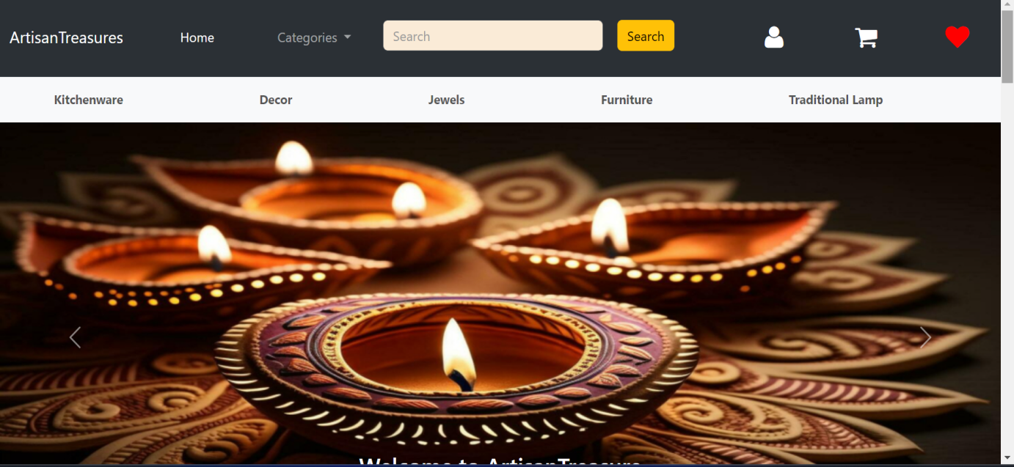

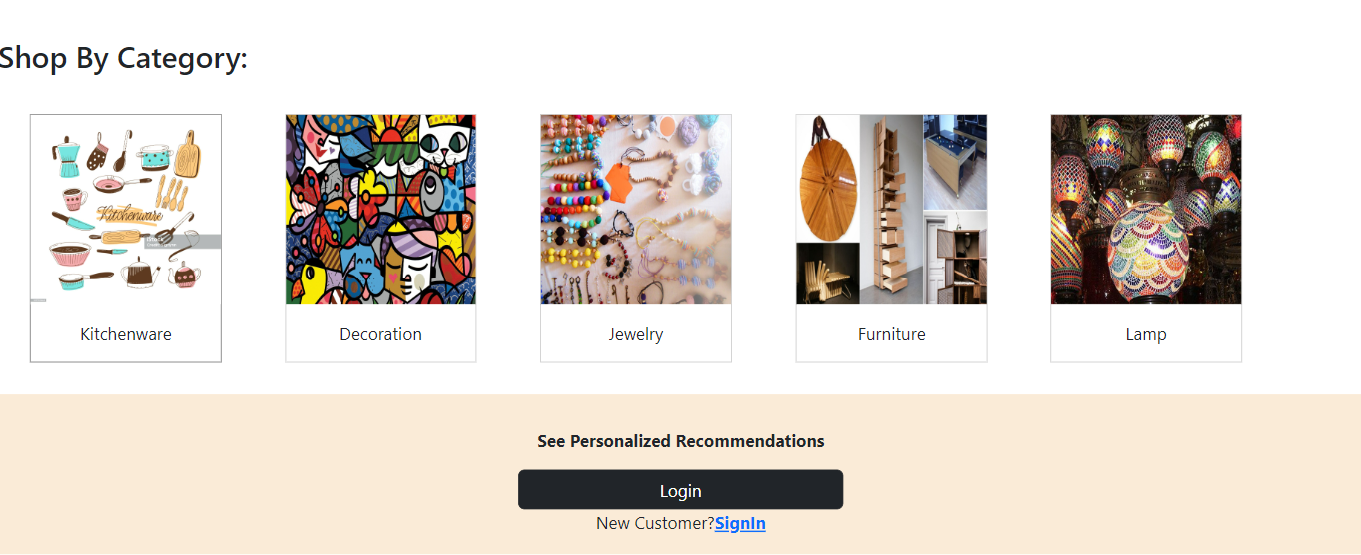

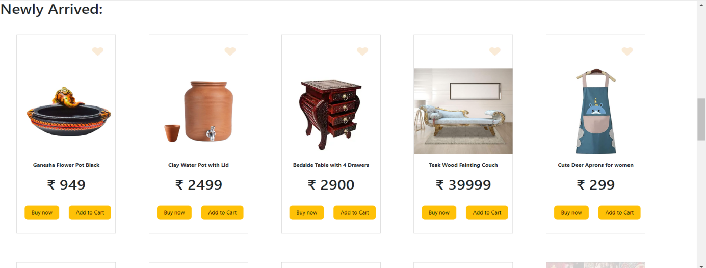

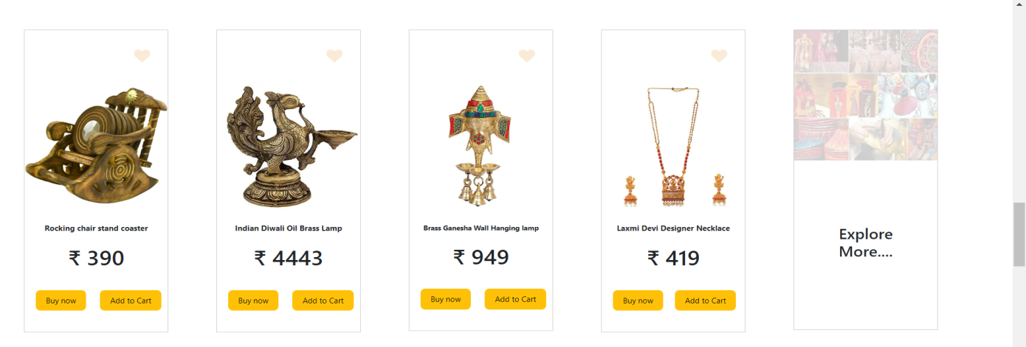

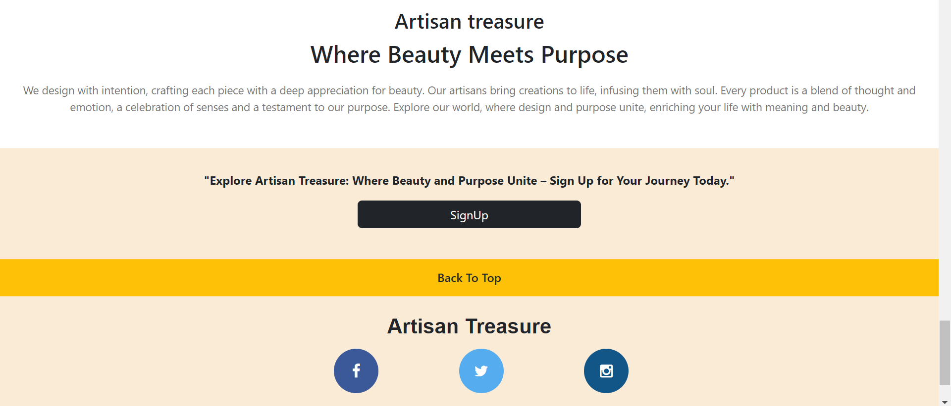

**LOGIN PAGE:**

The Login Page is where registered users log in to their accounts. It includes the following elements:

**Username/Email and Password Fields:** Users input their login credentials.

**"Remember Me" Option:** An option for users to stay logged in.

**"Forgot Password" Link:** In case users forget their password and need to reset it.

**"Create Account" or "Sign Up" Link:** For new users to register on the website.

**Login page and Sign in page UI:**

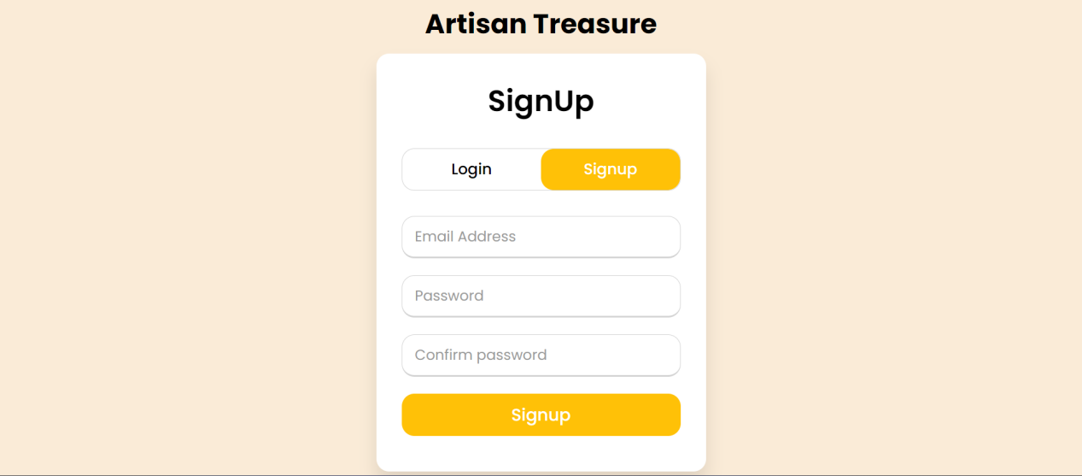

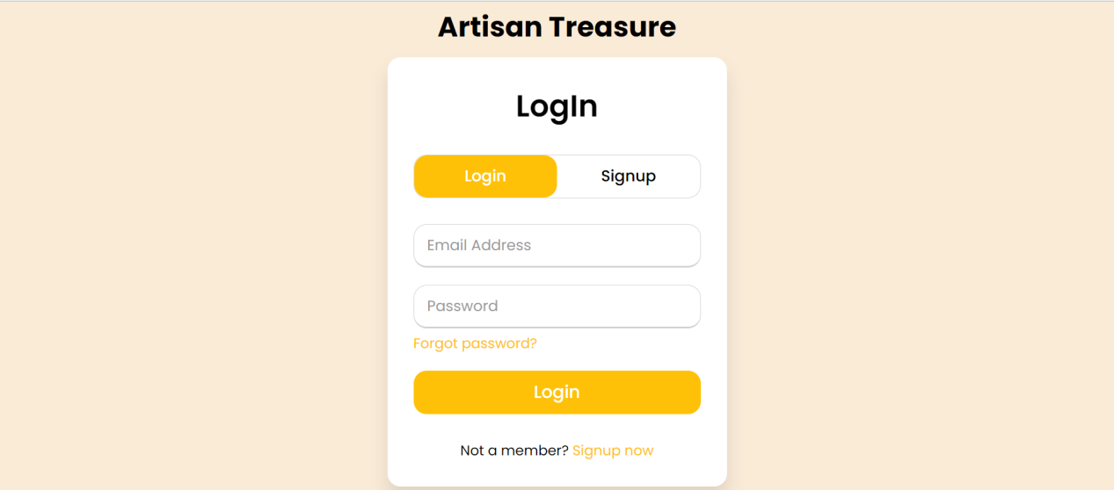

**PRODUCT PAGE:**

The Product Page is where users can view detailed information about a specific product they are interested in purchasing. It typically includes:

**Product Images:** High-quality images of the product from different angles.

**Product Description:** Information about the product's features, specifications, and benefits.

**Price and Availability:** The cost of the product and its current stock status.

**Add to Cart Button:** To add the product to the shopping cart.

**Customer Ratings:** Feedback from other customers

**PRODUCT PAGE UI:**

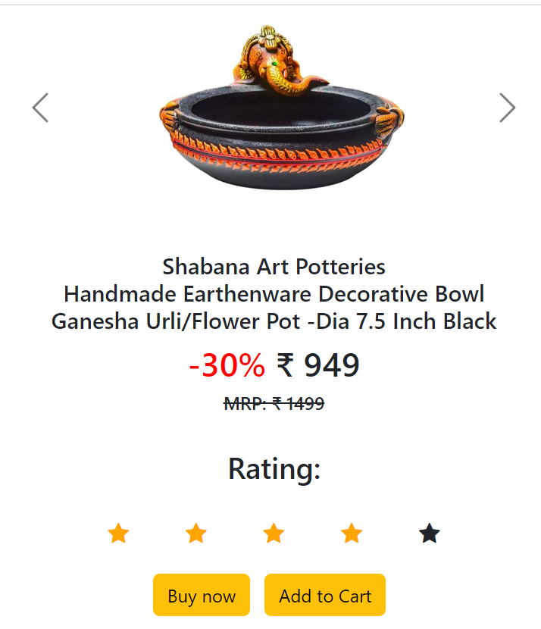

**Technology Stack Used:**

The technologies that we used for both frontend and backend are:

* + HTML
  + CSS
  + JavaScript
  + Bootstrap
  + Flask
  + IBM db2

**Flask and IBM db2**

Flask and IBMdb2 are used in backend to enable users for creating account and managing it securely.

**HTML, CSS, JavaScript and Bootstrap:**

Used to create an intuitive user interface with fast and responsive layout.

**Setting up a Database for The Ecommerce Website**

**Step1:First Connect to DB2:**

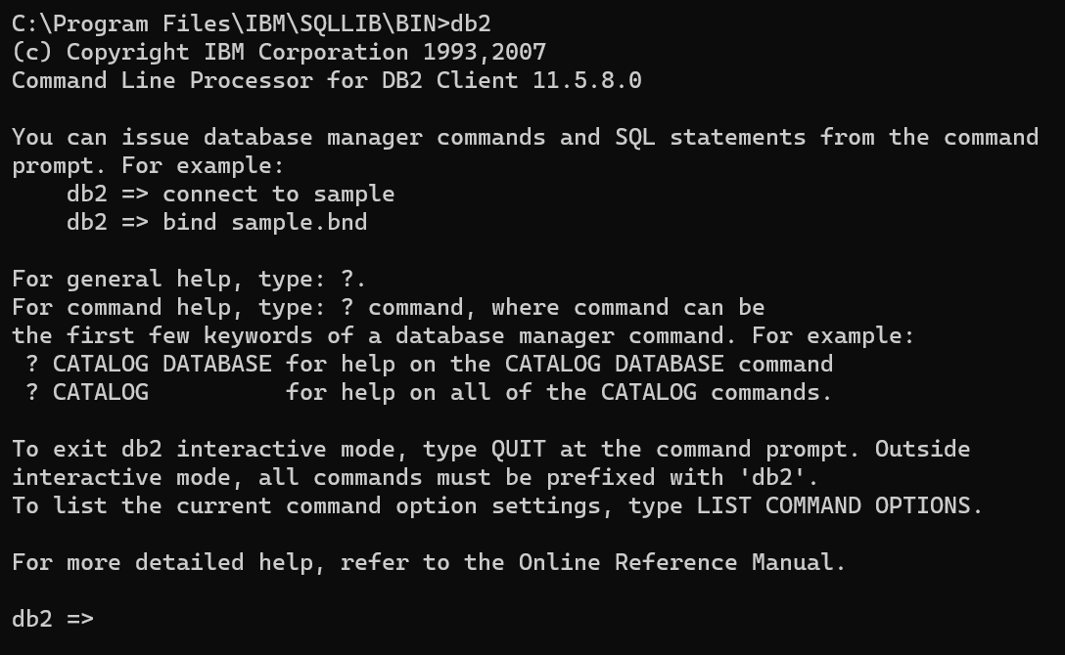

**Step2: Created a database with a name MYDB**

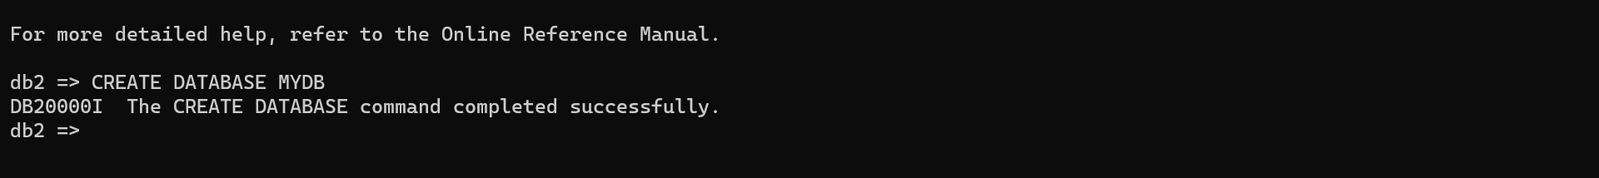

* This database created to store product details for my e-commerce website “Artisan treasure”.
* In future phases datas of all products will be stored in the database.

**Flask Integration:** To bring this data to live on your ecommerce website, we'll show you how to integrate the Flask web framework. We'll set up routes and templates to dynamically display the product details stored in the "product" table.

**CONCLUSION:**

As we wrap up Phase 3 Development part-1 of our project, we've achieved significant milestones in building a robust ecommerce platform. We've successfully established the foundation for our online store by creating an attractive and interactive front-end layout that promises an engaging user experience. The addition of a well-structured database to store product details ensures that our platform is equipped to handle the complexities of modern ecommerce.