**Intro to Flask**

In the past few weeks in Python: Data, Science and Design, we’ve been working with Flask to create our own websites.

**What is Flask?**

[Flask](http://flask.pocoo.org/) is a framework that allows for web development, using a mix of Python and HTML. It functions as a sort of web API, setting up all the HTTP conventions necessary to run your site.

**Getting Started**

First, you have to choose a text editor that works well for code. We used Visual Studio Code, but there are other options out there if you’re not a fan.

The first thing you do is import Flask. Then, you create app routes, which is basically just defining the pathway to get to each page of your website. When you code “render_template,” it returns the specified HTML file in response, called a template (we’ll get into this in a bit). So, for each webpage you will create for your site, you create an app route, as shown below.

Also, don’t forget that this is a Python file, so when you save it, save it with a .py extension!

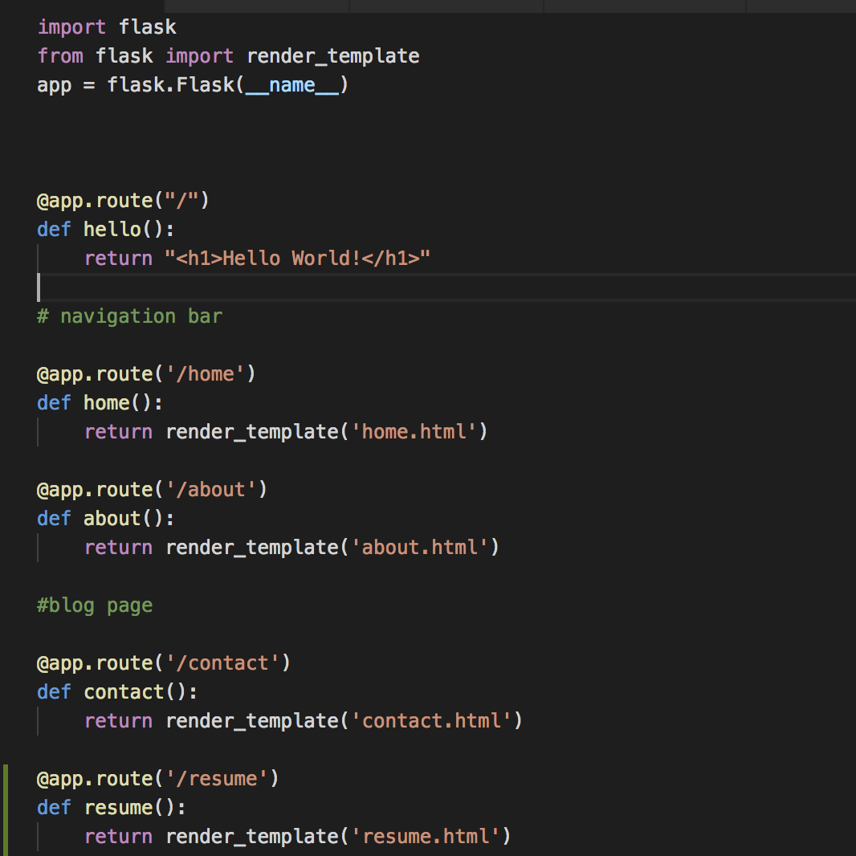I called this page hello_world.py

**Base Template**

A base template is the HTML file in which you code the structure and/or style you would like to be seen on every other template, so that you don’t have to re-code certain elements multiple times. The way that we do this is by using [Jinja Base Template](http://jinja.pocoo.org/docs/2.10/templates/#base-template) for the base, and then their [Child Template](http://jinja.pocoo.org/docs/2.10/templates/#child-template) for the rest of the templates. You put the structural code in the base template, which then allows you to “extend” it into other templates by using the child template.

We wanted to use ready-made code from [Bootstrap](https://getbootstrap.com/docs/4.3/getting-started/introduction/) in our website, such as Jumbotrons, Carousels, and Navigation Bars. In order to do this, we had to insert this line of code:

<link rel="stylesheet" href="https://stackpath.bootstrapcdn.com/bootstrap/4.3.1/css/bootstrap.min.css" />

into the head of our base.

Then, we got to really using bootstrap. We wanted to have a navigation bar that shows up on each page of the site, so we inserted the ready-made NavBar code from Bootstrap, changing the links and names of the pages from the arbitrary ones they have included, to the real ones for our website.

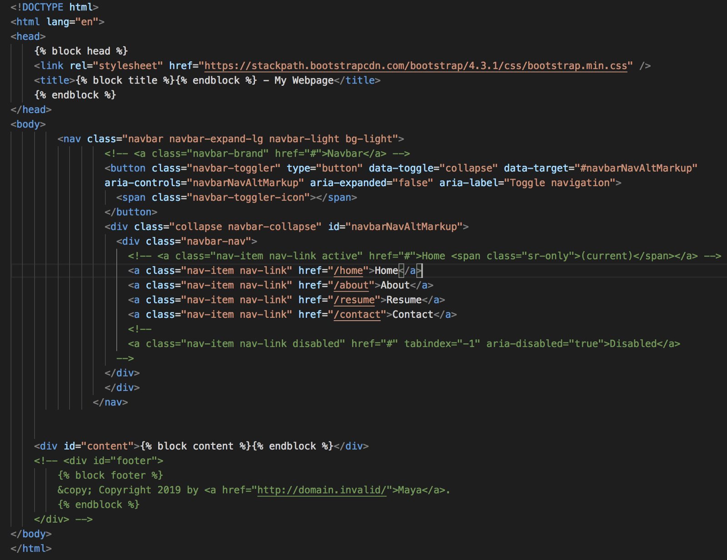

As you can see, I have certain things commented out of the code. For example, the Navbar on Bootstrap says “Navbar” at the front, but I didn’t want that to be seen on my webpage, so I commented out that line. Also, Jinja includes a footer that “Copyright 2019 [Your Name],” which I didn’t like either, so I commented it out.

**Home, About, and Contact**

So far, I have had a chance to work a lot on my Home, About, and Contact pages.

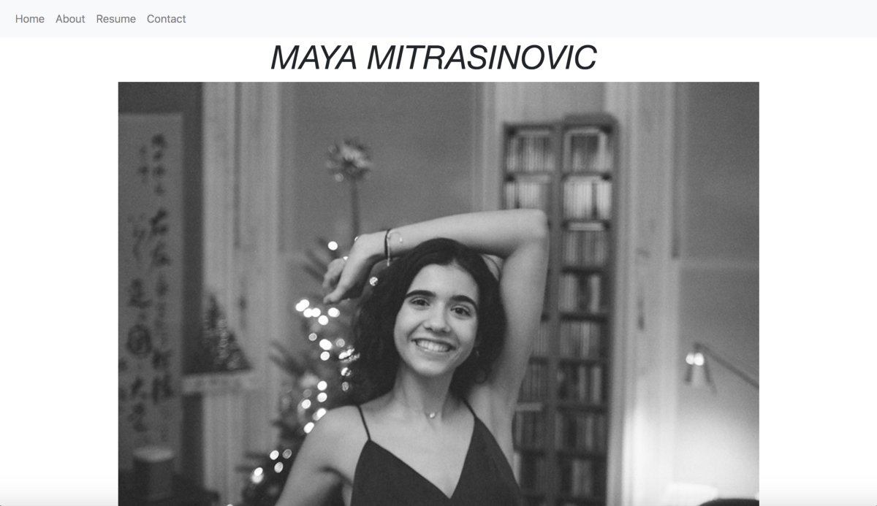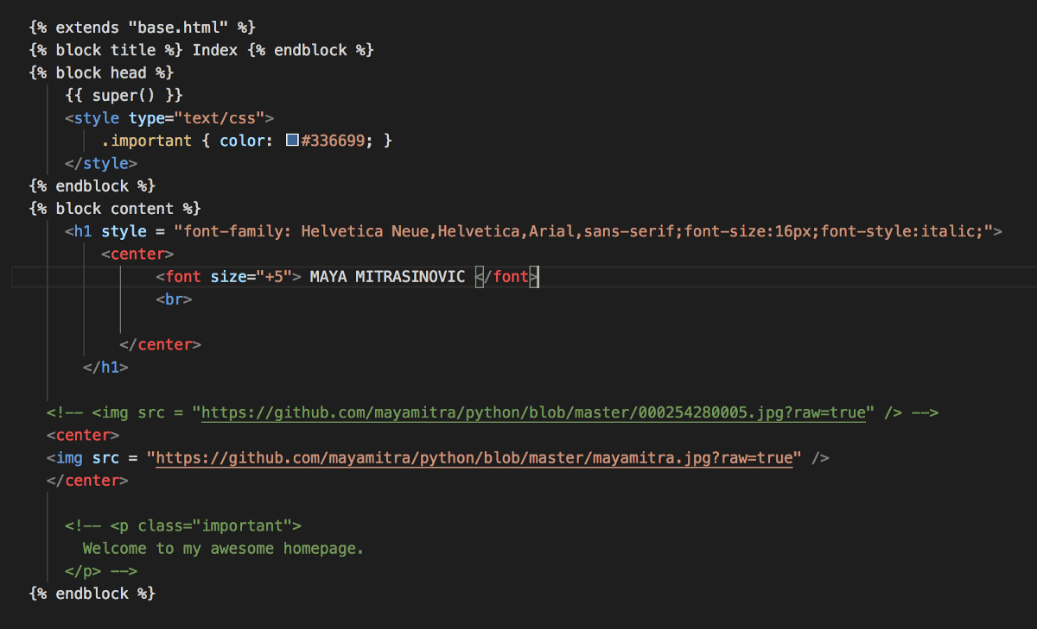

For my Home page, I experimented with different fonts and sizes/styles, as well as adding pictures and centering elements on my page. Next, I’m planning on adding a carousel with my art /writing on it (but first I have to find the scans of my work!) to replace the picture of me.

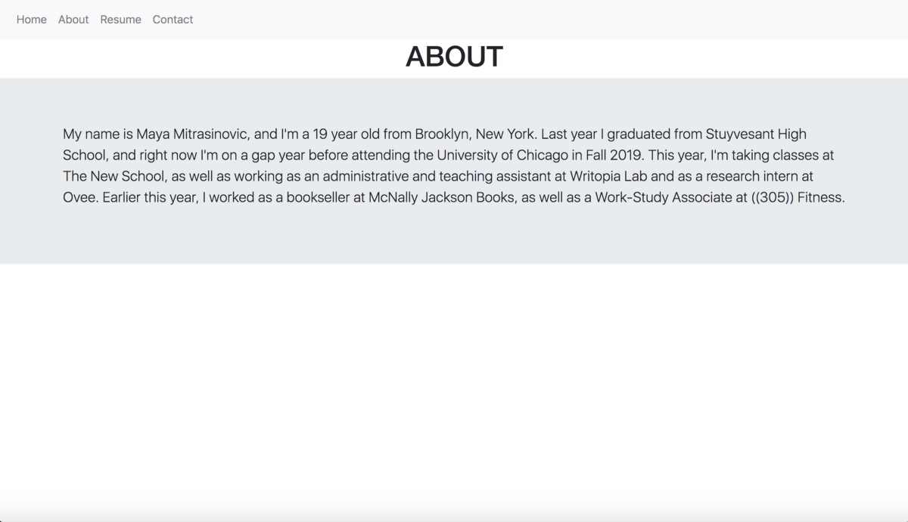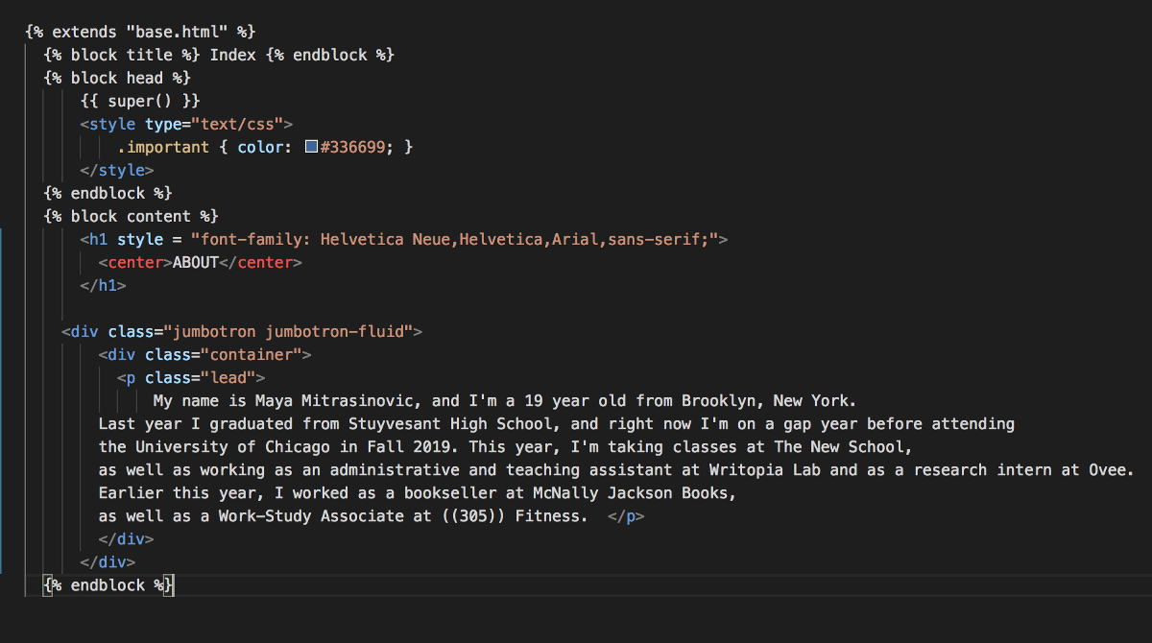

For my About page, I added a Jumbotron, which is a Bootstrap element. I’m not super sure if I like it yet, so I intend to play with it a bit more. One thing that I changed was the heading, using all-caps Helvetica (instead of what is given by Bootstrap) and centering it to match my Home page.

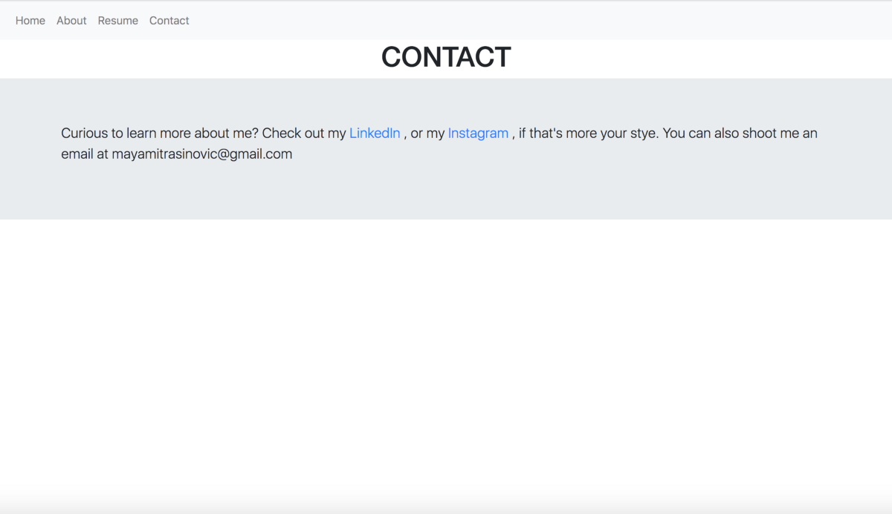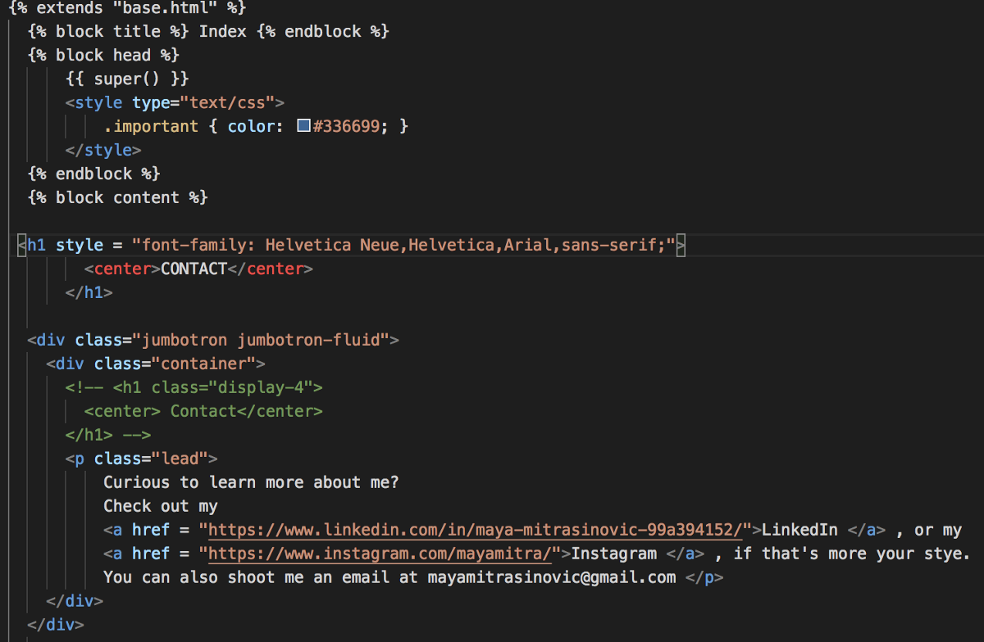

For my Contact page, I also used a Jumbotron and altered the heading to match my About page. I hyperlinked to my Instagram and LinkedIn, and just included my email in the text of the page. Ideally, I’d like to link directly to a new email with my email address as the receiver when clicking on “Email Me” text. Also, I’d like to include a form through which to contact me if someone wants to contact me directly through the website.

I am also currently working on a Resume page, but I’m not too sure what exactly I want for it to look like. In my mind, it’s an extended version of my current resume, but I don’t know if it’s better to just add more current things or have a survey of the past five years of my life.

Also, once I find the scans of my art, I’d like to create a Work page, including excerpts of my writing (both published and not, with links to the published pieces) and art.

**Final Thoughts**

I’ve really enjoyed working with Flask, Bootstrap, and Jinja. One thing that I’ve really enjoyed about HTML is how easy it is to find the answers to your questions online. With Python, I found it frustrating when I couldn’t figure out the answer to a problem, because I felt like the work I was doing was super specific. However, HTML is much more simple, and thus the questions become more universal.

For my final project, I’m excited to continue work on my webpage, working with more Python and HTML elements.