EXPLORATORY_DATA _ANALYSIS1
#importing packages and loading dataset
import numpy as np
import pandas as pd
import seaborn as sns
import matplotlib.pyplot as plt
df_automobile=pd.read_csv("Z:\Automobile_data.csv")
df_automobile.head()
#Replacing “?” by NAN and finding their sum
df_data=df_automobile.replace('?',np.NAN)
df_data.isnull().sum()
#ploting for num-of-doors
plt.subplot(222)
df_automobile['num-of-doors'].value_counts(normalize=True).plot(figsize=(10,8),kind='bar',color='green')
# Plotting for fuel-type
plt.subplot(223)
df_automobile['fuel-type'].value_counts(normalize=True).plot(figsize=(10,8),kind='bar',color='purple')
plt.title("number of fuel type frequency diagram")
plt.ylabel('number of vehicles')
plt.xlabel('fuel-type');
# Plotting for body-style
plt.subplot(224)
df_automobile['body-style'].value_counts(normalize=True).plot(figsize=(10,8),kind='bar',color='pink')
plt.title("number of body style frequency diagram")
plt.ylabel('number of vehicles')
plt.xlabel('body-style');
plt.show()

OUTPUT:
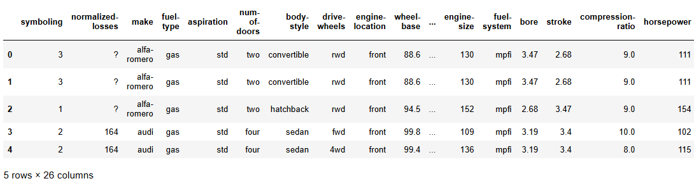

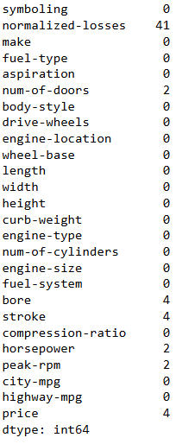

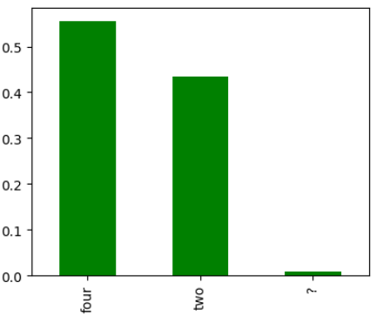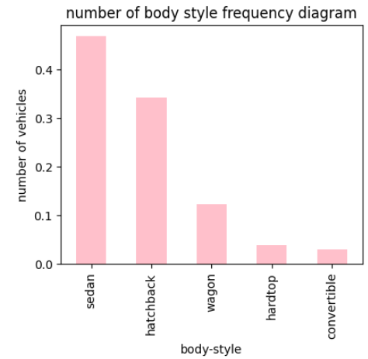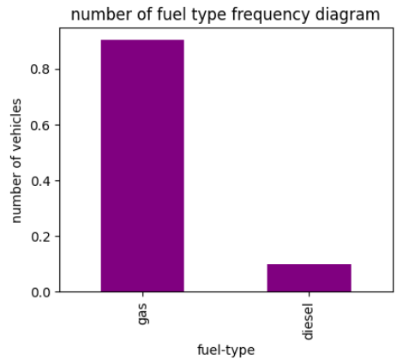

iris_cleaning_preparing
#importing packages and loading dataset
import pandas as pd
data = pd.read_csv("Z:\IRIS.csv")
data.head()

#Print data from 10 to 21
print(data[10:21])

#Find sum,mean,mediun
sum_data = data["sepal_length"].sum()
mean_data = data["sepal_length"].mean()
median_data = data["sepal_length"].median()
print("Sum:",sum_data, "\nMean:", mean_data, "\nMedian:",median_data)

#Find minimum and maximum
min_data=data["sepal_length"].min()
max_data=data["sepal_length"].max()
print("Minimum:",min_data, "\nMaximum:", max_data)

# PAIRPLOT

g = sns.pairplot(data,hue="species")
import seaborn as sns
OUTPUT:
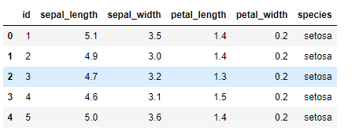

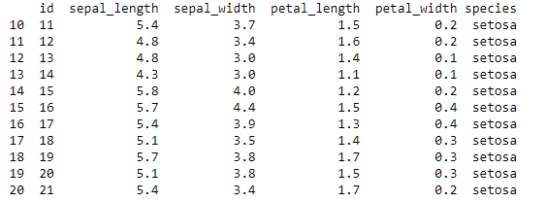

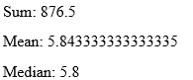

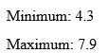

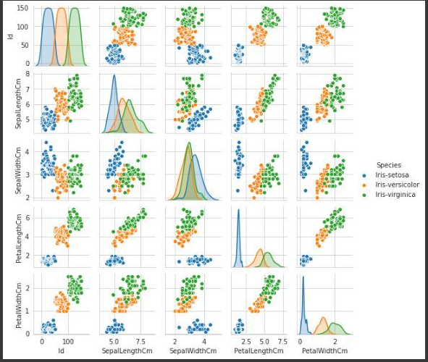

EMP
#importing packages and loading dataset
import pandas as pd
data=pd.read_csv("Z:\employees.csv")
data.head()

#scatterplot
import seaborn
import pandas
import matplotlib.pyplot as plt
csv=pandas.read_csv(r'z:\employees.csv')
res=seaborn.scatterplot(x="FIRST_NAME",y="length",data=csv)
plt.show()

#lineplot
import seaborn
import pandas
import matplotlib.pyplot as plt
csv=pandas.read_csv(r'z:\employees.csv')
res=seaborn.lineplot(x="FIRST_NAME",y="length",data=csv)
plt.show()

OUTPUT:
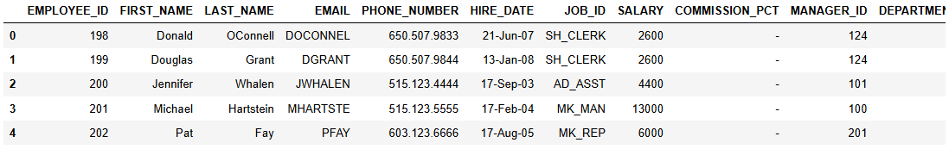

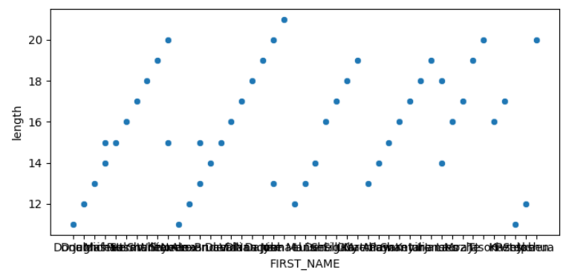

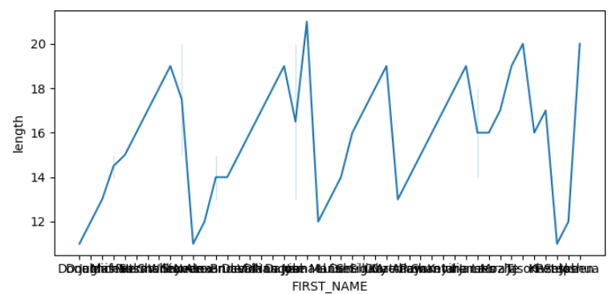

org
# importing packages and loading dataset
import pandas as pd
mydata=pd.read_csv(r"Z:\org.csv")
mydata.tail()

#
mydata=pd.read_csv("z:\org.csv",header=None)
mydata.head()

#
Mydata

#
mydata=pd.read_csv("z:\org.csv",sep="::",header=None,names=['ID','title','genre'])
mydata.head()

OUTPUT:

