Assignment 3 for csci580

Your assignment is to add the transformation process to your HW2 rastorizer. The API calls in rend.cpp *must* be provided just as they are outlined. The standard application must work without modification.

*** Changes in the API are not allowed ***

The files in hw3.zip include:

Assigment3.doc : This file
Gz.h : A few new definitions for hw3
Application3.cpp , Applicaiont3.h : New application that calls your rend.cpp functions
rend.cpp : New skeleton file with API definition and comments
tri.asc : A one-triangle data file
tri.ppm : The result of running "app3 <tri.asc >tri.ppm"
pot4.asc : The Utah teapot triangle data file
pot4.ppm : The result with default camera
pot4.cam.ppm : The result of with app1 camera
CS580HWView.cpp : Link to your application3 and the user interface.
Other files for frame work

/* Camera defaults */
#define DEFAULT_FOV 35.0
#define DEFAULT_IM_Z (-10.0) /* world coords for image plane origin */
#define DEFAULT_IM_Y (5.0) /* default look-at point = 0,0,0 */
#define DEFAULT_IM_X (-10.0)

The result images are created in a 256x256 window. Now you should be able to change the size of your image to magnify or shrink the image. Again - your background color may be different than mine.

You should "stress-test" your renderer by changing the camera and look at point with the PutCamera call. Don't forget to clip triangles that are behind the view plane. Try to get an intuition for what happens with different camera parameters.

From now, you can move your object using given user interface. If you click edit button, you can choose three transformation options; Rotate, Translate, and Scale.
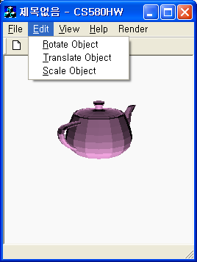

If you choose “Rotate Object”, rotation dialog pops up and you can type the value.
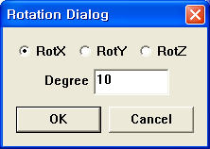

If you choose “Translate Object”, translation dialog pops up and you can type the value.

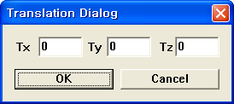
If you choose “Scale Object”, scale dialog pops up and you can type the value.
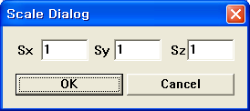

If you push “Render >> RunRender” button, the transformed object is rendered.

We gladly support whole code for the user interface but you should fill the function body in the rend.cpp file. Callback function which pops-up dialog and accumulate transformation to the renderer is in the CS580HWView.cpp. Please check the followings functions in the CS580HWView.cpp and fill the function body of GZ* functions in the rend.cpp.

void CCS580HWView::OnRotate()

void CCS580HWView::OnTranslate()

void CCS580HWView::OnScale()

*** Changing user interface is not allowed ***

We welcome you to add extra GUI for other parameters. If you add GUI, please explain it in your readme file. (No extra point, just for fun)

Submit process is similar to your previous homework. Please read homework guide line carefully. (We can give you some penalty of missing file. DO NOT include Debug directory.)

