**Lab Assignment–1**

**1. Create table Student (Rno, Name, DOB, Gender, Class, College, City, Marks)**

Ans.

|  |
| --- |
| CREATE TABLE student(  Rno int,  FullName varchar(32),  Dob date,  Gender varchar(10),  ClassName varchar(10),  College varchar(20),  City varchar(20),  Marks int  );  desc student |

OUTPUT:-

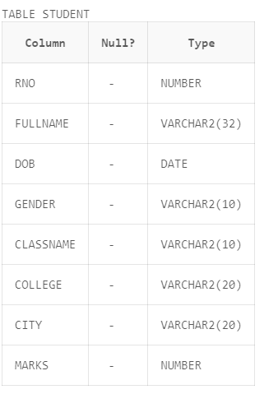

**2. Insert 5 records in student table**

Ans.

|  |
| --- |
| INSERT INTO student VALUES ('1','Mayank','04-July-2003','MALE','BTECH','TIET','PATIALA','100');  INSERT INTO student VALUES ('2','Shivam','03-june-2002','MALE','BTECH','TIET','PATIALA','95');  INSERT INTO student VALUES ('3','Naman','13-june-2003','MALE','BTECH','TIET','bathinda','90');  INSERT INTO student VALUES ('4','Samarth','04-may-2003','MALE','BTECH','TIET','abhor','80');  INSERT INTO student VALUES ('5','Saksham','04-july-2003','MALE','BTECH','TIET','abhor','70'); |

OUTPUT:-

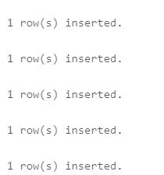

**3. Display the information of all the students**

Ans.

|  |
| --- |
| SELECT * FROM student |

OUTPUT:-

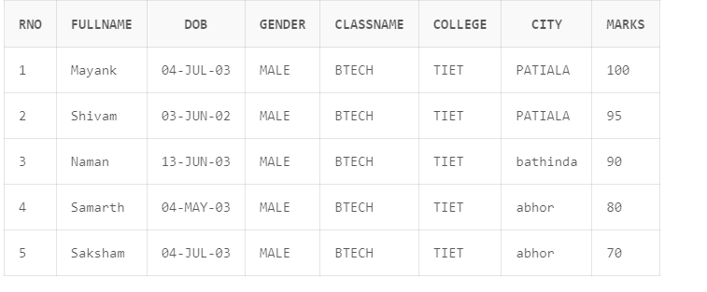

**4. Display the detail structure of student table**

Ans.

|  |
| --- |
| DESC student; |

OUTPUT:-

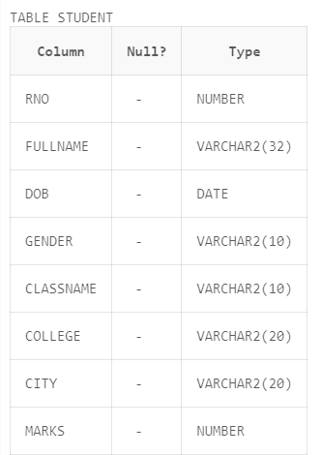

**5. Display Rno, Name and Class information of ‘Patiala’**

**students.**

Ans.

|  |
| --- |
| SELECT RNO,FULLNAME,CLASSNAME FROM student  WHERE CITY='PATIALA'  select * from student |

OUTPUT:-

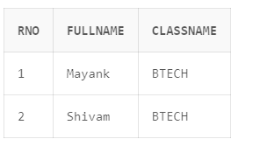

**6. Display information on ascending order of marks**

Ans.

|  |
| --- |
| SELECT * FROM student  ORDER BY MARKS ASC;  select * from student |

OUTPUT:-

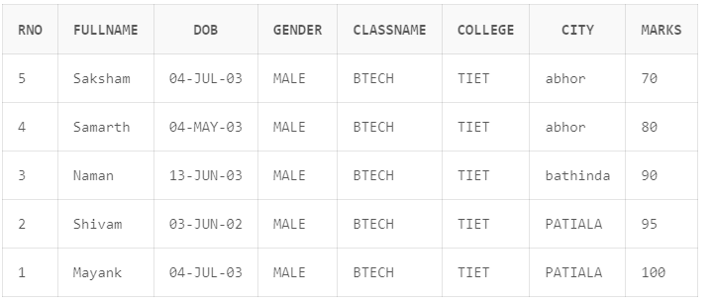

**7. Change the marks of Rno 5 to 89.**

Ans.

|  |
| --- |
| UPDATE student  SET MARKS='89'  WHERE RNO='5';  select * from student |

OUTPUT:-

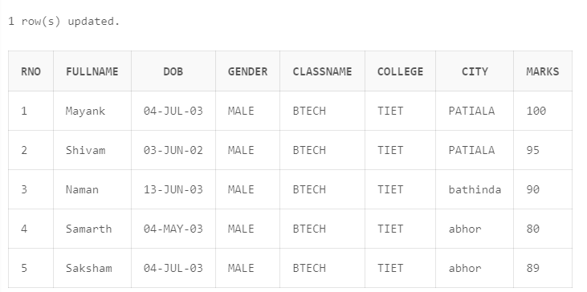

**8. Change the name and city of Rno 9.**

Ans.

|  |
| --- |
| //Changing Roll no first.  UPDATE student  SET RNO='9'  WHERE RNO='4';  select * from student |

OUTPUT:-

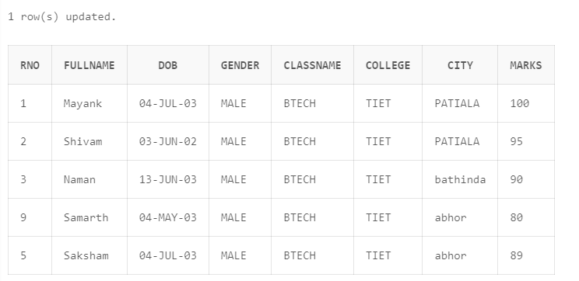

|  |
| --- |
| UPDATE student  SET FULLNAME='YASH',CITY='TALWADA'  WHERE RNO='9';  select * from student |

OUTPUT:-

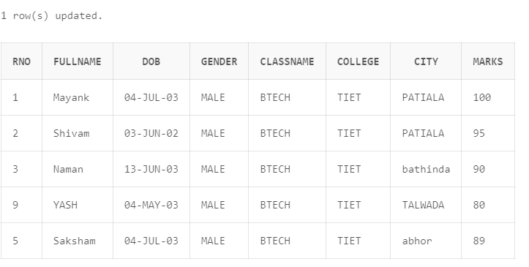

**9. Delete the information of ‘Amritsar’ city records**

Ans.

|  |
| --- |
| DELETE FROM student WHERE CITY='abhor';  select * from student |

OUTPUT:-

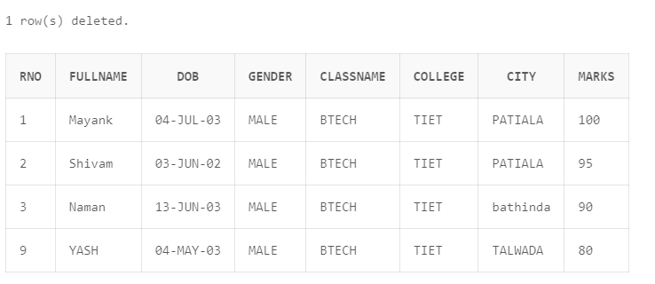

**10. Delete the records of student where marks<30.**

Ans.

|  |
| --- |
| DELETE FROM student WHERE MARKS<'90';  select * from student |

OUTPUT:-

