**Lab Assignment–3**

Q1) Use the following functions

1. chr (n):

|  |
| --- |
| Query. select chr(97) from dual; |

OUTPUT:

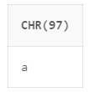

2. cancat(char1,char2):

|  |
| --- |
| Query. select concat('mayank','agg') from dual; |

OUTPUT:

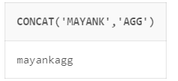

3. instr(string,char):

|  |
| --- |
| Query. select instr('mayank','a') from dual; |

OUTPUT:

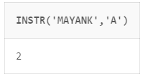

4. length(n):

|  |
| --- |
| Query. select length('mayankaggarwal') from dual; |

OUTPUT:

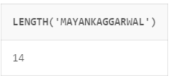

5. lpad(char1 ,n [,char2]):

|  |
| --- |
| Query. select lpad('mayank',10,'_')  from dual; |

OUTPUT:

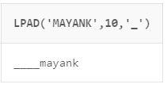

6. ltrim(string [,char(s)]):

|  |
| --- |
| Query. select ltrim('mayank','ma') from dual; |

OUTPUT:

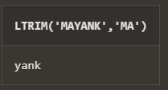

7. rtrim(string [,char(s)]):

|  |
| --- |
| Query. select rtrim('mayank','k') from dual; |

OUTPUT:

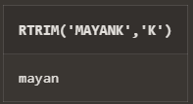

8. rpad(char1 ,n [,char2]):

|  |
| --- |
| Query. select rpad('mayank','8','_') from dual; |

OUTPUT:

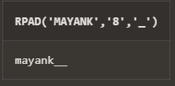

9. replace(main_char ,search_string , replacement_string):

|  |
| --- |
| Query. select replace('mayank','a','A') from dual; |

OUTPUT:

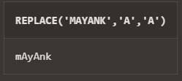

10. substr(string ,position ,substring length):

|  |
| --- |
| Query. select substr('mayank',2,4) from dual; |

OUTPUT:

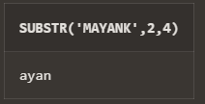

11. initcap(char):

|  |
| --- |
| Query. select initcap('mayank') from dual; |

OUTPUT:

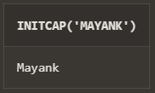

12. lower(string):

|  |
| --- |
| Query. select lower('MAYANK') from dual; |

OUTPUT:

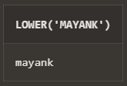

13. upper(string):

|  |
| --- |
| Query. select upper('mayank') from dual; |

OUTPUT:

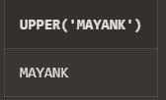

14. translate(char ,from string ,to string):

|  |
| --- |
| Query. select translate('mayank','ay','_') from dual; |

OUTPUT:

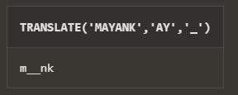

15. abs(n):

|  |
| --- |
| Query. select abs(-13) from dual; |

OUTPUT:

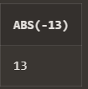

16. ceil(n):

|  |
| --- |
| Query. select ceil(13.4) from dual; |

OUTPUT:

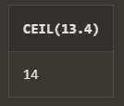

17. cos(n):

|  |
| --- |
| Query. select cos(13.4) from dual; |

OUTPUT:

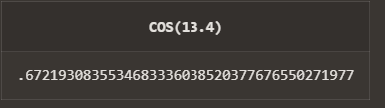

18. exp(n):

|  |
| --- |
| Query. select exp(23) from dual; |

OUTPUT:

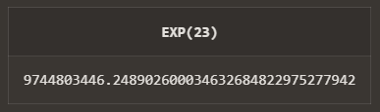

19. floor(n):

|  |
| --- |
| Query. select floor(23.4) from dual; |

OUTPUT:

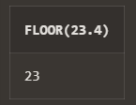

20. mod(m ,n):

|  |
| --- |
| Query. select mod(32,3) from dual; |

OUTPUT:

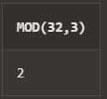

21. power(x ,y):

|  |
| --- |
| Query. select power(32,3) from dual; |

OUTPUT:

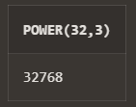

22. round(x [,y]):

|  |
| --- |
| Query. select round(32.45) from dual; |

OUTPUT:

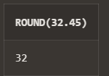

23. sign(n): 3

|  |
| --- |
| Query. select sign(-32),sign(32),sign(0) from dual; |

OUTPUT:

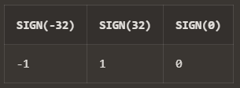

24. sqrt(n);

|  |
| --- |
| Query. select sqrt(46) from dual; |

OUTPUT:

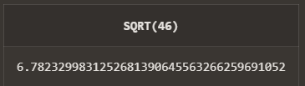

25. trunc(x ,n):

|  |
| --- |
| Query. select trunc(13.2323424242,1) from dual; |

OUTPUT:

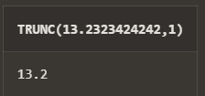

26. sysdate:

|  |
| --- |
| Query. select sysdate from dual; |

OUTPUT:

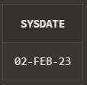

27. add_months(d ,n):

|  |
| --- |
| Query. select add_months('02-february-2023',2) from dual; |

OUTPUT:

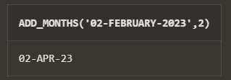

28. last_day():

|  |
| --- |
| Query. select last_day('02-february-2023') from dual; |

OUTPUT:

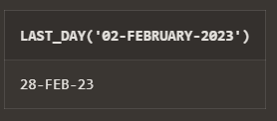

29. months_between(date1 ,date2):

|  |
| --- |
| Query. select months_between('02-february-2023','02-june-2022') from dual; |

OUTPUT:

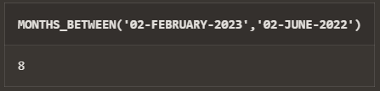

30. next_day(date ,char):

|  |
| --- |
| Query. select next_day('02-february-2023','monday') from dual; |

OUTPUT:

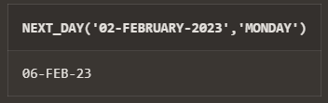

31. greatest(expr):

|  |
| --- |
| Query. select greatest(234,1,23232) from dual; |

OUTPUT:

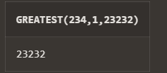

32. least(expr):

|  |
| --- |
| Query. select least(234,1,23232) from dual; |

OUTPUT:

