**Lab Assignment–4**

1. Create table emp which has the following attributes (employeetable) *(@empno, ename, job, sal, deptno)* Where empno is primary key, ename is unique, job in (Prof, AP, and Lect), sal is not NULL, and deptno default is 10.

Insert appropriate records, check error messages in case of

violation and list all the constraint names for given table.

CODE:

|  |
| --- |
| CREATE TABLE Employee_table(  empno integer,  ename varchar(20) UNIQUE,  job varchar(20),  sal varchar(20) NOT NULL,  deptno integer DEFAULT 10,  PRIMARY KEY (empno),  CONSTRAINT all_job CHECK(job='Prof' OR job='AP' OR job='Lect')  ); |

|  |
| --- |
| INSERT INTO Employee_table(EMPNO,ENAME,JOB,SAL) VALUES(1,'Mayank','Prof','10000');  INSERT INTO Employee_table(EMPNO,ENAME,JOB,SAL) VALUES(2,'Naman','Prof','10000'); |

OUTPUT:

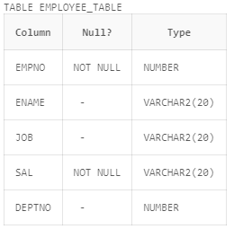

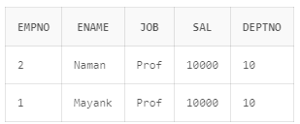

2. Create table book:

Rno number—PK

DOI-date

DOR-date

DOR>DOI

Insert appropriate records, check error messages in case of

violation and list all the constraint names for given table.

CODE:

|  |
| --- |
| CREATE TABLE book(  rno integer PRIMARY KEY,  DOI Date,  DOR Date,  CONSTRAINT check_date CHECK (DOR > DOI)  ); |

|  |
| --- |
| INSERT INTO book VALUES(2,DATE '2022-01-07',DATE '2023-02-07');  INSERT INTO book VALUES(3,DATE '2022-01-05',DATE '2023-02-09'); |

OUTPUT:

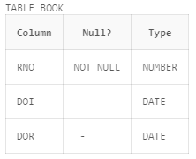

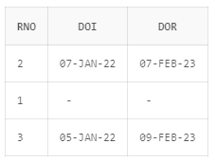

3. Create table st

Rno-Number

Class-Char

Marks-Number

Primary key(rno,class)

Marks>0

Insert appropriate records, check error messages in case of

violation and list all the constraint names for given table.

CODE:

|  |
| --- |
| CREATE TABLE st(  rno integer,  class varchar2(10),  marks integer,  PRIMARY KEY(rno,class),  CONSTRAINT check_marks CHECK(marks>0)  ); |

|  |
| --- |
| INSERT INTO st VALUES(1,'12th',97);  INSERT INTO st VALUES(2,'12th',97);  INSERT INTO st VALUES(3,'12th',97);  INSERT INTO st VALUES(3,'11th',97);  INSERT INTO st VALUES(3,'10th',97); |

OUTPUT:

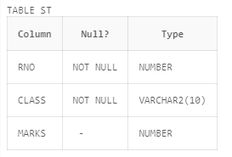

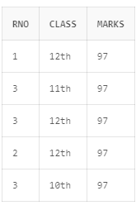

4. Create table S which has the following attributes (Salesperson table) *(sno, sname, city)*

Where sno is primary key

CODE:

|  |
| --- |
| CREATE TABLE salesperson(  sno integer PRIMARY KEY,  sname varchar2(29),  city varchar2(29)  ); |

OUTPUT:

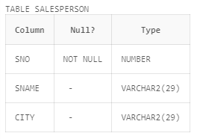

5. Create table P which has the following attributes (Part table) *(pno, pname, color)*

Where pno is primary key

CODE:

|  |
| --- |
| CREATE TABLE p(  pno integer PRIMARY KEY,  pname varchar2(29),  color varchar2(29)  ); |

OUTPUT:

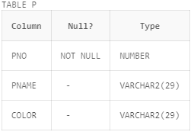

6. *Create table SP which has the following attributes (sno, pno qty)*

Where combination of (sno, pno) is primary key, also sno and

pno are foreign keys

CODE:

|  |
| --- |
| CREATE TABLE sp(  sno int,  pno integer,  color varchar2(29),  FOREIGN KEY (sno) REFERENCES salesperson(sno),  FOREIGN KEY (pno) REFERENCES p(pno)  ); |

OUTPUT:

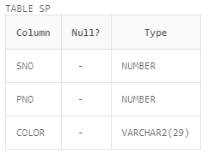

7. Create table dept which has the following attributes

(department table) *(deptno, dname)*

Where deptno is primary key, dname in (Acc, comp, elect)

CODE:

|  |
| --- |
| CREATE TABLE department(  deptno integer PRIMARY KEY,  dname varchar2(20),  CONSTRAINT check_dname CHECK(dname='Acc' OR dname='comp' OR dname='elect')  ); |

OUTPUT:

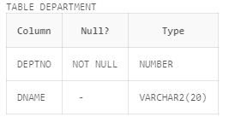

8. Create table emp which has the following attributes (employeetable) *(@empno, ename, job, sal, deptno)*

Where empno is primary key, ename is unique, job in (Prof, AP,

and Lect), sal is not NULL, and deptno is foreign key

CODE:

|  |
| --- |
| CREATE TABLE emptable(  empno integer PRIMARY KEY,  ename varchar2(20) UNIQUE,  job varchar2(20),  sal varchar2(20) NOT NULL,  deptno integer,  CONSTRAINT check_job CHECK(job='Prof' OR job='AP' OR job='Lect'),  FOREIGN KEY (deptno) REFERENCES department(deptno)  ); |

OUTPUT:

