**Lab Assignment–3**

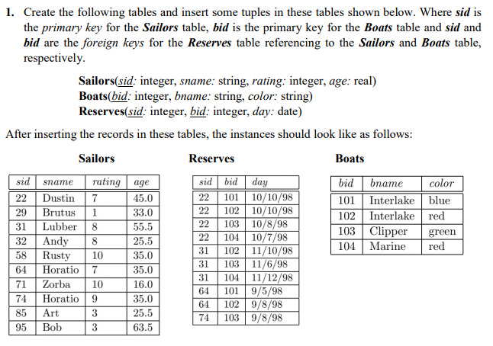**CODE:**

|  |
| --- |
| **CREATE TABLE sailors(**  **sid integer PRIMARY KEY,**  **sname varchar2(20),**  **rating integer,**  **age real**  **);**  **DESC sailors;**  **CREATE TABLE boats(**  **bid integer PRIMARY KEY,**  **bname varchar2(20),**  **color varchar2(20)**  **);**  **DESC boats;**  **CREATE TABLE reserves(**  **sid integer,**  **bid integer,**  **day date,**  **PRIMARY KEY (sid,bid),**  **FOREIGN KEY (sid) REFERENCES sailors(sid),**  **FOREIGN KEY (bid) REFERENCES boats(bid)**  **);**  **DESC reserves;**  **-- inserting to sailors**  **INSERT INTO sailors VALUES(1,'Dustbin',7,45.0);**  **INSERT INTO sailors VALUES(2,'Brutus',1,33.0);**  **INSERT INTO sailors VALUES(3,'Lubber',8,35.5);**  **INSERT INTO sailors VALUES(4,'Andy',9,40.0);**  **INSERT INTO sailors VALUES(5,'Rusty',2,35.5);**  **INSERT INTO sailors VALUES(6,'Horato',4,35.5);**  **INSERT INTO sailors VALUES(7,'Zobra',10,16.0);**  **INSERT INTO sailors VALUES(8,'Horatio',9,35.0);**  **INSERT INTO sailors VALUES(9,'Art',3,25.5);**  **INSERT INTO sailors VALUES(10,'BOB',3,63.5);**  **-- inserting into boats**  **INSERT INTO boats VALUES(101,'Interlake','blue');**  **INSERT INTO boats VALUES(102,'Interlake','red');**  **INSERT INTO boats VALUES(103,'Clipper','green');**  **INSERT INTO boats VALUES(104,'Marine','red');**  **INSERT INTO reserves(sid,bid,day) VALUES((select sid from sailors where sid=1),(select bid from boats where bid=101),'2023-feb-09');**  **select * from sailors;**  **select * from boats;**  **-- inserting into reserves**  **INSERT INTO reserves VALUES(1,102,'09-oct-2022');**  **INSERT INTO reserves VALUES(2,101,'09-oct-2022');**  **INSERT INTO reserves VALUES(3,103,'10-Aug-2022');**  **INSERT INTO reserves VALUES(4,104,'10-July-2022');**  **INSERT INTO reserves VALUES(5,101,'10-oct-2022');**  **INSERT INTO reserves VALUES(6,102,'11-June-2022');**  **INSERT INTO reserves VALUES(7,104,'1-June-2022');**  **INSERT INTO reserves VALUES(8,103,'11-Dec-2022');**  **INSERT INTO reserves VALUES(9,103,'09-May-2022');**  **INSERT INTO reserves VALUES(10,103,'09-May-2022');**  **select * from sailors;**  **select * from boats;**  **select * from reserves;** |

**OUTPUT:**

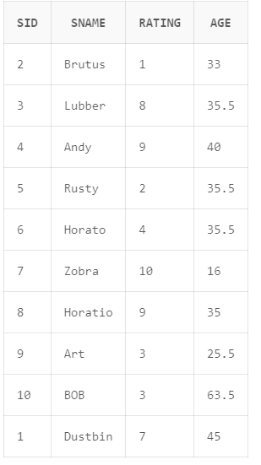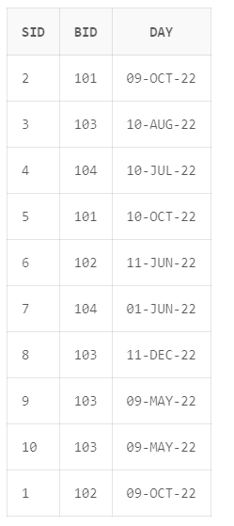 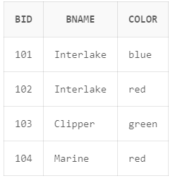

**Q2. Write SQL Commands for the following:**

i) Show the names and ages of all sailors.

CODE:

|  |
| --- |
| select sname,age from sailors; |

OUTPUT:

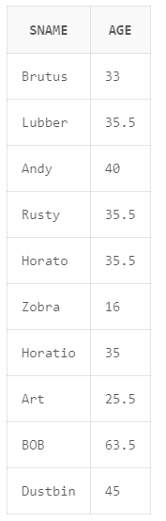

ii) Show the details of the boats which are red and blue in color.

CODE:

|  |
| --- |
| select * from boats  where color in('red','blue'); |

OUTPUT:

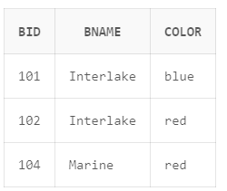

iii) Find the oldest and youngest sailors’ age.

CODE:

|  |
| --- |
| select min(age),max(age) from sailors; |

OUTPUT:

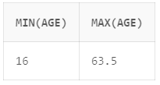

iv) Find the ages of sailors whose name begins and ends with B and has at leastthree characters

CODE:

|  |
| --- |
| select age from sailors  where sname Like 'B_%B'; |

OUTPUT:

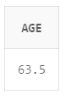

v) Show the average rating of the sailors.

CODE:

|  |
| --- |
| select avg(rating) from sailors; |

OUTPUT:

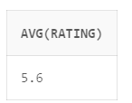

vi) Find all sailors with a rating above 7.

CODE:

|  |
| --- |
| select * from sailors  where rating>7; |

OUTPUT:

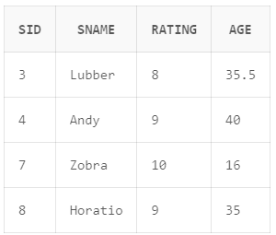

vii) Find the number of boats reserved by reserved by the sailor namedHoratio.

CODE:

|  |
| --- |
| select count(sid) from reserves  where sid=(select sid from sailors where sname='Horatio'); |

OUTPUT:

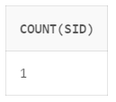

viii) Find the colors of boats reserved by Lubber..

CODE:

|  |
| --- |
| select color from boats  where bid=(  select bid from reserves  where sid=(  select sid from sailors  where sname='Lubber'  )); |

OUTPUT:

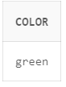

ix) Show the details of the sailors who have reserved the boat with bid 102.

CODE:

|  |
| --- |
| select * from reserves,sailors,boats  where reserves.sid=sailors.sid  and  reserves.bid=102  and  boats.bid=102; |

OUTPUT:

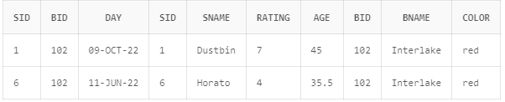

x) Find the sid of sailors who have reserved green boats.

CODE:

|  |
| --- |
| select * from reserves,sailors,boats  where reserves.sid=sailors.sid  and  boats.color='green'  and  reserves.bid=boats.bid; |

OUTPUT:

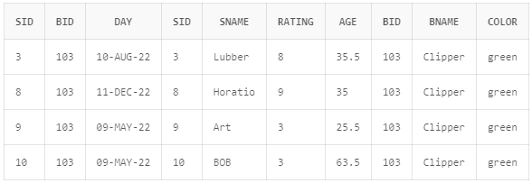

xi) Find the names of sailors who have reserved boat number 103. .

CODE:

|  |
| --- |
| select sailors.sname from reserves,sailors,boats  where reserves.sid=sailors.sid  and  reserves.bid=103  and  boats.bid=103; |

OUTPUT:

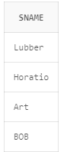

xii) Find the sids and names of sailors who have reserved a red boat.

CODE:

|  |
| --- |
| select sailors.sname,sailors.sid from reserves,sailors,boats  where reserves.sid=sailors.sid  and  boats.color='red'  and  reserves.bid=boats.bid; |

OUTPUT:

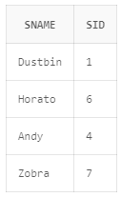

xiii) Find the names of the sailors who have reserved a green or a blue boat.

CODE:

|  |
| --- |
| select sailors.sname from reserves,sailors,boats  where reserves.sid=sailors.sid  and  boats.color='green'  or  boats.color='blue'  and  reserves.bid=boats.bid; |

OUTPUT:

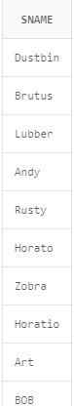

xiv) Find the names of sailors who have reserved both a red and a green boat.

CODE:

|  |
| --- |
| select sailors.sname from reserves,sailors,boats  where reserves.sid=sailors.sid  and  boats.color='green'  and  boats.color='red'  and  reserves.bid=boats.bid; |

OUTPUT:



xv) Find the names of sailors who have reserved at least one boat.

CODE:

|  |
| --- |
| select sailors.sname from reserves,sailors  where reserves.sid=sailors.sid; |

OUTPUT:

