TASK 2: Create Linux Virtual Machine and Connect Using SSH

Objective
To create a Linux Virtual Machine in Microsoft Azure, configure networking resources, assign a Public IP Address, and establish remote connectivity using SSH.

Linux Virtual Machine Theory
A Linux Virtual Machine (VM) is a cloud-based server that runs a Linux operating system. Azure Virtual Machines provide Infrastructure as a Service (IaaS), allowing users to deploy and manage Linux servers without maintaining physical hardware. Linux Virtual Machines are commonly used for web hosting, application deployment, development, testing, and cloud administration. Secure Shell (SSH) is used to remotely access Linux virtual machines over Port 22.

Components Used
• Linux Virtual Machine (VM): Provides compute resources such as CPU, RAM, and storage.
• Ubuntu Server 24.04 LTS: Linux operating system installed on the virtual machine.
• Virtual Network (VNet): Enables secure communication between Azure resources.
• Subnet: Logical segmentation within a Virtual Network.
• Public IP Address: Allows external internet connectivity to the virtual machine.
• Network Security Group (NSG): Controls inbound and outbound traffic through security rules.
• Managed Disk: Stores the operating system and application data.
• SSH (Port 22): Used for secure remote administration of Linux virtual machines.
• Network Interface (NIC): Connects the virtual machine to the Virtual Network.
• Resource Group: Logical container used to organize Azure resources.

Procedure

Step 1: Open Virtual Machines Service
Navigate to the Virtual Machines service in Azure Portal.
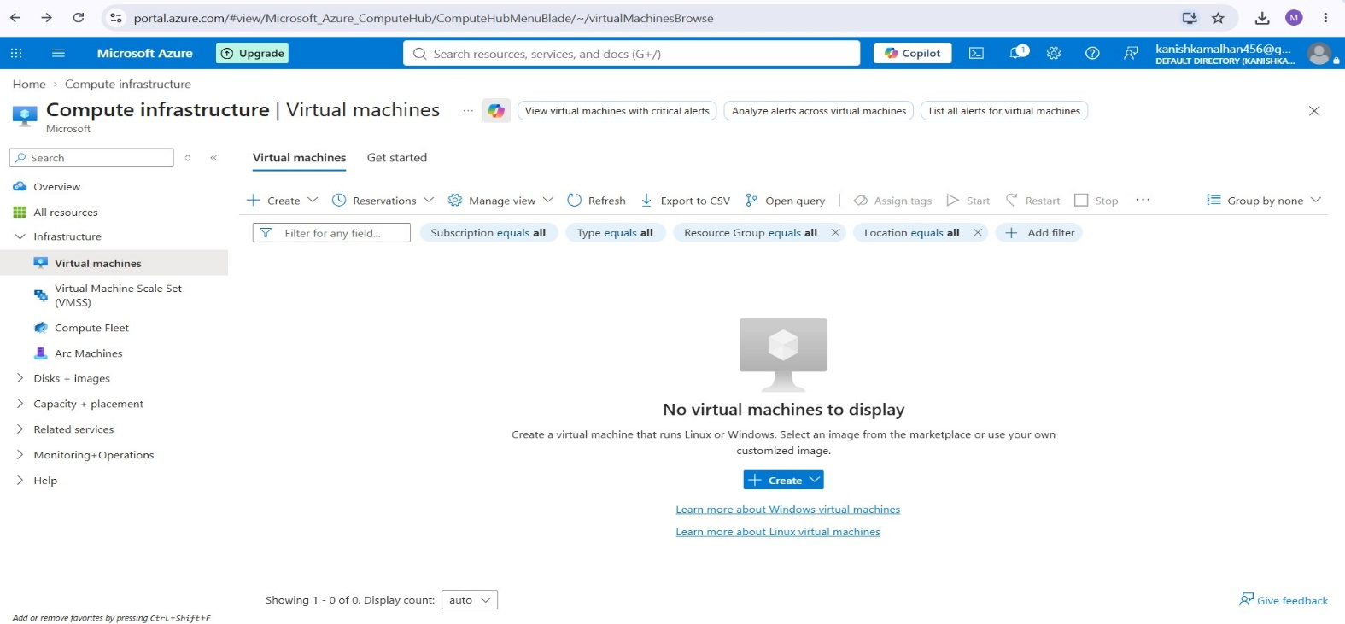

Step 2: start Creation Virtual Machine
Click Create → Azure Virtual Machine to start the deployment process.
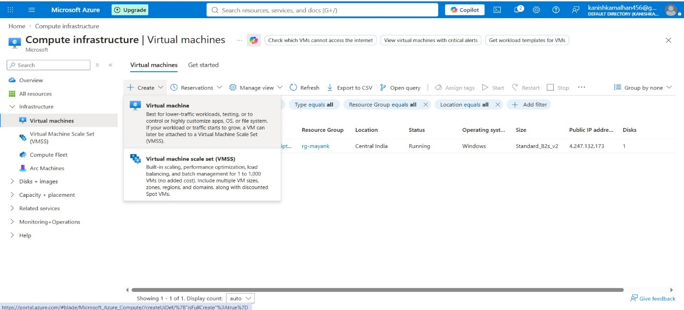
Step 3: Configure Basic vm Details
Select the Azure Subscription, Resource Group, Virtual Machine Name, and Region.
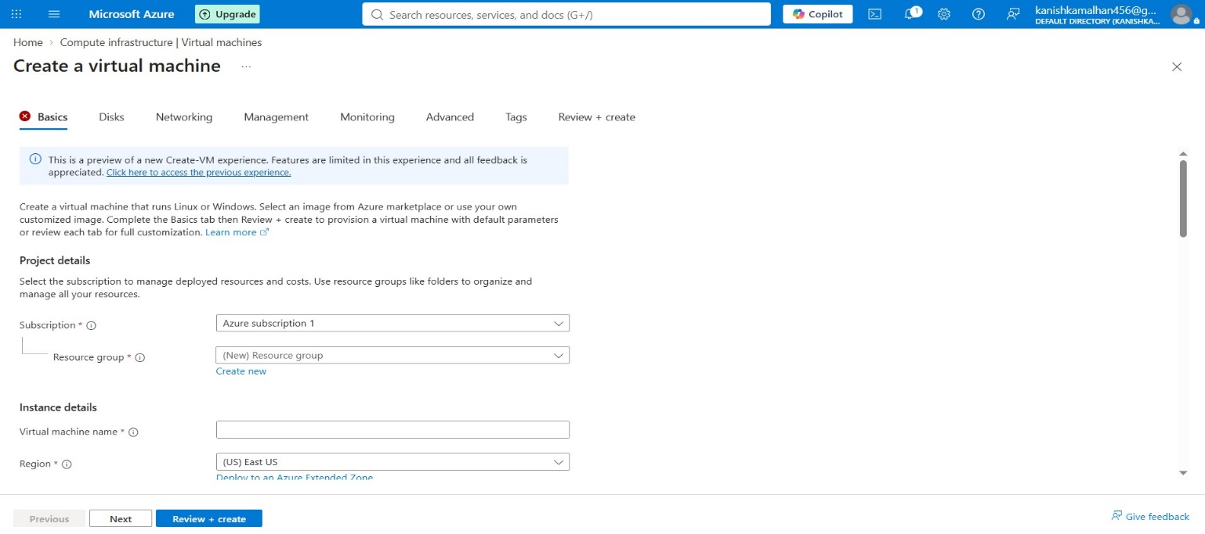

Step 4: Configure Resource Group and Region
Select the Resource Group rg-mayank, provide the VM name, and choose the deployment region.
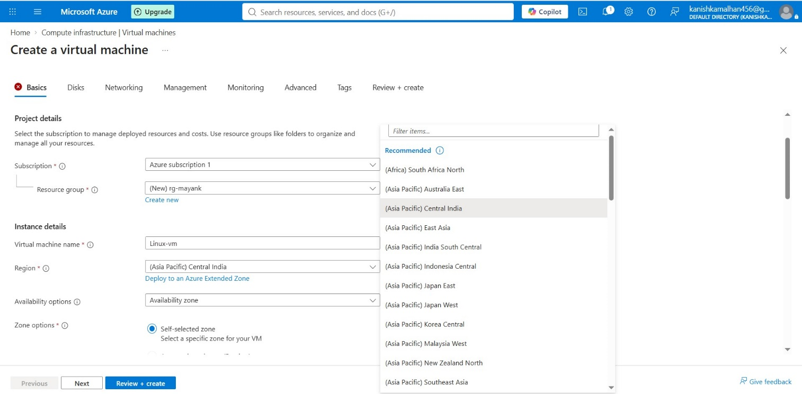

Step 5: Select Linux Operating System
Select Ubuntu Server 24.04 LTS - x64 Gen2 as the operating system image.
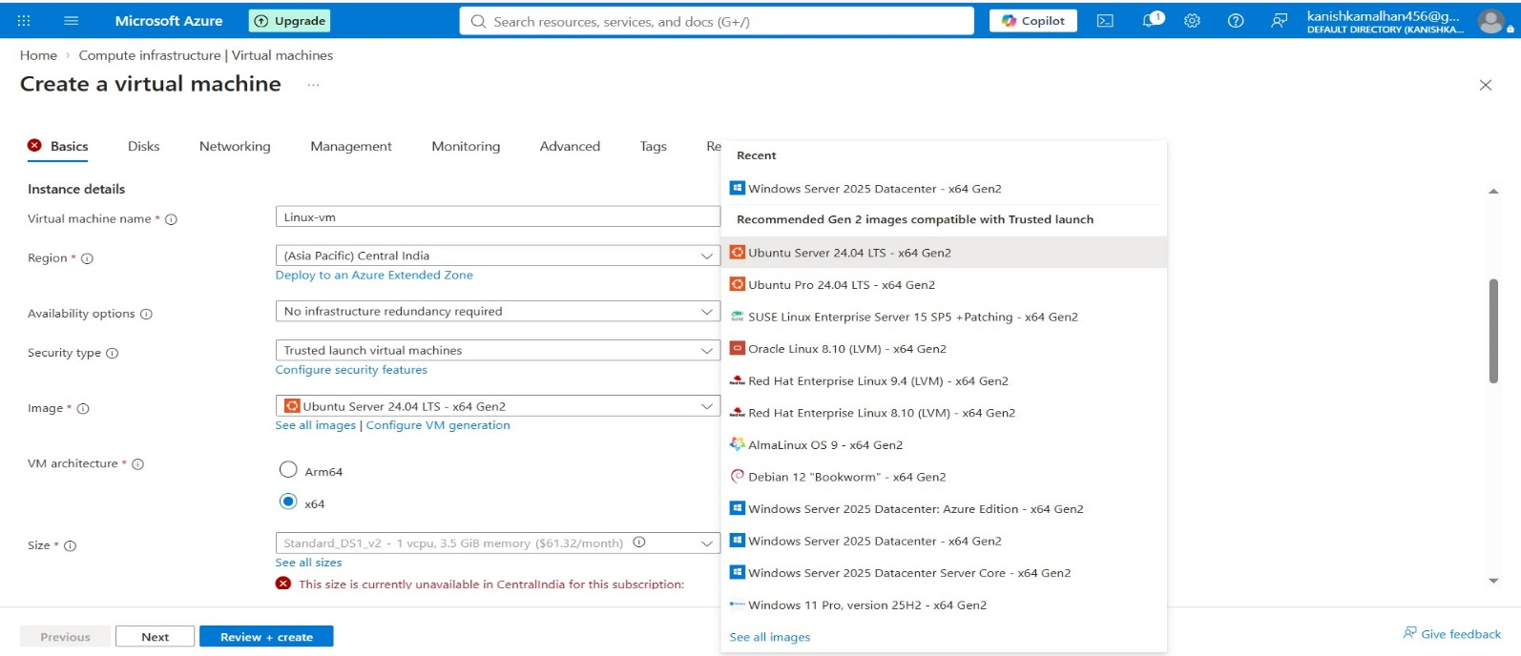

Step 6: Select Virtual Machine Size
Click See All Sizes and select Standard_B2s_v2 virtual machine size.
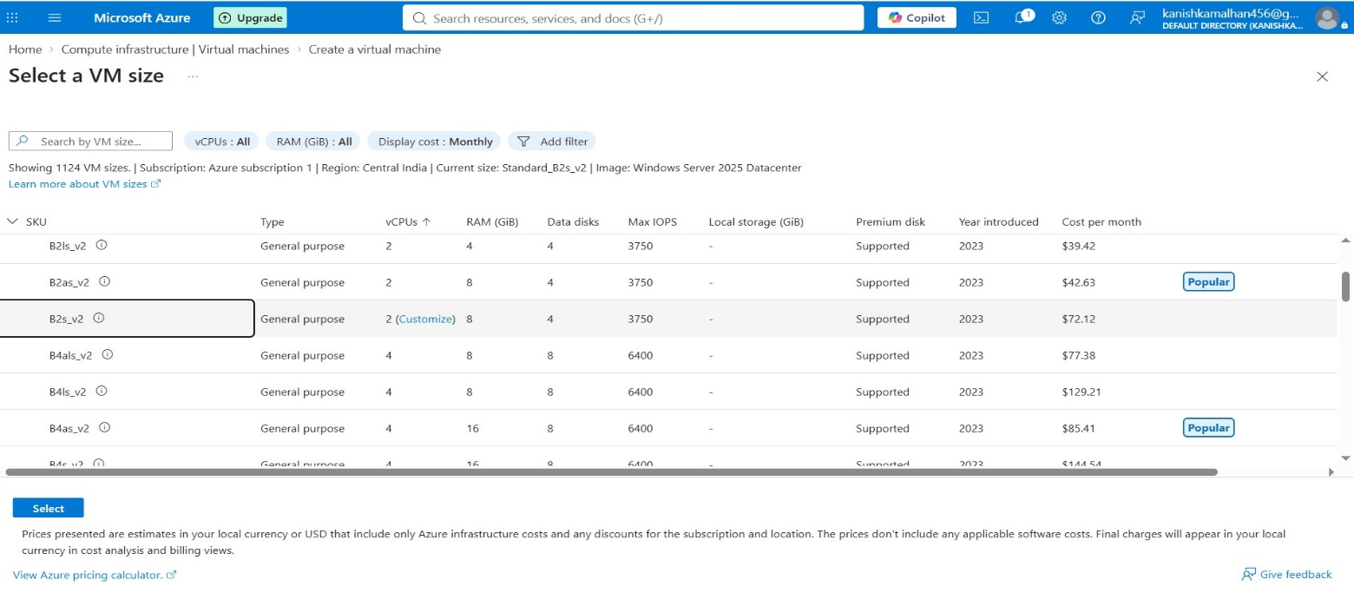

Step 7: Configure Administrator Account and SSH Access
Provide the administrator username and password. Under Public Inbound Ports, select Allow Selected Ports and enable SSH (22).
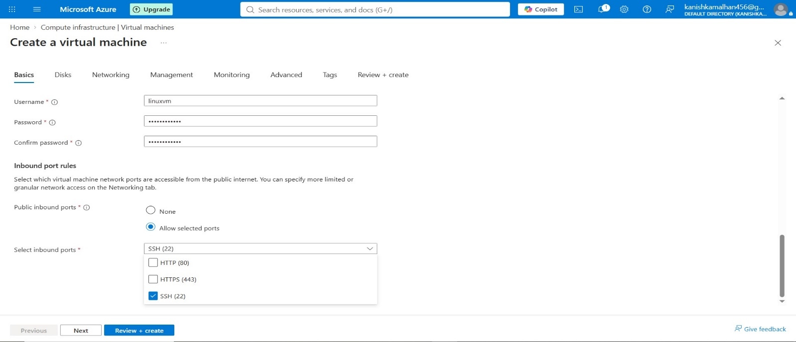

Step 8: Configure Disk Settings
Navigate to the Disks tab and configure the operating system disk settings.
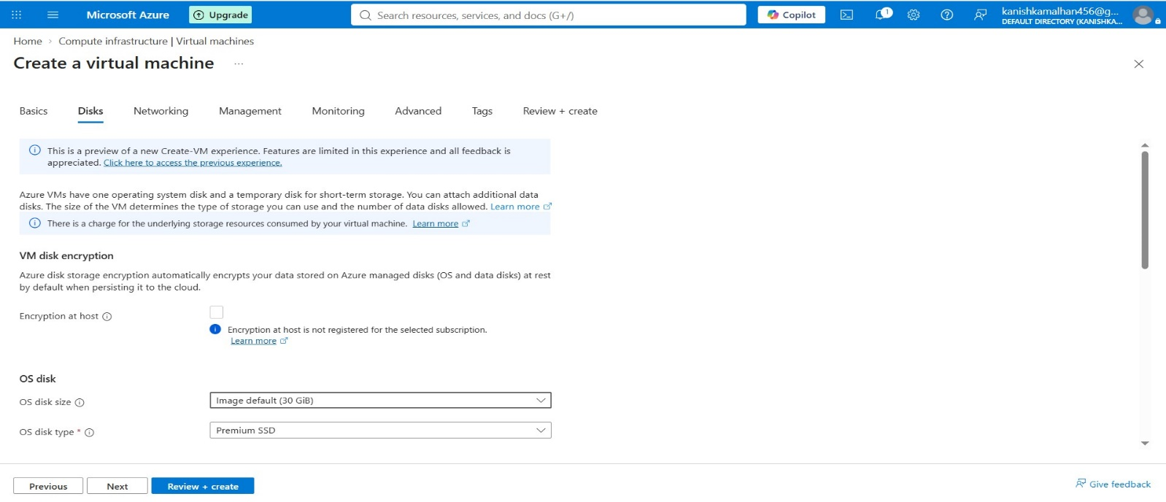
Step 9: Configure Virtual Network
Create a Virtual Network and configure the address space required for the virtual machine.
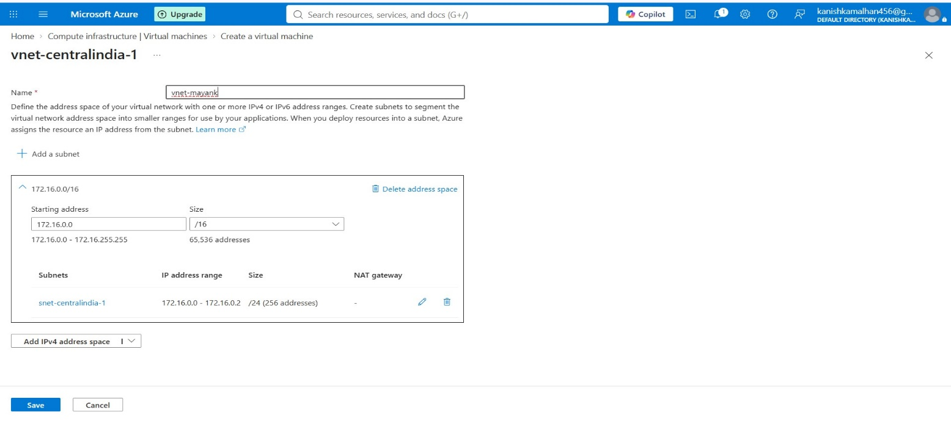

Step 10: Create Subnet
Create a subnet within the Virtual Network and configure the subnet address range.
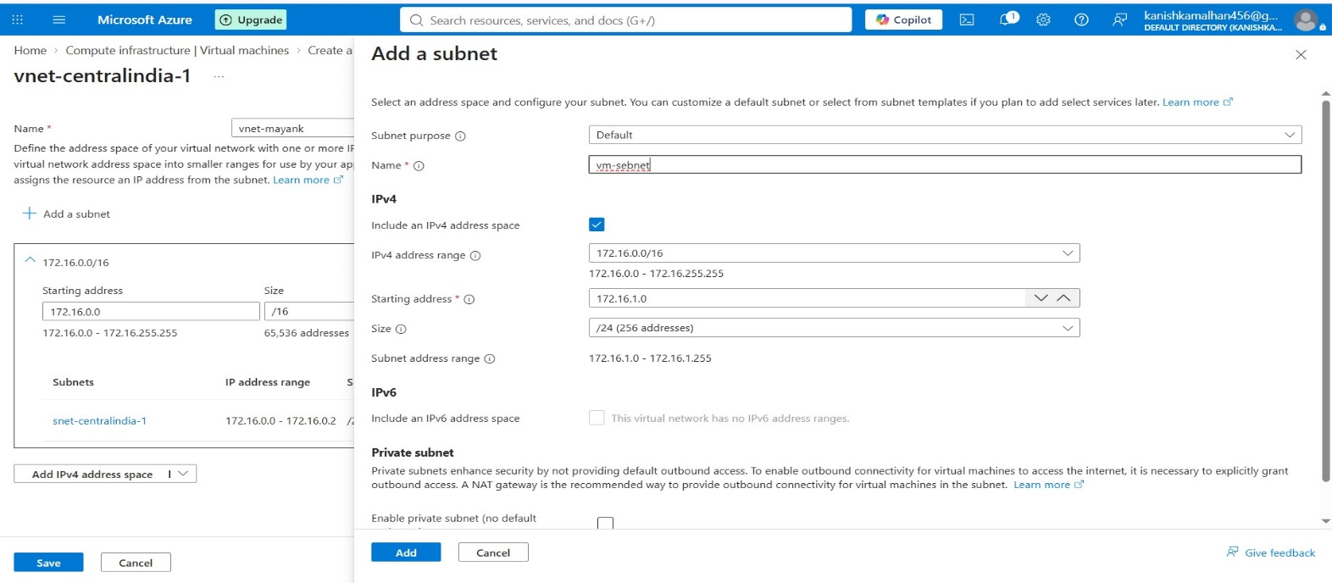

Step 11: Configure Public IP Address and NSG
Create a Public IP Address for the virtual machine and configure the Network Security Group. Allow inbound traffic on SSH Port 22.
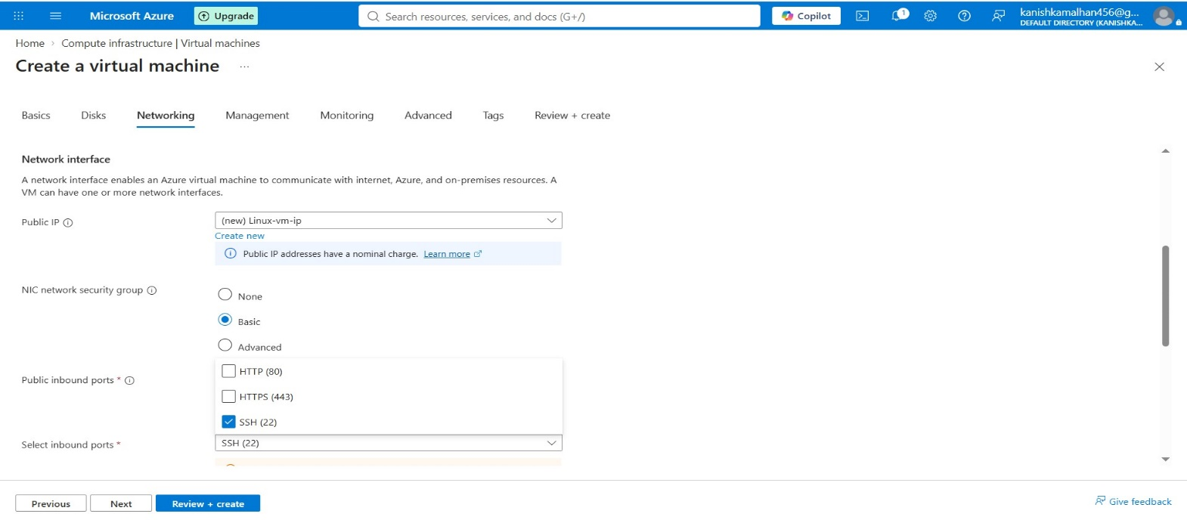

Step 12: Review and Create Virtual Machine
Review all VM, networking, storage, and security configurations. Click Create to deploy the virtual machine.
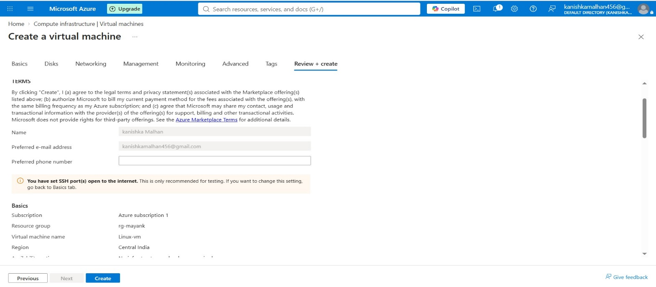
Step 13: Verify Resource Deployment
Verify that all resources including the Linux VM, Managed Disk, NIC, VNet, NSG, and Public IP Address have been created successfully.
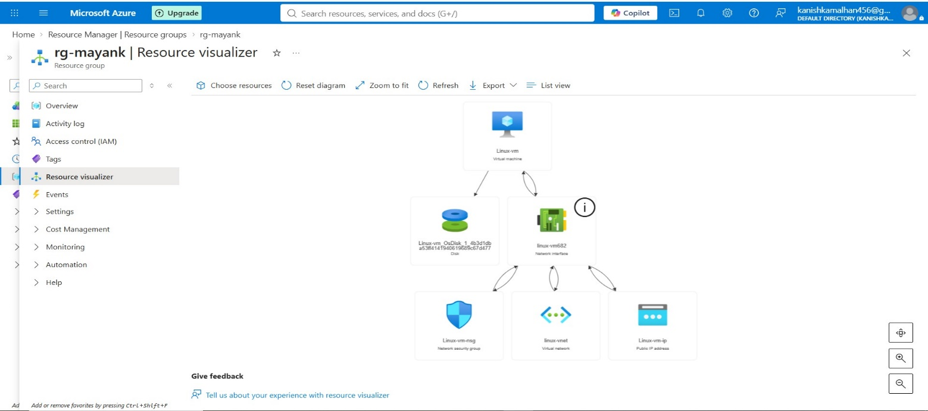

Step 14: Obtain SSH Connection Details
Open the Connect page of the virtual machine and verify the Public IP Address, SSH Port (22), and SSH command.
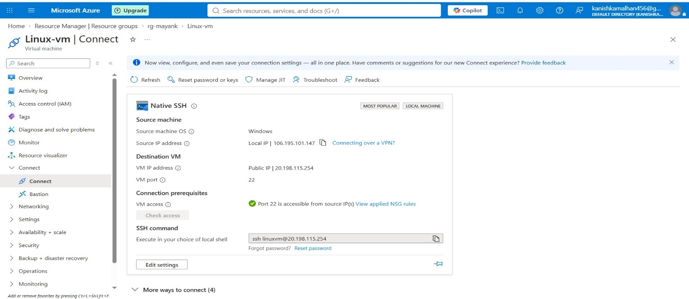

Step 15: Connect to Linux Virtual Machine Using SSH

Open PowerShell or Command Prompt and execute the SSH command provided by Azure. Enter the configured credentials to establish the connection.
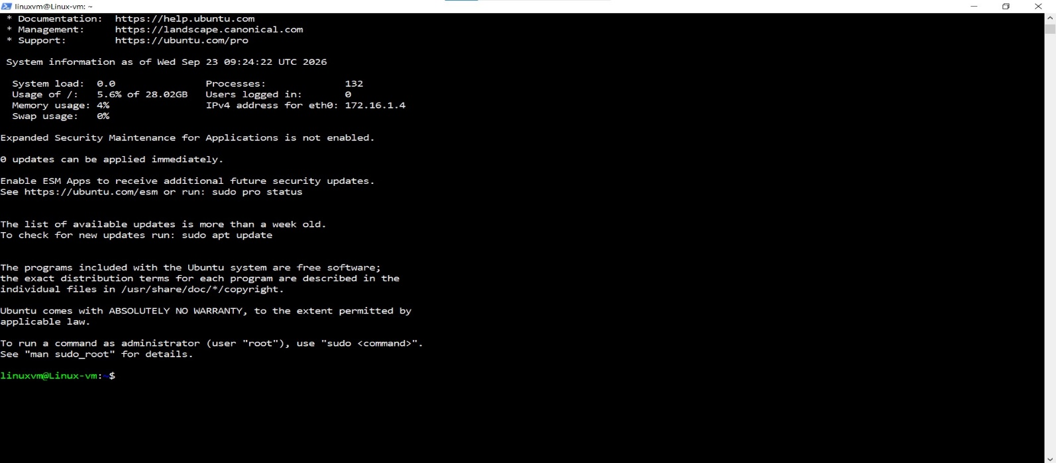

Step 16: Perform Basic Linux File Operations

Execute basic Linux commands to verify directory navigation, folder creation, and file management operations.

Basic Commands Executed:
- pwd
- mkdir mayank
- cd mayank
- touch demo_file
- ls
- cat demo_file
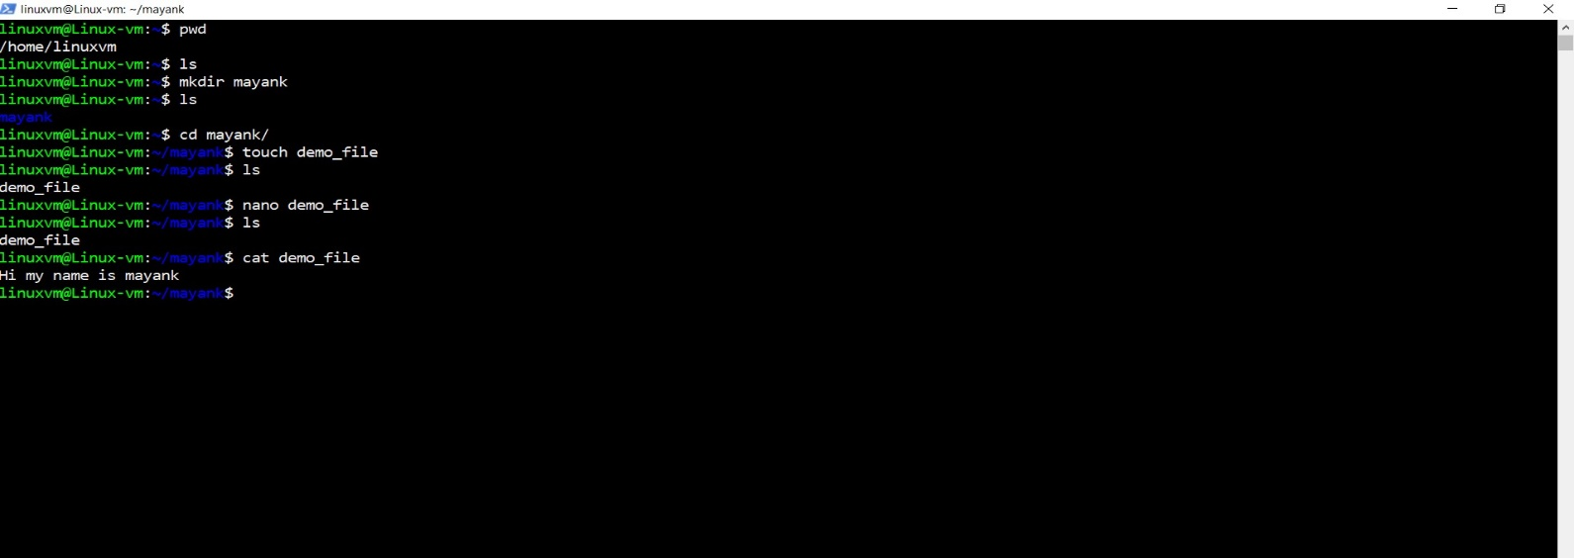

Step 17: Verify Memory and Storage Utilization
Execute Linux commands to verify system memory and storage utilization.
Commands Executed:
- free -h
- du -sh
- df -h
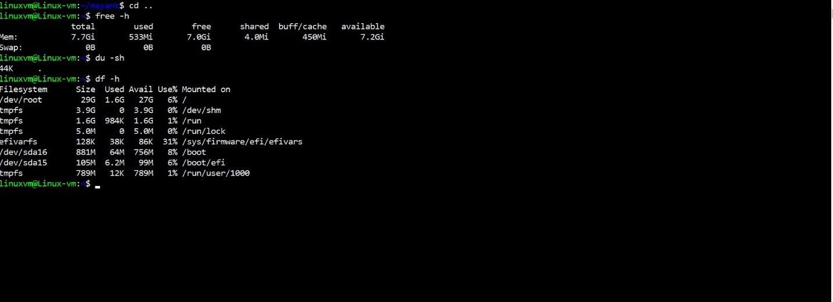

Step 18: Verify Network Services and Logout

Check active listening ports and services. Remove the test file and close the SSH session.

Commands Executed:
- sudo ss -tulnp
- rm demo_file
- exit
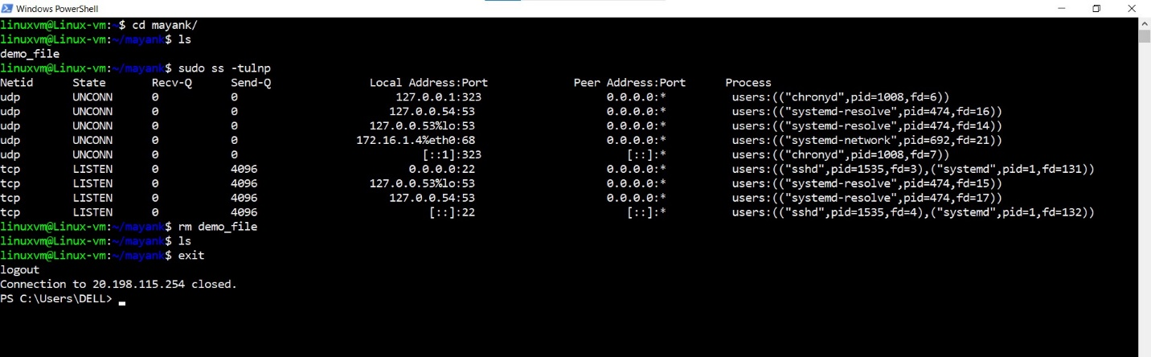

Validation
- Linux Virtual Machine Created Successfully
- Ubuntu Server 24.04 LTS Installed Successfully
- Standard_B2s_v2 VM Size Selected
- Virtual Network Created
- Subnet Created
- Public IP Address Assigned
- Network Security Group Configured
- SSH Port 22 Enabled
- SSH Connection Successful
- Linux Commands Executed Successfully
- Memory and Storage Information Verified
- Network Services Verified

Conclusion
A Linux Virtual Machine running Ubuntu Server 24.04 LTS was successfully deployed in Microsoft Azure using the Standard_B2s_v2 VM size. Required networking resources including a Virtual Network, Subnet, Public IP Address, and Network Security Group were configured successfully. Secure remote access was established using SSH over Port 22, and various Linux administrative commands were executed to verify system functionality, storage utilization, network services, and overall connectivity.

