Analysis 1

Backlog and Delivery

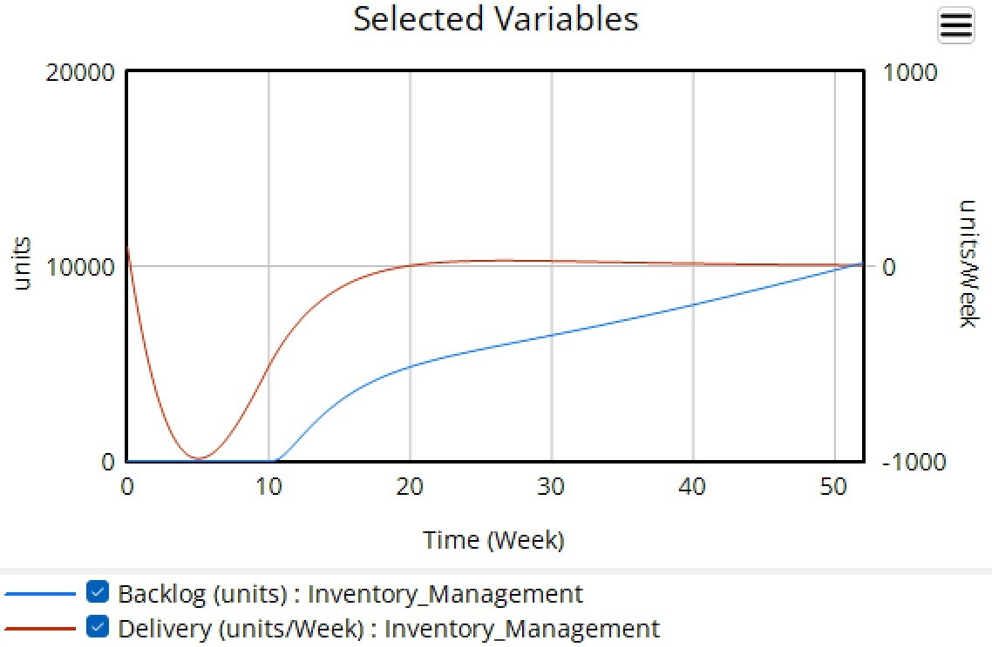
Figure 1: Backlog vs Delivery

Time | Backlog |  | Time | Delivery
99.237410 | 5.670767 |  | 49.500025 | 0.404573
98.971232 | 17.548048 |  | 63.581379 | 3.323709
98.708107 | 26.996162 |  | 76.657717 | 6.245546
99.197060 | 37.789744 |  | 87.726052 | 9.710417
89.887629 | 48.096407 |  | 94.019553 | 12.919305
83.344410 | 56.498800 |  | 98.564409 | 18.821066
78.055107 | 66.783762 |  | 90.560762 | 28.520001
74.525628 | 76.249508 |  | 75.019503 | 38.239198
72.250743 | 87.058010 |  | 59.492427 | 51.721797
69.469612 | 100.838205 |  | 52.753153 | 63.567871
66.690176 | 113.268863 |  | 49.537511 | 77.017375
65.169065 | 124.073295 |  | 48.338990 | 92.343177
62.894519 | 134.611889 |  | 48.676359 | 115.191733
60.871909 | 144.609312 |  | 48.974216 | 127.556524
58.846926 | 156.496087 |  | 49.293349 | 145.566418
57.325476 | 167.570427 |  | 49.581075 | 155.243064
53.547112 | 175.148178 |  | 49.879945 | 167.876670
52.024644 | 187.032240 |  | 49.931614 | 181.586208
48.745405 | 197.306352 |  | 50.491870 | 196.907283

Inventory and Pipeline Inventory

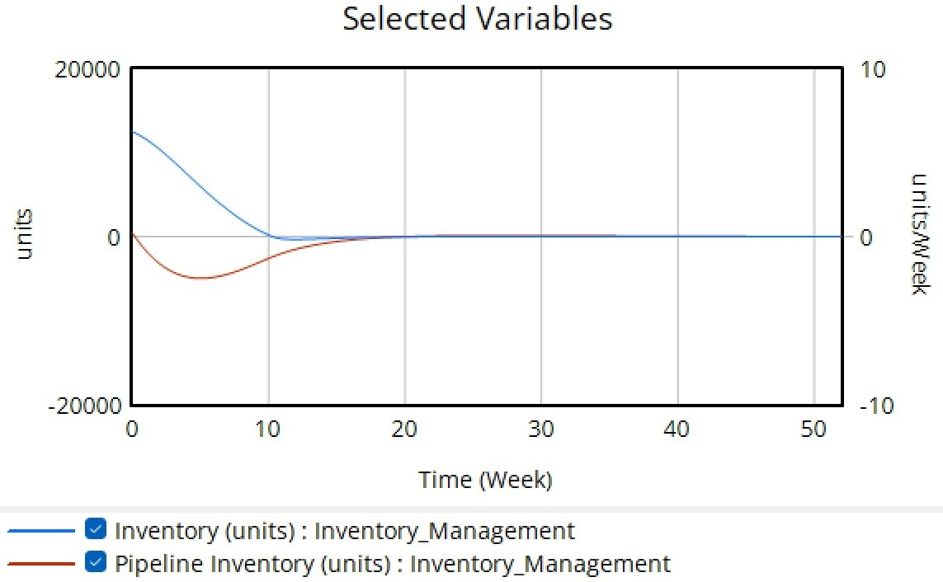
Figure 2: Inventory vs Pipeline Inventory

Time | Inventory |  | Time | Pipeline Inventory
20.891365 | 1.876676 |  | 54.874652 | 2.144772
25.905292 | 7.238606 |  | 59.610028 | 8.310992
32.311978 | 13.672922 |  | 62.395543 | 16.621984
38.997214 | 21.179625 |  | 60.167131 | 26.541555
45.403900 | 29.758713 |  | 56.545961 | 36.193029
49.582173 | 36.729223 |  | 52.924791 | 45.844504
50.139276 | 52.546917 |  | 50.696379 | 59.785523
50.696379 | 65.951743 |  | 50.417827 | 68.632708
49.860724 | 77.479893 |  | 49.860724 | 78.820375
49.582173 | 88.203753 |  | 50.139276 | 87.399464
49.582173 | 98.123324 |  | 49.860724 | 96.782842
49.582173 | 109.919571 |  | 49.582173 | 105.898123
49.303621 | 119.839142 |  | 49.582173 | 114.477212
49.582173 | 130.831099 |  | 49.860724 | 123.860590
49.025070 | 143.699732 |  | 49.303621 | 134.852547
49.582173 | 155.495979 |  | 49.582173 | 145.576408
49.303621 | 163.806971 |  | 49.303621 | 157.640751
49.582173 | 178.820375 |  | 49.582173 | 172.922252
49.582173 | 198.391421 |  | 49.303621 | 191.957105

Inventory and Returned Inventory

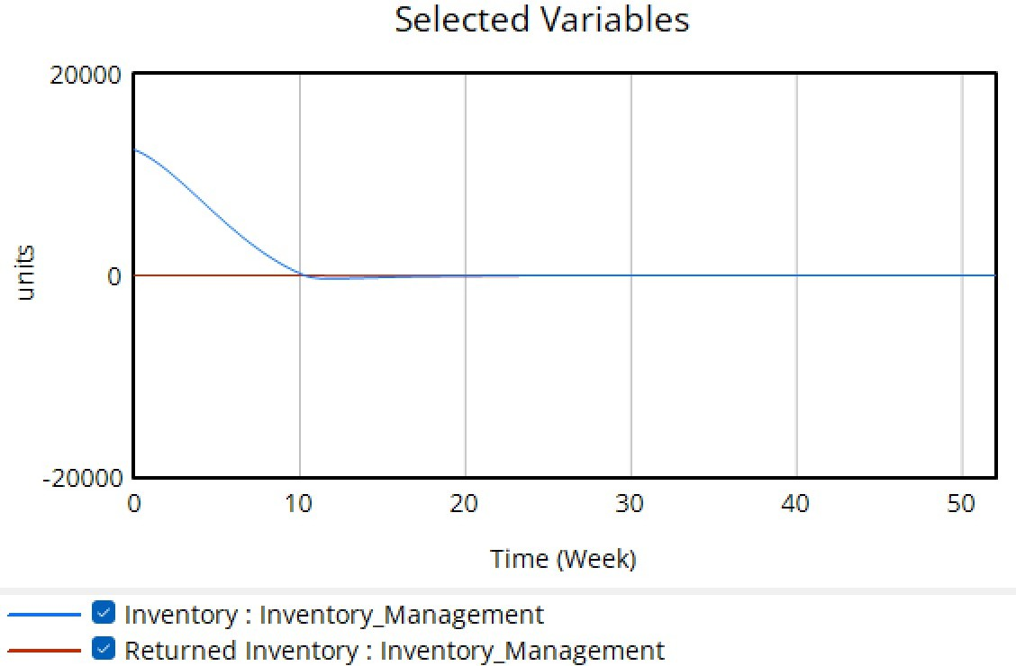
Figure 3: Inventory vs Returned Inventory

Time | Inventory |  | Time | Returned Inventory
20.891365 | 1.876676 |  | 50.311907 | 11.437955
25.905292 | 7.238606 |  | 50.362614 | 21.579345
32.311978 | 13.672922 |  | 50.192804 | 37.617481
38.997214 | 21.179625 |  | 50.243511 | 47.758871
45.403900 | 29.758713 |  | 50.296577 | 58.371953
49.582173 | 36.729223 |  | 50.584309 | 65.918444
50.139276 | 52.546917 |  | 50.140918 | 77.240245
50.696379 | 65.951743 |  | 50.699874 | 89.031379
49.860724 | 77.479893 |  | 50.499404 | 98.937513
49.582173 | 88.203753 |  | 50.807184 | 110.493390
49.582173 | 98.123324 |  | 50.600818 | 119.220292
49.582173 | 109.919571 |  | 50.647988 | 128.654143
49.303621 | 119.839142 |  | 50.952229 | 139.502482
49.582173 | 130.831099 |  | 50.760015 | 151.059539
49.025070 | 143.699732 |  | 50.801288 | 159.314159
49.582173 | 155.495979 |  | 51.094916 | 168.039882
49.303621 | 163.806971 |  | 50.892089 | 177.474322
49.582173 | 178.820375 |  | 51.206943 | 190.445278
49.582173 | 198.391421 |  | 51.752927 | 199.642103

Waste Accumulation and Waste Disposal

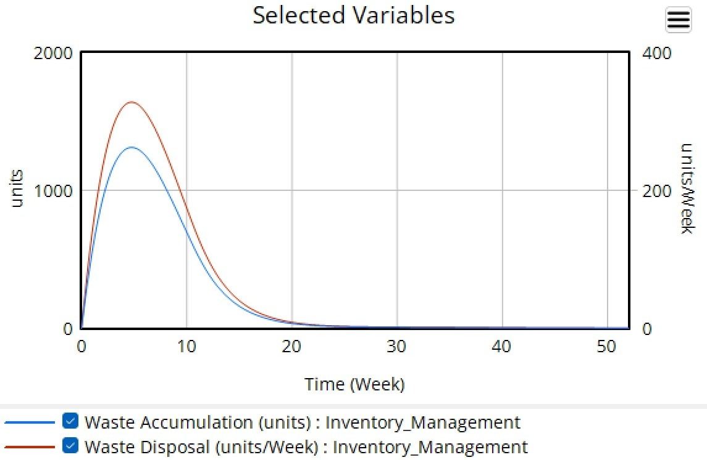
Figure 4: Waste Analysis

Time | Waste Accumulation |  | Time | Waste Disposal
90.354052 | 0.491238 |  | 86.546302 | 0.997541
74.614788 | 3.031266 |  | 76.138280 | 2.519068
57.859316 | 6.342864 |  | 58.369221 | 4.537729
42.625700 | 10.432584 |  | 39.329493 | 7.843433
34.239940 | 18.410943 |  | 17.997321 | 17.594833
45.141165 | 28.245527 |  | 28.898219 | 27.687481
58.330249 | 35.247306 |  | 42.343074 | 33.141532
73.549784 | 42.254324 |  | 56.295542 | 38.596893
86.989399 | 51.837394 |  | 69.740725 | 43.792881
95.349614 | 63.988001 |  | 78.871856 | 48.461606
98.626171 | 82.060972 |  | 87.492427 | 55.451595
98.348131 | 101.157029 |  | 94.077635 | 66.307299
98.575737 | 121.802778 |  | 96.857715 | 75.604796
99.569348 | 138.837600 |  | 98.616019 | 90.060946
99.040776 | 155.352365 |  | 99.107257 | 102.965440
99.278535 | 167.998140 |  | 98.840678 | 113.029268
99.514984 | 181.676169 |  | 99.328641 | 128.514398
99.498610 | 194.579353 |  | 99.550354 | 153.805293
 |  |  | 99.247096 | 192.772252

Delivery and Unfulfilled Demand
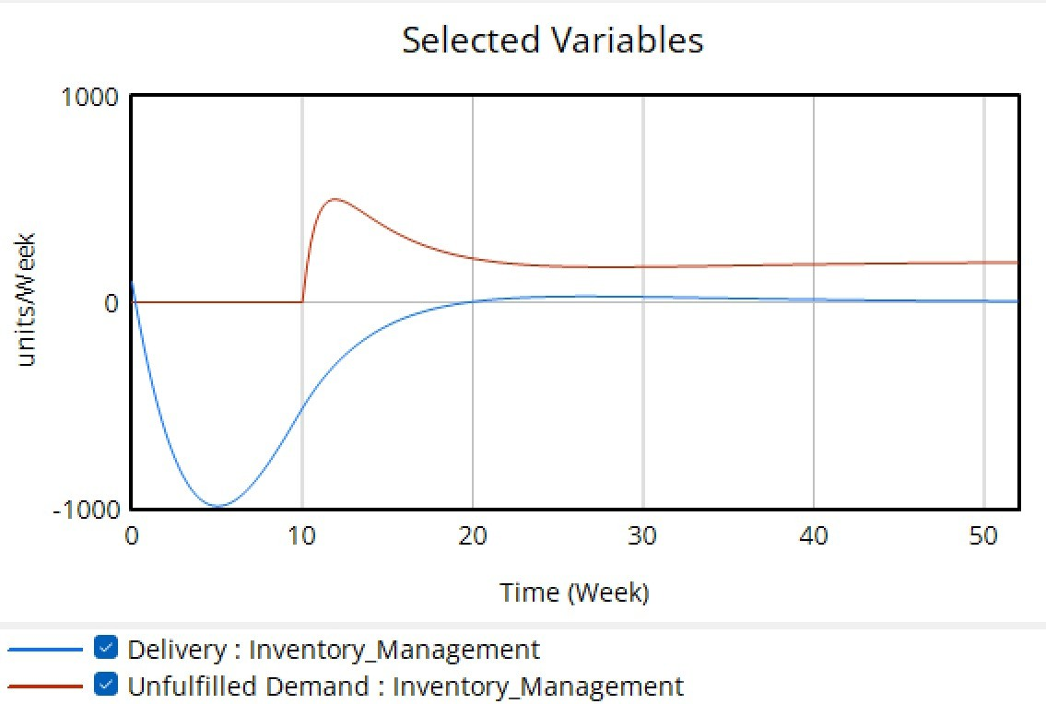
Figure 5: Delivery vs Unfulfilled Demand

Time | Delivery |  | Time | Unfulfilled Demand
49.500025 | 0.404573 |  | 50.118660 | 5.311925
63.581379 | 3.323709 |  | 50.357476 | 16.647737
76.657717 | 6.245546 |  | 50.340439 | 30.106884
87.726052 | 9.710417 |  | 49.824849 | 37.423185
94.019553 | 12.919305 |  | 34.126097 | 39.437125
98.564409 | 18.821066 |  | 24.752218 | 44.801655
90.560762 | 28.520001 |  | 29.552737 | 52.391741
75.019503 | 38.239198 |  | 34.098898 | 60.924536
59.492427 | 51.721797 |  | 39.396177 | 76.074221
52.753153 | 63.567871 |  | 41.151575 | 89.309797
49.537511 | 77.017375 |  | 41.639966 | 103.480907
48.338990 | 92.343177 |  | 41.372755 | 114.577007
48.676359 | 115.191733 |  | 41.359006 | 125.438775
48.974216 | 127.556524 |  | 41.600512 | 134.649458
49.293349 | 145.566418 |  | 41.587062 | 145.275101
49.581075 | 155.243064 |  | 40.812630 | 157.075991
49.879945 | 167.876670 |  | 40.540040 | 172.422348
49.931614 | 181.586208 |  | 40.521508 | 187.062122
50.491870 | 196.907283 |  | 40.505966 | 199.340642

Backlog and Backlog Fulfillment
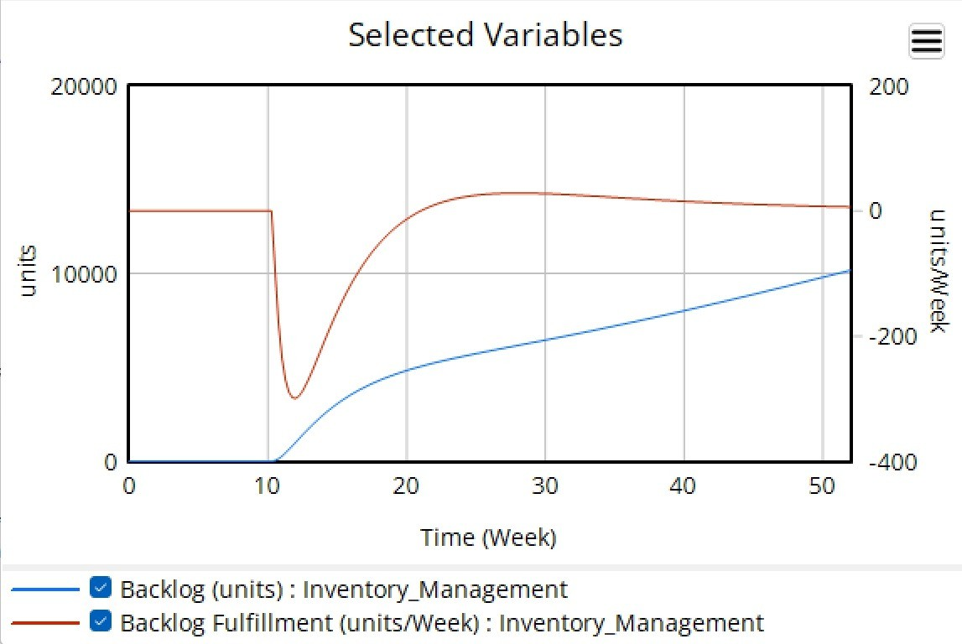
Figure 6: Backlog vs Fulfillment

Time | Backlog |  | Time | Backlog Fulfillment
99.237410 | 5.670767 |  | 32.820513 | 12.566845
98.971232 | 17.548048 |  | 33.076923 | 27.272727
98.708107 | 26.996162 |  | 33.333333 | 37.967914
99.197060 | 37.789744 |  | 50.512821 | 39.304813
89.887629 | 48.096407 |  | 67.179487 | 40.106952
83.344410 | 56.498800 |  | 83.076923 | 44.117647
78.055107 | 66.783762 |  | 62.307692 | 55.080214
74.525628 | 76.249508 |  | 42.820513 | 67.112299
72.250743 | 87.058010 |  | 34.871795 | 76.203209
69.469612 | 100.838205 |  | 29.487179 | 91.711230
66.690176 | 113.268863 |  | 28.974359 | 107.219251
65.169065 | 124.073295 |  | 28.461538 | 121.925134
62.894519 | 134.611889 |  | 29.487179 | 132.887701
60.871909 | 144.609312 |  | 29.743590 | 143.582888
58.846926 | 156.496087 |  | 30.769231 | 157.219251
57.325476 | 167.570427 |  | 31.538462 | 170.053476
53.547112 | 175.148178 |  | 31.794872 | 181.550802
52.024644 | 187.032240 |  | 32.051282 | 197.326203
48.745405 | 197.306352 |  | 73.333333 | 50.267380

Overall Digital Twin Model –

