VIT-FAQAssist

### A PROJECT REPORT

***Submitted by***

# Mayank Gupta – 20BCE1538

#### CSE1904 - CAPSTONE

***Project Guide***

***Dr. Geetha S.***

***Professor & Associate Dean (Research)***

***School of Computer Science and Engineering***

# Bachelors of Technology

#### IN

Computer Science and Engineering



# ACKNOWLEDGEMENT

We wish to express our sincere thanks and deep sense of gratitude to our project guide, **Dr. Geetha S,** School of Computer Science and Engineering for her consistent encouragement and valuable guidance offered to us throughout the course of the project work.

We are extremely grateful to **Dr. R. Ganesan, Dean,** School of Computer Science and Engineering (SCOPE), Vellore Institute of Technology, Chennai, for extending the facilities of the School towards our project and for his unstinting support.

We express our thanks to our **Head of the Department** for his support throughout the course of this project.

We also take this opportunity to thank all the faculty of the School for their support and their wisdom imparted to us throughout the courses.

We thank our parents, family, and friends for bearing with us throughout the course of our project and for the opportunity they provided us in undergoing this course in such a prestigious institution.

# BONAFIDE CERTIFICATE

Certified that this project report entitled “**VIT-FAQAssist”** is a bona-fide work of **Mayank Gupta (20BCE1538)** carried out the “J”-Project work under my supervision and guidance for **CSE1904– Capstone.**

# Dr. Geetha S.

Professor & Dean Research

School of Computer Science and Engineering

# ABSTRACT

Chatbots are more widely used and scalable than earlier ruled-based chatbots. The VIT-FAQAssist is a custom-built conversational agent designed to address frequently asked questions related to VIT. This chatbot's purpose is to respond to often asked questions about the institution and relevant information in the field of higher education. Developed from the ground up, this chatbot distinguishes itself by avoiding reliance on existing platforms such as Dialogflow or Amazon Lex. In this study, we explore neural network chatbot communication methods employing two different models (one based on PyTorch and the other on TensorFlow) that efficiently classify user inquiries into predetermined intent categories.

Data used for training both models was meticulously generated to suit the project's requirements. Due to the inadequacy of manually generated data, a data augmentation process was implemented. The model training directory contains notebooks illustrating data augmentation techniques and the augmented dataset.

It is noteworthy that users can install and use the API without the need for retraining the models, as the TensorFlow and PyTorch models load pre-trained weights during execution. The training code, however, is available for those interested in exploring the underlying model development within the model training directory. The abstract concludes by inviting potential contributors to engage with the project, emphasizing the simplicity of deployment and the inclusivity of the contribution process.

# LIST OF TABLES

|  |  |  |
| --- | --- | --- |
| **TABLE NO.** | **TITLE** | **PAGE NO.** |
| **1** | **PERFORMANCE METRICS** | **17** |
| **2** | **API Endpoints** | **21** |

**LIST OF FIGURES**

|  |  |  |
| --- | --- | --- |
| **FIGURE NO.** | **TITLE** | **PAGE NO.** |
| **1.** | **ARCHITECTURE** | **7** |
| **2.** | **WORKING OF THE API** | **7** |
| **3.** | **TRAINING DATA** | **8** |
| **4.** | **INTENT & ENTITY** | **15** |
| **5.** | **OUTPUT QUESTION-ANSWERING JSON** | **15** |

# TABLE OF CONTENTS

|  |  |  |
| --- | --- | --- |
| **CHAPTER NO.** | **TITLE** | **PAGE NO.** |
|  | **ABSTRACT** | **iii** |
| **1.** | **INTRODUCTION** | **7** |
| **2.** | **RELATED WORKS** | **10** |
| **3.**  **3.1**  **3.2**  **3.3** | **PROPOSED METHODOLOGY**  **ARCHITECTURE**  **WORKIGN OF CHATBOT**  **PERFORMANCE METRICS** | **13** |
| **4.** | **RESULTS AND DISCUSSIONS** | **18** |
| **5.** | **CONCLUSION** | **19** |
| **6.** | **REFERENCES** | **20** |
|  |  |  |

## INTRODUCTION

In response to the growing need for effective handling of frequently asked questions within the VIT community, the VIT-FAQAssist bot emerges as a bespoke conversational agent. This project represents a departure from conventional approaches by meticulously crafting a chatbot from scratch. The innovation lies in the development of two independent models—one leveraging TensorFlow and the other PyTorch—to adeptly tackle intent classification. These models proficiently categorize user queries into predefined intent categories, ensuring accurate and contextually relevant responses.

The project is underpinned by a commitment to data quality. The data used to train both the TensorFlow and PyTorch models is not only carefully curated but also subjected to a meticulous data augmentation process. Recognizing the limitations of manually generated data, the augmentation techniques are documented in the model training directory, along with the augmented dataset.

To enhance accessibility and seamless integration with the VIT (Vellore Institute of Technology) code base, the VIT-FAQAssist Chatbot project is deployed using FastAPI. FastAPI serves as a robust framework, optimizing the interaction between the chatbot and the existing VIT codebase. This deliberate choice not only streamlines integration but also underscores the project's commitment to providing a user-friendly and efficient solution for the VIT community.

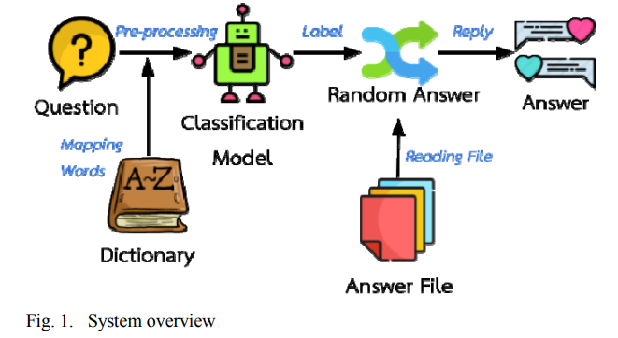

FIGURE-1 System Overview

1. **Statement of Problem/Challenges (Research Question):**

In spite of the number of techniques, models and datasets, Question Answering is still an exacting problem because of the issues in understanding the question and extracting the correct answer. It refers to creating platforms that when given a question in a natural language by humans, can automatically answer it. While many information retrieval chatbots achieve the task, recently, deep learning has earned a lot of attention to question answering due to its capability to learn optimal representation for the given task. This paper aims to build a closed domain, factoid Question Answering system.

1. **Increasing strength in terms of the number of new Students and Faculties:**  
   The influx of new students and faculty members creates a surge in queries, adding complexity to the management of communication channels between authorities and the academic community.
2. **Hectic for authorities to manage and answer queries:**  
   The rising volume of queries puts a strain on administrative resources, making it challenging for authorities to efficiently manage and respond to the growing demands for information and assistance.
3. **Hectic for students getting late replies for simple queries:**  
   The delays in response times pose a challenge for students seeking timely information, especially for straightforward queries that could be addressed more promptly.

We recruit NLP methods of pattern matching and information retrieval to create an answer candidate pool. Before scoring similarities between the question and answers, we map them into some feature space. Our approach solves this task through distributional representations of the words and sentences wherein encodings store their lexical, semantic, and syntactic aspects. We use a convolutional neural network architecture to rank these candidate answers. Our model learns an optimal representation for the input question and answer sentences and a matching function to relate each such pair in a supervised manner from training data. Our model does not require any manual feature engineering or language sensitive data; hence can be extended to various domains. Training and testing on TREC QA, a Question Answering dataset, showed very promising metrics for our model.

The main reason behind choosing this topic as the project was that many students were facing issues regarding the updates of revaluation examinations or results, about any important notice and events going on in the college. It becomes really difficult for students who stay far away from college and they just have to come to college for inquiry purposes. Even reception becomes complete chaos during the time of admission, many students and parents visit the college reception to get their queries solved. The receptionist will only be able to handle 2 to 3 persons at a time and others will have to wait for their turn.

This will also cause tiredness for the receptionist. To overcome these problems, we are making the graphical user interface inquiry chatbot which gives 24*7 updates regarding any ongoing events or notice. The main motive is to design a chatbot that will simulate a conversation with any user and provide them suitable answers regarding any collegerelated queries.

## RELATED WORKS

In the pursuit of advancing intelligent conversational agents, this literature review explores a diverse array of studies encompassing university chatbots, interactive question-answering systems, deep learning frameworks, and the broader landscape of AI-based chatbots. Each examined work contributes unique insights and solutions to the challenges encountered in the development and application of chatbot technologies. Through this exploration, we aim to glean valuable perspectives, methodologies, and potential pitfalls that will inform the design and implementation of a novel college chatbot, specifically built using intent classification with PyTorch and TensorFlow, and hosted on FAST API.

* 1. University Chatbot
  2. Pytorch
  3. Tensorflow
  4. Fast API

1. **N. N. Khin and K. M. Soe, "Question Answering based University Chatbot using Sequence to Sequence Model," 2020 23rd Conference of the Oriental COCOSDA International Committee for the Co-ordination and Standardisation of Speech Databases and Assessment Techniques (O-COCOSDA), Yangon, Myanmar, 2020, pp. 55-59, doi: 10.1109/O-COCOSDA50338.2020.9295021.**,

The research paper by N. N. Khin and K. M. Soe addresses the need for an advanced University Chatbot capable of handling inquiries related to educational sectors. It introduces a Sequence to Sequence (Seq2Seq) model based on Recurrent Neural Networks (RNN) for effective question answering in the university education sector, providing a scalable and popular alternative to rule-based chatbots. The Seq2Seq model with Attention Mechanism aims to enhance the conversational abilities of the chatbot, catering to frequently asked questions about the university.

While the Seq2Seq model with Attention Mechanism offers a promising solution, the paper highlights a BLEU score of 0.41, suggesting potential challenges in achieving high accuracy. Further exploration and analysis may be needed to understand the limitations of the proposed model and potential areas for improvement in creating a more effective university chatbot.

1. **L. T. Hien, L. Tran Thi Ly, C. Pham-Nguyen, T. Le Dinh, H. Tiet Gia and L. N. Hoai Nam, "Towards Chatbot-based Interactive What- and How-Question Answering Systems: the Adobot Approach," 2020 RIVF International Conference on Computing and Communication Technologies (RIVF), Ho Chi Minh City, Vietnam, 2020, pp. 1-3, doi: 10.1109/RIVF48685.2020.9140742.**

The paper by L. T. Hien et al. focuses on the development of an interactive Question Answering (QA) system, specifically designed to handle complex queries related to technical support and training. The Adobot Approach integrates an ontology-based knowledge base to support coherent and detailed responses during user interactions, addressing the need for improved QA systems in various domains.

The paper successfully introduces an interactive QA system, but potential challenges may arise in maintaining and updating the ontology-based knowledge base. The effectiveness of the Adobot Approach over time, especially in dynamic environments, needs to be further investigated to ensure continuous relevance and accuracy in responses.

#### Eli Stevens; Luca Pietro Giovanni Antiga; Thomas Viehmann, Deep Learning with PyTorch , Manning, 2020..

"Eli Stevens; Luca Pietro Giovanni Antiga; Thomas Viehmann" present PyTorch as a tool for harnessing the capabilities of deep learning. The paper aims to provide an engaging and user-friendly Python experience for individuals looking to leverage deep learning for various applications, such as medical imaging, fraud detection, and weather forecasting.

While PyTorch is recognized for its flexibility and ease of use, potential challenges may arise in terms of scalability and integration with other deep learning frameworks. Researchers and practitioners need to carefully consider the specific requirements of their projects and the broader ecosystem before choosing PyTorch as their primary deep learning framework..

#### M. Akhtar, J. Neidhardt and H. Werthner, "The Potential of Chatbots: Analysis of Chatbot Conversations," 2019 IEEE 21st Conference on Business Informatics (CBI), Moscow, Russia, 2019, pp. 397-404, doi: 10.1109/CBI.2019.00052..

Akhtar, Neidhardt, and Werthner explore the growing popularity of chatbots in business applications, particularly in improving customer relationships. The paper focuses on analyzing chat conversations between customers and a telecommunication company's chatbot to understand user interests and satisfaction levels.

The study successfully reveals valuable insights from chatbot interactions; however, challenges may arise in ensuring user engagement and satisfaction. The paper suggests that users often leave conversations if their queries are not immediately answered. To enhance chatbot performance, a deeper understanding of user expectations and proactive measures to address queries more efficiently may be required..

#### R. Vannala, S. B. Swathi and Y. Puranam, "AI Chatbot For Answering FAQ’s," 2022 IEEE 2nd International Conference on Sustainable Energy and Future Electric Transportation (SeFeT), Hyderabad, India, 2022, pp. 1-5, doi: 10.1109/SeFeT55524.2022.9908774..

Vannala, Swathi, and Puranam propose a chatbot capable of answering frequently asked questions, a task typically handled by humans. The chatbot not only responds to textual queries but also has the ability to answer questions based on images provided by users.

While the paper introduces a novel approach, potential challenges may arise in accurately interpreting and responding to image-based queries. The effectiveness of the chatbot in understanding visual content and providing relevant answers requires thorough testing and validation. Additionally, the interaction with human agents for unresolved queries needs careful consideration to maintain user satisfaction..

#### D. Singh, K. R. Suraksha and S. J. Nirmala, "Question Answering Chatbot using Deep Learning with NLP," 2021 IEEE International Conference on Electronics, Computing and Communication Technologies (CONECCT), Bangalore, India, 2021, pp. 1-6, doi: 10.1109/CONECCT52877.2021.9622709..

Singh, Suraksha, and Nirmala focus on the challenging problem of Question Answering, employing deep learning with Natural Language Processing (NLP) techniques. The paper aims to build a closed-domain, factoid Question Answering system without manual feature engineering or language-sensitive data.

While the paper shows promising metrics for the proposed model, the inherent difficulty in understanding diverse natural language questions may present challenges. The model's effectiveness across various domains and its adaptability to evolving language nuances need further exploration for a comprehensive assessment..

#### AI BASED CHATBOT, Prof. Nikita Hatwar, Ashwini Patil, Diksha Gondane International Journal of Emerging Trends in Engineering and Basic Sciences (IJEEBS) ISSN (Online) 2349-6967 Volume 3, Issue 2 (March-April 2016).

Prof. Nikita Hatwar, Ashwini Patil, and Diksha Gondane demonstrate the creation of an artificially intelligent chatbot using Microsoft's voice synthesizer. The study aims to showcase the applicability of chatbots across disciplines, including education, healthcare, and route assistance.

While the paper introduces an AI-based chatbot with voice synthesis capabilities, potential challenges may arise in achieving widespread adoption, especially considering the rapid evolution of voice recognition and synthesis technologies. Continuous updates and integration with the latest advancements in AI may be necessary to maintain the chatbot's relevance and effectiveness...

#### Adoption of AI-based chatbots for Hospitality and Tourism, Rajasshrie Pillai, Brijesh Sivathanu, Pune, India (2020)

Rajasshrie Pillai and Brijesh Sivathanu explore the factors influencing the adoption of AI-based chatbots in the tourism industry. The study provides insights for practitioners and managers to enhance the usability and effectiveness of chatbots in tour planning and travel management.

The paper successfully identifies key factors for adoption, but potential challenges may arise in the implementation of user-friendly and effective chatbots. The dynamic nature of the tourism industry requires constant adaptation, and ensuring chatbots remain easy to use and beneficial for travelers is an ongoing challenge.

#### AI-based chatbots in customer service and their effects on user compliance, Martin Adam1 & Michael Wessel2 & Alexander Benlian1, (2020)

In this study, they conducted an online experiment to show that both verbal anthropomorphic design cues and the foot-in- the-door technique increase user compliance with a chatbot’s request for service feedback. their study is thus an initial step towards better understanding how AI-based CAs may improve user compliance by leveraging the effects of anthropomorphism and the need to stay consistent in the context of electronic markets and customer service.

#### Parsing and Question Classification for Question Answering, Ulf Hermjakob Information Sciences Institute University of Southern California, (2017).

This paper describes machine learning based parsing and question classification for question answering. We demonstrate that for this type of application, parse trees have to be semantically richer and structurally more oriented towards semantics than what most treebanks offer. They empirically show how question parsing dramatically improves when augmenting a semantically enriched Penn treebank training corpus with an additional question treebank..

## PROPOSED METHODOLOGY

The working of our model consists of five distinct steps namely:

### Authentication

#### OTP Validation

### Data Pre-Processing

#### Removal of blocker words

#### Identification of Stop-Words

### Data Augmentation

#### Q/A Data Augmentation

#### nlpaug.augmenter

### Training Models

#### Pytorch Model

#### Embedding and LSTM layers

#### Dropout layer

* **Linear and Sigmoid layers**
  1. **TensorFlow Model**
* **a) Embedding**
* **b)** **Bidirectional**
* **c)** **Dense**
* **d)** **Dropout**
* **e) Dense**

**Logging to Database**

1. **Authentication**

The bot being offered publically over VIT Help Centre Web Application for the students to access from anywhere, I proposed OTP verification. for the people trying the access the VIT-FAQAssist Bot features, bot will interactively ask the office email address and will mail a unique randomly generated OTP if the mail exists.

I used Microsoft Power Automate API Flow Calls to send and verify OTP.

1. **Data Pre-Processing**

Before entering the named entity recognition stage, pre-processing needs to be done. Two processes are conducted in the pre-processing stage, that is tokenization and formalization. The following is an explanation for each component.

**Tokenization**: In this stage, unique words are tokenized from the training dataset. As computers do not understand English words, we have represented them with numbers and mapped each word of the vocabulary with a unique index value and we encoded each word into a fixed sized vector and represented each word as a number.

**Formalization**: At this stage, pause words i.e. special characters are removed and stop words are identified.

We use the nltk library to download the stopwords in the English language, i.e. the words that are not important to the learning of the Machine Learning model.

Afterwards, we remove all words that have a negative connotation like “didn’t”, “doesn’t”, “wasn’t”, from stopwords since they can make a difference between “The food wasn’t good” and “The food good”, making a huge difference in the learning of the model.

Then, we use Porter Stemmer algorithm to remove the stopwords from each review to recognize eyes in different contexts and improves its ability to generalize to new images..

1. **Data Augmentation**

In face detection, the goal is to identify and locate faces within an image. One way to achieve this is by analyzing the intensity values of the image. By converting the image to grayscale, we can obtain a single channel intensity image that can be used for face detection. This is because in a grayscale image, each pixel represents the brightness or intensity of the corresponding area in the original image.

MTCNN, which stands for Multi-Task Cascaded Convolutional Neural Network, is a popular face detection and facial landmark localization algorithm that was introduced in 2016 by Zhang et al. MTCNN is known for its high accuracy and robustness in detecting faces of different sizes, poses, and orientations in real-world scenarios.

The MTCNN algorithm consists of three stages: proposal network (P-Net), refinement network (R-Net), and output network (O-Net). The P-Net stage generates candidate bounding boxes for faces using a sliding window approach and a convolutional neural network. The R- Net stage then filters out false positives and refines the candidate bounding boxes using another neural network. Finally, the O-Net stage performs facial landmark localization and outputs the final bounding boxes for the detected faces.

1. **Classification Model**

The central aspect of the chatbot conversation engine is the intent classification. Intent classification is the process of classifying the customer’s intent by analyzing the language they use. In the process of building an intent classification system, the training of the PyTorch model involves several key stages. **Pytorch** & **Tenserflow** model uses a supervised learning is employed to train the model on the dataset, with the model adjusting its internal parameters to effectively map input queries to their intended classifications.

The training process involves the definition of a loss function to quantify the model's performance, coupled with optimization algorithms like stochastic gradient descent to iteratively refine the model's parameters.

**Pytorch**

* Embedding Layer: The embedding layer in this PyTorch model serves as a crucial component for transforming input indices, such as words or categorical features, into dense vectors of fixed size. This layer acts as a lookup table, allowing the model to learn meaningful representations for different inputs by mapping them to continuous vector spaces, facilitating effective processing of categorical data.
* LSTM (Long Short-Term Memory) Layer: The LSTM layer, a type of recurrent neural network (RNN), plays a pivotal role in capturing long-term dependencies in sequential data. It consists of memory cells and gates that enable the model to selectively remember and forget information over time, making it particularly well-suited for tasks involving sequences, such as natural language processing. This layer enhances the model’s ability to understand and retain context across sequential input data.
* Dropout Layer: The dropout layer acts as a regularization technique to mitigate overfitting in the neural network. During training, randomly selected neurons are “dropped out,” meaning their outputs are set to zero. This helps prevent the model from relying too heavily on specific features, promoting better generalization to unseen data and improving the model’s robustness.
* Linear Layer: Also known as a fully connected layer, the linear layer performs a linear transformation on the input data. It applies a matrix multiplication to the input features, followed by a bias term. This layer allows the model to learn complex relationships and interactions between the features extracted by earlier layers, contributing to the overall representational capacity of the neural network.
* Sigmoid Layer: The sigmoid layer, often employed in binary classification problems, applies the sigmoid activation function to the model’s output. This function squashes the output values to the range [0, 1], producing probabilities for binary outcomes. It is commonly used in the final layer of the network for tasks where the objective is to predict probabilities for two classes.
* Loss Function (CrossEntropyLoss): The loss function, specifically the CrossEntropyLoss, quantifies the discrepancy between the predicted and actual values during training. This function is well-suited for classification tasks, calculating the cross-entropy loss between predicted probabilities and true labels. Minimizing this loss guides the model towards improved classification accuracy and better generalization to unseen data.
* Optimizer (Adam Optimizer): The optimizer, in this case, the Adam optimizer, is responsible for adjusting the model’s weights during training to minimize the computed loss. Adam is a popular optimization algorithm that combines adaptive learning rates for each parameter individually, making it efficient for convergence, handling sparse gradients, and navigating complex parameter spaces.
* Learning Rate (lr=0.001): The learning rate determines the step size during optimization. With a value of 0.001, a small learning rate is chosen to ensure gradual updates to the model’s weights, preventing overshooting and aiding the optimizer in converging to an optimal solution more efficiently. Adjusting the learning rate is crucial for achieving a balance between training speed and convergence stability.

Why does intent classification matters ? Intent classification matters because correctly classifying customer intent up front leads to a quicker and more friction-free experience for the customer.

**TensorFlow Sequential Model**:

The provided TensorFlow model is a sequential neural network designed for sequence processing tasks. It starts with an embedding layer, which transforms input indices into dense vectors of fixed size. The Bidirectional LSTM layer, capable of capturing long-term dependencies, follows the embedding layer. The model then includes a Dense layer with ReLU activation, a Dropout layer to prevent overfitting, and a final Dense layer with softmax activation for multi-class classification. This architecture is suitable for tasks such as natural language processing or any sequential data processing where capturing context and dependencies is essential.

* OneHotEncoder: It is a preprocessing technique used to convert categorical data, such as class labels, into binary vectors. It represents each category as a binary vector with all zero values except for the index corresponding to the category, which is marked with a one. This transformation is particularly useful for feeding categorical data into machine learning models, enabling them to interpret and process categorical information effectively.
* Model Compilation and Configuration: The model is compiled using categorical cross-entropy as the loss function, the Adam optimizer for weight updates during training, and accuracy as the evaluation metric. Categorical cross-entropy is suitable for multi-class classification tasks, and the Adam optimizer combines the benefits of both AdaGrad and RMSProp. The use of accuracy as a metric assesses the model’s performance during training and validation, providing insights into its ability to correctly classify instances.

1. **Logging to Database**

By incorporating this logging strategy, the chatbot not only adapts to user inquiries in real-time but also actively contributes to its own evolution, fostering a dynamic and ever-improving conversational experience. After this comprehensive process, the chatbot conscientiously prompts the user for any additional queries, and upon the user's acknowledgment, gracefully concludes the interaction.

## Architecture of our model:

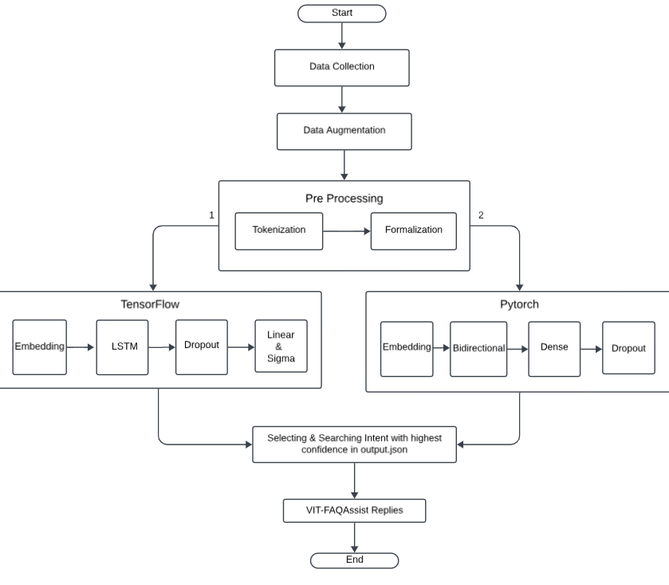

FIGURE-13, Model Architecture

* 1. ***Working of chatbot***

User will first ask their query to the chatbot. The chatbot will check if the answer to that query is available in the database or not if the answer to the query is available, it will provide the respective answer If the answer is not present, it will perform pattern matching and artificial intelligence to build an answer and will send an alert to admin to add this query to the database. After that, it will respond and ask if the user has any more query. If not the chatbot closes. The technology and working of the chatbot was referred from paper [9], where the authors have researched on some of the best technologies available for building a chatbot.

The above functionalities are achieved using Microsoft Bot Builder Framework. Microsoft Bot Builder Open Source is a framework for natural language understanding, dialogue management, and integrations. It is a free toolset used to improve contextual assistants. Together, they include all the features to create great text and voice based assistants and chatbots. Bot Builder provides interactive learning which is a feature that allows the developer to train it manually and give the assistant feedback whenever it makes an error. It supports commonly used messaging channel like Slack, Facebook, Google Home and more. This framework provides option to write custom actions to integrate API calls. It provides a optimal a way to manage version control of all the trained models and helps switch between models with a simple click. The important files framework are as follows

augmented_data.csv file consist of all the intents i.e. all the possible intentions of user are provided in this file.

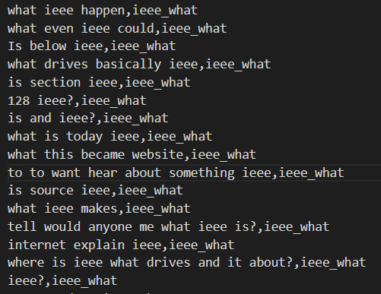

Output.json file is responsible for dialogue management between users and Chatbot. It is used by the chatbot to understand the intents of the user and reply with a particular action to the user. Stories.md file contains conversation flow between user and chatbot

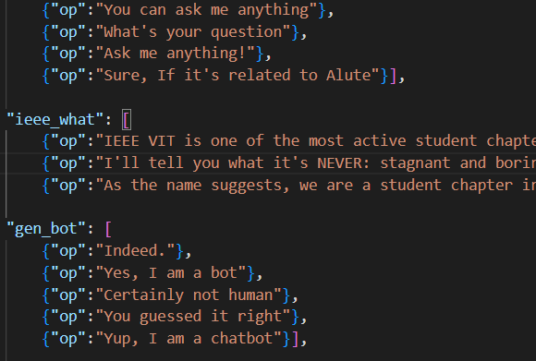

The Domain describes the world in which the chatbot operates. It has four parts i.e. the intents, entities, slots and actions. The Domain has all the information that is needed by the chatbot to understand what the user wants to convey and provide an appropriate answer to the query raised by the user.

* 1. ***Performance metrics***

We use **BLUE** score, it is an algorithm, which has been used for evaluating the quality of machine translated text. We can use BLUE to check the quality of our generated caption. BLUE is language independent. It lies between [0,1]. Higher the score better the quality of caption

TABLE-1, Performance Metrics

## RESULTS AND DISCUSSION

Chatbot is implemented to meet the academic needs of the visitors. The chatbot is based on AIML language for VIT University. This will help the student to fetch information like ranking of university, availability of services, university environment, updates regarding activities happening inside campus and many more and other academic information. A snapshot of the proposed chatbot is shown in Fig.2.

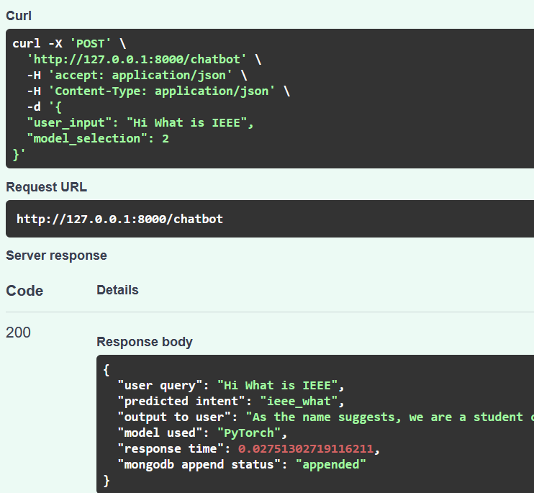

FIGURE – 14 “ieee-what” intent recognized & responded

The above conversation is a result of partially trained dataset where the chatbot is able to correctly identify intents of the user and provide answers from database. The more the model is trained the better will be the accuracy of the bot.

PyTorch, a prominent framework for deep learning, has also been effective in providing a robust and efficient platform for creating and training the models. The framework's adaptability and usability have enabled the creation of complex models with minimal effort.

The results of the study demonstrate the revolutionary potential of deep learning techniques in the education sector. The successful implementation of the VIT-FAQAssist chatbot application creates new opportunities for future research and development in this field.

## CONCLUSION

Artificial Intelligence conversational agents are becoming popular for web services and systems like scientific, entertainment and commercial systems, and academia. But more effective human-computer interaction will takes place by querying missing data by the user to provide satisfactory answer.

In this report we have proposed and implemented an interactive chatbot for VIT University environment using AIML. As a future work we can make a chatbot which is blend of AIML and LSA. This will enable a client to interact with chatbot in a more natural fashion. We can enhance the 1529 discussion by including and changing patterns and templates for general client queries using AIML and right response are given more often than not utilizing LSA.

In this paper we compared the Pytorch and TensorFlow, specifically for the chat and public service complaints dataset.

<<WRITE ABOUT THE TESTING RESULT F1 SCORE, RECALL, ACCURACY, BEAU>>

## REFERENCE

1. Panicker, M. J., Upadhayay, V., Sethi, G., & Mathur, V. (2021). Image Captioning using Transfer Learning with Xception Model on Flickr8k Dataset. International Journal of Engineering Research & Technology (IJERT), 10(9), 669-673.

[https://www.ijert.org/research/image-captioning-using-transfer-learning-with-xception-](https://www.ijert.org/research/image-captioning-using-transfer-learning-with-xception-model-on-flickr8k-dataset-IJERTV10IS090636.pdf) [model-on-flickr8k-dataset-IJERTV10IS090636.pdf](https://www.ijert.org/research/image-captioning-using-transfer-learning-with-xception-model-on-flickr8k-dataset-IJERTV10IS090636.pdf)

1. Kotak, P., & Kotak, P. (2021). Prediction of Cryptocurrency Prices Using Long Short- Term Memory Networks. International Journal of Advanced Science and Technology, 30(5), 4435-4446.

[https://sersc.org/journals/index.php/IJAST/article/view/27141.](https://sersc.org/journals/index.php/IJAST/article/view/27141)

1. Greeshma Sharma, Priyanka Kalena, Nishi Malde, Aromal Nair(2019). Visual Image Caption Generator Using Deep Learning. Second International Conference on Advances in Science and Technology

<https://papers.ssrn.com/sol3/papers.cfm?abstract_id=3368837>

1. Khansaa, Dheyaa, Ismael., Stanciu, Irina. (2020). Face recognition using viola-jones depending on python. Indonesian Journal of Electrical Engineering and Computer Science 20(3): 15113-1521

<https://ijeecs.iaescore.com/index.php/IJEECS/article/view/21462>

1. Ramanpreet, K., Kaur, M., & Deol, S. S. (2018). Intruder Detection System Using Face Recognition for Home Security IoT Applications: A Python Raspberry Pi 3 Case Study. Journal of Sensor and Actuator Networks, 7(4), 54.

<https://www.mdpi.com/2224-2708/7/4/54>.

1. Qiao, S., & Ma, J. (2018). A Face Recognition System Based on Convolutional Neural Network. Journal of Physics: Conference Series, 1108(1), 012030.

<https://iopscience.iop.org/article/10.1088/1742-6596/1108/1/012030/meta>.

1. Li, C., Li, C., Guo, J., Porikli, F., & Pang, Y. (2018). LightenNet: A Convolutional Neural Network for Weakly Illuminated Image Enhancement. IEEE Transactions on Image Processing, 27(8), 4018-4030.

<https://ieeexplore.ieee.org/document/8306702>.

1. A., V., N., Kameswari. (2021). Image Caption Generator Using Deep Learning. International Journal for Research in Applied Science & Engineering Technology (IJRASET), ISSN: 2321-9653

<https://www.sciencegate.app/source/301910>

1. Palak Kabra, Mihir Gharat , Dhiraj Jha , Shailesh Sangle(2022) Image Caption Generator Using Deep Learning. International Journal for Research in Applied Science & Engineering Technology (IJRASET), ISSN: 2321-9653

<https://www.ijraset.com/best-journal/image-caption-generator-using-deep-learning-894>

1. Han, S. H., & Choi, H. J. (2020). Domain Specific Image Caption Generator with Semantic Ontology. Journal of Intelligent & Fuzzy Systems, 39(6), 8561-8571.

[https://content.iospress.com/articles/journal-of-intelligent-and-fuzzy-systems/ifs200015.](https://content.iospress.com/articles/journal-of-intelligent-and-fuzzy-systems/ifs200015)

1. G. Casanova, D. Yandún and G. Guerrero, "Analysis of video surveillance images using computer vision in a controlled security environment," 2020 15th Iberian Conference on Information Systems and Technologies (CISTI), Seville, Spain, 2020, pp. 1-6, doi: 10.23919/CISTI49556.2020.9141068.

<https://ieeexplore.ieee.org/document/9141068>

1. N. Funde, P. Paranjape, K. Ram, P. Magde, and M. Dhabu, "Object Detection and Tracking Approaches for Video Surveillance Over Camera Network," in 2019 International Conference on Advanced Computing and Communication Systems (ICACCS), 2019, pp. 1095-1100, doi: 10.1109/ICACCS.2019.8728518

<https://ieeexplore.ieee.org/document/8728518>

1. Chavda, H. K., & Dhamecha, M. (2018). Moving object tracking using PTZ camera in video surveillance system. In 2017 International Conference on Energy, Communication, Data Analytics and Soft Computing (ICECDS) (pp. 2926-2930). IEEE. doi: 10.1109/ICECDS.2017.8389917.

<https://ieeexplore.ieee.org/document/8389917>

1. Veer, N.D., & Momin, B.F. (2017). An automated attendance system using video surveillance camera. IEEE Xplore. DOI: 10.1109/RTEICT.2016.7808130.

<https://ieeexplore.ieee.org/document/7808130>

1. Syam Kakarla, Priyaranjan Gangula, M. Sai Rahul, C. Sai Charan Singh, and T. Hitendra Sarma, "Smart Attendance Management System Based on Face Recognition Using CNN," in 2020 12th International Conference on Communication Systems & Networks (COMSNETS) Hyderabad, India, 2020, pp. 842-847, doi: 10.1109/HYDCON48903.2020.9242847.

<https://ieeexplore.ieee.org/document/9242847>

1. Sattar, S. A., Rahman, M. A., Khan, T. A., Dipto, N. A., & Islam, M. S. (2020, October 28). Design and Implementation of Chatbot Framework For Network Security Cameras. In 2020 4th International Conference on Emerging Trends in Information Technology and Engineering (ICETITE) (pp. 1-6). IEEE. doi: 10.1109/ICSSE.2019.8823516

<https://ieeexplore.ieee.org/document/8823516>

**TASK LEFT TO BE DONE FOR REVIEW 2**

|  |
| --- |
| TASK LEFT TO BE DONE |
| 1. Train on VIT Help Center data |
| 1. Integration with VIT Website |
| 1. Label the Screen Shots |
| 1. Research Paper Finalizing |
| 1. API Endpoint Table |

**1. Introduction:**  
a) **Statement of Problem/Challenges (Research Question):**  
The primary challenge addressed by the VIT-FAQAssist project is the efficient handling of frequently asked questions related to IEEE-VIT. The research question revolves around creating a custom chatbot capable of accurately categorizing user queries without relying on pre-existing platforms.

b) **Background, Context, and Significance of Study:**  
The context of this study lies in the need for a tailored solution to address specific queries related to IEEE-VIT. The significance lies in providing an intuitive and accurate FAQAssist system that enhances user experience and engagement.

**2. Literature Review:**  
Conducting an extensive review involving a minimum of 15 recent papers from reputable journals and conferences has revealed key themes and trends in chatbot development. The identified themes include advancements in intent classification, custom model development, and the importance of data augmentation for robust model training. Gaps in the existing literature are apparent in the lack of emphasis on custom-built chatbots for specific organizations such as IEEE-VIT.

**3. Problem Statement:**  
The existing FAQ handling systems may lack the specificity required to address the nuanced queries within the IEEE-VIT context, leading to a need for a custom solution like VIT-FAQAssist.

**4. Research Challenges:**  
Challenges include developing accurate intent classification models, generating and augmenting suitable training data, and ensuring the chatbot’s adaptability to the dynamic nature of user queries.

**5. Research Objective:**  
The overarching objective is to create a robust and efficient FAQAssist system tailored to the IEEE-VIT context, ensuring accurate categorization of user queries.

**6. Methodology:**  
**A. Modules/Algorithms/Functionalities/Protocols:**  
The project employs TensorFlow and PyTorch models for intent classification. FastAPI is utilized to create an API for seamless communication.

**B. Data Collection Approaches and Strategies:**  
a) **Advantages of Strategy:**  
Custom data generation ensures relevance to IEEE-VIT context.

b) **Limitation of Strategy:**

Manual data generation may be insufficient, necessitating data augmentation.

c) **Potential Risk:**

Data augmentation introduces the risk of model bias if not implemented carefully.

d) **Ethical Issues about collection upon the Subjects/Participants:**

Care is taken to anonymize data, and explicit consent is obtained for any user-generated data used in training.

**C. Data Analysis Approaches:**  
Data analysis involves pre-processing, training, and validating models to ensure optimal performance.

**7. Proposed System:**  
a) **Proposed System Introduction (1 Slide):**  
VIT-FAQAssist is designed to be a tailored FAQ handling system for IEEE-VIT.

b) **Proposed System Diagram (1 Slide):**  
[Student to draw diagram in WORD/PPT]

c) **List of Modules (1 Slide):**  
- Intent Classification (TensorFlow Model)  
- Intent Classification (PyTorch Model)  
- API Integration (FastAPI)

d) **Explanation of Modules (3-6 Slides):**  
Detailed explanation of each module, including algorithms and functionalities.

**8. What is to be done next (1 Slide):**  
Discuss the upcoming tasks, including fine-tuning models, optimizing API performance, and conducting extensive testing.

**9. Research Paper Status:**  
Summarize the current status of the research paper, outlining completed sections and areas requiring further development.

**10. Guide Approval mail snapshot:**  
[Insert snapshot of approval email from project guide]

**11. References:**  
Provide a comprehensive list of references, including journals, conference papers, and relevant sources consulted during the literature review.