Code
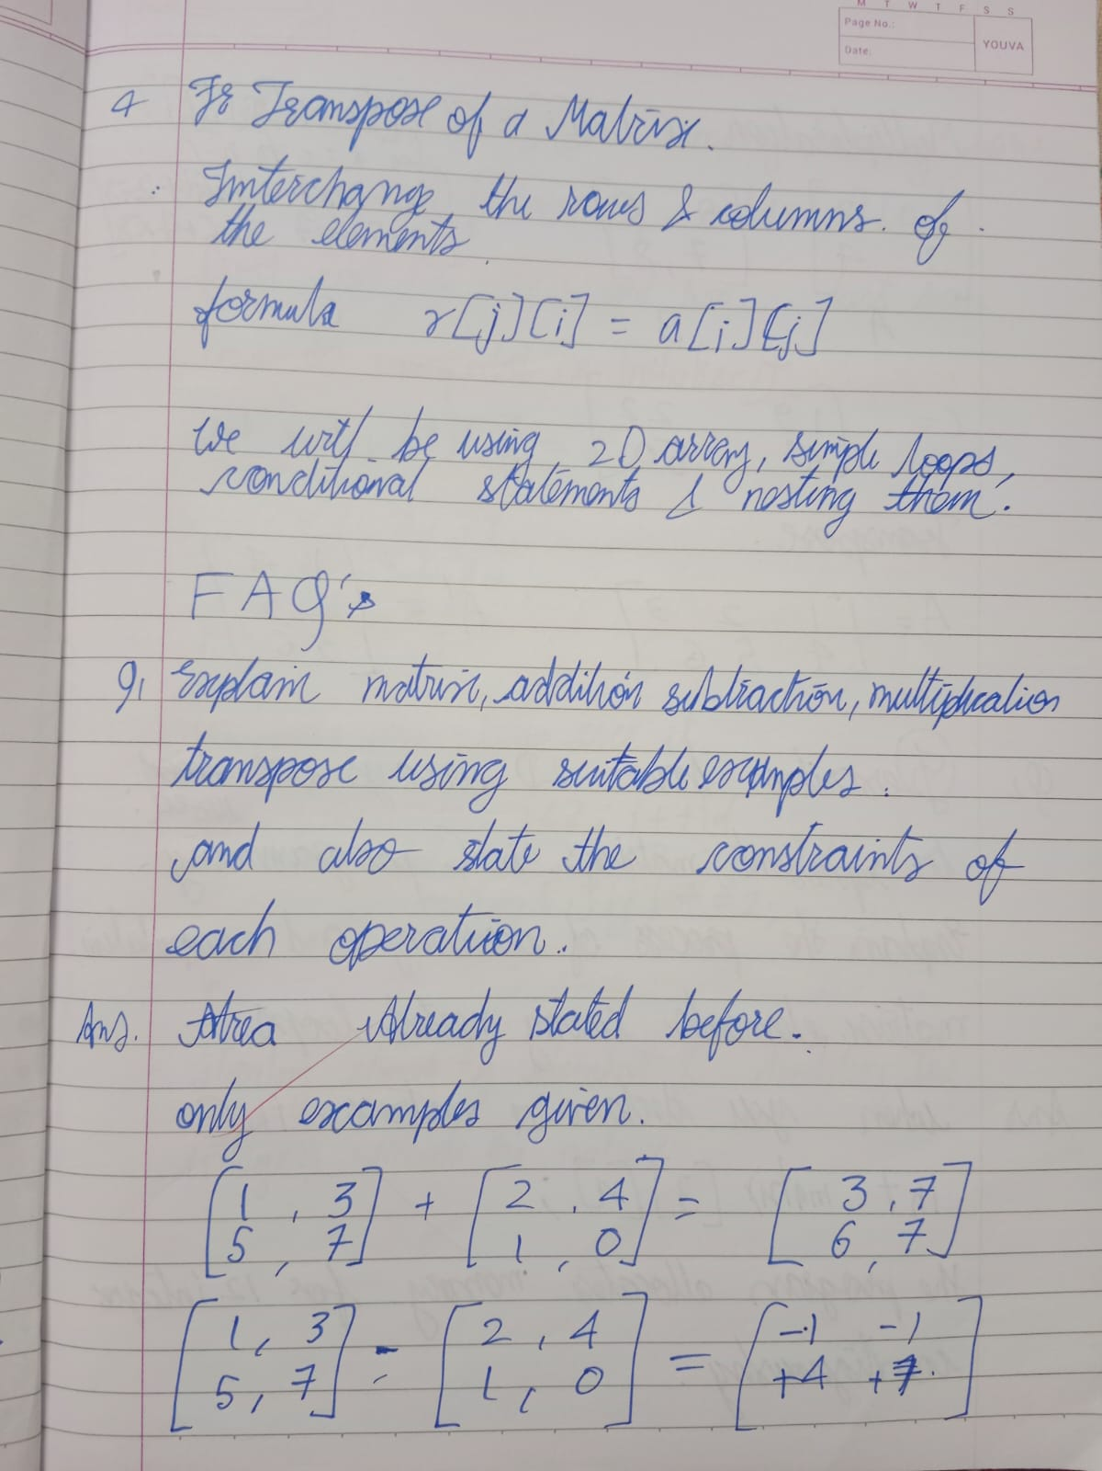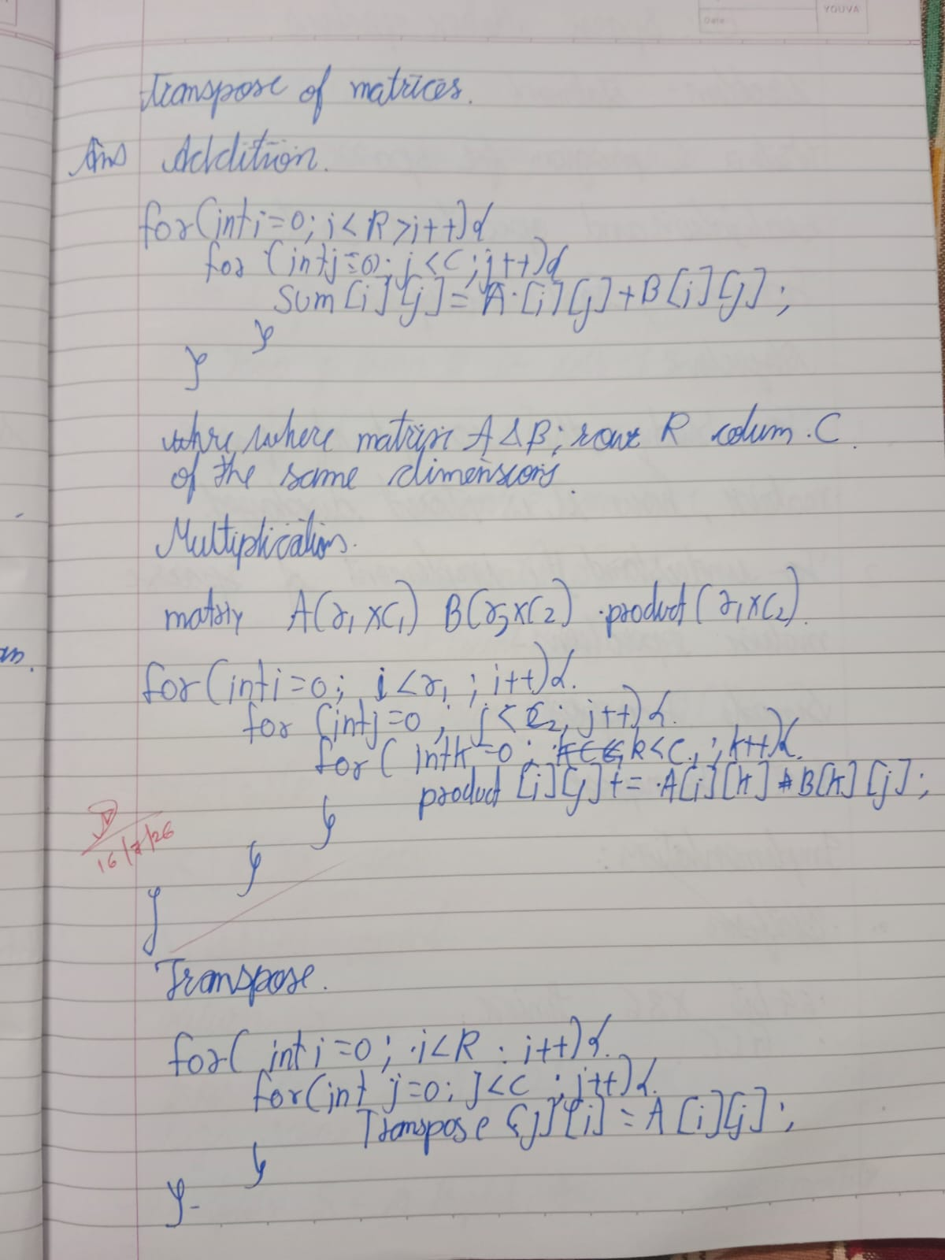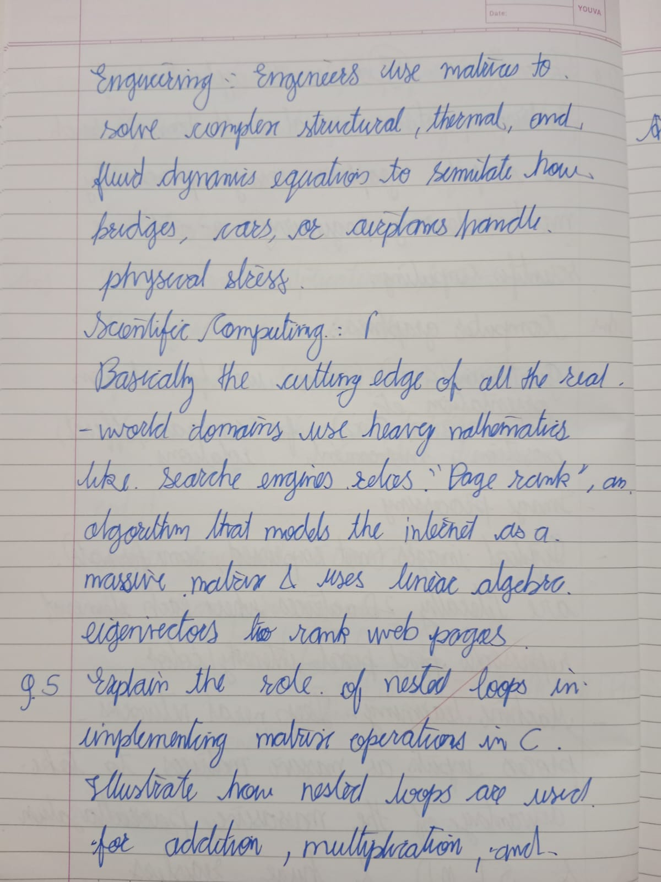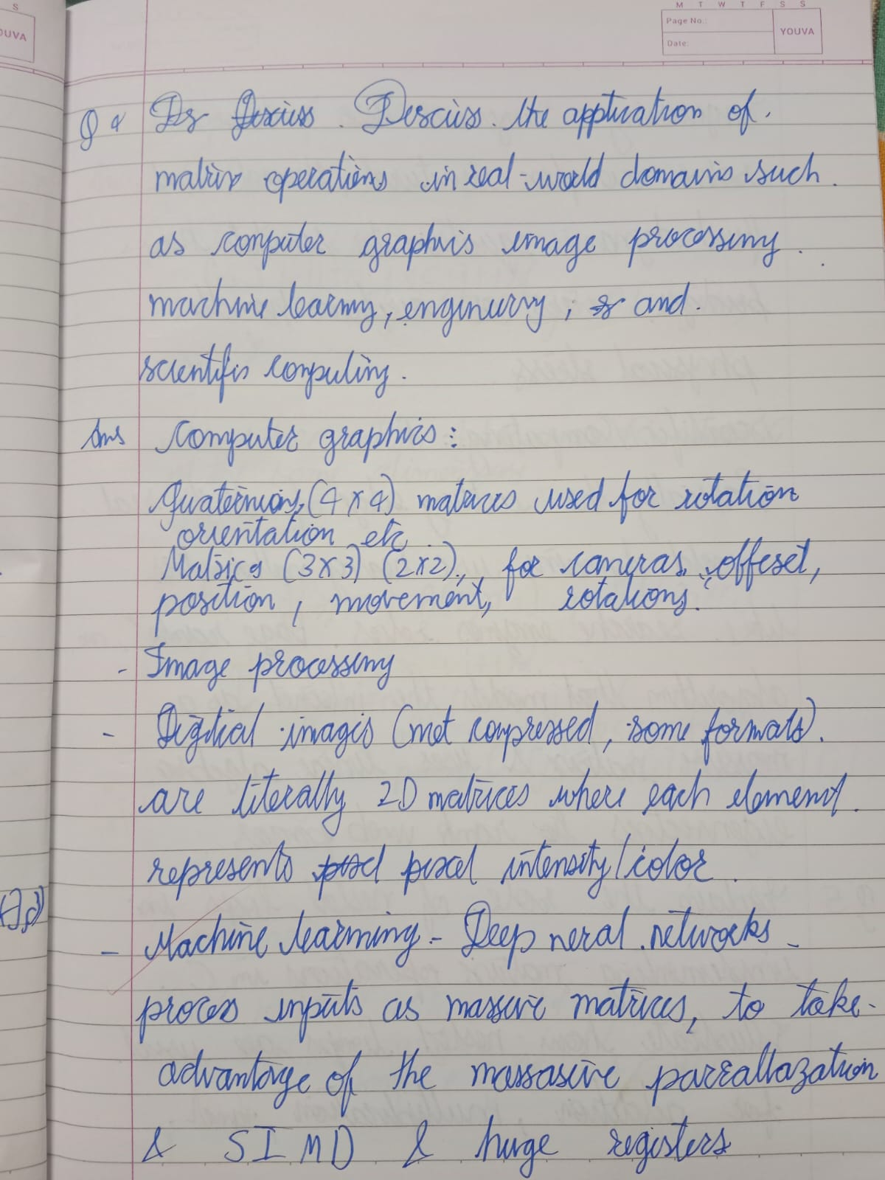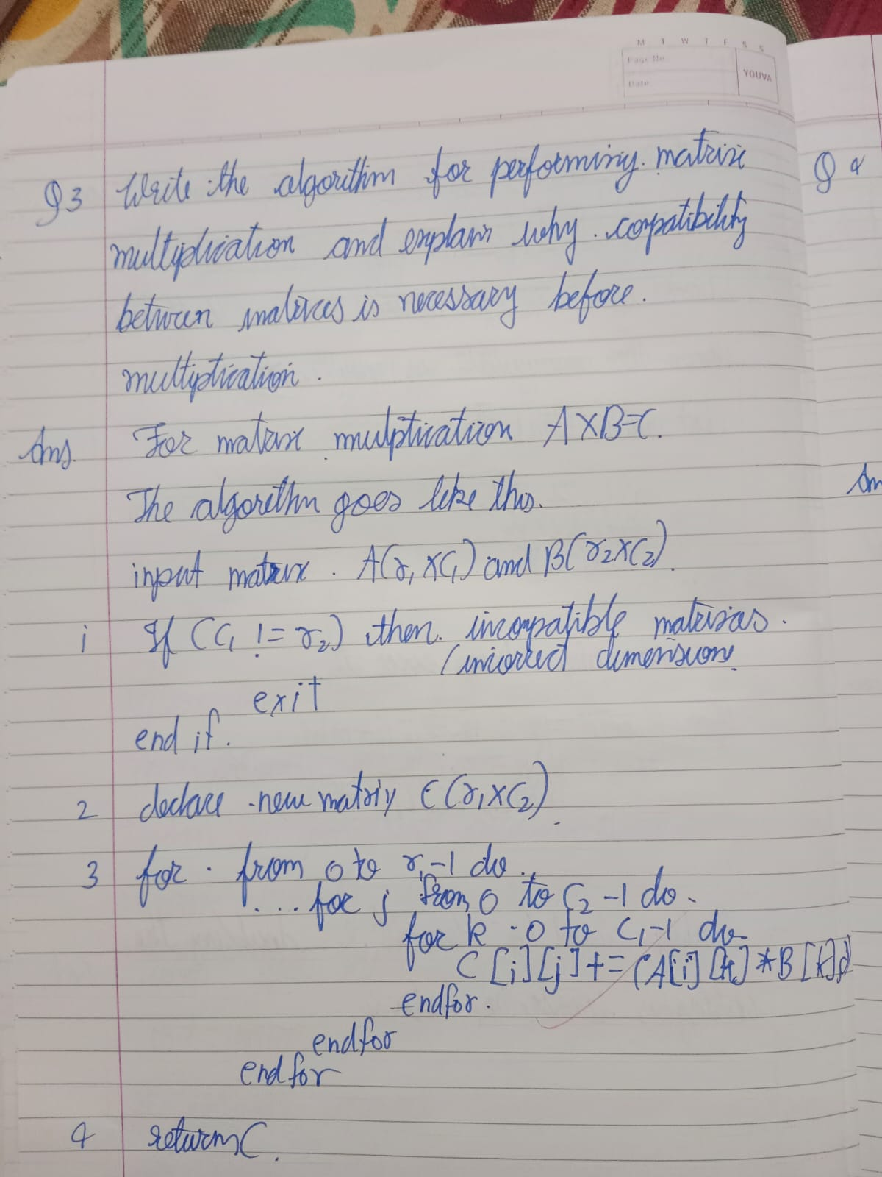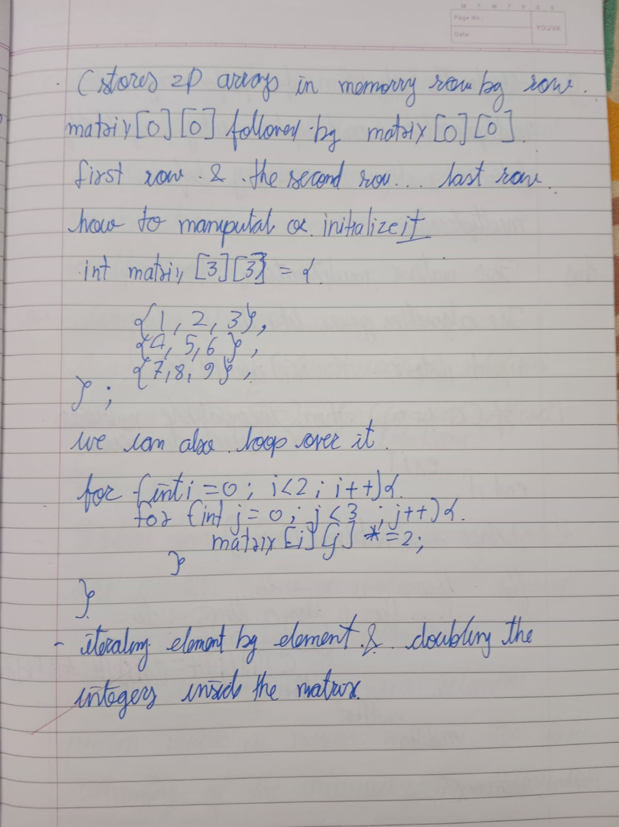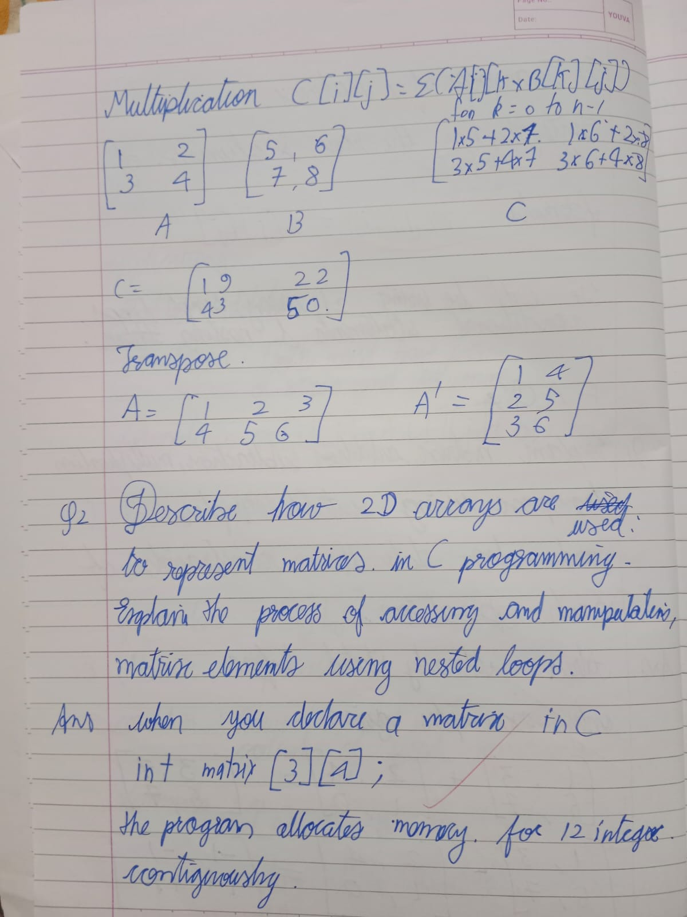
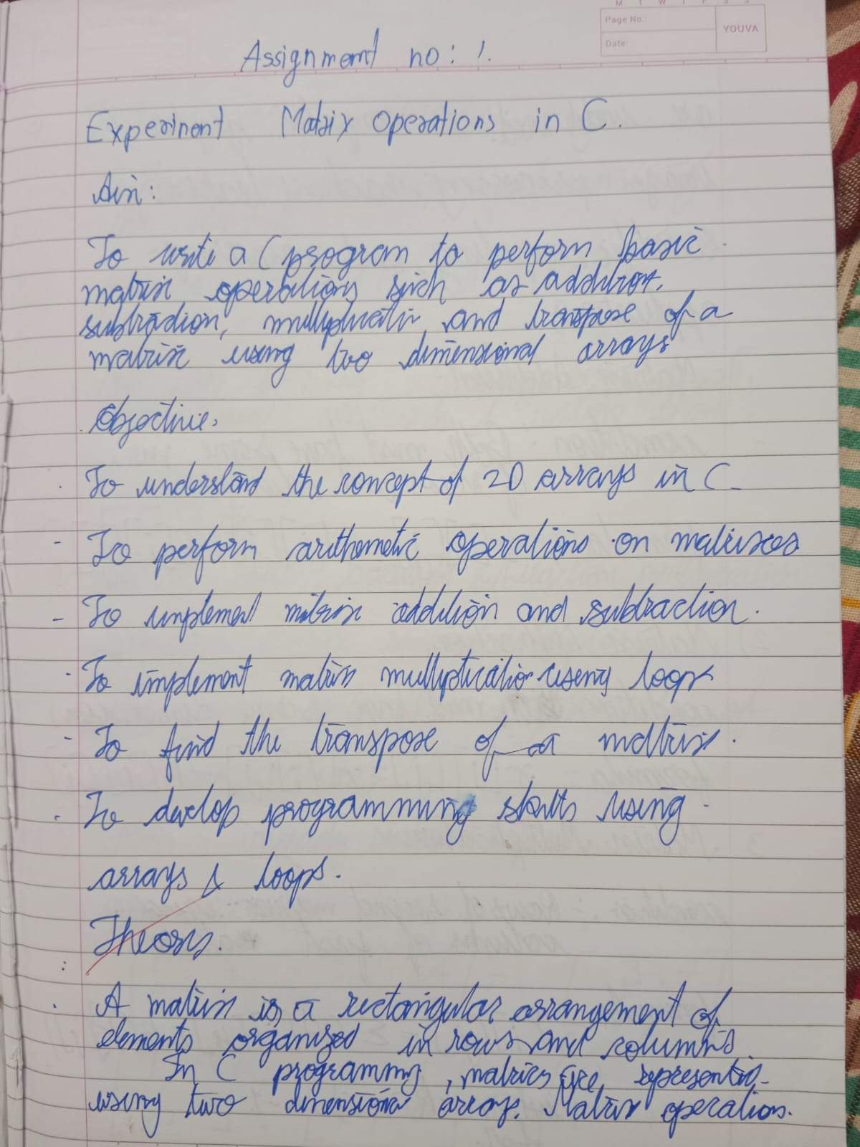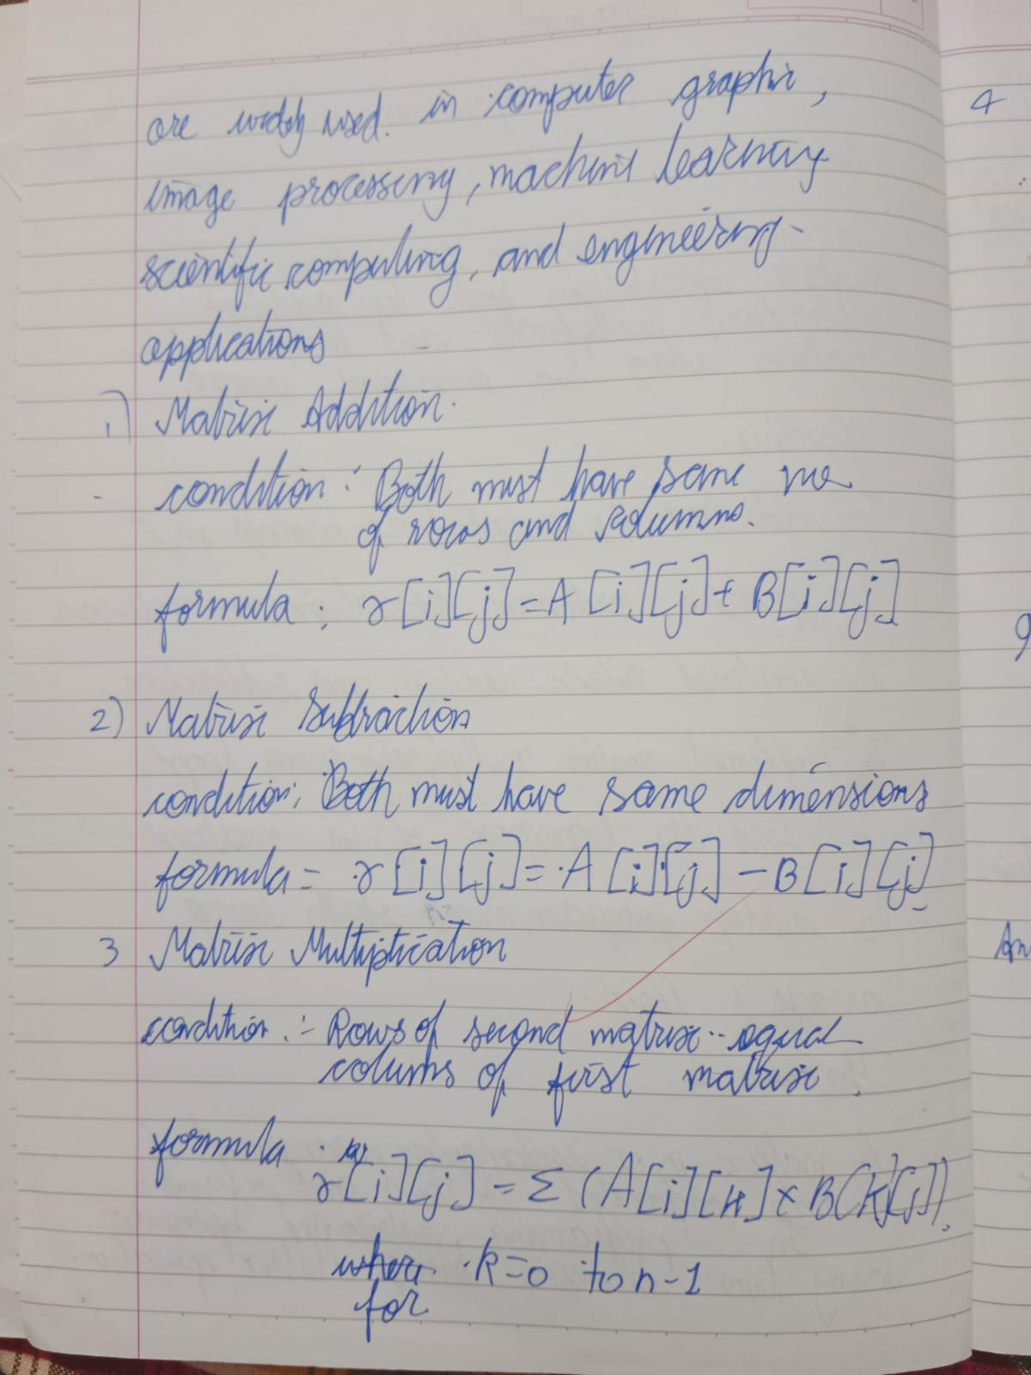
#include <stdio.h>
#include <stdlib.h>
#include <string.h>
#include <ctype.h>
#include <stdbool.h>

#define MAX_ROWS 10
#define MAX_COLS 10

typedef struct matrix {
int rows;
int cols;
int data[MAX_ROWS][MAX_COLS];
} matrix;

typedef enum {
MENU_INPUT_A = 1,
MENU_INPUT_B,
MENU_PRINT,
MENU_ADD,
MENU_SUBTRACT,
MENU_MULTIPLY,
MENU_TRANSPOSE_A,
MENU_TRANSPOSE_B,
MENU_EXIT
} MenuOption;

bool is_alpha_ext(char c) {
return (c >= 'a' && c <= 'z') || (c >= 'A' && c <= 'Z');
}

bool is_allowed_char(char c) {
return isdigit((unsigned char)c) || c == '-' || c == '+' || isspace((unsigned char)c);
}

bool is_str_clean(const char *s) {
for (int i = 0; s[i] != '\0'; i++) {
if (is_alpha_ext(s[i]) || !is_allowed_char(s[i])) {
return false;
}
}
return true;
}

bool check_bounds(int val, int min, int max) {
return val >= min && val <= max;
}

bool read_line(char *buf, size_t sz) {
if (fgets(buf, sz, stdin) == NULL) {
clearerr(stdin);
return false;
}
return true;
}

bool parse_int_str(const char *buf, int *res) {
if (!is_str_clean(buf)) {
return false;
}
char dummy;
return sscanf(buf, "%d %c", res, &dummy) == 1;
}

int get_int() {
char buf[256];
int val;
while (1) {
if (read_line(buf, sizeof(buf)) && parse_int_str(buf, &val)) {
return val;
}
printf("Not int.\nRetry: ");
}
}

int get_int_range(int min, int max) {
while (1) {
int val = get_int();
if (check_bounds(val, min, max)) {
return val;
}
printf("Out of range.\nRetry: ");
}
}

matrix input_matrix(const char *name) {
matrix m = {0};
printf("Matrix %s Rows: ", name);
m.rows = get_int_range(1, MAX_ROWS);
printf("Matrix %s Cols: ", name);
m.cols = get_int_range(1, MAX_COLS);

for (int i = 0; i < m.rows; i++) {
for (int j = 0; j < m.cols; j++) {
printf("[%d][%d]: ", i, j);
m.data[i][j] = get_int();
}
}
return m;
}

void print_matrix(const matrix *m, const char *name) {
printf("\n%s (%dx%d):\n", name, m->rows, m->cols);
for (int i = 0; i < m->rows; i++) {
printf(" | ");
for (int j = 0; j < m->cols; j++) {
printf("%6d ", m->data[i][j]);
}
printf("|\n");
}
}

bool matrix_add(const matrix *a, const matrix *b, matrix *res) {
if (a->rows != b->rows || a->cols != b->cols) {
return false;
}
res->rows = a->rows;
res->cols = a->cols;
for (int i = 0; i < a->rows; i++) {
for (int j = 0; j < a->cols; j++) {
res->data[i][j] = a->data[i][j] + b->data[i][j];
}
}
return true;
}

bool matrix_subtract(const matrix *a, const matrix *b, matrix *res) {
if (a->rows != b->rows || a->cols != b->cols) {
return false;
}
res->rows = a->rows;
res->cols = a->cols;
for (int i = 0; i < a->rows; i++) {
for (int j = 0; j < a->cols; j++) {
res->data[i][j] = a->data[i][j] - b->data[i][j];
}
}
return true;
}

bool matrix_multiply(const matrix *a, const matrix *b, matrix *res) {
if (a->cols != b->rows) {
return false;
}
res->rows = a->rows;
res->cols = b->cols;
for (int i = 0; i < a->rows; i++) {
for (int j = 0; j < b->cols; j++) {
res->data[i][j] = 0;
for (int k = 0; k < a->cols; k++) {
res->data[i][j] += a->data[i][k] * b->data[k][j];
}
}
}
return true;
}

matrix matrix_transpose(const matrix *m) {
matrix res = {0};
res.rows = m->cols;
res.cols = m->rows;
for (int i = 0; i < m->rows; i++) {
for (int j = 0; j < m->cols; j++) {
res.data[j][i] = m->data[i][j];
}
}
return res;
}

int main(void) {
matrix mat_a = {0}, mat_b = {0}, result = {0};
bool has_a = false, has_b = false, running = true;

while (running) {
printf("\n1.InA 2.InB 3.Print 4.Add 5.Sub 6.Mul 7.TrA 8.TrB 9.Exit\nPick: ");
MenuOption choice = (MenuOption)get_int_range(1, 9);

switch (choice) {
case MENU_INPUT_A:
mat_a = input_matrix("A");
has_a = true;
break;

case MENU_INPUT_B:
mat_b = input_matrix("B");
has_b = true;
break;

case MENU_PRINT:
if (!has_a && !has_b) {
printf("Empty.\n");
} else {
if (has_a) print_matrix(&mat_a, "Matrix A");
if (has_b) print_matrix(&mat_b, "Matrix B");
}
break;

case MENU_ADD:
if (!has_a || !has_b) {
printf("Empty.\n");
} else if (matrix_add(&mat_a, &mat_b, &result)) {
print_matrix(&result, "A + B");
} else {
printf("Dim mismatch.\n");
}
break;

case MENU_SUBTRACT:
if (!has_a || !has_b) {
printf("Empty.\n");
} else if (matrix_subtract(&mat_a, &mat_b, &result)) {
print_matrix(&result, "A - B");
} else {
printf("Dim mismatch.\n");
}
break;

case MENU_MULTIPLY:
if (!has_a || !has_b) {
printf("Empty.\n");
} else if (matrix_multiply(&mat_a, &mat_b, &result)) {
print_matrix(&result, "A * B");
} else {
printf("Dim mismatch.\n");
}
break;

case MENU_TRANSPOSE_A:
if (!has_a) {
printf("Empty.\n");
} else {
result = matrix_transpose(&mat_a);
print_matrix(&result, "Transpose A");
}
break;

case MENU_TRANSPOSE_B:
if (!has_b) {
printf("Empty.\n");
} else {
result = matrix_transpose(&mat_b);
print_matrix(&result, "Transpose B");
}
break;

case MENU_EXIT:
running = false;
break;
}
}
return 0;
}
