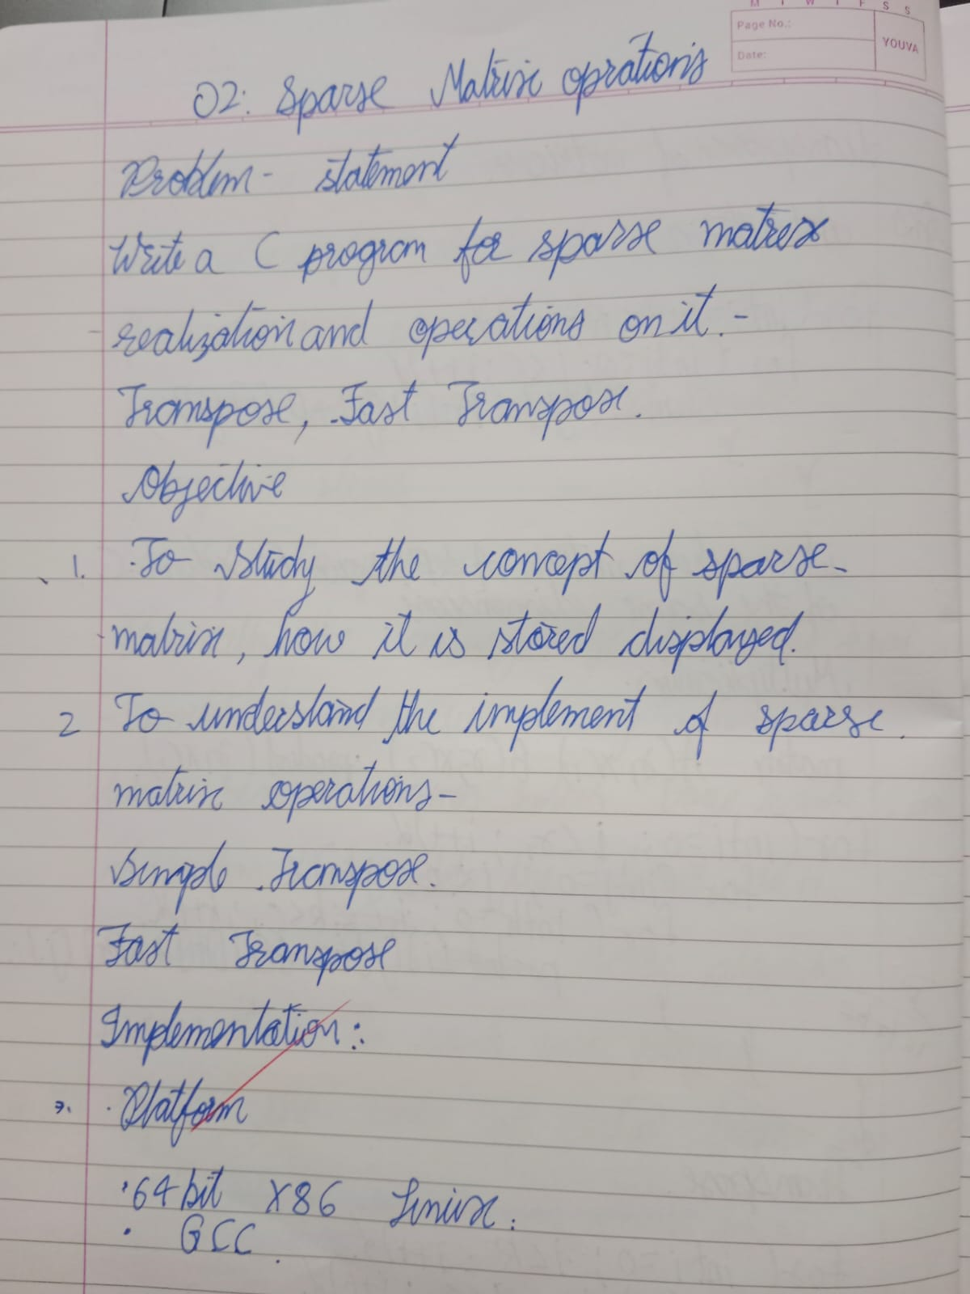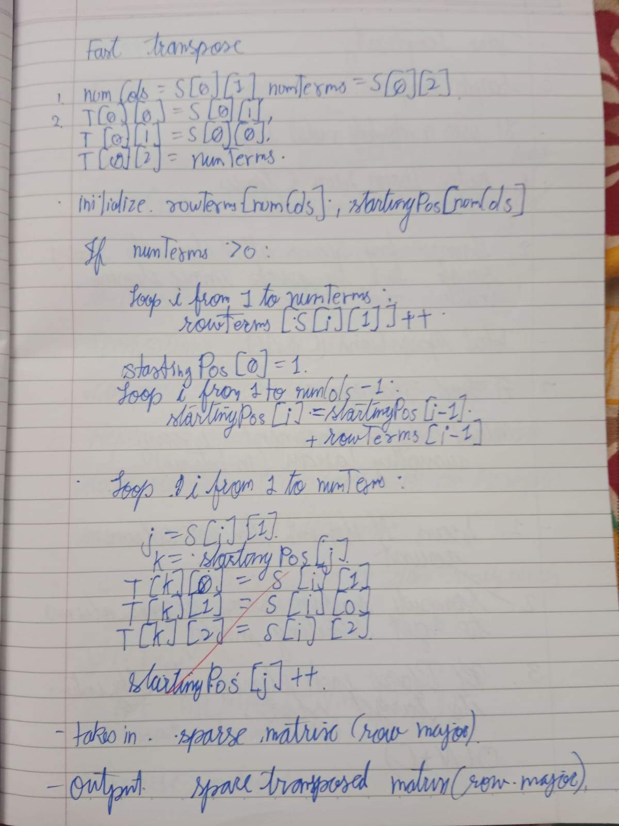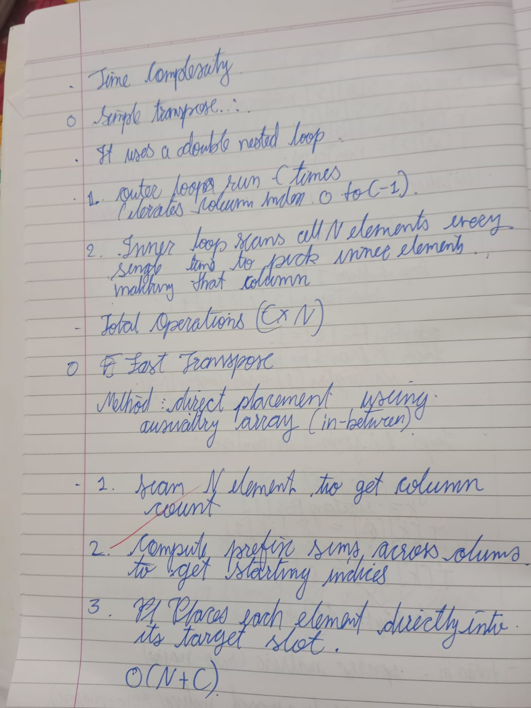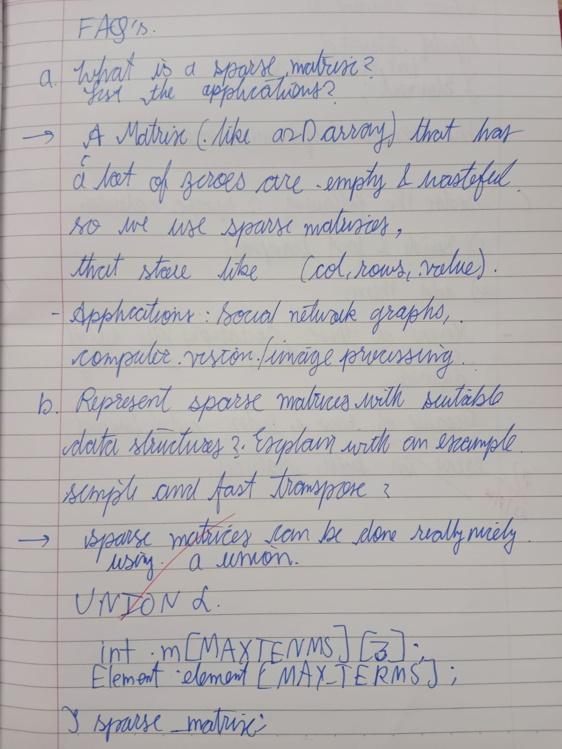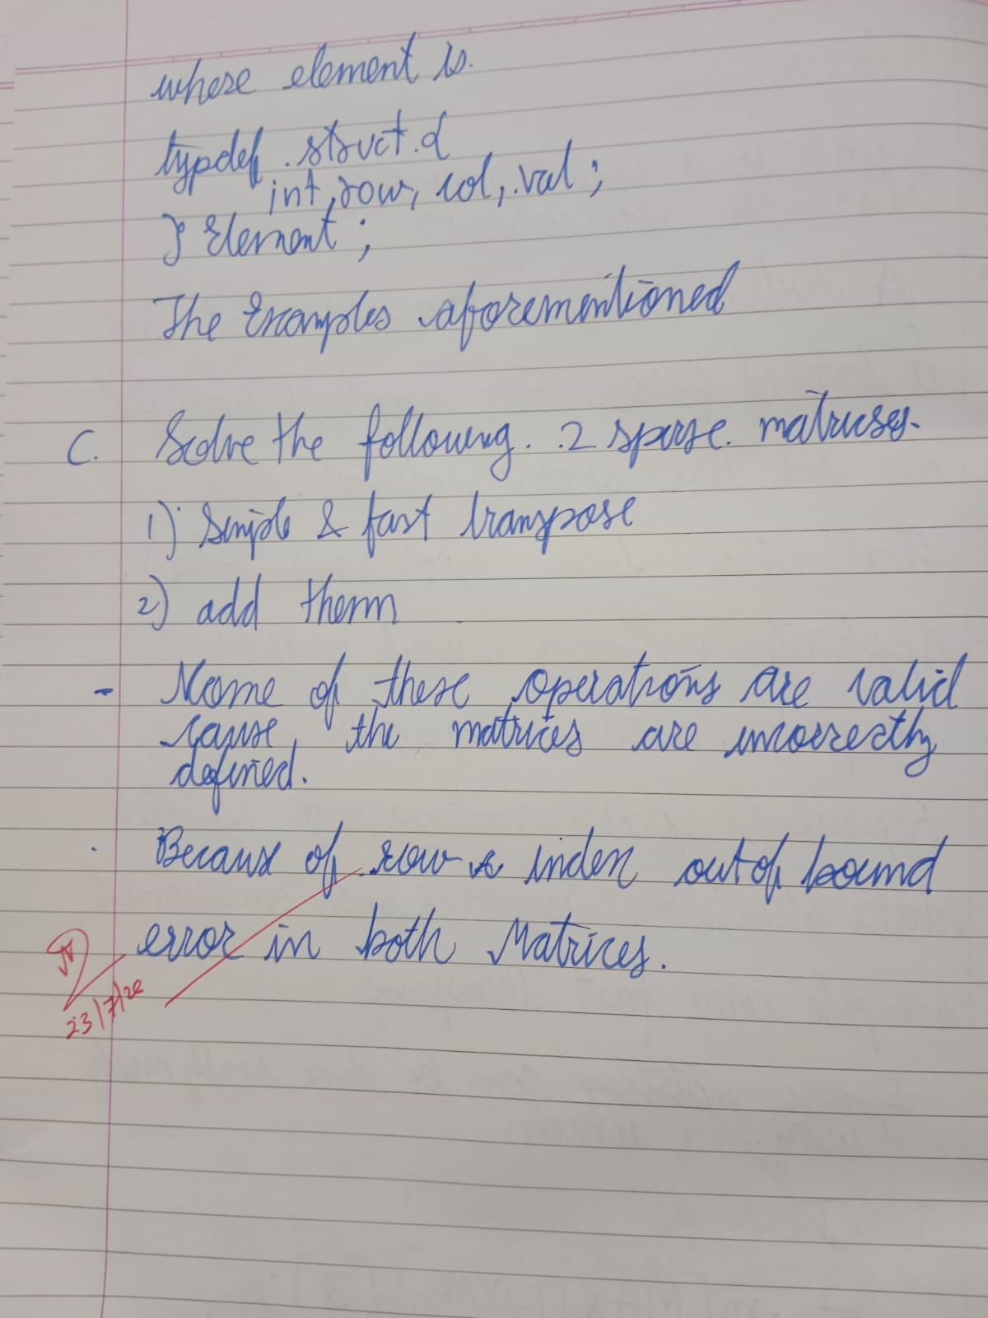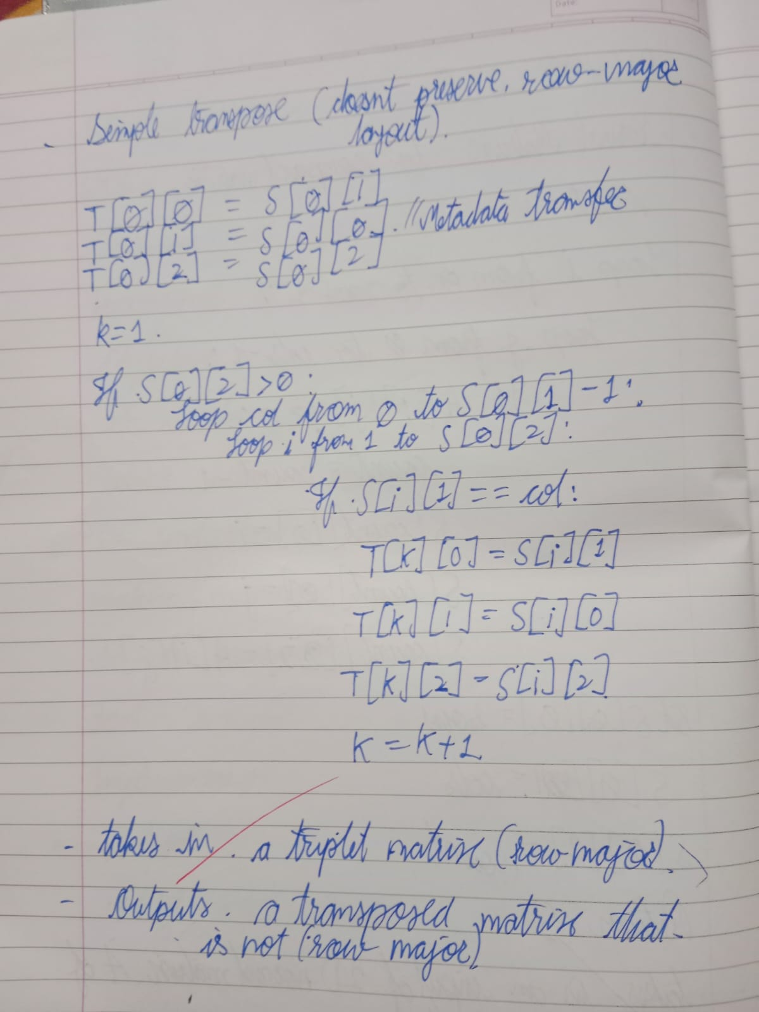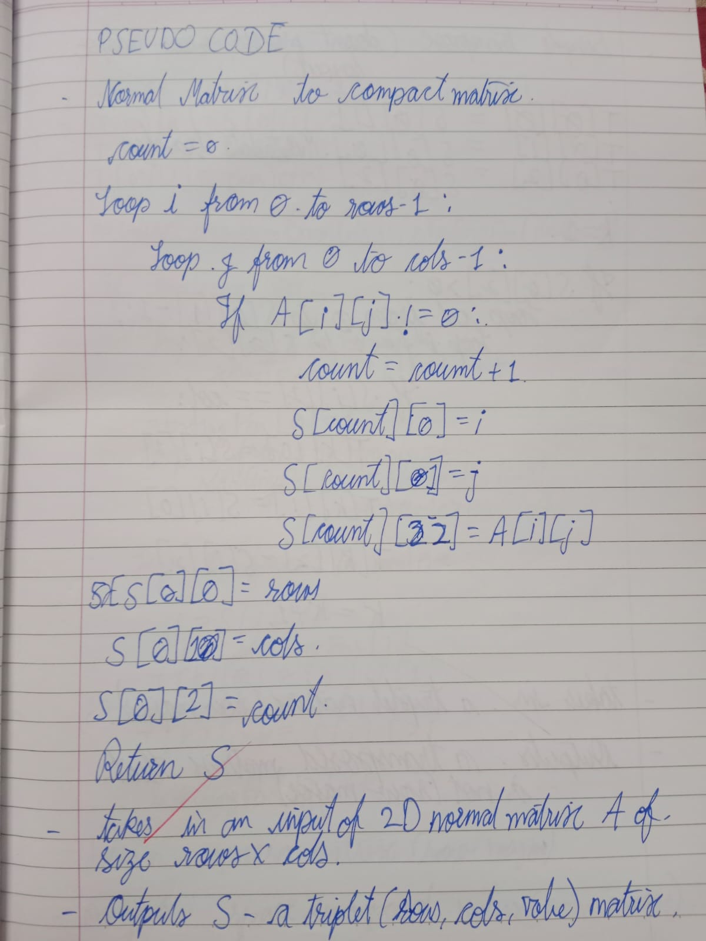
#include <ctype.h>
#include <stdbool.h>
#include <stdio.h>
#include <stdlib.h>
#include <string.h>

#define MAX_TERMS 101

typedef struct {
int row;
int col;
int val;
} Element;

typedef union {
int m[MAX_TERMS][3];
Element data[MAX_TERMS];
} SparseMatrix;

typedef enum { INPUT = 1, DISPLAY, SIMPLE, FAST, EXIT } MenuOption;

bool is_alpha_ext(char c) { return (c >= 'a' && c <= 'z') || (c >= 'A' && c <= 'Z'); }

bool is_allowed_char(char c) { return isdigit((unsigned char)c) || c == '-' || c == '+' || isspace((unsigned char)c); }

bool is_str_clean(const char *s) {
for (int i = 0; s[i] != '\0'; i++) {
if (is_alpha_ext(s[i]) || !is_allowed_char(s[i])) {
return false;
}
}
return true;
}

bool check_bounds(int val, int min, int max) { return val >= min && val <= max; }

bool check_coords(int r, int c, int max_r, int max_c) { return check_bounds(r, 0, max_r - 1) && check_bounds(c, 0, max_c - 1); }

bool read_line(char *buf, size_t sz) {
if (fgets(buf, sz, stdin) == NULL) {
clearerr(stdin);
return false;
}
return true;
}

bool parse_int_str(const char *buf, int *res) {
if (!is_str_clean(buf)) {
return false;
}
char dummy;
return sscanf(buf, "%d %c", res, &dummy) == 1;
}

bool parse_triplet_str(const char *buf, int *a, int *b, int *c) {
if (!is_str_clean(buf)) {
return false;
}
char dummy;
return sscanf(buf, "%d %d %d %c", a, b, c, &dummy) == 3;
}

int get_int() {
char buf[256];
int val;
while (1) {
if (read_line(buf, sizeof(buf)) && parse_int_str(buf, &val)) {
return val;
}
printf("Not int.\nRetry: ");
}
}

int get_int_range(int min, int max) {
while (1) {
int val = get_int();
if (check_bounds(val, min, max)) {
return val;
}
printf("Out of range.\nRetry: ");
}
}

void get_three_ints(int *a, int *b, int *c) {
char buf[256];
while (1) {
if (read_line(buf, sizeof(buf)) && parse_triplet_str(buf, a, b, c)) {
return;
}
printf("Need 3 ints.\nRetry: ");
}
}

void input_matrix(SparseMatrix *sm) {
printf("Rows: ");
sm->data[0].row = get_int_range(1, 100);
printf("Cols: ");
sm->data[0].col = get_int_range(1, 100);
printf("Non-zero: ");
sm->data[0].val = get_int_range(0, MAX_TERMS - 1);

for (int i = 1; i <= sm->data[0].val; i++) {
printf("R C V for term %d: ", i);
while (1) {
int r, c, v;
get_three_ints(&r, &c, &v);
if (check_coords(r, c, sm->data[0].row, sm->data[0].col)) {
sm->data[i].row = r;
sm->data[i].col = c;
sm->data[i].val = v;
break;
}
printf("Bad R/C.\nRetry R C V: ");
}
}
}

void display(SparseMatrix *sm) {
printf("R\tC\tV\n");
for (int i = 0; i <= sm->data[0].val; i++) {
printf("%d\t%d\t%d\n", sm->data[i].row, sm->data[i].col, sm->data[i].val);
}
}

void simple_transpose(SparseMatrix *sm, SparseMatrix *tm) {
tm->data[0].row = sm->data[0].col;
tm->data[0].col = sm->data[0].row;
tm->data[0].val = sm->data[0].val;

if (sm->data[0].val > 0) {
int q = 1;
for (int c = 0; c < sm->data[0].col; c++) {
for (int p = 1; p <= sm->data[0].val; p++) {
if (sm->data[p].col == c) {
tm->data[q].row = sm->data[p].col;
tm->data[q].col = sm->data[p].row;
tm->data[q].val = sm->data[p].val;
q++;
}
}
}
}
}

void fast_transpose(SparseMatrix *sm, SparseMatrix *tm) {
int row_terms[100] = {0};
int starting_pos[100] = {0};

tm->data[0].row = sm->data[0].col;
tm->data[0].col = sm->data[0].row;
tm->data[0].val = sm->data[0].val;

if (sm->data[0].val > 0) {
for (int i = 1; i <= sm->data[0].val; i++) {
row_terms[sm->data[i].col]++;
}
starting_pos[0] = 1;
for (int i = 1; i < sm->data[0].col; i++) {
starting_pos[i] = starting_pos[i - 1] + row_terms[i - 1];
}
for (int i = 1; i <= sm->data[0].val; i++) {
int j = starting_pos[sm->data[i].col]++;
tm->data[j].row = sm->data[i].col;
tm->data[j].col = sm->data[i].row;
tm->data[j].val = sm->data[i].val;
}
}
}

int main() {
SparseMatrix sm, tm;
bool loaded = false;
bool running = true;

while (running) {
printf("\n1.Input 2.Display 3.Simple 4.Fast 5.Exit\nPick: ");
MenuOption choice = (MenuOption)get_int_range(1, 5);

switch (choice) {
case INPUT:
input_matrix(&sm);
loaded = true;
break;
case DISPLAY:
if (!loaded)
printf("Empty.\n");
else
display(&sm);
break;
case SIMPLE:
if (!loaded)
printf("Empty.\n");
else {
simple_transpose(&sm, &tm);
display(&tm);
}
break;
case FAST:
if (!loaded)
printf("Empty.\n");
else {
fast_transpose(&sm, &tm);
display(&tm);
}
break;
case EXIT:
running = false;
break;
}
}
return 0;}
