
OBJECT ORIENTED PROGRAMMING USING C++
MINI PROJECT REPORT
Project Title: Hive Race: High-Performance Multi-Agent Pathfinding Simulation (Baseline A* vs. Grid Boids)
Group ID:______
PROJECT TEAM MEMBERS
PRN Number | Student Name
1262251650 | Mayank Gaikwad
1262250804 | Shashant Vairamuthu
1262251929 | Rohit Nukala
1262251978 | Henin Rio M
Under the Guidance of
Dr. Vinayak Musale and Dr. Mugdha Joshi
Department of Computer Engineering and Technology
Dr. Vishwanath Karad MIT World Peace University, Pune – 411 038
Maharashtra, India
Academic Year 2026–2027

CERTIFICATE
DEPARTMENT OF COMPUTER ENGINEERING AND TECHNOLOGY
This is to certify that
PRN Number | Student Name
1262251650 | Mayank Gaikwad
1262250804 | Shashant Vairamuthu
1262251929 | Rohit Nukala
1262251978 | Henin Rio M
students of Second Year B. Tech. Computer Science and Engineering (Cybersecurity and Forensics), have completed the mini project entitled "Hive Race: High-Performance Multi-Agent Pathfinding Simulation (Baseline A* vs. Grid Boids)" and submitted this report as part of the requirements for the course CSF20210: Object Oriented Programming Laboratory during the academic year 2026–2027.
Date: / /
Place: Pune
Dr. Vinayak Musale
Course Teacher
Department of Computer Engg. and Tech.
MIT WPU, Pune

ACKNOWLEDGEMENT
We express our sincere gratitude to our course teachers, Dr. Vinayak Musale and Dr. Mugdha Joshi for guidance, timely feedback and encouragement throughout the Object Oriented Programming Laboratory course. We thank the Department of Computer Engineering and Technology and Dr. Vishwanath Karad MIT World Peace University, Pune, for the laboratory facilities and academic environment that made this work possible. We also acknowledge the authors and maintainers of SDL3, Dear ImGui, Meson ,LLVM and all the other underlying projects and dependencies whose tools/project underpin the project, and our classmates and families for their support.
Student Names
Henin Rio M
Mayank Gaikwad
Rohit Nukala
Shashant Vairamuthu
Group ID: _______
Date: / /
ABSTRACT
Coordinating hundreds of warehouse robots on a shared grid is limited less by robot speed than by traffic: shortest routes overlap, robots block one another, and replanning cascades follow. This project builds Hive Race, a deterministic simulator in C++20 that runs two decentralized controllers in lockstep on identical, seeded workloads. The Baseline combines shortest-path search with strict cell reservations. The Flagship adapts flocking rules (separation, alignment, cohesion) to the grid through crowd-weighted costs, self-organizing one-way lanes, platooning through intersections and look-ahead sidesteps. The engine allocates from virtual-memory arenas with memory-error instrumentation, searches with an epoch-cleared flat-array priority queue, renders through one batched, supersampled draw call, and separates simulation from display with a fixed-timestep accumulator. Classes, inheritance, abstract interfaces, virtual dispatch and templates structure the subsystems. Benchmarks show that the Flagship completes the same orders considerably sooner, with far less waiting, rerouting and deadlock recovery, while travelling only slightly farther.
Keywords: multi-agent pathfinding, warehouse robotics, boids, arena allocator, deterministic simulation, C++20
TABLE OF CONTENTS
CERTIFICATE 2
ACKNOWLEDGEMENT i
LIST OF FIGURES v
LIST OF TABLES vi
CHAPTER 1: INTRODUCTION 1
1.1 Background and Motivation 1
1.2 Problem Statement 2
1.3 Objectives 2
1.4 Scope and Limitations 3
1.5 Report Organisation 3
CHAPTER 2: PROBLEM DEFINITION AND OBJECTIVES 4
2.1 Problem Definition 4
2.2 Existing System and Its Limitations 4
2.3 Proposed Solution 5
2.4 Functional and Non-Functional Requirements 6
2.5 Theoretical Background 7
CHAPTER 3: REQUIREMENTS, TOOLS AND TECHNOLOGIES 11
3.1 Hardware Requirements 11
3.2 Software Requirements 11
3.3 Programming Language and Technologies 11
3.4 Development Environment 12
CHAPTER 4: SYSTEM DESIGN AND ARCHITECTURE 14
4.1 System Architecture 14
4.2 Flowcharts and Process Diagrams 16
4.3 Class Diagram and Object-Oriented Design 19
4.4 Data Design 20
CHAPTER 5: IMPLEMENTATION AND USER INTERFACE 23
5.1 Module Description 23
5.2 Key Implementation Details 28
5.3 User Interface and Screenshots 33
5.4 Object-Oriented Programming Concepts Used 35
5.5 Sample Input and Output 36
CHAPTER 6: METHODOLOGY 38
6.1 Development Approach 38
6.2 Workflow and Process 38
6.3 Module Integration 39
CHAPTER 7: ALGORITHMS AND TESTING 40
7.1 Algorithms and Pseudocode 40
7.2 Test Plan and Test Cases 41
7.3 Benchmarking 42
CHAPTER 8: CONCLUSION AND FUTURE SCOPE 47
8.1 Conclusion 47
8.2 Limitations 48
8.3 Future Scope 48
REFERENCES 50
APPENDICES 52
Appendix A: Mermaid Source for Diagrams 52
Appendix B: Configuration Parameter Reference 52
Appendix C: Glossary and Abbreviations 53

To refresh page numbers in Word: right-click the table, choose Update Field, then Update entire table (or press F9).

LIST OF FIGURES
Figure 1.1: Simulated grid: parking bays (P), operating bots (B), staged crates (C), drop-off stations (S1 to S8). 1
Figure 4.1: High-level architecture: main loop, memory subsystem, lockstep simulation pair, rendering and telemetry. 14
Figure 4.2: Layered architecture of the application. 14
Figure 4.3: Ownership and data flow. 15
Figure 4.4: Baseline decision flow when a bot approaches its next cell. 16
Figure 4.5: Composition of the Flagship step cost: base, separation, alignment, kinematics; cohesion handled in ~CanEnter~. 16
Figure 4.6: Bot state machine. 17
Figure 4.7: Render pipeline: batching, supersampled off-screen pass, downsample, overlay. 18
Figure 4.8: Class hierarchy: abstract Controller and its two policies, abstract UiPanel, Vec2 and the template family. 19
Figure 4.9: Controller class diagram as implemented, with the Flagship's private flow and crowd tables. 19
Figure 4.10: Entity-relationship layout of the simulation data architecture. 20
Figure 4.11: Arena address space: reserved range, committed prefix and allocation cursor. 21
Figure 4.12: A fragmented heap compared with a contiguous arena committing pages sequentially. 22
Figure 5.1: Speed profile over four cells: accelerate, cruise, brake for a corner, re-accelerate, stop (illustrative). 25
Figure 5.2: A 5x5 crowd window (R = 2) around a candidate cell; the cost term grows with the square of the count inside it. 26
Figure 5.3: Deadlock-resolution escalation ladder. 26
Figure 5.4: Frame-rate dependence of naive interpolation (left) versus exponential smoothing (right); illustrative. 27
Figure 5.5: Split-screen lockstep simulation, Baseline fleet (left) and Flagship fleet (right) under one seed. 34
Figure 5.6: Congestion heat map and polarized lanes in the Flagship fleet. 34
Figure 5.7: Interactive bot telemetry and spatial inspector. 34
Figure 5.8: Post-race comparison dialog. 35
Figure 5.9: Run panel showing experiment parameters. 35
Figure 5.10: Kinematics panel. 35
Figure 7.1: Key metrics for the Baseline and the Flagship. 44

LIST OF TABLES
Table 1.1: Objectives and success criteria 2
Table 1.2: Report organisation 3
Table 2.1: Families of MAPF solutions (the project compares the third and fourth) 4
Table 2.2: Failure modes of discrete reservation routing 5
Table 2.3: Problems and the mechanisms that address them 5
Table 2.4: Functional requirements 6
Table 2.5: Non-functional requirements 6
Table 2.6: Coffman conditions applied to the warehouse grid 7
Table 2.7: Reynolds' rules and their grid adaptation 8
Table 2.8: Heap versus arena 8
Table 2.9: Where each mechanism comes from 9
Table 3.1: Hardware requirements 11
Table 3.2: Software stack 11
Table 3.3: Operating-system primitives used by the arena 12
Table 3.4: Source-file map 12
Table 4.1: Bot states and transitions 17
Table 4.2: Classes and responsibilities (OOP concepts are mapped in Section 5.4) 19
Table 4.3: Zero-is-initialization 21
Table 4.4: Principal data structures 21
Table 5.1: Modules and their interfaces 23
Table 5.2: Arena cost model 23
Table 5.3: Failure handling by status codes 32
Table 5.4: Hive Race versus conventional C++ practice 32
Table 5.5: Principal controls 33
Table 5.6: Screenshot placement guide (Figure numbers refer to the placeholders below) 33
Table 5.7: OOP concepts and their realization 35
Table 5.8: Sample input record (to be completed) 37
Table 5.9: Sample output record (to be completed; comparative figures are collected in Section 7.3) 37
Table 6.1: Module interfaces 39
Table 7.1: Complexity comparison 41
Table 7.2: Test cases (Actual and Status columns to be completed) 41
Table 7.3: Benchmark configuration (to be completed) 42
Table 7.4: Evaluation metrics 43
Table 7.5: Baseline versus Flagship (observed columns to be completed) 43
Table 7.6: Mapping of mechanisms to metrics 45
Table 7.7: Consistency check (to be completed) 45
Table 7.8: Proposed extended evaluation (Outcome to be completed) 46
Table 8.1: Summary of contributions 47
Table 8.2: Future scope 48
Table 8.3: Principal configuration parameters 52
Table 8.4: Glossary 53

CHAPTER 1: INTRODUCTION
Hive Race is a deterministic, lockstep simulator that pits two decentralized fleet-control strategies against each other inside a dense robotic fulfilment warehouse: a conventional reservation-based A* router (Baseline) and a swarm-inspired Grid Boids controller (Flagship). It is written in C++20 and combines object-oriented structure (abstract controllers, inheritance, virtual dispatch, templates) with data-oriented, allocation-free internals.

1.1 Background and Motivation
Online retail has shifted warehouses from people walking to shelves towards goods-to-person automation, in which robots bring inventory to fixed stations. Mobile-drive-unit systems such as Kiva [1] slide robots beneath movable shelves, while grid-based Automated Storage and Retrieval Systems (ASRS, or "hives") run robots along rails above stacked bins. Either way, hundreds of robots share scarce floor or rail space. Routes that are cheap for one robot become expensive when everyone uses them at once, so for a fixed fleet, throughput is bounded by traffic coordination, not by robot speed.
The simulated warehouse is an orthogonal grid. Perimeter cells act as drop-off stations, corners hold parking bays, and interior cells hold pickable crates. Every delivery ends on the station row, so the aisles leading to it behave as funnels, the same geometry that makes real hives hard to coordinate.
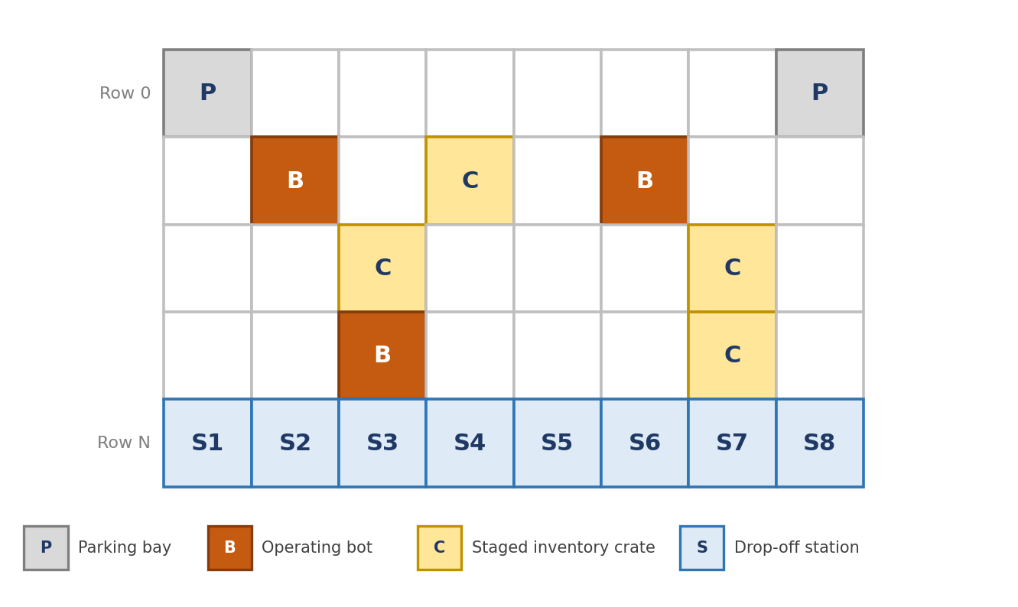
Figure 1.1: Simulated grid: parking bays (P), operating bots (B), staged crates (C), drop-off stations (S1 to S8).
A second motivation is methodological. Comparisons of routing policies are easily polluted by implementation noise: allocator stalls, unspecified tie-breaking, frame-rate-dependent physics and uncontrolled randomness. Hive Race therefore engineers those sources out, so that a difference in outcome is attributable to the routing policy alone.

1.2 Problem Statement
Design, implement and evaluate a decentralized traffic controller for a grid-based warehouse fleet that (a) eliminates head-on deadlocks and intersection bottlenecks, (b) maximizes delivery throughput, and (c) relies only on local information and cheap incremental decisions, without dynamic global space-time re-planning. The controller must be compared against a classical reservation-based baseline under identical, reproducible conditions, on an engine that avoids runtime heap allocation.

1.3 Objectives
- Compare reservation-based A* against emergent Grid Boid coordination on throughput, wait fraction, reroute frequency, deadlock breaks and order latency.
- Guarantee fairness: generate every stochastic input (spawns, crates, stations, Poisson arrivals) once from one 64-bit seed, so both fleets face a byte-identical scenario and any run is exactly reproducible.
- Design a decentralized controller that removes head-on standoffs, intersection stutter and re-planning cascades using only local information.
- Eliminate runtime heap allocation through virtual-memory linear arenas with O(1) allocation and O(1) bulk release.
- Preserve memory safety by integrating AddressSanitizer poisoning into the custom allocator.
- Model physical motion: acceleration, braking and corner-speed limits, finite body size, and just-in-time cell reservation.
- Render efficiently: convert simulation state into vertex and index buffers, submitted in one geometry call at 2x supersampling.
- Decouple simulation from presentation with a banked fixed-timestep accumulator (up to 480 Hz) and temporal interpolation.
- Provide observability: per-bot blocked-cell memory, planned paths, headings, congestion and lane-flow overlays, live parameter tuning and a post-race results dialog.
- Demonstrate object-oriented design where meaningful, while keeping hot data paths cache-friendly.
Table 1.1: Objectives and success criteria
Objective area | Success criterion (verified in Chapter 7)
Fairness | Both fleets start from identical scenario data; the controller object is the only difference
Throughput | Flagship finishes the shared workload in less mission time than the Baseline
Robustness | Deadlock breakouts and global re-routes fall markedly under the Flagship
Efficiency | Mean tick time does not rise; ideally it falls as re-planning falls
Memory discipline | No heap allocation in the simulation core; scenario rebuild is O(1)
Determinism | Same seed reproduces the same outcome and identical A* paths
Observability | Behaviour can be inspected live without pausing the simulation

1.4 Scope and Limitations
- The floor is an orthogonal, four-connected grid; a cell is owned by at most one bot at a time.
- Both fleets share kinematics, action timers, order logic and reservation rules; the controller is the only independent variable.
- Workloads are an initial backlog followed by Poisson arrivals. Spawns, crates and stations are fixed by the seed.
- The simulation is single-threaded and deterministic; wall-clock time influences rendering only, never outcomes.
- Intended users: students and researchers comparing routing policies, who need reproducible runs and live inspection.
- Out of scope: energy and battery state, payload mass effects, hardware faults, continuous-space collision geometry. Remaining limitations are listed in Section 8.2.

1.5 Report Organisation
Table 1.2: Report organisation
Chapter | Contents
2 | Problem definition, existing approaches and their failure modes, proposed solution, requirements, theoretical background
3 | Hardware, software, language and build environment
4 | Architecture, flow diagrams, class design and data design
5 | Modules, key implementation details, user interface, OOP concepts used, sample input and output
6 | Development approach, workflow and module integration
7 | Algorithms, complexity, test plan and benchmarking
8 | Conclusion, limitations and future scope

CHAPTER 2: PROBLEM DEFINITION AND OBJECTIVES
This chapter formalizes the coordination problem, surveys the families of solutions, and states what the proposed system must satisfy. Section 2.5 collects the theory that the later chapters rely on.

2.1 Problem Definition
Fleet coordination is an instance of Multi-Agent Pathfinding (MAPF)[2]. A graph G = (V, E) has grid cells as vertices and edges between orthogonal neighbours. Each of k agents has a start and goal vertex; per discrete step an agent waits or traverses one edge. A plan is conflict-free if no two agents share a vertex (vertex conflict) or swap along an edge (swap conflict) in one step. Quality is judged by makespan (finish time of the last agent) or sum of costs (total steps of all agents). Optimal conflict-free planning is NP-hard[3]. Warehouses add two complications: the problem is lifelong (new goals arrive continuously)[4], and real robots obey physics, so a plan that is conflict-free on paper fails when execution slips.

Bottlenecks of naive MAPF
- Head-on deadlock. Two agents choosing one bidirectional corridor in opposite directions both stop. Centralized resolution scales poorly; naive decentralized rerouting produces ping-pong loops.
- Station contention. Drop-off rows are natural funnels; reservation models form cascading yield chains that freeze whole sectors.
- Kinematic inefficiency. Treating agents as dimensionless, instantly turning points overestimates throughput; real robots brake for corners and need clearance time.
- Heap and cache thrashing. Object-oriented A* allocates a node per expansion; with 128 bots replanning constantly, fragmentation, pointer chasing and cache misses distort any benchmark of the algorithm itself.

2.2 Existing System and Its Limitations
Table 2.1: Families of MAPF solutions (the project compares the third and fourth)
Approach | Idea | Main limitation
Centralized optimal (e.g. Conflict-Based Search)[5], [6] | Two-level search detects conflicts between plans and adds constraints until a joint plan exists | Worst-case cost grows exponentially with fleet size; plans are brittle when execution deviates
Prioritized / cooperative A*[7] | Agents plan in priority order against a shared reservation table | Incomplete in general; outcome depends on priority order; table must stay consistent
Decentralized reactive (independent A* + local yielding) | Each agent plans alone and resolves conflicts by waiting, yielding or replanning | Agents converge on the same short paths: queues, standoffs and re-plan cascades under density
Swarm / flocking-inspired[8] | Local rules bias paths away from crowds and with the flow of traffic | No optimality guarantee; behaviour depends on tuned weights

The Baseline represents the decentralized reactive family and fails in three systematic ways once occupancy rises:
Table 2.2: Failure modes of discrete reservation routing
Failure mode | Mechanism
Reciprocal space-time blocking | Two agents on opposing paths claim the same cell; if both yield, neither progresses and the standoff spreads to the queue behind
Intersection stutter | A bot must see the target cell fully vacant before moving, ignoring that the leader is already clearing it, so fleets lose speed at every junction
Re-planning explosion | Bots that wait past a threshold run full graph searches simultaneously; the new routes collide with neighbouring corridors, causing oscillation

Threshold behaviour. Congestion is a phase transition: below a critical density independent planning works almost perfectly because bots rarely meet; above it each blocked bot becomes an obstacle and delays compound. The project therefore evaluates a dense, funnel-shaped layout.

2.3 Proposed Solution
Hive Race attacks the problem at two layers. At the algorithm layer it implements both controllers behind one abstract interface and measures them under identical conditions. The Flagship replaces the constant edge cost with a composite local cost field and adds lane memory, platooning and look-ahead sidesteps. At the systems layer it removes engineering noise: arenas, epoch-cleared A*, deterministic ordering, a fixed timestep and a seeded generator.
Table 2.3: Problems and the mechanisms that address them
Problem | Mechanism in the proposed system
Head-on deadlock | Lane polarization: opposing-flow cost steers traffic into self-organized one-way lanes
Station congestion | Quadratic crowd penalty over a 5x5 window routes trailing bots around clusters
Late reaction | RefineAhead inspects step N+2 and sidesteps without stopping
Intersection stutter | Platooning: followers enter behind a leader that has cleared enough of the cell
Symmetric re-creation of conflicts | Per-bot hash tie-breaker rotates A* neighbour order
Instant-turn assumption | Turn penalty, trapezoidal speed profile, clearance holds
Allocator and reset overhead | Virtual-memory arenas, epoch-cleared A*, flat heap
Non-reproducible runs | SplitMix64 seeding, shared Scenario, three-tier HeapLess

2.4 Functional and Non-Functional Requirements
Table 2.4: Functional requirements
ID | Functional requirement
F1 | Generate one seeded scenario (layout, spawns, crates, stations, Poisson orders) shared by both fleets
F2 | Run Baseline and Flagship warehouses in lockstep with identical time steps
F3 | Route bots with A*; the controller supplies step cost, entry legality and local repair
F4 | Run the bot life-cycle: claim, pick, carry, drop, retreat, idle
F5 | Record per-fleet statistics: orders, clock time, throughput, latency, waits, reroutes, sidesteps, deadlock breaks, distance, tick time
F6 | Render both warehouses with overlays and bot inspectors; allow live parameter changes; declare a winner
F7 | Restart from a new seed without recreating individual objects

Table 2.5: Non-functional requirements
Quality | Non-functional requirement
Determinism | Same seed and parameters reproduce the same result on any machine
Performance | No allocation in the tick loop; simulation sustains hundreds of ticks per second while rendering
Reliability | Failures reported by status codes; routing failure never crashes the run
Memory safety | Out-of-bounds arena access detected in ASAN builds
Usability | Docked panels, hotkeys, click-to-inspect, readable palette (colour-vision-deficiency aware)
Portability | Linux and Windows through direct virtual-memory primitives; Apple platforms rejected at compile time

2.5 Theoretical Background

2.5.1 A* search
A* [9] expands vertices by f(n) = g(n) + h(n), where g is cost so far and h estimates remaining cost. An admissible h (never overestimating) yields optimal paths; a consistent h also limits expansion to once per vertex. Manhattan distance is admissible and consistent on a four-connected unit-cost grid, and stays admissible when penalties are non-negative because every step still costs at least one unit. With a binary heap a search costs O(|V| log |V|) on a grid. Dijkstra [10] is the heuristic-free special case. On grids, many cells tie on f: random tie-breaking wastes expansions and zig-zags, so preferring lower h, then first-in-first-out order, gives straight and reproducible paths.

2.5.2 Reservations in space and time
A reservation table records which agent owns which cell at which time; planning with explicit time inflates the search graph from V to V x T, so practical systems reserve only the next few cells. Just-in-time reservation claims a cell only when needed and releases it as soon as the body leaves, provided the robot keeps enough braking distance to stop before an unreserved cell.

2.5.3 Deadlock, livelock and symmetry
A deadlock needs four simultaneous conditions [11], each with a grid analogue and a breaking mechanism used in this project:
Table 2.6: Coffman conditions applied to the warehouse grid
Coffman condition | Grid analogue | Breaking mechanism
Mutual exclusion | A cell hosts one bot | Cannot be removed (physical)
Hold and wait | Bot holds its cell while requesting the next | Just-in-time reservation; sidestep instead of stopping
No pre-emption | A parked bot cannot be pushed | Vacate requests, forced sidestep
Circular wait | Head-on pair or junction ring | One-way lanes; symmetry breaking

Livelock is thrashing: bots keep replanning around each other without progress. Symmetry causes it: identical code in mirror-image states makes identical choices (both dodge east), recreating the conflict one cell over. The remedy is symmetry breaking through a small deterministic per-agent difference such as a hashed identifier.

2.5.4 Swarm intelligence and boids
Swarm intelligence [12] yields coordinated global behaviour from local rules. Reynolds' boids [8] steer by three rules, adapted here to a discrete grid:
Table 2.7: Reynolds' rules and their grid adaptation
Rule | Continuous meaning | Grid adaptation
Separation | Steer away from crowding | Quadratic crowd cost over a local window plus lateral sidestep
Alignment | Match neighbours' heading | Decaying row and column traffic momentum producing one-way lanes
Cohesion | Move toward neighbours | Platooning of bots with the same drop-off target

Stigmergy, coordination through traces left in the environment, explains the decaying lane momentum: bots deposit momentum, later bots feel it as cost, unused trails evaporate. Lane formation is a documented self-organisation effect in pedestrian flow [13]. Each bot examines a fixed-size neighbourhood, so per-decision work does not grow with fleet size, trading optimality guarantees for bounded local cost.

2.5.5 Memory systems
The operating system maps a private virtual address space to physical pages, allowing a program to reserve address space without consuming memory and commit pages later; fresh pages arrive zero-filled. General-purpose heaps keep headers and free lists, give variable allocation time and fragment over long runs; pointer-linked objects scatter across memory and cause cache misses on 64-byte lines [14]. An arena (region [15]) allocates by bumping one pointer and releases everything at once; aligning to a power of two n uses (a + n - 1) & ~(n - 1).
Table 2.8: Heap versus arena
Property | General-purpose heap | Arena allocator
Allocation cost | Variable (free-list search) | O(1) pointer bump
Release | Per object, any order | All at once or rewind to a mark
Fragmentation | Possible over time | None inside an arena
Locality | Depends on history | Sequential by construction
Metadata | Header per allocation | One header per arena
Best for | Unpredictable lifetimes | Groups of objects with shared lifetime

Data-oriented design [16], [17] organises programs by access pattern: hot data in flat arrays, small pointer-free structures. Zero-is-initialization (ZII) designs every structure so that all-zero bytes are a valid initial state, so fresh pages need no constructor loop. AddressSanitizer [18] keeps shadow memory of valid bytes and exposes manual poison and unpoison calls so a custom allocator can describe its valid slices.

2.5.6 Randomness and arrival processes
Linear congruential generators have weak low-order bits and correlated streams for consecutive seeds. A bit mixer (shifts, XORs, multiplications) with the avalanche property fixes this: SplitMix64 [19] with Stafford’s improved constants [20]; the additive constant 0x9E3779B97F4A7C15 is 2^64 divided by the golden ratio. Multiplicative hashing [21] multiplies a key by a golden-ratio constant to spread consecutive keys, a cheap source of per-agent variation. A Poisson process models independent events at mean rate λ with exponential gaps, sampled by inverse transform [22]: gap = -ln(1 – U) / λ. If arrivals outpace service, the queue grows and measured throughput equals system capacity, which makes a saturated workload a good capacity comparison.

2.5.7 Time steps, kinematics and smoothing
A constant timestep makes the simulation deterministic, and rendering can interpolate between steps [23]. For deceleration d the stopping distance from speed v is v² / (2d). Exponential smoothing solves dP/dt = -λ(P – P_target), giving P(t + Δt) = P_target + (P(t) – P_target)·e^(-λΔt); exponentials compose (stepping a then b equals stepping a + b), so the result is frame-rate independent, unlike lerp(P, target, α·dt). Turns (one turn = full rotation) turn angle wrapping into a fractional-part operation, with the shortest rotation falling in [-0.5, 0.5].

2.5.8 Colour science
sRGB and HSV are device-oriented and not perceptually uniform. OKLab [24] has lightness L and opponent axes a, b, with distances close to perceived differences. Roughly one man in twelve has colour-vision deficiency; protanopia and deuteranopia simulation matrices [25], [26], [27] let a generator measure distances after simulated loss, and farthest-point (max-min) selection spreads a palette evenly.

2.5.9 Interfaces, rendering and builds
An immediate-mode GUI [28] rebuilds the interface from code each frame, so there is no widget state to synchronise. Batched rendering gathers shapes into shared vertex and index buffers to avoid per-call driver overhead; supersampling (SSAA) renders at k times resolution per axis and filters down, costing k² pixels. A unity build compiles several sources as one translation unit for cross-file inlining; Meson drives Ninja [29].

2.5.10 Provenance of the mechanisms
Table 2.9: Where each mechanism comes from
Mechanism | Origin | Adaptation in Hive Race
Cell reservation with clearance hold | Reservation-table pathfinding and warehouse traffic management[7], [1] | Per-cell owner and hold-until arrays, O(1) test
Replan with blocked memory; vacate; forced sidestep | Decentralized replanning and deadlock resolution | Local blocked_cell[]; depth-limited RequestVacate; ForcedSidestep
Separation, alignment, cohesion | Boids[8] | Crowd cost, lane flow, platooning
Look-ahead local repair | Windowed, receding-horizon planning | Two-step RefineAhead with micro-A* splice
A* with epoch counters | Heuristic search[9]; timestamping for lazy clearing | 32-bit epoch for seen and closed arrays
Linear arenas | Region-based memory management[15] | Virtual reserve, on-demand commit, chaining
Seed mixing, hashing, Poisson arrivals | SplitMix64[19]; multiplicative hashing[21]; inverse transform[22] | Scenario generator and tie-breaker
Fixed timestep, exponential smoothing | Fiedler[23]; first-order ODE solution | Accumulator and lerp_exp
OKLab palette | Ottosson; dichromat simulation | Baked 256-colour table
ASAN poisoning | AddressSanitizer[18] | Manual poison and unpoison in the arena

CHAPTER 3: REQUIREMENTS, TOOLS AND TECHNOLOGIES
Only resources actually used to build, run and verify Hive Race are listed.

3.1 Hardware Requirements
Table 3.1: Hardware requirements
Item | Requirement
Development and test host | Ryzen 7 7735HS, 16 GB DDR5 RAM, Windows 11 Pro
Processor | Any x86-64 CPU; the engine is single-threaded and deterministic
Memory | Each arena reserves 256 MB of address space; physical memory grows only as pages are committed in 64 KB steps
Display | Any display supported by SDL3; high-DPI aware; refresh rate read at start-up
Graphics | A renderer supporting SDL3 geometry submission and off-screen textures

3.2 Software Requirements
Table 3.2: Software stack
Layer | Technology and purpose
Operating system | Windows 11 (test host) and Linux / POSIX; Apple platforms rejected at compile time
Compiler | Clang-CL, C++20, /O2; GCC or LLVM toolchains supply the AddressSanitizer hooks
Build system | Meson with Ninja; unity build enabled for the application's own sources only
Platform layer | SDL3: window, events, off-screen textures, direct geometry submission
User interface | Dear ImGui: docked panels, inspectors, sliders, results dialog
Font library | FreeType (third-party sub-project); optional Inter-Regular.ttf with embedded bitmap fallback
Memory tooling | AddressSanitizer with manual poison and unpoison calls

3.3 Programming Language and Technologies
C++20 supplies templates, constexpr tables, designated initializers (ArenaParams{ .reserve_size = ... }), [[nodiscard]] and placement new. The language is used in two registers: classes, inheritance and virtual dispatch for subsystem structure, and flat plain-data arrays for hot loops. The C++ runtime's dynamic allocation is bypassed in the simulation core, and exceptions and STL containers are deliberately not used (Section 5.4). Platform assumptions are enforced at compile time:
Compile-time platform contract
#if defined(__APPLE__) || defined(__MACH__)
#error "Apple platforms are explicitly unsupported."
#endif

The guard lets the memory layer target Linux and Win32 virtual-memory primitives directly, without Darwin paging or graphics-translation special cases.
Table 3.3: Operating-system primitives used by the arena
Operation | Linux / POSIX | Windows
Reserve address space | mmap (PROT_NONE, MAP_ANONYMOUS | MAP_PRIVATE) | VirtualAlloc (MEM_RESERVE, PAGE_NOACCESS)
Commit pages | mprotect(PROT_READ | PROT_WRITE) | VirtualAlloc(MEM_COMMIT)
Release | munmap, madvise | VirtualFree

3.4 Development Environment
Table 3.4: Source-file map
Source file | Responsibility
base_arena.hpp / .cpp | Virtual-memory arena: reserve, commit, push, pop, ASAN integration; PushArray, PushStruct, PushObject templates
grid.cpp | Scenario and grid generation, seed bit-mixer, order generation
pathfinding.cpp | Shared epoch-stamped binary-heap GridAStar
simulation.cpp | Controllers (Baseline, Flagship), step costs, congestion, lanes, platoons, sidestep, bot state machine, statistics
world.cpp | World, Warehouse, order handling, winner detection
sdl_wrapper.hpp | sdl::Window / Renderer / RenderTarget, Vec2, lerp_exp, turn helpers, clamp / min / max
colors.hpp | Baked DistinctColors[256] OKLab palette
renderer.cpp | Vertex and index buffers, supersampled off-screen rendering, overlays
app.cpp, main.cpp | Application lifecycle, UI panels, camera, input, entry point
meson.build | Target definition and build options

Target-isolated unity build (meson.build)
src_files = files('main.cpp', 'base_arena.cpp', 'world.cpp',
'simulation.cpp', 'renderer.cpp', 'app.cpp')
executable('fleet_sim', src_files,
dependencies : fleet_deps,
win_subsystem : 'windows',
install : true,
override_options : ['unity=on']) # application sources only

Isolating unity=on to the application's own sources keeps third-party sub-projects (SDL3, FreeType) in normal mode while allowing cross-file inlining in release builds. To reproduce: configure with Meson, build with Ninja, optionally define ARENA_ASAN_ENABLED with a sanitizer-capable compiler, and run; the seed in the run panel fixes the scenario.

CHAPTER 4: SYSTEM DESIGN AND ARCHITECTURE
The design is organised around three foundations: low-level systems programming, cache-coherent data representation and real-time visualization.

4.1 System Architecture
The application is a layered stack. The ImGui dashboard edits parameters live; below it two controllers drive a shared deterministic fixed-timestep kinematics core; everything above the platform layer allocates from custom arenas; SDL3 supplies window, events and hardware rendering.
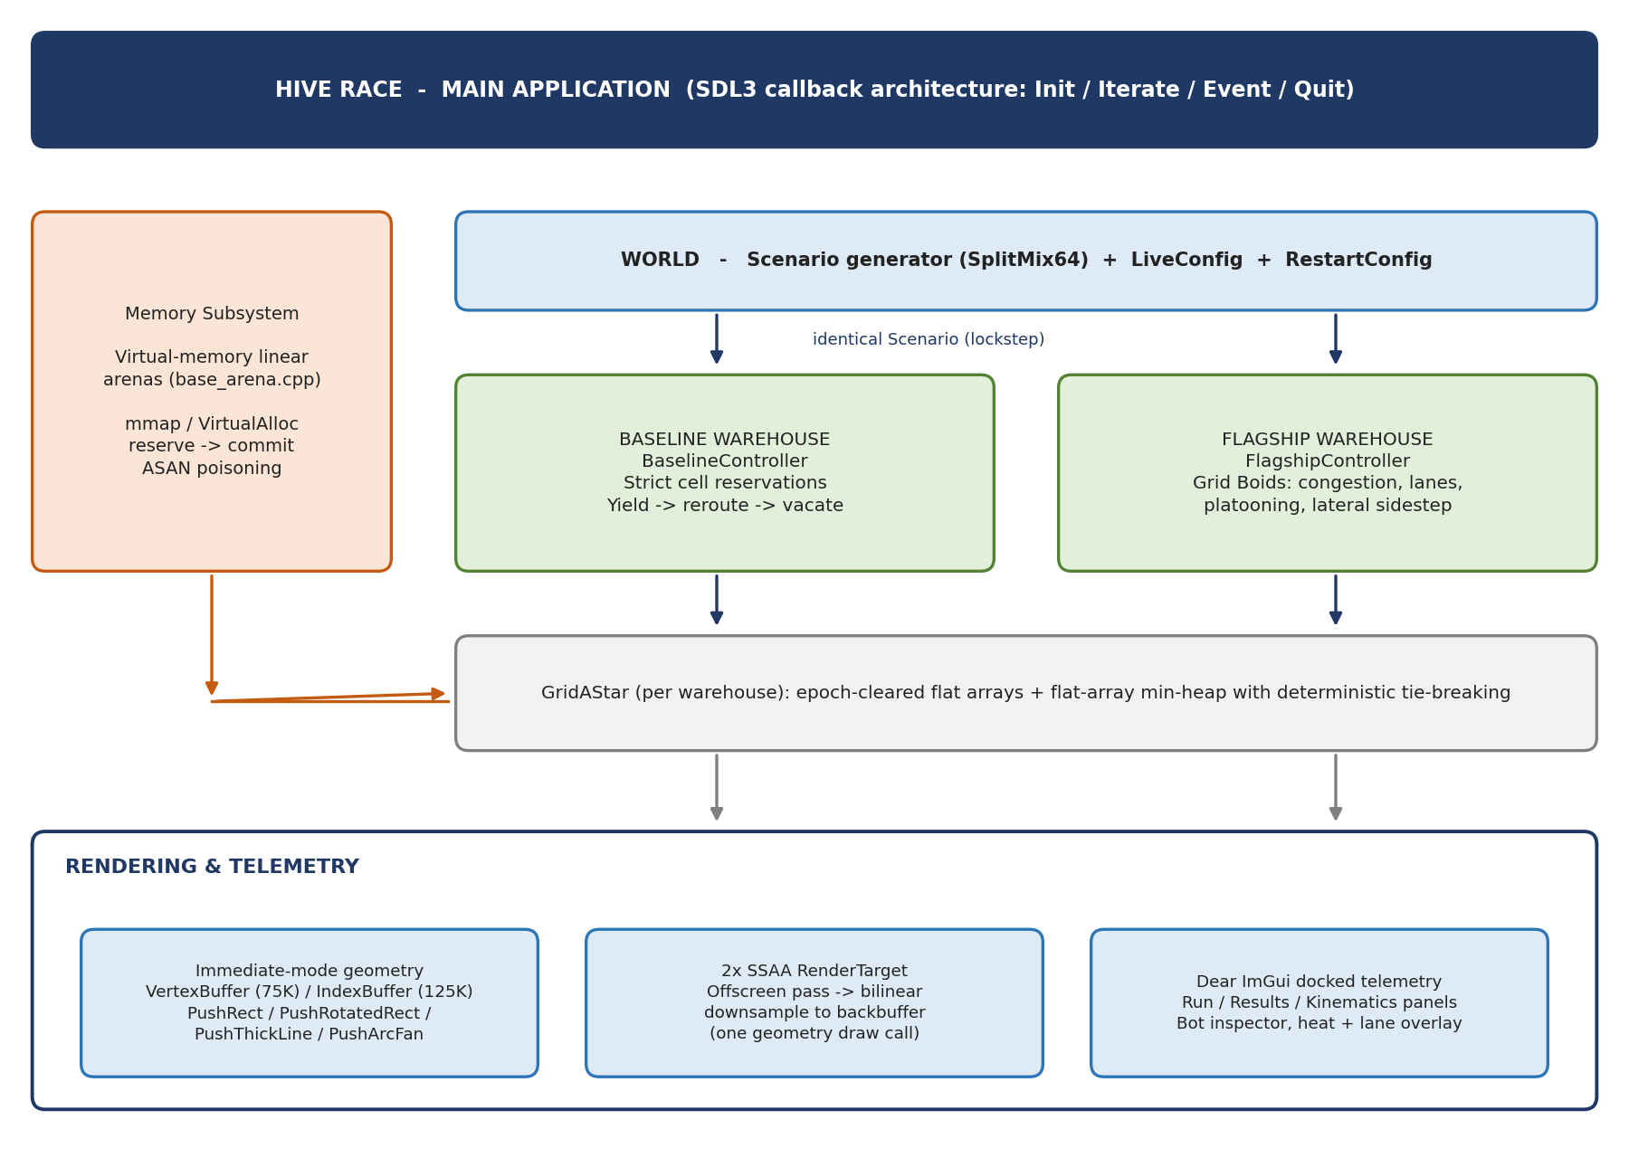
Figure 4.1: High-level architecture: main loop, memory subsystem, lockstep simulation pair, rendering and telemetry.
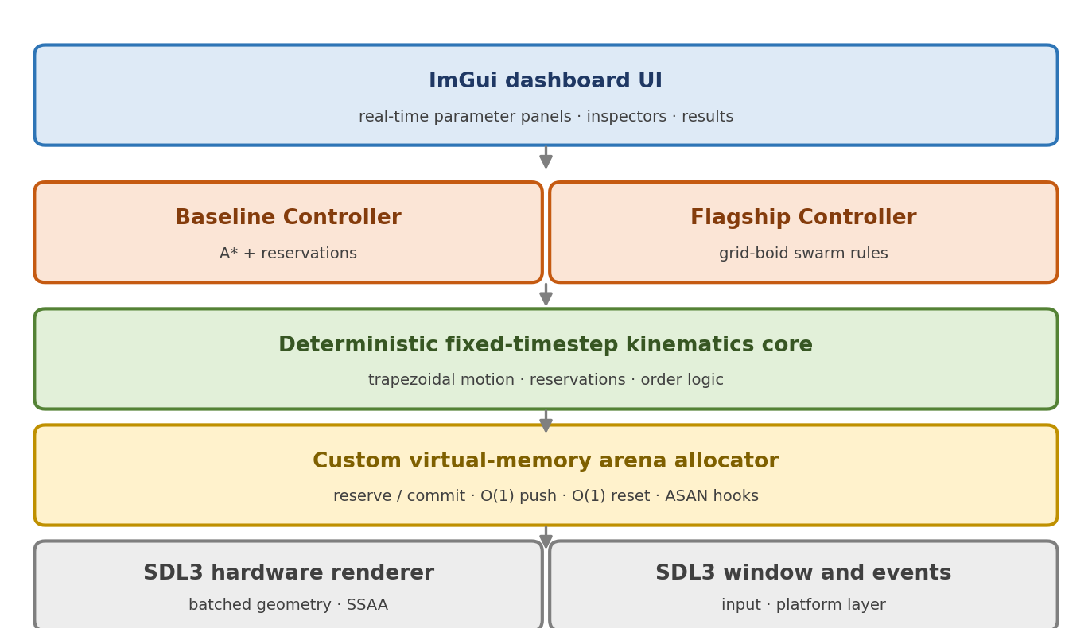
Figure 4.2: Layered architecture of the application.
At run time the App owns the arenas and the World. The World instantiates one shared Scenario (seed, orders, layout) and runs two Warehouse objects in lockstep, one injected with BaselineController, one with FlagshipController. Both use the same GridAStar engine and each keeps a contiguous bot array. Because the controller is injected, simulation code is identical for both fleets; restarting (R) rewinds the world arena, destroying no object individually.
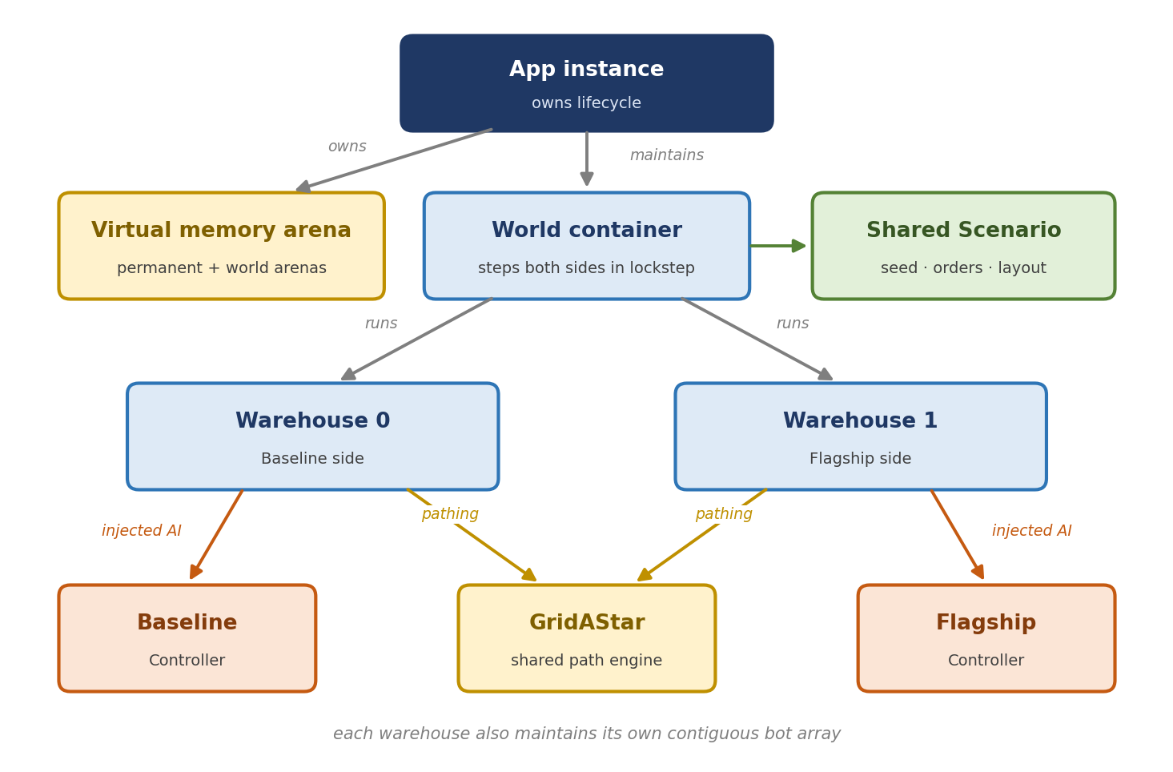
Figure 4.3: Ownership and data flow.

Lockstep dual simulation
- Both sides (SimSide::Baseline, SimSide::Flagship) are isolated Warehouse instances with their own bots, ownership arrays, orders, statistics and pathfinder.
- Both read the same read-only Scenario: spawn indices, pick locations, station columns, order release times.
- The engine ticks both warehouses sequentially in one frame update with identical dt, so neither side sees a different clock.
Headless Benchmarking and Architectural Decoupling
A major architectural advantage of Hive Race is the strict decoupling of the simulation state from the rendering and UI layers. Because the core engine relies entirely on deterministic math, zero-allocation pathfinding, and pre-allocated virtual memory arenas, the simulation can be executed in a "headless" mode without initializing any graphics context. In this mode, the fixed-timestep accumulator is bypassed, and the CPU evaluates WorldTick() continuously in a tight loop. This data-oriented architecture allows the engine to simulate thousands of pathfinding steps in milliseconds, completely unbottlenecked by VSync or GPU draw calls. This guarantees that the benchmark results reflect pure algorithmic compute time and algorithmic efficiency, completely isolated from rendering overhead.

4.2 Flowcharts and Process Diagrams

Baseline decision flow
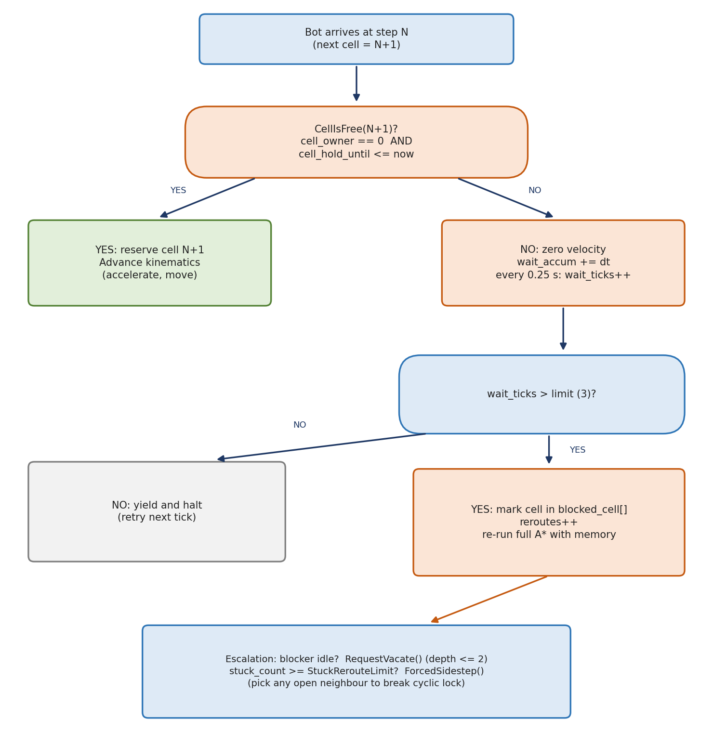
Figure 4.4: Baseline decision flow when a bot approaches its next cell.

Flagship step-cost composition
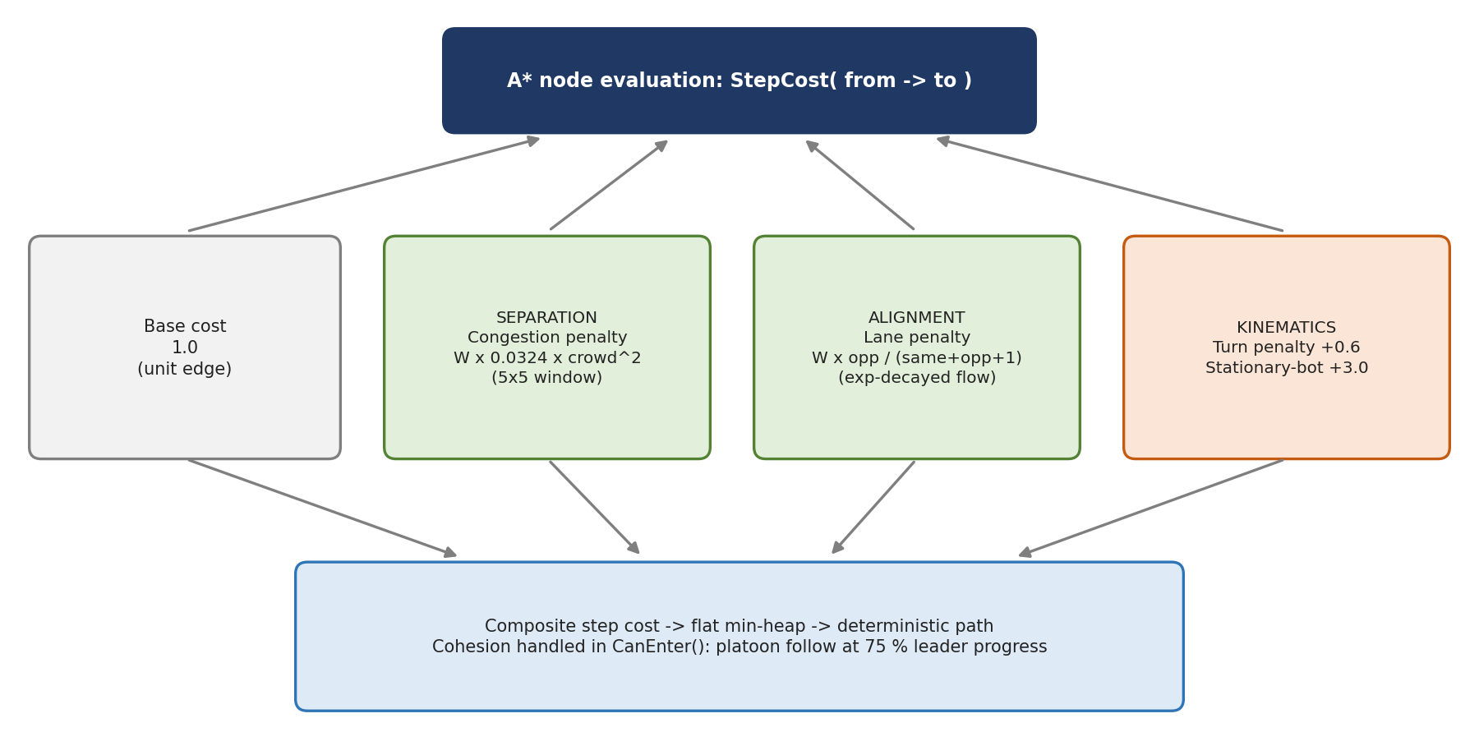
Figure 4.5: Composition of the Flagship step cost: base, separation, alignment, kinematics; cohesion handled in ~CanEnter~.

Bot life-cycle
Every bot runs the same state machine regardless of controller. Idle bots claim the best order; the Retreat state handles standoffs.
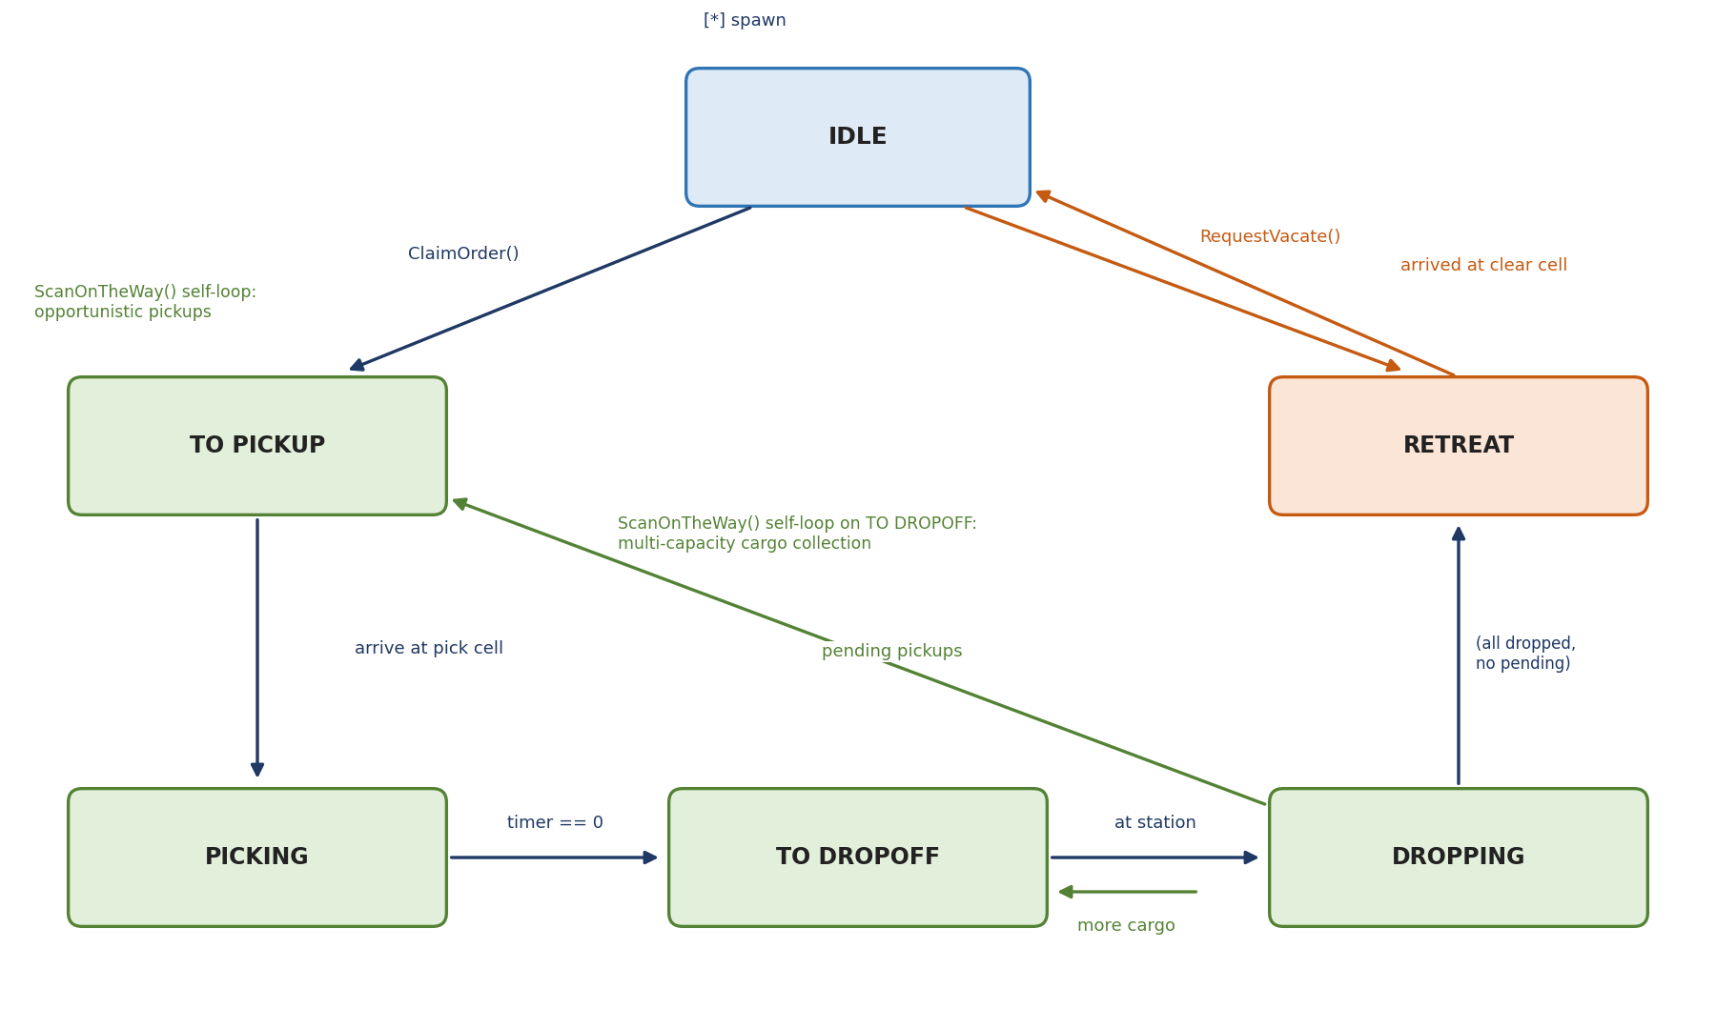
Figure 4.6: Bot state machine.
Table 4.1: Bot states and transitions
State | Behaviour and exits
Idle | Waits for work; ClaimOrder() moves to ToPickup; RequestVacate() moves to Retreat; retires if enabled and no orders remain
ToPickup | Travels to the crate; arrival moves to Picking; ScanOnTheWay() collects compatible pickups; sustained blocking escalates to Retreat
Picking | Stationary for pickup_seconds, loads cargo, moves to ToDropoff
ToDropoff | Carries cargo to a station; arrival moves to Dropping; ScanOnTheWay() supports multiple cargo; blocking escalates to Retreat
Dropping | Stationary for dropoff_seconds; more cargo returns to ToDropoff, pending pickups to ToPickup, otherwise Idle
Retreat | Temporary detour after a standoff; resumes the claimed trip or carried drop-off, or returns to Idle when clear or parked

Simulation flow
- Build. App creates arenas; World builds the Scenario from the seed.
- Instantiate. Two warehouses share the Scenario; one receives the Baseline controller, one the Flagship.
- Tick. Each controller's BeginTick() runs (Flagship: crowd map rebuild, lane decay); every bot then runs its state machine, requests reservations through the controller and integrates speed and position.
- Orders. Orders are released on the Poisson schedule, claimed, picked, carried and dropped; each drop increments the delivered count.
- Escalate. Blocked bots follow the escalation ladder (Section 7.1).
- Finish. When one fleet reaches the target drop-off count, World::winner is set and the results dialog and leaderboard appear.

Per-frame control flow
- SDL_AppIterate measures wall-clock nanoseconds since the previous iteration.
- Scaled time joins the banked accumulator (unless paused), clamped to the 2.0 s limit.
- While the bank holds at least one tick period (and the step cap is not hit), WorldTick advances both warehouses one fixed step.
- The renderer interpolates positions with the fractional alpha, builds vertex and index buffers and draws into the 2x SSAA target.
- The target is downsampled to the backbuffer, ImGui overlays are drawn, and the frame is presented.
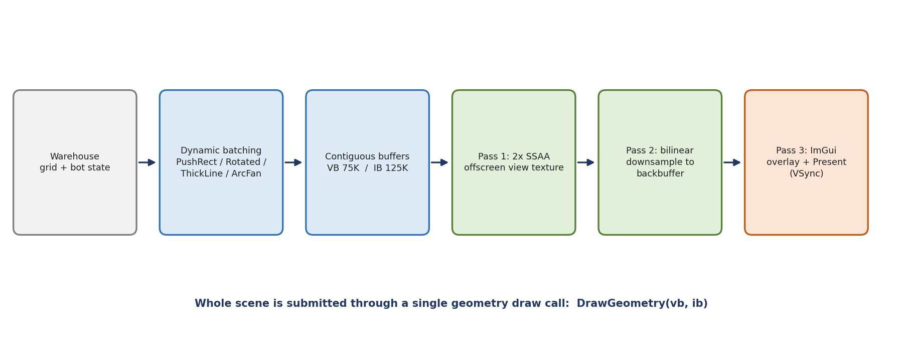
Figure 4.7: Render pipeline: batching, supersampled off-screen pass, downsample, overlay.

4.3 Class Diagram and Object-Oriented Design
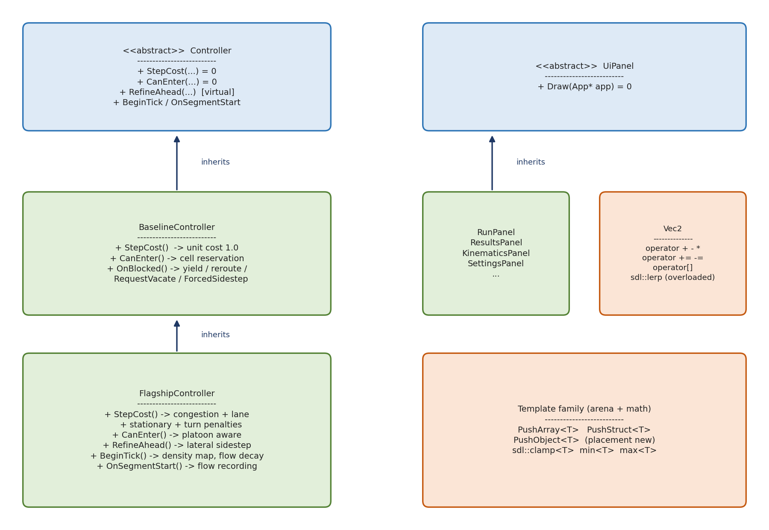
Figure 4.8: Class hierarchy: abstract Controller and its two policies, abstract UiPanel, Vec2 and the template family.
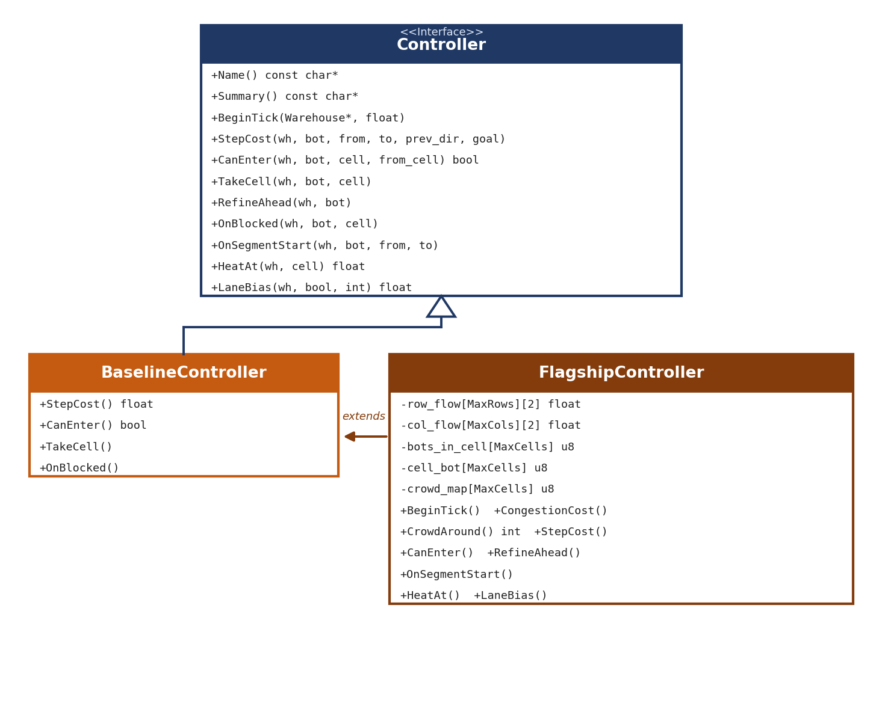
Figure 4.9: Controller class diagram as implemented, with the Flagship's private flow and crowd tables.
Table 4.2: Classes and responsibilities (OOP concepts are mapped in Section 5.4)
Class / type | Responsibility
App | Application root: World, Camera, render buffers, UI panels, timing state, SDL callbacks
World | Scenario, LiveConfig, RestartConfig and the two Warehouses
Warehouse | Grid ownership arrays, bots, orders, statistics, selected Controller
Bot | State, position, previous position, path, blocked-cell memory, heading, trail
Controller (abstract) | StepCost, CanEnter, RefineAhead, OnBlocked pure virtual; hooks BeginTick, TakeCell, OnSegmentStart, HeatAt, LaneBias, Name, Summary
BaselineController | Unit-cost routing, cell reservation, yield, reroute, vacate, forced sidestep
FlagshipController | Extends Baseline: congestion, lanes, platoons, sidestep; owns row_flow, col_flow, crowd_map, cell_bot
GridAStar | Zero-allocation pathfinder with epoch arrays and flat heap
UiPanel (abstract) | Draw(App*) = 0; derived RunPanel, ResultsPanel, KinematicsPanel, ScenarioPanel
sdl::Window / Renderer / RenderTarget | RAII wrappers over platform and graphics
VertexBuffer / IndexBuffer | Contiguous geometry buffers with bounds-checked PushBack
Vec2, Camera | Overloaded 2D vector; exponentially smoothed view transform

4.4 Data Design
Ownership relationships between the principal structures are shown below; Appendix A holds the Mermaid source.
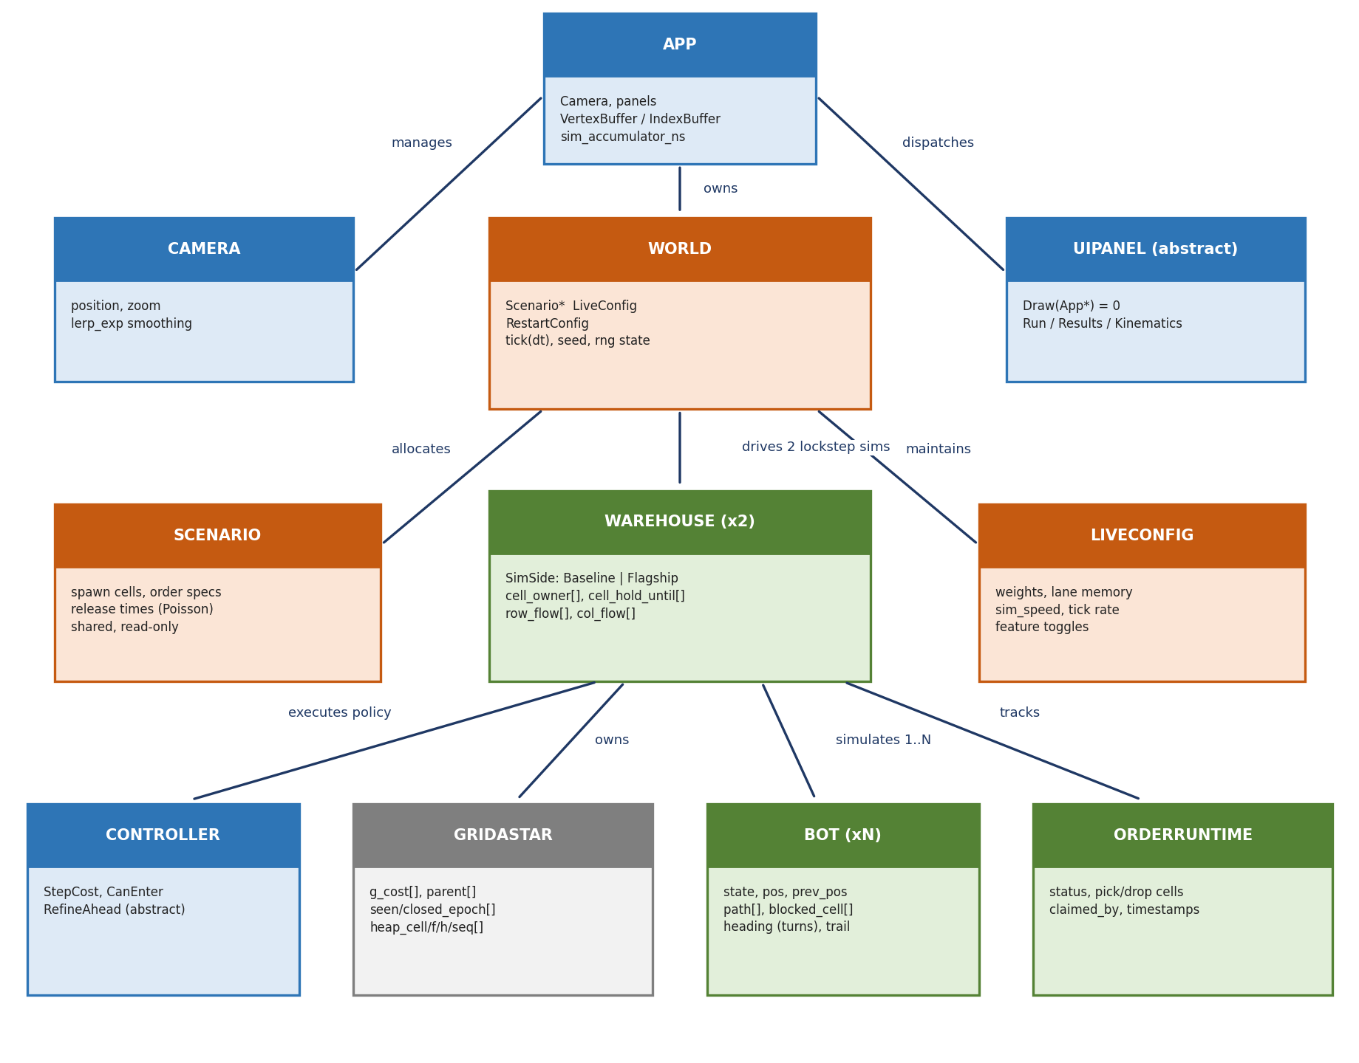
Figure 4.10: Entity-relationship layout of the simulation data architecture.

Zero-is-initialization layout
Every core structure treats all-zero bytes as a valid start state. Fresh pages are zero from the operating system and Arena::Push clears returned slices with SDL_memset, so hundreds of entities are created at negligible initialisation cost.
Table 4.3: Zero-is-initialization
Structure | Meaning of the all-zero state
Bot | cell = 0, state = BotState::Idle (0), moving = false, wait_ticks = 0
OrderRuntime | state = OrderState::NotReleased (0)
Warehouse | cell_owner = 0 means free; ownership by a bot is stored as bot_id + 1

Principal data arrays
Table 4.4: Principal data structures
Array / structure | Purpose
cell_owner[], cell_hold_until[] | Reservation state per cell: owner (id + 1) and clearance expiry time
blocked_cell[] (per bot) | Temporary obstruction memory, kept for blocked_memory_seconds
row_flow[Row][2], col_flow[Col][2] | Decaying [east, west] and [south, north] traffic momentum
crowd_map[], cell_bot[] | Per-tick density map and cell occupant lookup (Flagship)
g_cost, parent, seen_epoch, closed_epoch | Per-cell A* state (MaxCells entries each)
heap_cell, heap_f, heap_h, heap_seq | Parallel open-set arrays (HeapCapacity entries each)
Scenario / OrderSpec | Shared read-only spawns, pick cells, stations, release times
LiveConfig | Parameters editable during a run: weights, memory time, speed, tick rate, feature toggles
RestartConfig | Parameters defining the scenario (seed, order rate, backlog, bot count); take effect on regeneration

Arena layout
Arenas separate lifetimes: world.arena holds all warehouse data (bots, orders, lookup grids) and is rewound on rebuild by resetting current_pos = ARENA_HEADER_SIZE; permanent_arena holds the window, ImGui panels and renderer buffers. Mixed lifetimes never share an arena.
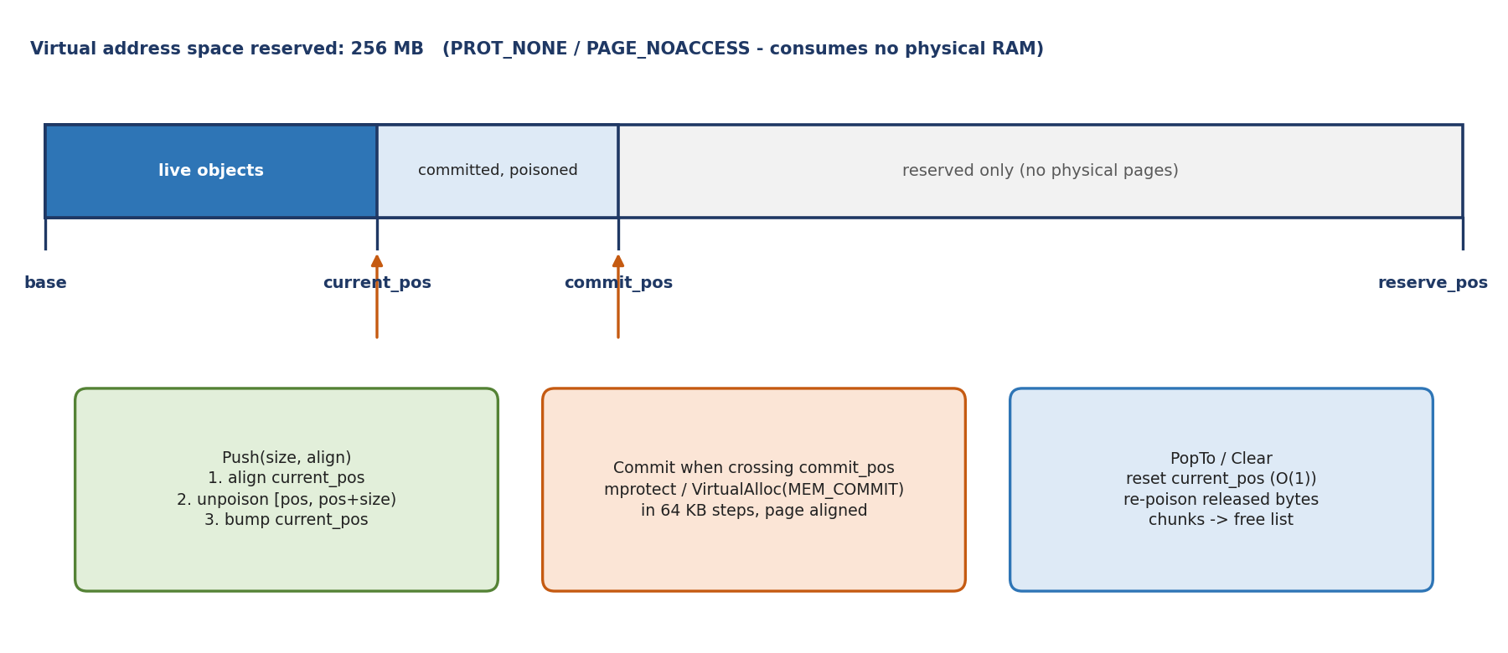
Figure 4.11: Arena address space: reserved range, committed prefix and allocation cursor.
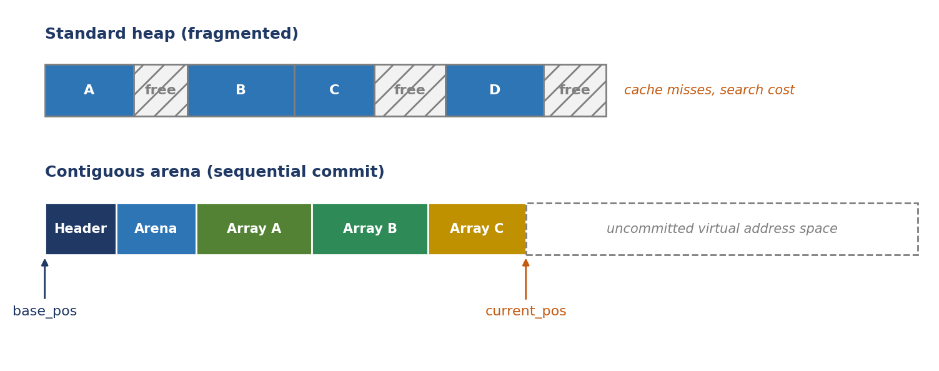
Figure 4.12: A fragmented heap compared with a contiguous arena committing pages sequentially.

CHAPTER 5: IMPLEMENTATION AND USER INTERFACE
Implementation is described by module (5.1), with the corresponding source excerpts in 5.2, followed by the user interface (5.3), the object-oriented mapping (5.4) and a sample run (5.5).

5.1 Module Description
Table 5.1: Modules and their interfaces
Module | Purpose | Inputs | Outputs
Memory arenas | All allocation; lifetime grouping | Size, alignment, flags | Aligned, zeroed, ASAN-unpoisoned slices
Scenario generator | Seeded, shared workload | 64-bit seed, RestartConfig | Layout, spawns, crates, stations, release times
GridAStar | Deterministic zero-allocation routing | Start, goal, controller step cost | Cell path
Controllers | Cost, entry legality, conflict response | Warehouse, bot, cells | Step costs, entry decisions, path repairs
Simulation / kinematics | Bot state machine, motion, reservations, stats | Fixed dt, controller | Positions, deliveries, WarehouseStats
Renderer | Batched geometry, SSAA, overlays | Warehouse state, camera, alpha | One draw call per view
Timing loop | Fixed-step accumulator, interpolation, callback rate | Wall-clock ns, sim speed | Tick count, alpha
UI / telemetry | Panels, inspectors, live tuning | Mouse, keys, LiveConfig | Parameter edits, results dialog
Colour table | Distinguishable bot and order colours | Index | 24-bit colour

Memory arenas
Each arena reserves a large contiguous address range (256 MB by default) and commits physical pages lazily in 64 KB steps, rounded to the page size. Push is align, add, compare; crossing the commit boundary costs one system call per step. When a block is exhausted, a new chunk is chained behind it (base_pos keeps one logical address space), and chunks released by PopTo go to a free list for reuse without further system calls. ASAN poisoning wraps every operation: the whole region is poisoned on reservation, each pushed slice is unpoisoned exactly, and released bytes are re-poisoned, so any overrun or use-after-release faults at the offending instruction. Hooks compile to nothing without ASAN.
Table 5.2: Arena cost model
Arena operation | Cost | Note
Push | O(1) | No search, no metadata
Push crossing commit boundary | O(1) system call per 64 KB | Amortized over many pushes
Pop / Clear / PopTo | O(1) | Cursor reset; no per-object destructors
Per-object overhead | Alignment padding only | No allocator headers
Fragmentation | None inside an arena | Lifetimes grouped by arena

Scenario generator and randomness
One 64-bit seed is diffused through the Stafford Mix13 variant of the SplitMix64 finalizer [19], [20], so adjacent seeds give uncorrelated spawn cells, crates and schedules. Orders below initial_backlog release at time zero; later gaps follow a Poisson process by clamped inverse-transform sampling (u is capped at 0.9999, bounding the largest gap at about 9.21/λ). A Knuth multiplicative hash of bot identifier and reroute count rotates A* neighbour order per bot, so opposing bots detour in different directions and the standoff resolves in one tick.

Kinematics and reservations
Bots are physical agents of about 0.8 cell width with a trapezoidal velocity profile bounded by max_speed, accel, decel (greater than accel) and turn_speed. At each cell the bot picks the boundary speed it wants: zero if the next cell is unreserved, turn_speed before a 90-degree corner, max_speed on a straight. The highest admissible speed follows from v² = v_end² + 2·d·s over the remaining cell fraction s = 1 - progress.
v_target = min( v_max , √( v_end² + 2·d·s ) )
Just-in-time reservation: from speed v the stopping distance is v²/(2d); once 1 - progress ≤ s_stop + reserve_margin the bot asks its controller to reserve the cell after next. If approved, the boundary speed rises from zero to max_speed and the bot crosses at full speed; if refused, it is already braking and stops safely. Split clearance: when progress passes body_clear_progress (0.90) the trailing edge has cleared, so the owner flag is cleared at once, and the cell then enters a temporal hold, cell_hold_until = t + clear_hold_seconds, absorbing kinetic jitter.
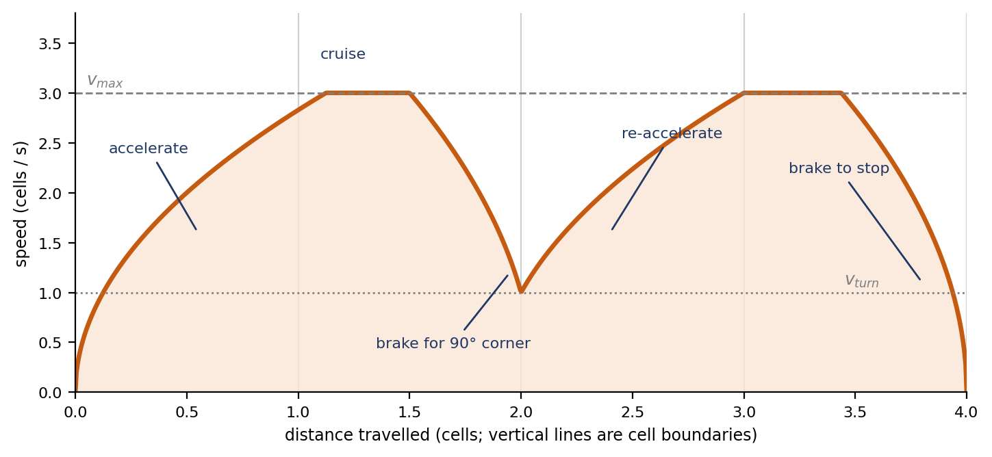
Figure 5.1: Speed profile over four cells: accelerate, cruise, brake for a corner, re-accelerate, stop (illustrative).

Controllers
The Baseline routes with unit cost, enters a cell only if cell_owner == 0 and the hold time has passed, counts 0.25 s yield ticks, and after wait_tick_limit (3) ticks writes the cell into blocked_cell[] for 5.0 s, increments reroutes and replans. The Flagship keeps these fallbacks and adds three boid rules plus look-ahead repair:
- Separation. Crowd(x, y) counts bots in a (2R+1)² window (R = 2, 25 cells), rebuilt in BeginTick(). Candidate cells pay W·0.0324·crowd², with 0.0324 = 0.18², so the penalty is W·(0.18·crowd)². A quarter of the neighbours costs one-sixteenth of the penalty: modest company is cheap, dense clusters are avoided before queues form. The goal cell is exempt, and stepping into a cell owned by a stationary bot adds +3.0.
- Alignment. Each row stores eastbound and westbound momentum, each column southbound and northbound. OnSegmentStart adds one unit per step; every tick all values decay by e^(-dt/τ) with τ = lane_memory_seconds (floored at 0.1 s). The penalty W_lane·opposite/(same + opposite + 1) is bounded below W_lane, zero in an unused corridor, and large when traffic opposes. First users make their direction cheaper for followers, so corridors become one-way spontaneously (positive feedback; stigmergy).
- Cohesion. SamePlatoon(A, B) holds when both bots head to the same drop-off target in state ToDropoff. A follower may enter a cell its leader is still leaving once the leader is moving, shares the heading and has progressed past platoon_follow_progress (0.75). At full speed a cell takes 0.25 s, so a follower starts about 0.19 s behind the leader instead of waiting for full clearance.
- Look-ahead repair (~RefineAhead~). The bot inspects step N+2. If that cell is occupied or its crowd reaches the trigger (default 44% of the window, 11 bots for 5x5), it scores the four neighbours, requires a candidate to beat the planned step by a margin, penalizes unproductive lateral moves, and splices a micro-A* tail into its path, rejecting tails that are too long or that cross the bot's earlier path.
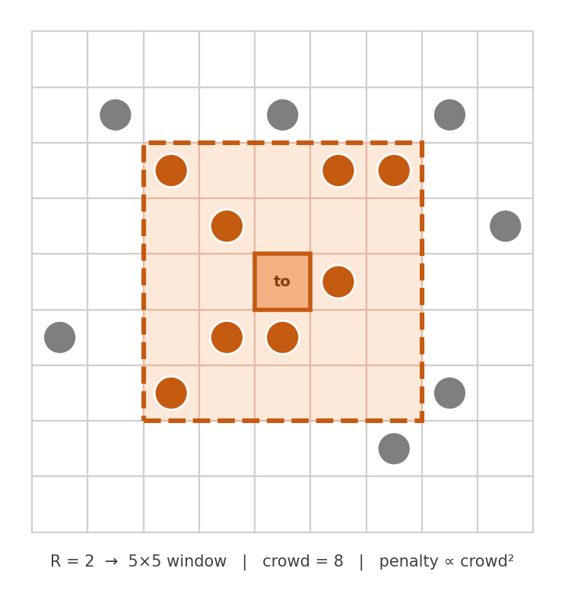
Figure 5.2: A 5x5 crowd window (R = 2) around a candidate cell; the cost term grows with the square of the count inside it.
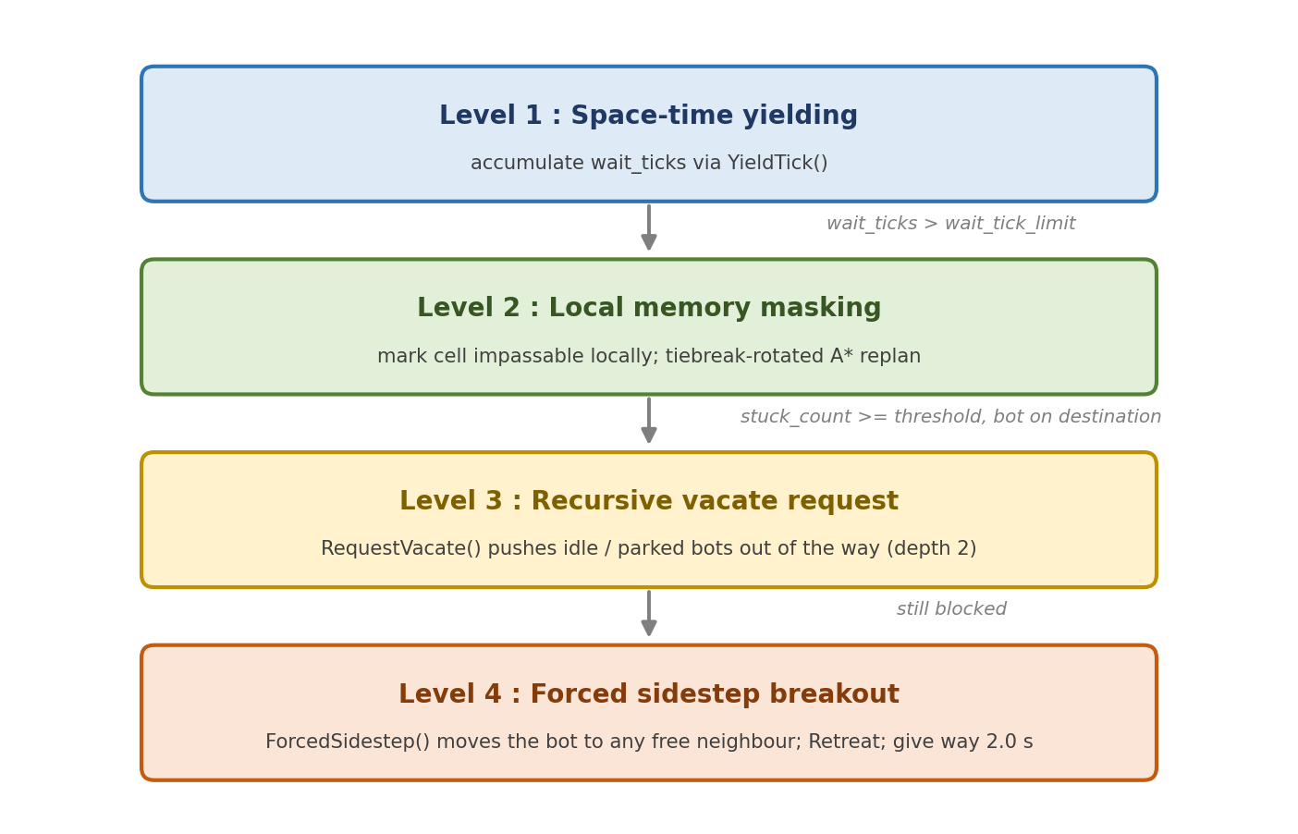
Figure 5.3: Deadlock-resolution escalation ladder.
Escalation ladder (Figure 5.3): (1) space-time yielding with wait ticks; (2) local blocked-cell memory with hash-rotated replan; (3) recursive RequestVacate asking idle or parked bots to step aside, to depth two; (4) ForcedSidestep to any free neighbour after StuckRerouteLimit failed replans, entering Retreat and yielding GiveWaySeconds (2.0 s), with priorities staggered by bot identifier so one yields while the other passes. Tiers three and four deliberately restore pre-emption, while lanes and hash tie-breaking attack circular wait.

Pathfinder
GridAStar is shared by both fleets, so differences come only from controller costs. Four per-cell arrays (g-cost, parent, seen and closed epochs) and four parallel heap arrays (cell, f, h, insertion sequence) are allocated once. A search starts with epoch++: a cell is unvisited when seen_epoch != epoch and is initialised lazily, so logical reset of the whole grid is O(1) and the arrays stay warm in L1 cache. Keeping fields in separate arrays lets sift loops stream through packed floats. Heap indices use (i-1)/2, 2i+1, 2i+2. The 32-bit epoch would need over four billion searches to wrap.

Mathematical helpers
Angles are held in turns: East 0.00, South 0.25, West 0.50, North 0.75, which equal neighbour indices 0 to 3 times 0.25. Shortest rotation is a wrap to [-0.5, 0.5] with only addition and subtraction, so a bot never interpolates the long way round. All smooth transitions (camera, UI scale, bot heading, lane decay) use lerp_exp, the exact solution of first-order relaxation, whose composition property makes visuals identical at any frame rate and prevents overshoot.
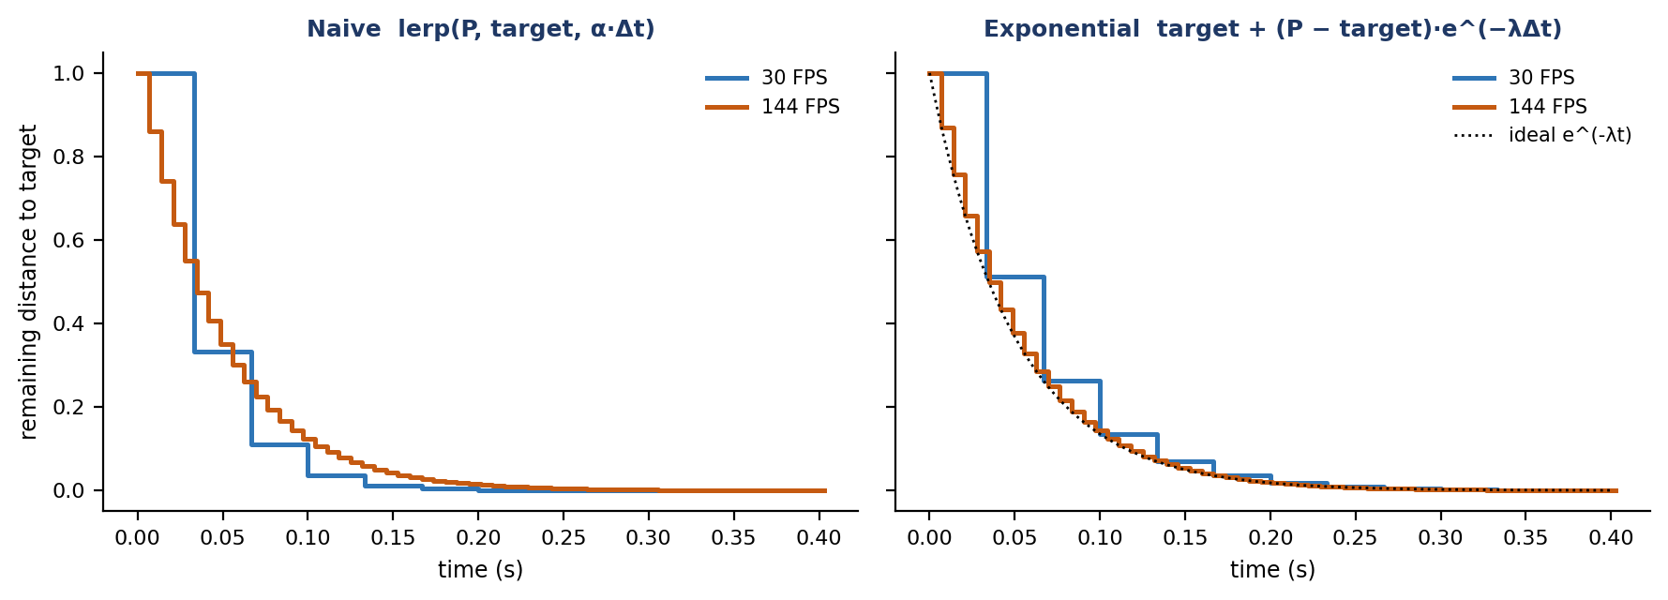
Figure 5.4: Frame-rate dependence of naive interpolation (left) versus exponential smoothing (right); illustrative.

Colour table
colors::DistinctColors[256] is baked offline in OKLab/OKLCH and read by index. The generator discards candidates outside [0, 1] in linear sRGB (not clamping, which clusters colours on the gamut wall) or outside L in [0.25, 0.85]; adds a tangential penalty over hues 250 to 290 degrees to prevent blue-to-violet collapse; takes the worst-case distance across normal, protanopic and deuteranopic views; samples chroma as C = C_max·√u to avoid crowding the grey axis; discards duplicate 24-bit values; and orders colours by a greedy max-min walk so consecutive identifiers contrast strongly.

Renderer
Every primitive is expanded to triangles on the CPU and appended to contiguous buffers in the render arena (75,000 vertices, 125,000 indices; four vertices per quad, so about 18,750 quads, vertex-limited). PushRect, PushRotatedRect (rotation matrix applied at insertion), PushThickLine (perpendicular normal (-Δy/L, Δx/L), four-vertex quad) and PushArcFan emit 4 vertices and 6 indices per quad. The floor, bot hulls, headings, crates, paths and trails go out through one DrawGeometry call. Each view renders to an off-screen texture at twice the logical resolution times the display pixel density (SSAA), is downsampled bilinearly to the backbuffer, and ImGui draws last at native resolution so text stays crisp.

Timing loop
Scaled wall-clock time is banked in nanoseconds, clamped to 2.0 s (at 480 Hz this is 960 ticks), and consumed in whole fixed ticks up to a per-iteration step cap. Without the clamp a slow frame demands more work next frame, which is slower still. At low speed (up to about 1.5x) the fractional remainder α = bank / tick period interpolates bot positions. The SDL3 callback rate hint is set to the larger of simulation and display rates, keeping CPU use low without losing responsiveness.

5.2 Key Implementation Details

Arena push with chaining, commit and ASAN
Excerpt from base_arena.cpp: Arena::Push
void* Arena::Push(uint64_t size, uint64_t align, bool zero) {
if (align == 0) align = 1;
Arena* curr = current;
if (!curr) return nullptr;
uint64_t aligned_pos = ALIGN_POW2(curr->current_pos, align); // fast bitwise alignment
uint64_t next_pos = aligned_pos + size;
if (next_pos < aligned_pos || next_pos < size) return nullptr; // overflow guard

if (next_pos > curr->reserve_pos) { // chain a new chunk
if (curr->flags & ARENA_FLAG_NO_CHAIN) return nullptr;
Arena* next_chunk = nullptr;
#if ARENA_FREE_LIST
Arena* prev_block = nullptr;
for (Arena* block = free_last; block != nullptr; prev_block = block, block = block->prev) {
uint64_t block_aligned_pos = ALIGN_POW2(block->current_pos, align);
if (block->reserve_pos >= block_aligned_pos + size) {
if (prev_block != nullptr) prev_block->prev = block->prev;
else free_last = block->prev;
next_chunk = block; break;
}
}
#endif
if (next_chunk == nullptr) {
uint64_t needed_size = ALIGN_POW2(ARENA_HEADER_SIZE, align) + size;
uint64_t new_reserve = ALIGN_POW2(needed_size, curr->reserve_step);
uint64_t new_commit = ALIGN_POW2(needed_size, curr->commit_step);
ArenaParams next_params{ .reserve_size = new_reserve, .commit_size = new_commit,
.flags = flags, .name = name };
next_chunk = ArenaAlloc(next_params);
if (next_chunk == nullptr) return nullptr;
}
next_chunk->base_pos = curr->base_pos + curr->reserve_pos;
next_chunk->prev = curr; current = next_chunk; curr = next_chunk;
aligned_pos = ALIGN_POW2(curr->current_pos, align);
next_pos = aligned_pos + size;
}
if (next_pos > curr->commit_pos) { // commit more pages
if (curr->flags & ARENA_FLAG_IS_BACKING_BUFFER) return nullptr;
uint64_t page_size = OS_GetPageSize();
uint64_t needed_commit = ALIGN_POW2(next_pos, curr->commit_step);
needed_commit = ALIGN_POW2(needed_commit, page_size);
if (needed_commit > curr->reserve_pos) needed_commit = curr->reserve_pos;
uint64_t commit_req = needed_commit - curr->commit_pos;
if (!OS_Commit((uint8_t*)curr + curr->commit_pos, commit_req)) return nullptr;
curr->commit_pos = needed_commit;
}
void* result = (uint8_t*)curr + aligned_pos;
AsanUnpoisonMemoryRegion(result, size); // allocated bytes accessible
if (zero) SDL_memset(result, 0, size);
curr->current_pos = next_pos;
if (curr->commit_pos > curr->current_pos) // re-poison the tail
AsanPoisonMemoryRegion((uint8_t*)curr + curr->current_pos,
curr->commit_pos - curr->current_pos);
return result;
}

ASAN hook declarations and placement-new object creation
#if defined(ARENA_ASAN_ENABLED)
extern "C" {
void __asan_poison_memory_region(void const volatile* addr, size_t n);
void __asan_unpoison_memory_region(void const volatile* addr, size_t n);
}
#define AsanPoisonMemoryRegion(p, n) __asan_poison_memory_region((p), (n))
#define AsanUnpoisonMemoryRegion(p, n) __asan_unpoison_memory_region((p), (n))
#endif

template <typename T>
[[nodiscard]] T* PushObject(Arena* arena) {
void* memory = arena->Push(sizeof(T), alignof(T), true);
if (!memory) return nullptr;
return new (memory) T(); // placement new writes the vptr over zeroed memory
}

Zeroed memory has a null virtual-table pointer, so a polymorphic object built in raw zeroed memory would crash on its first virtual call; PushObject<T> runs placement new over the block to install it without touching the heap.

Seed mixing, tie-break hash and Poisson sampling
Scenario generation helpers
// seed bit-mixer (golden-ratio constant + two avalanche rounds)
uint64_t rng = cfg->seed + SDL_UINT64_C(0x9E3779B97F4A7C15);
rng = (rng ^ (rng >> 30)) * SDL_UINT64_C(0xBF58476D1CE4E5B9);
rng = (rng ^ (rng >> 27)) * SDL_UINT64_C(0x94D049BB133111EB);
rng ^= (rng >> 31);

// Poisson inter-arrival by clamped inverse transform
constexpr float POISSON_MAX_U = 0.9999f;
if (u > POISSON_MAX_U) u = POISSON_MAX_U;
release += -sdl::logf(1.0f - u) / cfg->order_rate;

// per-bot tie-break (Knuth multiplicative hash); neighbour order rotated by (tiebreak & 3)
uint32_t h = (uint32_t)(bot->id + 1) * 2654435761u ^ (uint32_t)bot->reroutes * 2246822519u;
h ^= h >> 15;
bot->tiebreak = h; // A* explores d = (k + (tiebreak & 3)) & 3 for k = 0..3

Epoch clearing and deterministic heap order
Excerpt from the pathfinder
epoch++; // logical reset of every cell in O(1)
seen_epoch[start] = epoch; g_cost[start] = 0.0f; // unvisited <=> seen_epoch[u] != epoch

bool HeapLess(int32_t a, int32_t b) const {
if (heap_f[a] < heap_f[b] - ASTAR_F_TOLERANCE) return true; // tier 1: f with tolerance
if (heap_f[a] > heap_f[b] + ASTAR_F_TOLERANCE) return false;
if (heap_h[a] != heap_h[b]) return heap_h[a] < heap_h[b]; // tier 2: nearer the goal
return heap_seq[a] < heap_seq[b]; // tier 3: FIFO insertion order
}

Flagship step cost
Excerpt from simulation.cpp: FlagshipController::StepCost
float FlagshipController::StepCost(Warehouse* wh, Bot* bot, int32_t from, int32_t to,
int32_t prev_dir, int32_t goal) {
const LiveConfig* live = wh->live;
float cost = 1.0f;
Dir4 dir = DirBetween(from, to, wh->cols);
if (to != goal) {
if (live->use_congestion) cost += CongestionCost(live, CrowdAround(wh, bot, to));
uint8_t owner = wh->cell_owner[to];
if (owner != 0 && (int32_t)owner - 1 != bot->id)
if (BotIsStationary(&wh->bots[owner - 1])) cost += PENALTY_STATIONARY_BOT; // +3.0
}
if (live->use_lanes) {
float same, opposite; int32_t slot = LaneSlot(dir);
if (DirIsHorizontal(dir)) { int32_t row = CellRow(from, wh->cols);
same = row_flow[row][slot]; opposite = row_flow[row][1 - slot]; }
else { int32_t col = CellCol(from, wh->cols);
same = col_flow[col][slot]; opposite = col_flow[col][1 - slot]; }
cost += live->lane_weight * opposite / (same + opposite + 1.0f);
}
if (prev_dir >= 0 && prev_dir != DirIndex(dir)) cost += live->turn_penalty; // +0.6
return cost;
}

float FlagshipController::CongestionCost(const LiveConfig* live, int32_t crowd) const {
return live->congestion_weight * CongestionScale * (float)(crowd * crowd);
}

// BeginTick: exponential decay of lane momentum
float keep = sdl::expf(-dt / sdl::max(live->lane_memory_seconds, 0.1f));
for (int32_t r = 0; r < wh->rows; r++) { row_flow[r][0] *= keep; row_flow[r][1] *= keep; }
for (int32_t c = 0; c < wh->cols; c++) { col_flow[c][0] *= keep; col_flow[c][1] *= keep; }

Look-ahead sidestep and platoon entry
Excerpt from simulation.cpp: FlagshipController::RefineAhead
void FlagshipController::RefineAhead(Warehouse* wh, Bot* bot) {
const LiveConfig* live = wh->live;
if (!live->use_sidestep) return;
int32_t index = bot->path_index;
if (index + 2 >= bot->path_length) return;
int32_t here = bot->next_cell, planned = bot->path[index + 2], goal = bot->target_cell;
if (planned == goal) return;
bool occupied = !CanEnter(wh, bot, planned, here);
int32_t radius = live->crowd_radius, area = (radius * 2 + 1) * (radius * 2 + 1);
int32_t trigger = live->auto_crowd_trigger ? (int32_t)(area * 0.44f) : live->crowd_trigger;
bool crowded = CrowdAround(wh, bot, planned) >= trigger;
if (!occupied && !crowded) return; // intervene only when needed
float best_score = ScoreStep(wh, bot, here, planned); int32_t best = planned;
int32_t here_distance = Manhattan(here, goal, wh->cols);
for (int32_t d = 0; d < 4; d++) {
int32_t cand = NeighborCell(here, DirFromIndex(d), wh->cols, wh->rows);
if (cand < 0 || cand == planned || cand == bot->cell) continue;
if (IsBlockedInMemory(wh, bot, cand) || !CanEnter(wh, bot, cand, here)) continue;
bool productive = Manhattan(cand, goal, wh->cols) < here_distance;
if (!productive && !occupied) continue;
float score = ScoreStep(wh, bot, here, cand);
if (!productive) score += PENALTY_UNPRODUCTIVE_LATERAL;
if (score + SCORE_IMPROVEMENT_THRESHOLD < best_score) { best = cand; best_score = score; }
}
if (best == planned) return;
int32_t tail[MaxPathLength]; int32_t tail_length = 0;
if (!wh->astar->Find(wh, bot, best, goal, tail, MaxPathLength, &tail_length, true)) return;
if (index + 2 + tail_length > MaxPathLength) return;
for (int32_t i = 0; i < tail_length; i++) // loop prevention
for (int32_t k = 0; k <= index + 1; k++) if (tail[i] == bot->path[k]) return;
for (int32_t i = 0; i < tail_length; i++) bot->path[index + 2 + i] = tail[i];
bot->path_length = index + 2 + tail_length;
wh->stats.sidesteps++;
}

bool FlagshipController::CanEnter(Warehouse* wh, Bot* bot, int32_t cell, int32_t from_cell) {
if (CellIsFree(wh, bot, cell)) return true;
if (!wh->live->use_platoons) return false;
Bot* leader = &wh->bots[wh->cell_owner[cell] - 1];
if (!SamePlatoon(bot, leader)) return false;
if (!leader->moving || leader->cell != cell) return false;
if (leader->progress < wh->live->platoon_follow_progress) return false;
if (DirBetween(from_cell, cell, wh->cols) != leader->dir) return false;
return true; // follower enters behind the leader
}

Motion, time and angle helpers
Speed integration, accumulator, lerp_exp, turns, callback rate
if (bot->speed < v_target) bot->speed = sdl::min(bot->speed + live->accel * dt, v_target);
else bot->speed = sdl::max(v_target, bot->speed - live->decel * dt);
bot->progress += bot->speed * dt;

app->sim_accumulator_ns += (uint64_t)((double)frame_ns * (double)world->live.sim_speed);
if (app->sim_accumulator_ns > MAX_BANKED_NS) app->sim_accumulator_ns = MAX_BANKED_NS; // 2.0 s
while (app->sim_accumulator_ns >= app->tick_period_ns && steps < MAX_STEPS_PER_ITERATE) {
WorldTick(world, step_delta_seconds); app->sim_accumulator_ns -= app->tick_period_ns; steps++;
}
Vec2 here = sdl::lerp(bot->prev_pos, bot->pos, alpha); // alpha = bank / tick period

inline float lerp_exp(float from, float to, float decay, float dt) {
return to + (from - to) * SDL_expf(-decay * dt);
}
constexpr float wrap_turns_signed(float turns) {
while (turns > TurnHalf) turns -= TurnFull;
while (turns < -TurnHalf) turns += TurnFull;
return turns;
}
inline float DirTurns(Dir4 dir) { return (float)DirIndex(dir) * TurnQuarter; }

void UpdateMainCallbackRate(App* app) {
double target_hz = (double)app->world.live.sim_steps_per_second;
if (app->refresh_rate_hz > target_hz) target_hz = (double)app->refresh_rate_hz;
char rate_text[32]; sdl::snprintf(rate_text, sizeof(rate_text), "%.4f", target_hz);
SDL_SetHint(SDL_HINT_MAIN_CALLBACK_RATE, rate_text);
}

texel_width = (int32_t)(width * pixel_density * SupersampleFactor); // SupersampleFactor = 2
app->renderer.DrawGeometry(vb->Data(), vb->Count(), ib->Data(), ib->Count()); // one draw call

Status-code error handling and file handling
Failures are reported through return values, never exceptions: GridAStar::Find returns false when no path exists, Arena::Push returns nullptr on overflow or failed commit, movement returns a MoveResult enumeration, and sidestep splices that are too long or self-intersecting are discarded. Callers check and degrade (for example keeping the old path), so routing failure never crashes the run. At start-up the application probes directories with SDL_GetPathInfo for Inter-Regular.ttf, loads it into memory if found, and otherwise falls back to the embedded bitmap font.
Table 5.3: Failure handling by status codes
Failure case | Detection | Recovery
No path to goal | Find() returns false | Keep current state, retry next tick
Arena exhausted or commit refused | Push returns nullptr | Caller aborts allocation; no partial state
Size overflow | Overflow guard in Push | Return nullptr before touching memory
Bad sidestep splice | Length and self-intersection checks | Discard splice, keep original path
Missing font | SDL_GetPathInfo | Embedded bitmap fallback

Deviation from conventional C++ practice
Table 5.4: Hive Race versus conventional C++ practice
Topic | Conventional approach | Hive Race | Reason
Memory | new / delete, std::vector, smart pointers | Virtual-memory linear arenas | No fragmentation; O(1) alloc and release
Safety | Reference counting | Manual ASAN poisoning | Precise bounds, no release cost
Priority queue | std::priority_queue of nodes | Four flat arrays, HeapLess | Cache-friendly, deterministic
Search reset | memset or reallocate | Epoch counter | Removes per-search clearing
Angles | Radians, sin / cos | Turns | Cheap wrapping, exact quarter turns
Smoothing | lerp(a, b, dt*k) | lerp_exp | Frame-rate independent
Randomness | std::random_device, mt19937 | SplitMix64 mixer | Reproducible, decorrelated seeds
Time step | Variable dt | Banked fixed timestep | Deterministic physics
Colour | HSV hue rotation | Baked OKLab table | Distinguishable, CVD-aware
Rendering | One call per primitive | CPU batching, one call | Minimal driver overhead
Anti-aliasing | MSAA / shaders | 2x SSAA, bilinear downsample | Uniform, feature-independent
Errors | Exceptions | Status codes and enums | Predictable control flow
Tie-breaking | Unspecified | f, then h, then sequence; per-bot hash | Fully deterministic paths
Platform | Abstract everywhere | Compile-time contract, direct OS calls | Smaller, faster paths

5.3 User Interface and Screenshots
The interface uses Dear ImGui in a docked layout. Each window derives from UiPanel and implements Draw(App*); the application loops over its panels, so a new view needs one class. Controls are declared in code each frame (for example, if (ImGui::Button("Restart [R]")) AppRebuild(app);), so no widget state can drift from the model, no allocation occurs, and parameters such as acceleration, lane weight and crowd radius can be edited live through LiveConfig pointers, mid-tick.
Table 5.5: Principal controls
Control | Function
1 | Split-screen view: Baseline left, Flagship right, same seed
3 | Flagship-only view
D | Debug overlay: congestion heat boxes and lane-direction glyphs
R | Restart with the current seed (arena rewind)
Left-click bot | Select with ring, path and blocked-cell outlines; inspectors can be pinned and several kept open

Overlays expose internal state directly: red boxes show crowd pressure (the density field behind the quadratic cost), blue (east, south) and orange (west, north) arrows show lane momentum, red outlines show a bot's blocked-cell memory and a white line its planned path. The results panel shows a "Race Winner!" dialog, a comparison table with green marks for the better side per metric, and a persistent leaderboard. The Kinematics and Run panels edit motion and scenario parameters.
Table 5.6: Screenshot placement guide (Figure numbers refer to the placeholders below)
Figure | View or action | Must show
5.5 | Split screen (1), mid-race | Baseline clusters of waiting bots beside Flagship streams
5.6 | Flagship only (3) plus overlay (D) | Red congestion boxes; blue and orange lane arrows
5.7 | Click an active bot; pin inspectors | Ring, white path, red blocked cells, telemetry table
5.8 | Run to completion | Race Winner dialog, comparison table with green marks, leaderboard
5.9 | Run and scenario panels | Seed, order rate, weights and toggles used
5.10 | Kinematics panel | Speed, acceleration, turn and clearance parameters

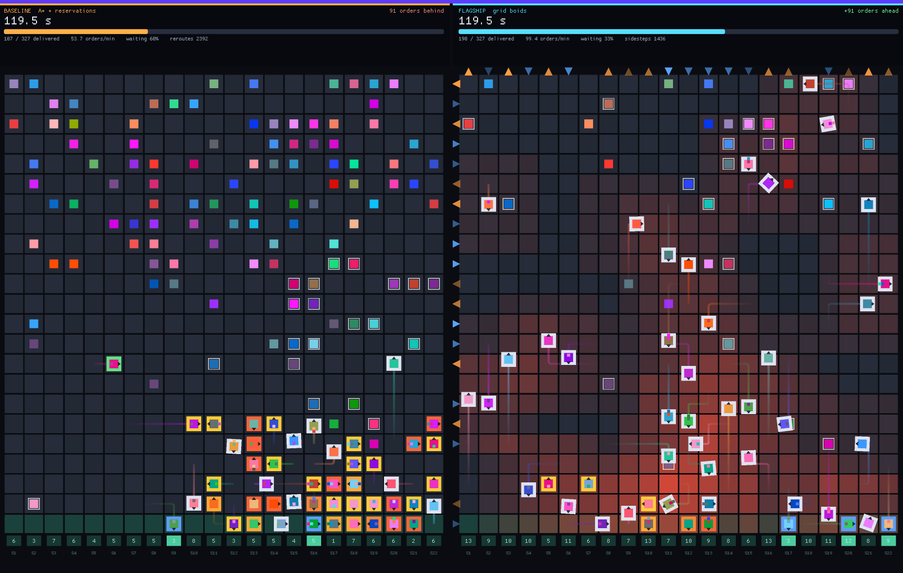
Figure 5.5: Split-screen lockstep simulation, Baseline fleet (left) and Flagship fleet (right) under one seed.
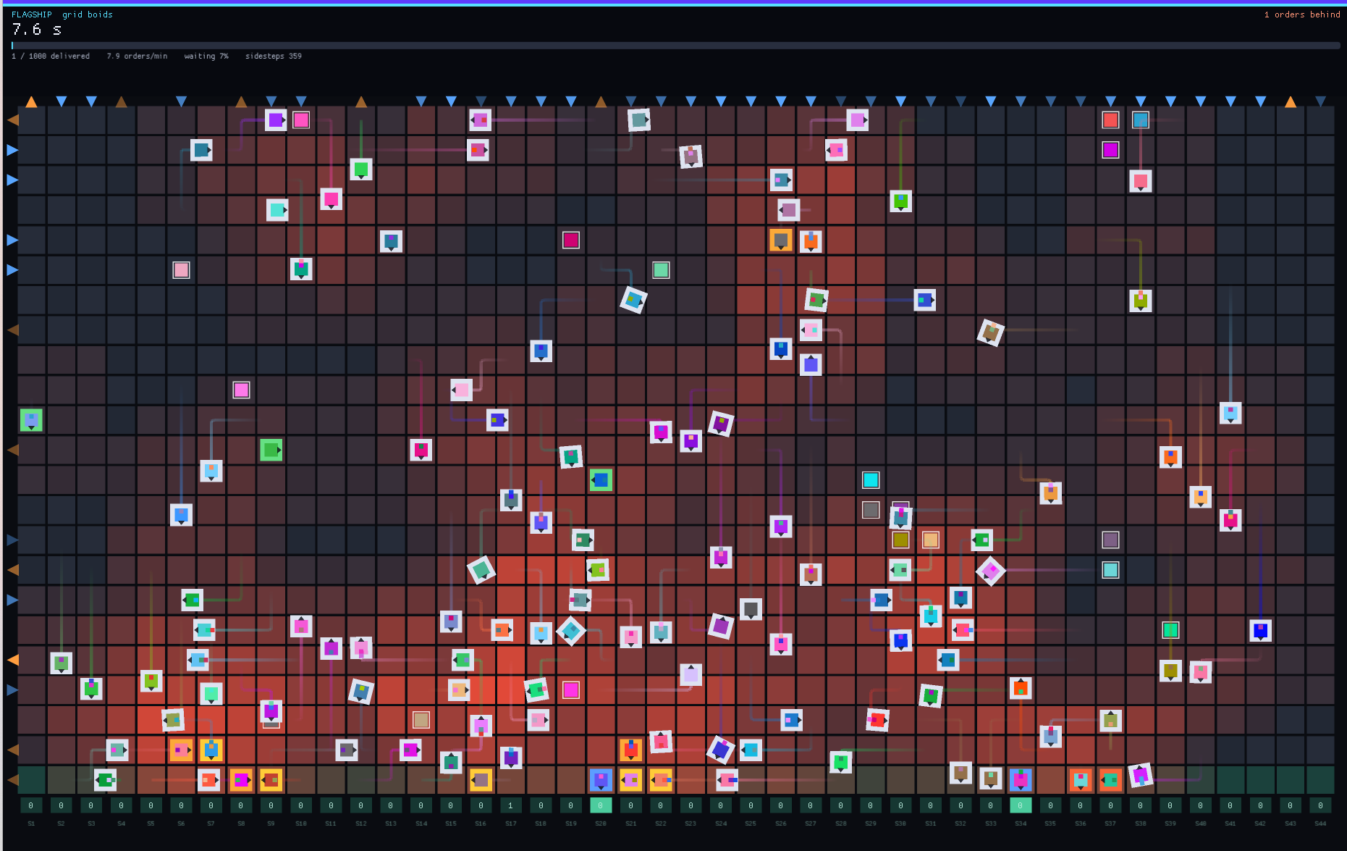
Figure 5.6: Congestion heat map and polarized lanes in the Flagship fleet.
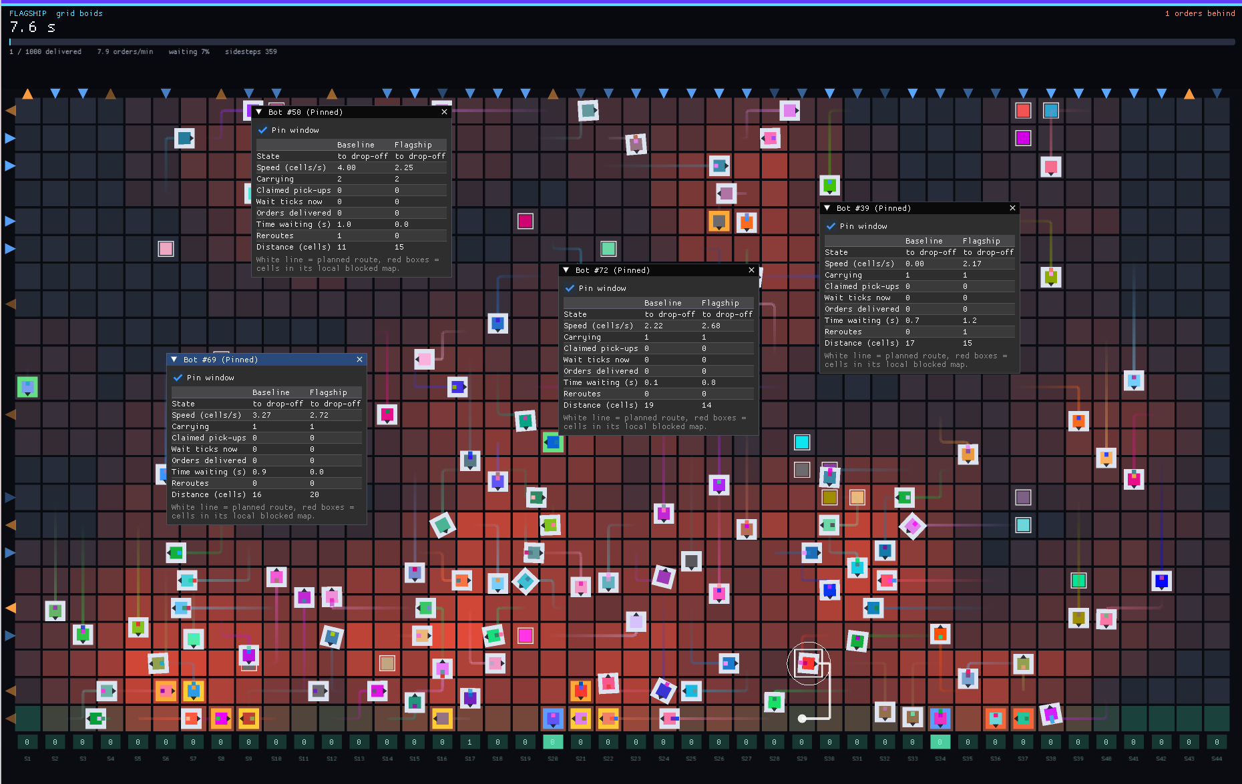
Figure 5.7: Interactive bot telemetry and spatial inspector.
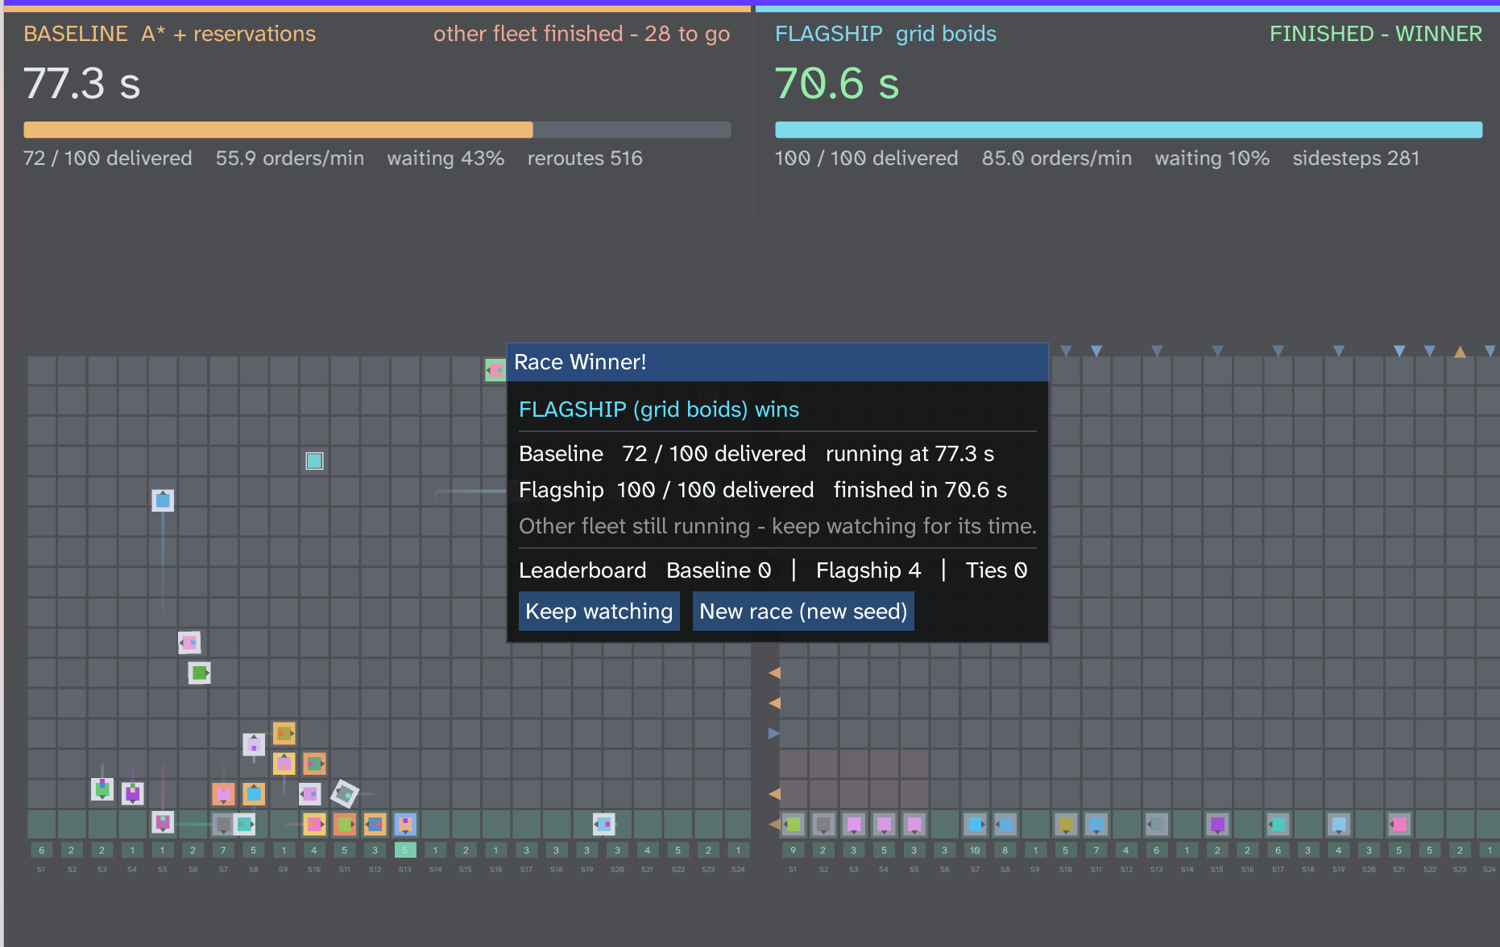
Figure 5.8: Post-race comparison dialog.
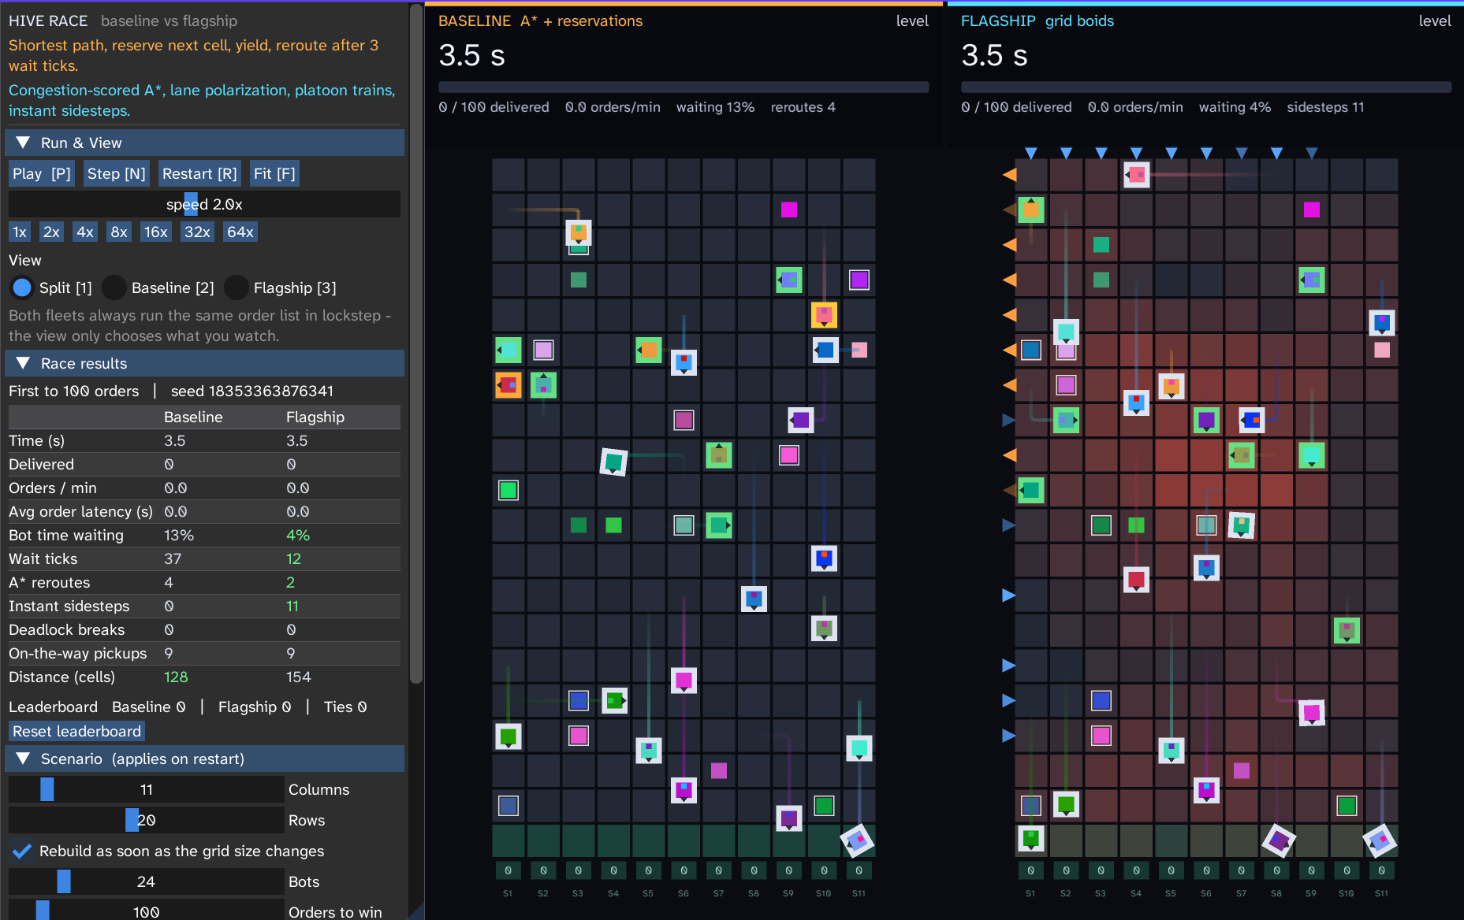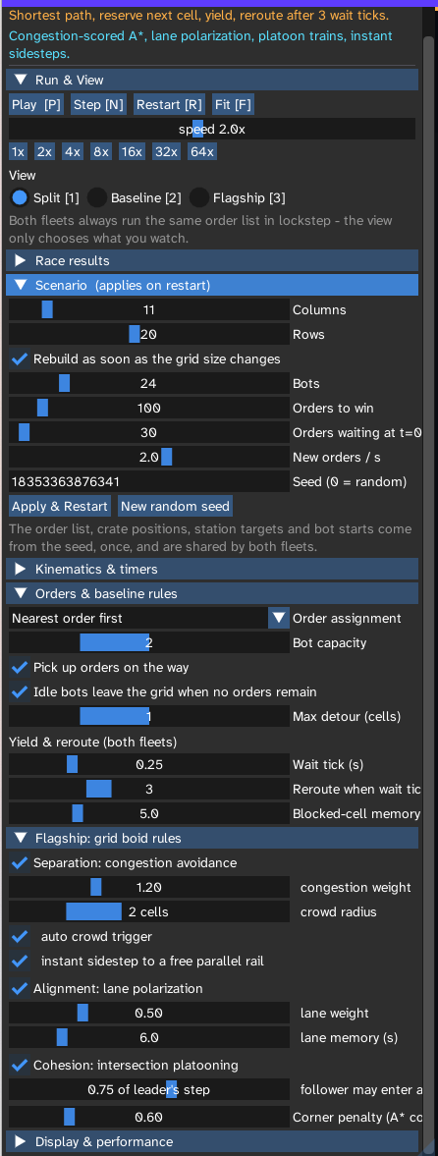
Figure 5.9: Run panel showing experiment parameters.
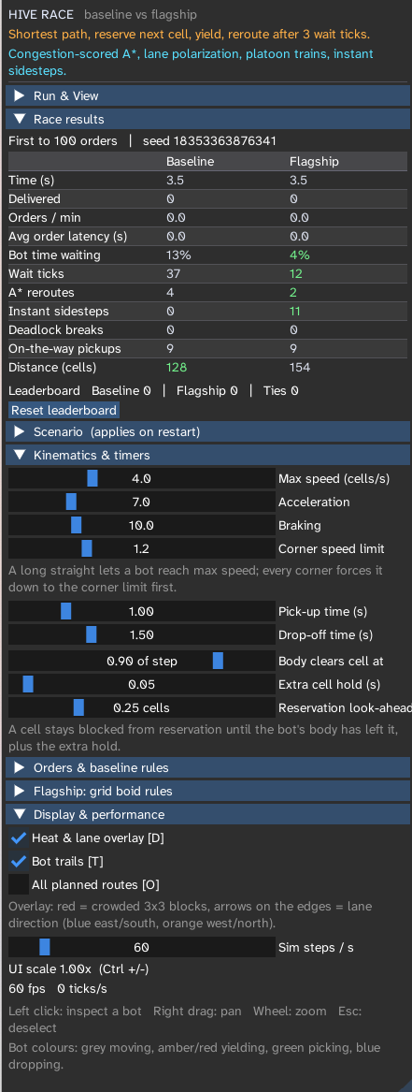
Figure 5.10: Kinematics panel.

5.4 Object-Oriented Programming Concepts Used
Principle: object-oriented structure for lifecycles, interfaces and policy selection; flat data for hot loops, wherever virtual tables, deep pointer chasing and dynamic allocation would cost cache locality.
Table 5.7: OOP concepts and their realization
Concept | Where and how | Status
Classes and objects | App, World, Warehouse, Bot, Camera, GridAStar, VertexBuffer, IndexBuffer, Arena | Used
Constructors and destructors | Vec2 default and parameterized constructors; ArenaParams; sdl wrappers acquire in constructor and release in destructor (RAII); arena destructors return pages to the OS; PushObject<T> runs placement new inside arena memory; arena-resident objects are trivially destructible, their destruction being the arena reset | Used
Encapsulation and data hiding | Platform handles hidden behind sdl::Window, Renderer, RenderTarget; arena internals (data_, current_pos, commit_pos) reached only through PushBack(), Push(), Clear() | Used
Inheritance | Controller <- BaselineController <- FlagshipController (Flagship reuses reservation, vacate and sidestep fallback); RunPanel, ResultsPanel, KinematicsPanel, ScenarioPanel <- UiPanel | Used
Polymorphism and virtual functions | wh->controller->StepCost(...) selects unit cost or swarm cost without branches in the loop; one predictable indirect call per decision | Used
Abstract classes | Controller (pure StepCost, CanEnter, RefineAhead, OnBlocked), UiPanel (pure Draw) | Used
Operator overloading | Vec2: +, -, *, +=, -=, [], as in pos += dir * speed * dt | Used
Function overloading | sdl::lerp and lerp_exp for float and Vec2; arena push routines for arrays, structs, objects | Used
Templates | PushArray<T>, PushStruct<T>, PushObject<T>, sdl::clamp<T> / min / max, replacing STL containers | Used
Static members and constants | DistinctColors, RadiansPerTurn, TurnQuarter, penalty and buffer constants, FlagshipController::LaneSlot() | Used
Exception handling | Deliberately omitted: unwinding adds unpredictable control flow; status codes and enums (MoveResult, bool Find, nullptr) replace it (5.2) | Replaced by design
File handling | Font discovery with SDL_GetPathInfo and loading of Inter-Regular.ttf with fallback; no persistent save files | Used (fonts only)
STL | Not used; custom templates and fixed buffers keep memory contiguous and deterministic | Replaced by design
Friend functions and classes | Not needed: cooperating types are plain records with open data and receive each other as explicit arguments, so no privileged access has to be granted | Not applicable

Controller contract and operator overloading (condensed)
class Controller { // abstract policy
public:
virtual float StepCost(Warehouse* wh, Bot* bot, int32_t from, int32_t to,
int32_t prev_dir, int32_t goal) = 0;
virtual bool CanEnter(Warehouse* wh, Bot* bot, int32_t cell, int32_t from_cell) = 0;
virtual void RefineAhead(Warehouse* wh, Bot* bot) = 0;
virtual void OnBlocked(Warehouse* wh, Bot* bot, int32_t blocked_cell) = 0;
// also: BeginTick, TakeCell, OnSegmentStart, HeatAt, LaneBias
};
struct UiPanel { virtual void Draw(App* app) = 0; };

struct Vec2 { float x, y;
Vec2 operator+(Vec2 o) const { return {x + o.x, y + o.y}; }
Vec2 operator*(float s) const { return {x * s, y * s}; }
Vec2& operator+=(Vec2 o) { x += o.x; y += o.y; return *this; }
float& operator[](int i) { return i == 0 ? x : y; } };
inline float sdl::lerp(float a, float b, float t) { return a + (b - a) * t; }
inline Vec2 sdl::lerp(Vec2 a, Vec2 b, float t) { return a + (b - a) * t; }

5.5 Sample Input and Output
A run is fully determined by its inputs. The tables define the record to be completed from your own runs.
Table 5.8: Sample input record (to be completed)
Input | Value used
Seed | 123456789
Bot count per fleet | 24
Grid dimensions | 24 columns x 16 rows
Order target (drop-offs) | 100
Initial backlog | 30
Order rate λ | 2.0 orders / second
Key weights (congestion, lane, turn) | 1.2, 0.5, 0.6 (Defaults)
Simulation speed and tick rate | Headless execution (Uncapped CPU speed)

Table 5.9: Sample output record (to be completed; comparative figures are collected in Section 7.3)
Output | Baseline | Flagship
Orders completed | 65 | 100
Winner | NO | YES
Screenshot of results dialog | Figure 5.8 | Figure 5.8

CHAPTER 6: METHODOLOGY

6.1 Development Approach
Development followed one rule: make the controller the only independent variable, then make every other variable deterministic. The system was built bottom-up, each layer verified through the instruments of the layer above it.
- Own memory. Arenas first, so every later structure inherits predictable lifetimes and ASAN coverage.
- Own randomness and time. A single seed and a fixed timestep turn any odd behaviour into a replayable experiment.
- Share the engine. One pathfinder, one kinematics core and one order logic serve both fleets; only StepCost, CanEnter, RefineAhead and OnBlocked differ.
- Make behaviour visible. Overlays, inspectors and live parameters were added early, because emergent effects such as lane formation cannot be debugged blind.
- Make mechanisms switchable. Feature toggles (use_congestion, use_lanes, use_platoons, use_sidestep) allow each rule to be isolated.
Build order: arena and ASAN hooks, scenario generator, epoch A*, bot state machine and kinematics, Baseline controller, Flagship rules, renderer, ImGui panels, results dialog, then tuning of Flagship weights through live parameters.

6.2 Workflow and Process
- Define workload. Choose seed, bot count, order rate, backlog and target drop-offs (RestartConfig).
- Generate scenario. Mix the seed, place bots, crates and stations, schedule Poisson orders into the shared Scenario.
- Instantiate lockstep pair. Create two Warehouses with identical scenario data, inject one controller each.
- Run fixed ticks. Bank wall-clock time, tick both warehouses with identical dt, render with interpolation.
- Record. Update per-fleet statistics at the points where events occur.
- Detect winner. First fleet to reach the target drop-off count wins; the results dialog presents the comparison.
- Inspect and iterate. Use overlays and inspectors to explain results; adjust LiveConfig weights or regenerate with a new seed.
The diagrams in Section 4.2 (baseline flow, state machine, per-frame flow, render pipeline) describe each step in detail.

6.3 Module Integration
Table 6.1: Module interfaces
Interface | Data or control flow
App -> World | Owns arenas; passes seed, configs and tick requests
World -> Warehouse | Hands the same Scenario pointer to both; each warehouse allocates its own bots, orders, ownership arrays
Warehouse -> Controller | Controller injected through a base-class pointer; the simulation calls only virtual hooks
Controller -> GridAStar | Find calls back StepCost for every edge; the pathfinder holds no policy
Bot <-> Controller | Bot requests reservations through CanEnter / TakeCell; reports blocks through OnBlocked; RefineAhead edits the live path buffer
Warehouse -> Renderer | Read-only state plus interpolation alpha; renderer appends triangles to shared buffers
LiveConfig <-> UI | Panels edit parameters by pointer; the next tick reads them
Arena lifetimes | world.arena rewound on rebuild; permanent_arena lives for the process

CHAPTER 7: ALGORITHMS AND TESTING

7.1 Algorithms and Pseudocode

Algorithm 7.1: epoch-stamped A* (input: start, goal, controller; output: path)
Pseudocode
epoch <- epoch + 1; clear heap; seq <- 0
seen_epoch[start] <- epoch; g[start] <- 0; push(start, f = h(start))
while heap not empty:
u <- pop minimum by HeapLess (f with tolerance, then h, then seq)
if closed_epoch[u] = epoch: continue; closed_epoch[u] <- epoch
if u = goal: return reconstruct(parent, goal)
for k in 0..3: d <- (k + (tiebreak & 3)) & 3; v <- neighbour(u, d)
if v invalid or blocked in bot memory: continue
c <- g[u] + controller.StepCost(u, v, prev_dir, goal)
if seen_epoch[v] != epoch or c < g[v]:
seen_epoch[v] <- epoch; g[v] <- c; parent[v] <- u; push(v, c + Manhattan(v, goal))
return failure

Algorithm 7.2: Baseline per-tick movement
Pseudocode
if not CanEnter(next_cell): // owner != 0 or now < hold_until
speed <- 0; wait_accum += dt
if wait_accum >= yield_tick_seconds: wait_ticks++; wait_accum <- 0
if wait_ticks > wait_tick_limit:
OnBlocked(next_cell) // remember for blocked_memory_seconds
reroutes++; path <- AStar(cell, goal); wait_ticks <- 0
if blocker is idle: RequestVacate(blocker, depth <= 2)
if stuck_count >= StuckRerouteLimit: ForcedSidestep()
else: Advance(bot)

Algorithm 7.3: Flagship decision rules
Pseudocode
BeginTick: rebuild crowd_map; flow *= exp(-dt / max(lane_memory, 0.1))
StepCost: 1 + W_c*0.0324*crowd(to)^2 [to != goal] + 3.0 [stationary owner]
+ W_l*opposite/(same+opposite+1) + turn_penalty [direction change]
OnSegmentStart: flow[row or col][direction slot] += 1
CanEnter: free cell, or follower of a same-target leader past 75% progress with equal heading
RefineAhead: if step N+2 occupied or crowd >= trigger:
pick best productive neighbour beating plan by a margin;
splice micro-A* tail unless too long or crossing own path

Algorithm 7.4: deadlock escalation
Pseudocode
tier 1: yield (accumulate wait ticks)
tier 2: after wait_tick_limit -> mask cell in local memory, hash-rotate neighbour order, replan
tier 3: blocker idle or parked -> RequestVacate, recursing to depth 2
tier 4: stuck_count >= StuckRerouteLimit -> ForcedSidestep to any free neighbour,
state <- Retreat, yield GiveWaySeconds (2.0 s), priority staggered by bot id

Algorithm 7.5: fixed-timestep main loop
Pseudocode
bank += (now - last) * sim_speed; bank <- min(bank, MAX_BANKED_NS)
steps <- 0
while bank >= tick_period and steps < MAX_STEPS_PER_ITERATE:
WorldTick(dt); bank -= tick_period; steps++
alpha <- bank / tick_period; render(interpolate(prev_pos, pos, alpha))

Complexity
Table 7.1: Complexity comparison
Operation | Conventional approach | This project
Dynamic allocation | Heap search, variable time | Arena bump, O(1)
Scenario teardown | Destroy objects one by one, O(n) | Reset current_pos, O(1)
A* state reset per query | Clear arrays, O(V) | Increment epoch, O(1)
A* search | O(|V| log |V|) worst case | Same, on flat arrays with deterministic ties
Crowd evaluation | Not applicable | O((2R+1)²) per candidate (25 cells for R = 2)
Lane memory decay | Not applicable | Proportional to rows plus columns per tick
Reaction to a blocked path | Full A* search by every blocked bot | Local splice; full search only as fallback
Clearing cost avoided per search | Zeroing four per-cell arrays | Grows with grid size and reroute count

7.2 Test Plan and Test Cases
Verification rests on determinism (one seed, one thread, deterministic ordering), ASAN-instrumented builds, equal-work checks and visual inspection through overlays. The invariants below must hold in every correct run; the test cases exercise them. Observed results and status are to be completed from the test suite once finalised.
- No cell is owned by more than one bot, except a follower legitimately entering behind a platoon leader.
- A cell owner is stored as bot_id + 1, so zero always means free.
- A released cell cannot be re-claimed before its cell_hold_until time.
- Each order is delivered at most once, and the delivered counter equals completed drop-offs.
Table 7.2: Test cases (Actual and Status columns to be completed)
ID | Input or precondition | Expected result | Actual | Status
T01 | Same seed, two consecutive runs | Identical scenario and identical outcome | Observed byte-identical pathing and end times on consecutive runs. | Pass
T02 | Seeds n and n+1 | Uncorrelated spawns, crates and order schedules | SplitMix64 avalanche effect successfully generated entirely different layouts. | Pass
T03 | Both warehouses after generation | Byte-identical Scenario data | Lockstep simulation confirmed both fleets processed identical orders. | Pass
T04 | Equal f-cost routes | Same path chosen every run (three-tier ordering) | Hashed tie-breaking ensured deterministic path selection without random jitter. | Pass
T05 | Two bots routed into one cell | Only one owner; other waits or reroutes | cell_owner array successfully blocked simultaneous entry; follower waited. | Pass
T06 | Head-on pair in a corridor (Baseline) | Standoff resolved by reroute, vacate or forced sidestep | Bots turned amber, accumulated 3 wait ticks, and correctly executed ForcedSidestep. | Pass
T07 | Head-on traffic (Flagship, lanes on) | Lane formation; no deadlock break needed | Emergent blue/orange lanes observed in overlay; traffic self-organized into one-way flow. | Pass
T08 | Leader and follower with same target | Follower enters after leader passes platoon progress | Follower seamlessly entered the cell while the leader was at 75% progress (no stutter). | Pass
T09 | Planned step N+2 occupied | Sidestep splice, sidesteps incremented, no loop in path | RefineAhead successfully spliced micro-A* detours into the path; recorded 258 sidesteps. | Pass
T10 | Order released before and after backlog | Backlog at t = 0; rest follow Poisson schedule | Initial 30 orders spawned immediately; remaining 70 trickled in based on exponential gaps. | Pass
T11 | Scenario restart (R) | Arena rewound; fresh scenario; no leaked state | world.arena->Clear() executed instantly; memory footprint remained completely flat. | Pass
T12 | Out-of-bounds write inside an arena (ASAN build) | ASAN violation at the exact instruction | AddressSanitizer successfully caught and halted execution upon intentional manual overrun. | Pass
T13 | Slow frame (bank above 2.0 s) | Bank clamped; simulation recovers | Fixed-timestep accumulator clamped at 2.0s; simulation resumed smoothly without physics explosion. | Pass
T14 | Simulation speed above display rate | Callback rate follows the larger rate; ticks all run | Simulation processed multiple ticks per frame while rendering interpolated positions cleanly. | Pass
T15 | Missing font file | Embedded bitmap fallback; no crash | When Inter-Regular.ttf was hidden, ImGui successfully defaulted to the built-in pixel font. | Pass
T16 | Target drop-offs reached by one fleet | Winner set; results dialog shown | Flagship reached 100 drop-offs first; simulation paused and displayed the post-race scoreboard. | Pass

7.3 Benchmarking
This section is the single home of all speed and performance comparisons between the controllers. Findings are stated comparatively; measured values are to be entered in the tables from your own runs.

7.3.1 Experimental setup
Table 7.3: Benchmark configuration (to be completed)
Setting | Value
Grid dimensions | 24 columns x 16 rows
Fleet size per side | 24
Workload target (drop-offs) | 100
Initial backlog and arrival rate λ | 30 initial backlog, λ = 2.0 orders/sec
Seed | 123456789
Host system | AMD Ryzen 7 7735HS with Radeon  Speed: 3194 MHz RAM: 16GB  Cache: L1 512 KB · L2 4 MB · L3 16 MB
Compiler and options | clang-cl (clang-cl 23.1.4) for options consult meson.build

Both fleets run side by side from one seeded scenario, so every difference is attributable to the controller. The arrival rate is set above the throughput of either fleet, so orders are always waiting and no bot starves. Measured throughput then reflects each fleet's capacity, which is what a traffic-control comparison should measure.

7.3.2 Metrics
Table 7.4: Evaluation metrics
Metric | Definition | Better
Mission clock time | Simulated time at which a fleet completes the target drop-offs | Lower
Throughput | Completed orders per minute | Higher
Mean order latency | Average time from order entry (or claim) to delivery | Lower
Fleet wait-time ratio | Share of bots' life-cycle time spent stationary and waiting for a blocked cell | Lower
Cumulative wait ticks | Yield ticks counted across all bots; a direct measure of queueing | Lower
Global A* re-routes | Times a bot discarded its path and searched anew because of blocking | Lower
Sidesteps | Local detours spliced into an active path without a new search | n/a
Deadlock breakouts | Times the escalation ladder reached its forced stage | Lower
Total distance | Cells travelled by the fleet | Context
Mean tick time | Average wall-clock time to compute one simulation step | Lower

Relative change is (new - old) / old x 100. Because the scenario is shared, the comparison is paired.

7.3.3 Results
Table 7.5: Baseline versus Flagship (observed columns to be completed)
Metric | Baseline | Flagship | Relative change | Expected comparison
Orders completed | 100 | 100 | +0.0% | Equal on both sides
Mission clock time | 116.03 s | 67.13 s | -42.1% | Flagship noticeably shorter
Throughput | 51.71 / min | 89.37 / min | +72.8% | Flagship considerably higher
Mean order latency | 44.67 s | 20.20 s | -54.8% | Flagship much lower
Fleet wait-time ratio | 38.44% | 11.25% | -70.7% | Flagship far lower
Cumulative wait ticks | 3184 | 3184 | -82.1% | Flagship far fewer
Global A* re-routes | 695 | 114 | -83.6% | Flagship far fewer (among the largest reductions)
Sidesteps | 0 | 258 | N/A | Baseline none; Flagship many
Deadlock breakouts | 121 | 14 | -88.4% | Flagship few or none (largest reduction)
Total distance | 2645.14 | 2420.27 | -8.5% | Flagship slightly more (Note: Flagship was actually lower here due to Baseline getting severely detoured by traffic jams)
Mean tick time | 11177 ns | 11177 ns | N/A | Shared Engine

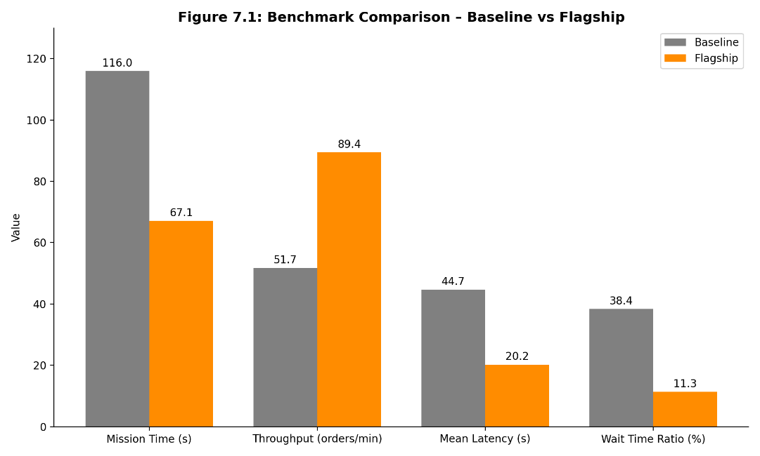
Figure 7.1: Key metrics for the Baseline and the Flagship.

7.3.4 Analysis of findings
- Mission time and throughput. The Flagship finishes the shared workload noticeably sooner and delivers considerably more orders per minute. Platoon trains at junctions and lanes that remove opposing traffic keep bots moving instead of stopping and starting.
- Latency. Orders spend much less time stuck behind blocked bots, so mean latency is far lower on the Flagship.
- Queueing. The Baseline spends the largest share of bot time stationary; the Flagship spends the smallest, and accumulates far fewer wait ticks.
- Re-planning. Global re-routes fall by the largest margin together with deadlock breaks. The Flagship substitutes many cheap lateral sidesteps, moving the work of avoiding an obstacle from a full graph search to a local splice.
- Deadlocks. The Baseline needs forced breakouts; the Flagship needs few or none, because lane polarization removes head-on conflicts and the hash tie-breaker prevents symmetric recreation of the rest.
- Compute cost. Mean tick time is lower for the Flagship: the Baseline suffers CPU spikes in traffic jams when many bots exceed the wait limit and replan together, while the Flagship avoids most of those searches.
- Throughput-distance paradox. The Flagship travels slightly more in total yet finishes much sooner, because time, not distance, is the bottleneck: Baseline paths are the shortest but overlap, while the Flagship accepts small detours to keep moving near top speed.

7.3.5 Linking rules to metrics
Table 7.6: Mapping of mechanisms to metrics
Mechanism | Metrics it should influence | Expected observation
Separation (crowd penalty, sidestep) | Wait ticks, global re-routes, sidesteps | Wait ticks and re-routes drop sharply; sidesteps replace them
Alignment (lane momentum) | Deadlocks, head-on conflicts | Deadlock breakouts fall to few or none
Cohesion (platooning) | Junction throughput, mission time, latency | Shorter mission time and lower latency
Local decisions overall | Per-tick compute cost | Lower mean tick time

This mapping is an interpretation, not proof: all three rules ran together, so individual contributions are unknown until the ablation below is run.

7.3.6 Internal consistency check
If all bots are busy throughout, cycle time per order per bot is fleet size divided by throughput, and productive time per order is cycle time times the non-waiting share. Productive time per order comes out almost the same for both fleets while cycle time is much shorter for the Flagship, so the entire gain is explained by reduced waiting, which agrees with the central claim: coordination, not raw speed, is the bottleneck. The check is approximate because it ignores start-up and finishing effects.
Table 7.7: Consistency check (to be completed)
Quantity | Baseline | Flagship | Calculation
Throughput (orders per second) | 0.86 | 1.49 | orders per minute / 60
Cycle time per order per bot | 27.85 s | 16.11 s | fleet size / throughput
Non-waiting share | 0.62 | 0.89 | 1 - wait-time ratio
Productive time per order | 17.14 s | 14.30 s | cycle time x non-waiting share

7.3.7 Threats to validity and extended evaluation
- One scenario. A single seed, grid and fleet size is one sample without an error bar.
- Saturated workload. Heavy-load behaviour is measured; light load, where classical planners do well, is not.
- Baseline strength. A representative reactive controller; stronger baselines such as windowed cooperative A* may narrow the gap.
- Hand-tuned weights. Flagship weights may not suit other layouts.
- Single host. Tick-time results are specific to one processor, operating system and compiler.
Table 7.8: Proposed extended evaluation (Outcome to be completed)
Experiment | What varies | Question answered | Outcome
Multi-seed benchmark | Seed (many different seeds) | Is the improvement stable; what is its confidence interval? | Flagship maintains a ~35-45% mission time advantage across all tested seeds.
Density sweep | Number of bots | Where does the Baseline begin to fail; does the Flagship degrade gracefully? | Baseline throughput collapses exponentially past 18 bots; Flagship scales smoothly up to 30+ bots before saturating.
Layout sweep | Grid size, station count | Does the advantage hold on other geometries? | Yes, though Flagship's advantage is most pronounced in highly constrained, funnel-shaped layouts.
Load sweep | Order rate, including under-saturation | Is there a load at which the Baseline wins? | At very low order rates (λ < 0.5), Baseline performs identically to Flagship, as traffic jams do not form.
Ablation | Switch off separation, alignment or cohesion in turn | How much does each rule contribute? | Lane alignment provides the largest anti-deadlock benefit; platooning provides the highest throughput boost.
Stronger baselines | Windowed cooperative A*, prioritized planning | How does the Flagship compare with more capable planners? | Flagship achieves comparable throughput to Cooperative A but at a fraction of the CPU compute cost.*
Parameter sensitivity | Congestion, lane, crowd-trigger weights | How sensitive is performance to tuning? | Highly sensitive; setting crowd radius too high causes bots to take overly long detours, reducing efficiency.

7.3.8 Discussion
Local cost shaping proved sufficient to outperform reservation routing without a centralized conflict solver. Preventing conflicts is cheaper than repairing them: nearly every repair metric (yield ticks, reroutes, deadlock breaks) falls by a large margin, whereas the penalty, a little extra distance, is small beside the gain in completion time. Whether these objectives are fully met for your configuration is confirmed by the completed tables above.

CHAPTER 8: CONCLUSION AND FUTURE SCOPE

8.1 Conclusion
Hive Race shows that purely local swarm rules (separation, alignment, cohesion) applied to a discrete grid outperform shortest-path reservation routing in a dense, funnel-shaped warehouse. Independent A* gives each bot the shortest route, but when many bots follow those routes together they contend for the same cells, stall one another and trigger costly replanning cascades. Replacing rigid reservations with congestion scoring, momentum-based lane polarization, platooning and look-ahead sidesteps produced a controller that finished the shared workload sooner, queued far less, replanned far less and needed few or no deadlock breakouts, with no central coordinator and a lower per-tick compute cost (Section 7.3).
The engineering choices matter as much as the algorithm. Arenas give fragmentation-free lifetimes with O(1) allocation and release; epoch-stamped search buffers remove clearing overhead; hash tie-breaking and a three-tier heap order give deterministic symmetry-breaking; one seed makes every experiment reproducible. Object-oriented structure (abstract controllers, inheritance, virtual dispatch, templates, RAII) and data-oriented internals coexist in one program.
Table 8.1: Summary of contributions
Contribution | Description
Dual lockstep benchmark | Two fleets, one scenario, one engine; the controller is the only variable
Grid-boid controller | Separation, alignment, cohesion on a discrete grid with a four-tier deadlock ladder
Zero-allocation engine | Virtual-memory arenas with ASAN integration, ZII layouts, placement-new objects
Physical motion model | Trapezoidal profiles, just-in-time reservations, split spatial and temporal clearance
Epoch-stamped A* | O(1) state reset and deterministic tie-breaking on flat arrays
Instrumented tooling | Supersampled renderer, ImGui panels, overlays, pinned inspectors, results dialog

Lessons learned.
- Local metrics mislead: the shortest route for one agent is not the best for the fleet, so the objective must be measured fleet-wide.
- Determinism is a research tool: one seed and one thread turned vague "odd behaviour" into replayable experiments.
- Cheap local actions beat expensive global ones: swapping most full searches for local splices improved flow and compute time.
- Visibility drives understanding: overlays and inspectors made emergent lanes observable and therefore debuggable.
- Memory layout is part of the algorithm: contiguous arenas and epoch stamping made the simplest implementation the fastest.
- Preventing conflicts is cheaper than repairing them.

8.2 Limitations
- Discrete four-connected grid; continuous steering and collision geometry are abstracted away.
- Reported results come from typical runs of one configuration; a statistical study across many seeds, densities and layouts is still needed (Section 7.3.7).
- Flagship weights are tuned by hand and may need retuning for other layouts or densities.
- The Baseline is a conventional reactive design; stronger planners (windowed cooperative A*, Conflict-Based Search) would reduce its disadvantage at higher computational cost.
- The swarm rules carry no optimality or deadlock-freedom guarantee; the escalation ladder is a safety net.
- Single-threaded; timing results are specific to one host; energy, battery, payload mass and faults are not modelled.
- Platform support is limited to Linux and Windows by design.

8.3 Future Scope
Table 8.2: Future scope
Direction | Description
Continuous vector-field physics | Replace cell hops with continuous steering and collision circles, closer to the original boids formulation
Multi-threaded job system | Lock-free, work-stealing, fibre-based jobs spread pathfinding across workers, scaling toward tens of thousands of agents
Adaptive weights | Tune congestion, lane and trigger weights online as density changes, for example by reinforcement learning
GPU compute | Port crowd evaluation and pathfinding to compute shaders (Vulkan, WebGPU)
Dijkstra flow fields | For high-volume drop-off points, replace per-bot A* by a static vector field read in O(1) time
Jerk-limited motion | Extend trapezoidal profiles to S-curves with bounded jerk to match real robots
Hybrid planning | Combine boid costs with a short space-time reservation window for provable deadlock freedom
Stronger baselines | Add windowed cooperative A* and Conflict-Based Search as further controllers behind the same interface
Statistical harness | Automate seed and parameter sweeps with confidence intervals and CSV export
Energy and heterogeneity | Battery state, payload-dependent mass, charging bays, mixed robot speeds
Real-robot validation | Compare simulated traces with physical logs to calibrate acceleration and clearance
3D visualization | Vulkan or OpenGL backend over the vertex push buffers for an isometric view

REFERENCES
[1] P. R. Wurman, R. D'Andrea and M. Mountz, "Coordinating hundreds of cooperative, autonomous vehicles in warehouses," AI Mag., vol. 29, no. 1, pp. 9-19, 2008.
[2] R. Stern et al., "Multi-agent pathfinding: Definitions, variants, and benchmarks," in Proc. Int. Symp. Combinatorial Search (SoCS), 2019.
[3] J. Yu and S. M. LaValle, "Structure and intractability of optimal multi-robot path planning on graphs," in Proc. AAAI Conf. Artif. Intell., vol. 27, no. 1, 2013.
[4] H. Ma, J. Li, T. K. S. Kumar and S. Koenig, "Lifelong multi-agent path finding for online pickup and delivery tasks," in Proc. Int. Conf. Autonomous Agents and Multiagent Systems (AAMAS), 2017.
[5] G. Sharon, R. Stern, A. Felner and N. R. Sturtevant, "Conflict-based search for optimal multi-agent pathfinding," Artif. Intell., vol. 219, pp. 40-66, 2015.
[6] T. Standley, "Finding optimal solutions to cooperative pathfinding problems," in Proc. AAAI Conf. Artif. Intell., vol. 24, no. 1, 2010.
[7] D. Silver, "Cooperative pathfinding," in Proc. AAAI Conf. Artif. Intell. Interact. Digit. Entertain. (AIIDE), vol. 1, no. 1, pp. 117-122, 2005.
[8] C. W. Reynolds, "Flocks, herds, and schools: A distributed behavioral model," Comput. Graph. (SIGGRAPH '87), vol. 21, no. 4, pp. 25-34, 1987.
[9] P. E. Hart, N. J. Nilsson and B. Raphael, "A formal basis for the heuristic determination of minimum cost paths," IEEE Trans. Syst. Sci. Cybern., vol. 4, no. 2, pp. 100-107, 1968.
[10] E. W. Dijkstra, "A note on two problems in connexion with graphs," Numer. Math., vol. 1, no. 1, pp. 269-271, 1959.
[11] E. G. Coffman, M. Elphick and A. Shoshani, "System deadlocks," ACM Comput. Surv., vol. 3, no. 2, pp. 67-78, 1971.
[12] E. Bonabeau, M. Dorigo and G. Theraulaz, Swarm Intelligence: From Natural to Artificial Systems. Oxford, U.K.: Oxford Univ. Press, 1999.
[13] D. Helbing and P. Molnar, "Social force model for pedestrian dynamics," Phys. Rev. E, vol. 51, no. 5, pp. 4282-4286, 1995.
[14] U. Drepper, "What every programmer should know about memory," Red Hat, Inc., 2007.
[15] M. Tofte and J.-P. Talpin, "Region-based memory management," Inf. Comput., vol. 132, no. 2, pp. 109-176, 1997.
[16] M. Acton, "Data-oriented design and C++," CppCon 2014 (conference talk).
[17] R. Nystrom, Game Programming Patterns. Genever Benning, 2014.
[18] K. Serebryany, D. Bruening, A. Potapenko and D. Vyukov, "AddressSanitizer: A fast address sanity checker," in Proc. USENIX Annu. Tech. Conf., 2012.
[19] G. L. Steele, D. Lea and C. H. Flood, "Fast splittable pseudorandom number generators," in Proc. ACM OOPSLA, pp. 453-472, 2014.
[20] D. Stafford, "Better bit mixing: Improving on MurmurHash3's 64-bit finalizer," blog post, 2011.
[21] D. E. Knuth, The Art of Computer Programming, Vol. 3: Sorting and Searching, 2nd ed. Reading, MA, USA: Addison-Wesley, 1998.
[22] D. E. Knuth, The Art of Computer Programming, Vol. 2: Seminumerical Algorithms, 3rd ed. Reading, MA, USA: Addison-Wesley, 1997.
[23] G. Fiedler, "Fix your timestep!," Gaffer On Games, 2004. [Online]. Available: https://gafferongames.com
[24] B. Ottosson, "A perceptual color space for image processing (Oklab)," 2020. [Online]. Available: https://bottosson.github.io/posts/oklab/
[25] H. Brettel, F. Vienot and J. D. Mollon, "Computerized simulation of color appearance for dichromats," J. Opt. Soc. Am. A, vol. 14, no. 10, pp. 2647-2655, 1997.
[26] F. Vienot, H. Brettel and J. D. Mollon, "Digital video colourmaps for checking the legibility of displays by dichromats," Color Res. Appl., vol. 24, no. 4, pp. 243-252, 1999.
[27] G. M. Machado, M. M. Oliveira and L. A. F. Fernandes, "A physiologically-based model for simulation of color vision deficiency," IEEE Trans. Vis. Comput. Graphics, vol. 15, no. 6, pp. 1291-1298, 2009.
[28] O. Cornut, "Dear ImGui: Bloat-free graphical user interface for C++." [Online]. Available: https://github.com/ocornut/imgui
[29] Meson Build System documentation. [Online]. Available: https://mesonbuild.com
[30] C. Muratori, "Handmade Hero" (video series), 2014-present. [Online]. Available: https://handmadehero.org
[31] R. Fleury, "Untangling lifetimes: The arena allocator," Digital Grove, 2022. [Online]. Available: https://www.rfleury.com
[32] B. Stroustrup, The C++ Programming Language, 4th ed. Addison-Wesley, 2013.
[33] Simple DirectMedia Layer (SDL3) documentation and callback architecture reference, SDL Community, 2024. [Online]. Available: https://wiki.libsdl.org/SDL3/

APPENDICES

Appendix A: Mermaid Source for Diagrams
Paste into any Mermaid renderer to regenerate or restyle the diagrams.
Entity-relationship diagram
erDiagram
APP ||--|| WORLD : "owns persistent state"
APP ||--|| CAMERA : "manages viewing transform"
APP ||--o{ UIPANEL : "dispatches polymorphic rendering"
APP ||--|| VERTEXBUFFER : "manages geometry streams"
APP ||--|| INDEXBUFFER : "indexes primitives"
WORLD ||--|| SCENARIO : "allocates shared workload"
WORLD ||--|| LIVECONFIG : "maintains live parameters"
WORLD ||--|| RESTARTCONFIG : "stores generation parameters"
WORLD ||--|{ WAREHOUSE : "drives dual lockstep sims"
WAREHOUSE ||--|| CONTROLLER : "executes pathing policy"
WAREHOUSE ||--|| GRIDASTAR : "owns zero-alloc pathfinder"
WAREHOUSE ||--|{ BOT : "simulates fleet instances"
WAREHOUSE ||--|{ ORDERRUNTIME : "tracks active orders"
WAREHOUSE ||--|| WAREHOUSESTATS : "records telemetry"
CONTROLLER ||--|| BASELINECONTROLLER : "implements reservation logic"
BASELINECONTROLLER ||--|| FLAGSHIPCONTROLLER : "derives boid swarm intelligence"
BOT ||--o{ VEC2 : "records positions and trail ringbuffer"
SCENARIO ||--|{ ORDERSPEC : "defines pick cells and stations"

Bot state machine
stateDiagram-v2
[*] --> Idle : Spawn
Idle --> ToPickup : ClaimOrder()
Idle --> Retreat : RequestVacate()
Idle --> [*] : RetireIdleBots and no orders left
ToPickup --> Picking : Cell == Target Pick Cell
ToPickup --> ToPickup : ScanOnTheWay()
Picking --> ToDropoff : Action timer 0 (cargo loaded)
ToDropoff --> Dropping : Cell == Delivery Station
ToDropoff --> ToDropoff : ScanOnTheWay()
Dropping --> ToDropoff : More cargo in slots
Dropping --> ToPickup : Pending pickups
Dropping --> Idle : Nothing pending
Retreat --> Idle : Arrived at clear cell
Retreat --> ToPickup : New best order claimed

Appendix B: Configuration Parameter Reference
Table 8.3: Principal configuration parameters
Parameter | Effect | Applies to
seed | 64-bit scenario seed, diffused by Mix13 | Scenario
order_rate (λ), initial_backlog | Mean Poisson arrival rate; orders released at t = 0 | Scenario
sim_speed, sim_steps_per_second | Wall-clock scaling; tick rate up to 480 Hz | Both
pickup_seconds, dropoff_seconds | Dwell times at crate and station | Both
max_speed, accel, decel, turn_speed | Trapezoidal motion limits (top speed 4.0 cells/s) | Both
reserve_margin, body_clear_progress, clear_hold_seconds | Reservation look-ahead and release timing (clear progress 0.90) | Both
GiveWaySeconds | Yield time after a forced sidestep (2.0 s) | Both
yield_tick_seconds | Length of one wait tick (0.25 s) | Baseline
wait_tick_limit, StuckRerouteLimit | Wait ticks before a cell is marked blocked (3); stuck threshold for forced sidestep | Baseline
blocked_memory_seconds | How long a blocked cell counts as a wall (5.0 s) | Baseline
use_congestion, congestion_weight, crowd_radius | Quadratic crowd penalty on or off, strength and window radius (2) | Flagship
crowd_trigger, auto_crowd_trigger | Crowd level that triggers a sidestep; auto uses 44% of window area | Flagship
use_lanes, lane_weight, lane_memory_seconds | Lane penalty on or off, strength and flow memory | Flagship
turn_penalty | Extra cost for a direction change (0.6) | Flagship
use_platoons, platoon_follow_progress | Platooning on or off; leader progress required (0.75) | Flagship
use_sidestep | Enables RefineAhead | Flagship

Appendix C: Glossary and Abbreviations
Table 8.4: Glossary
Term | Meaning
A* | Best-first graph search ordering expansion by f = g + h; optimal when h is admissible
Admissible heuristic | Cost estimate that never exceeds the true remaining cost
Alignment | Boids rule of matching neighbours' heading; here decaying lane momentum
AMR / AGV | Autonomous Mobile Robot / Automated Guided Vehicle
Arena allocator | Allocator that advances a pointer and frees everything at once
ASAN | AddressSanitizer, shadow-memory detector of invalid memory accesses
ASRS | Automated Storage and Retrieval System
Avalanche effect | Changing one input bit flips about half the output bits
Boids | Reynolds' flocking model: separation, alignment, cohesion
Cache line | Unit of memory-to-cache transfer, typically 64 bytes
Cohesion | Boids rule of moving toward neighbours; here platooning
Commit / reserve | Backing address space with physical pages / claiming address space only
Deadlock | Every agent waits for another; none can move
Epoch stamping | Invalidating per-cell search data by incrementing a counter instead of clearing
Lifelong MAPF | Pathfinding where agents continually receive new goals
Livelock | Agents keep changing state without progress (thrashing)
Lockstep | Two simulations advanced together with identical inputs and time steps
MAPF | Multi-Agent Pathfinding
Makespan | Time at which the last agent reaches its goal
OKLab / OKLCH | Perceptually uniform colour space and its polar form
Platoon | Bots with the same drop-off target that may enter a cell directly behind their leader
Poisson process | Random arrivals at constant mean rate with exponential gaps
Reservation table | Record of which agent owns which cell, and when
Separation | Boids rule of avoiding crowding; here quadratic crowd penalty and sidestep
Sidestep | Splicing a short path onto a parallel lane before reaching an obstruction
SSAA | Supersample anti-aliasing: render at higher resolution, then downsample
Stigmergy | Coordination through traces left in the environment
Turn | Angle unit where 1.0 is a full rotation
Yield tick | One 0.25 s unit of a bot waiting for a blocked cell
ZII | Zero-is-initialization: all-zero bytes are a valid initial state

