This Doc is about getting the notification alert in your Gmail account for vaccina availability in the area PIN entered by you

#1. Lambda dashboard:

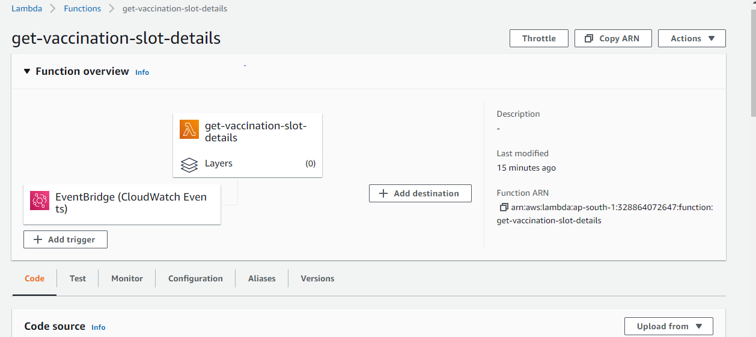

#2. Lambda code:

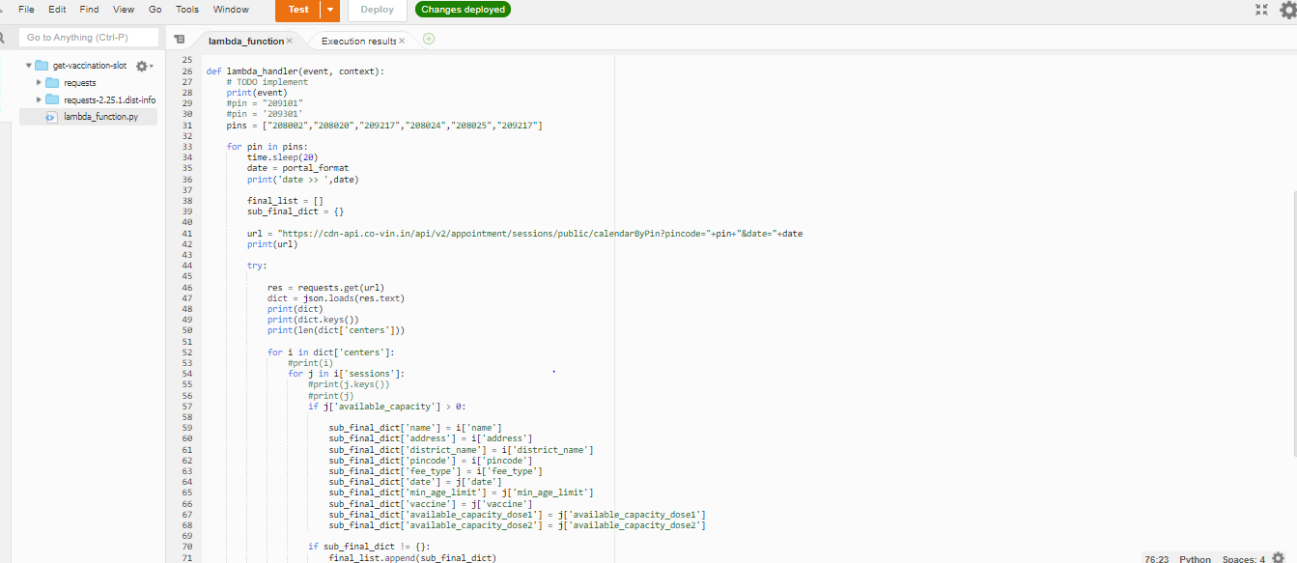

#3. Event bridge details:

