Lambda functions:

Lambda function which registers the user:

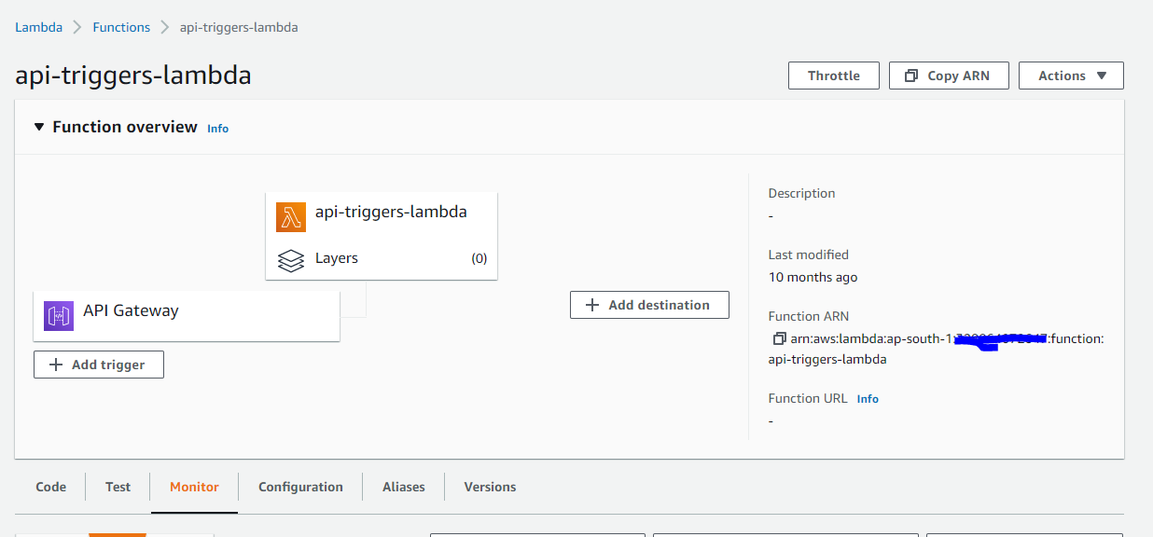

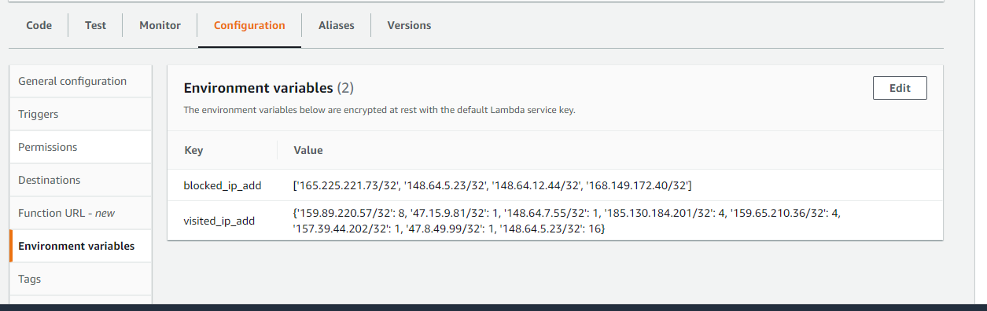

Api Gateway associated with above lambda functions:

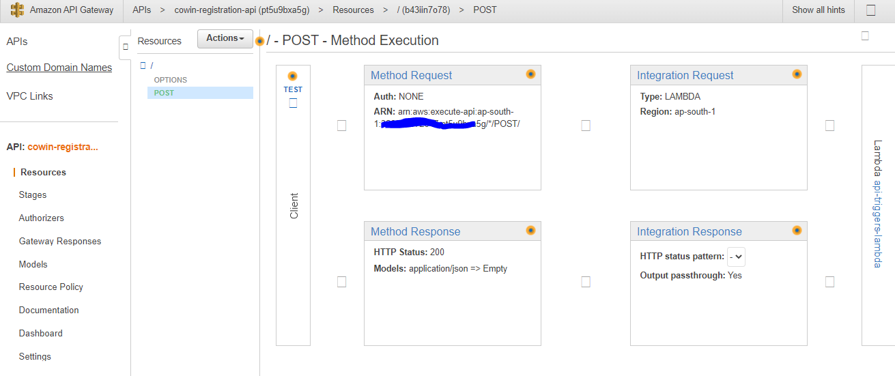

Lambda which sends alert mails:

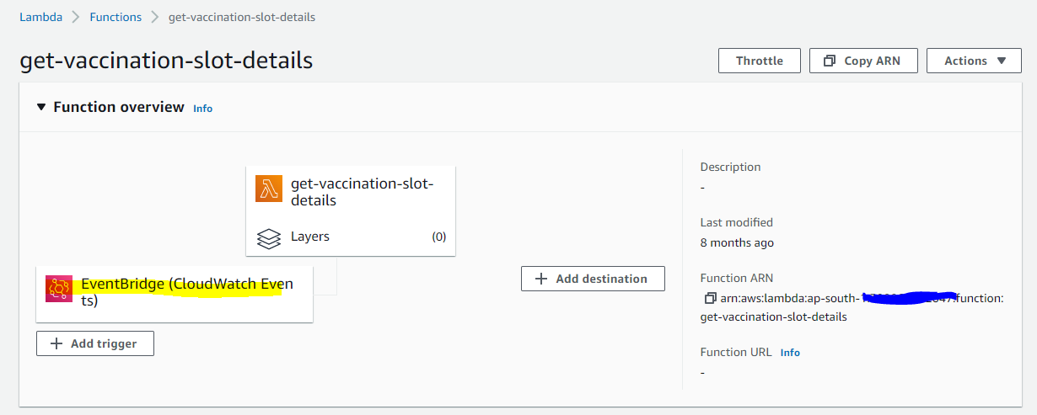

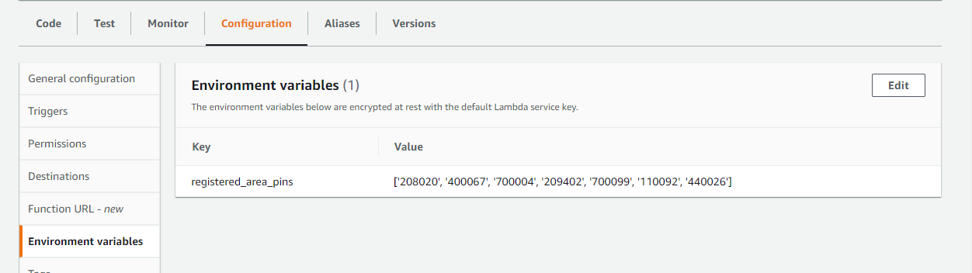

Event bridge associated with above lambda function:

